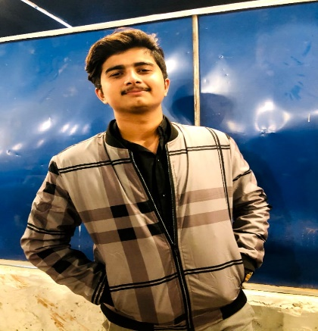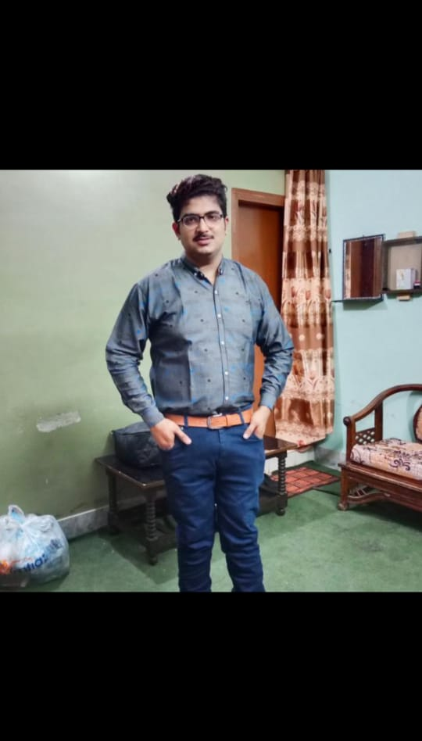HOBBIES

. EXPERT IN OPEARTING COMPUTER

EXPERIENCE

MUSIC

🎧

WRITING

🖆

READING BOOKS

📚

🛪

TRAVEL

HOBBIES

CREATIVE;

ADAPTABLE;

MANAGEMENT SKILLS;

COMMUNICATION

**Private hostle**

0332078504

🏠

🕻

aadreshnaghnani49@gmail

🖄

UNIVERSITY OF SINDH JAMSHORO

BACHELOR OF COMPUTER SCIENCE

EDUCTION

CONTACT

PROFILE

AADRESH MAGHNANI

CURICULUM VITAE