**Kubernetes (K8s)**

Kubernetes is an open source container orchestration engine for automating deployment, scaling, and management of containerized applications. The open source project is hosted by the Cloud Native Computing Foundation (CNCF).

It provides a scalable and resilient framework for automating the deployment, scaling, and management of applications across clusters of servers.

**A SMALL HISTORY OF K8S**:

1. In the early 2000s, Google started developing a system called Borg to manage their internal containerized applications.

2. Borg enabled Google to run applications at scale, providing features such as automatic scaling, service discovery, and fault tolerance.

3. In 2014, Google open-sourced a version of Borg called Kubernetes.

4. Kubernetes was donated to the Cloud Native Computing Foundation (CNCF), a neutral home for open-source cloud-native projects, in July 2015.

5. Kubernetes 1.8 added significant enhancements for storage, security, and networking. Key features included the stable release of the stateful sets API, expanded support for volume plugins, and improvements in security policies.

6. Check URL: https://kubernetes.io/releases/ for more release details.

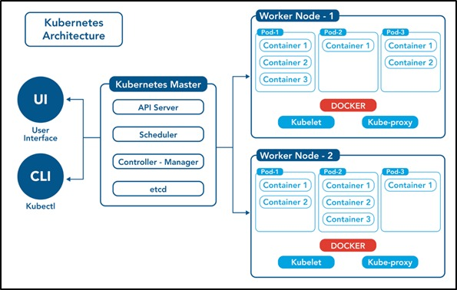

**Control Plane /Master Node**

The control plane's components make global decisions about the cluster (for example, scheduling), as well as detecting and responding to cluster events (for example, starting up a new pod when a deployment's replicas field is unsatisfied).

Control plane components can be run on any machine in the cluster. Do not run user containers on this machine.

**Node Components / Worker Nodes**

Node components run on every node, maintaining running pods and providing the Kubernetes runtime environment.

1. Master Node: The master node is responsible for managing the cluster and coordinating the overall state of the system. It includes the following components:

a. API Server: The API server is the central control point for all interactions with the cluster. It exposes the Kubernetes API and handles requests from users and other components.

b. Scheduler: The scheduler is responsible for assigning workloads (pods) to individual worker nodes based on resource requirements, constraints, and other policies.

c. Controller Manager: The controller manager runs various controllers that monitor the cluster state and drive it towards the desired state. Examples include the replication controller, node controller, and service controller.

d. etcd: etcd is a distributed key-value store used by Kubernetes to store cluster state and configuration data.