# **Design**

**UML DIAGRAMS FOR ADVANCED SCIENTIFIC CALCULATOR**

**ACTIVITY DIAGRAM:**

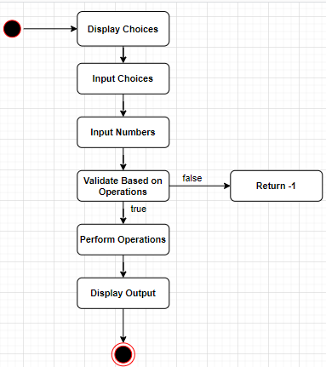

**USE CASE DIAGRAM**

