Week-1
1# Prepare a report on SageMath tool and its different functionalities.
Introduction to SageMath-SageMath (short for System for Algebra and Geometry Experimentation) is an open-source mathematical software system designed to support research, education, and advanced computation in mathematics. It integrates many existing open-source mathematics packages into a unified Python-based interface. SageMath provides tools for symbolic computation, numerical analysis, algebra, geometry, combinatorics, cryptography, statistics, and more.Unlike proprietary systems such as MATLAB, Mathematica, or Maple, SageMath is free and open-source, making it widely accessible for academic and professional use.
Core Features of SageMath
1 Symbolic Computation
SageMath supports symbolic mathematics through integration with libraries such as SymPy and Maxima. Users can:
- Perform symbolic differentiation and integration
- Simplify algebraic expressions
- Expand and factor polynomials
- Solve algebraic equations symbolically
- Work with symbolic limits and series expansions
Example capabilities:
- Compute derivatives and integrals of symbolic functions
- Solve systems of equations
- Manipulate expressions involving variables
2 Algebra
SageMath is particularly strong in algebraic structures and abstract algebra. It supports:
- Polynomial rings
- Groups, rings, and fields
- Linear algebra operations
- Matrix computations
- Finite fields
- Algebraic number theory
Users can define custom algebraic structures and perform operations such as computing eigenvalues, determinants, inverses, and solving linear systems.

3 Calculus and Analysis
SageMath provides tools for both symbolic and numerical calculus, including:
- Limits
- Differentiation and integration
- Multivariable calculus
- Differential equations
- Taylor and power series expansions
It can solve ordinary differential equations symbolically or numerically and visualize solutions graphically.

4 Numerical Computation
For numerical work, SageMath integrates powerful numerical libraries. Features include:
- Floating-point and arbitrary precision arithmetic
- Numerical integration
- Root finding
- Optimization
- Numerical linear algebra
It supports high-precision calculations, which are essential in scientific computing.

5 Graph Theory
SageMath includes extensive tools for graph theory:
- Creation and manipulation of graphs
- Directed and undirected graphs
- Graph traversal algorithms
- Shortest path algorithms
- Graph coloring
- Connectivity analysis

6 Combinatorics
SageMath has advanced combinatorics capabilities, including:
- Permutations and combinations
- Partitions
- Combinatorial structures
- Generating functions
- Counting techniques
It is widely used for research in algebraic combinatorics.

7 Geometry and Topology
SageMath supports:
- Euclidean and non-Euclidean geometry
- Polyhedra
- Algebraic geometry
- Computational topology
Users can define geometric objects and perform transformations and visualizations.

8 Number Theory
SageMath is highly regarded for its number theory functionality:
- Modular arithmetic
- Prime number testing
- Integer factorization
- Cryptographic algorithms
- Elliptic curves
- Diophantine equations
It is frequently used in cryptographic research and computational number theory.

9 Statistics and Data Analysis
SageMath includes statistical tools such as:
- Descriptive statistics
- Probability distributions
- Hypothesis testing
- Random variable simulation
It can also interface with other statistical packages.

10 Visualization and Plotting
SageMath offers strong 2D and 3D plotting capabilities:
- Function plots
- Parametric plots
- Implicit plots
- Surface plots
- Interactive visualizations
Plots can be exported in various formats for publication.
Programming Interface
SageMath uses Python as its primary programming language. Users can:
- Write scripts
- Create functions and modules
- Automate computations
- Combine symbolic and numerical workflows
Because it is Python-based, it can integrate with other Python libraries such as NumPy and Matplotlib.
User Interface
SageMath provides multiple ways to interact:
- Command-line interface
- Jupyter Notebook interface
- Web-based Sage Notebook
- Integration with other IDEs
The Jupyter interface is especially popular in educational settings.
Applications of SageMath
- Academic research
- University teaching
- Engineering mathematics
- Cryptography
- Data science
- Scientific computing

Advantages of SageMath
- Free and open-source
- Integrates many powerful mathematical libraries
- Python-based and highly extensible
- Strong support for algebra and number theory
- Active research and educational community

Conclusion-SageMath is a comprehensive and powerful open-source mathematics software system. Its integration of numerous mathematical libraries under a Python-based framework makes it versatile and accessible. With capabilities ranging from symbolic algebra and calculus to number theory, graph theory, statistics, and visualization, SageMath serves as a valuable tool for students, educators, researchers, and professionals in mathematics and related fields.

Overall, SageMath stands as a cost-effective and highly capable alternative to commercial mathematical software systems.
2# Write a Python program to detect whether given integer is perfect or not ?
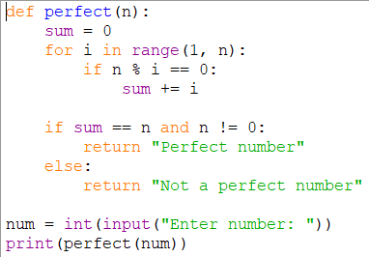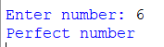
3# Write a Python program to detect whether given integer is Armstrong Integer or not?
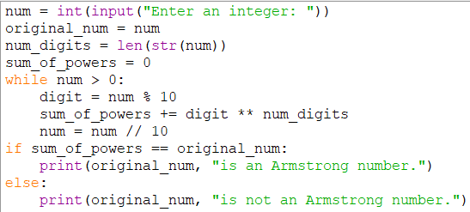
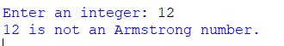

Week-2
1# Write a program to detect whether a number is prime or not.
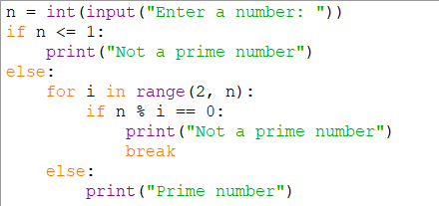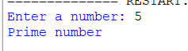
2# Write a function to compute GCD of two integers.
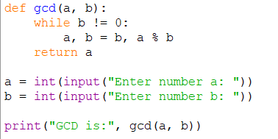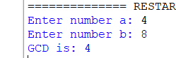
3# Write a program to detect whether two numbers are relatively prime or not?
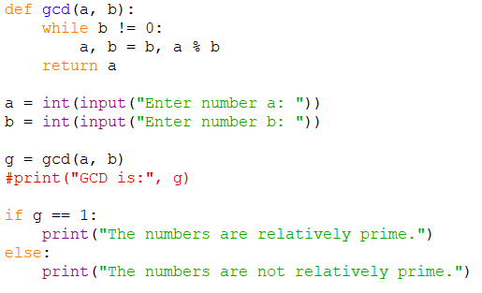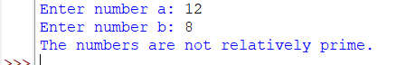
4# Write a function to display all‘n’ narcissistic number. For example, 153 is a 3 narcissistic number because 13 + 53 + 33 = 153, and 1634 is 4 narcissistic number because 14 + 64 + 34 + 44 = 1634.
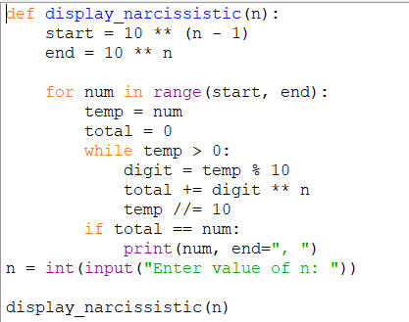

Week-3
1# Write a function to check whether a number is in the form of 2k or not.
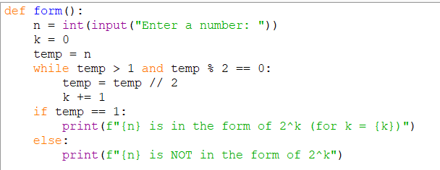
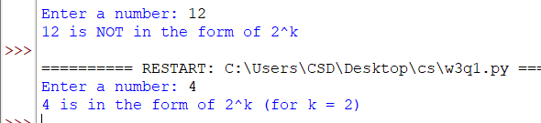
2# Write a function to check whether a prime number is Mersenne prime or not?
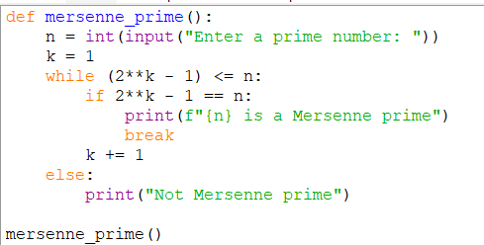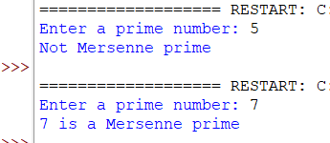
3# Write a program to evaluate Euler Totients (Totatives) of a given integer
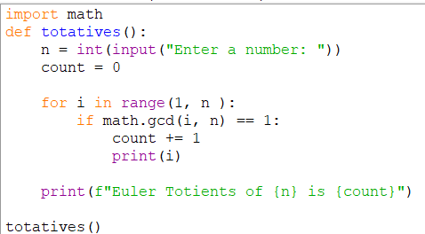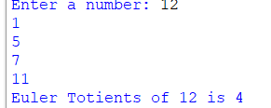

4# Implement a function that takes two arguments (r, n) and computer order of r under modulo(n) operation.
