WEEK-6
1# Write a program to perform encryption and decryption using XOR operation on plaintext ‘Cyber Security’ with value 0, 1 and 5.
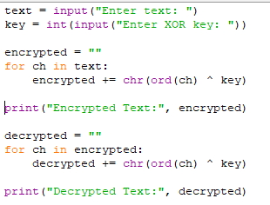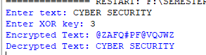
2# Implement the Caesar cipher in Python to encrypt and decrypt a given text.
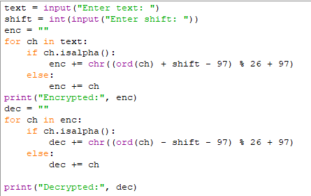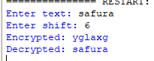
3# Write a program to implement the Playfair cipher for text encryption and decryption.
key = input("Enter key: ").upper().replace("J","I")
text = input("Enter text: ").upper().replace("J","I").replace(" ","")
alphabet = "ABCDEFGHIKLMNOPQRSTUVWXYZ"
matrix = ""
for c in key + alphabet:
if c not in matrix:
matrix += c
print("\nKey Matrix:")
for i in range(0,25,5):
print(matrix[i:i+5])
pairs = []
i = 0
while i < len(text):
a = text[i]
b = text[i+1] if i+1 < len(text) else 'X'
if a == b:
pairs.append(a+'X')
i += 1
else:
pairs.append(a+b)
i += 2
print("Pairs:", pairs)
def playfair(pairs, mode='encrypt'):
cipher = ""
for p in pairs:
a, b = p[0], p[1]
index1 = matrix.index(a)
r1 = index1 // 5
c1 = index1 % 5
index2 = matrix.index(b)
r2 = index2 // 5
c2 = index2 % 5
if r1 == r2:
shift = 1 if mode=='encrypt' else -1
cipher += matrix[r1*5 + (c1+shift)%5]
cipher += matrix[r2*5 + (c2+shift)%5]
elif c1 == c2:
shift = 1 if mode=='encrypt' else -1
cipher += matrix[((r1+shift)%5)*5 + c1]
cipher += matrix[((r2+shift)%5)*5 + c2]
else:
cipher += matrix[r1*5 + c2]
cipher += matrix[r2*5 + c1]
return cipher
encrypted = playfair(pairs, 'encrypt')
print("Encrypted Text:", encrypted)
dec_pairs = [encrypted[i:i+2] for i in range(0,len(encrypted),2)]
decrypted = playfair(dec_pairs, 'decrypt')
print("Decrypted Text:", decrypted)
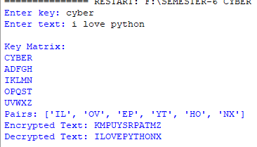
4# Write a program to encrypt and decrypt a simple text file using Hill Cipher technique in Python.
def text_to_numbers(text):
return [ord(c) - ord('A') for c in text]
def numbers_to_text(nums):
return ''.join(chr(n % 26 + ord('A')) for n in nums)
def process_text(text, n):
text = ''.join(filter(str.isalpha, text.upper()))
while len(text) % n != 0:
text += 'X'
return text
def get_minor(matrix, i, j):
return [
[row[c] for c in range(len(matrix)) if c != j]
for r, row in enumerate(matrix) if r != i
]
def determinant(matrix, mod=26):
n = len(matrix)
if n == 1:
return matrix[0][0] % mod
if n == 2:
return (matrix[0][0]*matrix[1][1] - matrix[0][1]*matrix[1][0]) % mod
det = 0
for c in range(n):
minor = get_minor(matrix, 0, c)
sign = (-1) ** c
det += sign * matrix[0][c] * determinant(minor, mod)
return det % mod
def mod_inverse(a, m):
a = a % m
for i in range(1, m):
if (a * i) % m == 1:
return i
return None
def multiply_matrix_vector(matrix, vector):
result = []
n = len(matrix)
for i in range(n):
s = 0
for j in range(n):
s += matrix[i][j] * vector[j]
result.append(s % 26)
return result
def transpose(matrix):
return [list(row) for row in zip(*matrix)]
def cofactor_matrix(matrix):
n = len(matrix)
cof = []
for i in range(n):
row = []
for j in range(n):
minor = get_minor(matrix, i, j)
sign = (-1) ** (i + j)
row.append(sign * determinant(minor))
cof.append(row)
return cof
def inverse_matrix(matrix):
n = len(matrix)

det = determinant(matrix)
inv_det = mod_inverse(det, 26)
if inv_det is None:
raise ValueError("Matrix not invertible mod 26")
cof = cofactor_matrix(matrix)
adj = transpose(cof)
inv = []
for i in range(n):
row = []
for j in range(n):
row.append((adj[i][j] * inv_det) % 26)
inv.append(row)
return inv
def encrypt(text, key):
n = len(key)
text = process_text(text, n)
nums = text_to_numbers(text)
result = []
for i in range(0, len(nums), n):
block = nums[i:i+n]
result.extend(multiply_matrix_vector(key, block))
return numbers_to_text(result)
def decrypt(cipher, key):
n = len(key)
inv_key = inverse_matrix(key)
nums = text_to_numbers(cipher)
result = []
for i in range(0, len(nums), n):
block = nums[i:i+n]
result.extend(multiply_matrix_vector(inv_key, block))
return numbers_to_text(result)
print("Hill Cipher (Variable Size Matrix)")

choice = input("1. Encrypt File\n2. Decrypt File\nEnter choice: ")
n = int(input("Enter matrix size (n x n): "))
print(f"Enter {n}x{n} key matrix:")
key = []
for i in range(n):
key.append(list(map(int, input().split())))
input_file = input("Enter input file name: ")
output_file = input("Enter output file name: ")
with open(input_file, 'r') as f:
text = f.read()
try:
if choice == '1':
cipher = encrypt(text, key)
with open(output_file, 'w') as f:
f.write(cipher)
print("File Encrypted Successfully!")
elif choice == '2':
plain = decrypt(text, key)
with open(output_file, 'w') as f:
f.write(plain)
print("File Decrypted Successfully!")
else:
print("Invalid choice!")
except Exception as e:
print("Error:", e)
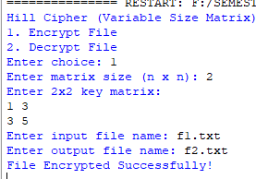

5# Write a program to implement a simplified version of the Feistel structure used in block ciphers.
def xor(a, b):
return format(int(a, 2) ^ int(b, 2), '04b')
def round_function(right, key):
temp = xor(right, key)
return temp[1:] + temp[0] # left shift
def feistel_encrypt(block, keys):
left = block[:4]
right = block[4:]
print("\nEncryption Process:")
for i in range(len(keys)):
print(f"Round {i+1}:")
temp = right
f_output = round_function(right, keys[i])
right = xor(left, f_output)
left = temp
print(f" Left: {left} Right: {right}")
return left + right
def feistel_decrypt(block, keys):
left = block[:4]
right = block[4:]
print("\nDecryption Process:")
for i in range(len(keys)-1, -1, -1):
print(f"Round {len(keys)-i}:")
temp = left
f_output = round_function(left, keys[i])
left = xor(right, f_output)
right = temp
print(f" Left: {left} Right: {right}")
return left + right
print("Simplified Feistel Cipher")
block = input("Enter 8-bit binary plaintext: ")
rounds = int(input("Enter number of rounds: "))
keys = []
print("Enter round keys (4-bit each):")
for i in range(rounds):
k = input(f"Key {i+1}: ")
keys.append(k)
cipher = feistel_encrypt(block, keys)
print("\nEncrypted Block:", cipher)
plain = feistel_decrypt(cipher, keys)
print("Decrypted Block:", plain)
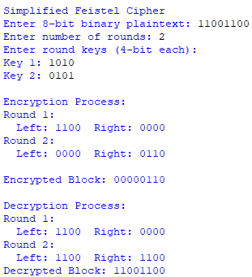

WEEK-7
1# Write a program to implement a Hash function.
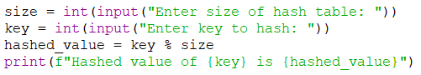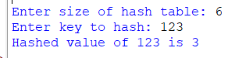
2# Write a program to implement BlowFish algorithm.
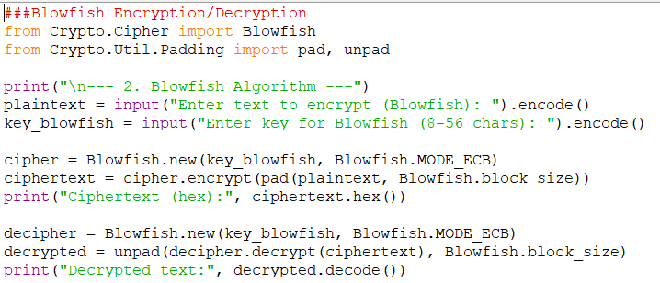
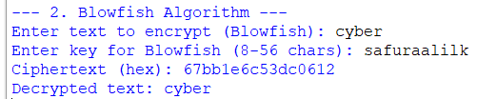
3# Write a program to implement TwoFish algorithm.
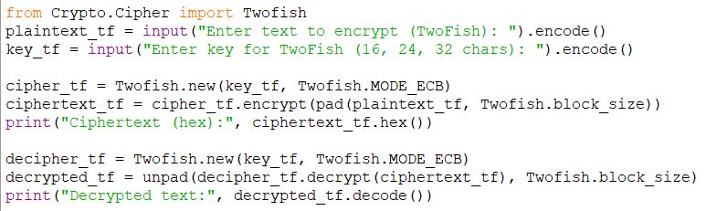

4# Implement the Diffie-Hellman Key Exchange scheme.
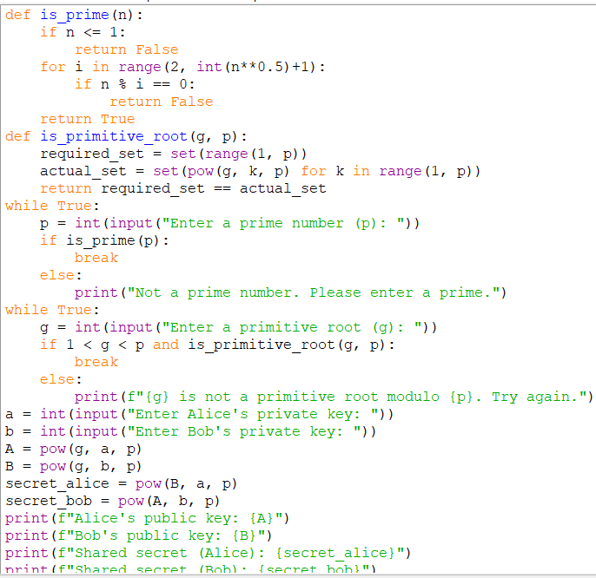
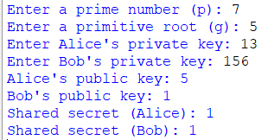
5# Calculate the message digest of a text using the SHA-1 algorithm.
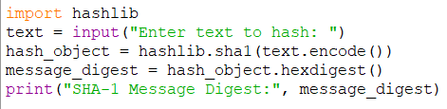

WEEK-8
1# Find Inverse of a number under modulo(p) (where p is a prime number) using SageMath.
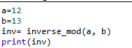
2# You have been given a set and you are required to check whether it is Group, Ring or Field using SageMath.
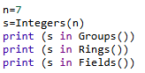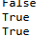
3# Implement Elliptic Curve cryptography using SageMath.
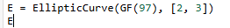
4# Perform a simulated elliptic curve Diffie-Hellman (ECDH) key exchange using the SageMath’s elliptic curve functionality.
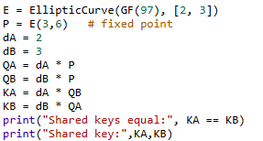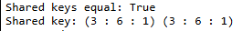
5# Write a program for RSA algorithm using SageMath.
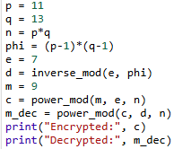

WEEK-9
1# Implement SHA-1, SHA-2 and SHA-3 using SageMath.
import hashlib
msg = b"Hello Cryptography"
print("SHA-1 :", hashlib.sha1(msg).hexdigest())
print("SHA-256 :", hashlib.sha256(msg).hexdigest())
print("SHA-3 :", hashlib.sha3_256(msg).hexdigest())
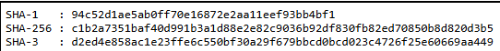s
2# Implement MD-5 using SageMath.
import hashlib
msg = b"Hello Cryptography"
print("MD5:", hashlib.md5(msg).hexdigest())
3# Demonstrate Hash-based Message Authentication Code (HMAC) implementation using Python.
import hmac
import hashlib
key = b"secret_key"
msg = b"Important message"
h = hmac.new(key, msg, hashlib.sha256).hexdigest()
print("HMAC:", h)
4# Compare Message Authentication Code (MAC) and Digital Signatures on parameters like how they use keys, security level, and computational cost by simulating both in Python.
import hmac
import hashlib
import time
print("=== MESSAGE AUTHENTICATION CODE (MAC) ===")
key = b"shared_secret"
message = b"Transfer 1000$"
# MAC generation
start_mac = time.time()
mac = hmac.new(key, message, hashlib.sha256).hexdigest()
end_mac = time.time()
print("MAC:", mac)
print("MAC Valid:", hmac.new(key, message, hashlib.sha256).hexdigest() == mac)
print("MAC Time:", end_mac - start_mac)
print("\n=== DIGITAL SIGNATURE (RSA SIMULATION) ===")
# RSA
p = 11
q = 13
n = p * q
phi = (p - 1) * (p - 1)
e = 7
d = pow(e, -1, phi)
msg = b"Transfer 1000$"
h = int(hashlib.sha256(msg).hexdigest(), 16)
# Signing
start_sig = time.time()
signature = pow(h, d, n)
# Verification
verified = pow(signature, e, n)
end_sig = time.time()
print("Signature:", signature)
print("Signature Valid:", verified == h % n)
print("Signature Time:", end_sig - start_sig)
print("\n=== COMPARISON SUMMARY ===")
print("MAC -> Fast, symmetric key, no non-repudiation")
print("Signature -> Slower, asymmetric key, provides non-repudiation")
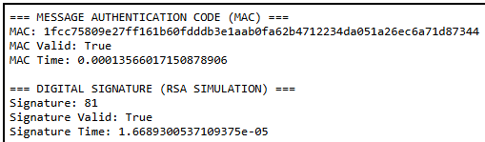

Week-10
1# Research and implement a digital signature verification process using a cryptographic library. Sign a document with a private key and verify the signature using a public key.
from cryptography.hazmat.primitives import hashes
from cryptography.hazmat.primitives.asymmetric import rsa, padding
from cryptography.hazmat.primitives import serialization

private_key = rsa.generate_private_key(
public_exponent=65537,
key_size=2048
)
public_key = private_key.public_key()
message = b"This is a secure document."
signature = private_key.sign(
message,
padding.PSS(
mgf=padding.MGF1(hashes.SHA256()),
salt_length=padding.PSS.MAX_LENGTH
),
hashes.SHA256()
)
print("Signature created.")
try:
public_key.verify(
signature,
message,
padding.PSS(
mgf=padding.MGF1(hashes.SHA256()),
salt_length=padding.PSS.MAX_LENGTH
),
hashes.SHA256()
)
print("Signature is valid.")
except Exception:
print("Signature verification failed.")
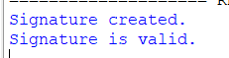
2# Write a report on working of Burp Suite and its different functionalities.
REPORT ON BURP SUITE AND ITS FUNCTIONALITIES
Introduction
Burp Suite is a comprehensive platform used for web application security testing. It is developed by PortSwigger and is widely used by penetration testers, security researchers, and developers.Burp Suite enables testers to analyze, intercept, and manipulate web traffic between a browser and a server, helping identify vulnerabilities in web applications.

Working Principle
Burp Suite works as an intercepting proxy between the client (browser) and the server.
Process Flow
- User configures browser to use Burp as proxy
- HTTP/HTTPS traffic passes through Burp
- Requests are intercepted and can be modified
- Responses are captured and analyzed
This allows testers to inspect how a web application behaves under different conditions.
Editions of Burp Suite
- Community Edition
  - Free version
  - Limited features (no automated scanner)
- Professional Edition
  - Paid version
  - Includes advanced tools like automated vulnerability scanning
Core Functionalities / Tools
1 Proxy
- Intercepts HTTP/HTTPS traffic
- Allows modification of requests and responses
- Useful for analyzing application behavior
2 Spider (Crawler)
- Automatically explores web applications
- Maps structure (pages, forms, endpoints)
- Helps identify attack surfaces
3 Scanner (Pro Feature)
- Automatically detects vulnerabilities such as:
  - SQL Injection
  - Cross-Site Scripting (XSS)
  - CSRF
4 Intruder
- Used for automated testing of inputs
- Performs fuzzing and payload testing
- Helps identify weak authentication mechanisms
5 Repeater
- Allows manual modification and resending of requests
- Useful for testing specific payloads repeatedly
6 Decoder
- Encodes/decodes data formats:
  - Base64
  - URL encoding
  - Hex
7 Comparer
- Compares two responses or data sets
- Helps identify subtle differences
8 Sequencer
- Analyzes randomness of tokens (e.g., session IDs)
- Detects weak session management
Key Features
- Interception and modification of traffic
- Automated and manual vulnerability testing
- Session handling support
- Extensibility via plugins (BApp Store)
- Supports modern web technologies
Applications
- Web application penetration testing
- Bug bounty hunting
- Security auditing
- Vulnerability assessment
Advantages
- User-friendly interface
- Powerful testing capabilities
- Combines multiple tools in one platform
- Widely accepted in industry
Limitations
- Full features require paid version
- Learning curve for beginners
- Automated scans may produce false positives
Ethical Considerations
Burp Suite should only be used:
- On applications you own, or
- With explicit authorization
Unauthorized testing may be illegal and unethical.
Conclusion
Burp Suite is a powerful and versatile tool for web security testing. Its wide range of functionalities—from intercepting traffic to automated vulnerability scanning—makes it essential for identifying and fixing security flaws in web applications.
3# Perform a brute-force attack on a dummy login page using Burp Suite. Document the findings and mitigation strategies.
