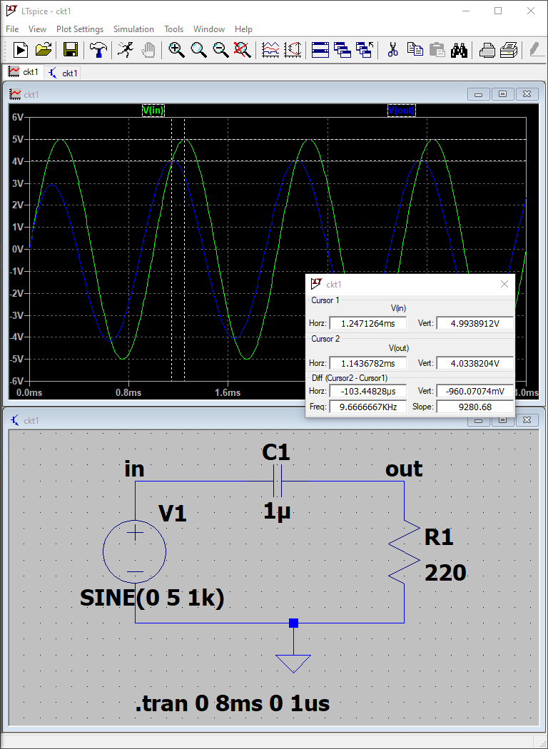

1. Phase Difference is, 97u \* 1k \* 360 = 34.92 deg
2. A. for f = 500Hz, Phase Difference = 57.78 deg

B. for f = 2kHz, Phase Difference = 19.20 deg

In both cases, Vout leads Vin