**INDEPENDENT UNIVERSITY BANGLADESH (IUB) School of Engineering and Computer Science (SECS) Department of Computer Science and Engineering**

**Autumn – 2019**



**Subject: Database Management System (CSE303/CSC401) Project: Admission Result Management System**

**Group:** 01

**Group Member:**

1. Azfar Hossain (1631350)

2. Ahmad Sayeef Khan (1520139)

3. Avirup Mondol (1720672)

4. Shoptorshi Rahman (1720360)

5. Sajedur Rahman Shakil (1530855)

**Supervisor:** Radiah Haque

**Date of Submission:** 28.11.2019

**Table of Contents:**

|  |  |
| --- | --- |
| Name | Page No. |
| 1.0 INTRODUCTION | 3 |
| 1.1 BACKGROUND OF THE PROJECT | 3 |
| 1.2 BACKGROUND OF THE ORGANIZATION | 4 |
| 1.3 OBJECTIVE OF THE PROJECT | 5 |
| 1.4 SCOPE OF THE PROJECT | 6 |
| 1.5 METHODOLOGY | 6-7 |
| 2.0 REQUIREMENT ANALYSIS | 8 |
| 2.1 EXISTING SYSTEM (with Rich picture) | 8-9 |
| 2.2 EXISTING BPMN | 10 |
| 2.3 EXISTING PROCESSES ALONG WITH SIX SYSTEM ELEMENTS | 11-13 |
| 2.4 EXISTING PROBLEM AND ANALYSIS OF THE PROBLEM | 14 |
| 2.5 SOLUTION OF THE PROBLEM | 15 |
| 2.6 PROPOSED SYSTEM (with Rich picture) | 16-17 |
| 2.7 PROPOSED BPMN | 18 |
| 2.8 PROPOSED PROCESSES ALONG WITH SIX SYSTEM ELEMENTS | 19-21 |
| 2.9 BUSINESS POLICY | 22 |
| 3.0 LOGICAL SYSTEM DESIGN | 23 |
| 3.1 DATA MODEL | 23-24 |
| 3.2 ERD (Entity Relationship Diagram) | 25 |
| 3.3 ERD TO RELATIONS | 26 |
| 3.4 NOMALIZATION | 27-28 |
| 3.5 DATA DICTIONARY | 29-31 |

**1.0 INTRODUCTION:**

**1.1 BACKGROUND OF THE PROJECT:**

The idea of this project is to get recognizable with Structured Query Language (SQL) used for Database Management System (DBMS) handling. The concept of this project was scrutinized to us by our instructor Ms. Radiah Haque. This project is a fundamental requirement of the course CSE303/CSC401-Database Management System.

The primary features of this project are to construct an online based software which will allow us to see the admission test result of IUB. The result of university will be organized according to respective department and show results in suitable graphs, pie charts and histograms.

Using this system people can know the acceptance rate of university. As technology is getting advance day by day most of the systems are being converted to an automated one which saves time and is less stressful to humans. The cost of manual procedure is greater than that of an automated one and thus is more cost effective. We can easily avoid human error by this process which will be a new revolution in the IT industries. Through this system, the government or higher authority can easily get reliable information of admission result of respective universities. Our purpose is to create a database which would store all the data and compute everything for us when required. we can let our web base software be used by other private university.

**1.2 BACKGROUND OF THE ORGANIZATIONS:**

**Independent University, Bangladesh (IUB)**

Independent University, Bangladesh (IUB) is a private university in Bangladesh. Its permanent campus is in Bashundhara R/A, Dhaka. It was established in 1993 is the leading private university in Bangladesh with an explicit focus on Research and Global partnerships. As stipulated by the Private University Act, 1992. The president of Bangladesh is the chancellor of the university and appoints the vice chancellor and treasurer.



Figure 1: Independent University, Bangladesh (IUB). Figure 2: IUB Logo.

**1.3 OBJECTIVES OF THE PROJECT:**

We hoped to develop a system which will take the admission result of IUB. The system will update the result data automatically without any manual input.

We planned to develop a new system which will be a further improved version of the current existing system and we will make the system much easier to use compared to the existing system. The system will also increase the efficiency of university's record management system such as maintaining the data of every graphs, histograms, pie charts and tables uploaded in the website. The system will also be having a centralized control over the records of each department’s admission records in terms of each semester fee which will be handled by the administrator. The administrator will also have the power to monitor the changes in these tables, for example, color change of graphs etc.

The improved system will be helping the university authorities to calculate graphs, histograms and tables easily and automatically just by using the concept of database. Knowing about how many students have been admitted in a specific semester is very important. If this information is easily available in the website without any manual input is a very big deal as no extra time is required to process the data. The system is also going to have a different interface for different departments which will to be easy to use and understand.

**1.4 SCOPE OF THE PROJECT:**

•Automation of most of the calculations required for graphs to be uploaded to the website.

• Anyone will be able to see accepted students online, for their respective departments, through the website.

•Semester wise Admission records will be stored in the database.

•Authority can check their admission data online through this website anytime.

•This process will contain less error as computation will be done automatically by machine.

• Maintenance will be less complicated as database is easier to maintain than actual human beings.

•Graphs will show the department of students admitted for recent 4 years (2015-2018).

• Graph will analysis the difference of department of students and yearly increment or decrement will be compared.

•With this system, administrators can analyze and predict future admission requirements.

**1.5 METHODOLOGY:**

We are using SDLC (System Development Life Cycle) as preferred methodology. It is a traditional methodology used to develop, maintain and replace the information system. This framework provides a sequence of activities for system designers and developers to follow. It consists of a set of steps or phases in which each phase of the SDLC uses the results of the previous one.

The SDLC adheres to important phases that are essential for developers—such as planning, analysis, design, implementation and maintenance —and are shortly explained bellows.

**Planning:** It develops a preliminary understanding of a business situation and how information systems might help solve a problem or make an opportunity possible.

**Analysis:** It analyzes the business situation thoroughly to determine requirements, structures those requirements, and selects among competing system features.

**Design:** It elicits and structures all information requirements, develops all technology and organizational specifications.

**Implementation:** It commits writing programs, building databases, testing and installing the new system, training users, and finalizing documentation.

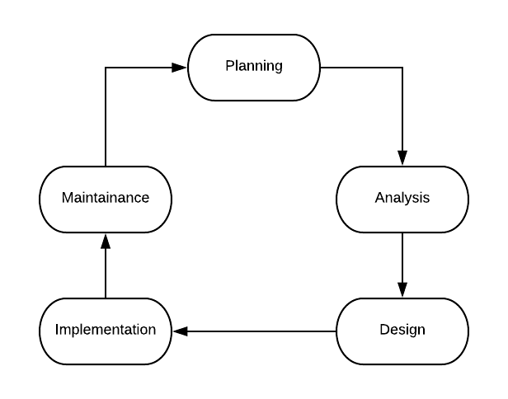

Figure 12: Process Flow

**Maintenance:** Monitoring the operation and usefulness of the system, and repairing and enhancing the system are committed in this stage.

The reasons why we chose SDLC are as follows:

* Easy and simple to understand with all the stages.
* High possibility that goals will be achieved.
* System requirements can be traced back to the original business needs.
* Different phases can be conducted in parallel.
* Allows for management to exercise their control greatly

**2.0 REQUIREMENT ANALYSIS:**

**2.1 EXISTING SYSTEM (with Rich picture):**

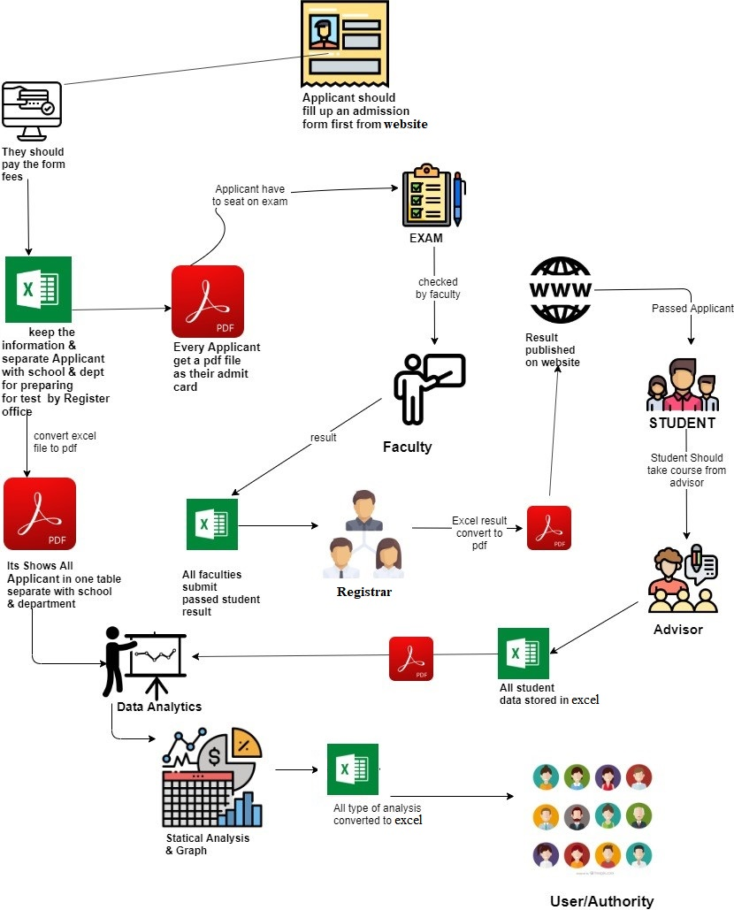

Figure 13: Rich Picture Current System

**Description of EXISTING SYSTEM**:

The students fill up the admission form from IUB website. They then pay for the admission form via bikash or bank. They receive confirmation from the university and get email regarding admission examination. University Conducts the admission test and selects students from the examinees based on admission test results. They then assign unique ID to each of the students. Publishes the compiled list of selected candidates for a specific semester on their web portal. The strategic policy maker/faculty Collects the published list of selected candidates from the web portal and Converts the PDF file to a CSV format to prepare the data to perform additional customization and data analysis Upload the CSV file of selected candidate admission list to the database of the web system Provides the system with necessary parameters for data analysis. Such as- Timeline of comparison, Types of graphical charts for representation of data. Customize the formatting of the generated report. Such as- Title, Description of charts, Date. All the data of IUB should be collected from the Annual Reports published by IUB. The different data of universities should be brought under /converted into under a same scale for the sake of comparison.

**2.2 EXISTING BPMN 2.0:**

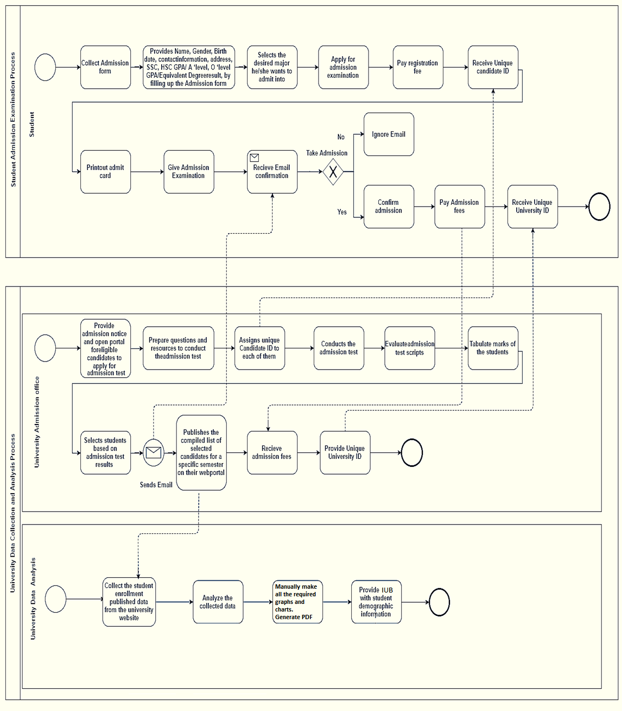

**2.2 PROCESS ALONG WITH SIX SYSTEM ELEMENTS:**

|  |  |  |  |  |  |  |
| --- | --- | --- | --- | --- | --- | --- |
|  | System Roles | | | | | |
| Process | Human | Non-computing Hardware | Computing Hardware | Software | Database | Communication & Network / Connectivity |
| Word to Excel conversion process | Analyst | Document | Computer | Office Excel | -- | -- |
| Excel to Pdf conversion process | Analyst | -- | Computer | Office Excel | -- | -- |
| Admission Result publication process | Registrar | -- | Utilizing computer to publishes the result | operating browser, university website | -- | Using internet to publish the results. |
| Admission result downloading and calculation process | policy maker | -- | Utilizing computer to download the result. | Operating browser, university website | Pile the information in Pdf. | Internet |
| Website publication process | Registrar | -- | Utilizing computer to download the annual result. | Utilizing browser to publish the annual report. | -- | Internet |
| Necessary file conversion process | Policy maker | -- | Utilizing computer to convert data from PDF to Excel. | Operating Office Excel to convert the PDF. | Store in the Office Excel. | -- |
| Data comparison and verification process | Policy maker | -- | Utilizing computer | Operating on Office Excel. | Store in the Office Excel. | -- |
| Graph calculation and plotting process | Policy maker | -- | Utilizing computer | Office excels. | Store in the Office Excel. | -- |
| Correction and analysis process | Policy maker | -- | Utilizing computer | Office excels. | Store in the Office Excel. | -- |
| Further analysis and policy making process | Policy maker | -- | Utilizing computer or smart phone. | Office word. | Computer storage. | -- |

**2.4 EXISTING PROBLEM AND ANALYSIS OF THE PROBLEM:**

|  |  |  |  |  |
| --- | --- | --- | --- | --- |
| Process | Stakeholders | Concerns (Problems) | Analysis (Reason of the  Problem) | Proposed Solution |
| Policy Maker/Faculty convert Pdf file to excel format and generate graphical representation. | Policy Maker | The process is done manually for graphs which is not time efficient. | Autonomous System can do it faster and less effort. | By Utilizing Database and data processing system that can maximize the output and minimize time. |
| Human error | Policy Maker | May contain error. | Manual calculation done by humans can contain error. | Automation of all sorts of calculations needed in this entire process |
| Time consuming | Policy Maker | The manual process takes more time. | Policy maker may take more time to finish everything. | Automation system will be faster at doing things |
| Maintenance | Policy Maker | Harder to maintain/replace/correct information. | Things are done manually so the main thing must do again if anything must be modified. | Everything is done automatically and stored in database. Easier to maintain and modify as things are present in the automation system. |

**2.5 SOLUTION OF THE PROBLEM:**

The problem we are mainly concerned with is the calculations and analysis which is being done manually. The graphs, histograms and pie charts of admission examination results are done manually by the policy maker/faculty. Therefore, the system is manual which is time consuming and may contain human error. We are proposing a system where the calculations and graph plotting will be done automatically and all the data will be stored in the database without any manual input. This will not contain error as every calculation and graph/histogram plotting will be done by a machine. Since no manual input is being done, the entire process will be faster and effortless. Our basic goal is to get maximum output of data with limited amount of time. If every process becomes automatic, we can immediately observe the admission test results i.e. Tables, graphs, pie charts and histograms in respected websites. We will not witness any delay in process unless the database itself crashes. The entire process will be faster than the current process and will be easier to maintain. Any data can be easily modified as everything is available in the database and in the automation system so the modification process will also be faster, easier and safer. The whole process is not needed to be repeated as the current system.

**2.6 PROPOSED SYSTEM (with Rich picture):**

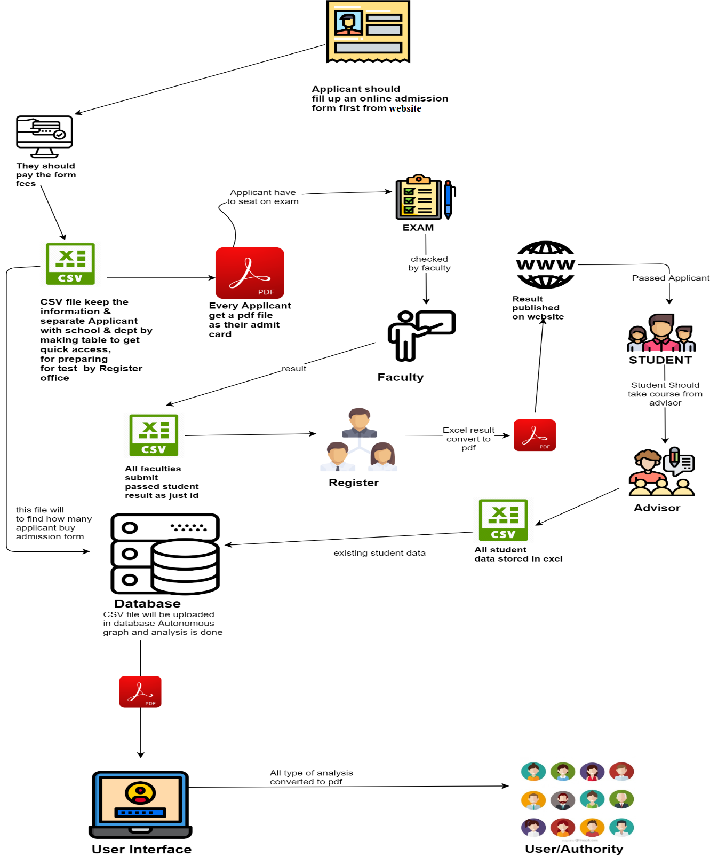

Figure 14: Rich Picture Proposed System

**Description of PROPOSED SYSTEM**:

University Conducts the admission test and selects students from the examinees based on admission test results. They then assign unique ID to each of the students. Publishes the compiled list of selected candidates for a specific semester on their web portal. The strategic policy maker/faculty Collects the published list of selected candidates from the web portal and Converts the PDF file to a CSV format. Later on, the policy maker immediately sends the data to the database so that the entire process of preparing the data to perform additional customization and data analysis can be done automatically by the automation system. The selected candidate admission list to the database of the web system also provides the system with all necessary parameters for data analysis and does the data analysis itself without needing any manual interference and help. The automation system does all the work Such as- Timeline of comparison, Types of graphical charts for representation of data etc. It then will automatically customize the formatting of the generated report. Such as- Title, Description of charts, Date etc. Then the system will upload all the necessary graphs, histograms, pie charts and tables in the respected websites of the University from where the faculty members, all the admins and other internal personal will be able to use the data. All the data of the different universities can be collected through specific websites with proper permission by the administrators of the website as they are the ones who will decide to keep the data private or public.

**2.7 PROPOSED BPMN 2.0:**

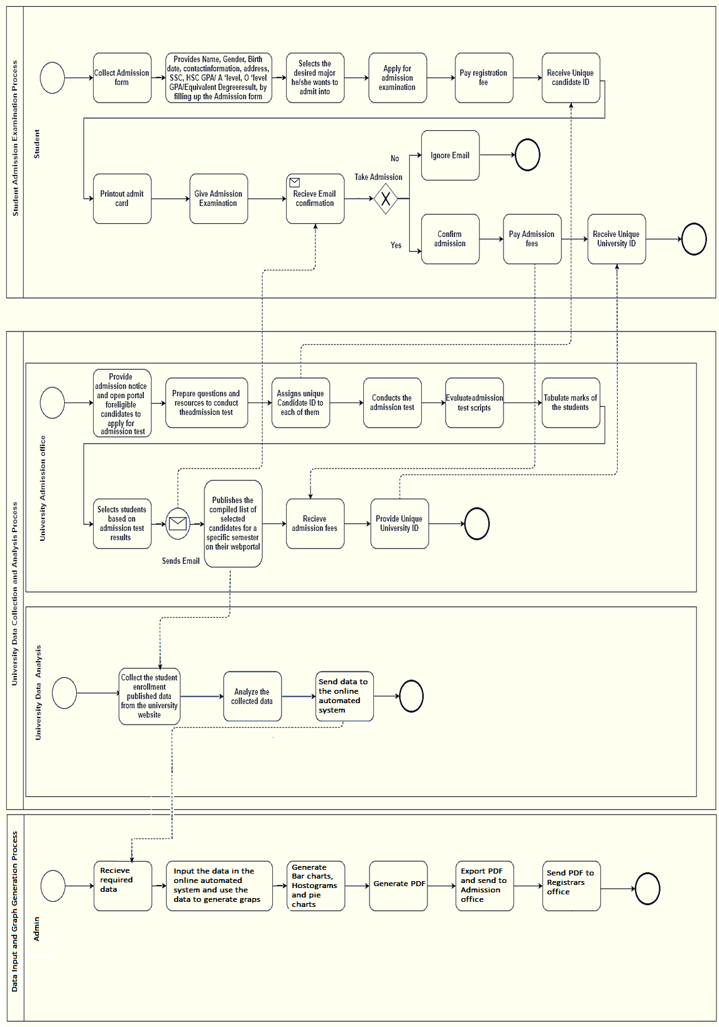

Figure 15: Process Models BPMN 2.0

**2.8 PROPOSED PROCESSES ALONG WITH SIX SYSTEM ELEMENTS:**

|  |  |  |  |  |  |  |
| --- | --- | --- | --- | --- | --- | --- |
|  | System Roles | | | | | |
| Process | Human | Non-computing Hardware | Computing Hardware | Software | Database | Communication & Network / Connectivity |
| Word to excel conversion process | Analyst | Document | Computer | Office Excel | -- | -- |
| Csv to Pdf conversion process | Analyst | -- | Computer | Office Excel | -- | -- |
| Admission result publication process | Registrar | -- | Utilizing computer to publishes the result | Operating browser, University website | -- | Using internet to publish the results. |
| Admission result downloading and calculation process | Policy maker | -- | Utilizing computer to download the result. | Operating browser, university website | Pile the information in Pdf. | Internet |
| Website publication process | Registrar | -- | Utilizing computer to publish the annual result. | Utilizing browser to publish the annual report. | Pile the result on their website. | Browser to publish the annual report. |
| Necessary file conversion process | Policy maker | -- | Utilizing computer to convert data from PDF to Excel. | Operating Office Excel to convert the PDF. | Store in the Office Excel. | -- |
| CSV file data comparison and verification process | Policy maker | -- | Utilizing computer office CSV to create graph. | Operating on Office CSV. | Store in the Office CSV. | -- |
| CSV file uploading process | Policy Maker | -- | Computer or laptop to upload the CSV. | -- | My SQL database. | -- |
| Data Facing process | Automation system | -- | Database. | -- | My SQL database. | Website. |
| Evaluation Process | Policy maker | -- | using computer to compare IUB report with admission report | Browsing in website. | Computer storage. | Website. |

**2.9 BUSINESS RULES FOR ADMISSION EXAMINATION:**

**Admission Eligibility**

* Combined GPA of 7 in S.S.C & H.S.C with minimum GPA of 3 in each.
* O'Level in minimum 5 subjects with a GPA 2.50 and A'Level in 2 subjects with a minimum GPA 2.00
* International Baccalaureate or U. S. High School Diploma
* Other 12 years equivalent degree (must have the equivalence certificate from Ministry of Education)
* Engineering Students must have Math and Physics in their H.S.C. with at least B grade.
* Students applying for Microbiology and Biochemistry must have Biology in their SSC or O-Level with at least B grade.
* Environmental Science students who have taken Chemistry/Physics in S.S.C. or O'Level will get preference.

**Admission Period**

There are three academic semesters namely, Autumn, Spring and Summer.

* The admission procedure for Autumn (the beginning of the academic year) starts within the first week of July and ends with the commencement of classes in the first week of September.
* The admission procedure for Spring starts within the first week of November and ends with the commencement of classes in the second week of January.
* The admission procedure for Summer takes place in the second week of March and ends with the commencement of classes in the second week of May.

**Special Considerations: Exemption from Admission Test**

* Minimum SAT-1 score of 1000 and
* Minimum TOEFL score of 550 (paper based) or 213 (computer based) or 80 (internet based) or
* IELTS score of 5.5

**Full Tuition waiver to student with:**

* GPA 5.00 in both SSC and HSC (Excluding 4 th subject)
* 5 A’s in O-level and 1 A in A-level.
* Top 5% scorers in Admission test will get 100% Scholarship

**Financial Assistance:**

* Discount on Tuition fee, based on performance in IUB and Financial need.
* Campus job & other Financial Assistance

**\*All the certificates will be verified and IUB reserves the right to take action in case of any discrepancy found.**

**3.0 LOGICAL SYSTEM DESIGN:**

**3.1 DATA MODEL:**

Designing a database properly is fundamental to establishing a database that meets the needs of the users. Data models capture the nature of and relationships among data and are used at different levels of abstraction as a database is conceptualized and designed. The effectiveness and efficiency of a database is directly associated with the structure of the database. Various graphical systems exist that convey this structure and are used to produce data models that can be understood by end users, systems analysts, and database designers. A typical data model is made up entities, attributes, and relationships. Here we have used the most common data modeling representation which is the entity-relationship model.

THE E-R MODEL:

An entity-relationship model (E-R model) is a detailed, logical representation of the data for an organization or for a business area. The E-R model is expressed in terms of entities in the business environment, the relationships (or associations) among those entities, and the attributes (or properties) of both the entities and their relationships. An E-R model is normally expressed as an entity-relationship diagram (E-R diagram, or ERD), which is a graphical representation of an E-R model.

Entities:

An entity is a person, a place, an object, an event, or a concept in the user environment about which the organization wishes to maintain data. Thus, an entity has a noun name. Some examples of each of these kinds of entities among which we have made relation are as follows:

Place: SCHOOL, DEPARTMENT.

Event: EXAM, EXAM_MAJOR

Concept: MAJOR.

RELATIONSHIPS:

Relationships are the glue that holds together the various components of an E-R model. Intuitively, a relationship is an association representing an interaction among the instances of one or more entity types that is of interest to the organization. Thus, a relationship has a verb phrase name. Relationships and their characteristics (degree and cardinality) represent business rules, and usually relationships represent the most complex business rules shown in an ERD. In other words, this is where data modeling gets really interesting and fun, as well as crucial for controlling the integrity of a database. To understand relationships more clearly, we must distinguish between relationship types and relationship instances. Just consider tow of the entity types in our ERD EXAM_NAJOR and EXAM, where many candidates can attend in an admission test conducted by university. An admission test may have many candidates. So, this is a many-many relationship.

**3.2 ERD (Entity Relationship Diagram):**

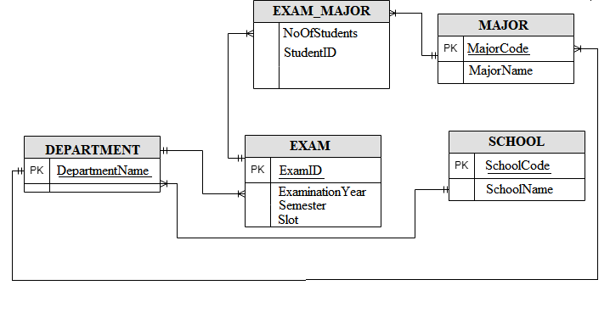

Figure: ERD (Entity Relationship Diagram)

**3.3 ERD TO RELATIONS:**

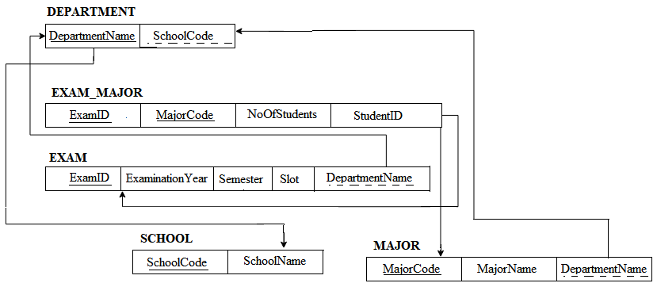

Figure: ERD to Relation.

**3.4 NOMALIZATION:**

**Table Name:** DEPARTMENT

|  |
| --- |
| DepartmentName |

1NF: The Primary key in the table: DepartmentName

2NF: There is no partial key dependency so no 2NF process.

3NF: There is no transitive dependency so no 3NF process.

|  |  |  |
| --- | --- | --- |
| MajorCode | MajorName | DepartmentCode |

**Table Name:** MAJOR

1NF: The Primary key in the table: MajorCode

2NF: There is no partial key dependency so no 2NF process.

3NF: There is no transitive dependency so no 3NF process.

**Table Name:** SCHOOL

|  |  |
| --- | --- |
| SchoolCode | SchoolName |

1NF: The Primary key in the table: SchoolCode

2NF: There is no partial key dependency so no 2NF process.

3NF: There is no transitive dependency so no 3NF process.

**Table Name:** EXAM

|  |  |  |  |  |
| --- | --- | --- | --- | --- |
| ExamID | ExaminationYear | Semester | Slot | DepartmentName |

1NF: The Primary key in the table: ExamID

2NF: There is no partial key dependency so no 2NF process.

3NF: There is no transitive dependency so no 3NF process.

**Table Name:** EXAM_MAJOR

|  |  |  |  |
| --- | --- | --- | --- |
| ExamID | MajorCode | NoOfStudents | StudentID |

1NF: The Primary key in the table: ExamID

2NF: There is no partial key dependency so no 2NF process.

3NF: There is no transitive dependency so no 3NF process.

**3.5 DATA DICTIONARY:**

3.7.1 Table_DEPARTMENT:

|  |  |  |  |
| --- | --- | --- | --- |
| **Name** | **Data Type** | **Size** | **Remark** |
| DepartmentName | Varchar | 40 | DepartmentName is the primary key in this relation. This contains the Department Name. Example: " Computer Science and Engineering " |

3.7.2 Table_EXAM:

|  |  |  |  |
| --- | --- | --- | --- |
| **Name** | **Data Type** | **Size** | **Remark** |
| ExamID | Varchar | 40 | ExamID is the primary key in this relation. This contains the name of admission Test Taken. Example: "Exam ID 2000- 2016". |
| ExaminationYear | Year | yyyy | This contains year of admission. Example: “2015 or 2017” |
| Semester | Varchar | 20 | This contains during of four-month courses of the candidate. Example: “Summer” or “Fall”. |
| Slot | Varchar | 20 | This contains the slot number of examination. Example: “slot1” or “slot2”. |
| DepartmentName | Varchar | 40 | This is the Foreign key in this relation from table1-Department. This contains the Department Name. Example: " Computer Science and Engineering " |

3.7.3 Table_SCHOOL:

|  |  |  |  |
| --- | --- | --- | --- |
| **Name** | **Data Type** | **Size** | **Remark** |
| SchoolCode | Varchar | 4 | SchoolCode is the primary key in this relation. This contains the School Code. Example: "SESM" or “SECS” |
| SchoolName | Varchar | 40 | This contains name of school. Example: “School of Environmental Science and Management”. |

3.7.5 Table_MAJOR:

|  |  |  |  |
| --- | --- | --- | --- |
| **Name** | **Data Type** | **Size** | **Remark** |
| MajorCode | Varchar | 10 | This is the primary key of this relation. This contain the major code of the student. Example: “CS” or “ECN” or “FIN”. |
| MajorName | Varchar | 40 | This contains School of the candidate. Example: “Computer Science” or “Economics”. |
| DepartmentName | Varchar | 40 | This is the Foreign key in this relation from table1-Department. This contains the Department Name. Example: " Computer Science and Engineering " |

3.7.6 Table_EXAM_MAJOR:

|  |  |  |  |
| --- | --- | --- | --- |
| **Name** | **Data Type** | **Size** | **Remark** |
| ExamID | Varchar | 40 | ExamID is the foreign key in this relation. This contains the name of admission Test Taken. Example: "Exam ID 2000- 2016". |
| MajorCode | Varchar | 10 | This is the foreign key of this relation. This contain the major code of the student. Example: “CS” or “ECN” or “FIN”. |
| NoOfStudents | Varchar | 40 | This contains the number of students. Example: “2000 students etc” |
| StudentID | Varchar | 40 | This contains the student ID. Example: 1620457 |

Reference:

1. Draw.io, [www.draw.io](http://www.draw.io)
2. Lucid chart, [www.lucidchart.com](http://www.lucidchart.com)
3. Chart.js, [www.chartjs.org](http://www.chartjs.org)
4. IUB, [www.iub.edu.bd](http://www.iub.edu.bd)