We train the model by First semester 5 courses GPA as X and Second Semester course GPA Y. Table shows the accuracy score of Multinomial NB.

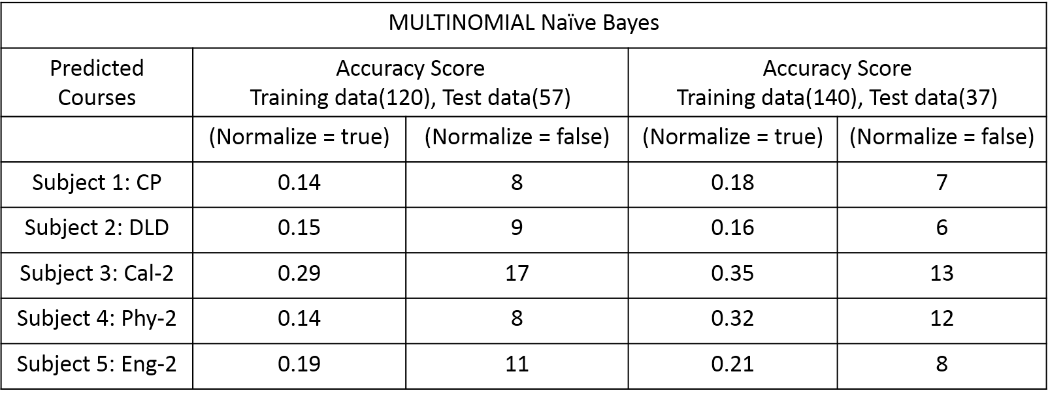

Normalize: If False, return the number of correctly classified samples. Otherwise, return the fraction of correctly classified samples.