Software Requirement Specifications
Freelance Marketplace Platform with Admin Dashboard



Submitted by
Waneeza Jaffir (S23BINFT1M01178)

Submitted to
Dr. Mustafa Hameed

Department of Information Technology
Faculty of Computing
The Islamia University of Bahawalpur

Meeting Details
Sr No | Details | Date | Supervisor Signature
Summary
This document covers the software requirements for a web-based freelance marketplace that connects clients with freelancers. Clients post projects with descriptions, budgets, and deadlines. Freelancers browse those listings and submit proposals. The system handles user accounts, project listings, bidding, direct messaging, and an admin dashboard for platform oversight. Additional features include search and filtering, notifications, and a post-project rating system. The platform is built using Flutter, Dart, Django for business logic, MySQL for data storage, and HTML, CSS, and JavaScript for the frontend.

Table of Contents
1. Introduction 5
1.1. Purpose 5
1.2. Scope 5
1.3. Product Perspective 6
1.4. User Characteristics 6
1.5. Similar apps and systems/Literature Review 6
1.6. Proposed Technologies 7
2. Requirements 8
2.1. Function Requirements 8
2.1.1. User Registration 8
2.1.2. User Login 9
2.1.3. Post a Project 9
2.1.4. Submit a Bid 9
2.2. Non-Functional Requirements 10
3. Use Cases and Flow of Processes 11
3.1. User Registration 12
3.2. User Login 13
3.3. Post a Project 14
3.4. Submit a Bid 16
4. References 18

- Introduction
This platform is a freelance marketplace designed to connect clients who need work done with skilled professionals who can deliver it. The system removes the traditional friction of finding reliable freelancers or quality projects by automating the posting, bidding, and communication process. The platform covers one complete module: the entire lifecycle from project creation to delivery and review, supported by an administrative layer for platform management.
  - Purpose
The main purpose of this document is to formally specify the requirements for the Freelance Marketplace Platform. It defines what the platform must do, how it should treat, and who the intended audience are. The document serves as a reference for the development team, project supervsor, and any evaluators reviewing the system.
  - Scope
The platform will include user registration and login for clients, freelancers, and admins; project creation and management by clients with budget and deadline fields; a bidding system for freelancers to submit and manage proposals; direct messaging between clients and freelancers; freelancer profile management with skills, bio, and portfolio; an admin dashboard for managing users, projects, and bids; search and filtering for projects and freelancer profiles; automated notifications for bids, messages, and project updates; and a post-completion feedback and rating system.
The following are out of scope for this version:
- in-platform payment processing,
- mobile application development,
- third-party platform integrations,
- formal dispute resolution workflows.
  - Product Perspective
The platform is a standalone web application built on three layers. The frontend layer uses HTML, CSS, and JavaScript to deliver the user interface. The middle-end layer uses Django to handle all business logic, routing, and API responses. The database layer uses MySQL to store all persistent data including users, projects, bids, messages, and reviews. Authentication is handled as a dedicated service managing sessions and access control. Each layer is independently maintainable and the overall architecture is designed to scale as the user base grows.
  - User Characteristics
Three types of users interact with the system.
- Clients are individuals or organizations looking to hire freelancers. They are comfortable using web-based forms and dashboards. Their main actions are posting projects, reviewing bids, messaging freelancers, and leaving ratings after project completion.
- Freelancers are skilled professionals offering services through the platform. They maintain profiles, browse project listings, submit proposals, and communicate with clients. They interact with bid tracking and messaging features regularly.
- Administrators are platform staff with elevated access. They use the admin dashboard to manage all user accounts, project listings, and bids, and monitor overall platform activity to maintain quality and resolve issues.

  - Similar apps and systems/Literature Review
- Upwork is one of the largest freelance platforms globally. It supports hourly and fixed-price contracts with integrated billing and work tracking. Its main shortcomings are high service fees and a complex interface that discourages new users.
- Fiverr uses a reverse model where freelancers post service packages rather than bidding on client projects. This works well for standardized tasks but limits flexibility for custom or complex work. The client-initiated project model is preserved in this platform to give clients more control.
- Freelancer.com closely matches the model adopted here, with clients posting projects and freelancers bidding. Its main drawbacks are a cluttered user experience and heavy reliance on paid features. This platform aims to offer a cleaner and more accessible alternative.

  - Proposed Technologies
Frontend: HTML5, CSS3, JavaScript for building the user interface. Middle-end: Django (Python) for business logic, routing, ORM-based database interaction, and REST API endpoints. Backend: A dedicated authentication service for session management, password hashing, and access control. Database: MySQL for structured storage of users, projects, bids, messages, and ratings.

- Requirements
The platform serves three main participant groups: clients, freelancers, and administrators. Clients register and post projects describing what they need along with a budget and deadline. Freelancers browse active listings and submit proposals with their price, estimated delivery time, and a cover letter. Clients review incoming bids, communicate through the messaging system, and select the most suitable freelancer. Once a freelancer is selected both parties communicate through the platform until the project is delivered and closed. Upon completion both parties can rate each other. Administrators monitor all activity from a central dashboard and can intervene when needed. Search and filtering tools help freelancers find relevant projects and help clients discover suitable freelancers. Notifications are triggered automatically for key events like new bids, messages, and project status changes.

  - Function Requirements
    - User Registration
- Name: FR001
- Purpose: Registration process is required for a user to become a member of the platform.
- User(s): Client, Freelancer
- Input:
- Full Name: Actual name of the user according to their ID card.
- Email Address: A valid and unique email address used for account identification and communication.
- Password: Must be at least 8 characters long and must include a number and a special character.
- Phone Number: A working phone number that is active and reachable.
- Role Selection: The user must select whether they are joining as a client or a freelancer.
- Profile Picture: A recent clear face photograph of the user.
- Output: The user becomes a member of the platform and is able to log in and access their role-specific dashboard.
    - User Login
- Name: FR002
- Purpose: Login process is required for a registered user to access their account and use the platform.
- User(s): Client, Freelancer, Admin
- Input:
- Email Address: The email address used during registration.
- Password: The password set by the user at the time of registration.
- Output: The user is authenticated and redirected to their role-specific dashboard. An error message is displayed for incorrect credentials.
    - Post a Project
- Name: FR003
- Purpose: Project posting is required for a client to publish their work requirement so that freelancers can discover and bid on it.
- User(s): Clients
- Input:
  - Project Title: A short and descriptive title that clearly reflects the nature of the work.
  - Project Description: A detailed explanation of what needs to be done, including any specific expectations.
  - Budget: The minimum and maximum amount the client is willing to pay for the work.
  - Deadline: The date by which the client expects the project to be completed.
  - Category: The relevant skill category that the project falls under.
- Output: The project is published on the platform and becomes visible to all freelancers. The client receives a confirmation and can manage the listing from their dashboard.
    - Submit a Bid
- Name: FR004
- Purpose: Bid submission is required for a freelancer to express interest in a project and present their proposal to the client.
- User(s): Freelancer
- Input:
- Bid Amount: The price the freelancer is proposing to complete the project.
- Estimated Delivery Time: The number of days the freelancer expects to take to deliver the work.
- Cover Letter: A personalized message explaining the freelancer's approach and why they are the right fit for the project.
- Output: The bid is recorded and the client is notified. The freelancer can track the status of their submitted bid from their dashboard.
  - Non-Functional Requirements
Performance: All primary pages must load within 3 seconds under normal network conditions. Search results and bid listings must render without noticeable delay even with large data volumes.
Security: Passwords must be stored using strong cryptographic hashing. All browser-to-server communication must be encrypted via HTTPS. Session tokens must expire after a defined period of inactivity.
Usability: The interface must be intuitive for users with no prior experience on similar platforms. Navigation must be consistent across all pages. Error messages must be written in plain language that guides the user toward a solution.
Scalability: The architecture must support a growing number of concurrent users without requiring a full redesign. The Django application and MySQL database must be deployable behind load balancers.
Reliability: The system must maintain at least 99% uptime during normal operating hours. Critical operations like bid submission and message delivery must include error handling to prevent silent failures.
Maintainability: The codebase must follow consistent naming conventions and be organized into logical Django apps, each covering a single domain such as users, projects, bids, or messaging.

- Use Cases and Flow of Processes
Use cases are the formal representation of process flow defined by functional requirements. The following use cases describe the system level interactions between the platform and its actors as defined in the requirements chapter.
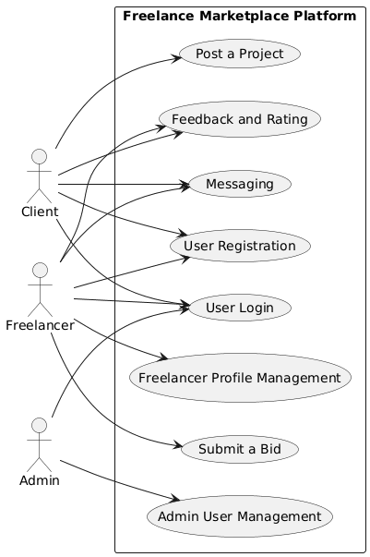
Figure 1: System Level Use Case Diagram
  - User Registration
ID | UC001
Name | User Registration
Description | This use case describes the process flow of Sing Up
Requirement(s) | FR001
Actor(s) | Client, Freelancer
Precondition | Actor must not already be a registered member of the platform.
Postcondition | Actor will receive a verification email and upon confirmation will be able to log in to their dashboard.
Basic Flow | Basic Flow  - Actor opens the registration page.  - System displays the registration form.  - Actor enters Full Name, Email Address, Password, Phone Number, selects Role, and uploads Profile Picture.  - Actor submits the registration form.  - System receives the request and checks for empty required fields.  - System validates the email format.  - System validates the password strength (minimum 8 characters, including number and special character).  - System validates the phone number (11 digits).  - System checks if the email already exists in the database.  - System processes validation results.  - If all validations pass, system creates a new user account.  - System securely stores user data in the database.  - System generates a success message.  - System redirects the user to the login page/dashboard.  - If any validation fails, system returns error messages and prompts the user to correct the data.
Diagrams
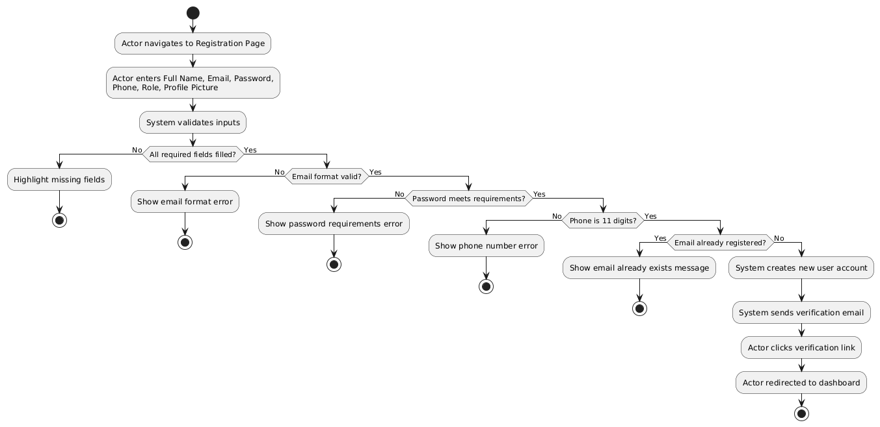
  - User Login
ID | UC001
Name | User Login
Description | This use case describes the process flow of Sing Up
Requirement(s) | FR002
Actor(s) | Client, Freelancer, Admin
Precondition | Actor must already be a registered and verified member of the platform.
Postcondition | Actor is successfully authenticated and redirected to their role-specific dashboard.
Basic Flow | Basic Flow  - Client navigates to the “Post a Project” section from the dashboard.  - System displays the project posting form.  - Client enters Project Title, Project Description, Budget Range, Deadline, and Category.  - Client submits the project details.  - System receives the input data.  - System checks for empty required fields (Project Title, Description, Budget Range, Deadline, Category).  - System validates the deadline to ensure it is a future date.  - System validates the budget range (minimum budget must not exceed maximum budget).  - System processes validation results.  - If all validations pass, system creates a new project entry.  - System stores the project details in the database.  - System publishes the project.  - System makes the project visible to freelancers.  - System displays a success message to the client.  - If validation fails, system displays error messages and prompts the client to correct the input data.
Diagrams
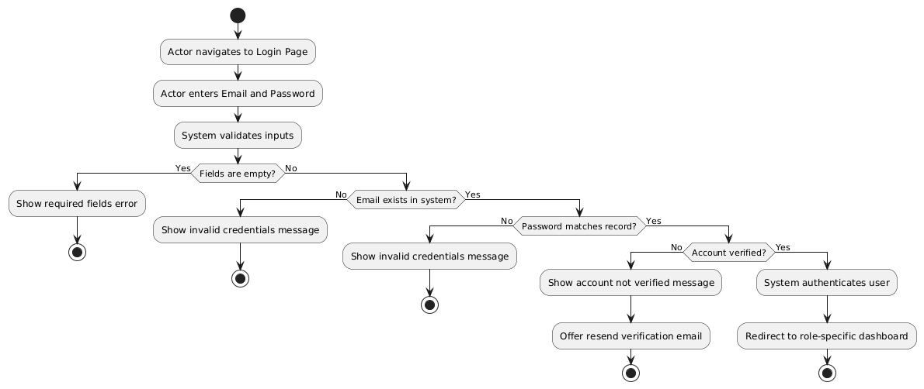
  - Post a Project
ID | UC003
Name | Post a Project
Description | This use case describes the process flow of a client creating and publishing a project listing on the platform.
Requirement(s) | FR003
Actor(s) | Client
Precondition | Actor must be logged in as a client.
Postcondition | The project is published and becomes visible to all freelancers on the platform.
Basic Flow | Basic Flow  - Actor navigates to the login page.  - System displays the login form.  - Actor enters Email Address and Password.  - Actor submits the login request.  - System receives the input data.  - System checks for empty required fields (Email Address and Password).  - System validates the email format.  - System searches for the email in the database.  - System verifies that the email matches a registered account.  - System compares the entered password with the stored credentials.  - System processes authentication results.  - If credentials are valid, system authenticates the user.
Diagrams
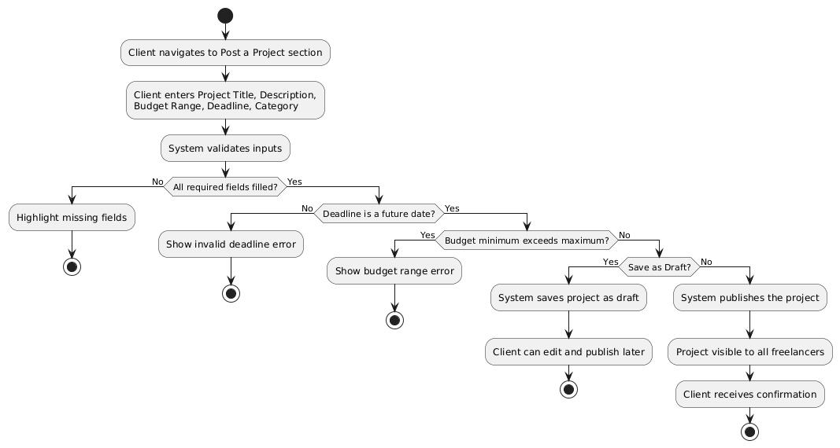
  - Submit a Bid
ID | UC004
Name | Submit a Bid
Description | This use case describes the process flow of a freelancer submitting a proposal in response to an active project listing.
Requirement(s) | FR004
Actor(s) | Freelancer
Precondition | Actor must be logged in as a freelancer and the project must be active and open for bids.
Postcondition | The bid is recorded and the client receives a notification about the new proposal.
Basic Flow | Basic Flow  - Freelancer navigates to project listings.  - System displays available projects.  - Freelancer selects and opens a project.  - System displays project details.  - Freelancer clicks the “Submit a Bid” button.  - System displays the bid submission form.  - Freelancer enters Bid Amount, Estimated Delivery Time, and Cover Letter.  - Freelancer submits the bid.  - System receives the input data.  - System checks for empty required fields (Bid Amount, Estimated Delivery Time, Cover Letter).  - System validates the bid amount (must be a valid number).  - System validates that the cover letter is not empty.  - System processes validation results.  - If all validations pass, system creates a new bid entry.  - System stores the bid in the database.  - System notifies the client about the new bid.  - System displays a success message to the freelancer.
Diagrams
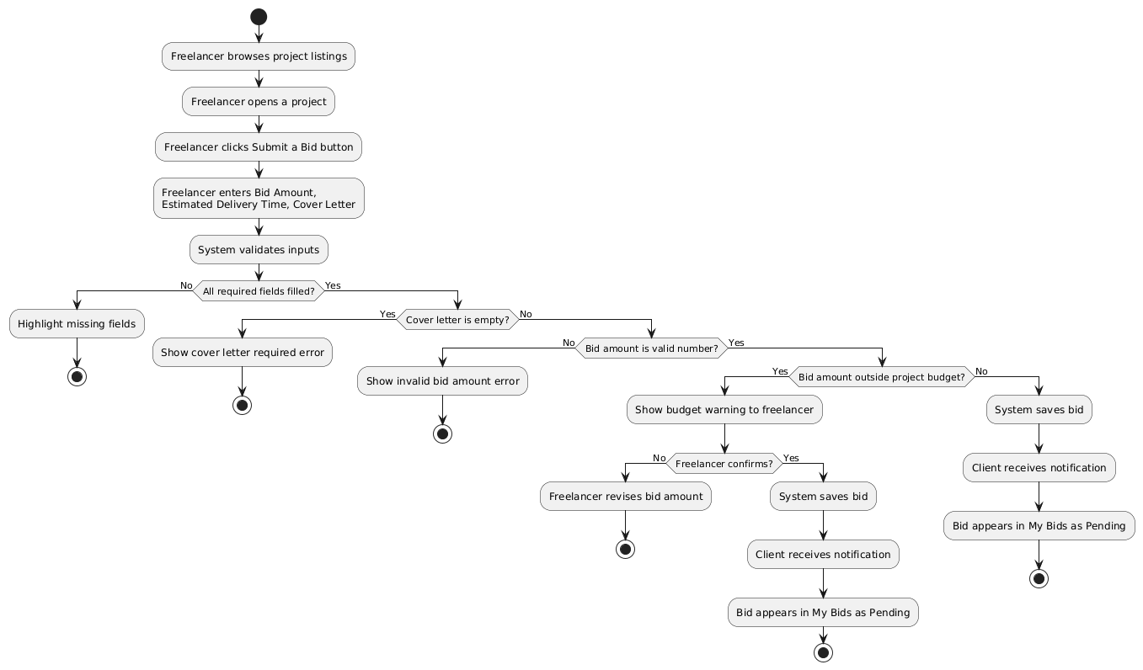

- References
- Upwork. (2024). How Upwork Works. Retrieved from https://www.upwork.com/about
- Fiverr International Ltd. (2024). Fiverr Help and Education Center. Retrieved from https://help.fiverr.com
- Freelancer.com. (2024). How Freelancer Works. Retrieved from https://www.freelancer.com/about
- Django Software Foundation. (2024). Django Documentation Version 5.0. Retrieved from https://docs.djangoproject.com
- Oracle Corporation. (2024). MySQL 8.0 Reference Manual. Retrieved from https://dev.mysql.com/doc/refman/8.0/en
- IEEE Computer Society. (1998). IEEE Std 830-1998: IEEE Recommended Practice for Software Requirements Specifications. New York: IEEE Press.

