Software Design Document
Freelance Marketplace Platform with Admin Dashboard



Submitted by
Waneeza Jaffir (S23BINFT1M01178)

Submitted to
Dr. Mustafa Hameed

Department of Information Technology
Faculty of Computing
The Islamia University of Bahawalpur

Summery
A web-based freelance marketplace connecting clients with freelancers. Clients post projects with descriptions, budgets, and deadlines. Freelancers browse listings and submit proposals. The system covers user accounts, project listings, bidding, direct messaging, and an admin dashboard. Additional features include search/filtering, notifications, and a post-project rating system. Built with Flutter/Dart, Django, MySQL, and HTML/CSS/JavaScript.

Table of Contents
1. Application Architecture 4
2. Data Model Schema 6
3. User Interface 9
Non-Functional Requirements 16
Technologies Used 16

- Application Architecture
Architecture Pattern: Three-Layer Architecture (Presentation → Business Logic → Data)
Layer 1 — Frontend (Presentation) HTML5, CSS3, JavaScript. Handles all user interface rendering and form interactions.
Layer 2 — Middle-End (Business Logic) Django (Python). Handles routing, ORM-based database interaction, REST API endpoints, and session management.
Layer 3 — Backend/Auth Service Dedicated authentication service: session management, password hashing, access control.
Layer 4 — Database MySQL. Stores users, projects, bids, messages, and ratings.
Proposed Models (Entities): User, Project, Bid, Message, Rating, Notification
Django Apps (by domain): users · projects · bids · messaging · admin_dashboard · notifications · ratings
External APIs / Libraries: Django ORM, Django REST Framework, Flutter SDK, Dart runtime
Architecture Diagram
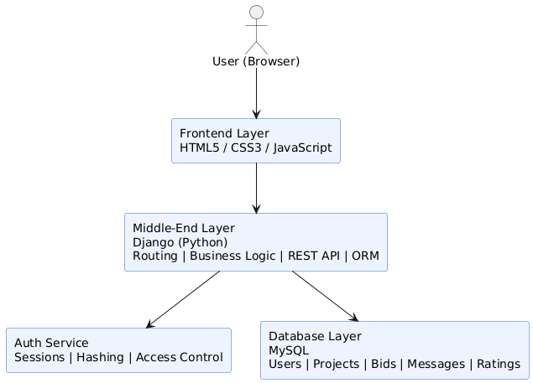
Class Diagram

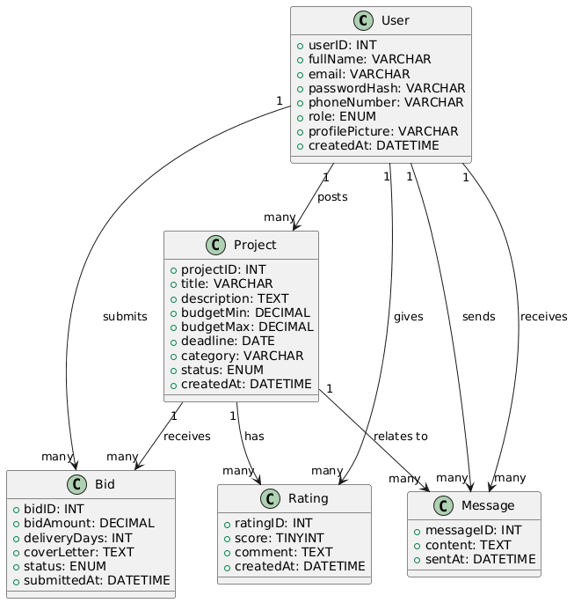

- Data Model Schema
Users
Field | Type | Constraints
userID | INT | PK, AUTO_INCREMENT
fullName | VARCHAR(100) | NOT NULL
email | VARCHAR(150) | UNIQUE, NOT NULL
passwordHash | VARCHAR(255) | NOT NULL
phoneNumber | VARCHAR(15) | NOT NULL
role | ENUM(Client, Freelancer, Admin) | NOT NULL
profilePicture | VARCHAR(255) | NULL
createdAt | DATETIME | DEFAULT NOW

Projects
Field | Type | Constraints
projectID | INT | PK, AUTO_INCREMENT
clientID | INT | FK → Users.userID
title | VARCHAR(200) | NOT NULL
description | TEXT | NOT NULL
budgetMin | DECIMAL(10,2) | NOT NULL
budgetMax | DECIMAL(10,2) | NOT NULL
deadline | DATE | NOT NULL
category | VARCHAR(100) | NOT NULL
status | ENUM(Open, Closed, InProgress) | DEFAULT Open
createdAt | DATETIME | DEFAULT NOW
Bids
Field | Type | Constraints
bidID | INT | PK, AUTO_INCREMENT
projectID | INT | FK → Projects.projectID
freelancerID | INT | FK → Users.userID
bidAmount | DECIMAL(10,2) | NOT NULL
deliveryDays | INT | NOT NULL
coverLetter | TEXT | NOT NULL
status | ENUM(Pending, Accepted, Rejected) | DEFAULT Pending
submittedAt | DATETIME | DEFAULT NOW

Messages
Field | Type | Constraints
messageID | INT | PK, AUTO_INCREMENT
senderID | INT | FK → Users.userID
receiverID | INT | FK → Users.userID
projectID | INT | FK → Projects.projectID
content | TEXT | NOT NULL
sentAt | DATETIME | DEFAULT NOW

ER Diagram
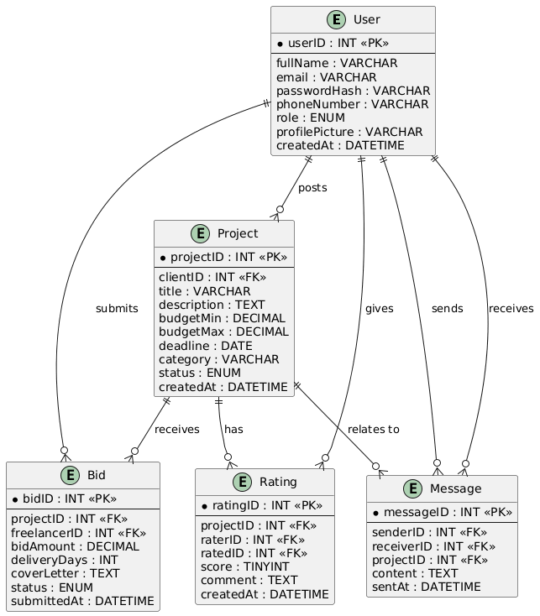
- User Interface
Design Philosophy: Clean, minimal interface. Prioritizes simplicity over complexity to contrast with Upwork/Freelancer.com's cluttered UX.
Color Scheme: Not specified in SRS — to be defined in UI design phase.
Font: Standard web-safe sans-serif (to be finalized).
Target Platform: Web browser (responsive, desktop-first). Mobile app is out of scope for this version.
Screens / Pages
1. Registration Page
Controls: Full Name (Textbox), Email (Textbox), Password (Textbox, masked), Phone Number (Textbox), Role (Dropdown: Client / Freelancer), Profile Picture (File Upload), Submit (Button)
Input Constraints: Email must be valid format and unique. Password min 8 chars with number and special character. Phone must be 11 digits.
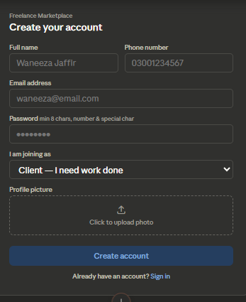
2. Login Page
Controls: Email (Textbox), Password (Textbox, masked), Login (Button)
Input Constraints: Both fields required. Email format validated.
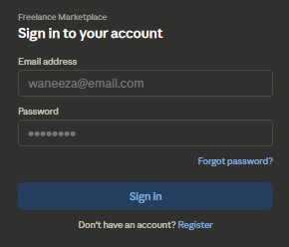
3. Client Dashboard
Controls: Post New Project (Button), My Projects list (Table), Notifications (Badge/Panel)
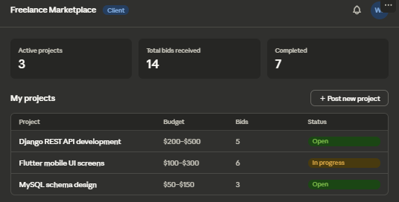
4. Post a Project Page
Controls: Project Title (Textbox), Description (Textarea), Budget Min (Number), Budget Max (Number), Deadline (Date Picker), Category (Dropdown), Submit (Button)
Input Constraints: All fields required. Deadline must be a future date. Budget Min ≤ Budget Max.
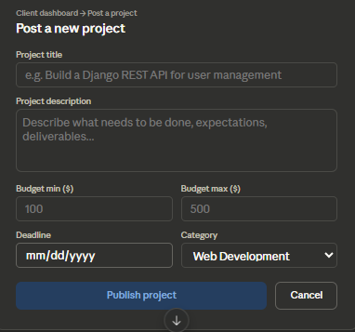
5. Freelancer Dashboard
Controls: Browse Projects (List/Filter), My Bids (Table), Notifications (Badge/Panel)
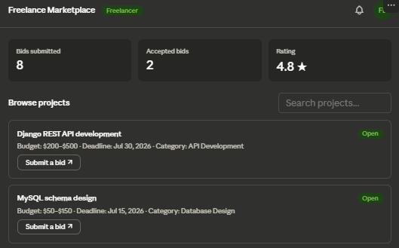
6. Project Listing / Bid Page
Controls: Project details (Read-only display), Bid Amount (Number), Estimated Delivery (Number, days), Cover Letter (Textarea), Submit Bid (Button)
Input Constraints: All fields required. Bid amount must be a valid positive number.
7. Messaging Page
Controls: Conversation list (Panel), Message thread (Scrollable), Message input (Textbox), Send (Button)
8. Admin Dashboard
Controls: User management table, Project management table, Bid overview table, Platform stats (Read-only)
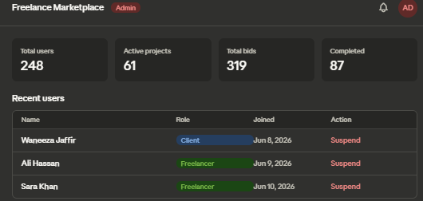
Use Case Diagram

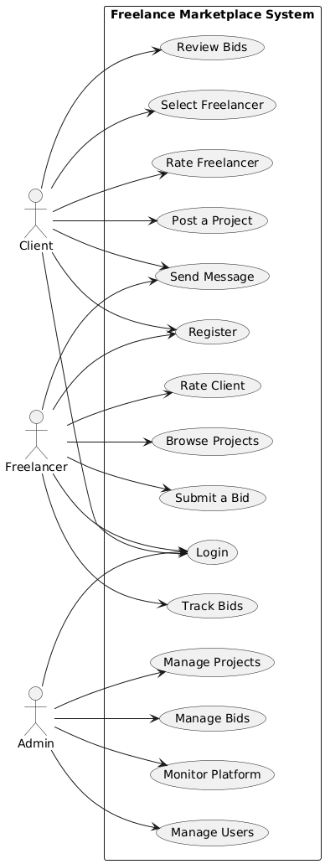

Non-Functional Requirements
Category | Requirement
Performance | Pages load within 3 seconds; search and bid lists render without delay
Security | Strong password hashing, HTTPS enforced, session tokens expire on inactivity
Usability | Intuitive for new users; consistent navigation; plain-language error messages
Scalability | Supports growing concurrent users; Django and MySQL deployable behind load balancers
Reliability | 99% uptime; proper error handling for bid submission and message delivery
Maintainability | Consistent naming conventions; modular Django apps with clear structure

Technologies Used
Layer | Technology
Frontend | HTML5, CSS3, JavaScript
Backend | Django (Python), REST API
Mobile (Future) | Flutter, Dart
Authentication | Django sessions, password hashing
Database | MySQL 8.0

