Software Design Document
Project Online Food Ordering and POS System



Submitted by
Muhammad Shehroz (S23BINFT1M01130)

Submitted to
Mr. Omer Riaz

Department of Information Technology
Faculty of Computing
The Islamia University of Bahawalpur

Summery
The Online Food Ordering and POS System is a web-based application that lets customers register, browse a food menu, manage a cart, place orders, and track delivery. Administrators manage the full catalog, assign delivery riders, and update order statuses via a dedicated dashboard. The system is built using HTML, CSS, and JavaScript on the frontend, Python (Flask/Django) on the backend, and SQLite as the database. It follows a clean MVC pattern Models handle data, Views handle the browser interface, and Controllers handle all the business logic between them. The design prioritizes simplicity, lightweight performance, and ease of use, with no payment gateway required in the initial scope.

Table of Contents
1. Application Architecture 4
2. Data Model Schema 6
3. User Interface 10
Reference 14

- Application Architecture
The system follows the MVC (Model-View-Controller) pattern.
Components:
- Model — Handles data logic and database interactions (Users, FoodItems, Orders, Cart)
- View — HTML/CSS/JavaScript frontend pages rendered for users and admin
- Controller — Python (Flask/Django) routes handling business logic between View and Model
Proposed Models:
- User
- FoodItem
- Category
- Cart
- CartItem
- Order
- OrderItem
Controllers and Their Functions:
AuthController
- register() – Register a new user.
- login() – Authenticate a user.
- logout() – Log out the current user.
MenuController
- getMenu() – Retrieve the complete menu.
- getItemsByCategory() – Retrieve menu items filtered by category.
CartController
- addToCart() – Add an item to the shopping cart.
- removeFromCart() – Remove an item from the cart.
- viewCart() – Display current cart contents.
- clearCart() – Remove all items from the cart.
OrderController
- placeOrder() – Create and submit an order.
- viewOrderConfirmation() – Show order confirmation details.
- viewOrderHistory() – Display a user's previous orders.
AdminController
- adminLogin() – Authenticate an administrator.
- manageFoodItems() – Add, edit, or delete food items.
- manageOrders() – View and update customer orders.
- viewUsers() – View registered user accounts.
No external APIs are used. No payment gateway is integrated (optional scope).
Coding Conventions:
- Python: snake_case for functions and variables, PascalCase for classes
- HTML/CSS: kebab-case for class names
- JavaScript: camelCase for variables and functions
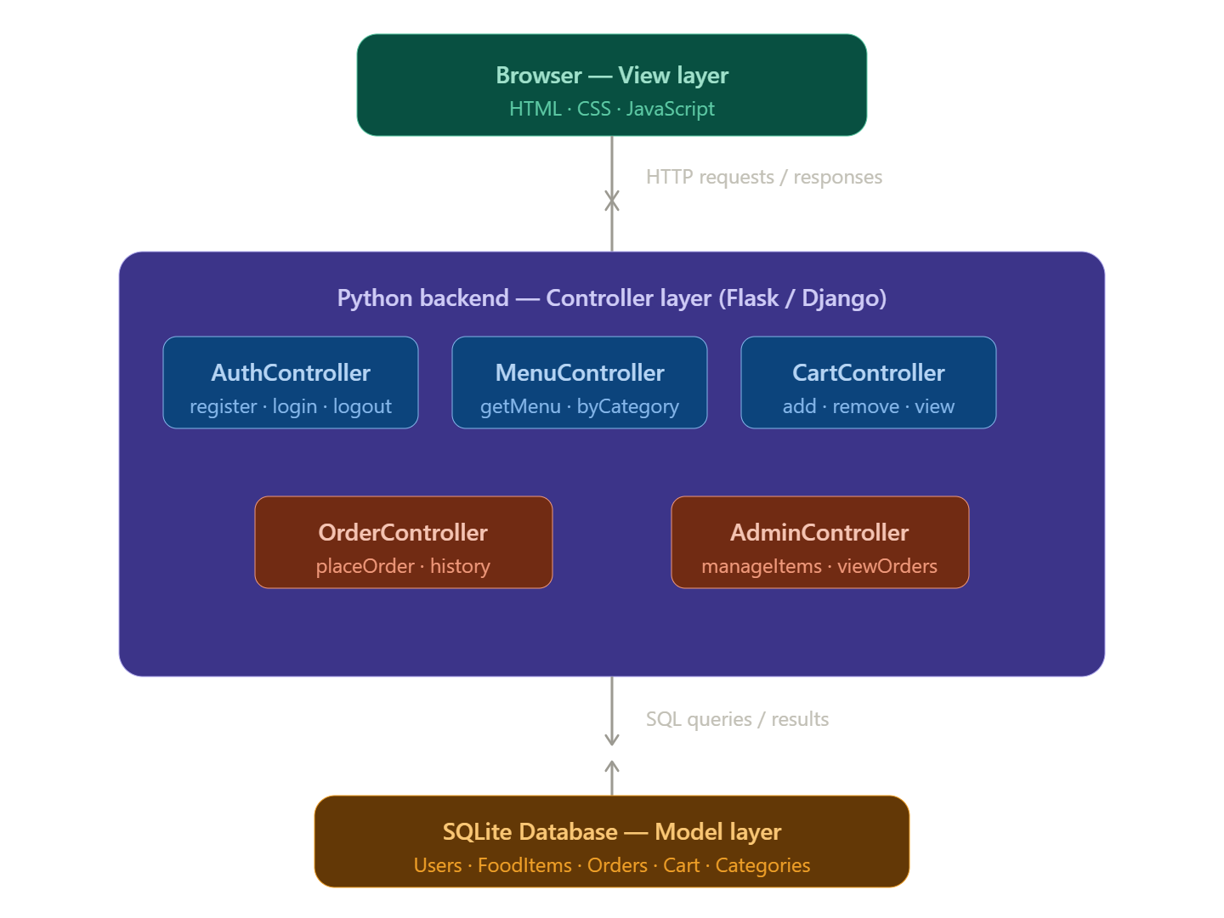

- Data Model Schema
Actors: Customer and Admin.
The system has 11 functional requirements mapped to use cases. Customers handle the full ordering lifecycle from registration to delivery tracking. Admins manage the catalog, orders, riders, and delivery statuses.

Use Case ID | Use Case | Actor | Functional Requirement
UC001 | Sign Up | Customer | FR001
UC002 | User Login | Customer | FR002
UC003 | Browse Menu | Customer | FR003
UC004 | Add to Cart | Customer | FR004
UC005 | Place Order | Customer | FR005
UC006 | Admin Login | Admin | FR006
UC007 | Manage Food Items | Admin | FR007
UC008 | View Orders | Admin | FR008
UC009 | Assign Delivery Rider | Admin | FR009
UC010 | Track Delivery | Customer | FR010
UC011 | Manage Delivery Status | Admin | FR011

Mapping with Controllers
Use Case ID | Controller | Function
UC001 | AuthController | register()
UC002 | AuthController | login()
UC003 | MenuController | getMenu(), getItemsByCategory()
UC004 | CartController | addToCart()
UC005 | OrderController | placeOrder()
UC006 | AdminController | adminLogin()
UC007 | AdminController | manageFoodItems()
UC008 | AdminController | manageOrders()
UC009 | AdminController | manageOrders() or assignDeliveryRider()*
UC010 | OrderController | trackDelivery()*
UC011 | AdminController | manageDeliveryStatus()*

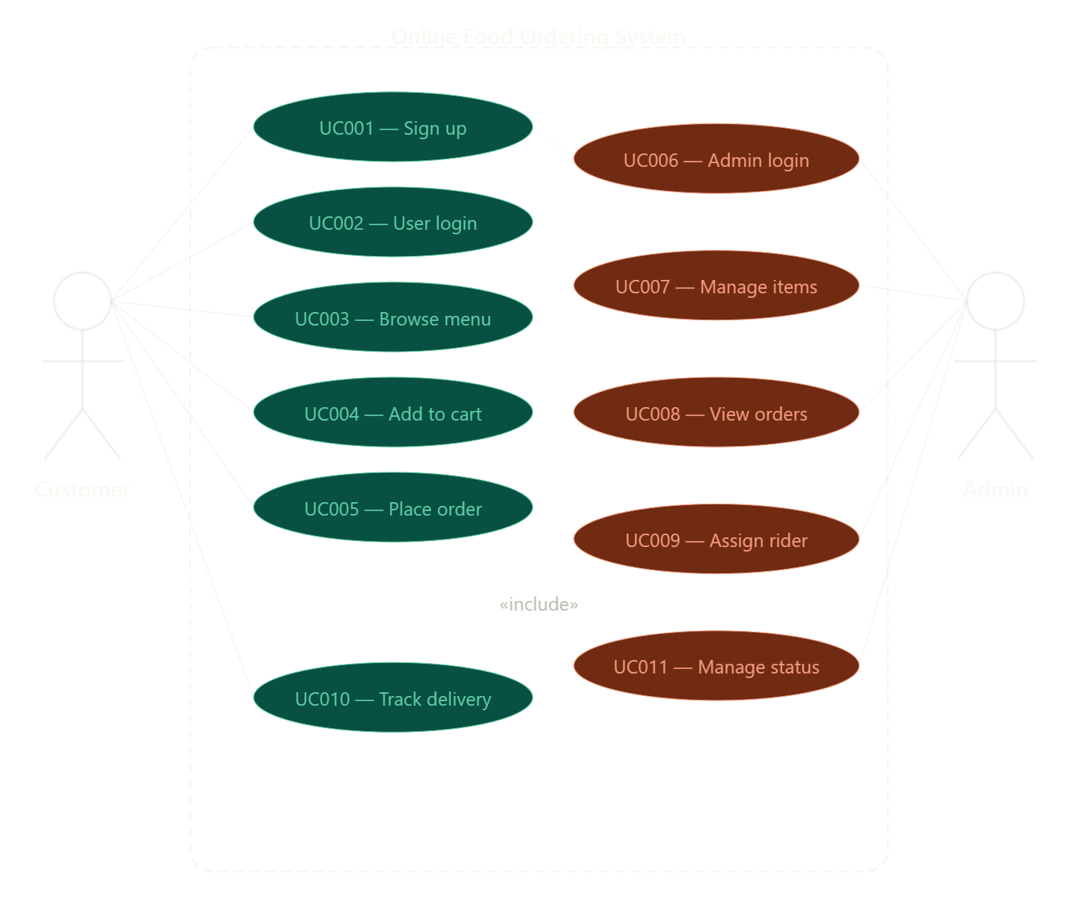
2.1 UC001 — Sign Up
ID: UC001
Requirement: FR001
Actor: Customer (also Admin via alternative flow)
Precondition: Actor must not already be a registered member. Postcondition: Actor sees an approval-pending message after successful registration.
Basic Flow: Actor enters Name, Email, Password, and Phone. System validates all inputs email format, password minimum 8 characters including a number, phone exactly 11 digits. On success, system creates the new user account and shows the approval message.
Alternative Flow: Admin can log in and create a user manually without going through the self-registration form.
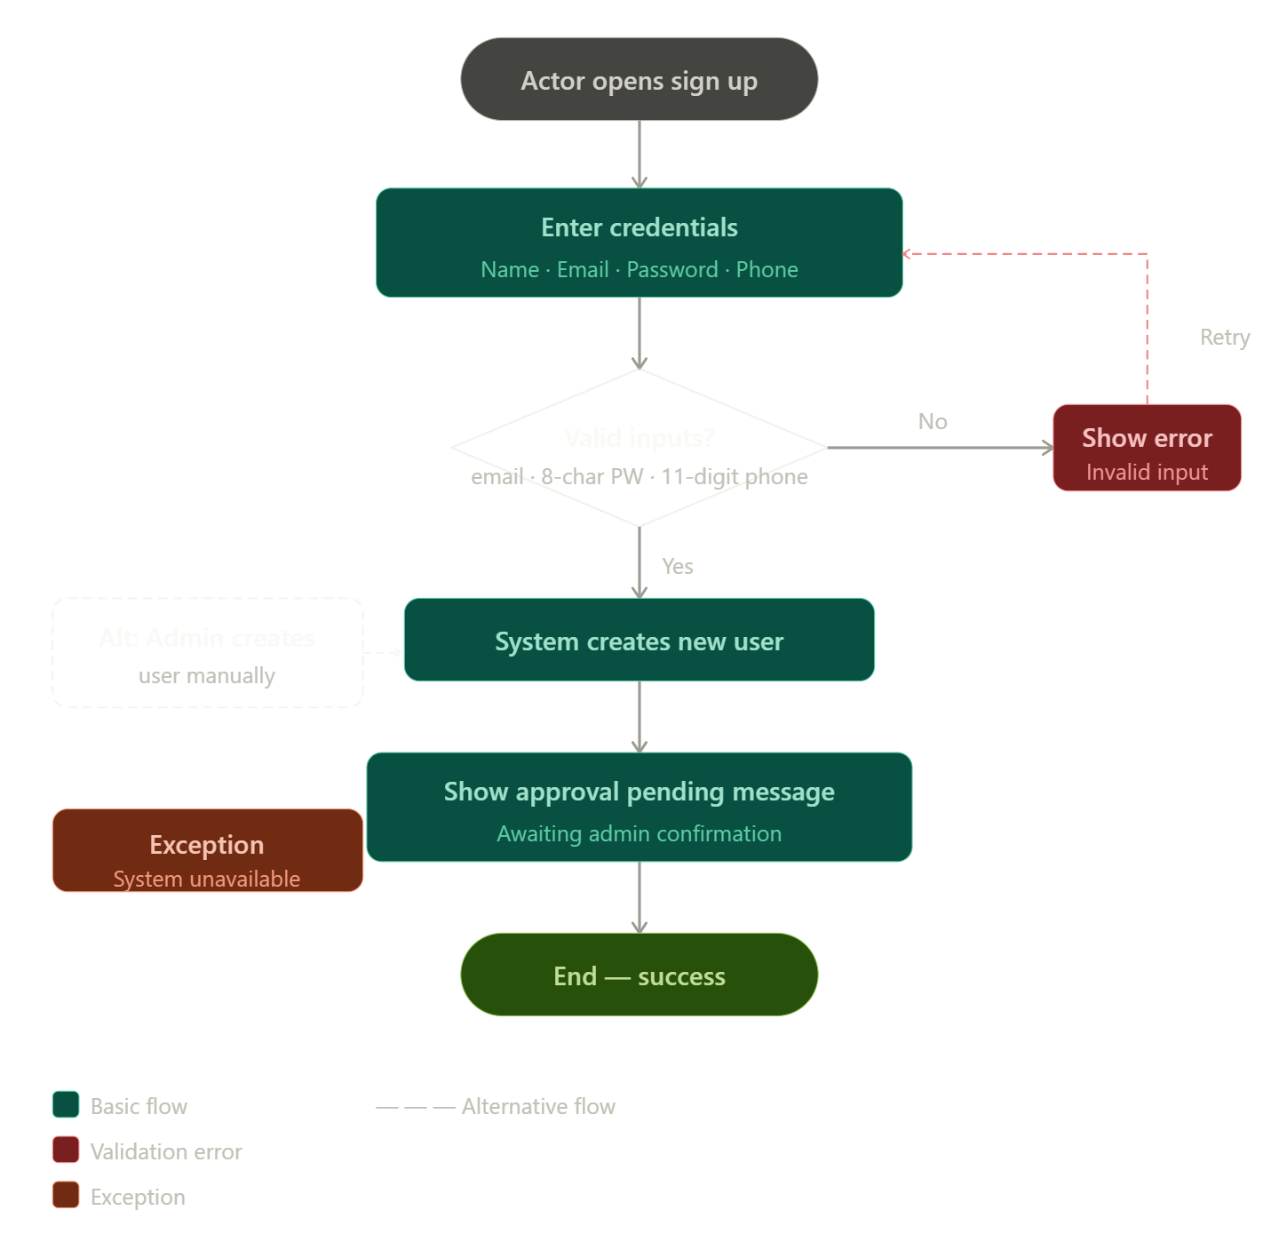
Exceptions: Invalid inputs trigger an inline error and return the actor to the form. System unavailability shows a generic error message.

- User Interface
The database has 7 entities. Every entity is described below with its full properties, data types, and relationships to other entities. Primary keys are auto-incrementing integers. Foreign keys are noted explicitly.
User — stores all registered users including customers and admins. The role field distinguishes between them.

Signup
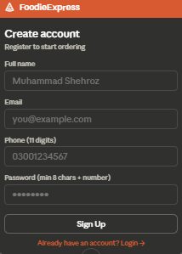
Login
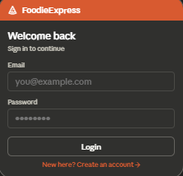

Browse Menu
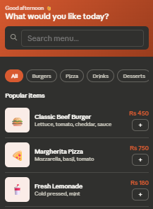
Field | Type | Notes
user_id | INT | Primary Key (PK), Auto Increment
name | VARCHAR(100) | Required
email | VARCHAR(100) | Unique, Required
password | VARCHAR(255) | Hashed, Minimum 8 Characters
phone | VARCHAR(11) | Must be 11 Digits
role | ENUM('customer', 'admin') | User Role
created_at | DATETIME | Automatically Generated

Category Table
Groups food items for browsing and filtering.
Field | Type | Notes
category_id | INT | Primary Key (PK)
name | VARCHAR(50) | e.g., Burgers, Pizza
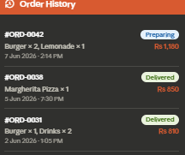
FoodItem Table
Stores food products available in the menu. Linked to Category.
Field | Type | Notes
item_id | INT | Primary Key (PK)
name | VARCHAR(100) | Required
price | DECIMAL(10,2) | Positive value
description | TEXT | Optional
category_id | INT | Foreign Key → Category
is_available | BOOLEAN | Controls menu visibility

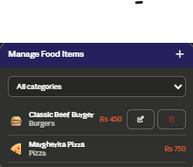
Cart Table
Represents a customer's active shopping cart.
Field | Type | Notes
cart_id | INT | Primary Key (PK)
user_id | INT | Foreign Key → Users
created_at | DATETIME | Creation timestamp

Reference
[1] Sommerville, I. (2016). Software Engineering (10th ed.). Pearson.
[2] Larman, C. (2004). Applying UML and Patterns: An Introduction to Object-Oriented Analysis and Design and Iterative Development (3rd ed.). Prentice Hall. (MVC Pattern)
[3] Flask Documentation. Pallets Projects.
[4] Django Documentation. Django Software Foundation.
[5] SQLite Documentation.
[6] Mozilla Developer Network (MDN) Web Docs. HTML, CSS, and JavaScript Reference.
[7] Fowler, M. (2002). Patterns of Enterprise Application Architecture. Addison-Wesley. (Data Model Patterns)
[8] ISO/IEC/IEEE 29148:2018. Systems and Software Engineering — Requirements Engineering. International Organization for Standardization (ISO), International Electrotechnical Commission (IEC), and Institute of Electrical and Electronics Engineers (IEEE).

