Software Requirement Specifications
Online Food Ordering and POS System



Submitted by
Muhammad Shehroz
S23BINFT1M01130
Submitted to
Mr. Omer Riaz

Department of Information Technology
Faculty of Computing
The Islamia University of Bahawalpur

Meeting Details
Sr No | Details | Date | Supervisor Signature

Summary
The Online Food Ordering System is a web-based application developed to allow customers to browse food menus, place orders, and track their food delivery online. The system aims to simplify the ordering process for users and reduce manual work for restaurants.
This system provides features including user registration, login, menu browsing, cart management, order placement, and admin management. The admin can manage food items, categories, and orders. The system will be developed using simple technologies such as HTML, CSS, JavaScript for frontend and Python (Flask/Django) for backend.
The proposed system will improve efficiency, reduce order errors, and provide convenience for customers.

Table of Contents
1. Introduction 5
1.1. Scope 5
1.2. Product Perspective 5
1.3. Similar apps and systems/Literature Review 6
2. Requirements 7
2.1. Function Requirements 7
2.1.1. Sign Up 7
2.1.2 User Login 7
2.1.3 View Food Menu 7
2.1.4 Add to Cart 8
2.1.5 Place Order 8
2.1.6 Admin Login 8
2.1.7 Manage Food Items 8
2.1.8 View Orders 9
2.2. Non-Functional Requirements 9
3. Use Cases and Flow of Processes 10
3.1. Sign up 10
4. References 12

- Introduction
The Online Food Ordering System is designed to provide customers with an easy and convenient way to order food online. Customers can browse menus, select food items, add them to cart, and place orders. The system also allows admin to manage food items, update prices, and track orders.
This project is developed as a web-based system that can be accessed through browsers.
Purpose
The purpose of this system is to:
- Provide online food ordering facility
- Reduce manual order processing
- Improve customer experience
- Allow admin to manage orders efficiently
- Provide simple and easy-to-use interface
  - Scope
The system will include:
- User registration and login
- Browse food menu
- Add to cart
- Place order
- Order confirmation
- Admin dashboard
- Manage food items
The system will not include:
- Online payment gateway (optional basic)
  - Product Perspective
The Online Food Ordering System is a standalone web application. Users will access the system through web browsers. The backend will process user requests and store data in database.
User Characteristics
- Manage food items
- Manage orders
- View users
- Customer
- Register/Login
- Browse menu
- Place order
- View order status
  - Similar apps and systems/Literature Review
Existing systems include:
- Foodpanda
- Uber Eats
Shortcomings:
- Complex interfaces
- Heavy systems
- Paid integrations
Our system advantages:
- Simple interface
- Lightweight
- Easy to use
- Basic functionality
Proposed Technologies
Frontend
- HTML
- CSS
- JavaScript
Backend
- Python (Flask / Django Basic)
Database
- SQLite

- Requirements
The system will allow users to register and login. Users can browse menu items and add them to cart. Customers can place orders and view confirmation. Admin can manage food items and orders.

  - Function Requirements
    - Sign Up
Name: FR001
Purpose: User creates account
Users: Customer
- Input:
- Name
- Email
- Password
- Phone
Output:
- User account created

2.1.2 User Login
Name: FR002
Purpose: User login into system
Users: Customer
Input:
Email
Password
Output:
User dashboard

2.1.3 View Food Menu
Name: FR003
Purpose: Show available food items
Users: Customer
Input:
Menu request
Output:
Food items list

2.1.4 Add to Cart
Name: FR004
Purpose: Add items to cart
Users: Customer
Input:
Food item
Output:
Cart updated

2.1.5 Place Order
Name: FR005
Purpose: Place food order
Users: Customer
Input:
Cart items
Address
Output:
Order confirmation

2.1.6 Admin Login
Name: FR006
Purpose: Admin login
Users: Admin
Input:
Username
Password
Output:
Admin dashboard

2.1.7 Manage Food Items
Name: FR007
Purpose: Add/Edit/Delete food items
Users: Admin
Input:
Food name
Price
Category
Output:
Updated menu

2.1.8 View Orders
Name: FR008
Purpose: View orders
Users: Admin
Input:
Order request
Output:
Order list
  - Non-Functional Requirements
Performance
- System should load within 3 seconds
Security
- User authentication required
Usability
- Easy interface
Reliability
- System available 24/7
Compatibility
- Works on all browsers

- Use Cases and Flow of Processes
Actors:
- Customer
- Admin
Use Cases:
- Register
- Login
- Browse Menu
- Add to Cart
- Place Order
- Manage Food
- View Orders
- FR009: Assign Delivery Rider
- FR010: Track Delivery Location
- FR011: Manage Delivery Statu

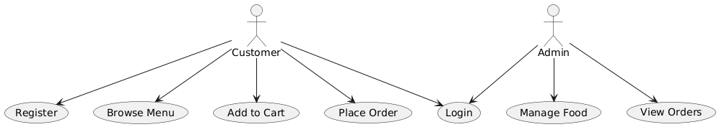
Figure 1: System Level Use Case Diagram
  - Sign up
ID | UC001
Name | Sign Up
Description | This use case describes the process flow of Sing Up
Requirement(s) | FR001
Actor(s) | Admin, Data Entry, Operator
Precondition | Actors must not be member of Hospital
Postcondition | Actors will view the message for approval from admin
Basic Flow | Basic Flow  - Actor enter credentials  - System validates the inputs  - Following fields are required  - Name  - Email  - Password  - Address  - Phone  - Check the proper inputs for following  - Email  - Password must be 8 character including number  - Phone Number on 11 digits  - On successful validation the system will create new user  Alternative Flow  - Admin Sign In  - Create a new User by entering data  Exceptions  - Invalid Inputs  - System unable to response
Diagrams
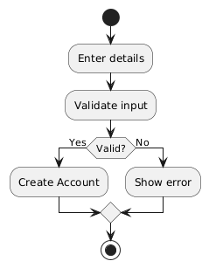
- References
- IEEE References
- Software Engineering Book
- IEEE SRS Standards
- Online Food Ordering Systems Research Papers

