Lab06 - Enforcing a Pod Security Standard Upon Pod Creation

You are tasked with defining a Pod Security Admission rule that should control the creation of Pods in the namespace `k29`.

1. Create the namespace `k29`. In the namespace, define a Pod Security Standard (PSS) with the level `restricted` that will cause a Pod to be rejected upon violation.

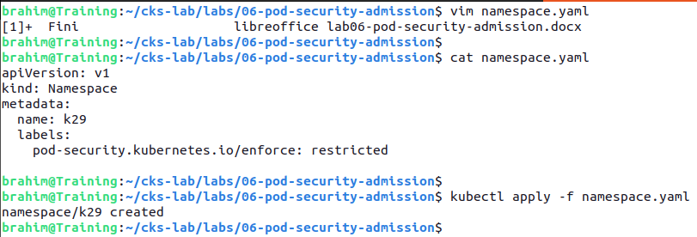

1. Create objects from the YAML manifests `pod-non-root.yaml`, `pod-root.yaml` and `pod-privileged.yaml`.

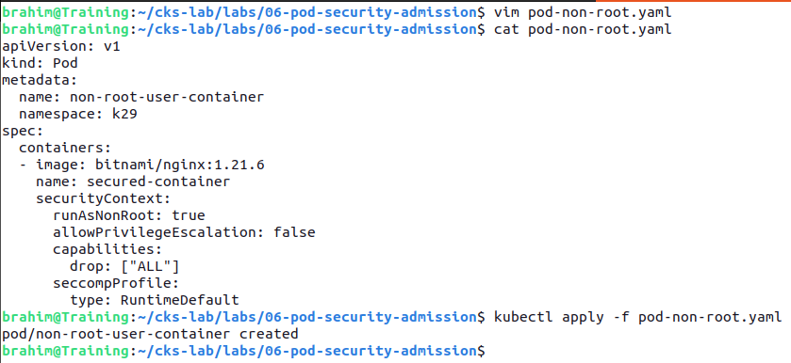

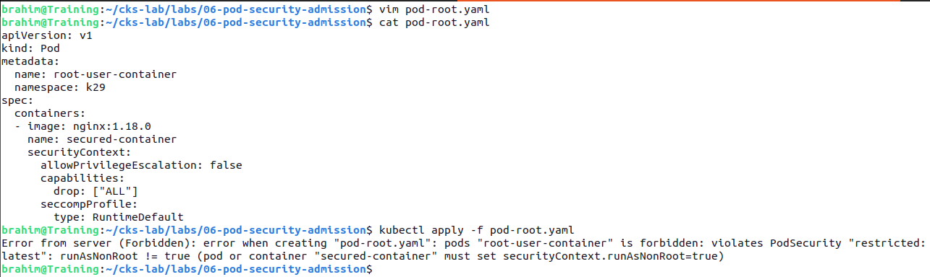

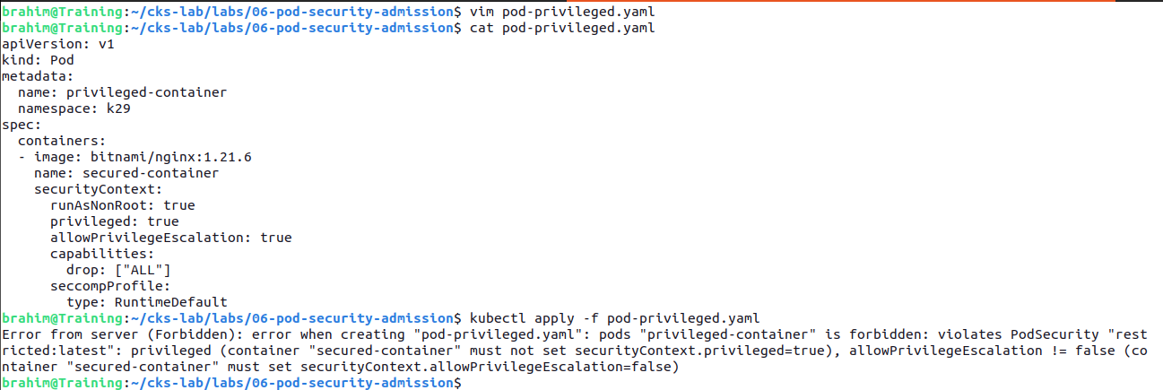

* + Which of the Pods will be created and why?

