Assignment 3: System Design & Architecture Documentation
CSE-2507M - Alibi Baigaliyev, Sayat Zeitkazy

Task 1. Non-Functional Requirements & Trade-offs
  - NFR Targets

Quality Attribute | Target (Numeric) | Measurement Method | Justification
Latency | P95 < 500ms, P99 < 1s (API) | Locust load tests, pytest benchmark | JWT authentication and database operations have to be fast; more than one second causes a bad user experience for students when submitting their assignments.
Availability | ≥ 99.5% uptime (monthly) | UptimeRobot monitoring + CI health-check endpoint | The application is sensitive to deadlines; downtime during exams equals lost data.
Throughput | ≥ 200 RPS at peak | Locust benchmark with 200 concurrent users | It supports a user base of more than 10,000 users; its peak use is during course enrollment or deadlines.
Consistency | Strong consistency for auth & assignments; Eventual for progress stats | Per-feature DB transaction audit | Authentication and data writing need immediate consistency; statistics aggregation can handle some delays.
Data Durability | RPO < 15 min, RTO < 30 min | DR drill: DB backup restore + failover simulation | The application needs to ensure that student data, including assignments and grades, will survive server failure.

1.2 Primary Trade-off Analysis

Trade-off Axis | What We Optimize FOR | What We Are Willing to Give Up | Decision Rationale
Latency vs Throughput | Low latency (fast individual responses <500ms) | Slightly lower peak RPS under extreme load | Students require immediate feedback regarding task progress; short throughput time is permitted
Consistency vs Availability | Strong consistency for core data (auth, assignments) | Eventual consistency for progress dashboard aggregations | Improper assignment status means lack of trust; slightly out-of-date statistics are permissible
Cost vs Performance | Performance within Docker + SQLite/PostgreSQL stack | Horizontal scaling infrastructure cost (cloud VMs) | Budget allocation for academic projects is nil; one-server processing will suffice for up to 10,000 users

Task 2. High-Level Architecture Diagram (C4 Model — L1 & L2)
2.1 Level 1 — System Context Diagram
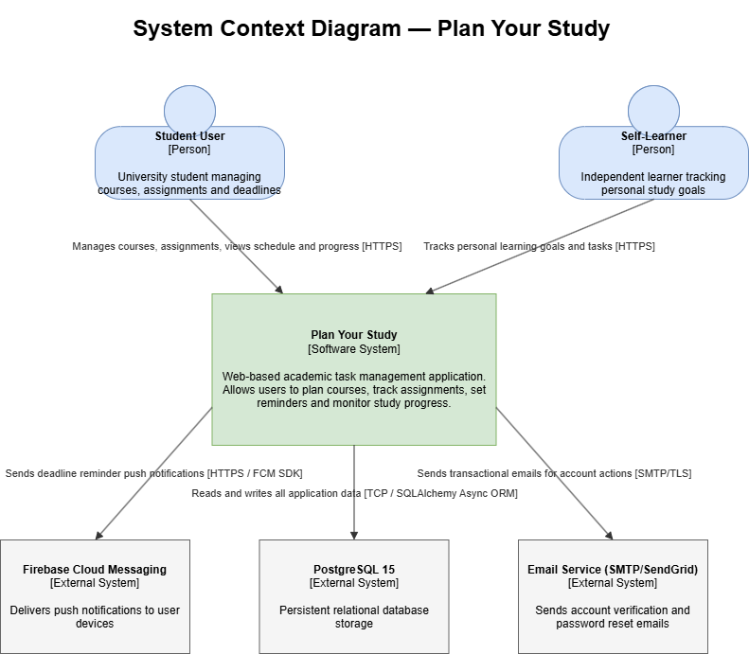

2.2 Level 2 — Container Diagram
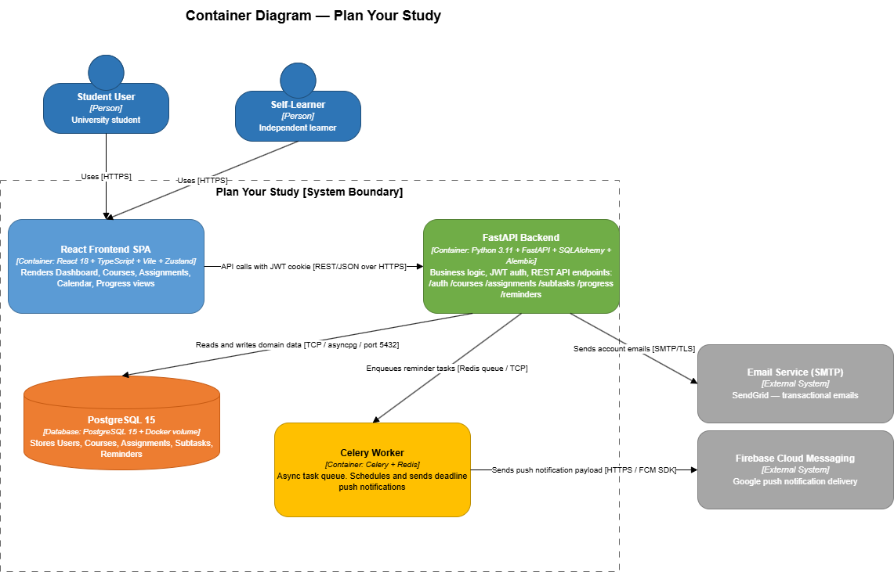

Task 3. Architecture Decision Record (ADR)

ADR-001 | Use PostgreSQL (Production) over SQLite — with SQLAlchemy Async ORM Abstraction
Status | Accepted
Date | March 2026
Context | Plan Your Study needs persistent storage for User data, Course data, Assignment data, Subtask data, Reminder data, and Schedule data. The application must be able to deal with multiple simultaneous users, implement referential integrity (assignments must be from courses belonging to the authorized user), and conduct advanced relational queries (progress tracking, calendar integration). In Sprint 0, the team considered the storage needs for a two-member academic team within ten weeks. The risk analysis (Deliverable 1) determined that Authentication and Assignment Management were CRITICAL (score: 9/9) features that relied heavily on transactional storage. Initial development was done using SQLite, but a more powerful database engine was needed for production (Docker Compose + Nginx).
Decision | PostgreSQL 15 should be used as the primary relational database system, which is accessible through the SQLAlchemy Async ORM interface. SQLite will still be maintained only for local and continuous integration tests (memory-based isolation). Migrations for all schemas will be handled with the help of Alembic.
Rationale | Availability (≥99.5%) NFR: PostgreSQL allows multiple connections and uses row-level locking, whereas SQLite does not allow multiple writes, failing to meet the availability NFR.  Data Durability (RPO <15 min) NFR: PostgreSQL offers streaming replication with point-in-time recovery using WAL technology, whereas SQLite does not support replication.  Consistency: PostgreSQL requires ACID transactions and correct isolation level in order to address the Authorization bypass risk (T-08: cross-user course access).  The ORM layer provides the optimal balance between Cost and Performance.
Alternatives Rejected | 1. MongoDB (NoSQL document store): Not considered due to a fundamentally relational nature of the Plan Your Study database, where Assignments have a foreign key dependency on Courses, Subtasks on Assignments, and Reminders on Assignments. The usage of documents implies implementing joins at the application level, which increases the probability of bugs occurring in already risky modules. No ACID support for assignments consistency.  2. SQLite for production: Not considered due to file-level locking, preventing simultaneous writes. This would produce unacceptable queue lengths under the 200 requests per second throughput non-functional requirement, especially when dealing with authenticated users. No native async I/O support in SQLite, conflicting with the FastAPI framework.
Consequences | Positive: High-quality production-grade concurrency and durability. ACID compliance safeguards against cross-user isolation issue experienced during testing in Assignment 2 (TC_COURSE_005). Alembic migrations ensure that schema changes are auditable.  Negative: Increased difficulty in development due to Docker Compose configuration. CI process should spin up PostgreSQL container service, thus increasing the build duration by 30 seconds.  Risks Introduced: Upgrade in PostgreSQL version may necessitate migration testing. Pool connection exhaustion under extremely heavy loads (>500 requests/sec) needs to be tested — to be addressed in Sprint 4.

Task 4. Detailed Component Design

Component 1 - React Frontend SPA

Field | Content
Component Name | React Frontend SPA
Purpose | The only point of contact between the user and the system.
Responsibilities | 1. Rendering all views: Dashboard, Courses, Assignments, Calendar, Progress  2. Managing global state using Zustand (authentication state, assignment caches)  3. Constructing REST calls to FastAPI using JWT cookie and response parsing  4. Route protection using React Router v6 (redirect to /login on 401 error)  5. Rendering FullCalendar component from data at /api/schedule endpoint
Inputs | - User interactions: clicks, form submissions, route navigation  - API responses: JSON from FastAPI  - Example: {"id": 7, "title": "Lab 3", "deadline": "2026-05-01T23:59:00Z", "priority": "HIGH", "status": "PENDING"}
Outputs | - REST requests to FastAPI: POST/GET/PATCH/DELETE with JSON body  - Example: POST /api/assignments {"title": "Lab 3", "deadline": "2026-05-01T23:59:00Z", "priority": "HIGH", "course_id": 7}  - Error: 401 → redirect to /login, 422 → inline form validation error
Dependencies | → FastAPI Backend (HTTPS REST/JSON API only)  → Zustand Store (state for the client, no state stored on server)  ← No dependencies from outside (Frontend acts as a leaf node in the call graph)
NFR Sensitivity | Latency (P95 < 500ms): Frontend affects latency as part of the end-to-end journey by contributing its bundle loading latency. The React application size after Vite code splitting is around 180KB. Load time measurement: 1.8s.

Component 2 - FastAPI Backend

Field | Content
Component Name | FastAPI Backend
Purpose | Sole owner of business logic. Responsible for JWT authentication, data validation, API routing, and ORM queries to the database.
Responsibilities | 1. Authenticate JWT from httpOnly cookie on every restricted route using Depends(get_current_user)  2. Route all incoming requests: /auth, /courses, /assignments, /subtasks, /progress, /schedule, /reminders  3. Implement per-user data separation by adding user_id filter to each WHERE clause (avoids data leaks between users)  4. Add Celery task to the queue whenever an assignment is created (trigger event)  5. Define business logic: Deadline should be a future date; Course belongs to the authenticated user
Inputs | - HTTP requests with JWT cookie from React SPA  - Example: POST /api/assignments + Cookie: access_token=<JWT> + Body: {"title": "Lab 3", "deadline": "2026-05-01T23:59:00Z", "priority": "HIGH", "course_id": 7}
Outputs | - JSON responses: 201 Created / 200 OK / 401 / 403 / 422  - Success example: {"id": 42, "title": "Lab 3", "deadline": "2026-05-01T23:59:00Z", "status": "PENDING"}  - Error 403: {"detail": "Course not found or access denied"}  - Error 422: {"detail": "Deadline must be a future UTC datetime"}
Dependencies | → PostgreSQL 15 (CRUD via SQLAlchemy Async ORM, TCP/5432)  → Celery Worker (enqueue task on assignment creation)  ← Called by: React Frontend SPA (all API requests)
NFR Sensitivity | Availability (≥99.5%): The backend acts as the sole gateway for all activities – any downtime means 100% availability outage. Rate limiter on /auth (5 req/60s) ensures protection from brute-force attacks. Async FastAPI handles simultaneous requests without thread blocking.

Component 3 - PostgreSQL 15

Field | Content
Component Name | PostgreSQL 15
Purpose | Sole persistent data store for the system. Owns all domain entities and guarantees transactional integrity.
Responsibilities | 1. Store all domain objects: User, Course, Assignment, Subtask, Reminder  2. Use foreign key constraints with CASCADE for referential integrity  3. Run ACID transactions on all write commands  4. Provide aggregate query capabilities for the Progress Dashboard (COUNT with GROUP BY status)  5. Use soft delete based on deleted_at field – never delete records physically
Inputs | - SQL queries from FastAPI Backend via asyncpg driver  - Example INSERT: INSERT INTO assignments (title, deadline, priority, status, course_id, user_id) VALUES ('Lab 3', '2026-05-01T23:59:00Z', 'HIGH', 'PENDING', 7, '<uuid>')
Outputs | - Result sets: table rows or aggregate values  - Example SELECT: [{"id": 42, "title": "Lab 3", "status": "PENDING", "deadline": "2026-05-01T23:59:00Z"}]  - Error: UniqueViolationError (duplicate email) → FastAPI returns 409 Conflict
Dependencies | ← Invoked by: FastAPI Backend (the main client application)  ← Invoked by: Celery Worker (fetches fcm_device_token from the users table during task execution)  ← No external dependencies (outgoing calls)
NFR Sensitivity | Data Integrity (RPO < 15 mins): Point-in-time restore possible due to logging with the WAL mechanism. Data is stored on Docker volumes. Data soft delete approach avoids any unintended deletion of data.

Component 4 - Celery Worker

Field | Content
Component Name | Celery Worker
Purpose | The only task scheduler for background processes that run asynchronously.
Responsibilities | 1. Dequeue tasks from the Redis queue upon creating an assignment in FastAPI.  2. Schedule the execution of the task with Celery ETA scheduling with a delay of deadline - 24h.  3. Get the device token for FCM from the PostgreSQL database during task execution (not during scheduling; ensures freshness of the token).  4. Send the push notification with FCM using the notification data.  5. Change Reminder status to SENT / FAILED in the database.
Inputs | - Celery task parameters from Redis queue:  {"user_id": "<uuid>", "assignment_id": 42, "assignment_title": "Lab 3", "eta": "2026-04-30T23:59:00Z"}  - FCM token from PostgreSQL at execution time: {"fcm_token": "fXm3k..."}
Outputs | - FCM API call -> push notification sent to user device  - DB write: UPDATE reminders SET status='SENT' WHERE assignment_id=42  - Error: FCM failure -> status='FAILED', task put into retry list  - If deadline <= 24h -> task creation not done (business logic in FastAPI)
Dependencies | -> Firebase Cloud Messaging (HTTP/S, FCM SDK -> third-party platform)  -> PostgreSQL 15 (accesses fcm_token, changes reminder status)  <- Invoked by: FastAPI backend (task enqueued in Redis upon assignment creation)
NFR Sensitivity | Availability (≥99.5%): A Celery worker process failure results in loss of all tasks currently in queue. Possible fix: Redis persistence via append-only file prevents task queue from being cleared. Inaccurate FCM token after app reinstallation (due to outdated cached value) -> silent failure -> fixed by obtaining token at execution time instead of scheduling time.

Component 5 - Firebase Cloud Messaging

Field | Content
Component Name | Firebase Cloud Messaging
Purpose | External push notification delivery engine. Handles routing and sending of deadline reminder notifications to user devices.
Responsibilities | 1. Receives notification message from Celery Worker through FCM HTTP API  2. Routes notification to the right device using the FCM device token  3. Ensures delivery during next online occurrence of the device if device is offline at present  4. Provides delivery confirmation or failure response to Celery Worker
Inputs | - HTTP POST from Celery Worker to the FCM API endpoint  - Example payload: {"to": "<device_token>", "notification": {"title": "Deadline tomorrow!", "body": "Lab 3 is due in 24 hours"}}
Outputs | - Success: {"message_id": "0:1234567890"} → Celery sets Reminder.status = SENT  - Error: {"error": "InvalidRegistration"} → token is stale, status = FAILED  - Error: {"error": "NotRegistered"} → user uninstalled the application
Dependencies | Called by: Celery Worker (single internal calling application)  Outgoing dependencies: None
NFR Sensitivity | Availability (≥99.5%): FCM is the external dependency with its own SLA (99.95% - Google). Unavailability of FCM will not impact system operations, as assignments and courses remain unaffected (notifications are not essential for the main process). The failures will be confined to the Celery Worker module alone and won’t affect the FastAPI Backend.

Task 5. UML Diagrams

5.1 Class Diagram
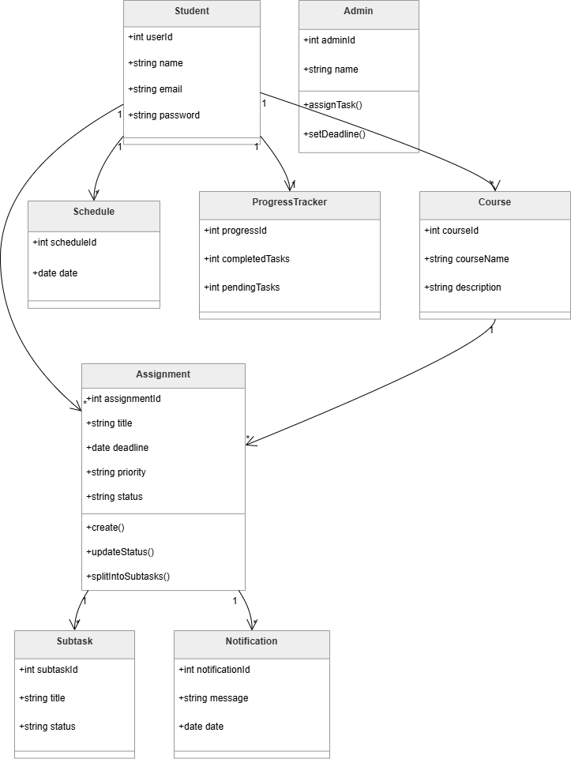

5.2 Sequence Diagram

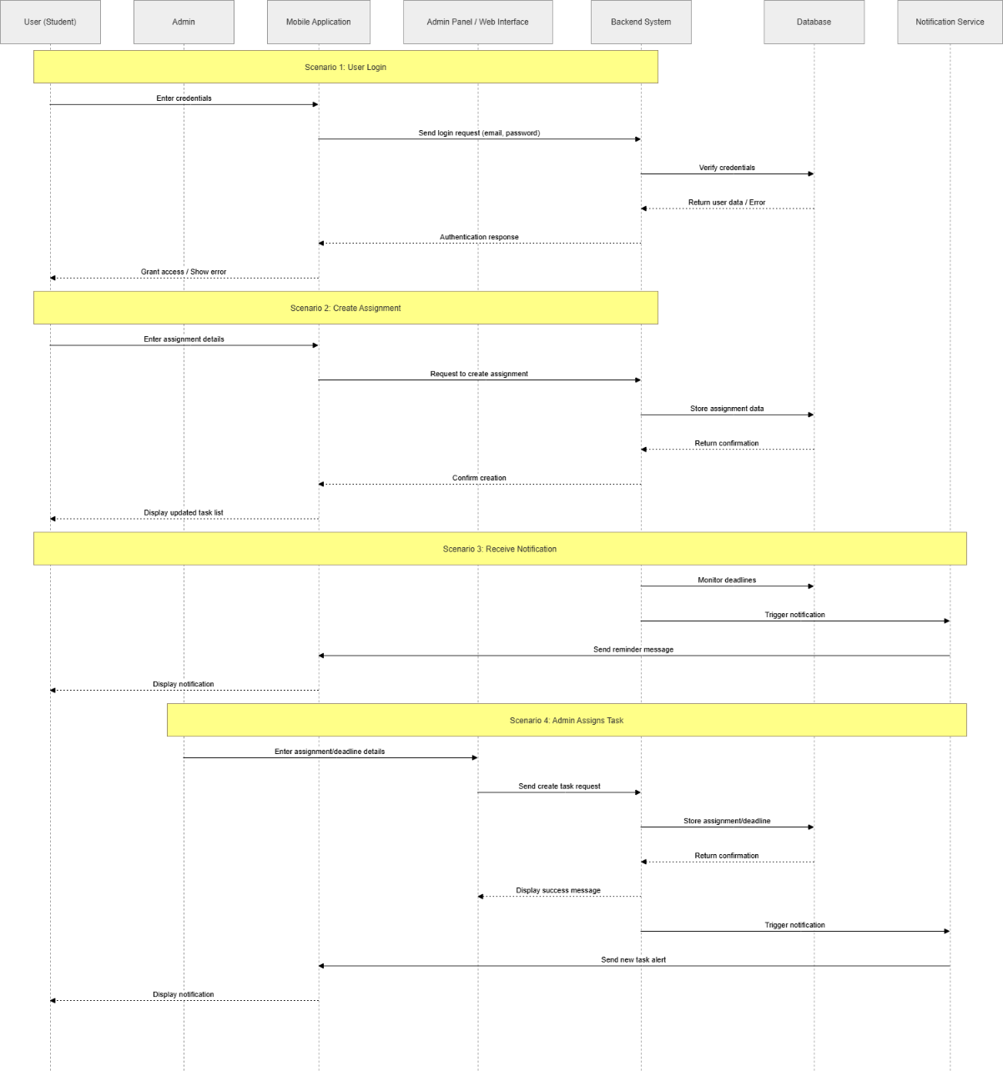

5.3 Entity-Relationship Diagram

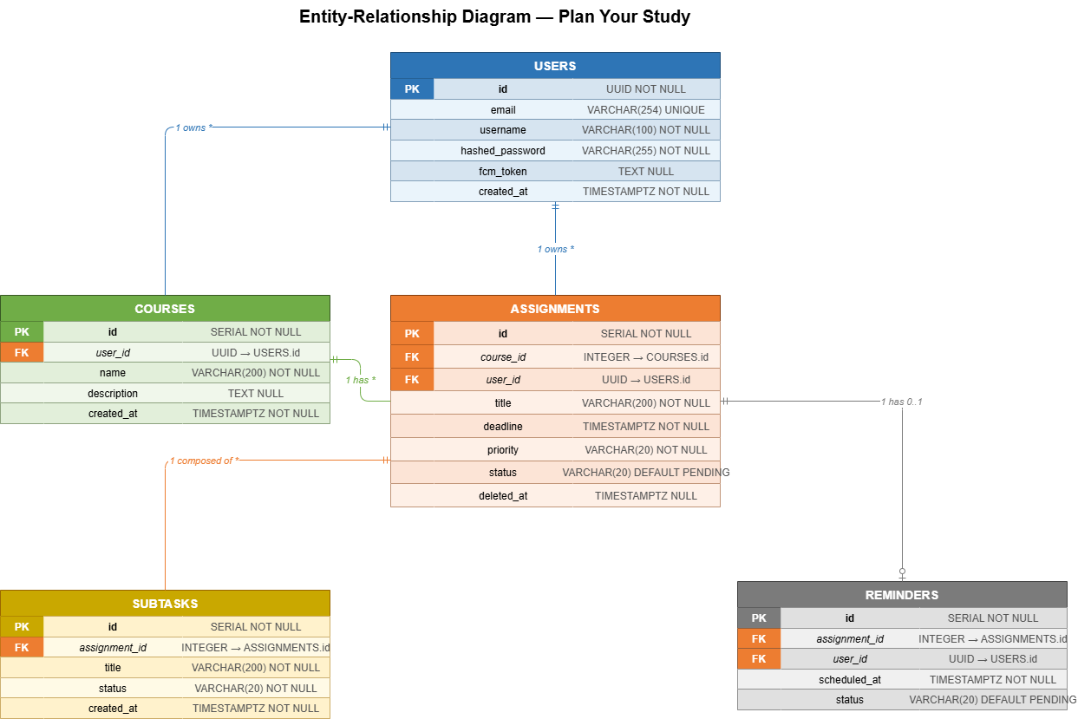

AI assistance was applied only for:
- generating initial ideas and alternative approaches during early brainstorming;
- reviewing wording and improving clarity of explanations;
- suggesting general examples of software engineering concepts (e.g., non-functional requirements, architecture structuring);
- refining the structure and readability of certain sections.

