**sasddsadsadasdsdasdsdad**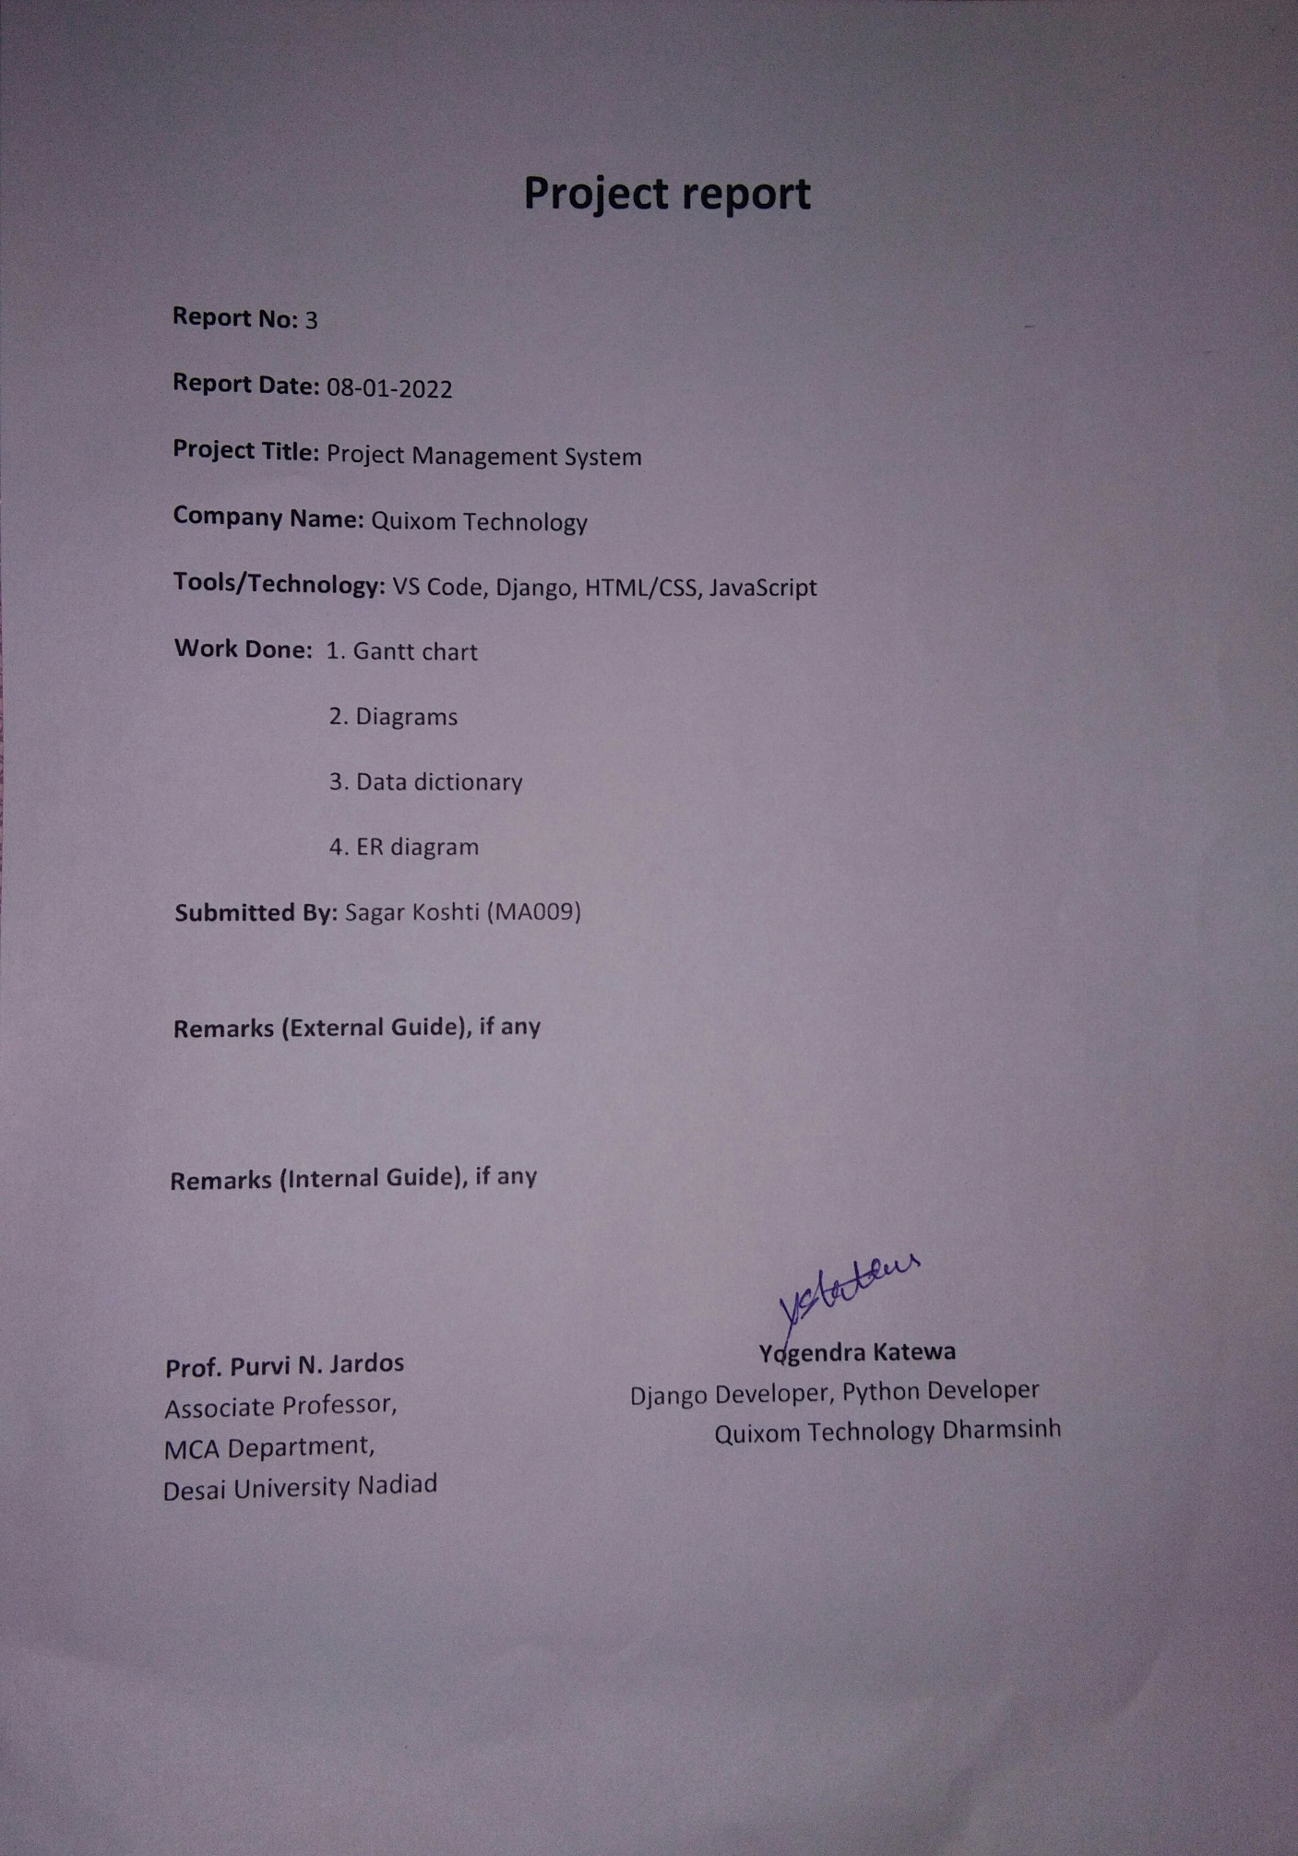

**Project report**

**Report No:** 3

**Report Date:** 08-01-2022

**Project Title:** Project Management System

**Company Name:** Quixom Technology

**Tools/Technology:** VS Code, Django, HTML/CSS, JavaScript

**Work Done:** 1. Gantt chart

2. Diagrams

3. Data dictionary

4. ER diagram

**Submitted By:** Sagar Koshti (MA009)

**Remarks (External Guide), if any**

**Remarks (Internal Guide), if any**

**Prof. Purvi N. Jardos Yogendra Katawe**

Associate Professor, Django Developer, Python Developer

MCA Department, Quixom Technology

Dharmsinh Desai University Nadiad

**Gantt chart**

|  |  |  |  |
| --- | --- | --- | --- |
| **Task/Time** | **Start** | **End** | **Duration (Days)** |
| Project planning | 06-12-2021 | 12-12-2021 | 7 |
| Requirement gathering & analysis | 13-12-2021 | 26-12-2021 | 14 |
| Designing | 27-12-2021 | 23-01-2022 | 21 |
| Coding & Testing | 24-01-2022 | 26-03-2022 | 62 |
| Documentations | 06-12-2021 | 26-03-2022 | 111 |

**Use case**

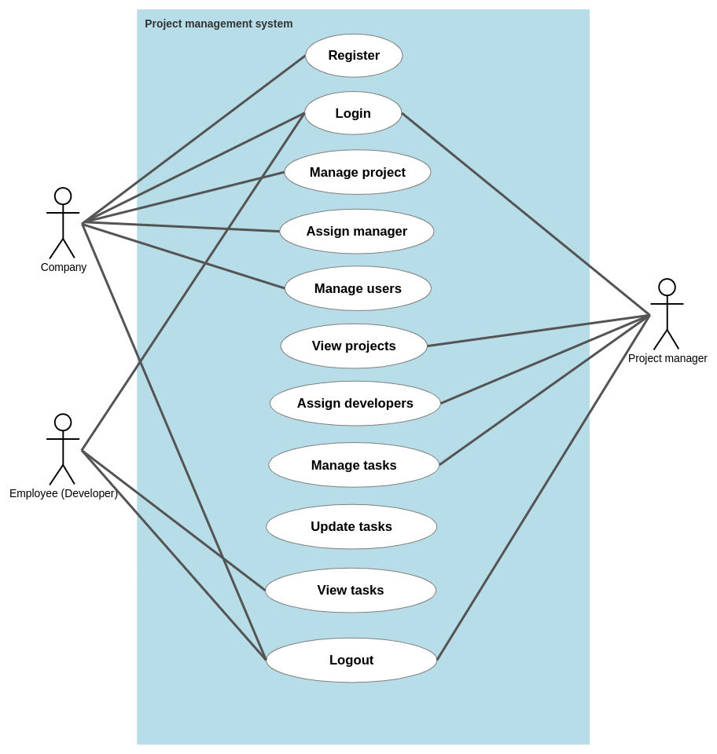

**Admin Use case diagram**

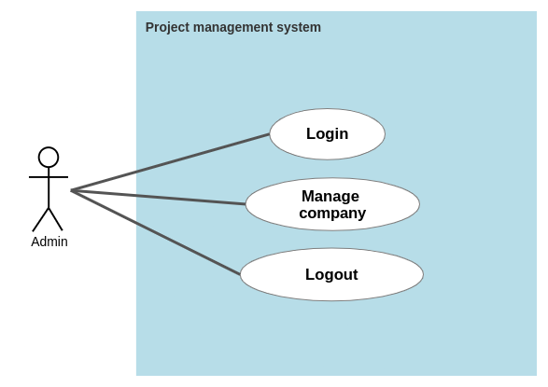

**Company (Activity Diagram)**

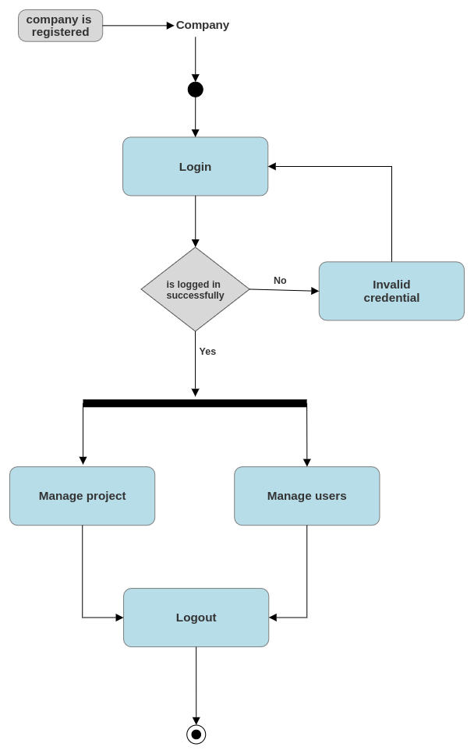

**Project manager (Activity Diagram)**

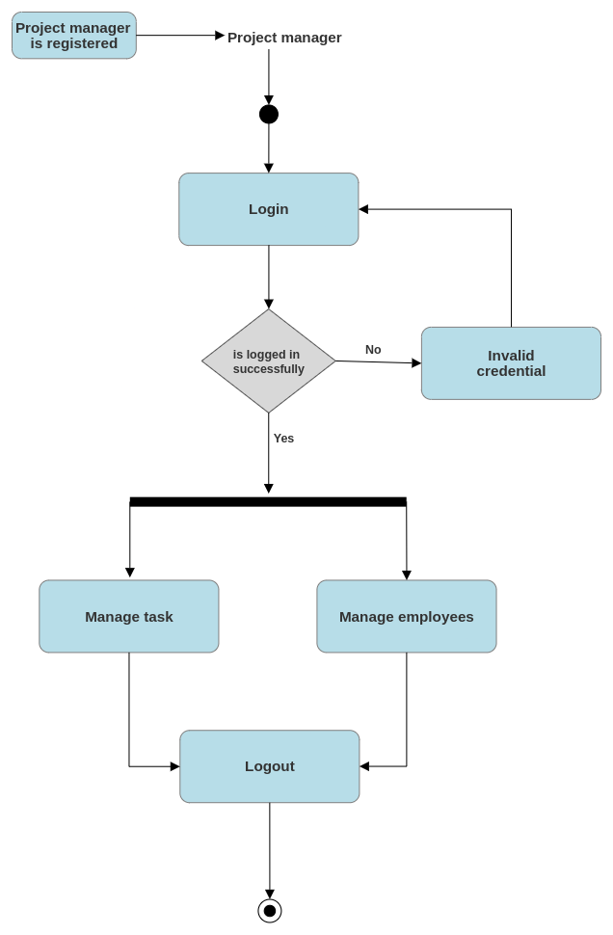

**Employee activity (Activity Diagram)**

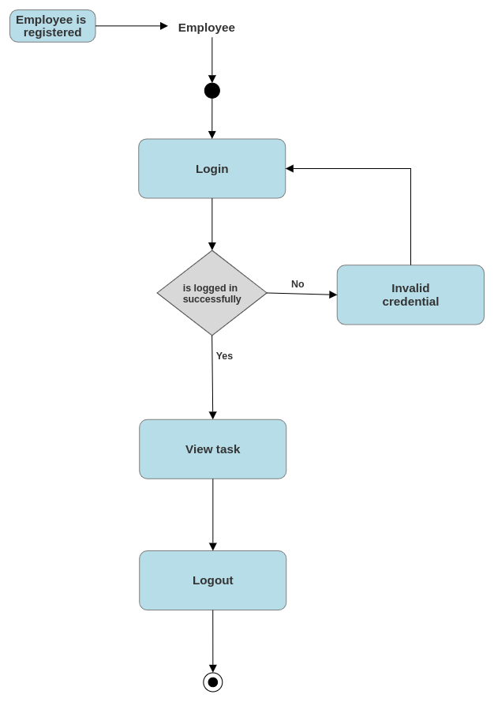

**Admin (Activity Diagram)**

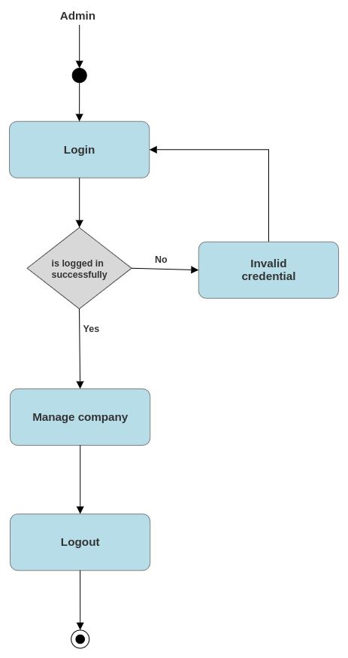

**Class diagrams**

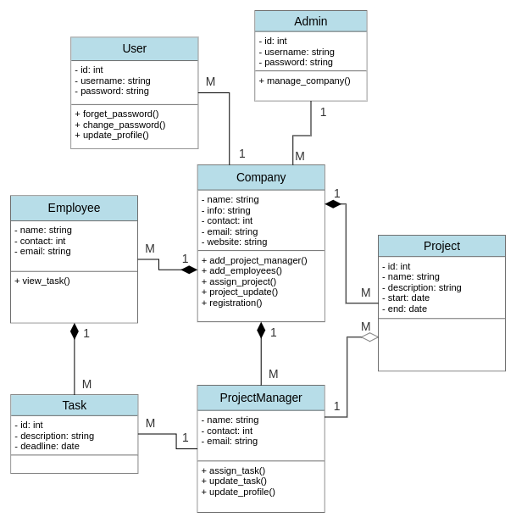

**Sequence diagram**

**Admin**

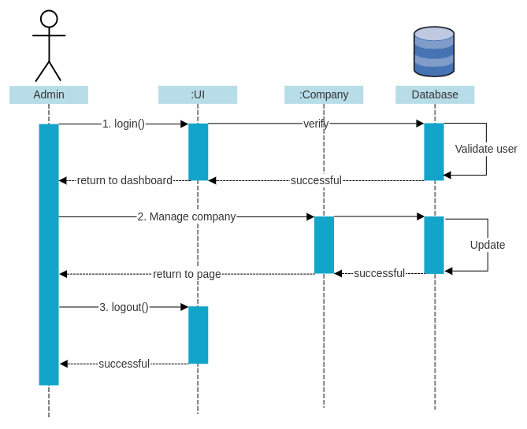

**Company**

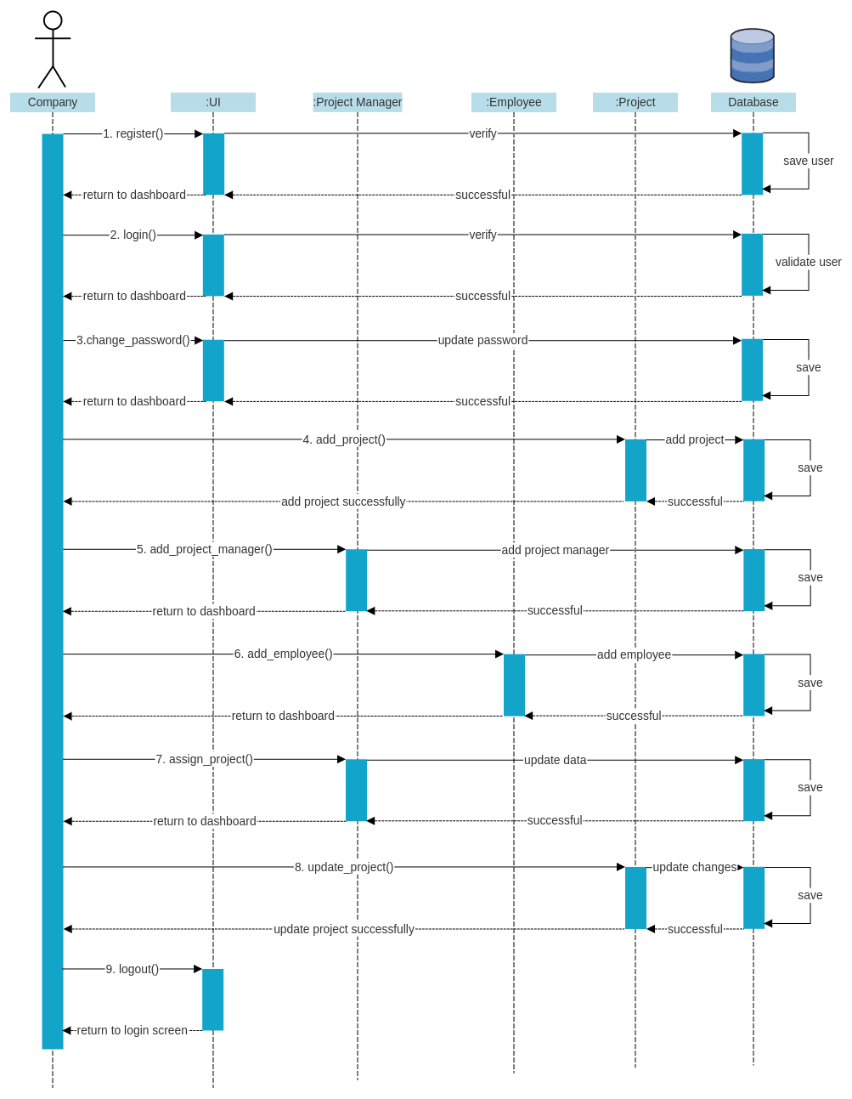

**Project manager**

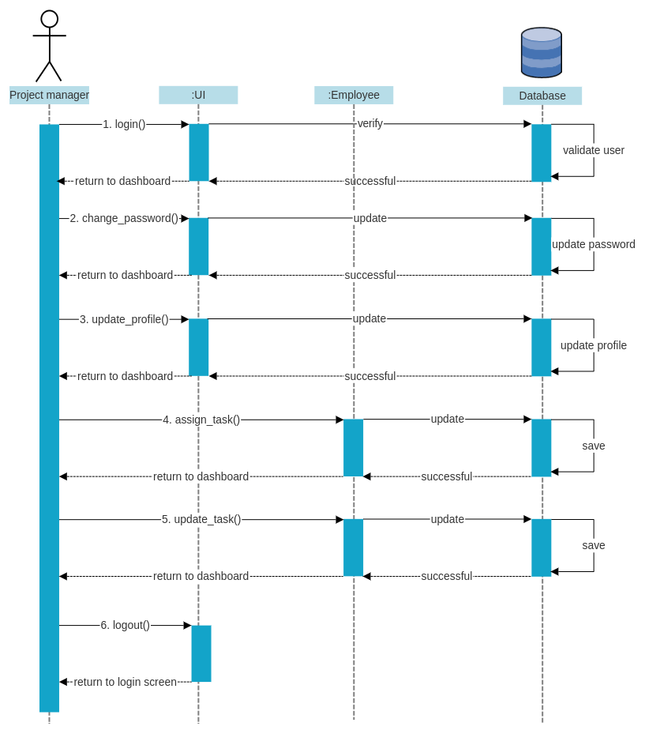

**Employee**

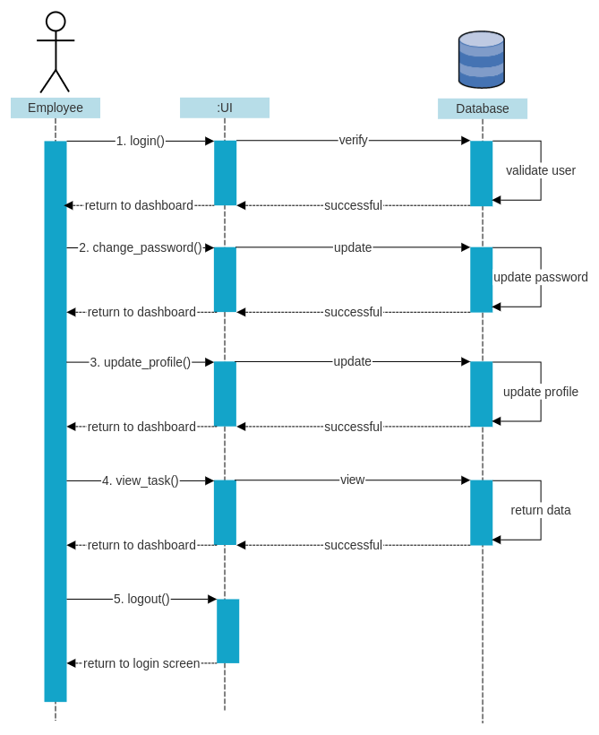

**Data Dictionary**

**1. Company:**

|  |  |  |  |  |
| --- | --- | --- | --- | --- |
| **Field name** | **Field type** | **Field size** | **Constraint** | **Description** |
| **c_id** | **Int** | **7** | **Primary key** | **This field stores PK of the company.** |
| **c_name** | **Varchar** | **30** | **Not null** | **This field stores name of the company.** |
| **c_info** | **Varchar** | **200** | **Not null** | **This field stores information about a company.** |
| **c_contact** | **Long int** | **10** | **Not null** | **This field stores the contact number of the company.** |
| **c_email** | **Varchar** | **30** | **Not null** | **This field stores the email id of the company.** |
| **c_website** | **Varchar** | **50** | **Not null** | **This field stores the website of the company.** |
| **c_username** | **varchar** | **20** | **Not null** | **This field stores the username of the company.** |
| **c_password** | **varchar** | **20** | **Not null** | **This field stores the password of the company.** |

**2. Project_manager:**

|  |  |  |  |  |
| --- | --- | --- | --- | --- |
| **Field name** | **Field type** | **Field size** | **Constraint** | **Description** |
| **pm_id** | **Int** | **7** | **Primary key** | **This field stores the PK of the manager.** |
| **pm_name** | **Varchar** | **30** | **Not null** | **This field stores the name of the project manager.** |
| **pm_contact** | **Long int** | **10** | **Not null** | **This field stores the contact number of the project manager.** |
| **pm_email** | **Varchar** | **30** | **Not null** | **This field stores the email-id of the project manager.** |
| **pm_username** | **Varchar** | **20** | **Not null** | **This field stores the username of the project manager.** |
| **pm_password** | **Varchar** | **20** | **Not null** | **This field stores the password of the project manager.** |

**3. Project:**

|  |  |  |  |  |
| --- | --- | --- | --- | --- |
| **Field name** | **Field type** | **Field size** | **Constraint** | **Description** |
| **p_id** | **Int** | **7** | **Primary key** | **This field stores the PK of the project.** |
| **c_id** | **Int** | **7** | **Foreign key** | **PK of the Company table stores the id of the company.** |
| **p_name** | **Varchar** | **30** | **Not null** | **This field stores the name of the project.** |
| **p_description** | **Varchar** | **100** | **Not null** | **This field stores the description of the project.** |
| **p_start** | **Date** |  | **Not null** | **This field stores the starting date of the project.** |
| **p_end** | **Date** |  | **Not null** | **This field stores the ending date of the project.** |
| **pm_id** | **Int** | **7** | **Foreign key** | **PK of Project_manager stores the id of the project manager.** |

**4. Employee:**

|  |  |  |  |  |
| --- | --- | --- | --- | --- |
| **Field name** | **Field type** | **Field size** | **Constraint** | **Description** |
| **em_id** | **Int** | **7** | **Primary key** | **This field stores the PK of the employee.** |
| **em_name** | **Varchar** | **30** | **Not null** | **This field stores name of the employee.** |
| **em_contact** | **Long int** | **10** | **Not null** | **This field stores the contact number of the employee.** |
| **em_email** | **Varchar** | **30** | **Not null** | **This field stores the email-id of the employee.** |
| **em_username** | **Varchar** | **20** | **Not null** | **This field stores the username of the employee.** |
| **em_password** | **Varchar** | **20** | **Not null** | **This field stores the password of the employee.** |

**5. Project_assignment:**

|  |  |  |  |  |
| --- | --- | --- | --- | --- |
| **Field name** | **Field type** | **Field size** | **Constraint** | **Description** |
| **pa_id** | **Int** | **7** | **Primary key** | **This field stores the PK of the project assignment.** |
| **p_id** | **Int** | **7** | **Foreign key** | **The PK of the Project table stores the id of the project.** |
| **pm_id** | **Int** | **7** | **Foreign key** | **PK of Project_manager stores the id of the project manager.** |
| **pa_description** | **Varchar** | **200** | **Not null** | **This field stored information of the project assignment.** |

**6. Project_update:**

|  |  |  |  |  |
| --- | --- | --- | --- | --- |
| **Field name** | **Field type** | **Field size** | **Constraint** | **Description** |
| **pu_id** | **Int** | **7** | **Primary key** | **This field stores the Pk of the project update.** |
| **p_id** | **Int** | **7** | **Foreign key** | **The PK of the Project table stores the id of the project.** |
| **pm_id** | **Int** | **7** | **Foreign key** | **PK of Project_manager stores the id of the project manager.** |
| **pu_description** | **Varchar** | **200** | **Not null** | **This field stored information of the project updates.** |

**7. Task assignment:**

|  |  |  |  |  |
| --- | --- | --- | --- | --- |
| **Field name** | **Field type** | **Field size** | **Constraint** | **Description** |
| **t_id** | **Int** | **7** | **Primary key** | **This field stores the PK of the task.** |
| **p_id** | **Int** | **7** | **Foreign key** | **PK of the Project table stores the id of the project.** |
| **e_id** | **Int** | **7** | **Foreign key** | **PK of the Employee table stores the id of the Employee.** |
| **t_description** | **Varchar** | **200** | **Not null** | **This field stored information of the task.** |
| **t_deadline** | **Date** |  | **Not null** | **This field stored the deadline of the task.** |

**8. Admin:**

|  |  |  |  |  |
| --- | --- | --- | --- | --- |
| **Field name** | **Field type** | **Field size** | **Constraint** | **Description** |
| **id** | **Int** | **7** | **Primary key** | **This field stores the PK of the admin.** |
| **username** | **Varchar** | **30** | **Not null** | **This field stores the username of the admin.** |
| **password** | **Varchar** | **20** | **Foreign key** | **This field stores the password of the admin.** |

**ER Diagram**

