AI – Assignment 2

SemEval-2026 Task 13: Detecting Machine-Generated Code with Multiple Programming Languages, Generators, and Application Scenarios

Domain: Subtask A – Binary Machine-Generated Code Detection
Name | CMS | Model
M. Ramis Khan | 504650 | Model_A
M. Moazzam Ali | 509740 | Model_B
Muhammad Abdullah | 503871 | Model_C

Baseline Architectures:
Model A Baseline: XGB Classifier – Optimized open-source model that utilizes decision trees.
Model B Baseline: CodeBERT – Pretrained Bert model customized for code-based datasets.
Model C: Baseline: DistilBERT – Faster and more efficient version of BERT model for NLP.

Model A:
Pipeline:
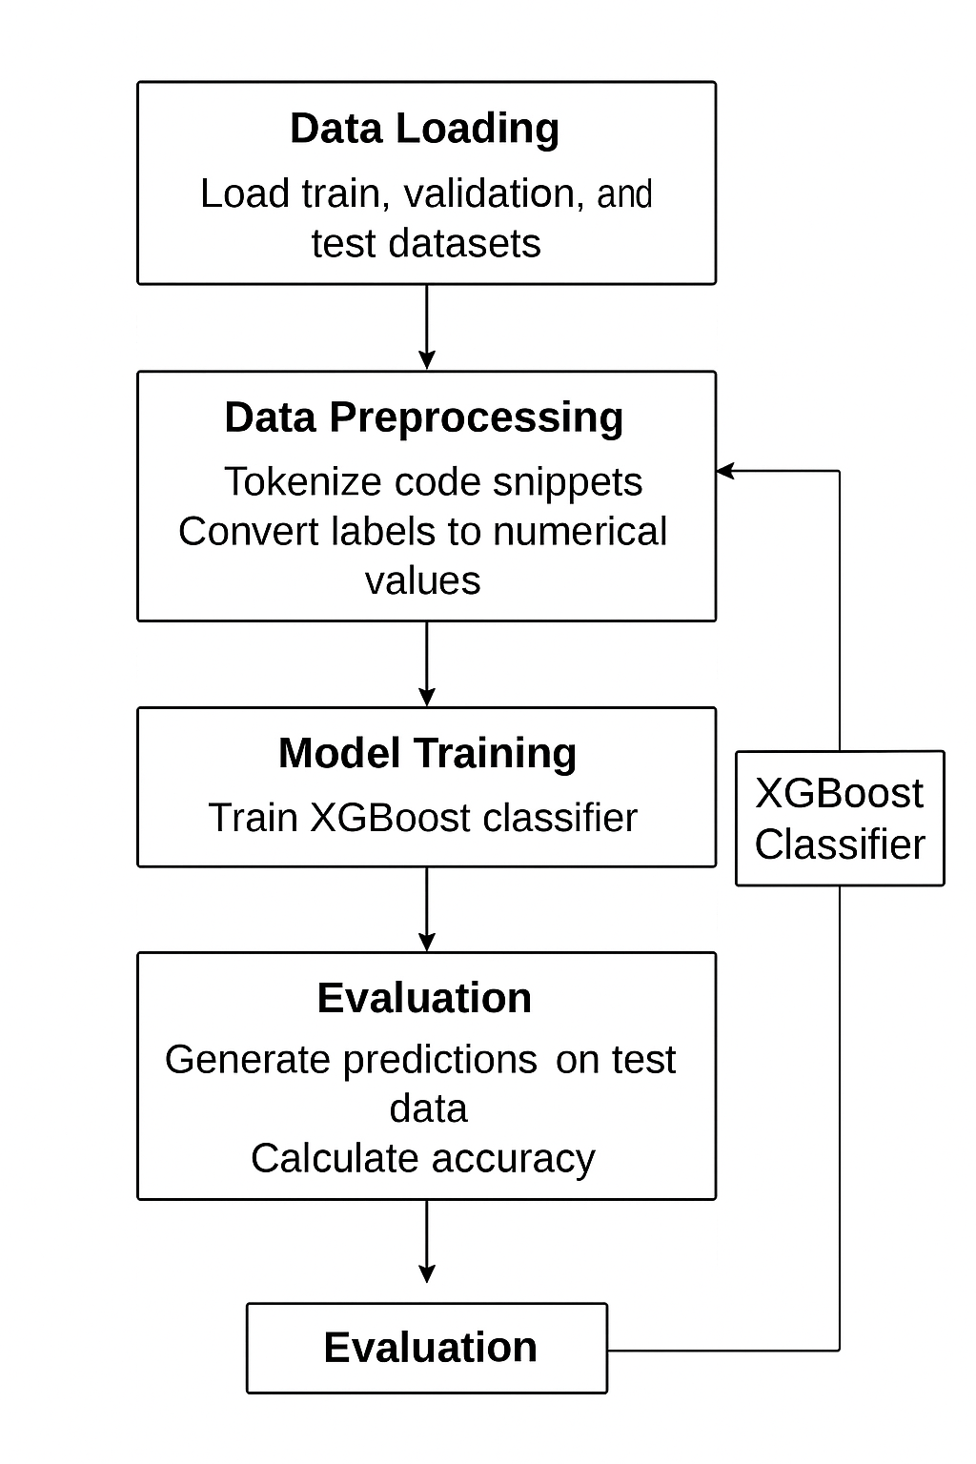
Hyperparameters:
N_ESTIMATORS=300
MAX_DEPTH=5
LEARNING_RATE=0.1
TREE_METHOD='GPU_HIST'
PREDICTOR='GPU_PREDICTOR'
EVAL_METRIC='LOGLOSS'
Validation Accuracy: 94.45%
Test Accuracy: 29.90%

Model B:
Pipeline:
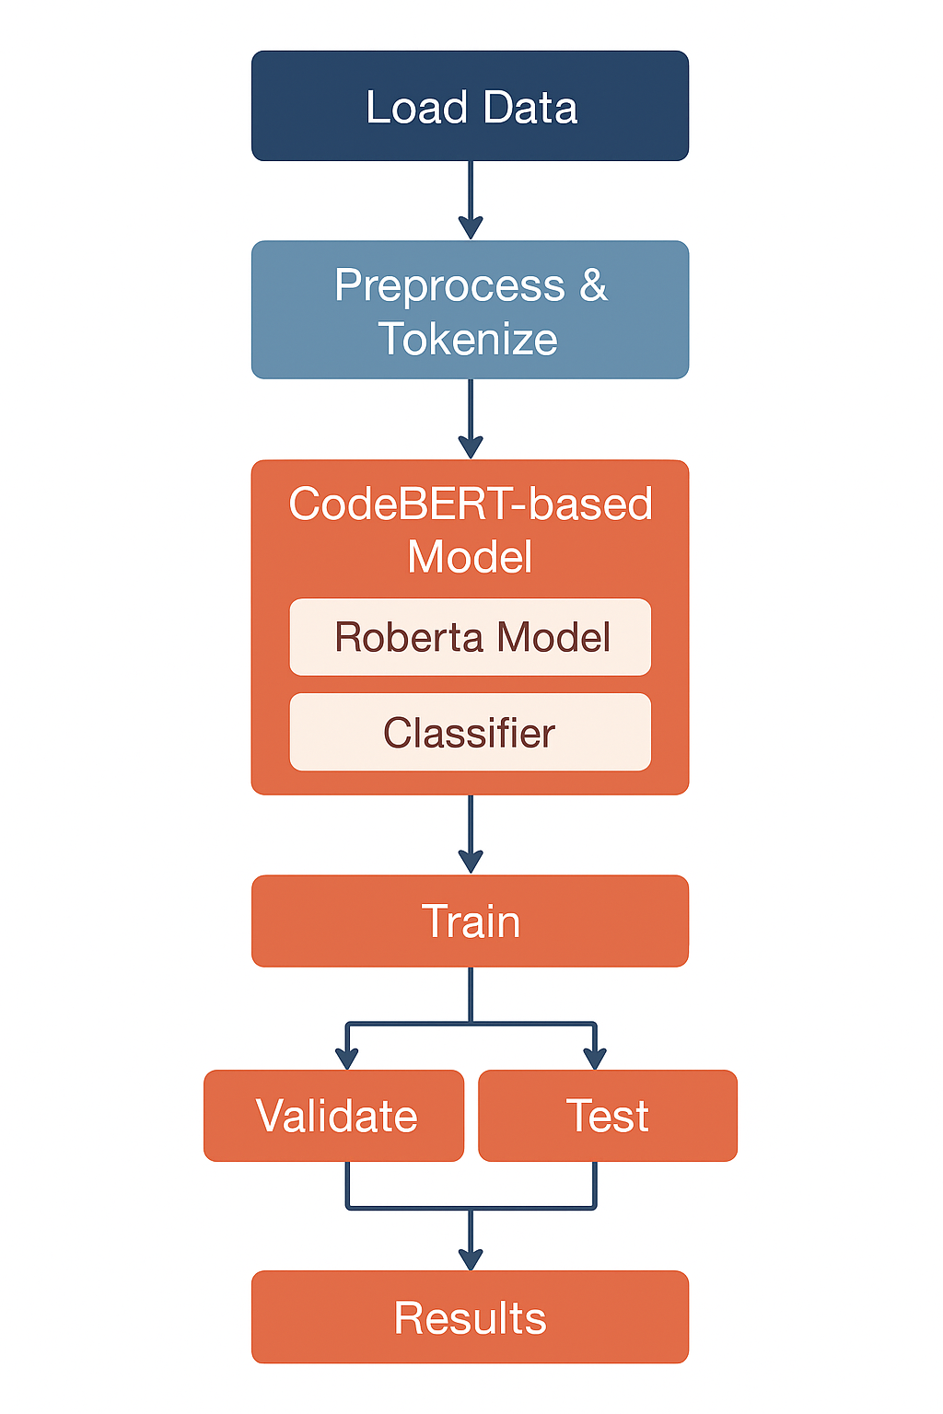
Hyperparameters:
LR = 2e-5
BATCH_SIZE = 8
EPOCHS= 3
WARMUP_STEPS = 0
MAX_LENGTH = 256
DROPOUT = 0.3
MODEL_NAME = "microsoft/codebert-base"
DEVICE = "cuda”
Validation Accuracy: 98.68%
Testing Accuracy: 35.60%

Model C:
Pipeline:
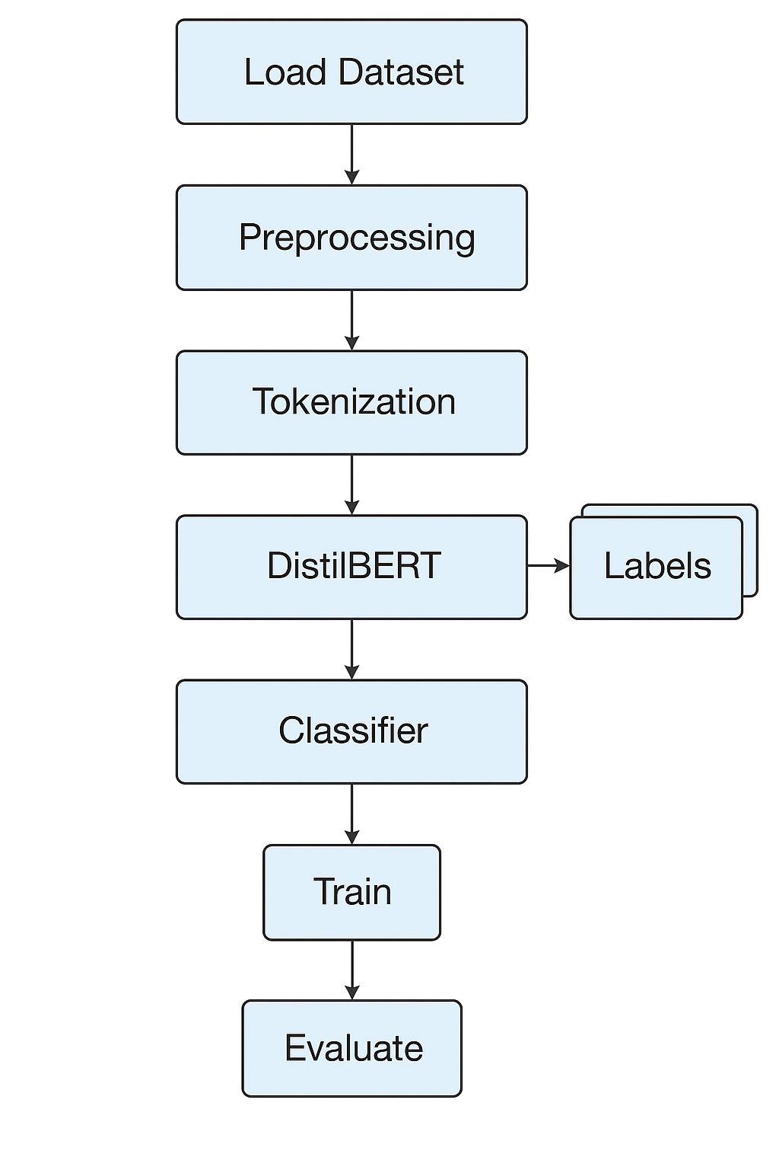
Hyperparameters:
EPOCHS = 2
LEARNING_RATE = 2E-5
OPTIMIZER = ADAMW
WEIGHT_DECAY = 0.01
BATCH_SIZE = 32
GRAD_ACC = 4
SCHEDULER = LINEAR WARMUP
LOSS_FN = CROSSENTROPYLOSS WITH CLASS WEIGHTS
Validation Accuracy: 96.04%
Test Accuracy: 29.10%

Results:
Validation:
Models | Accuracy | Precision | Recall
Model_A | 94.45 | 94.44 | 94.45
Model_B | 98.68 | 98.91 | 98.55
Model_C | 96.04 | 96.10 | 96.04

Test:
Models | Accuracy | Precision | Recall
Model_A | 29.90 | 78.50 | 29.90
Model_B | 35.60 | 24.36 | 89.69
Model_C | 29.10 | 64.77 | 29.10

Implementation Issues:
- Ram usage frequently exceeded the limit which had to be optimized.
- Model training took a lot of time so we had to limit the number of epochs.

