***PharmEasy Document***

***Name:-Sagar Kumr Behera* Project Name:-** 

***Intro:-***  *Here I would prefer to show you that this (PharmEasy) is an E-commerce Medicine provider website. It provides online all types of medicines door to door. Moreover, you can take Video calls for online doctor consultations, and Lab Tests. Also, you can order medicines through prescriptions and random Order also.*

***Project Details:-***

1. *Header part:*

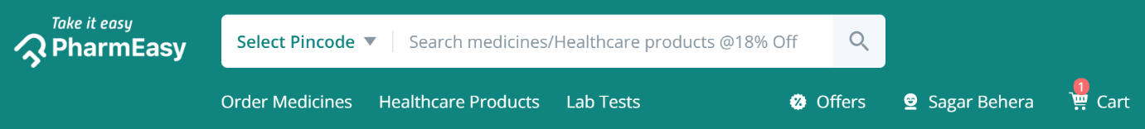

***Nav:-*** *There will be a search box and a pin select option where customers can easily search their products (Medicines) according to their needs and can easily search those using pin code beside the search box. And on the left top, there will be the company logo. In the bottom section, there will be six options that are:-*

***i.*** *Order Medicines:- Where Customers see the logo of products and read essentials and use guidance and order those.*

***ii.*** *Healthcare products:- Here customers can find some daily using healthy products*

***iii.***  *Lab Tests:- Here Customers can take online Lab Tests (All medical Tests) and can also upload prescription and order medicines and book a call also*

***iv.*** *Offers:- Here you can see discounts on products and Extra Discounts for ordering heavy products*

***vi.***  *Login / Sign In:- Here you can be part of this E-service giving personal Details so that company can easily provide service such as:-*

* + 1. *Your Full Name*
    2. *Email Id*
    3. *Phone Number*
    4. *Password etc.*

***vii.*** *Card:- Here you can add products for easy access where you can order later etc.*

1. *FrontPage:*

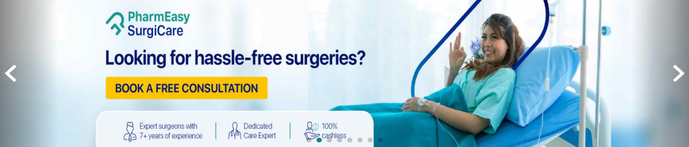

*Here will some Advertising Images where will offers, Discounts, New Facilities for customers. There will be four to six images that you see making Advertising.*

***Click: Frontpage with the advertising images > products discount wise > products with add to cart & buying option > payments***

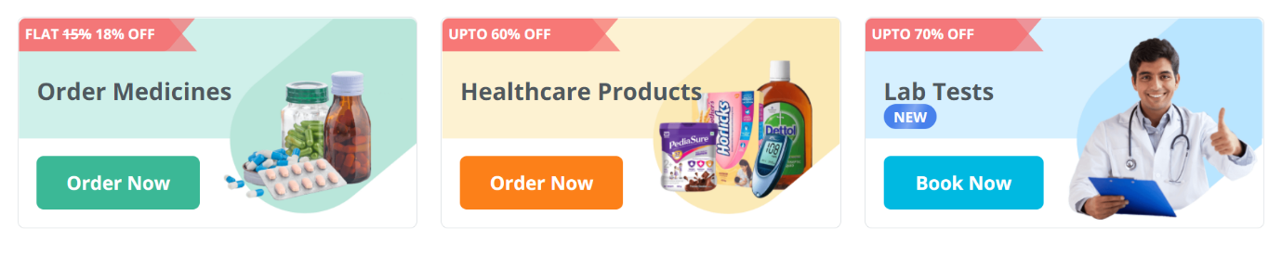

*At bottom of the front page, there will be three to four options including Order Medicines, Healthcare Products, Lab Tests, etc. with logos for easy detection and access.*

***Click: Products and Lab test with order option > related more products with user guidance and order option > payment options***

1. *middle part:*

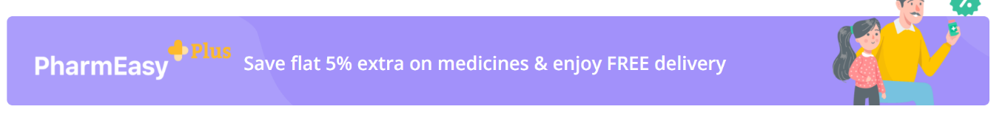

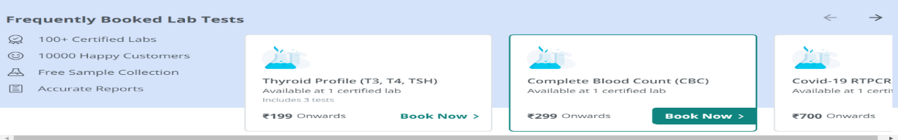

*In the middle part, the will be some Lab Test options like:-*

*1. Thyroid Test*

*2. Complete Blood Count(CBC) Test*

*3. Fasting Blood Sugar(FBS) Tests etc.*

*And other brands’ healthy products with user guidelines with materials, benefits, and harms, etc.*

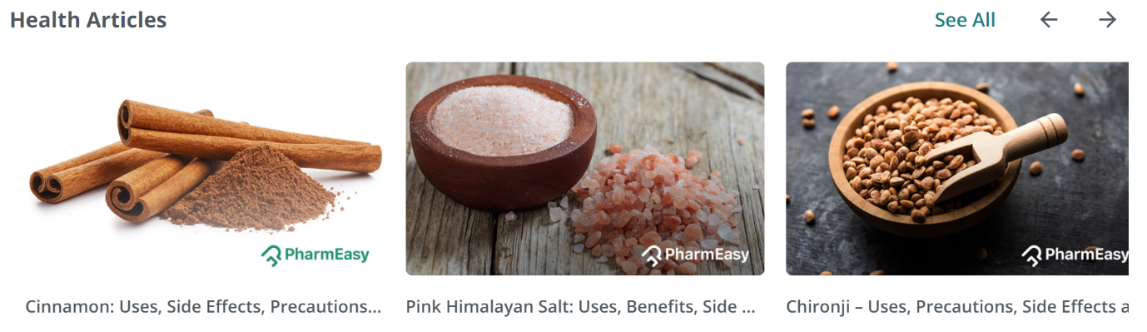

*And also some Vedic Ayurveda Medicines which you can see with logo and materials which is made for build it and all Product details.*

1. *footer part*:

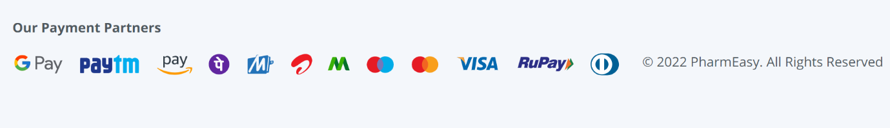

1. *type of medicine:- In this footer part there will be some types of medicines so that users can be able to know how many types of medicines are there.*
2. *social links:- Here you can find companies’ social media where you can get day-to-day updates. At last copyrights*

**--------- ---------**