**Master of Science Advanced Computing**  **SRKI** 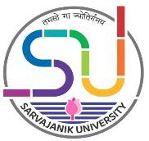

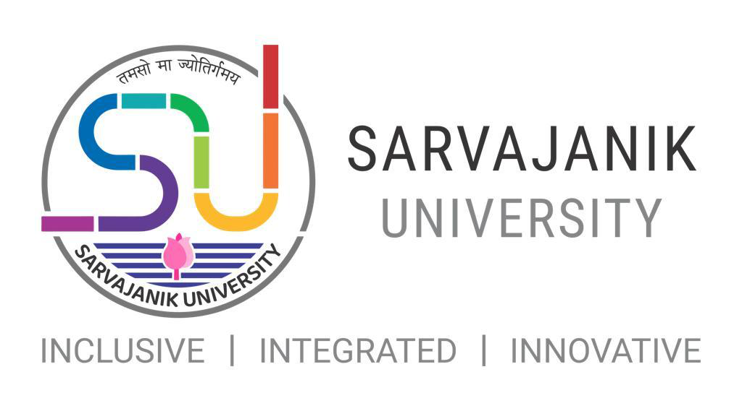

**Faculty of Science**

Shree Ramkrishna Institute of Computer

Education & Applied Sciences, Surat

**M.Sc. Advanced Computing**

1

**Master of Science Advanced Computing**  **SRKI** 

**Master of Science Advanced Computing 2021-22**

**Introduction:**

The demands of our global, data-intensive, knowledge based economy is creating a skills gap and making now the perfect time to gain the skills necessary to meet demand. This course is aimed at students who have a substantial background in computing and want to study advanced computing concepts and state of the art technologies in more depth.

This taught postgraduate course offers you the opportunity to study a wide variety of topics in depth in Artificial Intelligence, NLP, Data Science, BigData, Data Analytics etc. with dedicated experts.

The programme is suitable for students who are primarily interested in a career orientated towards development and applications in industry, as well as it is aimed at students interested in a research career either in the industrial or academic sector.

**Objectives of the programme:**

The Objective of the program is to impart knowledge of fundamentals and/or latest theories, concepts, methods, techniques and tools related to various areas of Advanced Computer Science. Applications and Information Technology and specifically in the area of Data Science, Cloud based, Web based Application Development, Machine Learning, Deep Learning and Intelligent Systems.

**Programme Outcome:**

At the successful completion of the program, students will be able to start their career in the field of Artificial Intelligence, Data Science and Research Domains of Computer Science.

**Eligibility Criteria:**

|  |  |
| --- | --- |
| •  • | A candidate Bechlor’s degree in Computer Science / Computer Applications / Information Technology / Cyber Security/ Data Science / IoT / Bigdata / AI / Computer Engineering / Electronics Engineering / Electronics and Communication engineering or an equivalent examination.  The candidate who has passed equivalent exam from other subjects or boards need to avail eligibility certificate for this programme from the Board of Equivalence (BoE) of the Sarvajanik University. |

2

**Master of Science Advanced Computing**  **SRKI** 

**Semester wise course group wise credit allocation for Post Graduate Programme**

**(Annexure I)**

|  |  |  |  |  |  |  |  |  |  |
| --- | --- | --- | --- | --- | --- | --- | --- | --- | --- |
| **Semester** | **DSC** | | **SEC** | | **DSE** | | **Practical** | | **Total** |
| No. of  Courses | Credit | No. of  Courses | Credit | No. of Course | Credit | No. of  Course | Credit |
| Th. | Th. | Th. |
| **1** | 2 | 8 | 1 | 4 | 1 | 4 | 1 | 8 | **24** |
| **2** | 2 | 8 | 1 | 4 | 1 | 4 | 1 | 8 | **24** |
| **3** | 2 | 8 | 1 | 4 | 1 | 4 | 1 | 8 | **24** |
| **4** | 1 | 20 | | | 1 | 4 | 1 | **-** | **24** |
| **Total** | **08** | **40** | **04** | **16** | **04** | **16** | **04** | **24** | **96** |

**Evaluation Scheme:**

|  |  |  |  |  |  |  |  |  |
| --- | --- | --- | --- | --- | --- | --- | --- | --- |
| **Semester** | **Subject group** | **Internal** | | | |  | **External** | **Grand Total** |
| **CCE** | **Attend.** | **Assign.** | **Internal Exam/**  **Viva-** **Voce** | **Total Int.** |
| 1 | DSC-1 | 40 | 10 | 20 |  | 70 | 30 | 100 |
| DSC-2 | 40 | 10 | 20 |  | 70 | 30 | 100 |
| SEC-1 | 40 | 10 | 20 |  | 70 | 30 | 100 |
| DSE-1 | 40 | 10 | 20 |  | 70 | 30 | 100 |
| Practical | 60 | 20 | - | 60 | 140 | 60 | 200 |
| **Total** | | | | | | **420** | **180** | **600** |
| 2 | DSC-3 | 40 | 10 | 20 |  | 70 | 30 | 100 |
| DSC-4 | 40 | 10 | 20 |  | 70 | 30 | 100 |
| SEC-2 | 40 | 10 | 20 |  | 70 | 30 | 100 |
| DSE-2 | 40 | 10 | 20 |  | 70 | 30 | 100 |
| Practical | 60 | 20 | - | 60 | 140 | 60 | 200 |
| **Total** | | | | | | **420** | **180** | **600** |
| 3 | DSC-5 | 40 | 10 | 20 |  | 70 | 30 | 100 |
| DSC-6 | 40 | 10 | 20 |  | 70 | 30 | 100 |
| SEC-3 | 40 | 10 | 20 |  | 70 | 30 | 100 |
| DSE-3 | 40 | 10 | 20 |  | 70 | 30 | 100 |
| Practical | 60 | 20 | - | 60 | 140 | 60 | 200 |
| **Total** | | | | | | **420** | **180** | **600** |
| 4 | DSC-7 | 150 | 50 | - | 150 | 350 | 150 | 500 |
| DSE-4 | 30 | 10 | - | 30 | 70 | 30 | 100 |
| **Total** | | | | | | **420** | **180** | **600** |

3

**Master of Science Advanced Computing**  **SRKI** 

**M.Sc. Advanced Computing Programme Subject List: (Annexure-2)**

|  |  |  |  |
| --- | --- | --- | --- |
| **Sem** | **Paper type** | **Paper No.** | **Paper Title** |
| 1 | Core course | DSC-1 | Fundamentals of Data Science |
| DSC-2 | Fundamentals of AI |
| Skill  Enhancement | SEC-1 | Advanced Database Technologies |
| Discipline  Specific  Elective | DSE-1 | Cyber Security and Forensics-1 |
| Web Programming-1 |
| Web Engineering |
| Distributed and Parallel Computing |
| Foundation of Advanced Computing |
| 2 | Core course | DSC-3 | Mobile Application Development - 1 |
| DSC-4 | Machine Learning |
| Skill  Enhancement | SEC-2 | Advanced Python Programming |
| Discipline  Specific  Elective | DSE-2 | 1.Cyber Security and Forensics-2 |
| 2.UI/UX development |
| 3.Advanced Cloud Programming |
| 4.Research in Computing |
| 5.Web Programming - 2 NodeJS |
| 3 | Core course | DSC-5 | Bigdata Analytics |
| DSC-6 | Artificial Neural Network and Deep Learning |
| Skill  Enhancement Course | SEC -3 | 1. Mobile Application Development - 2 2. Cyber Law and Practices  3. Internet of Things |
| Discipline  Specific  Elective | DSE-3 | 1. Advanced JavaScript Framework 2. Data Visualization  3. Blockchain Technology  4. Computational Linguistic  5. Social Media Mining and Analytics 6. Game Development |
| 4 | Core course | DSC-7 | Project / Dissertation |
| DSC-8 |
| Skill  Enhancement Course | SEC-4 |
| Discipline  Specific  Elective | DSE-4 | Seminar Presentation/Review of published research paper |

4