**Master of Science Information Technology**  **SRKI** 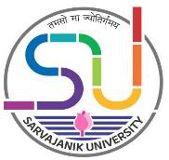

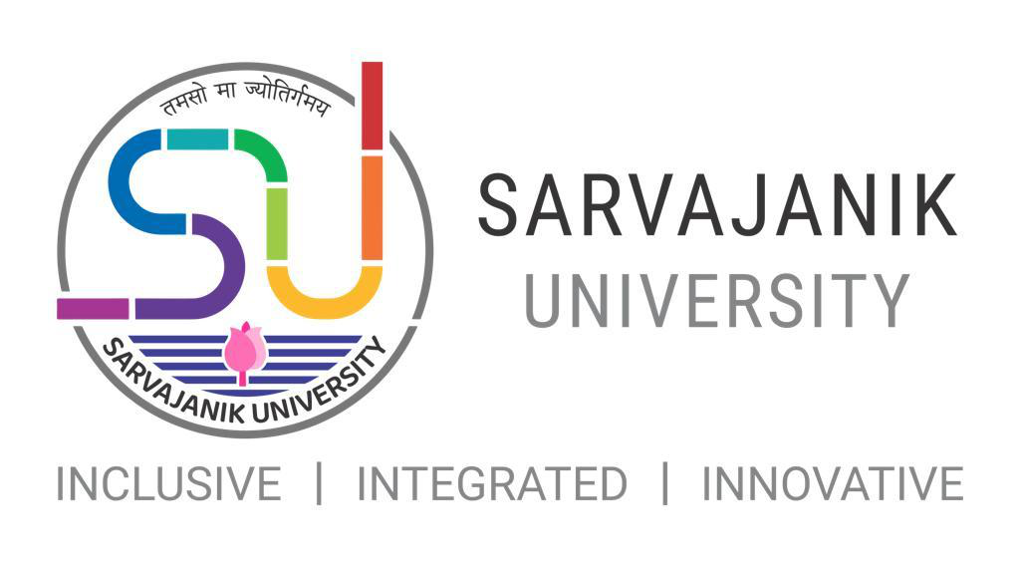

**Faculty of Science**

Shree Ramkrishna Institute of Computer Education &

Applied Sciences, Surat

**M.Sc. Information Technology**

1

**Master of Science Information Technology**  **SRKI** 

**Master of Science Information Technology 2021-22**

**Introduction:**   
This programme aims to develop critically informed, agile and resourceful graduates, who are prepared to adapt to future changes in information technology in the business context via a comprehensive understanding of fundamental theories and current practices.

The MSc IT examines issues, trends, current practices and technological alternatives in the field of business Information Technology and provides you with up-to-date technological and business skills, and specialist knowledge to help you design and/or implement appropriate, IT-driven solutions in ways that address the needs of modern business organisations.

The MSc IT provides a common foundation in IT for all students. This is then followed by a selection of modules which fall into two groups and depends upon your career goals and ambitions: a technical group (eg IOT, AR and VR etc.); or Info Security group (Cyber Security & Forensics, Blockchain,etc. ).

**Objective of Programme:**   
The Objective of the program is to impart knowledge of fundamentals and/or latest theories, concepts, methods, techniques and tools related to various areas of Computer Science, Applications and Information Technology and specifically in the area of Mobile based, cloud based, Web based Application Development, Software Engineering, Data Management and Intelligent Systems.

**Programme Outcome:**

At the successful completion of the program, students will be able to start their career in the IT and Software industry.

**Eligibility Criteria:**   
Any candidate who has passed-  
Bachelor’s degree in Computer Science / Computer Applications / Information Technology / Cyber Security/ Data Science / IoT / Bigdata / AI / Computer Engineering / Electronics Engineering / Electronics and Communication engineering or an equivalent examination OR   
The candidate who has passed equivalent exam from other subjects or boards need to avail eligibility certificate for this programme from the Board of Equivalence (BoE) of the   
Sarvajanik University.

2

**Master of Science Information Technology**  **SRKI** 

**Semester wise course group wise credit allocation for Post Graduate Programme (Annexure I)**

|  |  |  |  |  |  |  |  |  |  |
| --- | --- | --- | --- | --- | --- | --- | --- | --- | --- |
| **Semester** | **DSC** | | **SEC** | | **DSE** | | **Practical** | | **Total** |
| No. of  Courses | Credit | No. of  Courses | Credit | No. of  Course | Credit | No. of  Course | Credit |
| Th. | Th. | Th. |
| **1** | 2 | 8 | 1 | 4 | 1 | 4 | 1 | 8 | **24** |
| **2** | 2 | 8 | 1 | 4 | 1 | 4 | 1 | 8 | **24** |
| **3** | 2 | 8 | 1 | 4 | 1 | 4 | 1 | 8 | **24** |
| **4** | 2 | 16 | 1 | 4 | 1 | 4 | 1 | **-** | **24** |
| **Total** | **08** | **40** | **04** | **16** | **04** | **16** | **04** | **24** | **96** |

**Evaluation Scheme:**

|  |  |  |  |  |  |  |  |  |
| --- | --- | --- | --- | --- | --- | --- | --- | --- |
| **Semester** | **Subject group** | **Internal** | | | |  | **External** | **Grand Total** |
| **CCE** | **Attend.** | **Assign.** | **Internal Exam/**  **Viva-** **Voce** | **Total Int.** |
| 1 | DSC-1 | 40 | 10 | 20 |  | 70 | 30 | 100 |
| DSC-2 | 40 | 10 | 20 |  | 70 | 30 | 100 |
| SEC-1 | 40 | 10 | 20 |  | 70 | 30 | 100 |
| DSE-1 | 40 | 10 | 20 |  | 70 | 30 | 100 |
| Practical | 60 | 20 | - | 60 | 140 | 60 | 200 |
| **Total** | | | | | | **420** | **180** | **600** |
| 2 | DSC-3 | 40 | 10 | 20 |  | 70 | 30 | 100 |
| DSC-4 | 40 | 10 | 20 |  | 70 | 30 | 100 |
| SEC-2 | 40 | 10 | 20 |  | 70 | 30 | 100 |
| DSE-2 | 40 | 10 | 20 |  | 70 | 30 | 100 |
| Practical | 60 | 20 | - | 60 | 140 | 60 | 200 |
| **Total** | | | | | | **420** | **180** | **600** |
| 3 | DSC-5 | 40 | 10 | 20 |  | 70 | 30 | 100 |
| DSC-6 | 40 | 10 | 20 |  | 70 | 30 | 100 |
| SEC-3 | 40 | 10 | 20 |  | 70 | 30 | 100 |
| DSE-3 | 40 | 10 | 20 |  | 70 | 30 | 100 |
| Practical | 60 | 20 | - | 60 | 140 | 60 | 200 |
| **Total** | | | | | | **420** | **180** | **600** |
| 4 | DSC-7 | 150 | 50 | - | 150 | 350 | 150 | 500 |
| DSE-4 | 30 | 10 | - | 30 | 70 | 30 | 100 |
| **Total** | | | | | | **420** | **180** | **600** |

3

**Master of Science Information Technology**  **SRKI** 

**M.Sc.(IT) Programme subject list: (Annexure-2)**

|  |  |  |  |
| --- | --- | --- | --- |
| **Sem** | **Paper type** | **Paper No.** | **Paper Title** |
| 1 | Core course | DSC-1 | Fundamentals of Data Science |
| DSC-2 | Web Programming -1 |
| Skill Enhancement Course | SCE-1 | Advanced Database Technologies |
| Professional Elective | DSE-1 | 1. Cyber Security and Forensics-1  2. Web Engineering  3. Distributed and Parallel Computing 4. Foundation of Advanced Computing 5. Fundamentals of AI |
| 2 | Core course | DSC-1 | Mobile Application Development - 1 |
| DSC-2 | Web Programming -2 |
| Skill Enhancement Course | SCE-1 | Advanced Cloud Programming |
| Professional Elective | DSE-1 | 1. Cyber Security and Forensics-2 2. UI/UX development  3. Research in computing  4. Machine Learning  5. Advanced Python Programming |
| 3 | Core course | DSC-1 | Internet of Things |
| DSC-2 | Game Development |
| Skill Enhancement Course | SEC-1 | 1. Advanced JavaScript Framework 2. Data Visualization  3. Blockchain Technology  4. Computational Linguistic  5. Social Media Mining and Analytics |
| Professional Elective | DSE-1 | 1. Mobile Application Development - 2  2. Bigdata & Analytics  3. Artificial Neural Network and Deep Learning 4. Cyber Law and Practices |
| 4 | Core course | DSC-1 | Project / Dissertation |
| Skill Enhancement Course | SEC-2 | Seminar Presentation/Review of published research paper |

4

|  |  |
| --- | --- |
| **SRKI**  **Master of Science Information Technology** |  |

|  |  |  |  |  |  |  |  |  |  |  |  |
| --- | --- | --- | --- | --- | --- | --- | --- | --- | --- | --- | --- |
| Name of Program | | | | | **Master of Science [Information Technology]** | | | | | | |
| Abbreviation | | | | | M.Sc. IT | | | | | | |
| Duration | | | | | 2 Years | | | | | | |
| Objective of Program | | | | | The Objective of the program is to impart knowledge of fundamentals and/or latest theories, concepts, methods, techniques and tools related to various areas of Computer Science, Applications and Information Technology and specifically in the area of Mobile based, cloud based, Web based Application Development, Software Engineering, Data Management and Intelligent Systems. | | | | | | |
| Program Outcome | | | | | At the successful completion of the program, students will be able to start their career in the IT and Software  industry. | | | | | | |
| Program Structure | | | | |  | | | | | | |
| **Semester 1** | | | | | | | | | | | |
| **Course Code** | **Title** | | | **Teaching Hrs.**  **per week** | | **Course Credits** | **University**  **Examination** | | | **Internal Marks** | **Total**  **Marks** |
| **Theory** | **Practical** | **Marks** | **Duration** | | **Marks** |  |  |
|  | DCS-1 Fundamentals of Data science | | | 4 |  | 4 |  | | 30 | 70 | 100 |
|  | DSC-2 Web Programming -1 | | | 4 |  | 4 |  | | 30 | 70 | 100 |
|  | SEC - 1 Advanced Database Technologies | | | 4 |  | 4 |  | | 30 | 70 | 100 |
|  | DSE-1 Elective | | | 4 |  | 4 |  | | 30 | 70 | 100 |
|  | Practical | | |  | 16 | 8 |  | | 140 | 60 | 200 |
|  |  | | | 16 |  | 24 |  | |  |  | 600 |
| **NOTE:** |  | **ollowing s** | **ubjects are listed** | **as electi ELECT** | **ve subject IVE SUB** | **s of sem JECTS** | **ester.** |  |  |  |  |
|  |  | **1** | Cyber Security a | nd Foren | sics-1 |  |  |  |  |  |  |
|  |  | **2** | Web Engineering | g |  |  |  |  |  |  |  |
|  |  | **3** | Distributed and | Parallel C | omputing |  |  |  |  |  |  |
|  |  | **4** | Foundation of A | dvanced | Computin | g |  |  |  |  |  |
|  |  | **5** | Fundamentals of | AI |  |  |  |  |  |  |  |
|  | | | | | | | | | | | |
|  | | | | | | | | | | | |

5

|  |  |
| --- | --- |
| **SRKI**  **Master of Science Information Technology** |  |

|  |  |  |  |  |  |  |  |  |
| --- | --- | --- | --- | --- | --- | --- | --- | --- |
| **Semester 2** | | | | | | | | |
| **Course Code** | **Title** | **Teaching Hrs.**  **per week** | | **Course Credits** | **University**  **Examination** | | **Internal Marks** | **Total**  **Marks** |
|  |  | **Theory** | **Practical** | **Marks** | **Duration** | **Marks** |  |  |
|  | DSC-3 Mobile Application Development - 1 | 4 |  | 4 |  | 30 | 70 | 100 |
|  | DSC-4 Web Programming -2 NodeJS | 4 |  | 4 |  | 30 | 70 | 100 |
|  | SEC-2 Advanced Cloud Programming | 4 |  | 4 |  | 30 | 70 | 100 |
|  | DSE-2 Elective | 4 |  | 4 |  | 30 | 70 | 100 |
|  | Practical-1 |  | 16 | 8 |  | 140 | 60 | 200 |
|  |  | 16 |  | 24 |  |  |  | 600 |
| **NOTE: Following subjects are listed as elective subjects of semester.**  **ELECTIVE SUBJECTS**   |  |  | | --- | --- | | **1** | Cyber Security and Forensics-2 | | **2** | UI/UX development | | **3** | Research in computing | | **4** | Machine Learning | | **5** | Advanced Python Programming | | | | | | | | | |

6