**Master of Science Web and Mobile Technology**  **SRKI** 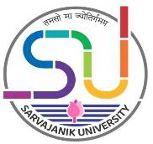

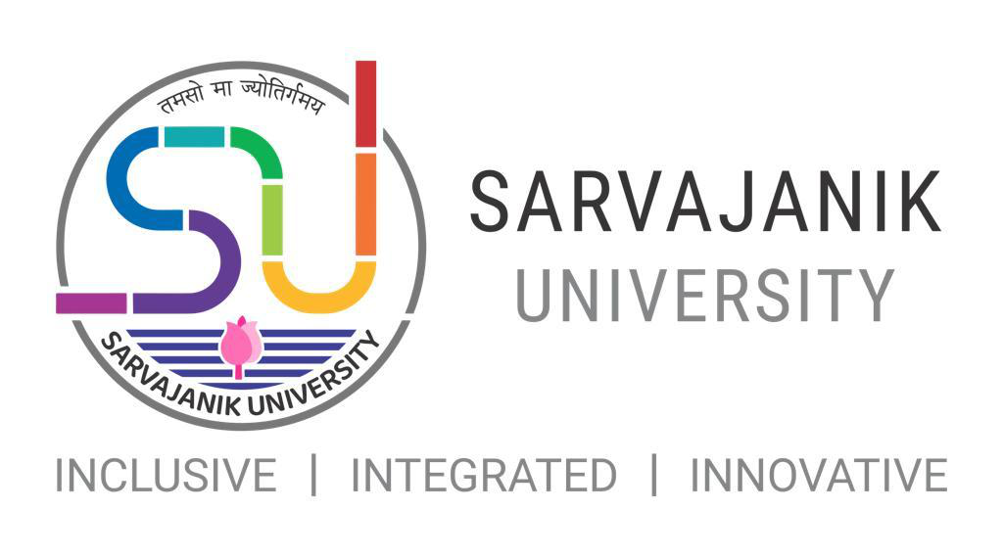

**Faculty of Science**

Shree Ramkrishna Institute of Computer

Education & Applied Sciences, Surat

**M.Sc. Web and Mobile Technology**

1

**Master of Science Web and Mobile Technology**  **SRKI** 

**Master of Science Web and Mobile Technology 2021-22**

**Introduction:**

MSc Web and Mobile Development Technology is aimed at providing firm grounding in strategic web development skills, with a specific focus on mobile development and user experience.

The programme aims to empower you to understand the current shape of emerging technologies in web, mobile and cloud and to develop lifelong learning skills.

This programme focuses on mobile development and web development skills needed to succeed in the cutting edge of technology. You will study the core skills required to gain a deep understanding of contemporary web and mobile development, industry practice and analysis which forms the basis of next generation technologies.

**Objective of the Programme:**

The Objective of the programme is to impart knowledge of fundamentals and/or latest theories, concepts, methods, techniques and tools related to various areas of web and mobile Applications specifically in the area of Mobile based, cloud based, Web based Application Development.

**Program Outcome:**

At the successful completion of the program, students will be able to start their career in the field of web and mobile application development in the Software industry.

**Eligibility Criteria:**

Any candidate who has passed-  
Bechlor’s degree in Computer Science / Computer Applications / Information Technology / Cyber Security/ Data Science / IoT / Bigdata / AI / Computer Engineering / Electronics Engineering / Electronics and Communication engineering or an equivalent examination. OR The candidate who has passed equivalent exam from other subjects or boards need to avail eligibility certificate for this programme fromthe Board of Equivalence (BoE) of the Sarvajanik University.

2

**Master of Science Web and Mobile Technology**  **SRKI** 

**Semester wise course group wise credit allocation for Post Graduate Programme**

**(Annexure I)**

|  |  |  |  |  |  |  |  |  |  |
| --- | --- | --- | --- | --- | --- | --- | --- | --- | --- |
| **Semester** | **DSC** | | **SEC** | | **DSE** | | **Practical** | | **Total** |
| No. of  Courses | Credit | No. of  Courses | Credit | No. of Course | Credit | No. of  Course | Credit |
| Th. | Th. | Th. |
| **1** | 2 | 8 | 1 | 4 | 1 | 4 | 1 | 8 | **24** |
| **2** | 2 | 8 | 1 | 4 | 1 | 4 | 1 | 8 | **24** |
| **3** | 2 | 8 | 1 | 4 | 1 | 4 | 1 | 8 | **24** |
| **4** | 2 | 16 | 1 | 4 | 1 | 4 | 1 | **-** | **24** |
| **Total** | **08** | **40** | **04** | **16** | **04** | **16** | **04** | **24** | **96** |

**Evaluation Scheme:**

|  |  |  |  |  |  |  |  |  |
| --- | --- | --- | --- | --- | --- | --- | --- | --- |
| **Semester** | **Subject group** | **Internal** | | | |  | **External** | **Grand Total** |
| **CCE** | **Attend.** | **Assign.** | **Internal Exam/**  **Viva-** **Voce** | **Total Int.** |
| 1 | DSC-1 | 40 | 10 | 20 |  | 70 | 30 | 100 |
| DSC-2 | 40 | 10 | 20 |  | 70 | 30 | 100 |
| SEC-1 | 40 | 10 | 20 |  | 70 | 30 | 100 |
| DSE-1 | 40 | 10 | 20 |  | 70 | 30 | 100 |
| Practical | 60 | 20 | - | 60 | 140 | 60 | 200 |
| **Total** | | | | | | **420** | **180** | **600** |
| 2 | DSC-3 | 40 | 10 | 20 |  | 70 | 30 | 100 |
| DSC-4 | 40 | 10 | 20 |  | 70 | 30 | 100 |
| SEC-2 | 40 | 10 | 20 |  | 70 | 30 | 100 |
| DSE-2 | 40 | 10 | 20 |  | 70 | 30 | 100 |
| Practical | 60 | 20 | - | 60 | 140 | 60 | 200 |
| **Total** | | | | | | **420** | **180** | **600** |
| 3 | DSC-5 | 40 | 10 | 20 |  | 70 | 30 | 100 |
| DSC-6 | 40 | 10 | 20 |  | 70 | 30 | 100 |
| SEC-3 | 40 | 10 | 20 |  | 70 | 30 | 100 |
| DSE-3 | 40 | 10 | 20 |  | 70 | 30 | 100 |
| Practical | 60 | 20 | - | 60 | 140 | 60 | 200 |
| **Total** | | | | | | **420** | **180** | **600** |
| 4 | DSC-7 | 150 | 50 | - | 150 | 350 | 150 | 500 |
| DSE-4 | 30 | 10 | - | 30 | 70 | 30 | 100 |
| **Total** | | | | | | **420** | **180** | **600** |

3

**Master of Science Web and Mobile Technology**  **SRKI** 

**M.Sc. WMT Programme subject list: (Annexure-2)**

|  |  |  |  |
| --- | --- | --- | --- |
| **Sem** | **Paper type** | **Paper No.** | **Paper Title** |
| 1 | Core course | DSC-1 | Fundamentals of Data Science |
| DSC-2 | Web Programming -1 |
| Skill Enhancement Course | SCE-1 | Advanced Database Technologies |
| Professional Elective | DSE-1 | 1. Cyber Security and Forensics-1  2. Web Engineering  3. Distributed and Parallel Computing 4. Foundation of Advanced Computing 5. Fundamentals of AI |
| 2 | Core course | DSC-3 | Mobile Application Development - 1 |
| DSC-4 | Web Programming -2 |
| Skill Enhancement Course | SCE-2 | Advanced Cloud Programming |
| Professional Elective | DSE-2 | 1. Cyber Security and Forensics-2 2. UI/UX development  3. Research in computing  4. Machine Learning  5. Advanced Python Programming |
| 3 | Core course | DSC-5 | Mobile Application Development - 2 |
| DSC-6 | Advance JavaScript Frameworks |
| Skill Enhancement Course | SEC-3 | 1. Data Visualization  2. Blockchain Technology  3. Computational Linguistic  4. Social Media Mining and Analytics 5. Game Development |
| Professional Elective | DSE-3 | 1. Bigdata & Analytics  2. Artificial Neural Network and Deep Learning 3. Internet of Things  4. Cyber Law and Practices |
| 4 | Core course | DSC-7 | Project / Dissertation |
| Professional Elective | DSE-4 | Seminar Presentation/Review of published research paper |

4

|  |  |
| --- | --- |
| **SRKI**  **Master of Science Web and Mobile Technology** |  |

|  |  |  |  |  |  |  |  |  |  |  |  |
| --- | --- | --- | --- | --- | --- | --- | --- | --- | --- | --- | --- |
| Name of Program | | | | | **Master of Science Web and Mobile Technology** | | | | | | |
| Abbreviation | | | | | M.Sc. WMT | | | | | | |
| Duration | | | | | 2 Years | | | | | | |
| Objective of Program | | | | | The Objective of the program is to impart knowledge of fundamentals and/or latest theories, concepts, methods, techniques and tools related to various areas of web and mobile Applications specifically in the area of Mobile based, cloud based, Web based Application Development. | | | | | | |
| Program Outcome | | | | | At the successful completion of the program, students will be able to start their career in the field of web and mobile application development in the Software  industry. | | | | | | |
| Program Structure | | | | |  | | | | | | |
| **Semester 1** | | | | | | | | | | | |
| **Course Code** | **Title** | | | **Teaching Hrs.**  **per week** | | **Course Credits** | **University**  **Examination** | | **Internal Marks** | | **Total**  **Marks** |
| **Theory** | **Practical** |  | **Dura tion** | **Marks** |  | |  |
|  | DCS-1  Fundamentals of Data science | | | 4 |  | 4 |  | 30 | 70 | | 100 |
|  | DSC-2 Web  Programming -1 | | | 4 |  | 4 |  | 30 | 70 | | 100 |
|  | SEC - 1  Advanced  Database  Technologies | | | 4 |  | 4 |  | 30 | 70 | | 100 |
|  | DSE-1 Elective | | | 4 |  | 4 |  | 30 | 70 | | 100 |
|  | Practical | | |  | 16 | 8 |  | 140 | 60 | | 200 |
|  |  | | | 16 |  | 24 |  |  |  | | 600 |
| **NOTE:** |  | **ollowing s** | **ubject** | **s are list**  **EL** | **ed as electi ECTIVE S** | **ve subje**  **UBJECT** | **cts of s S** | **mester.** |  |  |  |
|  |  | **1** | Cybe | r Securit | y and Foren | sics-1 |  |  |  |  |  |
|  |  | **2** | Web | Enginee | ring |  |  |  |  |  |  |
|  |  | **3** | Distr | ibuted an | d Parallel C | omputin | g |  |  |  |  |
|  |  | **4** | Foun | dation of | Advanced | Computi | ng |  |  |  |  |
|  |  | **5** | Fund | amentals | of AI |  |  |  |  |  |  |

5

|  |  |
| --- | --- |
| **SRKI**  **Master of Science Web and Mobile Technology** |  |

|  |  |  |  |  |  |  |  |  |
| --- | --- | --- | --- | --- | --- | --- | --- | --- |
|  | | | | | | | | |
| **Semester 2** | | | | | | | | |
| **Course Code** | **Title** | **Teaching Hrs.**  **per week** | | **Course Credits** | **University Examinatio n** | | **Internal Marks** | **Total**  **Marks** |
|  |  | **Theory** | **Practical** |  | **Dura tion** | **Marks** |  |  |
|  | DSC-3 Mobile  Application  Development – 1 | 4 |  | 4 |  | 30 | 70 | 100 |
|  | DSC-4 Web  Programming - 2 | 4 |  | 4 |  | 30 | 70 | 100 |
|  | SEC-2 Advanced Cloud  Programming | 4 |  | 4 |  | 30 | 70 | 100 |
|  | DSC-2 Elective | 4 |  | 4 |  | 30 | 70 | 100 |
|  | Practical |  | 16 | 8 |  | 140 | 60 | 200 |
|  |  | 16 |  | 24 |  |  |  | 600 |
| **NOTE: Following subjects are listed as elective subjects of semester.**  **ELECTIVE SUBJECTS**   |  |  | | --- | --- | | **1** | Cyber Security and Forensics-2 | | **2** | UI/UX development | | **3** | Research in computing | | **4** | Machine Learning | | **5** | Advanced Python Programming | | | | | | | | | |

6