**Line chart**

# Create Line Chart  
  
# convert factor to numeric for convenience  
Orange$Tree <- as.numeric(Orange$Tree)  
ntrees <- max(Orange$Tree)  
  
# get the range for the x and y axis  
xrange <- range(Orange$age)  
yrange <- range(Orange$circumference)  
  
# set up the plot  
plot(xrange, yrange, type="n", xlab="Age (days)",  
 ylab="Circumference (mm)" )  
colors <- rainbow(ntrees)  
linetype <- c(1:ntrees)  
plotchar <- seq(18,18+ntrees,1)  
  
# add lines  
for (i in 1:ntrees) {  
 tree <- subset(Orange, Tree==i)  
 lines(tree$age, tree$circumference, type="b", lwd=1.5,  
 lty=linetype[i], col=colors[i], pch=plotchar[i])  
}  
  
# add a title and subtitle  
title("Tree Growth", "example of line plot")  
  
# add a legend  
legend(xrange[1], yrange[2], 1:ntrees, cex=0.8, col=colors,  
 pch=plotchar, lty=linetype, title="Tree")

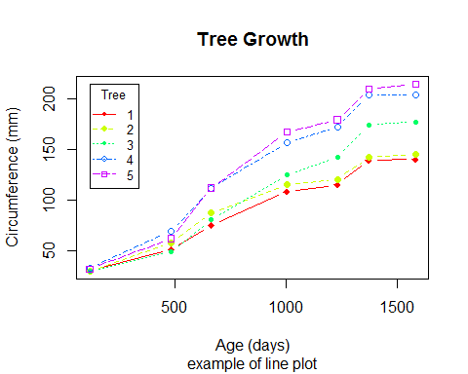

A line chart displays how quantitative values have changed over time for different categorical items.

Above plot shows the growth of 5 orange trees over time. Each tree will have its own distinctive line. The data come from the dataset Orange(inbuilt in R).

**Area Chart**

# basic area chart  
ggplot(economics, aes(x = date, y = psavert)) +  
 geom_area(fill="lightblue", color="black") +  
 labs(title = "Personal Savings Rate",  
 x = "Date",  
 y = "Personal Savings Rate")

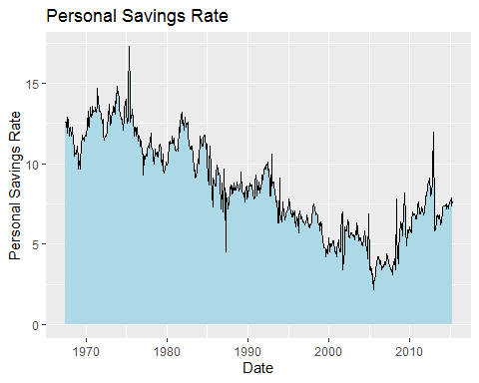

A simple area chart is basically a line graph, with a fill from the line to the x-axis.

**stacked area chart**

# stacked area chart  
data(uspopage, package = "gcookbook")  
ggplot(uspopage, aes(x = Year,  
 y = Thousands/1000,   
 fill = forcats::fct_rev(AgeGroup))) +  
 geom_area(color = "black") +  
 labs(title = "US Population by age",  
 subtitle = "1900 to 2002",  
 caption = "source: U.S. Census Bureau, 2003, HS-3",  
 x = "Year",  
 y = "Population in Millions",  
 fill = "Age Group") +  
 scale_fill_brewer(palette = "Set2") +  
 theme_minimal()

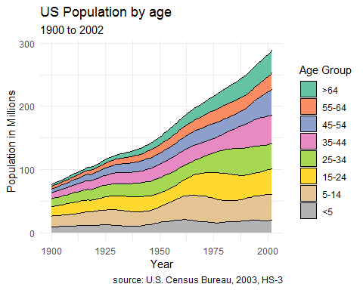

A stacked area chart can be used to show differences between groups over time. Consider the uspopage dataset from the gcookbook package. We’ll plot the age distribution of the US population from 1900 and 2002.

Apparently, the number of young children have not changed very much in the past 100 years.

Stacked area charts are most useful when interest is on both (1) group change over time and (2) overall change over time. Place the most important groups at the bottom. These are the easiest to interpret in this type of plot.

**Bump Chart**

df=read.csv("bump_chart.csv")  
#df  
library(reshape2)  
library(ggplot2)  
df$Horse <- with(df, reorder(Horse, Finish))  
  
  
dfm <- melt(df)

## Using Horse as id variables

p <- ggplot(dfm, aes(variable, value,  
 group = Horse, colour = Horse, label = Horse))  
p1 <- p + geom_line(size=2) + geom_text(data = subset(dfm,variable == "Finish"), size=6,   
 aes(x = variable, hjust = -0.1))  
  
labels <- c(expression(1/4), expression(1/2),  
 expression(3/4), "1m", "Str", "Finish",  
 "")  
  
p1 + theme_bw() + theme(legend.position = "none", panel.border = element_blank(), axis.ticks = element_blank()) +  
 scale_x_discrete(breaks = c(levels(dfm$variable), ""), labels = labels) +   
 scale_y_continuous(breaks = NULL,trans = "reverse") + xlab(NULL) + ylab(NULL)+  
 theme(axis.text=element_text(size=21))

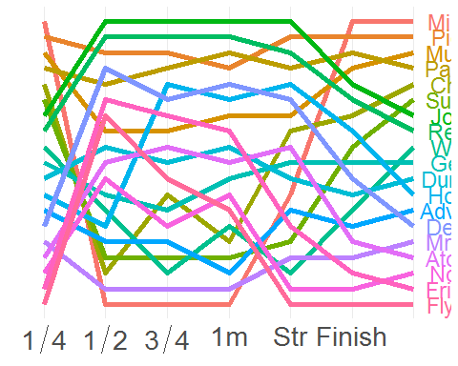

Bump chart is an alternative to Line chart.  
A Bump Chart is a special form of a line plot designed for exploring changes in rank over time.  
This chart helps compare the position / performance / ranking of multiple observations rather than the actual values itself

**slope graph**

library(knitr)  
library(dplyr)

##   
## Attaching package: 'dplyr'

## The following objects are masked from 'package:stats':  
##   
## filter, lag

## The following objects are masked from 'package:base':  
##   
## intersect, setdiff, setequal, union

library(CGPfunctions)

## Registered S3 methods overwritten by 'lme4':  
## method from  
## cooks.distance.influence.merMod car   
## influence.merMod car   
## dfbeta.influence.merMod car   
## dfbetas.influence.merMod car

library(gapminder)  
 library(magrittr)  
 # Select Central American countries data   
 # for 1992, 1997, 2002, and 2007  
   
 df <- filter(gapminder,year %in% c(1992, 1997, 2002, 2007) &  
 country %in% c("Panama", "Costa Rica",   
 "Nicaragua", "Honduras",   
 "El Salvador", "Guatemala",  
 "Belize")) %>%  
 mutate(year = factor(year,ordered = TRUE),  
 lifeExp = round(lifeExp))  
   
   
   
# create slope graph  
#   
 newggslopegraph(df, year, lifeExp, country) +  
 labs(title="Life Expectancy by Country",   
 subtitle="Central America",   
 caption="source: gapminder")

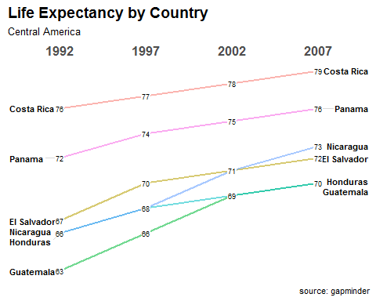

When there are several groups and several time points, a slope graph can be helpful. Aove plot Shows life expectancy for six Central American countries in 1992, 1997, 2002, and 2007

**streamgraph**

library(streamgraph)  
library(dplyr)  
  
data <- data.frame(  
 year=rep(seq(1990,2016) , each=10),  
 name=rep(letters[1:10] , 27),  
 value=sample( seq(0,1,0.0001) , 270)  
)  
  
pp <- streamgraph(data, key="name", value="value", date="year", height="300px", width="1000px")  
pp

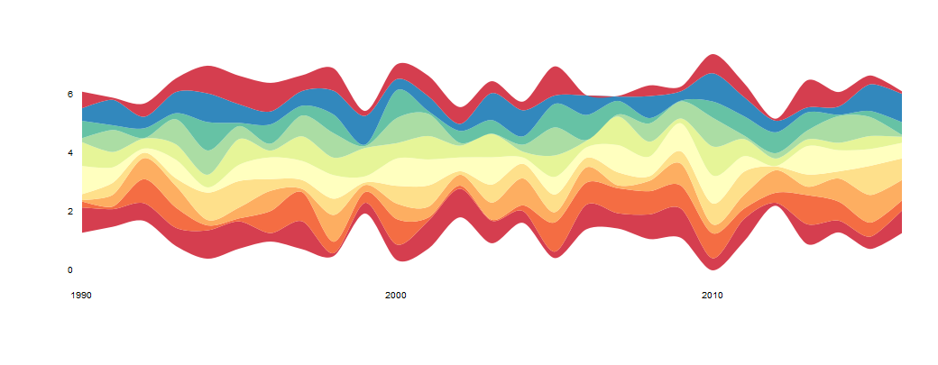

Stream Graphs display the changes in data over time of different category items.

**connected scatter plot**

Connected scatter plot is an extension of joined version of line chart and scatter plot.

library(tidyverse)

## -- Attaching packages ----------------------------------------------------------------------- tidyverse 1.3.0 --

## v tibble 2.1.3 v purrr 0.3.3  
## v tidyr 1.0.2 v stringr 1.4.0  
## v readr 1.3.1 v forcats 0.5.0

## -- Conflicts -------------------------------------------------------------------------- tidyverse_conflicts() --  
## x tidyr::extract() masks magrittr::extract()  
## x dplyr::filter() masks stats::filter()  
## x dplyr::lag() masks stats::lag()  
## x purrr::set_names() masks magrittr::set_names()

library(hrbrthemes)

## NOTE: Either Arial Narrow or Roboto Condensed fonts are required to use these themes.

## Please use hrbrthemes::import_roboto_condensed() to install Roboto Condensed and

## if Arial Narrow is not on your system, please see https://bit.ly/arialnarrow

#library(plotly)  
library(patchwork)  
library(babynames)  
library(viridis)

## Loading required package: viridisLite

# Load dataset from github  
data <- read.table("https://raw.githubusercontent.com/holtzy/data_to_viz/master/Example_dataset/3_TwoNumOrdered.csv", header=T)  
data$date <- as.Date(data$date)  
  
# Plot  
data %>%  
 tail(10) %>%  
 ggplot( aes(x=date, y=value)) +  
 geom_line(color="#69b3a2") +  
 geom_point(color="#69b3a2", size=4) +  
 ggtitle("Evolution of Bitcoin price") +  
 ylab("bitcoin price ($)") +  
 theme_ipsum()

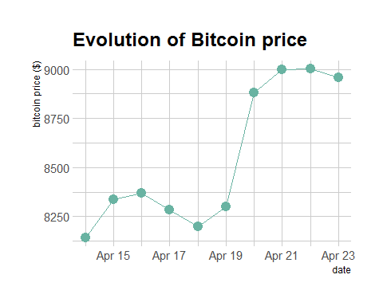

**Gantt chart**

library(plotrix)  
Ymd.format<-"%Y/%m/%d"  
gantt.info<-list(labels=c("Contract Preparation","Rapid Literature Review","CITI Training","IRB Addendum & Inclusion","Data Download","Data Analysis","Data Products"),  
 starts=as.POSIXct(strptime(c("2014/06/01","2014/06/04","2014/06/07","2014/06/19","2014/06/29","2014/07/01","2014/07/23"),  
 format=Ymd.format)),  
 ends=as.POSIXct(strptime(c("2014/06/16","2014/06/19","2014/06/17","2014/06/29","2014/07/02","2014/07/22","2014/08/05"),  
 format=Ymd.format)),  
 priorities=c(1,4,3,2,3,2,1))  
  
  
  
months <- seq(as.Date("2014/06/01", "%Y/%m/%d"), by="month", length.out=8)  
monthslab <- format(months, format="%b")  
  
vgridpos<-as.POSIXct(months,format=Ymd.format)  
vgridlab<-monthslab  
  
colfunc <- colorRampPalette(c("red", "darkgoldenrod1"))  
  
timeframe <- as.POSIXct(c("2014/06/01","2014/09/01"),format=Ymd.format)  
  
  
  
gantt.chart(gantt.info, taskcolors=colfunc(4),xlim=timeframe, main="Gantt Chart for Fieldwork 2014",  
 priority.legend=TRUE,vgridpos=vgridpos,vgridlab=vgridlab,hgrid=TRUE)

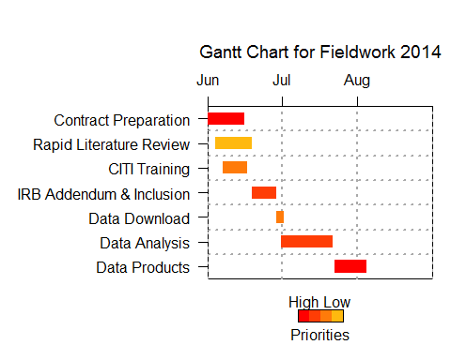

Gantt chart is used to visualize sub-tasks/sub-events of an event or a project over time.