End Sem: Data Visualization

Sagar Kumar

**waffle chart using ggplot**

library(ggplot2)  
data("mpg")  
var <- mpg$class #class is categorical data (eg:- 2seater,compact)  
nrows=10  
df <- expand.grid(y = 1:nrows, x = 1:nrows)  
# 'expand. grid' creates a data frame that is the cartesian product of its arguments.  
  
categ_table <- round(table(var) * ((nrows*nrows)/(length(var))))  
  
  
df$category <- as.factor(rep(names(categ_table), categ_table))   
  
  
  
   
theme<-theme(plot.title=element_text(size=15,   
 face="bold",   
 hjust=0.5,  
 lineheight=1.2),  
 plot.subtitle=element_text(size=10,   
 face="bold",  
 hjust=0.5),   
 plot.caption=element_text(size=8),   
 axis.title.x=element_text(size=15),   
 axis.title.y=element_text(size=15),   
 axis.text.x=element_text(size=8),   
 axis.text.y=element_text(size=8))   
  
  
ggplot(df, aes(x = x, y = y, fill = category)) +   
 geom_tile(color = "black", size = 0.5) +  
 labs(title="Waffle Chart", subtitle="'Class' of vehicles",  
 caption="Source: mpg (1 cell represents 1%)") +theme

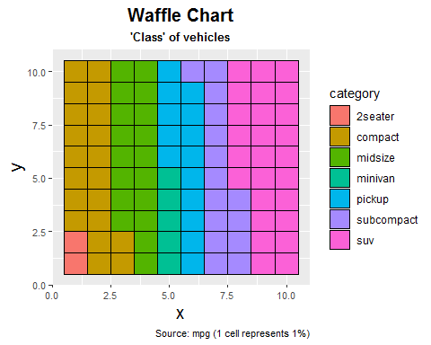

**Waffle chart Using Library(waffle)**

library(waffle)  
library(extrafont)  
data("mpg")  
var <- mpg$class   
parts<-c(two_seater=2,compact=20,midsize=18,minivan=5,pickup=14,subcompact=15,suv=26 )  
waffle(parts,rows=10,colors=rainbow(7),title="Waffle Chart",legend_pos ="right")

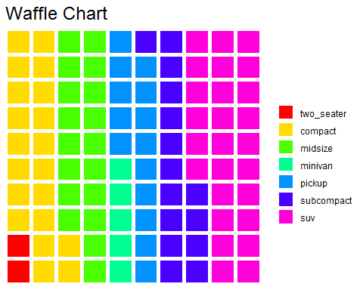

**Pie Chart**

library(ggplot2)  
data("mpg")  
var <- mpg$class  
#table(var)  
freq<-c(5,47,41,11,33,35,62)  
class<-c('2seater','compact' ,'midsize','minivan','pickup','subcompact', 'suv' )  
percent<-round(freq/sum(freq)*100)  
#percent  
lbls <- paste(class, percent) # add percents to labels  
#lbls  
lbls <- paste(lbls,"%",sep="") # ad % to labels  
#lbls  
pie(freq,labels = lbls, col=rainbow(length(lbls)),main="Pie Chart ")

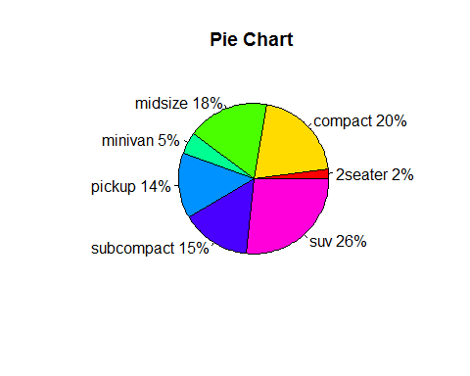

**Comparison between waffle and pie Chart**

**Pie v/s waffle** Pie charts is not the best way to present data because pie chart forces us to compare angles, which is pretty hard for human.

Waffle Chart is 10x10 grid in which each cell represents one percentage point. So, a block of 10 highlighted cells represents 10% of whole data and in waffle chart we can easily counts cell.

And from above figure we can easily visualize waffle chart compare to pie chart.

**About Waffle Chart :**

1.Waffle charts is a nice way of showing the categorical composition of the total population.

2.Waffle charts are an effective alternative to other proportional chart styles(eg: Pie Chart).

3.Waffle Charts are a form of pie charts that use squares instead of circles to represent percentages.

4.They are usually 10x10 grids,and each grid represents 1% of total population .

5.Waffle Charts are a form of pie charts that use squares instead of circles to represent percentages They are usually 10x10 grids.

6.Square pie chart (Waffle chart), showing how smaller percentages are more easily shown than on circular charts. On the 10x10 grid, each cell represents 1%.

7.There is a grid of small cells, of which coloured cells represent the data. A chart can consist of one category or several categories.

**Questions and Answers**

**Q1 What the Waffle Charts Dispaly?**

Ans:

Waffle chart is a 10 X 10 cell grid in which each cell represents 1 percentage point summing up to total 100%,Waffle chart can consist of one category or several categories.

The waffle chart is a chart in the shape of a square with small squares inside the big square. It is used to show the percentage of a certain category compared to all the categories. The waffle chart is a great alternative to the pie chart.

it’s typically made with 100 squares representing the whole, it can be shaded or filled based on the relation of several parts to a whole, just like a pie chart, but it’s also good for displaying a single percentage.

**Q2 What are the advantages and disadantages of waffle chart?**

Ans: **Advantages**  
With a Waffle chart, you get a more better view of the data

Makes analysis more quantitative. This is because, in a waffle chart, we count cells instead of angle and area.

The key pro is its diversity in being able to show individual parts of a whole and compare single percentages.

**Disadvantages**

When KPI(Key Performance Indicator) being measured could exceed 100%.

When exact percentages are vital, as showing fraction of a percent is more difficult to see beyond a rough approximation.

The cons are that it becomes too complicated when too many segments are involved, and the individualized spaces don’t leave a good spot to put numbers or much text within the visual itself.

**Q3 Is there any possibility to enhance visual information by using additional attributes**  
Ans: We can enhance Visual information by conditional formatting where cells are highlighted with different colors based on the percentage value of that KPI

**Q4 Is there any Variant of Waffle Chart.?**  
Ans:pie chart.