API Node (Public subnet):

DNS: ec2-54-183-218-250.us-west-1.compute.amazonaws.com

Public IP: 54.183.218.250

Private IP: 10.0.2.115

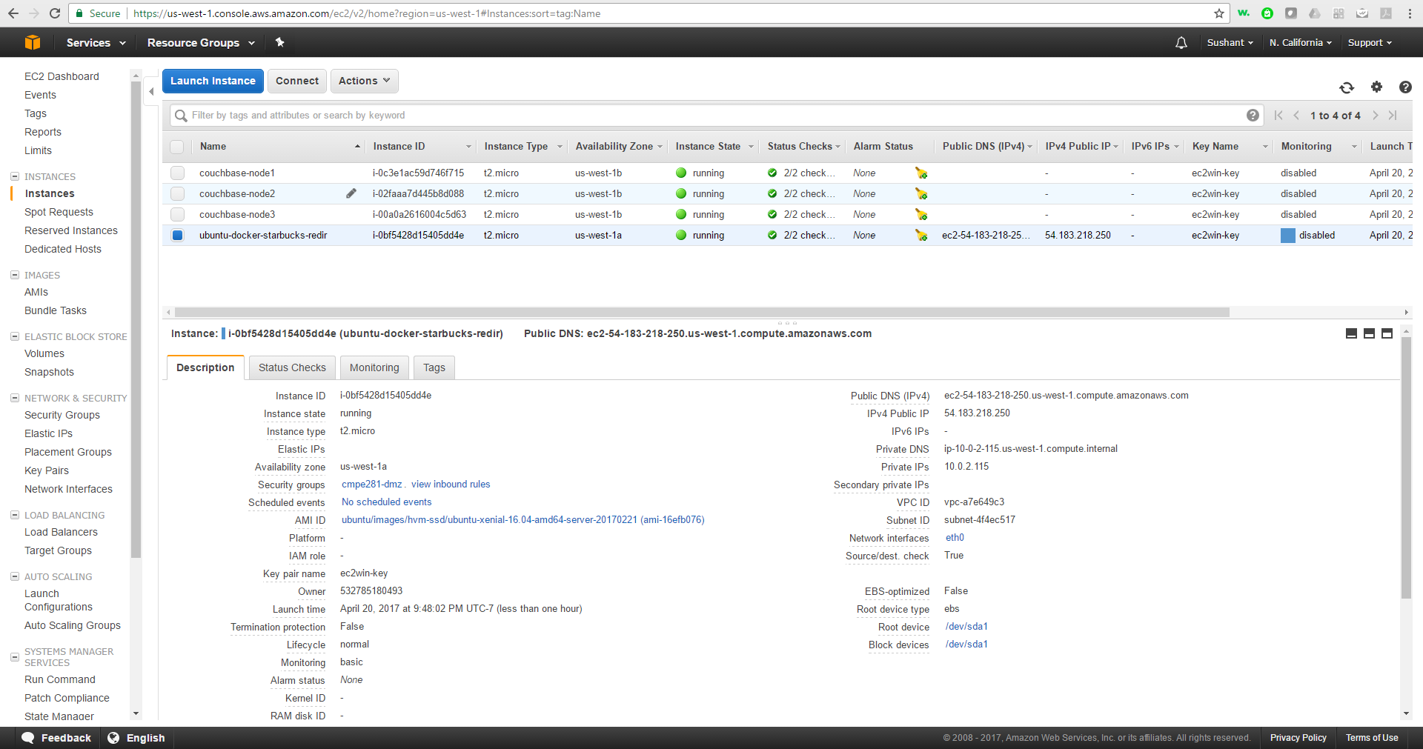

Couch base replicas (Private subnet):

couchbase-node1: 10.0.1.68

couchbase-node2: 10.0.1.167

couchbase-node3: 10.0.1.231

1

Get into couchbase-node1(in private subnet) via Starbucks API node (in public subnet):

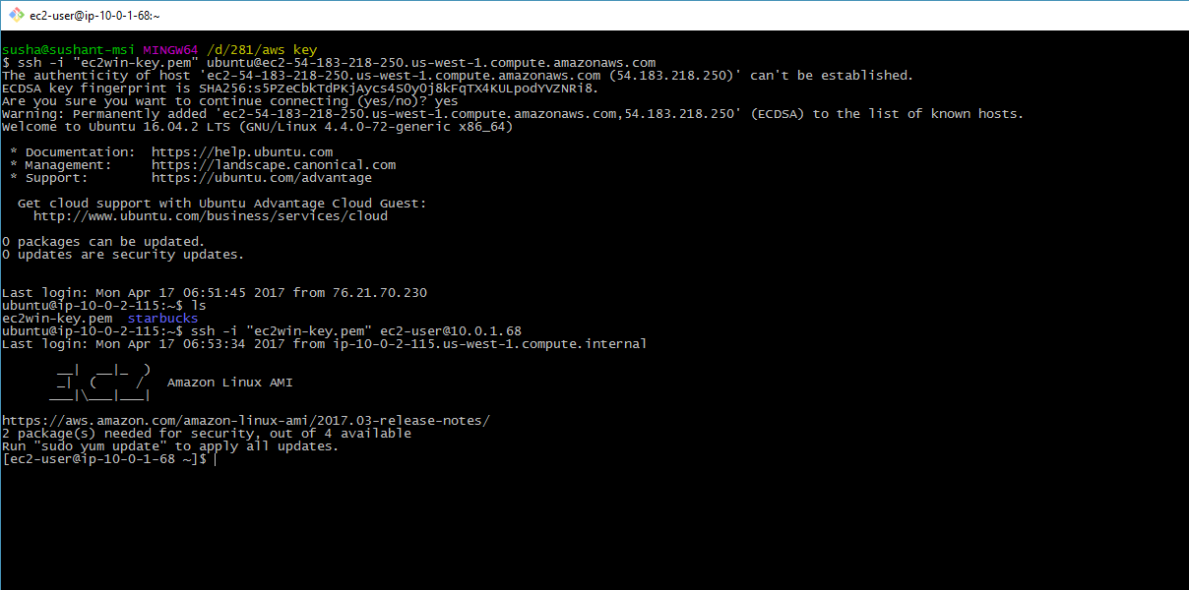

Start Couchbase server:

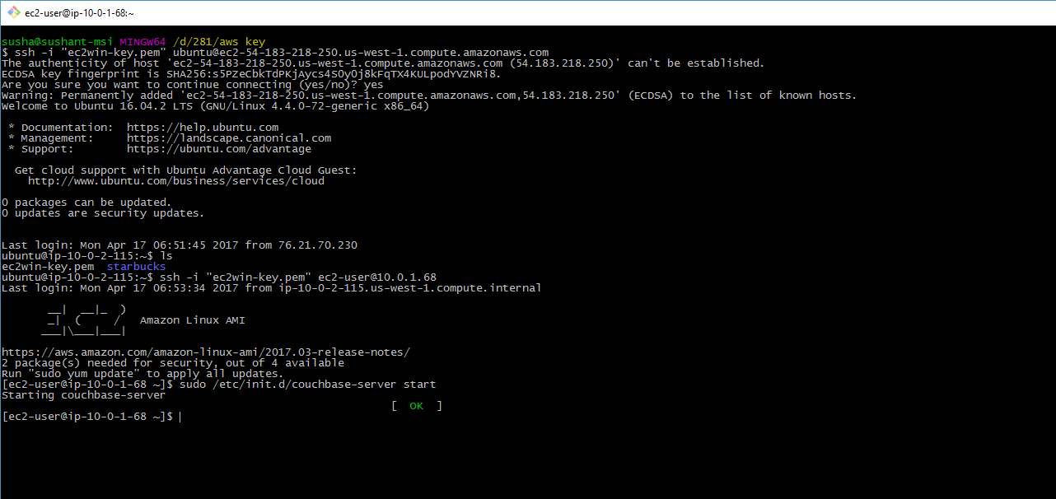

Since we cannot access couchbase console reason being node being in the private subnet we can expose the port to get the traffic redirected to it from the public subnet node (API node) by using ‘redir’

PS: We can also do this using couchbase-cli tool.

Couchbase console runs on port 8091, we can expose this using redir on API node:

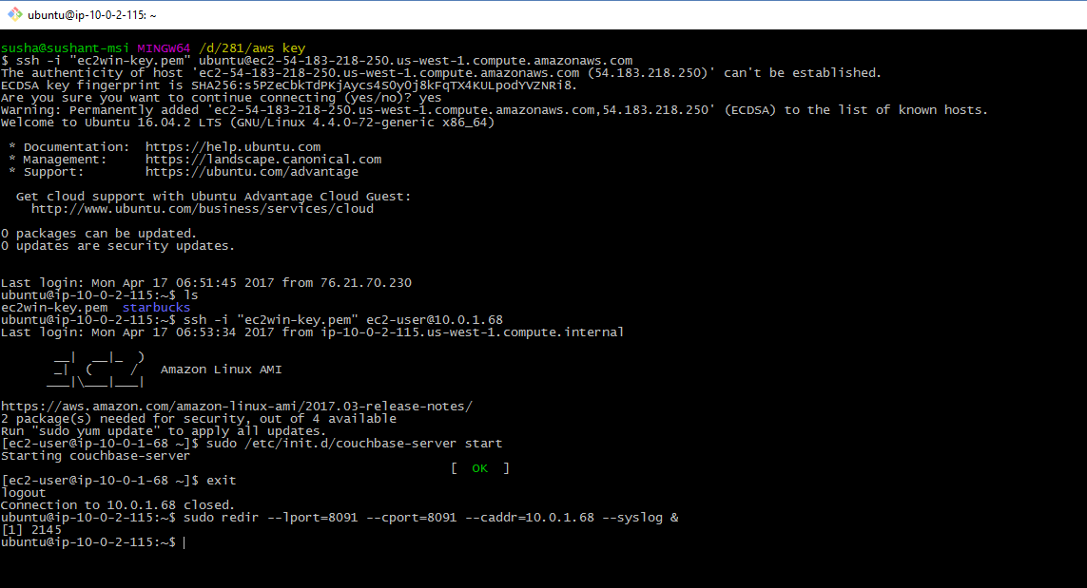

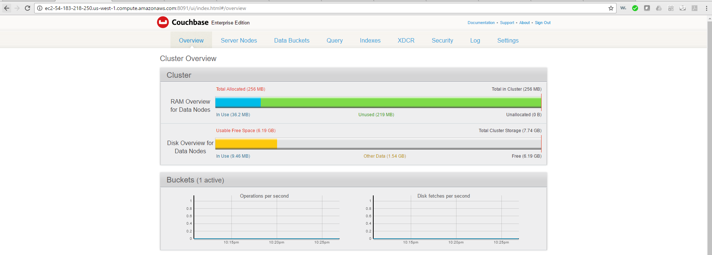

PS: It is not recommended to expose private subnet’s ports to public, once your couchbase setup is done we must close the exposed ports.

Start couchbase service on node 2 and 3:

Expose console port for these new 2 nodes by running below command on the API node:

sudo redir --lport=8092 --cport=8091 --caddr=10.0.1.167 --syslog &

sudo redir --lport=8093 --cport=8091 --caddr=10.0.1.231 --syslog &

Create bucket using couchbase-cli:

couchbase-cli bucket-create -c 127.0.0.1:8091 -u Administrator -p password --bucket=starbucks --bucket-type=couchbase --bucket-port=11222 --bucket-ramsize=200 --bucket-replica=2

add these two nodes as replica using below command:

couchbase-cli rebalance -c 10.0.1.68:8091 --server-add=10.0.1.167 -u Administrator -p password --server-add-username=Administrator --server-add-password=password

couchbase-cli rebalance -c 10.0.1.68:8091 --server-add=10.0.1.231 -u Administrator -p password --server-add-username=Administrator --server-add-password=password

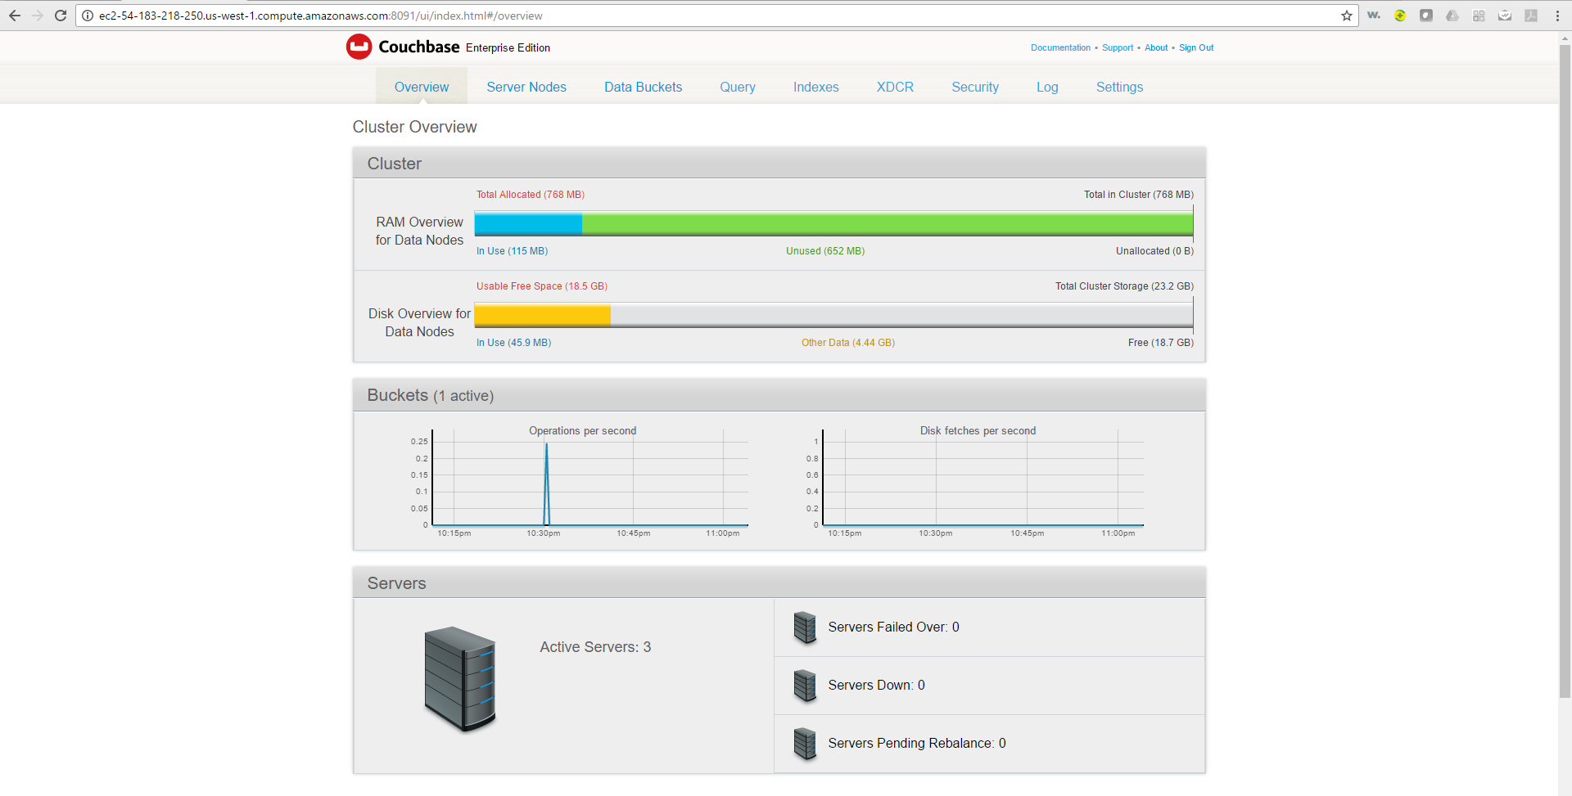

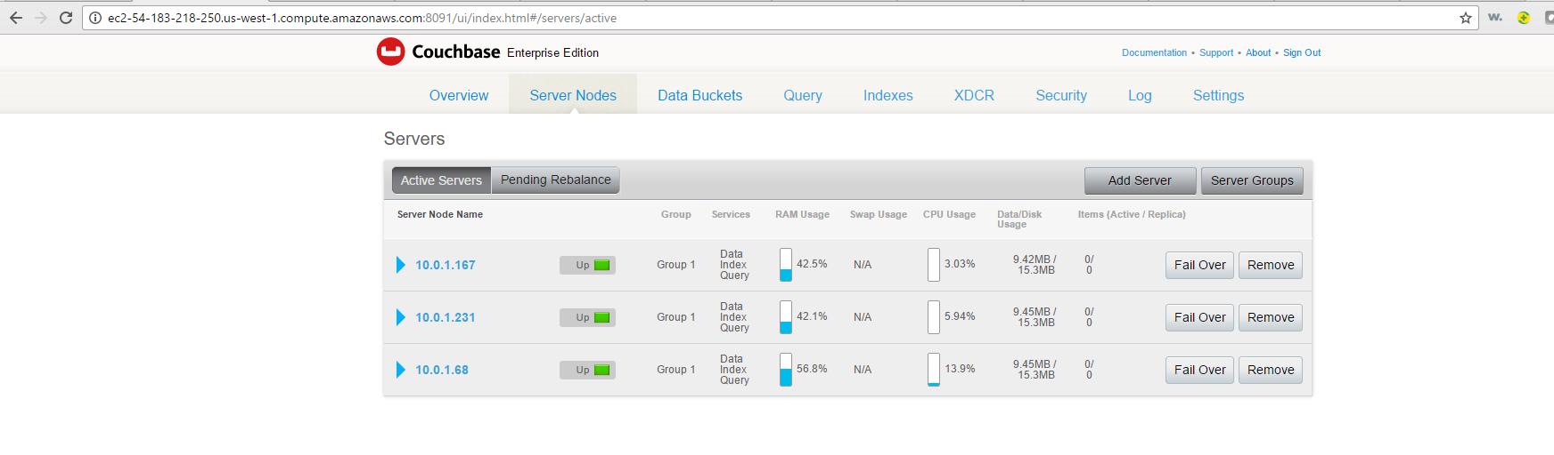

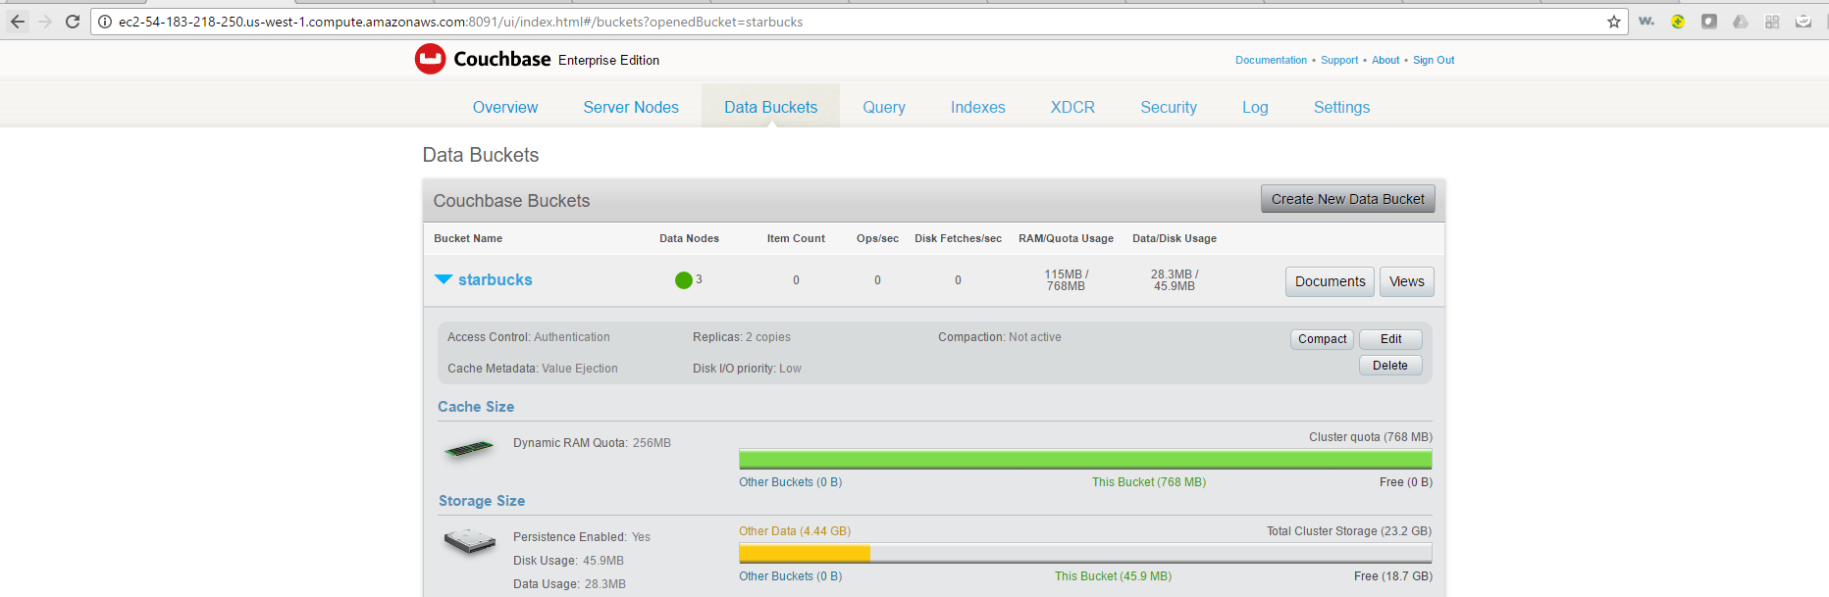

PS: You don’t need to create the bucket again on the other two nodes it will be rebalanced automatically.

Run Starbucks API:

Pull the latest image form Docker hub:

$ docker pull sushantsjsu/starbucks

Start a new container:

$ docker run –name starbucks -p 90:9090 -e DB_IP= 10.0.1.68 -e HOST_IP= 10.0.2.115 -e STORE_NAME=store1 -td starbucks

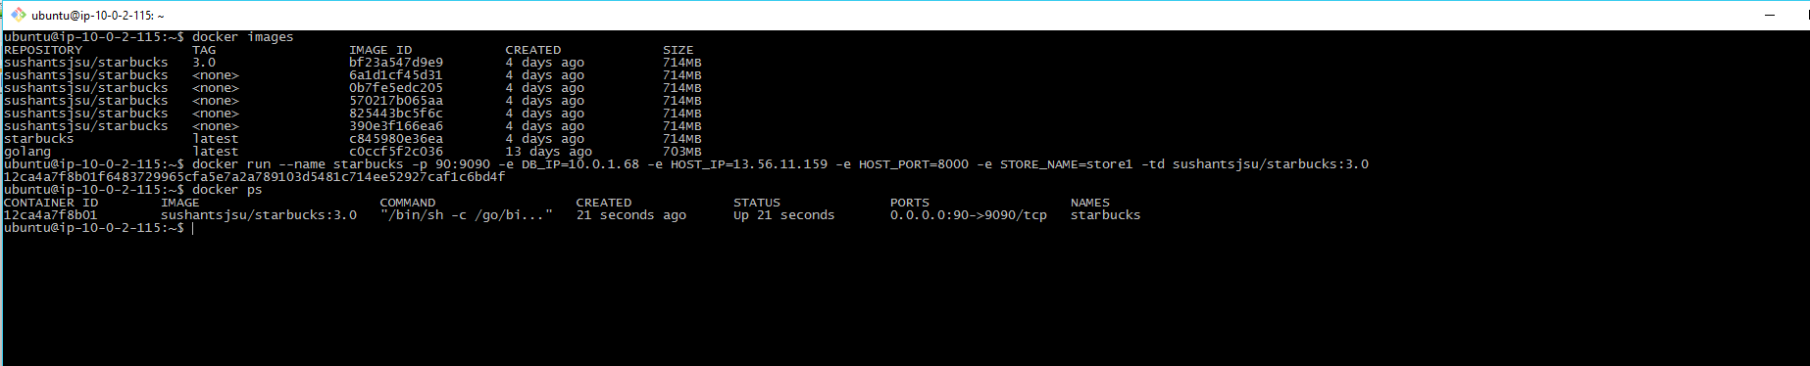

Get orders:

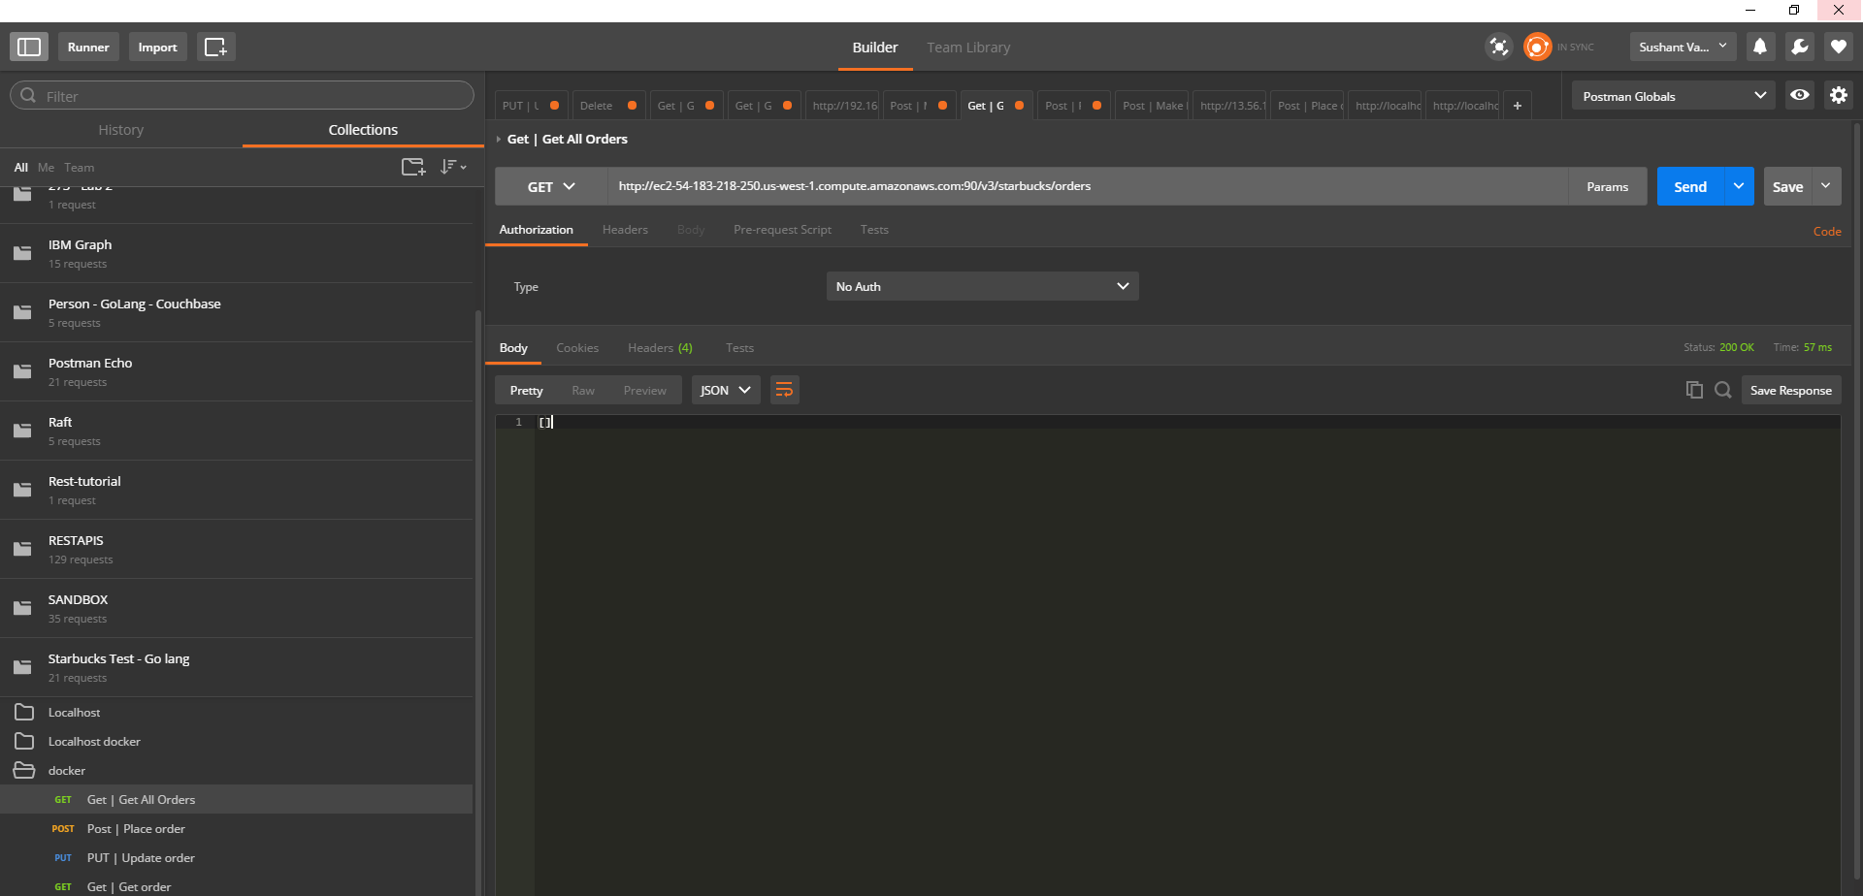

Place order:

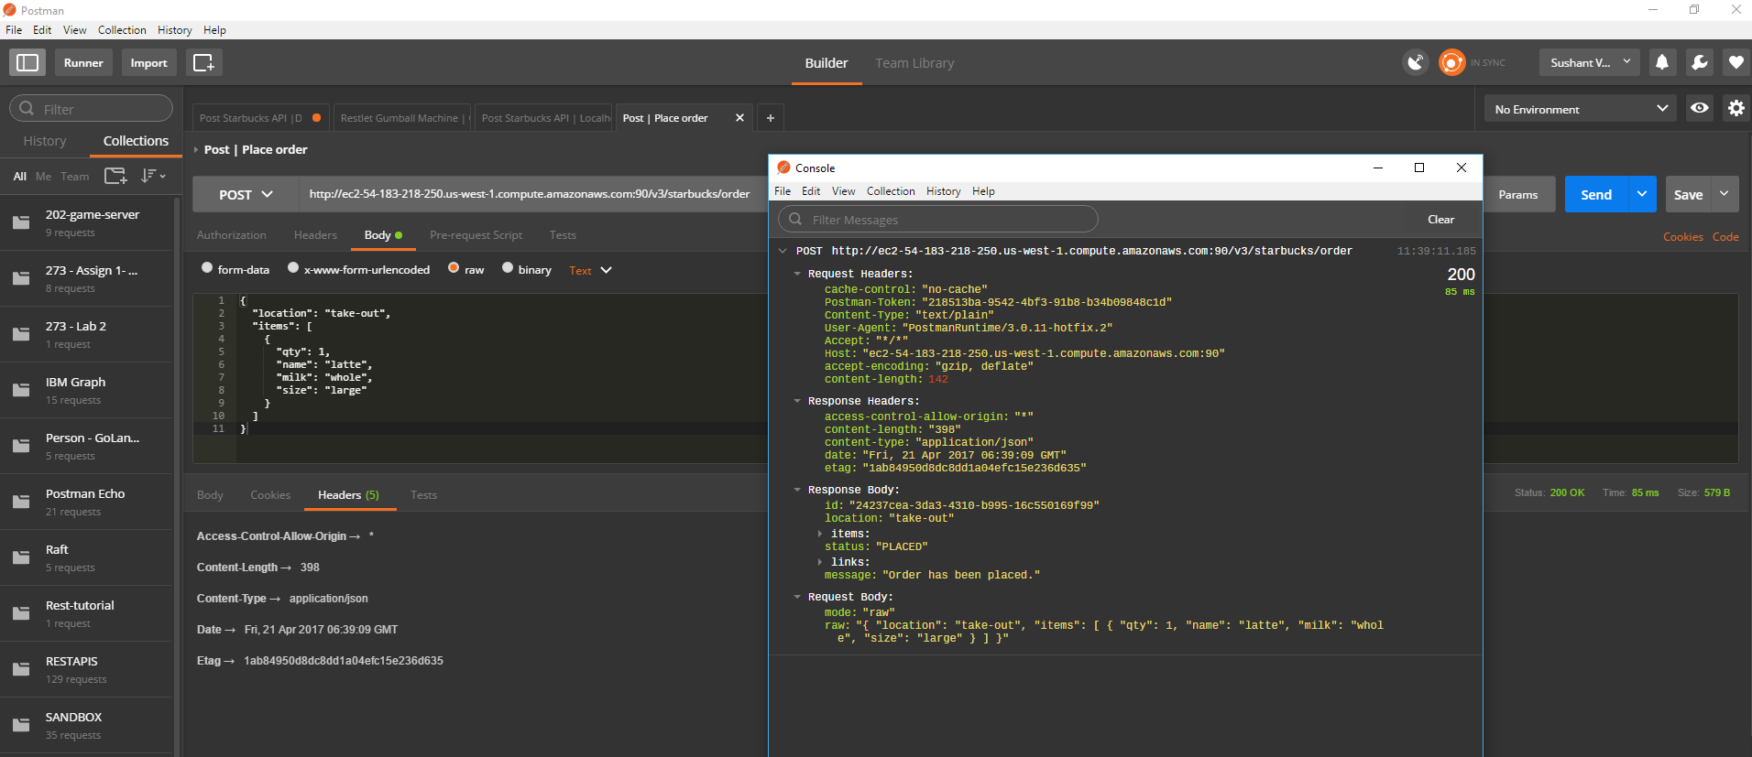

Couchbase Node 1:

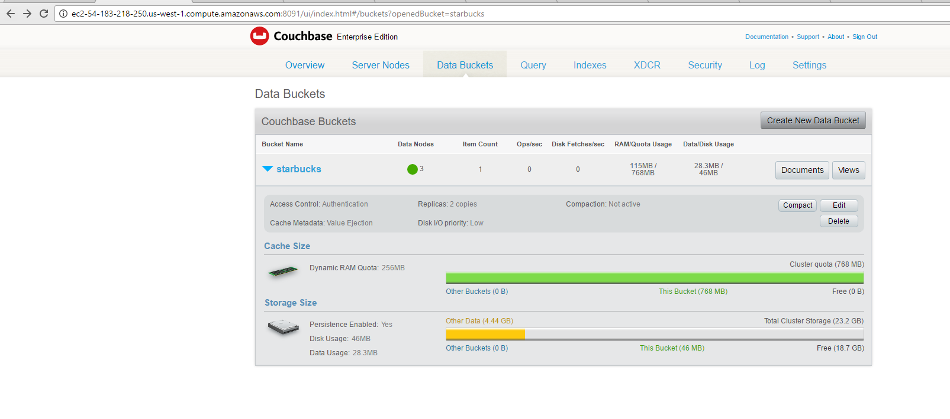

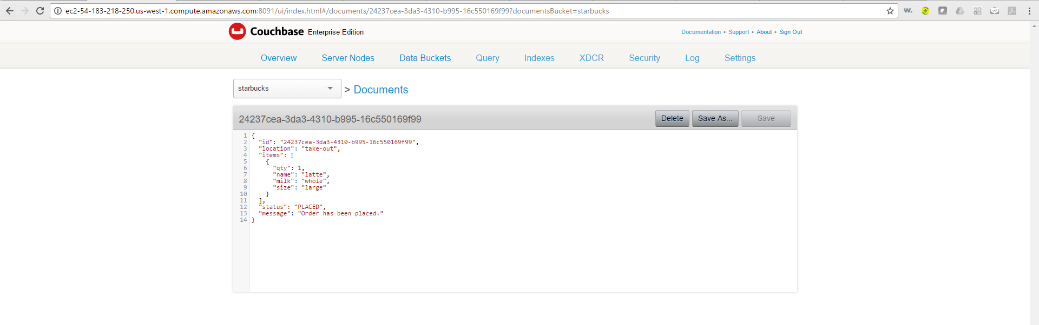

The document will be replicated in the remaining 2 nodes:

Node 2:

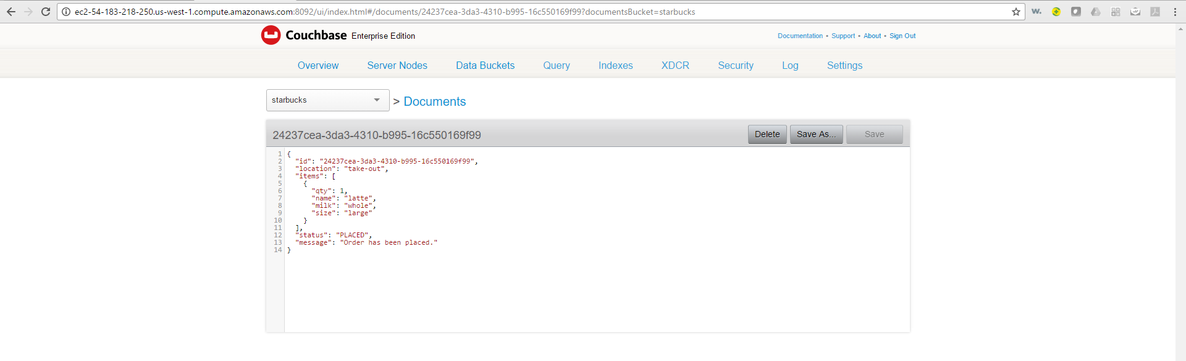

Node 3:

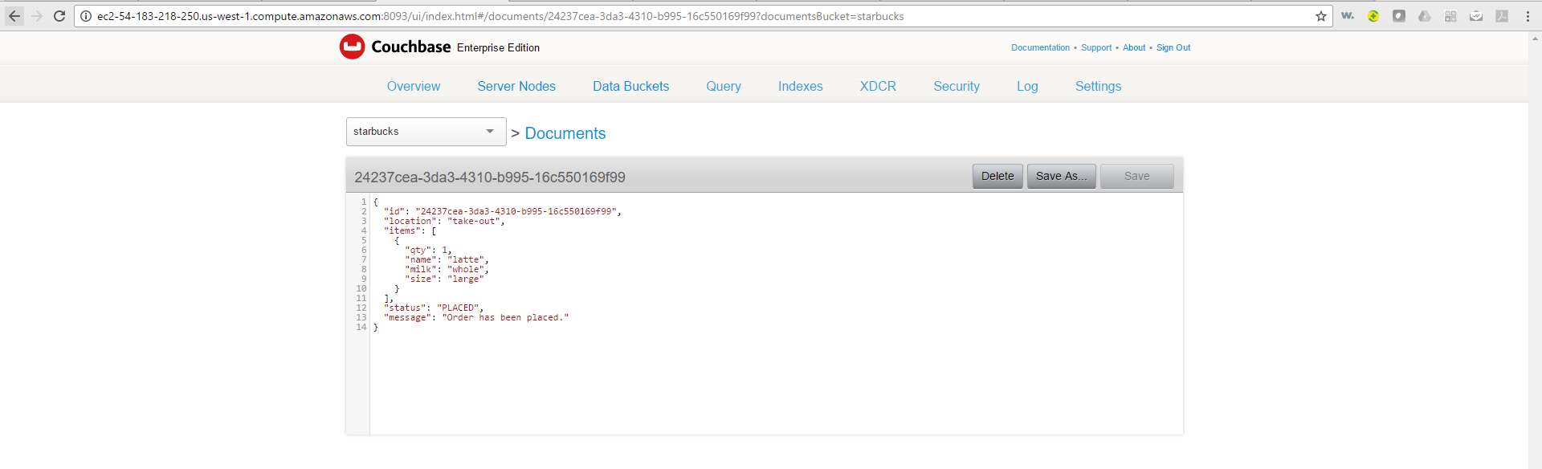

Once payment is done the status changes to -> “PREPARING” -> “SERVED” -> “COLLECTED” and document is updated on all the replicas

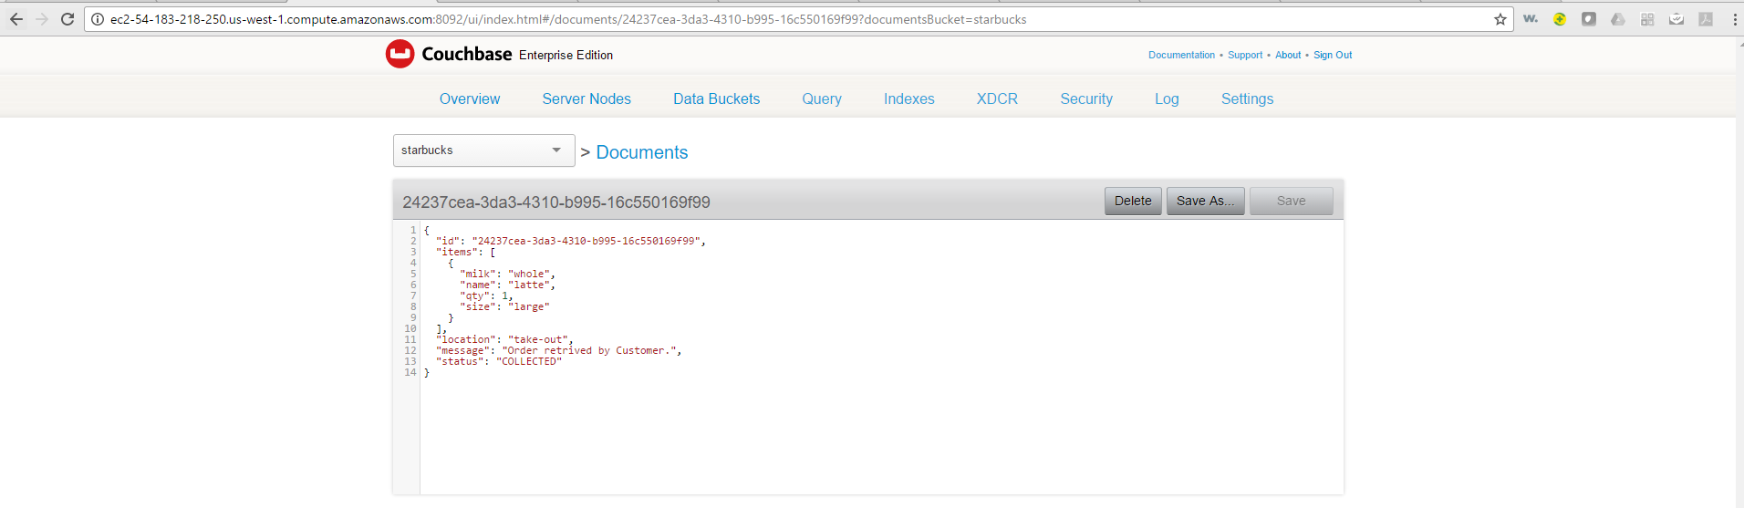

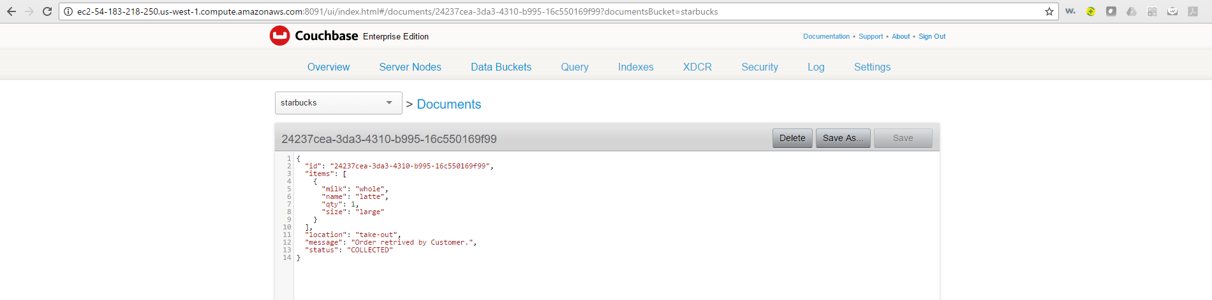

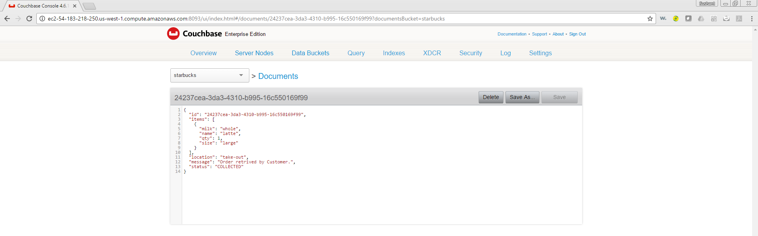

Get order:

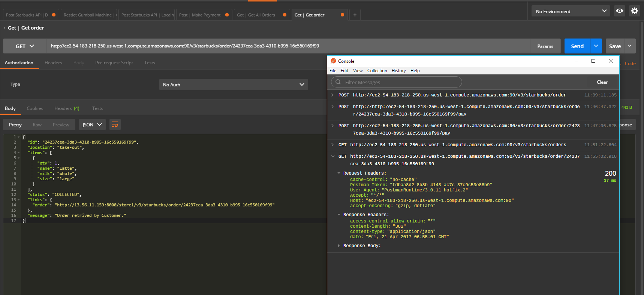

Get orders:

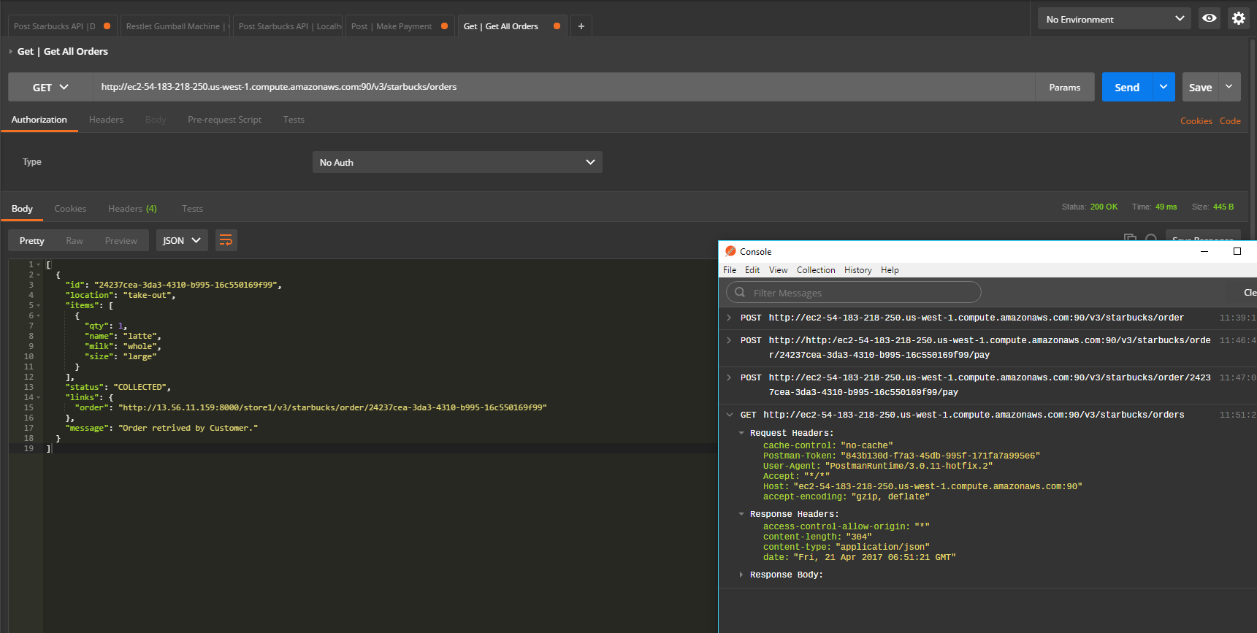

Place new order:

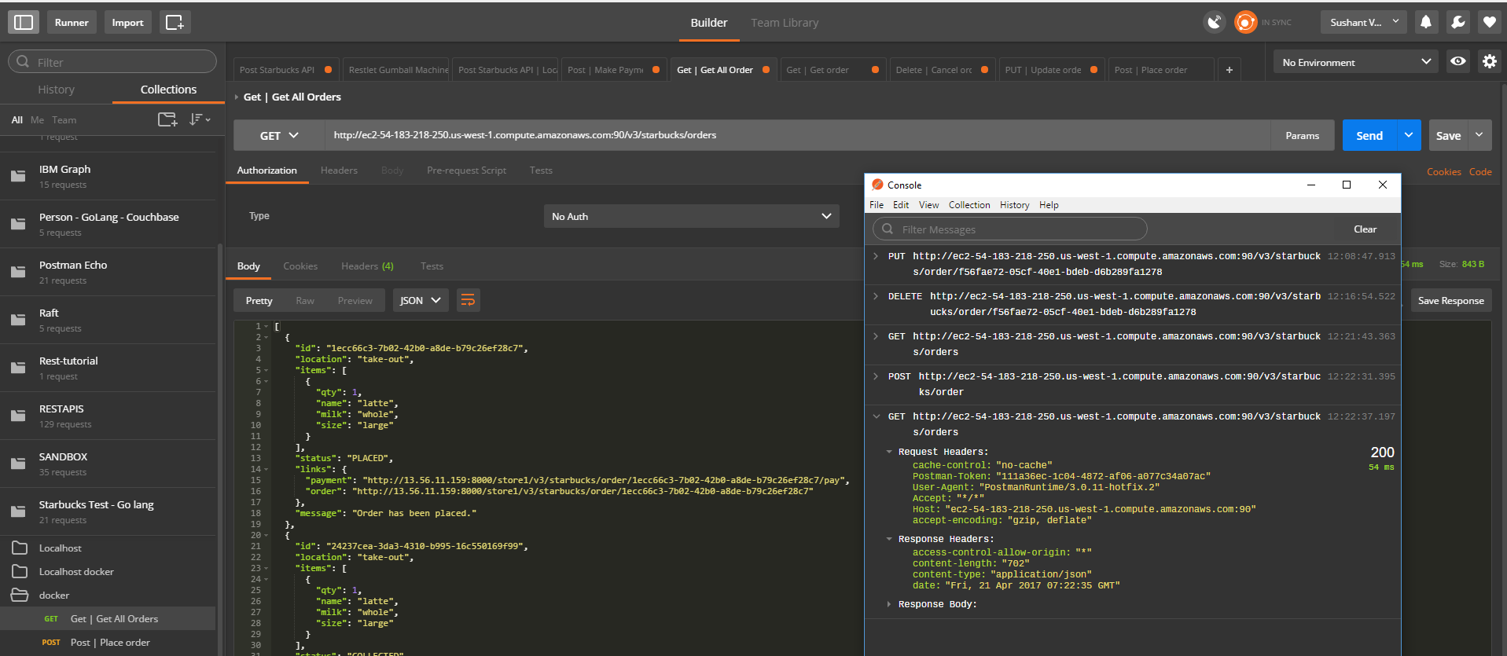

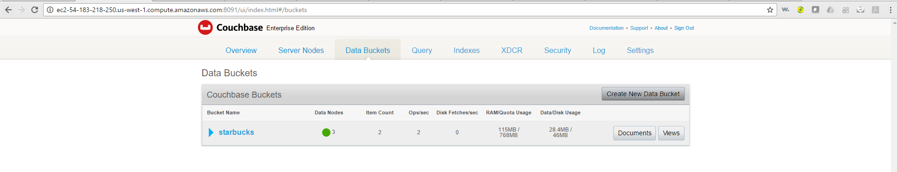

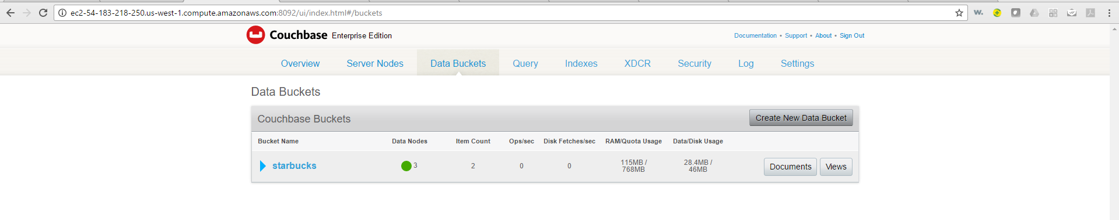

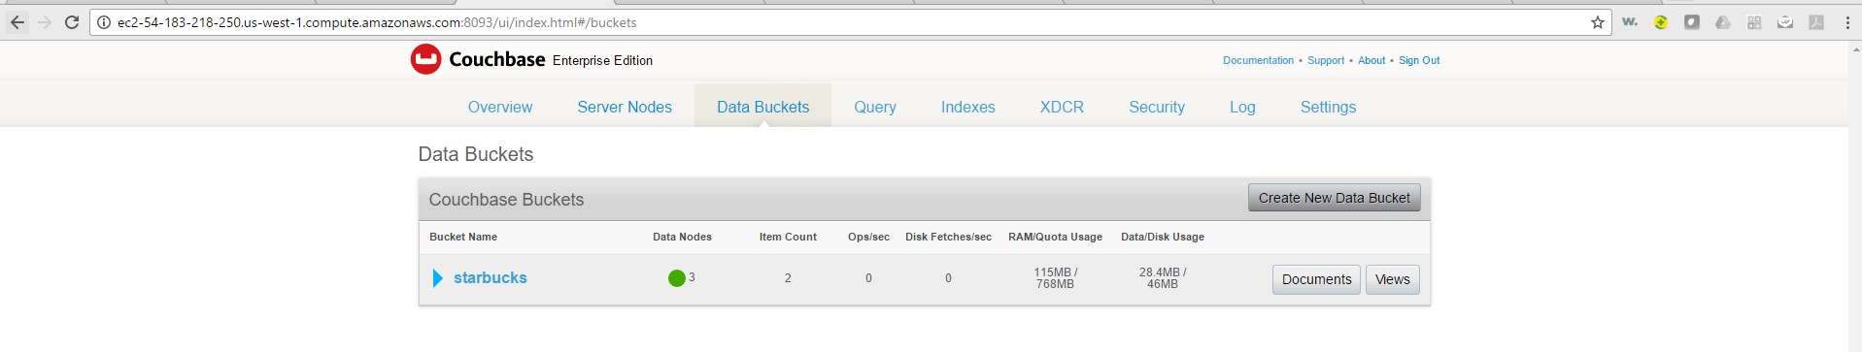

PS: Check the Item count on all the nodes of couchbase cluster.

Update placed order:

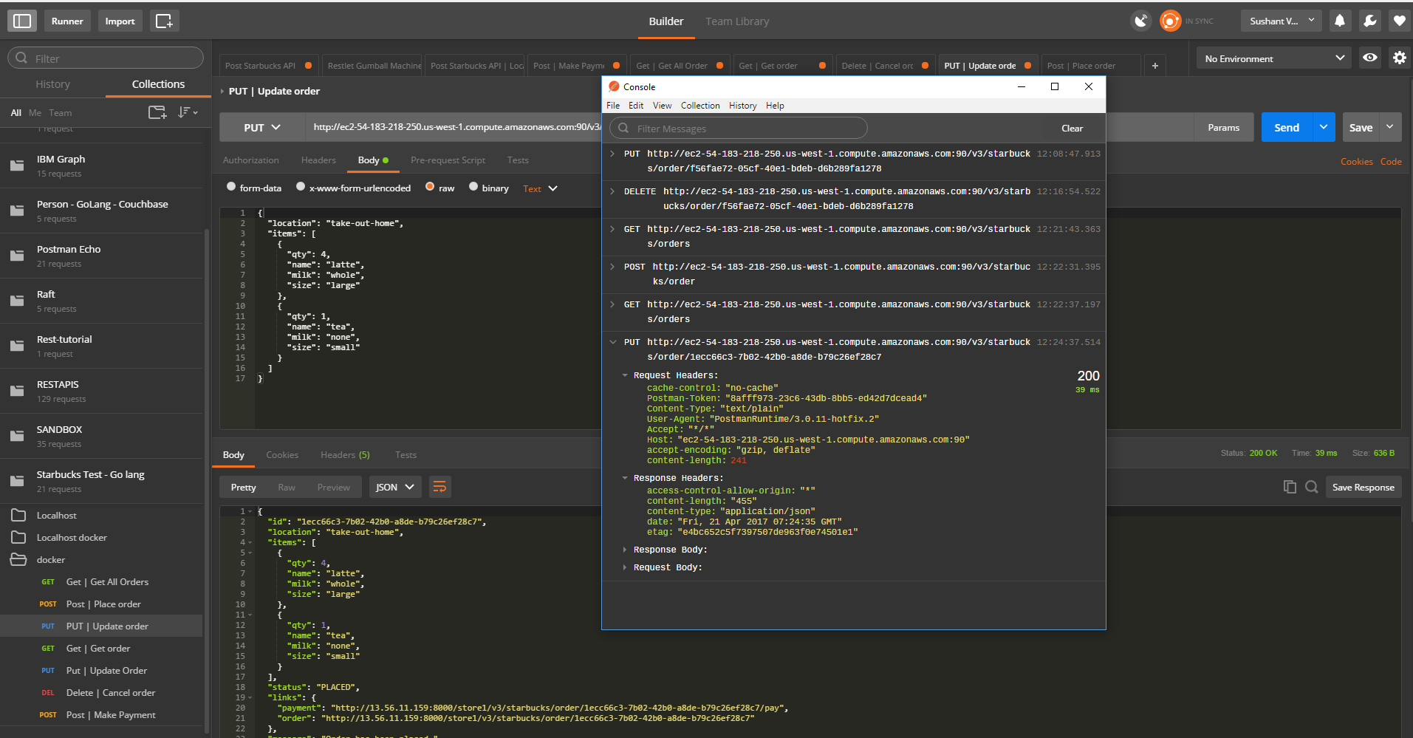

Updated and replicated on all the couchbase nodes:

Node1:

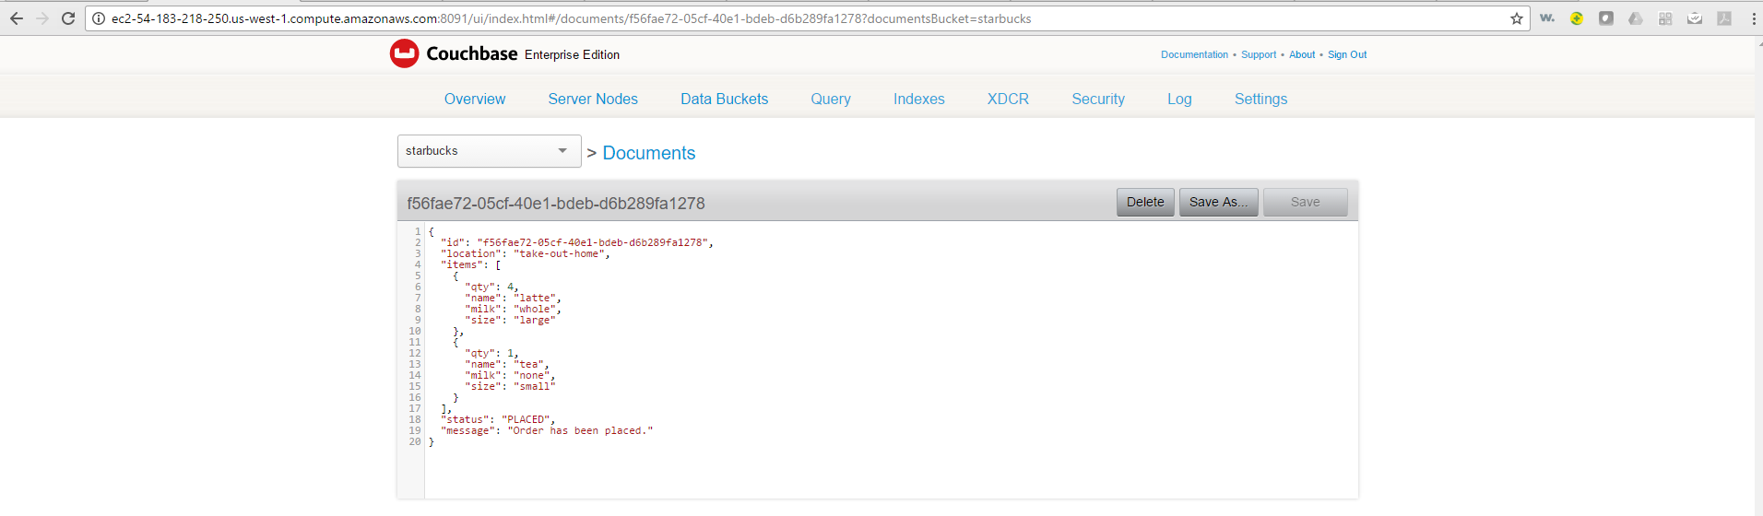

Node 2:

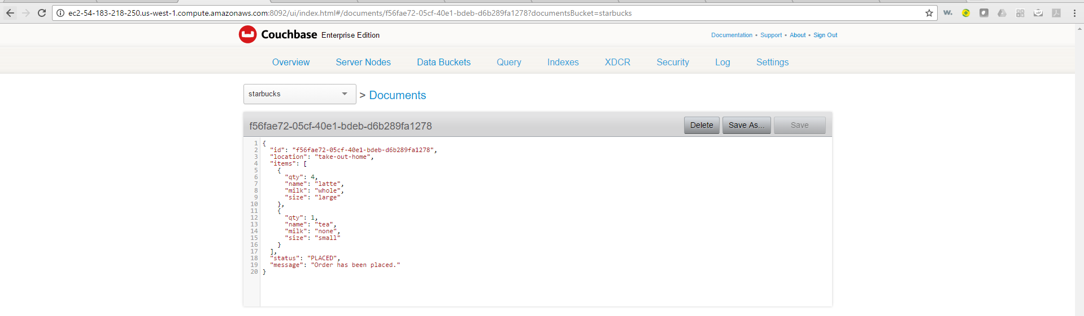

Node 3: 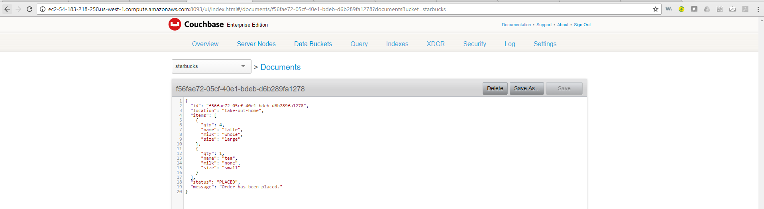

Get all orders:

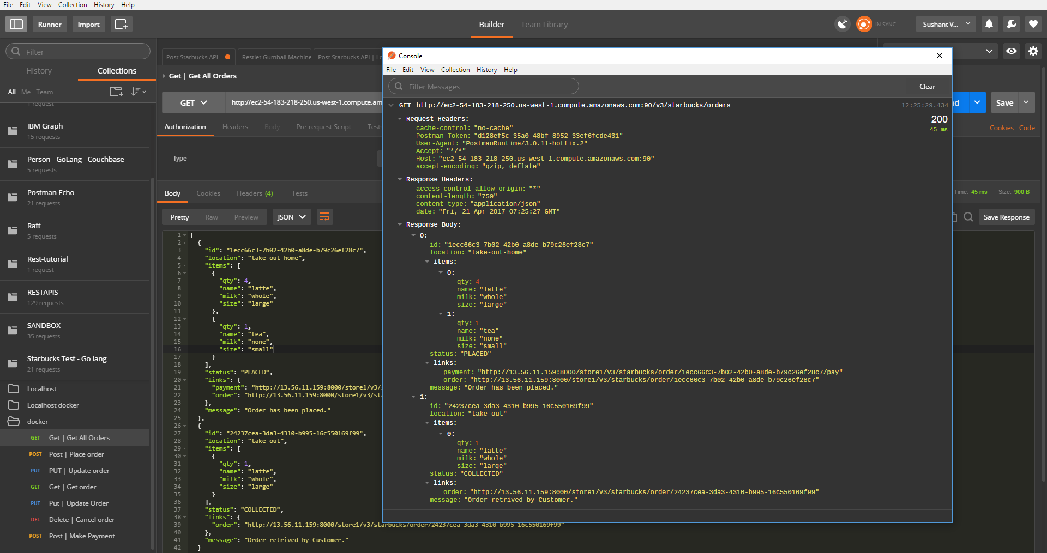

Cancel Order:

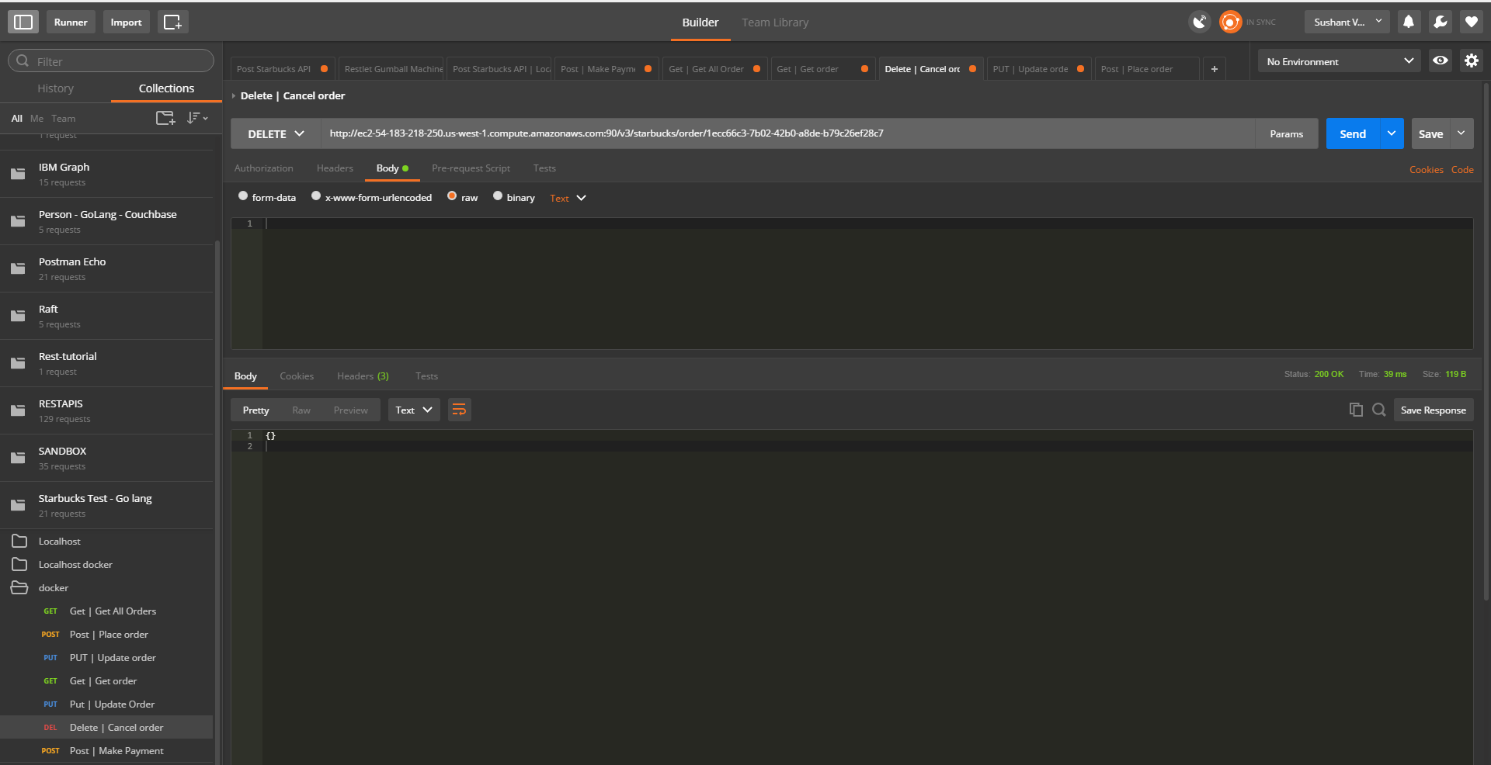

Entry deleted from Couchbase cluster:

Node 1:

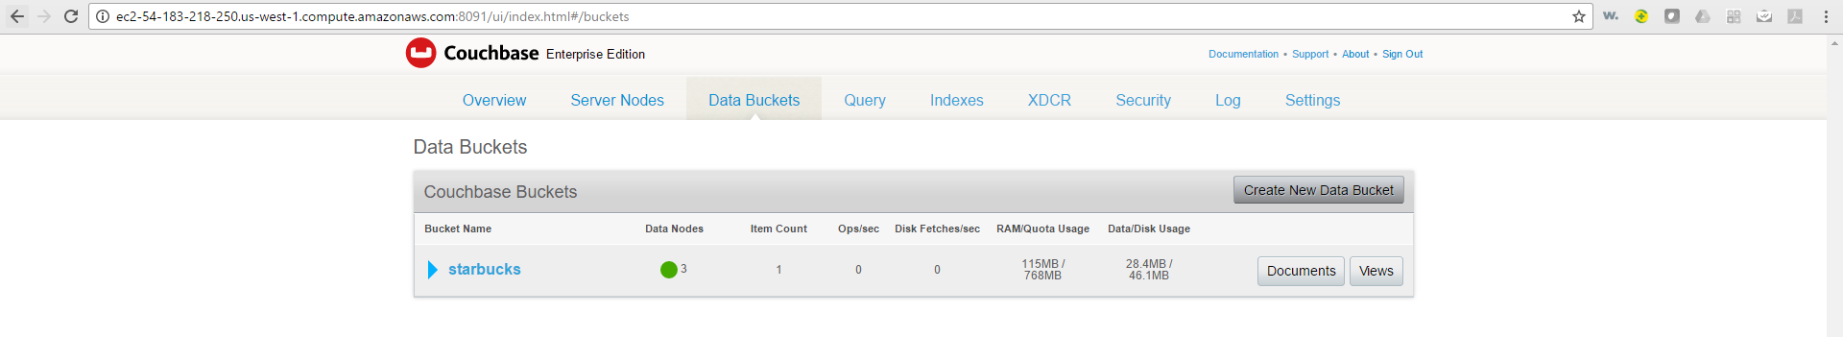

Node 2:

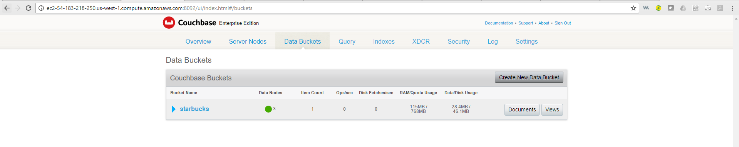

Node 3:

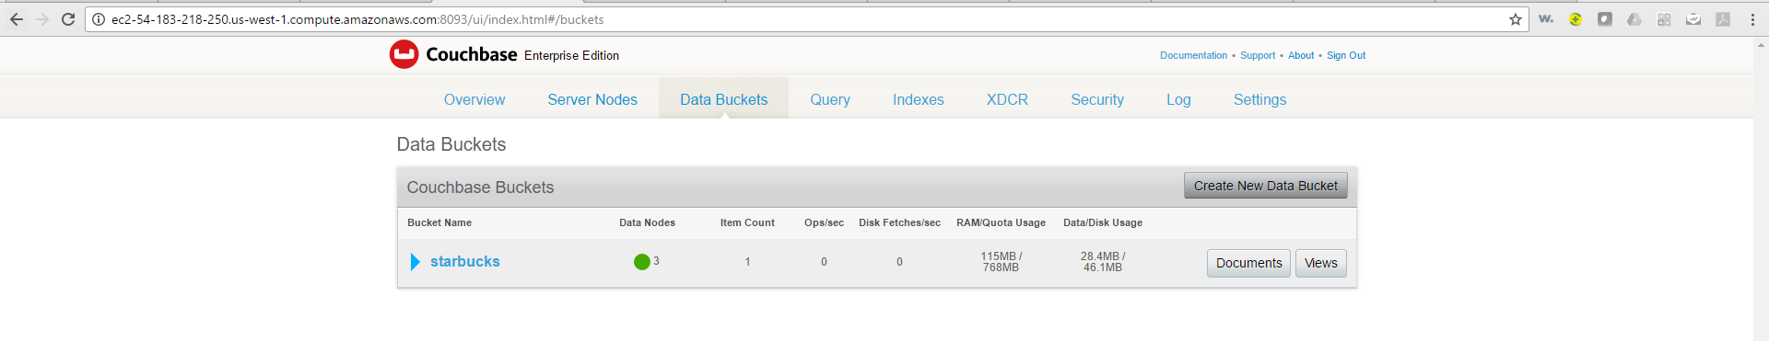

Errors:

Get cancelled order:

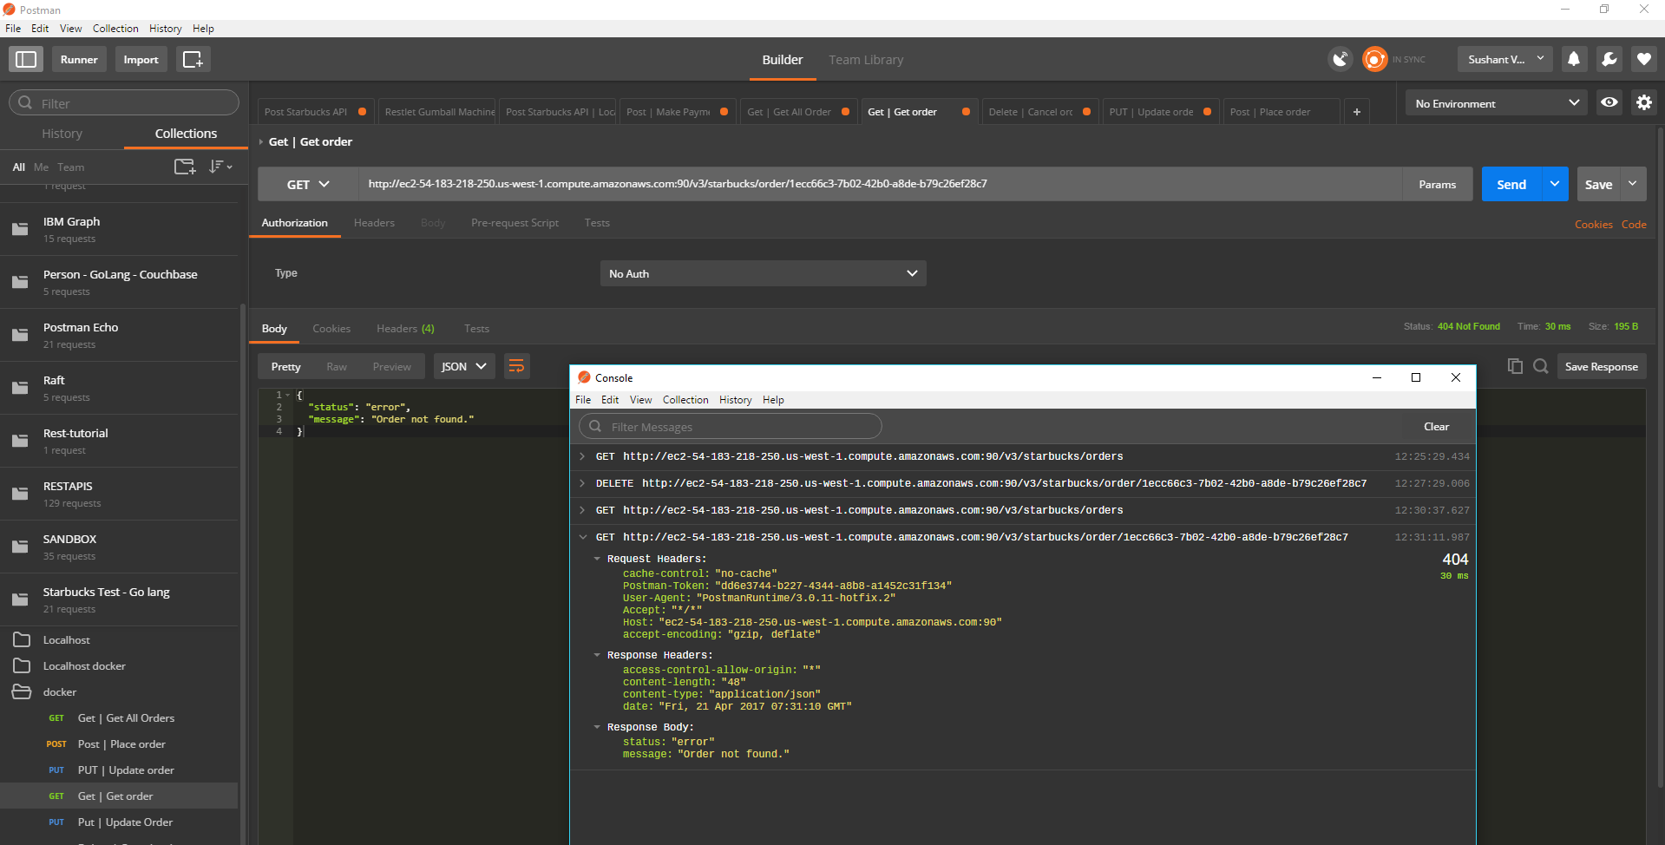

Try to update collected order;

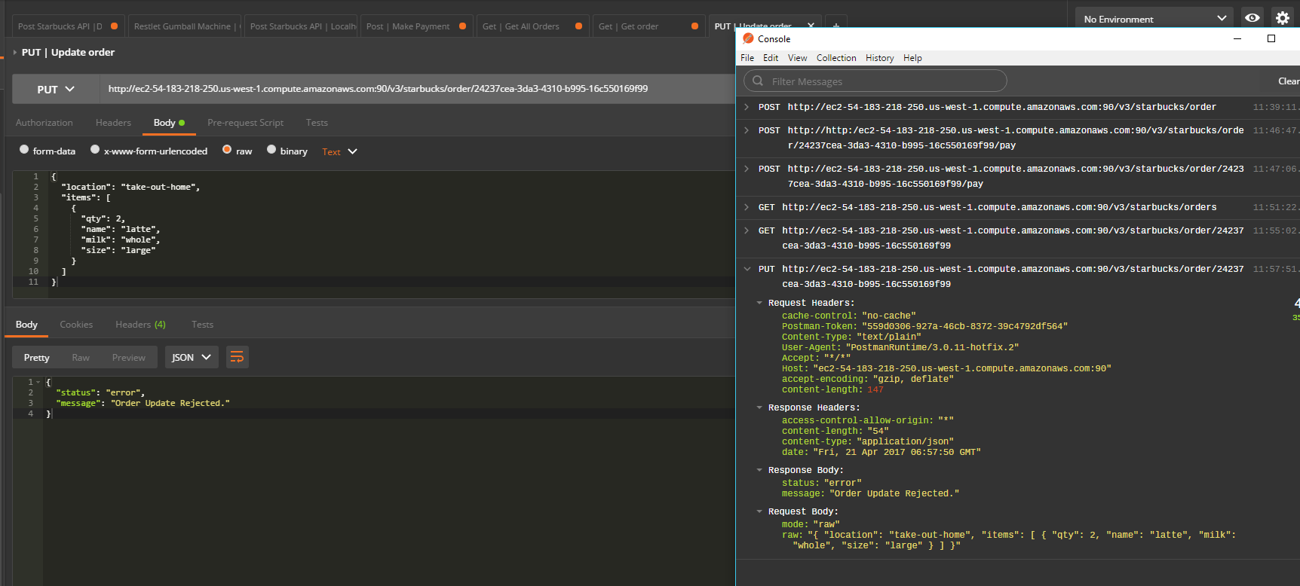

Trying to cancel this order:

