ASSIGNMENT 1
SAGAR SHARMA (7348)

1. Depth-First Search (DFS)

1.1 Definition
Depth-First Search (DFS) is a graph traversal algorithm that explores a graph by going as deep as possible along each branch before backtracking. It uses a stack-based strategy, either explicitly (using a stack data structure) or implicitly (using recursion and the call stack).

1.2 When to Use DFS
DFS is appropriate when:
- The solution is expected to be deep in the search tree
- Memory usage must be minimal
- Backtracking is required
- The problem involves combinatorial search or constraint satisfaction
Common applications:
- Cycle detection
- Topological sorting
- Connected components
- Puzzle solving using backtracking

1.3 Time Complexity
Let:
- V = number of vertices
- E = number of edges
Representation | Time Complexity
Adjacency List | O(V+E)
Adjacency Matrix | O(V2)

1.4 Space Complexity
DFS requires memory for:
- Visited array: O(V)
- Call stack or explicit stack: O(V) in the worst case
Total Space Complexity: O(V)

1.5 Limitations of DFS
- Does not guarantee shortest path
- Can enter infinite depth in unbounded graphs
- Recursive implementation may cause stack overflow
- Performance degrades in very deep or cyclic graphs without proper pruning

1.6 Failure Scenarios
DFS fails or performs poorly when:
- The graph is very deep and the solution is shallow
- Shortest path is required
- The branching factor is high and pruning is ineffective

2. Breadth-First Search (BFS)

2.1 Definition
Breadth-First Search (BFS) explores a graph level by level, visiting all neighbors of a node before moving deeper. It uses a queue-based strategy.

2.2 When to Use BFS
BFS is appropriate when:
- The shortest path in an unweighted graph is required
- Level-order traversal is needed
- The state space is small to moderate
Common applications:
- Shortest path in unweighted graphs
- Level-order tree traversal
- Social network analysis

2.3 Time Complexity
Representation | Time Complexity
Adjacency List | O(V+E)
Adjacency Matrix | O(V2)

2.4 Space Complexity
BFS requires memory for:
- Visited array: O(V)
- Queue: O(V) in the worst case
Total Space Complexity: O(V)

2.5 Limitations of BFS
- High memory consumption
- Not suitable for deep or infinite graphs
- Inefficient for problems where solutions lie deep in the search space

2.6 Failure Scenarios
BFS fails or becomes impractical when:
- The graph is very wide
- Memory constraints exist
- The state space grows exponentially

3. Limitations of DFS and BFS
DFS and BFS are uninformed search algorithms, meaning they do not use any knowledge about the goal.
Issue | DFS | BFS
Shortest path | No | Yes
Memory efficiency | High | Low
Deep solutions | Yes | Poor
Wide graphs | Moderate | Poor

4. Informed Search Algorithms (Replacements)

4.1 A* Search Algorithm

Definition
A* is an informed search algorithm that uses a heuristic to estimate the cost from the current state to the goal.
f(n)=g(n)+h(n)
Where:
- g(n): cost from start to current node
- h(n): heuristic estimate to goal

Advantages over DFS/BFS
- Focuses search toward goal
- Guarantees shortest path if heuristic is admissible
- Explores fewer nodes

Time Complexity
- Worst case: Exponential
- Practical performance depends on heuristic quality

Space Complexity
- Stores all generated nodes: O(bd)
Where:
- b = branching factor
- d = depth of optimal solution

4.2 Greedy Best-First Search
- Uses only heuristic: f(n)=h(n)
- Faster but not optimal
- Can get stuck in local minima

4.3 Backtracking Algorithms
Used for:
- Constraint satisfaction problems
- Combinatorial search
Backtracking is DFS with pruning and constraints.

5. Problem Case Studies

5.1 Tic-Tac-Toe

5.1.1 Problem Overview
Tic-Tac-Toe is a two-player, turn-based, deterministic, zero-sum game with complete information played on a 3×3 grid.

5.1.2 State Representation
A state is the complete board configuration along with the current player’s turn.
- Board: 3×3 grid
- Each cell ∈ {X, O, Empty}
The state space is finite and relatively small.

5.1.3 Use of DFS and BFS

DFS
- DFS explores the game tree by simulating moves until a terminal state (win/loss/draw) is reached.
- Naturally supports backtracking.
DFS is preferred because:
- Game depth is small (≤ 9)
- Memory usage is minimal

BFS
- BFS explores all game states level by level.
- Although correct, it is inefficient and unnecessary for turn-based games.

5.1.4 Limitations of DFS/BFS
- DFS alone does not ensure optimal play
- BFS wastes memory exploring symmetric or irrelevant states

5.1.5 Heuristics
Heuristics evaluate non-terminal board states:
- Favor winning positions
- Penalize losing positions
Example heuristic features:
- Number of two-in-a-row opportunities
- Center and corner control

5.1.6 Better Algorithms

Algorithm | Core Idea | Why Better Than DFS/BFS | Time Complexity | Space Complexity | Used Today?
Minimax | Simulate all possible moves assuming optimal opponent | Models adversarial games correctly | (O(b^d)) | (O(d)) | Yes
Alpha–Beta Pruning | Prunes useless branches in Minimax | Same result, far fewer nodes explored | Best: (O(b^{d/2})) | (O(d)) | Yes
Negamax | Simplified Minimax using symmetry | Cleaner implementation | (O(b^d)) | (O(d)) | Yes
Monte Carlo Tree Search (MCTS) | Random simulations guide decisions | Works when exhaustive search is infeasible | Depends on simulations | Depends on tree size | Yes
Expectiminimax | Minimax with randomness | Handles probabilistic moves | (O(b^d)) | (O(d)) | Rare
Reinforcement Learning (Q-Learning) | Learn optimal policy via reward | No explicit search required | Training-dependent | Policy table | Research
Neural Network + MCTS | Policy/value network + simulations | Scales to large games | Very high | Very high | Overkill

5.1.7 Algorithm (C++)
#include <bits/stdc++.h>
using namespace std;

const char PLAYER = 'X';
const char AI = 'O';

// Check if someone has won
int evaluate(vector<vector<char>>& board) {
// Rows and Columns
for (int i = 0; i < 3; i++) {
if (board[i][0] == board[i][1] && board[i][1] == board[i][2]) {
if (board[i][0] == AI) return +10;
if (board[i][0] == PLAYER) return -10;
}
if (board[0][i] == board[1][i] && board[1][i] == board[2][i]) {
if (board[0][i] == AI) return +10;
if (board[0][i] == PLAYER) return -10;
}
}

// Diagonals
if (board[0][0] == board[1][1] && board[1][1] == board[2][2]) {
if (board[0][0] == AI) return +10;
if (board[0][0] == PLAYER) return -10;
}
if (board[0][2] == board[1][1] && board[1][1] == board[2][0]) {
if (board[0][2] == AI) return +10;
if (board[0][2] == PLAYER) return -10;
}

return 0;
}

// Check if moves are left
bool movesLeft(vector<vector<char>>& board) {
for (auto& row : board)
for (char c : row)
if (c == '_') return true;
return false;
}

// Minimax DFS
int minimax(vector<vector<char>>& board, bool isMax) {
int score = evaluate(board);
if (score == 10 || score == -10) return score;
if (!movesLeft(board)) return 0;

if (isMax) {
int best = -1000;
for (int i = 0; i < 3; i++) {
for (int j = 0; j < 3; j++) {
if (board[i][j] == '_') {
board[i][j] = AI;
best = max(best, minimax(board, false));
board[i][j] = '_';
}
}
}
return best;
} else {
int best = 1000;
for (int i = 0; i < 3; i++) {
for (int j = 0; j < 3; j++) {
if (board[i][j] == '_') {
board[i][j] = PLAYER;
best = min(best, minimax(board, true));
board[i][j] = '_';
}
}
}
return best;
}
}

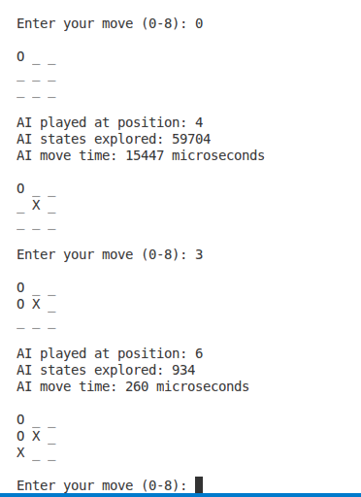

5.2 Sudoku Solver

5.2.1 Problem Overview
Sudoku is a constraint satisfaction problem where digits must be placed so that rows, columns, and sub-grids contain unique values.

5.2.2 State Representation
A state is the entire Sudoku grid at a given moment.
- Empty cells represent partial assignments
- A complete valid grid is a goal state

5.2.3 Use of DFS and BFS

DFS
- DFS assigns a value to one cell and recursively proceeds
- Backtracking occurs when constraints are violated
DFS is suitable because:
- Solutions are deep
- Memory usage is limited

BFS
- BFS generates all boards with k filled cells
- Memory usage grows exponentially
BFS is impractical for Sudoku.

5.2.4 Pruning and Constraint Checking
Pruning occurs when:
- A digit violates row, column, or sub-grid rules
Early pruning is essential to reduce the search space.

5.2.5 Heuristics
Minimum Remaining Values (MRV)
- Choose the cell with the fewest legal values
Forward Checking
- Remove invalid values from neighboring cells
Heuristics significantly reduce recursion depth.

5.2.6 Better Algorithms

Algorithm | Core Idea | Why Better Than DFS/BFS | Time Complexity | Space Complexity | Used Today?
Backtracking + Constraints | DFS with constraint checking | Eliminates invalid choices early | Exponential (pruned) | (O(81)) | Yes
MRV Heuristic | Choose cell with fewest choices | Reduces branching factor | Exponential (reduced) | (O(81)) | Yes
Forward Checking | Track domain reductions | Prevents dead-end paths | Exponential (reduced) | (O(81)) | Yes
Constraint Propagation | Enforce consistency repeatedly | Solves easy puzzles without search | Polynomial (easy cases) | (O(81)) | Yes
Algorithm X | Exact cover backtracking | Mathematical formulation | Exponential | (O(n)) | Yes
Dancing Links (DLX) | Efficient exact cover structure | Fast add/remove operations | Exponential (very fast in practice) | (O(n)) | Yes
SAT Solvers | Boolean satisfiability | Industrial-strength solvers | Exponential | High | Yes
Integer Programming (ILP) | Linear constraints | Uses optimization engines | NP-complete | High | Research
Genetic Algorithms | Evolutionary search | Avoids exhaustive search | Heuristic-based | Medium | Rare

5.2.7 Algorithm (C++)

#include <bits/stdc++.h>
using namespace std;

bool isSafe(vector<vector<int>>& board, int row, int col, int num) {
for (int x = 0; x < 9; x++) {
if (board[row][x] == num || board[x][col] == num)
return false;
}

int startRow = row - row % 3;
int startCol = col - col % 3;
for (int i = 0; i < 3; i++)
for (int j = 0; j < 3; j++)
if (board[startRow + i][startCol + j] == num)
return false;

return true;
}

bool solveSudoku(vector<vector<int>>& board) {
for (int row = 0; row < 9; row++) {
for (int col = 0; col < 9; col++) {
if (board[row][col] == 0) {
for (int num = 1; num <= 9; num++) {
if (isSafe(board, row, col, num)) {
board[row][col] = num;
if (solveSudoku(board))
return true;
board[row][col] = 0; // backtrack
}
}
return false;
}
}
}
return true;
}

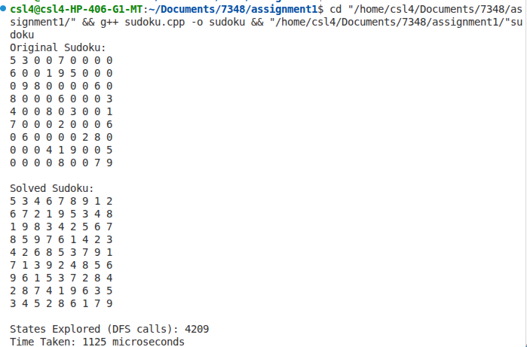

5.3 N-Queens Problem

5.3.1 Problem Overview
The N-Queens problem requires placing N queens on an N×N chessboard so that no two queens attack each other.

5.3.2 State Representation
A state is the set of queen placements up to a given row.
- One queen per row
- Columns and diagonals must be conflict-free

5.3.3 Use of DFS and BFS

DFS
- Places queens row by row
- Backtracks when conflicts arise
DFS is ideal because:
- Depth is fixed (N)
- Strong pruning is possible

BFS
- Generates all partial boards at each level
- Memory grows exponentially
BFS is infeasible for large N.

5.3.4 Pruning
Prune when:
- A queen attacks another queen
Use auxiliary arrays for columns and diagonals.

5.3.5 Heuristics
- Place queens in columns with fewer conflicts
- Symmetry breaking to reduce equivalent states

5.3.6 Better Algorithms

Algorithm | Core Idea | Why Better Than DFS/BFS | Time Complexity | Space Complexity | Used Today?
Backtracking | Place queens row by row | Avoids invalid placements early | (O(N!)) | (O(N)) | Yes
Backtracking + Pruning | Eliminate unsafe columns/diagonals | Reduces branching significantly | (O(N!)) (pruned) | (O(N)) | Yes
Bitmasking | Use bit operations for constraints | Extremely fast checks | (O(N!)) | (O(N)) | Yes
Symmetry Breaking | Avoid mirror solutions | Cuts search space in half | Reduced factorial | (O(N)) | Yes
Min-Conflicts | Local search minimizing conflicts | Solves very large (N) | Near-linear (practical) | (O(N)) | Yes
Genetic Algorithms | Evolutionary optimization | Escapes local minima | Heuristic-based | Medium | Research
Simulated Annealing | Probabilistic hill climbing | Avoids local optima | Heuristic-based | Low | Research
Constraint Programming (CP) | Declarative constraints | Solver handles pruning | Exponential | High | Yes

5.3.7 Algorithm (C++)
#include <bits/stdc++.h>
using namespace std;

bool isSafe(vector<vector<int>>& board, int row, int col, int num) {
for (int x = 0; x < 9; x++) {
if (board[row][x] == num || board[x][col] == num)
return false;
}

int startRow = row - row % 3;
int startCol = col - col % 3;
for (int i = 0; i < 3; i++)
for (int j = 0; j < 3; j++)
if (board[startRow + i][startCol + j] == num)
return false;

return true;
}

bool solveSudoku(vector<vector<int>>& board) {
for (int row = 0; row < 9; row++) {
for (int col = 0; col < 9; col++) {
if (board[row][col] == 0) {
for (int num = 1; num <= 9; num++) {
if (isSafe(board, row, col, num)) {
board[row][col] = num;
if (solveSudoku(board))
return true;
board[row][col] = 0; // backtrack
}
}
return false;
}
}
}
return true;
}

