A Project Report on
SMART PARKING SYSTEM
III SEMESTER PROJECT
B.TECH IN
COMPUTER SCIENCE
AND ENGINEERING

Submitted by:
Sagar Negi
University Roll No: 2016976
Batch: 2020-2024

Under the Supervision of:
Mr. Piyush Aggarwal
Associate Professor


DEPARTMENT OF

DEPARTMENT OF COMPUTER SCIENCE AND ENGINEERING
GRAPHIC ERA DEEMED TO BE UNIVERSITY
DEHRADUN, UTTARAKHAND


ACKNOWLEDGEMENT:
I would like to take this opportunity to express my gratitude to entire faculty at Department of Computer Science and Engineering, Graphic Era Deemed to be University, who evaluated the project from time to time and gave me valuable suggestions as to how to improve the project.
I am grateful to Mr. Piyush Aggarwal, Associate Professor, for his supervision, encouragement, inspiration and guidance. Working under him is being an enriched experience. In all, I found congenial work environment in Graphic Era Deemed to be University and this project completion will mark a new beginning for me in the coming days.
I am highly indebted to Graphic Era Deemed to be University for providing me the required infrastructure and facilities to accomplish the given task.
Sagar Negi
B.Tech CSE
2020-2024
Graphic Era University

CONTENTS

- INTRODUCTION
- PROBLEM STATEMENT
- AIM
- METHODOLOGY
- MOTIVATION
- MATERIALS REQUIRED
- PIN DIAGRAM
- IMAGES FROM THE PROJECT
- APPLICATIONS

SMART PARKING SYSTEM

INTRODUCTION:
This report is about the project chosen i.e., SMART PARKING SYSTEM. This report tries to give a brief overview of the objective of the project, material required, code, application and the Methodology followed to achieve this project.

PROBLEM STATEMENT:
We all know that parking spaces are very important in any city. A city must have enough parking spaces to provide their residents and their visitors a place to park their vehicles. Also, nowadays cars are a main means of transportation for many, but it’s not always easy for a person to find proper parking space in a crowded city. The drivers usually waste their time and efforts in finding parking space and end up parking their vehicles finding a space on streets.
Car parking is a major problem in urban areas. Following the rapid incense of car ownership, major cities are suffering with the lack of car parking areas, which can be considered the initial reason for requirement of a proper parking solutions.
So we are here with a project named SMART PARKING SYSTEM to deal with the problem of parking and further all the tasks are automated i.e., without human involvement and interaction.

AIM:
To design the infrastructure of parking system with the help of various iot sensors and devices in order to solve the traffic congestion problem and to enhance the parking facility to all the users.

METHODOLOGY:
In this project we will be using IR (infrared) sensors to detect whether a vehicle is there in its range or not. If the vehicle is detected then a red LED will glow indicating that the slot is full and if there is no obstacle(vehicle) then green led will glow indicating the slot is free(available).This availability of slots i.e. the output of the IR sensors, will be displayed in the Thingspeak application.
Further we will be using two more IR sensors and servo motor to let the vehicles in and out of the parking area. One IR sensor will be placed just after the servo motor to detect the vehicles coming inside the parking area and the other IR sensor will be placed just before the servo motor to detect the vehicles going outside the parking area. When a vehicle is detected by first IR/second IR, then servo motor will rotate up to 90 degrees thus opening the barrier to let the vehicles in/out. However when the vehicles are detected by both the IR sensors at the same time, the servo motor will not rotate thus ensuring that both the vehicles might not collide.

MOTIVATION:
IOT plays a major role in connecting the surrounding environmental thing to the Internet and makes it easy to access those un-internet things from any remote location. The ever growing traffic congestion and uncertainty in the parking availability and payment have enforced the need for a smart parking system. The smart parking continues to make progress as an increasing number of cities struggle with traffic congestion and inadequate parking availability. A smart parking system will help optimize parking space usage, improve the efficiency of the parking operations and help smoother traffic flow. It also helps people to search for parking spaces accessible with the ease of IOT automation by supplying the parking slot information. Over time, smart parking solutions can produce real-time data, which covers correlations and the insights of users and car parking lots. The best thing about the smart parking management is that it is easy, convenient and economic for parking owners to get real-time data and insights about the lots.
Basically, the project aims at fulfilling the following factors:
CONFIDENTIALITY: It ensures that the data is secure and is not accessible by unauthorized users of the system.
INTEGRITY: It ensures that the data or information reached to the user is correct and reliable.
AVAILABILITY: It ensures that all the services of the system is available to its each users all the time.

MATERIAL REQUIRED:

HARDWARE:

  - ARDUINO UNO
  - LED
  - USB CABLE
  - IR SENSOR
  - SERVO MOTOR
  - B-TYPE CABLE
  - BREADBOARD
  - JUMPER WIRES
- MALE TO MALE JUMPER WIRES
- MALE TO FEMALE JUMPER WIRES

SOFTWARE:

  - ARDUINO IDE
  - THINGSPEAK APPLICATION

PIN DIAGRAM:

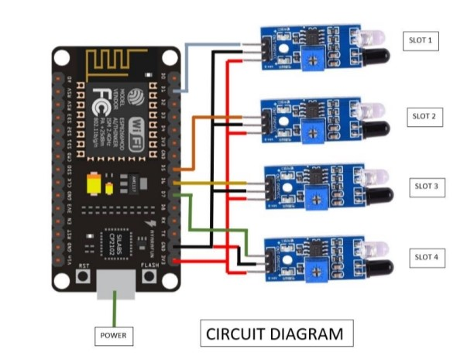

(I)CONNECTION OF IR SENSORS WITH ESP MODULE

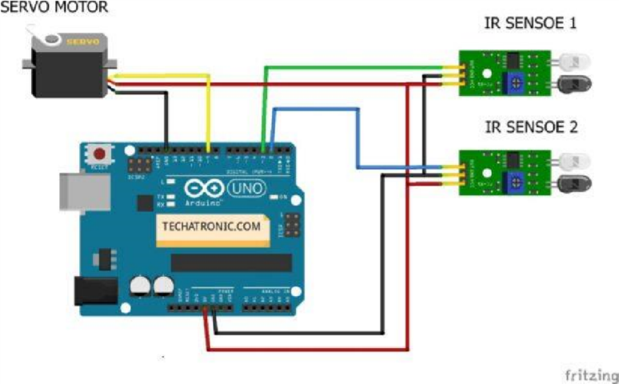

(II) CONNECTION OF IR SENSORS AND SERVO MOTOR WITH ARDUINO

DIAGRAM:
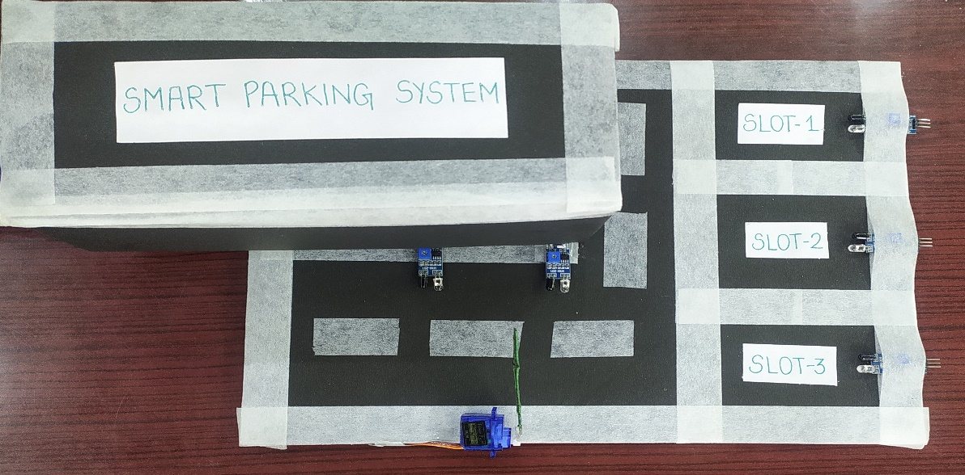

SLOTS EMPTY:
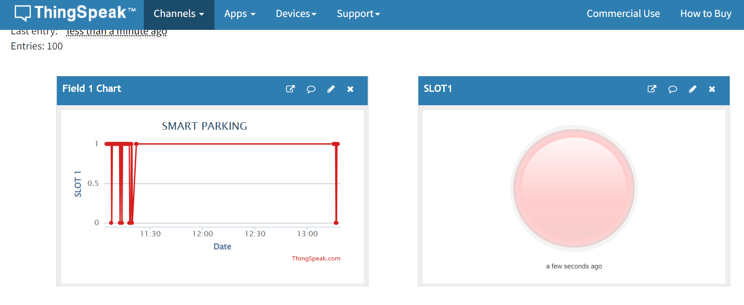

SLOTS FULL:
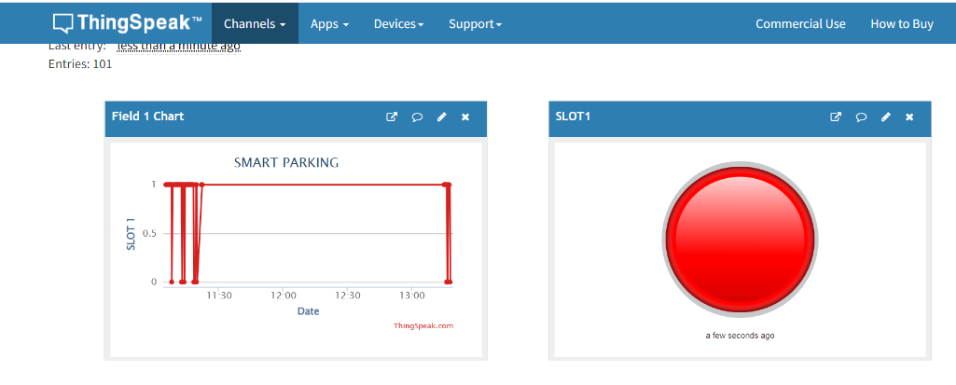

APPLICATIONS:
- Fully automated system without any human involvement.
- Parking facility for several vehicles.
- Reduction of traffic congestion.
- Reduction of parking violations and suspicious activity.
- Reduction of accident caused by distraction of searching for parking.

REFERENCES:

- www.create.arduino.cc
- www.stackoverflow.com
- www.esp8266.com
- www.circuits4you.com
- www.thingspeak.com

