Exploratory Data Analysis on Diwali Sales

Submitted for

DATA VISUALIZATION AND DASHBOARD

Submitted by:
(E23MCAG0029) SAMARTH SWAROOP SAXENA (E23MCAG0023) SAGAR SHARMA

Submitted to-
Dr. Nitin Arvind Shelke

July-Dec 2023
SCHOOL OF COMPUTER SCIENCE AND ENGINEERING


INDEX

Sr No
Content | Page No
1. | Abstract | 1
2. | Introduction | 1-2
3. | Software Used | 2
4. | Methodology | 2-4
5. | Experimental Results | 5
6. | Conclusion | 6
7. | References

1.ABSTRACT
The festival of lights, Diwali, is not only an important cultural event but also a critical time for businesses since it boosts consumer spending. An extensive analysis of Diwali sales trends, patterns, and customer behavior over the previous few years is summarized in this abstract.
In order to identify the complex factors that define Diwali sales, the study used data analytics, market research, and consumer surveys in a multimodal manner. Product categories, regional differences, online versus offline trends, and the effects of outside variables like world events and economic situations are all significant research topics.

2.INTRODUCTION AND RELATED WORK
The Diwali Sales Analysis stands as a pivotal investigation into the nuanced intricacies of retail dynamics during the vibrant Diwali season. This comprehensive study spans across diverse sectors, meticulously examining the performance of electronics, clothing, and home decor markets. At its core, the analysis seeks to unravel the underlying trends and patterns that shaped consumer behavior, offering a profound understanding of the factors driving purchasing decisions.

Delving into the realm of sales data, this analysis becomes a lens through which we explore the impact of various elements, such as discounts, promotions, and marketing strategies. By dissecting these components, we gain valuable insights into the efficacy of different approaches adopted by businesses during the festive season. This examination provides businesses with a strategic roadmap, highlighting the successful strategies that resonated with consumers and those that fell short.

Moving beyond the numerical lens, the study aims to understand the intricacies of consumer preferences during Diwali, spotlighting the specific product categories that experienced heightened demand. Additionally, we scrutinize regional variations, acknowledging the geographical subtleties that played a pivotal role in shaping sales patterns. Identifying top-performing markets becomes crucial as we elucidate the contributing factors to their success, offering businesses tailored insights into demographic-specific strategies.

In the ever-evolving landscape of retail, the Diwali Sales Analysis also casts a discerning eye on the escalating role of e-commerce platforms. We address the accelerated shift towards online shopping and the implications this has for traditional brick-and-mortar establishments. This facet of the analysis explores the challenges faced by traditional retailers and unveils innovative solutions that emerged during the festive period.
This introduction serves as a comprehensive prelude, providing a glimpse into the multifaceted dimensions of Diwali sales. By setting the stage for a detailed exploration, the analysis equips businesses with invaluable insights to refine their future marketing and sales strategies, navigating the dynamic landscape of festive retail with informed precision.

3. SOFTWARE USED
Platform - Jupiter Notebook
RAM - 4 GB
Language – Python
Modules – Pandas, NumPy, Matplotlib, Seaborn

4.METHODOLOGY
Diwali sales are analyzed using a sophisticated methodology to glean important insights about a business's performance during this momentous holiday season. Priority one should be given to precisely defining the objectives of the analysis, whether they are to understand the overall sales performance, pinpoint the top-performing products, examine consumer demographics, or assess the efficacy of marketing campaigns.
The next step is to compile data from various sources. Sales data, such as transaction logs and receipts, establishes the foundation, while customer data provides insights into demographics, preferences, and previous purchases. Inventory data is necessary to understand product availability and stock levels, and marketing and promotion data can help assess the effectiveness of Diwali-specific campaigns.
Determining how long the analysis will take is crucial. This typically includes the weeks leading up to Diwali and a short period following to demonstrate the full impact of the festive season. Then, by breaking up the data into product categories, customer segments, and sales channels, more in-depth insights can be obtained through data segmentation.
Key performance indicators, or KPIs, are crucial to the analysis. Average order value (AOV), conversion rates, inventory turnover, and total sales revenue are some of the critical metrics that need to be monitored. The next step is a trend analysis, which examines sales data for trends and anomalies and correlates them with external factors like occasions and promotions.
The analysis looks at popular products, customer preferences, and returning customers in order to focus on customer behavior. Businesses can assess their performance and adjust their strategies based on comparisons with market competitors. Analyzing customer engagement, ROI, and the efficacy of marketing campaigns can provide insightful information.
Surveys and feedback from customers are used to get direct input, which is helpful in understanding their opinions and experiences during the Diwali season. The effective communication of findings through graphs and charts thus requires the use of data visualization tools. In the end, the analysis produces useful information that directs strategic decisions about marketing, inventory control, and product offerings. A post-analysis review, which takes into account the lessons learned and opens the door for better strategies during future Diwali sales and similar holiday seasons, is the process's culmination.
Client is ready to purchase.
Yes
Quotation
Sign Contract

No
End
Notify the production department to start manufacturing.
Yes No
Stock available
Deliver after payment.

Delivery of goods

Receipt of goods

Aftersales service

- EXPERIMENTAL RESULTS
Current and industry-specific experimental results are available from a variety of sources. Industry reports can provide a detailed analysis of Diwali sales patterns across a range of industries. These reports are often published by reputable companies or market research agencies. These reports typically look at things like overall sales, consumer trends, and the outcomes of specific holiday marketing campaigns.
Company reports from publicly traded companies are another helpful source for experimental results. These reports often contain data on revenue, sales performance, and other relevant Diwali-specific metrics. They can be accessed via the company's official website or financial news platforms. Examining a number of companies reports from businesses in your sector will help you gain more knowledge about market dynamics.
Additionally, reliable businesses' surveys and market research studies shed light on consumer preferences, purchasing patterns, and the overall performance of the market around Diwali. These studies, which explore specific product categories, regional variations, and emerging trends, can offer a comprehensive picture of the market environment.
News articles and press releases are also excellent resources for experimental results. Businesses typically share highlights of their Diwali sales figures, marketing strategies, and customer engagement initiatives through these channels. Social media platforms and industry forums are a good place to find current discussions and anecdotal evidence about consumer experiences and market trends during the holiday season.
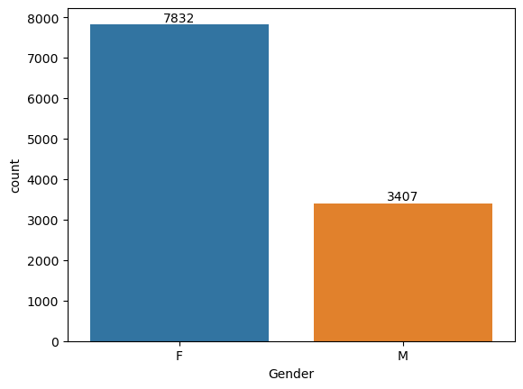F

Fig1: Gender Via Purchases

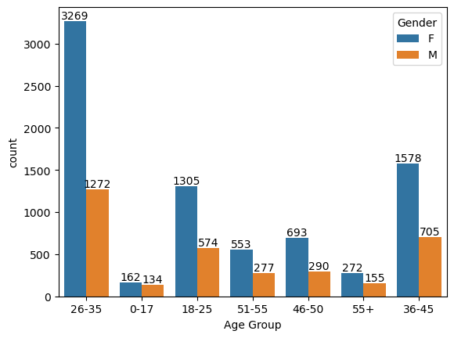
Fig2: Age Group Via Purchases

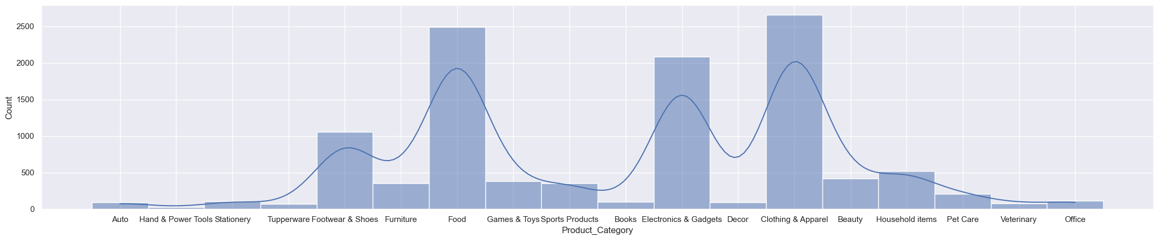Fig 3: Histplot on Product Category

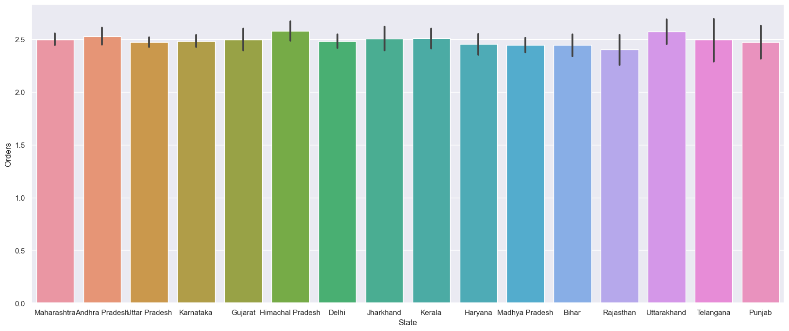Fig4: State Via Orders

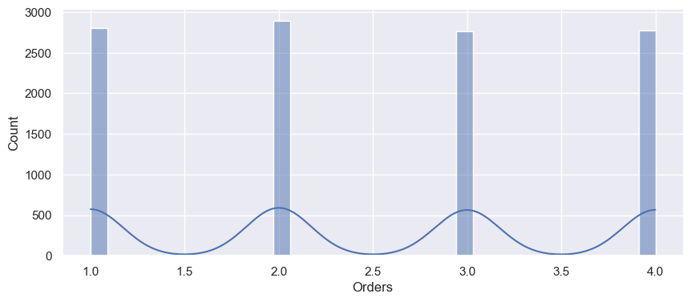Fig5: Histplot on Orders

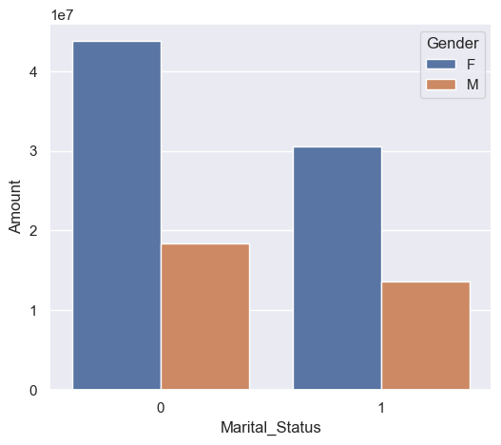
Fig6: Martial Status Via Purchases 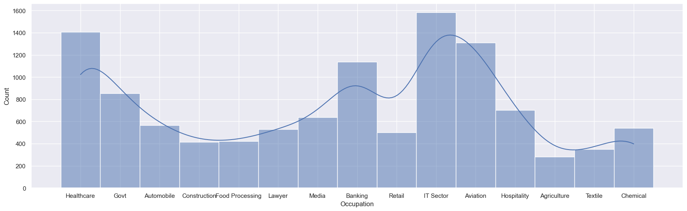
Fig 7: Occupation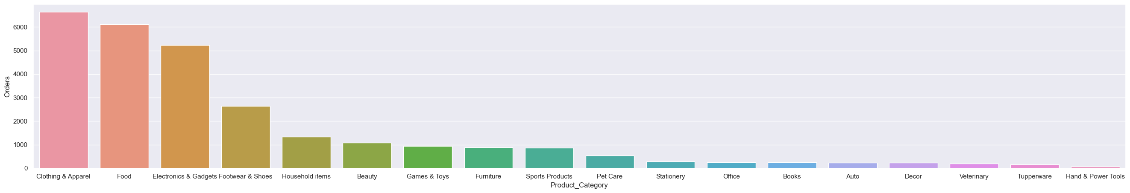
Fig8: Orders On Product Category

- CONCLUSION
In conclusion, the Diwali sales analysis methodology offers businesses a solid starting point for obtaining applicable insights from the holiday season. Businesses can identify trends, identify opportunities, and overcome challenges by collecting and analyzing large amounts of data on sales, customer behavior, and marketing effectiveness. While specific experimental results may vary between industries, the methodology presented here emphasizes the importance of segmentation, KPIs, and customer-focused analysis. To stay up to date on insights, industry reports, corporate disclosures, and market research studies become essential resources. Ultimately, the knowledge gained from this analysis helps businesses refine their strategies, maximize inventory, and enhance overall performance—developing a data-driven plan for the upcoming Diwali sales and other festive occasions.
- REFERENCES
a) Assessment of the effect of the judicial prohibition on firecracker celebration at the Diwali festival on air quality in Delhi, India. Shailendra Kumar Yadav, Rajeev Kumar Mishra, Bhola Ram Gurjar
Environmental Science and Pollution Research (2022),10.1007/s11356-021-17695-w

b) Spectrum of ocular firework injuries in children: A 5-year retrospective study during a festive season in Southern India. Deepa John, Swetha Sara Philip, Rashmi Mittal, Sheeja Susan John, Padma Paul, See fewer
Indian Journal of Ophthalmology (2015),10.4103/0301-4738.171966

c) Numerical simulations of different sectoral contributions to post monsoon pollution over Delhi
T. Mukherjee ,V. Vinoj, B. Adhikary, Helion (2020) , 10.1016/.2020.3548

d) Analysis and Forecasting of Sales Funnels Egor GrivaIrina ButorinaAnatoly SidorovPavel Senchenko See fewer Mathematics (2023), 10.3390/math11010105

