**Task-4, set up and use a fire wall**

**Fire wall rules**

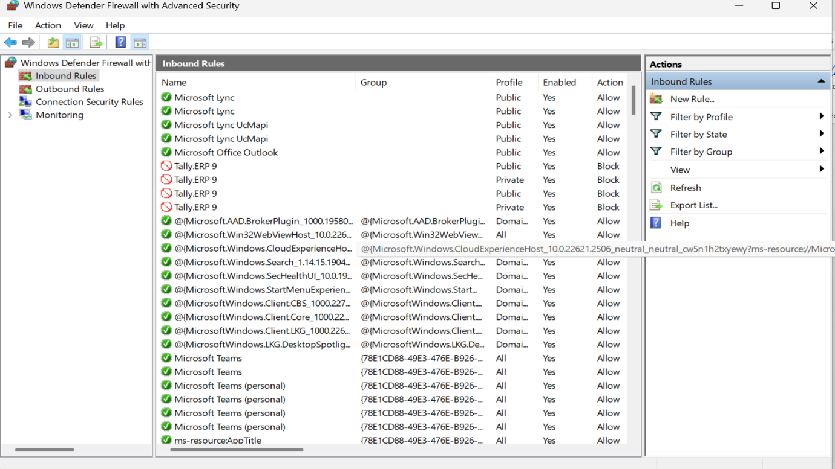**In bound rules**

**out bound rules**

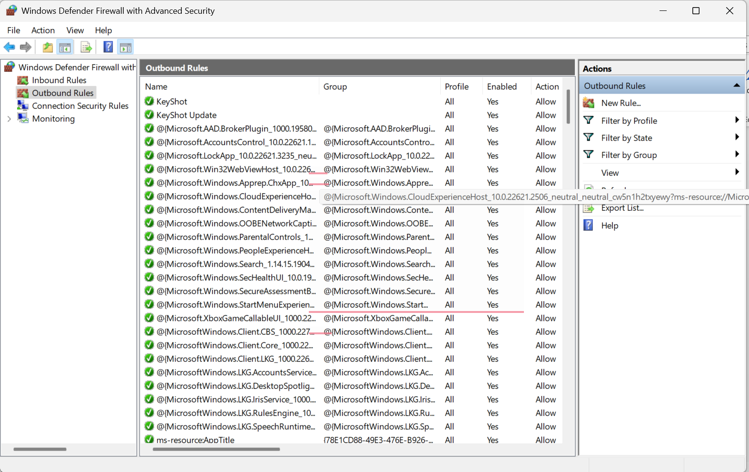

**In bound rules, the new rule port23 is blocked, deleted same via GUI afterward**

