

**Date: - 24/06/2020**

**COMP.6210**

**Web Services and Design Methodologies**

Assignment 1

**Sagar Devkota**

Student No: - 30004439

Date: - 03/09/2020

Toi Ohomai Institute of Technology

Table of Contents

Screenshot

PC ---------------------------------------------------------------------------------------------------3

Mobile ---------------------------------------------------------------------------------------------5

|  |  |
| --- | --- |
| **Name** | **Sagar Devkota** |
| **Student ID** | **30004439** |
| **cPanel**  **Username** | **a30004439** |
| **cPanel**  **password** | **toiohomai1234** |
| **cPanel**  **URL** | <https://cpanel.labnet.nz/cpsess6084934719/frontend/paper_lantern/index.html?login=1&post_login=61036873380096> |
| **GitHub**  **URL** | <https://github.com/Sagar1998a/6210.-Assignment> |

**Screenshot:**

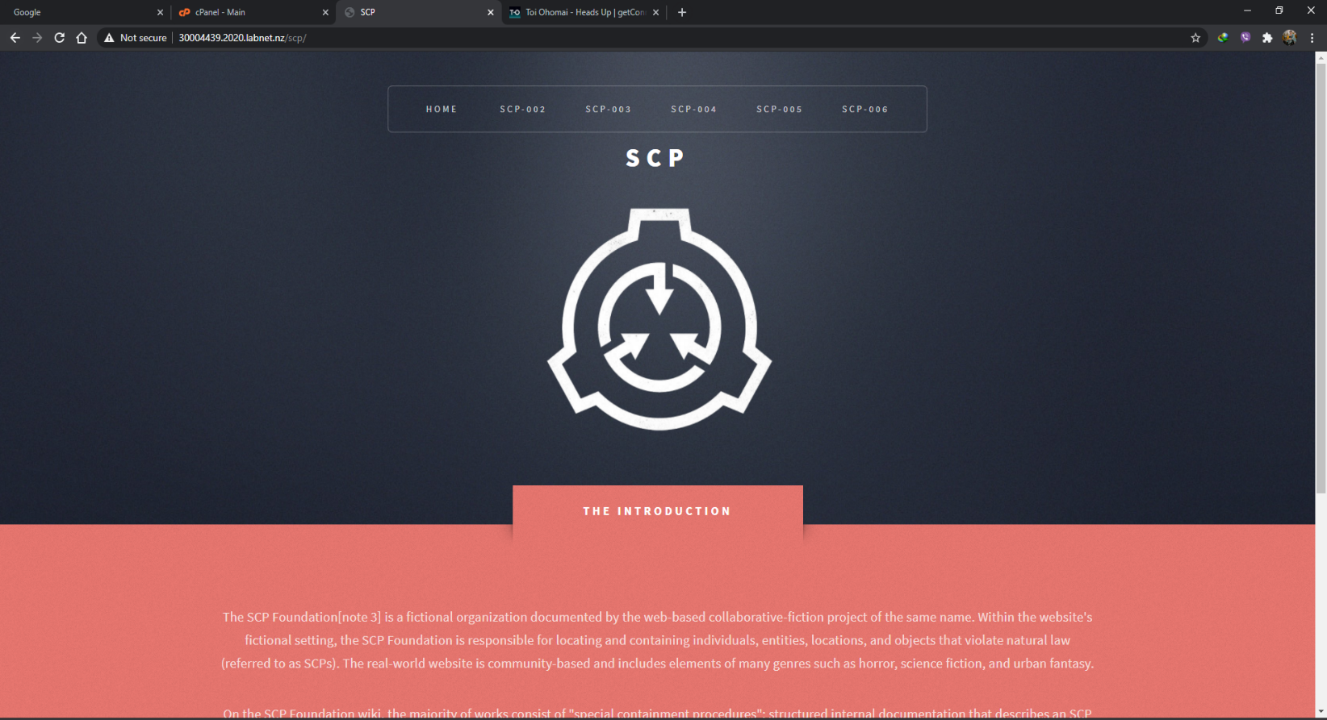**PC**

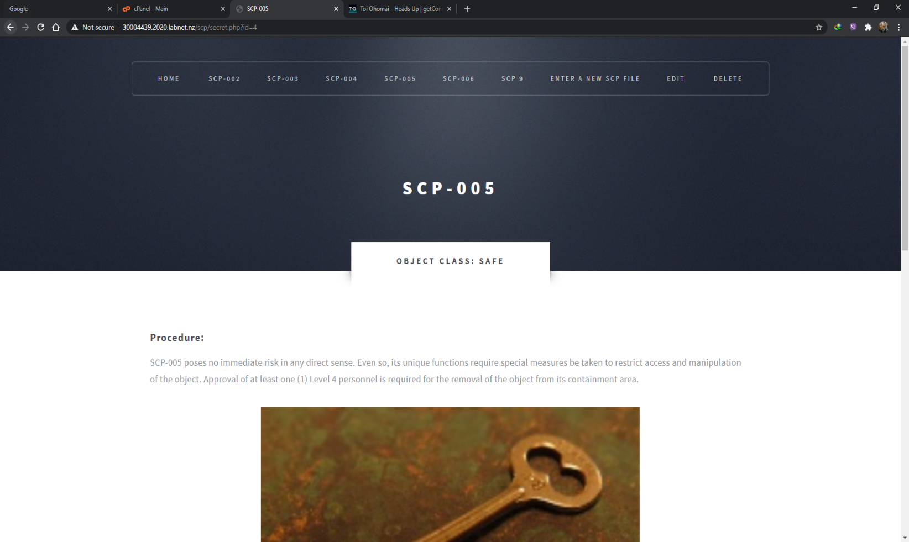

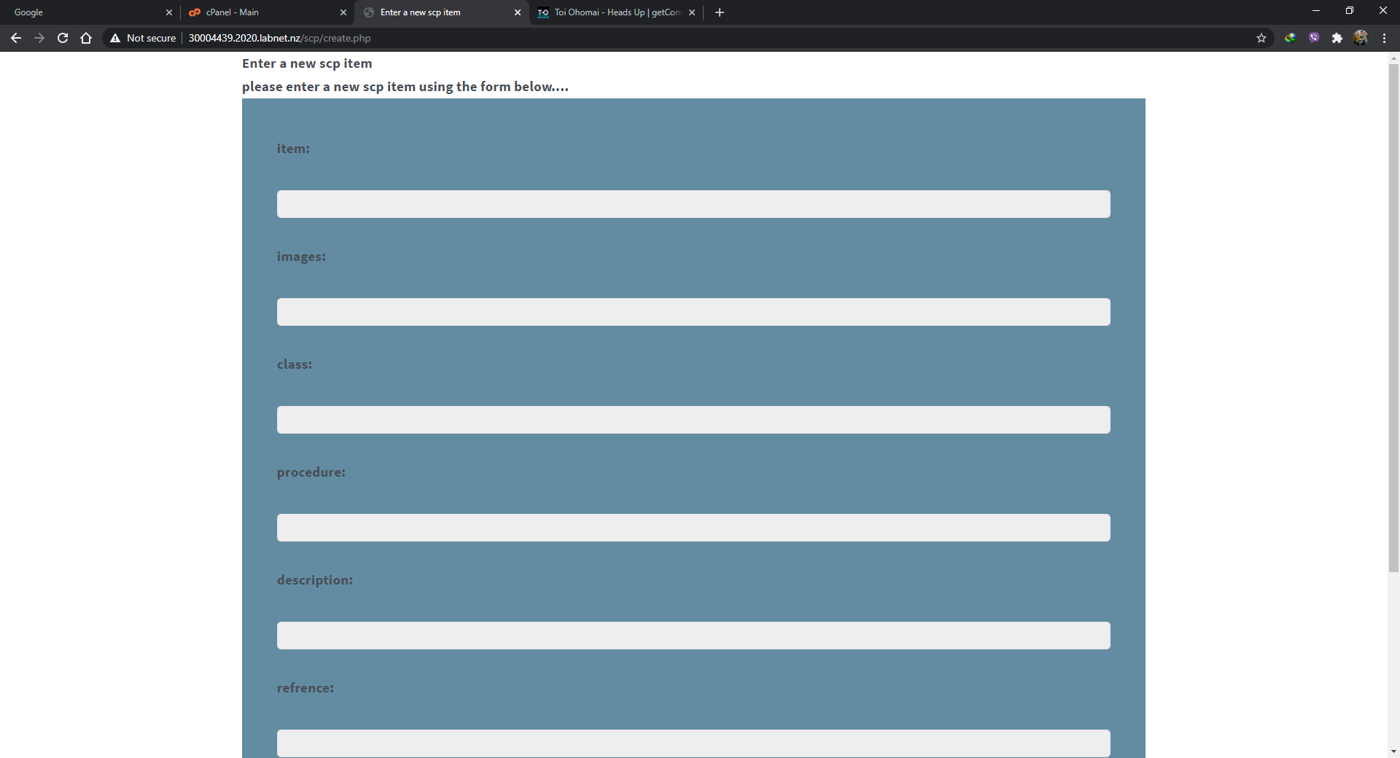

**Mobile: -**

