**Solar Panel Automated Data Dashboard.**

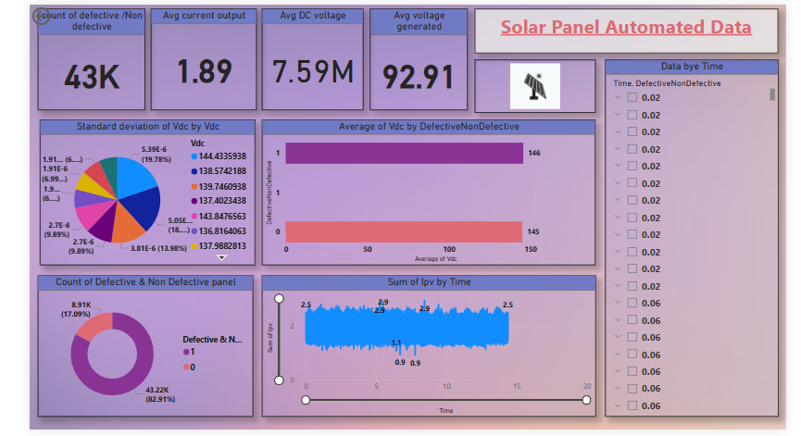

The solar panel automated data dashboard offers an in-depth analysis of defective and non-defective solar panels across different parameters such as Time, Ipv, Vdc, and Vpv. It highlights critical insights to reduce defects in solar panels, enabling stakeholders to make data-driven decisions.

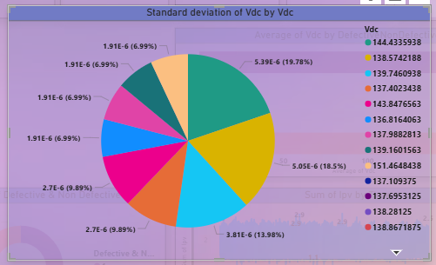

**Graph Name:** **Pie Chart**

**Standard Deviation of Vdc by Vdc**

**Analysis:**

The pie chart illustrates the distribution of standard deviation values for Vdc across different voltage levels. Higher deviations in certain segments indicate fluctuations in voltage regulation, which can affect overall system performance.

**+**

**Insight:**

Significant variations in Vdc suggest potential inconsistencies in solar panel voltage output. Addressing these deviations can help improve efficiency, reduce defects, and enhance overall system stability.

**Chart Name:**

**Average of Vdc by Defective/Non-Defective**

**Graph Type:**

**Bar Chart (Horizontal Bar Chart)**

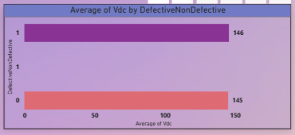

**Analysis:**

The chart compares the average Vdc values for defective and non-defective solar panels. Defective panels have a slightly higher average Vdc (146) compared to non-defective ones (145), indicating minimal variation.

**Insight:**

Since the difference in Vdc between defective and non-defective panels is small, other factors might contribute more significantly to panel defects. Further analysis of additional parameters like Ipv or Vpv could provide deeper insights.

**Chart Name:**

**Count of Defective & Non-Defective Panels**

**Graph Type:**

**Donut Chart**

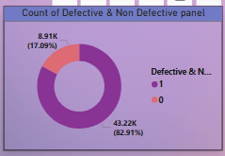

**Analysis:**

The chart shows the proportion of defective (1) and non-defective (0) solar panels. Non-defective panels make up **82.91% (43.22K)**, while defective panels account for **17.09% (8.91K)**, indicating a lower defect rate.

**Insight:**

The majority of solar panels are functioning correctly, but the **17.09% defect rate** suggests room for improvement in quality control and manufacturing processes to reduce defects further.

**Chart Name:**

**Sum of Ipv by Time**

**Graph Type:**

**Line Chart (or Area Chart)**

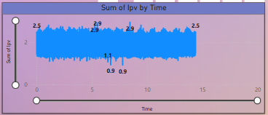

**Analysis:**

The graph shows the sum of Ipv (current) over time, with values fluctuating between **0.9 and 2.9**. The variations suggest continuous changes in current flow, possibly influenced by external conditions like sunlight intensity.

**Insight:**

The fluctuations in Ipv indicate varying solar panel performance over time. Monitoring these changes can help identify patterns and optimize efficiency by adjusting system parameters or maintenance schedules.

**Chart Name:**

**Data by Time**

**Graph Type:**

**Table View**

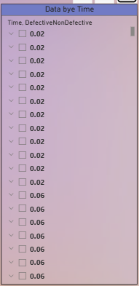

**Analysis:**

The table presents **Time** and **Defective/Non-Defective** values, where most entries show repeated values of **0.02** and **0.06**. This indicates a minimal variance in defect-related data over time.

**Insight:**

Since the defect data remains almost constant, it suggests that either the sampling method needs refinement or defects are not significantly time-dependent. Further analysis with additional parameters may be needed for deeper insights.

**Chart Name:**

**Key Performance Metrics Dashboard**

**Graph Type:**

**KPI (Key Performance Indicator) Cards**

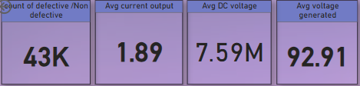

**Analysis:**

1. The total count of defective/non-defective panels is **43K**, indicating the dataset size.
2. The average current output is **1.89**, which may impact overall efficiency.
3. The average DC voltage is significantly high at **7.59M**, suggesting a large-scale operation.
4. The average voltage generated is **92.91**, indicating overall energy production efficiency.

**Insight:**

These KPIs provide a quick overview of solar panel performance. Monitoring the **current output and voltage generation** can help in optimizing panel efficiency and identifying potential defects early.

Project Build by:

Sagar jadhao