AI-Based Military Intrusion Detection System for Multiclass Network Threat Classification and Real-Time Monitoring
Prof. Sumedh Dhengre  Dept. Computer Engineering  AISSMS College of Engineering  Pune, India | Ms. Upeksha Kohak  Dept. Computer Engineering  AISSMS College of Engineering  Pune, India | Ms. Rajnandini Patil  Dept. Computer Engineering  AISSMS College of Engineering  Pune, India
Mr. Sagar Swami  Dept. Computer Engineering  AISSMS College of Engineering  Pune, India | Mr. Ayush Suryavanshi  Dept. Computer Engineering  AISSMS College of Engineering  Pune, India

ABSTRACT
The accelerating proliferation of cyber threats targeting defense networks, mission-critical communication infrastructures, and strategic command systems has necessitated the development of intelligent, adaptive, and operationally resilient intrusion detection mechanisms. Conventional signature-based detection methodologies, while effective against well-catalogued threat vectors, demonstrate significant performance degradation when confronted with evolving traffic behaviors, zero-day attack patterns, multiclass threat scenarios, and high-throughput network streams in which early and accurate classification is of paramount operational significance. This paper presents a comprehensive AI-based Military Intrusion Detection System (MIDS) specifically engineered to perform multiclass classification of malicious network activity and deliver real-time situational awareness through an integrated, command-center-style monitoring dashboard.
The implemented system is developed and evaluated using the UNSW-NB15 benchmark dataset, which is recognized for its broad representativeness of contemporary network attack behaviors. The system performs multiclass classification across ten distinct traffic categories encompassing DoS, Exploits, Fuzzers, Reconnaissance, Analysis, Backdoor, Shellcode, Worms, Generic attacks, and Normal traffic. A rigorous comparative evaluation framework is employed to benchmark K-Nearest Neighbors (KNN), Decision Tree (DT), Random Forest (RF), and Extreme Gradient Boosting (XGBoost) classifiers. Experimental results unambiguously demonstrate that XGBoost achieves superior predictive performance with a classification accuracy of approximately 83.39%, thereby constituting the primary deployment model for the operational system. The trained inference engine is subsequently integrated into a Streamlit-based interactive platform that supports telemetry ingestion, attack simulation presets, threat severity estimation, probability-aware classification reporting, baseline deviation analytics, historical alert logging, and multi-dimensional comparative visualization.
Beyond classification, the implemented system substantially enhances operator interpretability by systematically juxtaposing live telemetry observations against reference median profiles derived from the training corpus, thereby surfacing the most consequential signal deviations associated with each detection event. The culminating artifact constitutes a pragmatic cybersecurity prototype that harmonizes machine learning-driven prediction, operational analytics, and intuitive human-computer interaction paradigms. This work collectively demonstrates that intelligent multiclass intrusion detection frameworks can materially elevate both the detection efficacy and the operational usability of network defense workflows in high-security, defense-grade environments.
Keywords — Intrusion Detection System; Cybersecurity; UNSW-NB15; XGBoost; Multiclass Classification; Streamlit; Military Network Security; Real-Time Threat Monitoring; Machine Learning; Anomaly Detection
I. INTRODUCTION
Secure digital communication infrastructure constitutes an indispensable operational cornerstone for contemporary defense systems, strategic coordination networks, and mission-critical command-and-control architectures. These environments are persistently subjected to a diverse and continuously evolving spectrum of adversarial threats, encompassing distributed denial-of-service (DDoS) attacks, targeted service probing and reconnaissance operations, exploit-oriented intrusion attempts, covert backdoor communications, malware payload delivery mechanisms, and anomalous traffic bursts deliberately engineered to degrade service availability or compromise the integrity of classified assets. In such operationally demanding contexts, the velocity and reliability of threat detection are inextricably linked to the overall resilience of the defensive posture. Even transient delays or incomplete responses to malicious network behaviors can precipitate cascading consequences affecting confidentiality, data integrity, and service continuity within high-impact operational settings.
Conventional intrusion detection systems (IDS) have historically been predicated upon static signature repositories, threshold-based alerting mechanisms, and manually maintained security policy frameworks. While these approaches continue to deliver marginal utility against well-characterized threat signatures, their efficacy deteriorates substantially when network traffic patterns evolve beyond the boundaries of curated rule sets, or when a unified detection framework must simultaneously discriminate among multiple distinct attack families rather than performing a binary normal-versus-anomalous classification. Contemporary cybersecurity operational requirements therefore mandate the adoption of more adaptive, data-driven detection mechanisms capable of learning latent statistical patterns from representative training corpora and providing security analysts with expedited, high-fidelity, and contextually enriched threat classifications.
Machine learning (ML) methodologies provide a particularly compelling foundation for this paradigm shift, as they empower trained models to discover and internalize complex statistical dependencies among network-flow feature spaces and uncover behavioral signatures associated with both benign communication patterns and malicious activity. In contradistinction to traditional rule-based approaches, a properly trained ML model can infer intricate decision boundaries separating traffic classes and generalize effectively across morphologically related threat behaviors. This generalization capability is especially consequential in the context of multiclass intrusion detection, wherein the identification of the specific attack family confers substantially greater operational intelligence than a rudimentary binary anomaly verdict.
The system presented in this paper implements an AI-based Military Intrusion Detection System (MIDS) that seamlessly integrates multiclass threat classification with a real-time, operator-oriented visual monitoring dashboard. The system is trained and validated on the UNSW-NB15 dataset, benchmarks four canonical supervised learning algorithms, selects the empirically strongest classifier through rigorous comparative evaluation, and deploys the resulting inference engine within an analyst-facing Streamlit application. Alongside classification, the platform provides probabilistic threat confidence scores, threat severity interpretations, ranked signal deviation summaries, alert history archives, and comparative analytical visualizations, thereby ensuring that the final system deliverable constitutes not merely an academic model comparison, but a genuinely operational monitoring prototype of demonstrable practical value.
II. LITERATURE REVIEW
Intrusion detection has constituted an active and prolific research domain within the broader cybersecurity literature for several decades, driven by the persistent escalation in both the sophistication and operational frequency of network-based attack campaigns. Early scholarly contributions predominantly explored signature-based detection paradigms and statistical anomaly detection frameworks, while subsequent investigations increasingly embraced supervised machine learning methodologies applied to standardized benchmark datasets. The KDD Cup 99 and NSL-KDD datasets represented the foundational evaluation corpora for a substantial body of early research; however, both datasets have been subjected to sustained methodological criticism owing to issues of record redundancy, distributional artifacts, and temporal obsolescence. More recent scholarly work has progressively converged on the UNSW-NB15 dataset as the preferred evaluation benchmark, attributable to its more comprehensive representation of contemporary attack behavioral profiles and its substantially richer feature engineering.
An extensive body of empirical evidence demonstrates that tree-based and ensemble learning methodologies consistently deliver superior performance characteristics for structured intrusion detection classification tasks. Decision Tree (DT) classifiers are widely valued for their transparent decision logic and computationally efficient inference, though they remain susceptible to overfitting when trained on high-dimensional, overlapping feature spaces. Random Forest (RF) architectures mitigate this limitation through stochastic ensemble aggregation across multiple independently trained trees, typically exhibiting superior generalization performance relative to single-tree baselines. K-Nearest Neighbors (KNN) has similarly been applied to intrusion detection owing to its conceptual transparency, although its computational complexity during inference and performance degradation under high-dimensional class overlap represent significant practical limitations. Gradient boosting frameworks, most prominently XGBoost, have emerged as particularly compelling candidates, demonstrating consistent superiority in predictive performance through iterative residual correction and efficient non-linear feature interaction modeling on structured tabular data.
Within the specialized subdomain of multiclass intrusion detection, the scholarly community has increasingly emphasized that granular attack-family identification provides substantially greater operational value than coarse binary anomaly detection. Threat-category-specific classification enables more precisely tailored defensive response actions, including adaptive rate limiting for denial-of-service traffic, targeted forensic investigation protocols for backdoor-associated behavioral indicators, or directed vulnerability remediation workflows in response to exploit-oriented traffic patterns. Notwithstanding this acknowledged operational advantage, a substantial proportion of existing academic contributions continue to conclude their analyses at the classification stage, without extending their work to address the downstream challenge of result presentation and operator integration.
An increasingly prominent research theme in contemporary IDS literature concerns model explainability and operational integration within existing security infrastructure paradigms. Security analysts derive measurably greater operational benefit from detection systems that can justify their predictions through interpretable feature importance rankings, signal deviation quantification, or class-confidence reporting mechanisms. This research explicitly aligns with that trajectory by harmonizing rigorous model benchmarking and multiclass classification with a comprehensive user-facing monitoring interface that incorporates threat intelligence summaries, confidence-aware result presentations, baseline deviation comparisons, and persistent session intelligence logging.
III. PROBLEM IDENTIFICATION
The primary problem identified in this research initiative arises from the escalating complexity and sophistication of cyber threats targeting secure and defense-oriented network environments. As communication infrastructures expand in terms of scale, heterogeneity, and operational criticality, security operations teams are confronted with the formidable challenge of processing increasingly voluminous streams of network telemetry data within operationally constrained timeframes. The manual analysis of raw network flow records is inherently labor-intensive, cognitively demanding, and error-prone, particularly when operators must rapidly and reliably differentiate between inconsequential benign traffic fluctuations and behavioral indicators suggestive of reconnaissance activity, denial-of-service campaigns, exploitation attempts, or indicators of persistent compromise.
A second problem identified in existing intrusion detection workflows is the substantial and frequently underappreciated chasm that separates academic model evaluation from genuine operator-facing system usability. A preponderance of existing intrusion detection research efforts concentrate exclusively on maximizing classification accuracy metrics within offline experimental settings, without adequately addressing the pragmatic requirements of real-world operational deployment. In practice, however, detection outputs must be interpretable, temporally relevant, and immediately actionable. Security practitioners derive substantially greater operational value from systems that not only emit predicted threat labels, but also communicate classification confidence levels, elucidate the specific network-feature deviations that precipitated a detection event, and maintain persistent detection histories that support longitudinal situational awareness during continuous monitoring operations.
The concrete technical problem addressed in this paper is therefore the development of a practically deployable multiclass intrusion detection system capable of analyzing heterogeneous network-traffic feature vectors, identifying the most probable threat family with quantified confidence, and presenting the resulting analytical output within an intuitively structured dashboard suitable for continuous operational monitoring. The system must additionally support comparative model benchmarking, retain serializable trained model artifacts for reproducible deployment, generate interpretable analytical outputs, and remain fully accessible to security analysts requiring richer contextual information beyond a bare numeric classifier response. In its totality, this work simultaneously addresses both the prediction problem and the presentation problem inherent within contemporary intrusion detection system design.
IV. IMPLEMENTED SYSTEM AND METHODOLOGY
The implemented system constitutes a comprehensive AI-driven intrusion detection platform specifically architected for multiclass network threat classification and operator-centric operational monitoring. At the highest conceptual level, the system ingests network telemetry feature vectors, aligns them with the trained model's expected feature schema, performs probabilistic model inference, ranks probable attack-family classes in descending confidence order, assigns an operationally meaningful threat severity designation, and renders the resulting analytical output within an interactive, role-differentiated monitoring dashboard. This end-to-end workflow is designed to support both controlled experimental evaluation and realistic deployment-style operational usage scenarios.
The UNSW-NB15 dataset serves as the foundational data source for all model training, validation, and reference analytics construction activities. The training corpus encompasses both normal benign traffic records and a comprehensive enumeration of malicious traffic categories, thereby enabling the system to internalize a substantially richer multiclass classification structure than binary anomaly detection paradigms afford. In the implemented system configuration, the deployed multiclass inference model operates over 39 numerically encoded features encompassing session duration, packet counts, bytes transmitted, packet rate, source and destination load measurements, time-to-live values, inter-packet timing intervals, jitter statistics, mean packet size estimates, TCP timing indicators, and multiple connection-tracking statistics. These features collectively characterize network behavioral patterns from multiple complementary analytical perspectives, constituting a rich signal space for effective discrimination among distinct attack families.
To ensure rigorous and evidence-based model selection, four canonical supervised learning algorithms are systematically evaluated within a unified experimental framework. The comparative evaluation encompasses K-Nearest Neighbors, Decision Tree, Random Forest, and XGBoost. Each candidate model is independently trained and assessed against a held-out evaluation partition using accuracy, weighted precision, weighted recall, and weighted F1-score as primary performance indicators. This benchmark-driven model selection methodology guarantees that the ultimately deployed classifier is supported by verifiable empirical evidence rather than a priori assumptions regarding algorithmic superiority. Experimental results conclusively demonstrate XGBoost as the optimal performer across all evaluated metrics, qualifying it as the designated production inference bundle.
The methodological framework extends materially beyond the model training phase by constructing a comprehensive reference analytics layer derived directly from the training dataset. Category-specific median values and interquartile range statistics are computed for both normal and attack traffic profiles, along with granular attack-family behavioral signatures. These reference statistical profiles are subsequently leveraged within the operational dashboard to facilitate systematic comparison of live telemetry observations against learned behavioral baselines, thereby enabling the system to not only emit predicted attack-family labels but also expose the specific feature dimensions exhibiting the most pronounced deviation from established normal behavioral norms.
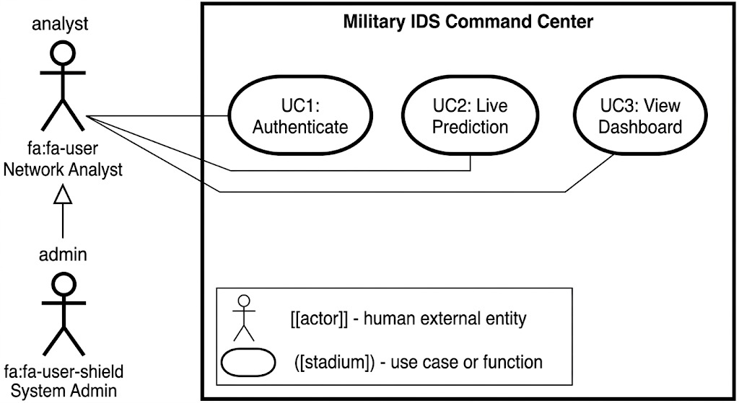
Fig. 1. Use case diagram of the Military IDS Command Center illustrating actor roles and system interactions.
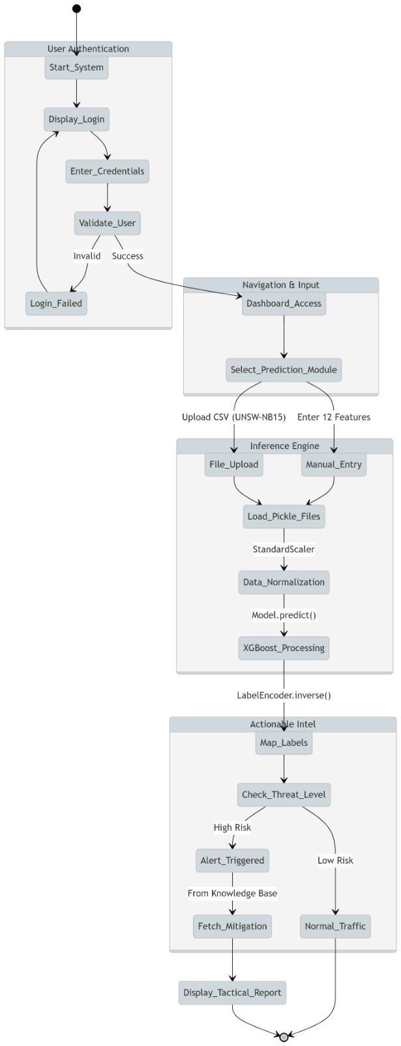
Fig. 2. Activity diagram depicting the authentication, inference engine, and threat response workflow.
V. IMPLEMENTED SYSTEM ARCHITECTURE
The overarching system architecture adheres to a rigorously stratified, three-tier layered paradigm that systematically interconnects the data acquisition and preprocessing subsystem, the machine learning inference and analytics engine, and the visual monitoring and presentation interface into a coherent, end-to-end operational workflow. This architectural decomposition ensures clear separation of concerns, facilitates independent component validation, and supports reproducible experimental evaluation.
The first architectural tier constitutes the Input and Telemetry Acquisition Layer, through which raw network telemetry feature values are introduced into the system either via manual analyst entry through the dashboard interface or through automated population utilizing preconfigured simulation presets encoding median behavioral signatures characteristic of each supported attack family. This layer functions as the primary live data ingestion point for the operational application.
The second architectural tier encompasses the Model Inference and Analytics Layer, wherein the system loads serialized model artifacts, feature schema definitions, and label encoding configurations from persistent storage. Input feature vectors are systematically organized into the expected column ordering and forwarded to the trained XGBoost classifier for probabilistic inference. Class posterior probability distributions are computed where supported by the model architecture, and the highest-confidence class designation is selected as the definitive prediction output. Concurrently, the identical input feature vector is systematically compared against both normal traffic reference medians and category-specific attack behavioral medians, enabling the quantification and ranked presentation of the most diagnostically significant feature deviations.
The third architectural tier implements the Presentation and Operational Monitoring Layer through the Streamlit application framework. This tier translates raw model inference outputs into a comprehensive, operator-oriented monitoring dashboard encompassing threat status indicators, classification confidence percentages, predicted attack-family designations, runner-up class probabilities, tactical threat intelligence briefings, telemetry snapshot summaries, anomaly signature visualization charts, feature comparison tables, live alert notification feeds, session detection timelines, and multi-session comparative analytics. The three-tier architectural decomposition collectively ensures reproducibility, operational interpretability, and a seamless transition pathway from offline model evaluation to interactive operational deployment.
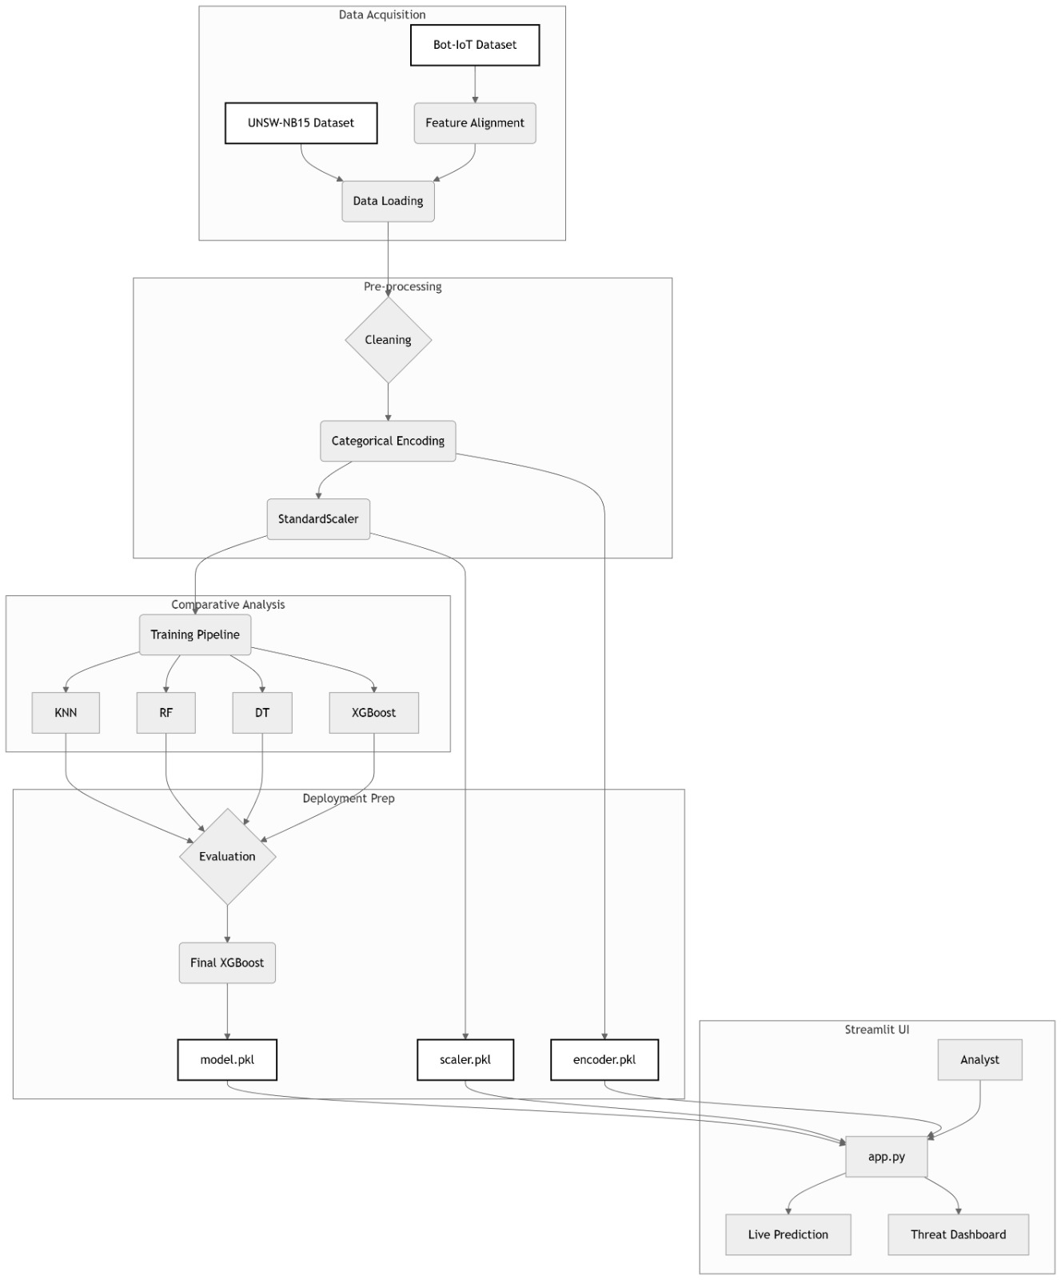
Fig. 3. System architecture diagram illustrating the data acquisition, preprocessing, model training, and Streamlit deployment pipeline.
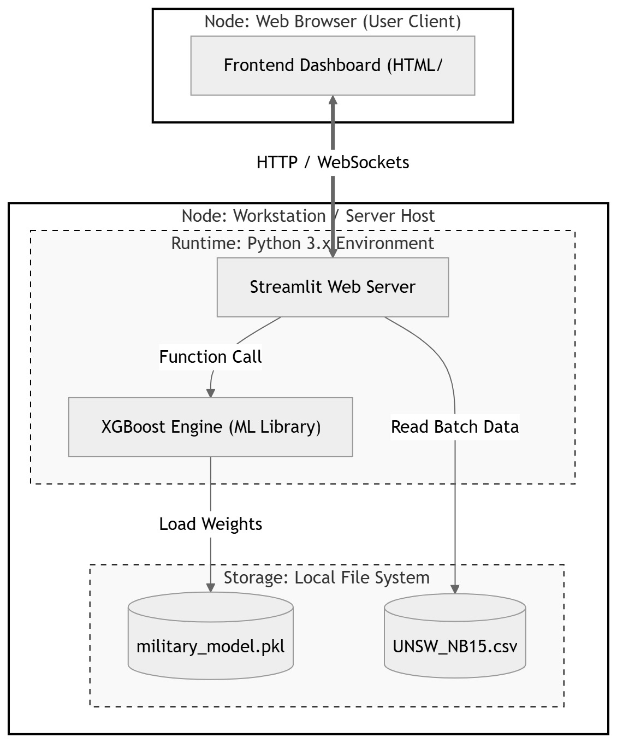
Fig. 4. Deployment diagram illustrating the client, Streamlit server, XGBoost inference engine, and persistent storage interactions.
VI. IMPLEMENTATION DETAILS
Dataset Description
This research employs the UNSW-NB15 benchmark dataset, which has achieved broad recognition and widespread adoption within the network intrusion detection research community owing to its substantially more representative characterization of contemporary network traffic dynamics relative to legacy evaluation corpora. Unlike antecedent benchmark datasets such as KDD Cup 99 and NSL-KDD, which have been extensively criticized for record redundancy, distributional artifacts, and temporal obsolescence, UNSW-NB15 encompasses a substantially broader and more realistic enumeration of attack behavioral categories alongside a correspondingly richer and more diverse feature engineering, rendering it highly suitable for contemporary machine learning experimentation within the cybersecurity domain.
In the specific implementation described herein, the training partition encompasses approximately 175,341 individual network flow records. The ratio of malicious traffic within the training corpus approximates 68.06%, indicating a dataset composition with a substantial adversarial component that meaningfully challenges classifier generalization. The observed class distribution encompasses Normal traffic alongside nine distinct adversarial traffic categories: Generic, Exploits, Fuzzers, DoS, Reconnaissance, Analysis, Backdoor, Shellcode, and Worms. This pronounced class diversity substantially reinforces the operational motivation for multiclass classification, as the appropriate defensive response strategy may differ significantly across these attack-family designations, with distinct categories demanding different prioritization levels, forensic workflows, and mitigation procedures.
The deployed inference model operates over a 39-dimensional feature space encompassing session duration, packet count statistics (transmitted and received), byte transfer volumes, packet transmission rate, source and destination time-to-live values, source and destination traffic load indicators, source and destination inter-packet timing statistics, network jitter measurements, mean packet size estimates, TCP timing indicators, and multiple connection-tracking statistical aggregates. Collectively, these feature dimensions characterize network communication behavioral patterns from packet-level, session-level, and aggregate-load analytical perspectives, providing the machine learning model with a rich and diagnostically informative signal space for learning discriminative boundaries among normal communication and the diverse enumeration of adversarial traffic behaviors.
The implemented MIDS application is developed entirely within the Python programming ecosystem and employs the Streamlit application framework as the primary deployment substrate for the interactive front-end monitoring dashboard. Core data acquisition, transformation, and analytical computation operations are implemented using the pandas data analysis library, while the joblib serialization framework is utilized for the persistent storage and efficient retrieval of trained model artifacts, feature schema definitions, and label encoder configurations. The machine learning inference stack is constructed upon the scikit-learn and XGBoost library ecosystems, and the matplotlib visualization library is employed for the programmatic generation of supporting analytical charts and comparative visualizations. This carefully curated technology stack provides a lightweight yet computationally sufficient execution environment for the construction and demonstration of a fully functional, deployable research prototype.
The application initiates operation with a role-differentiated authentication interface supporting distinct access modalities for Admin, Analyst, and Operator personnel classifications. Subsequent to successful credential validation, authenticated users are granted navigational access to two primary functional modules: the Real-Time Detection interface and the Comparative Analytics dashboard. Within the detection interface, the system exposes a primary telemetry feature control panel encompassing the most diagnostically influential input dimensions, including session duration, packet transmission rate, packet count statistics, byte transfer volumes, load measurement values, and session count indicators. Supplementary timing and session-level features are made accessible through a collapsible advanced configuration panel, enabling the interface to maintain operational approachability while simultaneously supporting the full richness of the model's input feature schema.
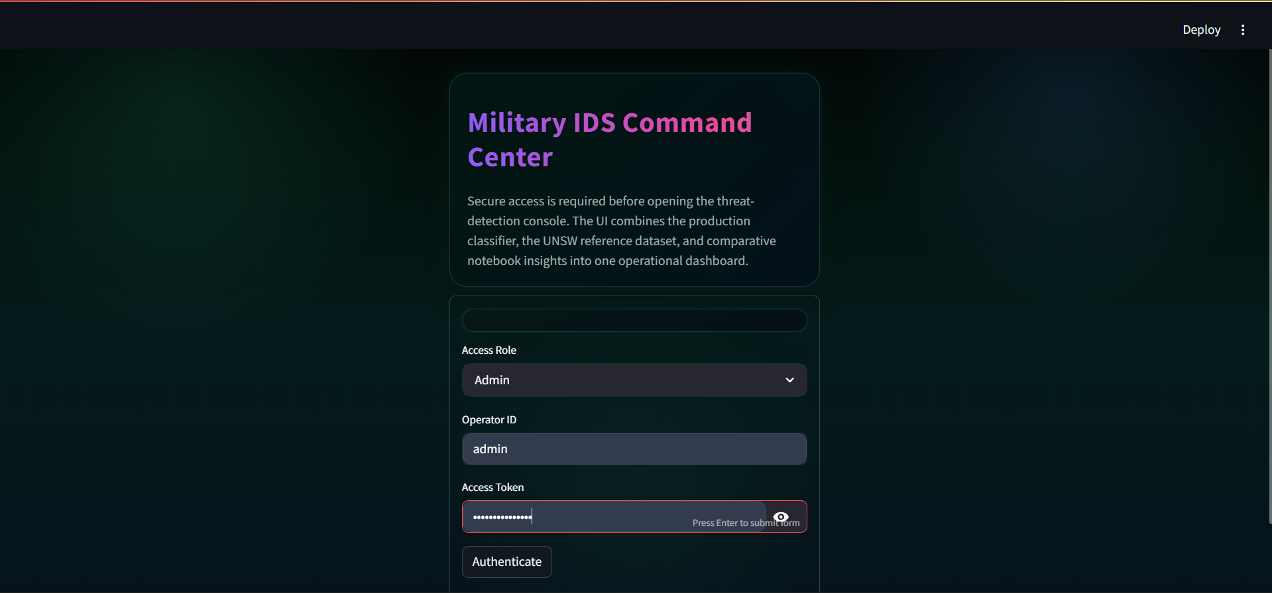
Fig. 6. Authentication interface of the Military IDS Command Center showing secure role-based operator access.
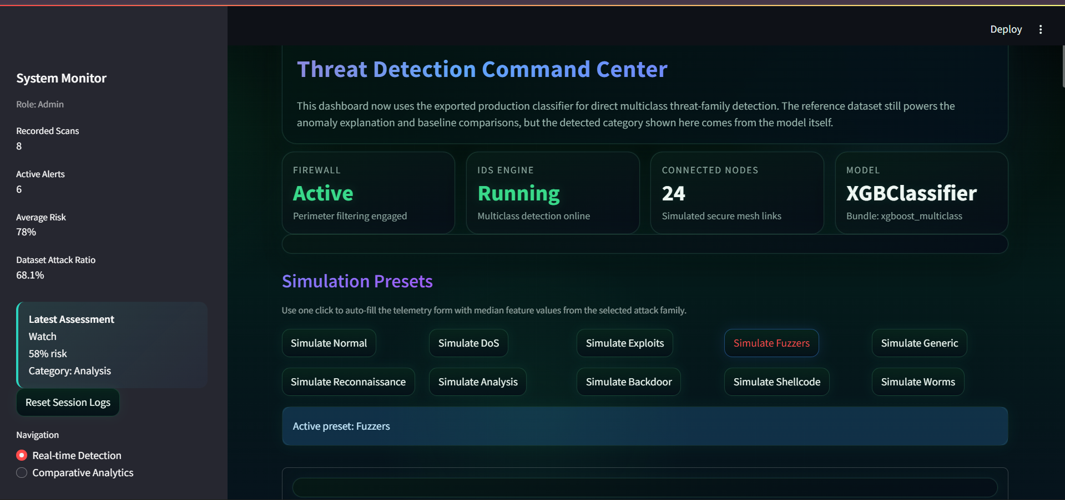
Fig. 7. Main dashboard overview presenting operational status cards and attack-family simulation presets.
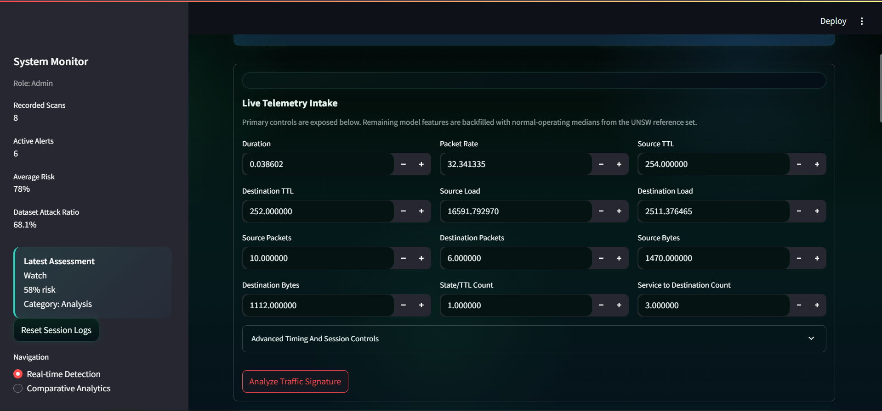
Fig. 8. Live telemetry intake interface used to enter key network-session features for real-time analysis.
Upon submission of a detection query, the application constructs a feature-complete input record by merging analyst-supplied telemetry values with reference default values for residual model inputs. The trained XGBoost classifier subsequently generates the predicted attack-family classification. When class posterior probability distributions are available from the model, the application computes a composite risk score derived from the maximum class probability and identifies the secondary runner-up class designation. A comprehensive threat knowledge base maps each predicted label to a corresponding severity tier, operational threat summary, anticipated operational impact assessment, and prioritized remediation recommendation. This contextual translation layer is of significant practical importance, as it transforms a raw classifier output into structured decision-support guidance that is substantially more comprehensible and actionable for human security analysts.
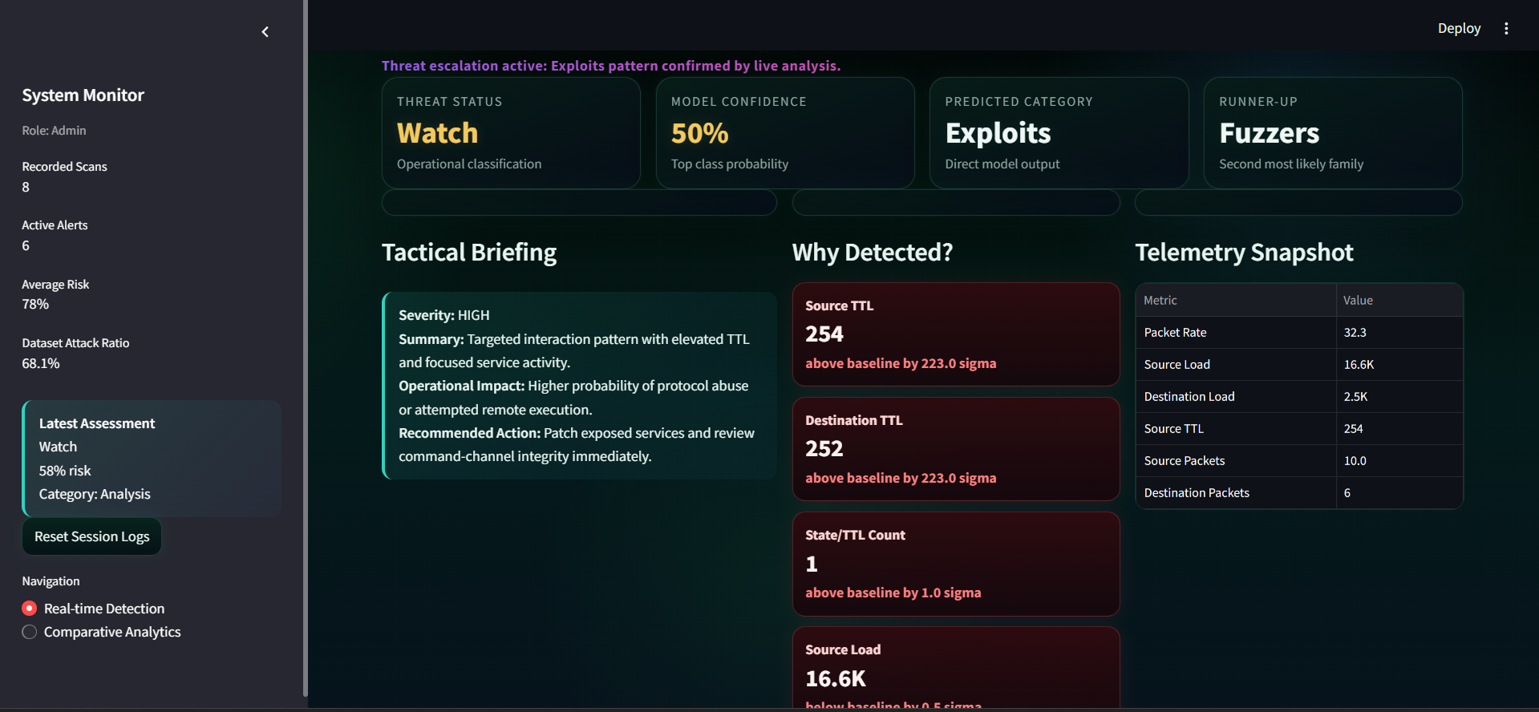
Fig. 9. Real-time detection result view showing predicted category, confidence score, and explainability-driven threat briefing.
The implementation additionally incorporates a persistent session logging subsystem that records each live or simulated detection event with associated metadata encompassing event timestamp, threat status classification, confidence score, predicted attack category, severity designation, primary signal deviation indicator, source IP address, and data feed type. This comprehensive event history supports timeline-based detection visualization, threat-distribution charting, downloadable session reporting, and a continuously updated live alert notification feed, collectively imbuing the deployed system with the operational character of a compact, functional command-center prototype for sustained continuous monitoring.
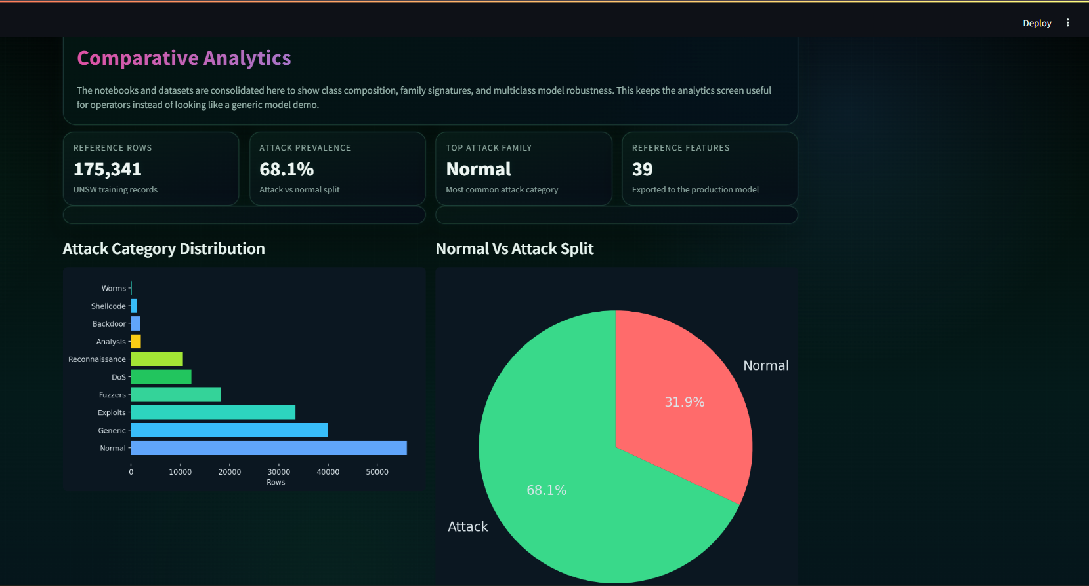
Fig. 10. Session intelligence dashboard illustrating the live alert feed, risk timeline, and session threat-mix analytics.
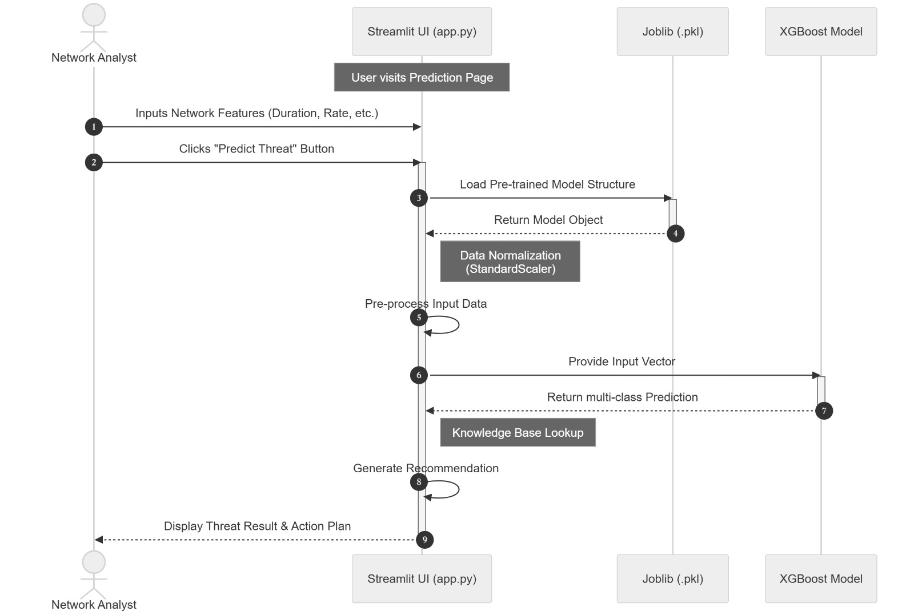
Fig. 5. Sequence diagram illustrating analyst interaction, model artifact loading, XGBoost inference, knowledge base lookup, and result presentation workflow.
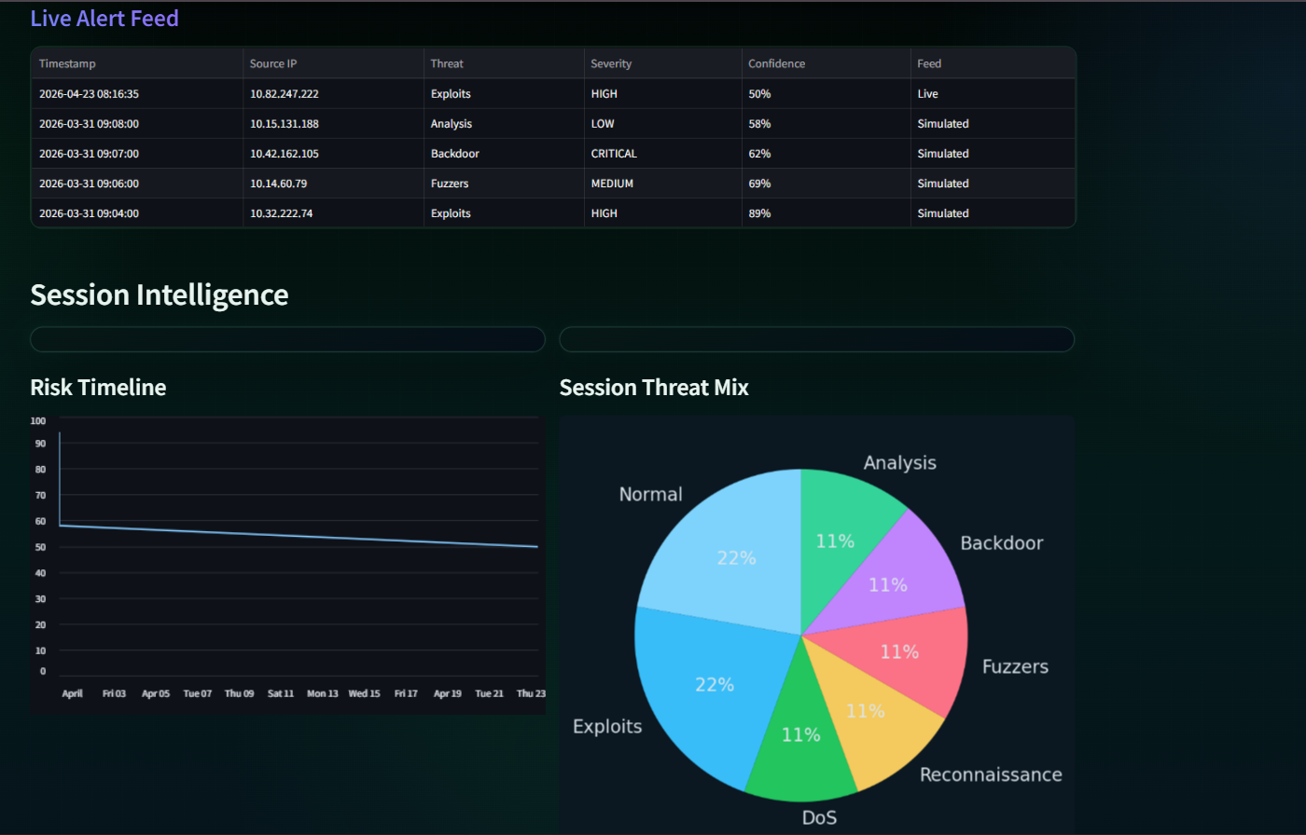
Fig. 11. Comparative analytics view summarizing attack-category distribution and the overall normal-versus-attack split in the reference dataset.
VIII. RESULTS, DISCUSSION, AND ADVANTAGES
A rigorous comparative empirical evaluation of four distinct machine learning classifier architectures was conducted as an integral component of the system development methodology. The evaluated models encompassed K-Nearest Neighbors, Decision Tree, Random Forest, and XGBoost. Benchmark evaluation results indicate that KNN attained a classification accuracy of approximately 66.67%, Decision Tree achieved 81.38%, Random Forest achieved 82.68%, and XGBoost achieved the superior performance of 83.39%. Consistent directional trends were observed across the weighted precision, recall, and F1-score metrics, with ensemble-based methodologies systematically outperforming the distance-based KNN baseline across all evaluation dimensions.
These empirical results substantiate the finding that the multiclass network intrusion detection task derives substantial benefit from classifier architectures capable of modeling non-linear feature interactions and complex decision boundaries among multiple overlapping traffic categories. KNN provides a useful lower-bound baseline but exhibits reduced robustness in this experimental setting, particularly when confronted with high-dimensional feature spaces and pronounced class overlap among related attack families. Decision Tree delivers substantially improved class separability but may exhibit sensitivity to training data perturbations. Random Forest achieves enhanced predictive consistency through stochastic ensemble aggregation, while XGBoost further elevates predictive performance quality through iterative residual error correction across a sequence of gradient-boosted trees.
The quantitative performance differential between Random Forest and XGBoost may appear numerically modest in isolation; however, in security-critical operational contexts, even incremental improvements in classification accuracy can translate into meaningfully more reliable detection outcomes across diverse and heterogeneous threat families encountered in production network environments. The practical significance of the selected XGBoost model is substantially amplified when the inference engine is embedded within the operational monitoring dashboard, wherein classification outputs are augmented with probabilistic confidence scoring, structured threat intelligence interpretation, and longitudinal session-level historical context.
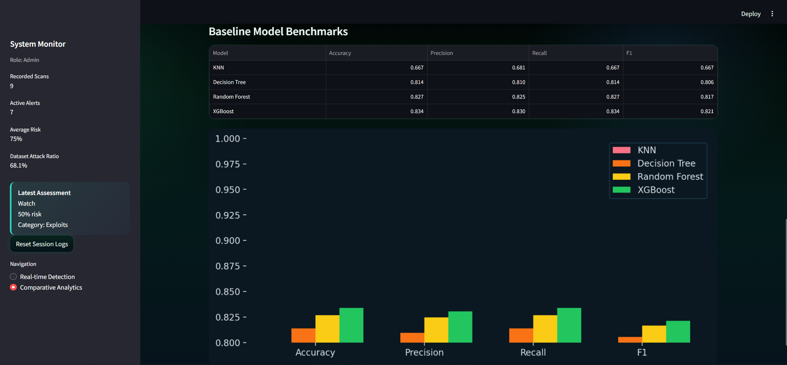
Fig. 12. Comparative benchmark dashboard showing model-wise accuracy, precision, recall, and F1-score, with XGBoost achieving the best overall performance.
An additional operational strength of the deployed system resides in its capacity to complement raw model output with explanation-oriented analytical features. Rather than exclusively presenting the predicted attack-family label, the application systematically surfaces the top-ranked deviating feature signals by quantitatively comparing the current sample against learned normal traffic baseline profiles. Category-specific median value comparisons and structured threat intelligence briefings incorporating severity designations and recommended defensive actions collectively serve to bridge the substantive gap between machine learning model experimentation and genuine operational analyst usability.
The implemented MIDS framework confers several operationally and academically significant advantages over conventional intrusion detection approaches. First and foremost, the system performs granular multiclass attack-family classification rather than constraining the detection task to a coarse binary normal-versus-anomalous discrimination. This substantially elevates the informational density of detection outputs and more effectively supports category-aware, differentiated incident response protocols.
Second, the system harmonizes probabilistic model inference with a real-time, operator-oriented visual monitoring dashboard. The preponderance of extant academic contributions terminate at offline evaluation metrics without extending their work into user-facing operational deployments; this implementation materially advances beyond that boundary by delivering a comprehensive command-center interface encompassing live alert notification feeds, detection risk timelines, threat-mix distribution analytics, and explainability-oriented feature deviation comparisons. Third, the project adheres to a benchmark-driven, evidence-based model selection methodology, ensuring that the deployed classifier is grounded in verifiable comparative empirical evidence. Finally, the system substantially enhances operational interpretability through structured threat intelligence summaries, confidence-stratified prediction ranking, systematic signal deviation analysis, and downloadable event history reporting, collectively rendering the solution more practically persuasive as a final-year research deliverable.
IX. CONCLUSION
This paper has presented a comprehensive AI-based Military Intrusion Detection System (MIDS) for multiclass network threat classification and real-time operational monitoring. Leveraging the UNSW-NB15 benchmark dataset, the research systematically evaluated four canonical supervised machine learning classifiers and unambiguously identified XGBoost as the superior performer among KNN, Decision Tree, Random Forest, and XGBoost architectures. The selected model attained a classification accuracy of approximately 83.39% and was successfully integrated into a Streamlit-based interactive monitoring dashboard supporting live telemetry analysis, probabilistic threat alerting, persistent session history management, and multi-dimensional comparative analytics.
A primary research contribution of this work resides in the successful harmonization of high-fidelity predictive classification capability with comprehensive operator-oriented presentation design. The system transcends the limitations of a conventional academic classifier by additionally communicating classification confidence levels, threat severity designations, recommended defensive actions, baseline feature deviation quantifications, and longitudinal session detection history. These integrative capabilities render the implemented solution substantially more operationally informative than a standalone academic classifier and considerably more persuasive as a demonstrably usable final-year cybersecurity research prototype.
In summation, this research demonstrates that rigorously designed machine learning frameworks can materially strengthen contemporary intrusion detection capabilities by delivering adaptive multiclass threat classification in conjunction with a usable, analyst-centric monitoring experience. The finalized system constitutes a substantive and meaningful foundation for future research endeavors in intelligent cyber-defense system design, real-time network traffic monitoring, and explainable operational analytics.
X. FUTURE SCOPE
The implemented MIDS framework is amenable to extension across multiple meaningful research and engineering directions that would materially elevate both its academic contribution and its practical operational utility. The most immediate and impactful extension pathway involves integration with real-time packet capture frameworks or network flow collection tools, enabling the dashboard to classify genuine live network traffic in lieu of analyst-entered telemetry values, thereby substantially advancing the system toward operational deployment readiness.
An additional high-impact extension direction concerns the systematic exploration of deep learning and hybrid classification architectures. While gradient boosted tree ensembles demonstrate superior performance on structured tabular feature representations, sequential neural network architectures or graph-based learning models may capture more complex temporal and topological dependencies present within richer, higher-fidelity network traffic streams. The integration of rigorous explainable artificial intelligence (XAI) frameworks, most prominently SHapley Additive exPlanations (SHAP), would additionally provide more mathematically principled feature attribution mechanisms and substantially enhance analyst trust in model predictions.
The system further presents compelling integration opportunities with established Security Operations Center (SOC) and Security Information and Event Management (SIEM) platform ecosystems, automated threat alert routing pipelines, and policy-governed response orchestration frameworks. Such integrations would enable ML-driven classification outputs to trigger downstream defensive actions including automated notification workflows, adaptive traffic rate limiting, targeted host isolation procedures, and guided forensic investigation processes. Through the systematic realization of these extensions, the current research prototype could evolve into a broadly capable, production-grade intelligent cyber-defense platform of substantial operational significance.
REFERENCES
[1] N. Moustafa and J. Slay, "UNSW-NB15: A comprehensive data set for network intrusion detection systems," in Proc. Military Communications and Information Systems Conf. (MilCIS), Canberra, Australia, Nov. 2015, pp. 1–6.
[2] T. Chen and C. Guestrin, "XGBoost: A scalable tree boosting system," in Proc. 22nd ACM SIGKDD Int. Conf. Knowledge Discovery and Data Mining (KDD), San Francisco, CA, USA, 2016, pp. 785–794.
[3] L. Breiman, "Random forests," Machine Learning, vol. 45, no. 1, pp. 5–32, Oct. 2001.
[4] J. R. Quinlan, "Induction of decision trees," Machine Learning, vol. 1, no. 1, pp. 81–106, Mar. 1986.
[5] I. H. Witten, E. Frank, and M. A. Hall, Data Mining: Practical Machine Learning Tools and Techniques, 3rd ed. Burlington, MA, USA: Morgan Kaufmann, 2011.
[6] M. Tavallaee, E. Bagheri, W. Lu, and A. A. Ghorbani, "A detailed analysis of the KDD CUP 99 data set," in Proc. IEEE Symp. Computational Intelligence for Security and Defense Applications (CISDA), Ottawa, ON, Canada, Jul. 2009, pp. 1–6.
[7] A. Shiravi, H. Shiravi, M. Tavallaee, and A. A. Ghorbani, "Toward developing a systematic approach to generate benchmark datasets for intrusion detection," Computers & Security, vol. 31, no. 3, pp. 357–374, May 2012.
[8] S. Ioffe and C. Szegedy, "Batch normalization: Accelerating deep network training by reducing internal covariate shift," in Proc. 32nd Int. Conf. Machine Learning (ICML), Lille, France, Jul. 2015, pp. 448–456.

