**Problem Statement: Flight Booking Automation**

**Verticle:**

**Advantages of Flight Automation:**

* **Easy to book Tickets**
* **Save time**
* **Provides every information about flight**
* **Easy to see price list**
* **Get paid quickly and securely**

**Test Data:**

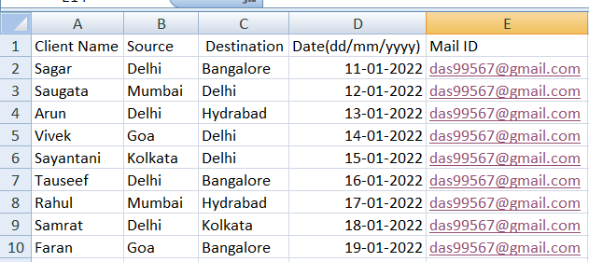

**Manual Process:**

**Automation Process:**

**Dispatcher**



Performer

