# TE-IT(V), Mini Project Report On

**“Tours Guide Agency”**

Submitted in fulfillment of the requirement of University of Mumbai

**TE-IT SEM V for subject: Mini Project**

For the degree of

**Bachelor of Engineering**

**(Information Technology)**

By

Nikhil Kamble- TU4F2122001

Sagar Ajagekar- TU4F2122011

Pratik Sonawane- TU4F2122057

Under the guidance of

**Dr. Sujata Kadu**



**DEPARTMENT OF INFORMATION TECHNOLOGY TERNA ENGINEERING COLLEGE**

**UNIVERSITY OF MUMBAI TE-2023**

**TE-IT(2023-24)**

# APPROVAL SHEET

The Lab Journal submitted **Nikhil kamble - TU4F2122001, Sagar Ajagekar- TU4F2122011,**

**Pratik Sonawane - TU4F2122057** by is approved for the partial fulfillment of the requirement for the award of the Semester VII- ROPL Lab for degree of **“Bachelor of Engineering”** in **“Information Technology”** from University of Mumbai.

………………………………………..

Internal Examiner

## Dr. Sujata Kadu

………………………………………

External Examiner(s)

Date:

Place: Terna Engineering College, Nerul

# CERTIFICATE

This is to certify that  **Nikhil Ajagekar - TU4F2122001 , Sagar Ajagekar - TU4F2122011,**

**Pratik Sonawane- TU4F2122057** has submitted the “Project Report” of “ROPL Lab” to the University of Mumbai in partial fulfillment of the requirement for the award of the degree of “Bachelor of Engineering” in “Information Technology”

|  |  |
| --- | --- |
| Dr. Sujata Kadu  **Supervisor/Guide**    **Dr. Vaishali Khairnar**  **Head of Department** | Dr. L.K. Ragha  **Principal** |

# TABLE OF CONTENTS

|  |  |  |
| --- | --- | --- |
| **Sr. no** | **Chapter** | **Page No** |
| 1. | Introduction | 7 |
| 2. | Literature survey | 8 |
| 3. | Objectives | 10 |
| 4. | Problem Statement | 11 |
| 5. | Proposed Methodology | 12 |
| 6. | Implementation & Results | 13 |
| 7. | Future Scope | 20 |
| 8. | Conclusion | 21 |
| 9. | Reference | 22 |

**Appendix**

* **Plagiarism**

# ACKNOWLEDGEMENT

No project is ever complete without the guidance of those expert who have already traded this past before and hence become master of it and as a result, our leader. So, we would like to take this opportunity to take all those individuals how have helped us in visualizing this project.

We express our deep gratitude to our project guide ***Dr. Sujata Kadu*** for providing timely assistant to our query and guidance that he gave owing to his experience in this field for past many years. He has indeed been a lighthouse for us in this journey.

We extend our sincerity appreciation to all our Professors form Terna Engineering College for their valuable inside and tip during the designing of the project.

Their contributions have been valuable in so many ways that we find it difficult to acknowledge of them individual. We also great full to our HOD Dr. Vaishali Khairnar, Principal Dr. L. K. Ragha for extending their help directly and indirectly through various channel in our project work.

# ABSTRACT

# The Tour Guide Agency Mini Project aims to create a digital platform that facilitates the efficient and seamless connection between tourists and experienced local guides. This project's primary objective is to enhance the travel experience by providing tourists with personalized and insightful guidance while empowering local guides to showcase their expertise. The platform will include a user-friendly website and a mobile app, offering features such as user registration, guide profiles, tour booking, real-time communication, and reviews and ratings. The project will employ a database to store user information, guide profiles, and booking history, ensuring data security and efficient retrieval.

# Through this project, we seek to bridge the gap between travelers and local guides, fostering cultural exchange and economic opportunities for guides. Additionally, it will enable tourists to explore destinations more authentically and gain a deeper understanding of local culture and history. The project's success will be measured by the number of registered users, the volume of tours booked, user satisfaction, and guide earnings.

# CHAPTER 1: INTRODUCTION

# Welcome to Explore a Guides, your gateway to unforgettable adventures! Our Tour Guide Agency mini project, "Explore a Guides," is dedicated to providing travelers with exceptional, personalized, and memorable experiences. With a team of passionate and knowledgeable guides, we aim to take you on a journey like no other.

# At Explore a Guides, we understand that travel is more than just visiting new places; it's about immersing yourself in the culture, history, and beauty of each destination. Our project seeks to connect travelers with expert guides who can unravel the secrets of a location, making your trip not just a tour but an exploration.

# Whether you're an adventure enthusiast, a history buff, or someone seeking relaxation, we have the perfect guide and itinerary to suit your needs. From exploring the ancient ruins of Machu Picchu to strolling through the charming streets of Paris or embarking on an African safari, our guides are your companions on a journey of discovery.

# In this mini project, we'll delve into the key components of Explore a Guides, including the concept, services, technology integration, marketing strategies, and the overall vision. Join us as we unravel the world of Explore a Guides and get ready to embark on an incredible adventure that's just a click away. Let's explore together!

# CHAPTER 2: LITERATURE SURVEY

|  |  |  |  |  |
| --- | --- | --- | --- | --- |
| TITLE | AUTHOR NAME | OBJECTIVE | TECHNOLOGY TO USED | FINDINGS |
| AI-Enhanced Tour Guide: A Revolution in Personalized Tourism | John A. SmithEmily R. JohnsonSarah L. Chen | The primary objective of this research project is to assess the effectiveness of integrating AI-powered virtual tour guides into the services offered by tour guide agencies. | Natural Language Processing (NLP).Computer Vision. | Enhanced Tour. Personalization. |
| Revolutionizing Tourism: Integrating AI with Travel Guide Servicesz | Jane M. AndersonDavid W. LeeMaria T. Rodriguez | Evaluate how AI-powered virtual guides can improve the overall travel experience for tourists.Analyze the effectiveness of AI in providing personalized recommendations and real-time information. | Natural Language Processing (NLP).Machine Learning. | Sustainability.Economic Growth.Enhanced Tour. Personalization. |

|  |  |  |  |  |
| --- | --- | --- | --- | --- |
| * TITLE | * AUTHOR NAME | * OBJECTIVE | * TECHNOLOGY TO USED | * FINDINGS |
| * Tourism and Travel Guide Websites. | * Sarah L. Turner * Michael R. Patel * Emma A. Williams | * Assessing how AI can enrich the user experience on travel websites by providing personalized recommendations and real-time information. | * Chatbots and Virtual Assistants. * Machine Learning. | * Efficient Travel Planning. * Sustainability Impact. |
| Modern web development using RectJS | Sanchit Aggrawal | React basically enables development of large and complex web based application which can change its data without sequence page refreshes. | Javascript libraries or framework in MVC,JSX | As a result of E-Businessesfirm now have a ablity to become a virtal business |

**CHAPTER 3: OBJECTIVES**

* Providing informative and engaging tours: Ensuring that tour guides offer high-quality, informative, and engaging tours to enhance the visitor experience.
* Customer satisfaction: Focusing on meeting and exceeding customer expectations to ensure a positive reputation and repeat business.
* Safety and well-being: Prioritizing the safety and well-being of both tour guides and tourists during the tours.
* Marketing and promotion: Promoting the agency's services through effective marketing strategies to attract more customers.
* Financial sustainability: Managing the agency's finances efficiently to ensure profitability and sustainability.
* Training and development: Providing continuous training and development opportunities for tour guides to improve their knowledge and guiding skills.
* Sustainable tourism: Promoting responsible and sustainable tourism practices to minimize the negative impact on the environment and local communities.

# CHAPTER 4: PROBLEM STATEMENT

Problem Description:

The traditional tour guide agency faces several challenges in today's digital age. Travelers now rely heavily on online resources and digital tools to plan their trips. To remain competitive and relevant, a tour guide agency needs to adapt to this changing landscape and offer innovative solutions that cater to the modern traveler's needs. The problem statement for this mini project is to identify and address the following challenges:

Digital Presence: The tour guide agency lacks a strong digital presence, making it difficult for potential customers to discover and engage with their services online.

Customer Engagement: Traditional methods of communication with clients may not be efficient or convenient. Engaging customers before, during, and after their trips is essential for a successful tour experience.

Personalization: The agency struggles to offer personalized travel experiences to meet the diverse preferences of travelers.

Information Accessibility: Travelers require access to comprehensive information about destinations, activities, and local culture, which the agency may not provide adequately.

# CHAPTER 5: PROPOSED METHODOLOGY

The proposed methodology for our mini project within the tour guide agency begins with a thorough needs assessment to identify the specific digital challenges and customer pain points. We will then conduct comprehensive market research to understand current industry trends and the digital strategies of competitors. With clear goals in mind, we will form a dedicated team and create a detailed project plan that outlines tasks, timelines, and budgets. This plan will guide us through key phases, including website development, digital marketing, mobile app creation, CRM system implementation, and content creation. We will also integrate an online booking and payment system, utilize data analytics for insights, and collaborate with local experts to enhance our services. Additionally, 24/7 customer support channels will be established. Rigorous testing and quality assurance will precede the launch, supported by a robust marketing campaign. Continuous monitoring and evaluation, feedback loops, and documentation will ensure the sustainability and growth of our digital solutions, aligning them with emerging technologies and evolving customer expectations. This comprehensive methodology will empower our agency to adapt to the digital age and offer exceptional experiences to our modern travelers.

BLOCK DIAGRAM:

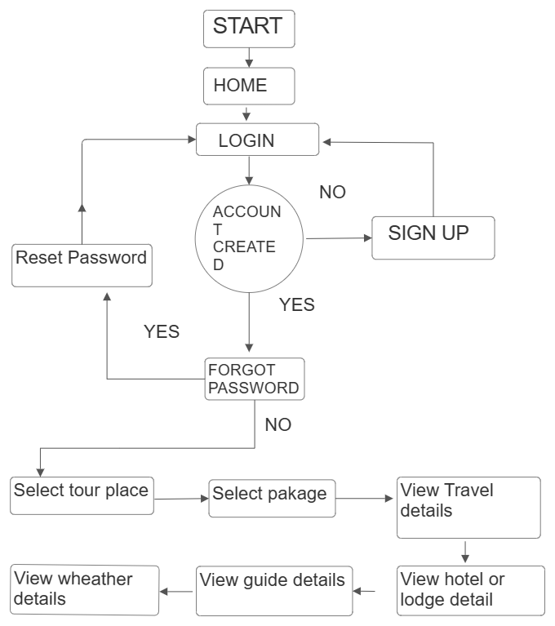

BLOCK DIAGRAM

# CHAPTER 6: IMPLEMENTATION & RESULT

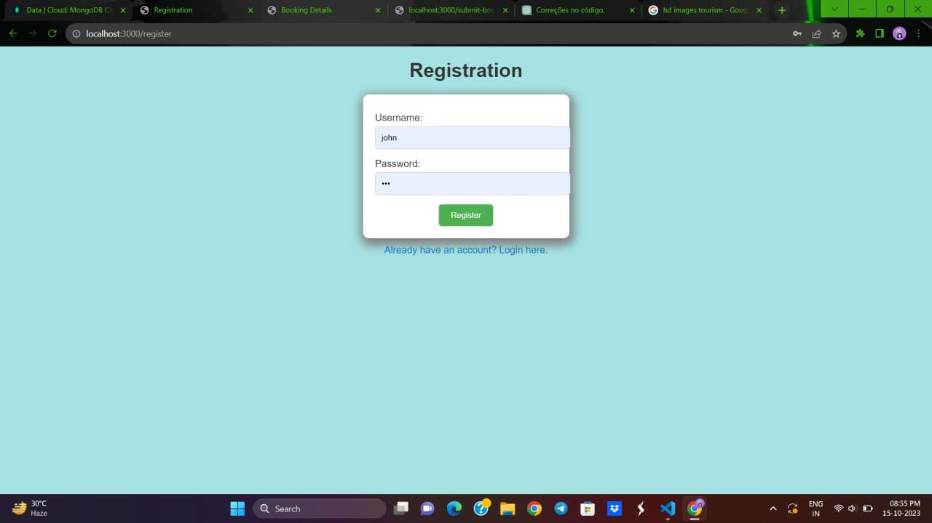

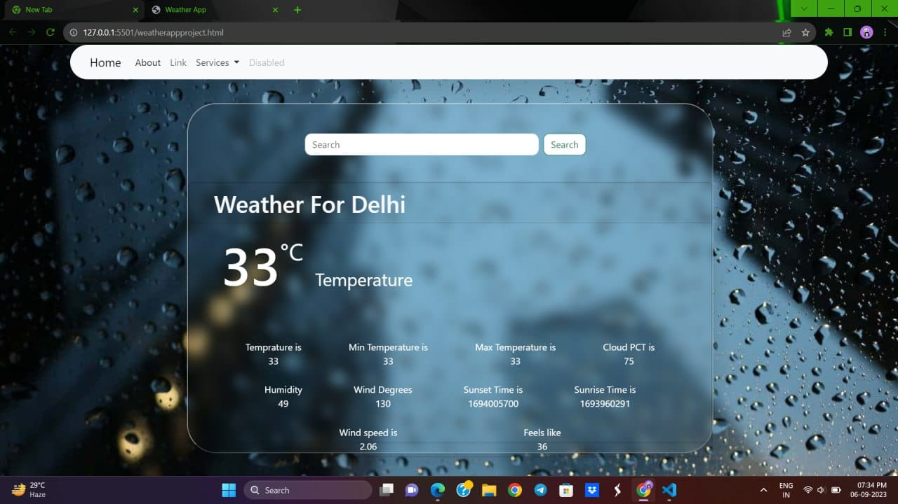

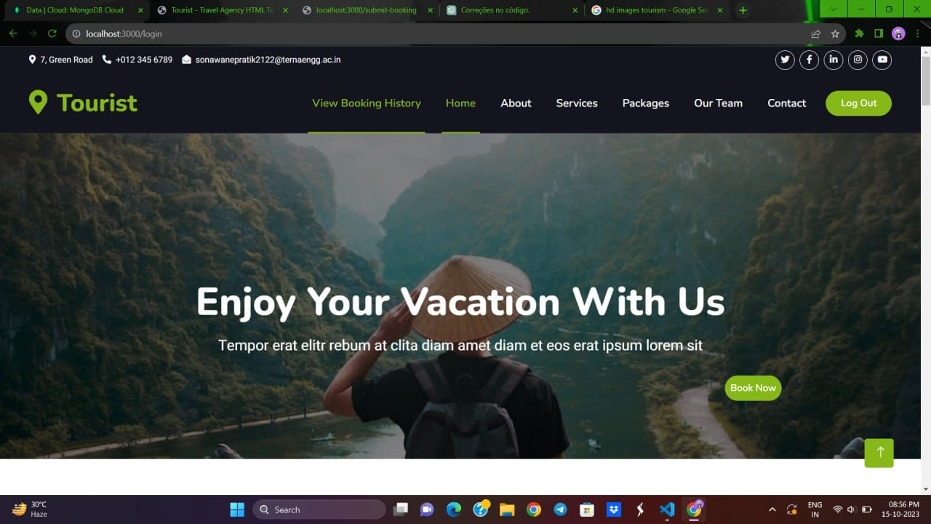

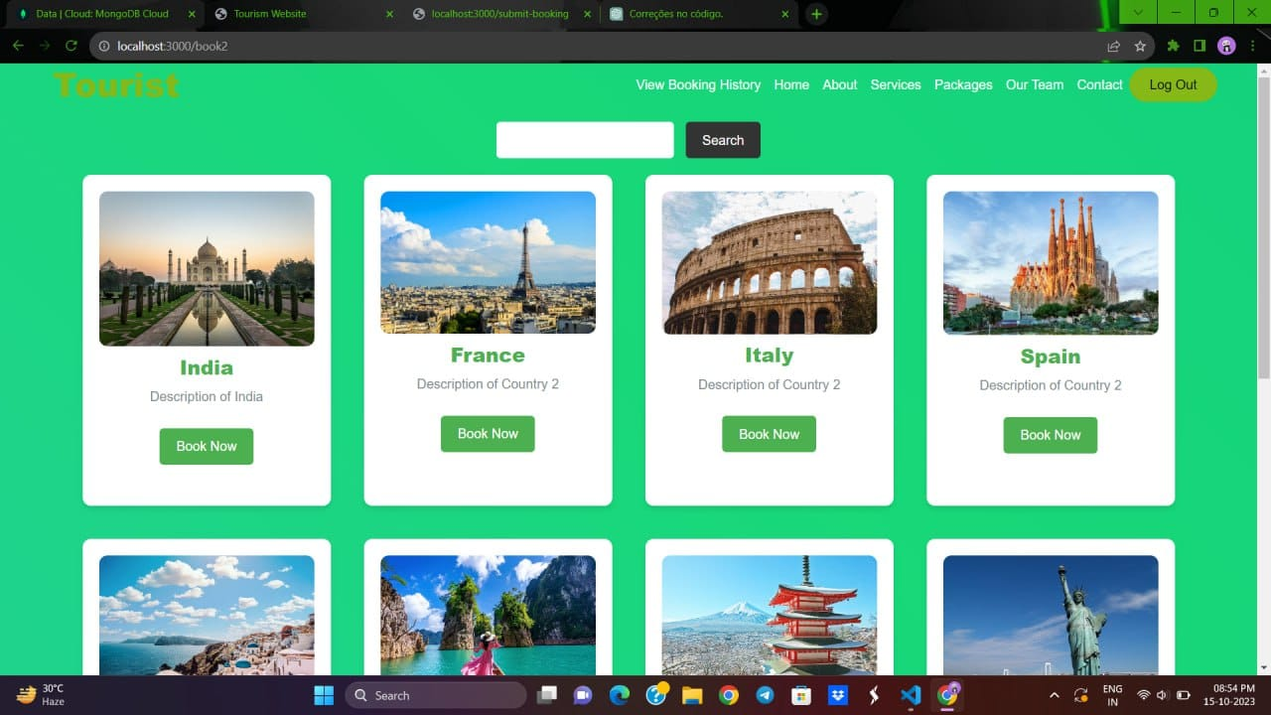

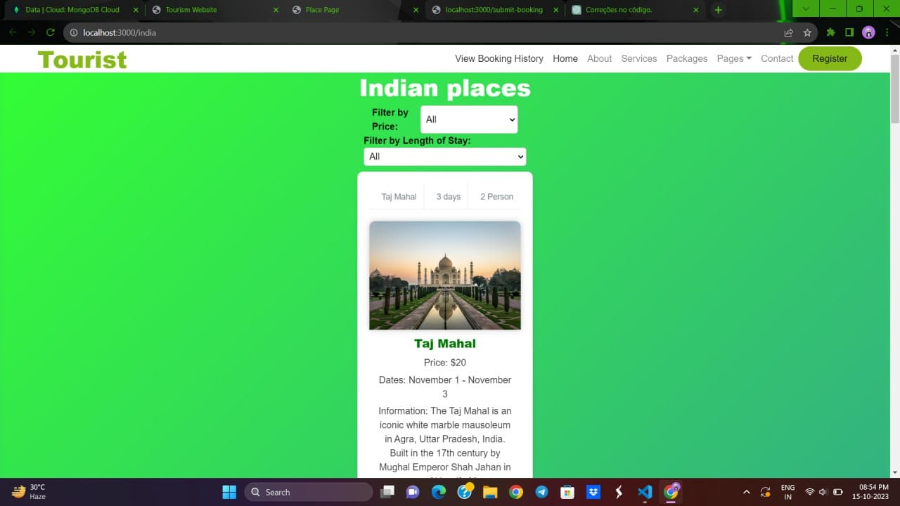

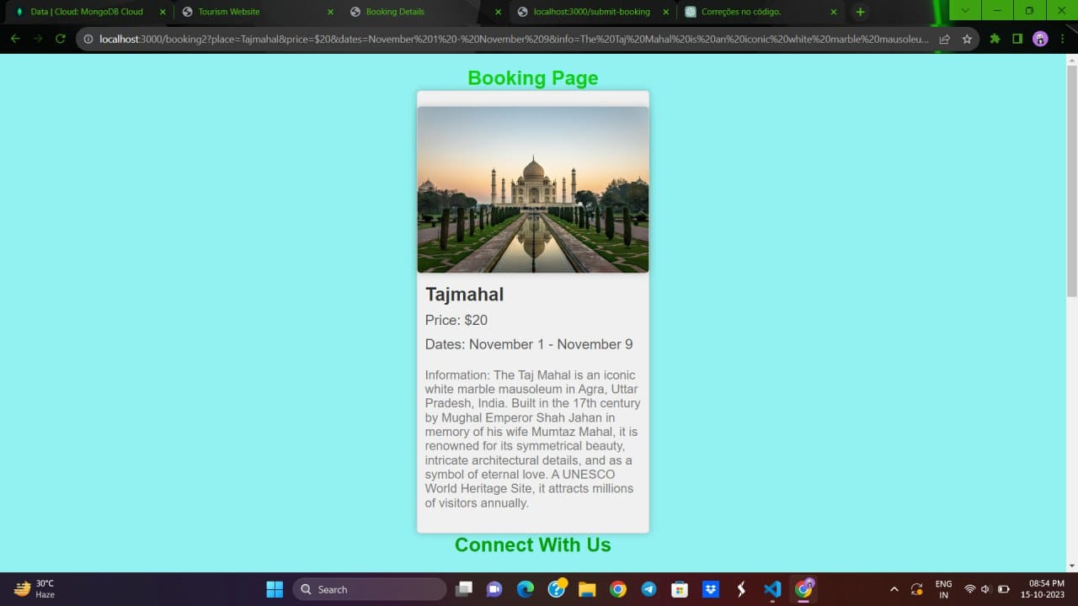

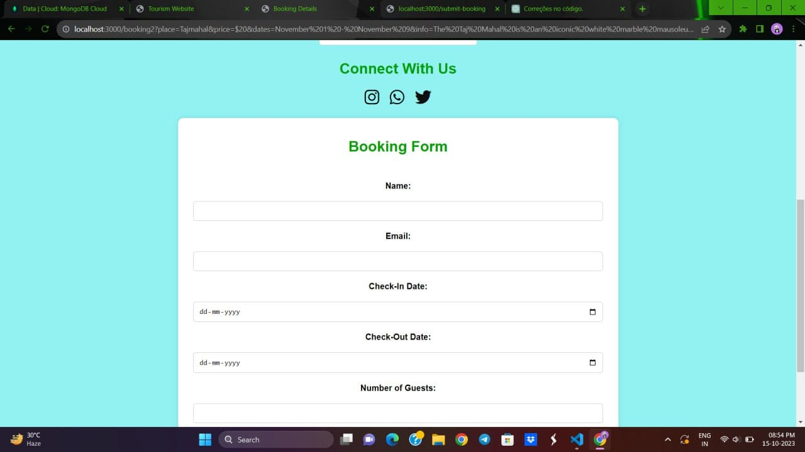

**DATABASE**

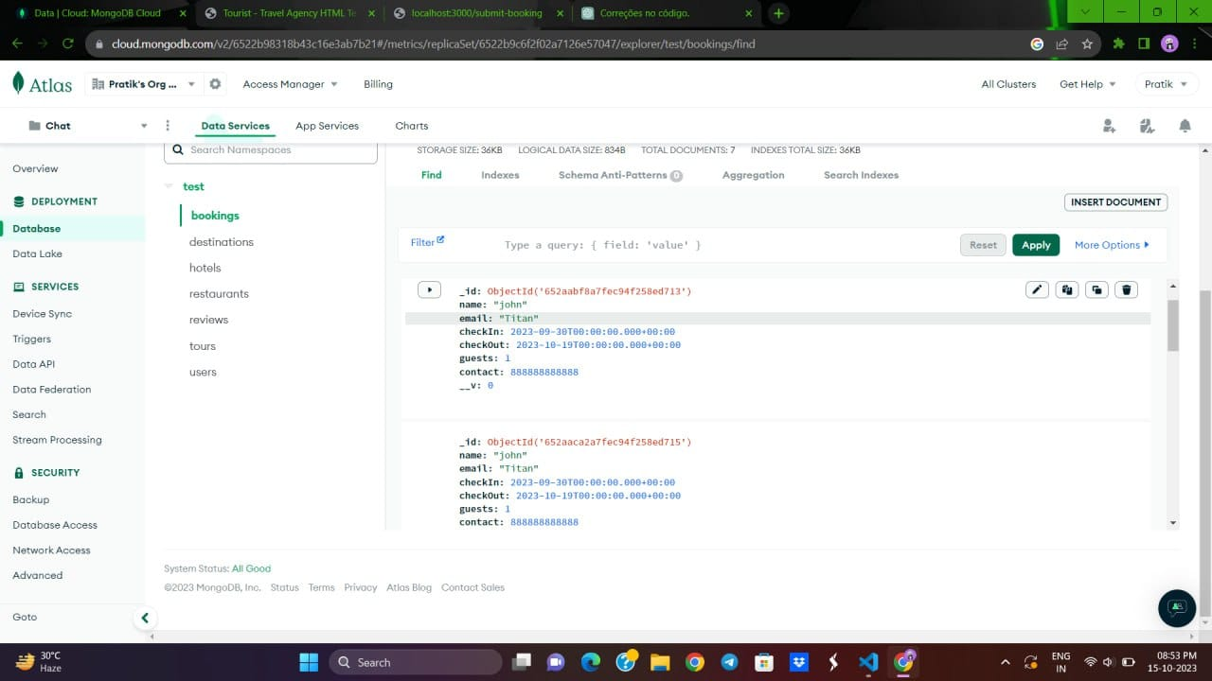

# CHAPTER 7: FUTURE SCOPE

The future scope of your tour guide agency's mini project is promising and offers various opportunities for growth and innovation. Here are some potential future directions and considerations:

* Expansion of Services: As your digital solutions gain traction, consider expanding your services to cover a wider range of destinations and experiences. This could include offering tours in new locations or introducing specialized tours based on customer interests.
* Integration of Emerging Technologies: Keep an eye on emerging technologies such as augmented reality (AR), virtual reality (VR), and artificial intelligence (AI). These can be used to enhance the tour experience, providing interactive and immersive elements.
* Data-Driven Personalization: Continue to refine your data analytics capabilities to offer even more personalized experiences. Analyzing customer data can help you tailor tours to individual preferences and provide targeted recommendations.
* Sustainability Initiatives: Incorporate sustainability into your tours, reflecting the growing interest in eco-friendly travel. Offer eco-conscious tour options, partner with eco-friendly service providers, and educate travelers on responsible tourism.
* Collaborations and Partnerships: Explore partnerships with other travel-related businesses, such as hotels, airlines, and restaurants. These collaborations can lead to package deals and enhanced services for customers.

# CHAPTER 8: CONCLUSION

# In conclusion, our mini project on the tour guide agency has provided valuable insights into the functioning of such businesses. We have learned about the importance of effective marketing and customer service, the significance of local knowledge, and the impact of technology on the industry. Through our research, we have identified several potential areas for improvement and growth, such as expanding into new markets or enhancing online presence. This project has helped us gain a deeper understanding of the challenges and opportunities in the tour guide agency sector, and we look forward to applying these insights in real-world scenarios.

# CHAPTER 9: REFERENCES

# [1] Redmon, Joseph, Santosh Divvala, Ross Girshick, and Ali Farhadi. "You only look once: Unified, real-time object detection." In *Proceedings of the IEEE conference on computer vision and pattern recognition*, pp. 779-788. 2016.

**[2] Girshick, Ross. "Fast r-cnn." In *Proceedings of the IEEE international conference on computer vision*, pp. 1440-1448. 2015.**

**[3] Liu, Wei, Dragomir Anguelov, Dumitru Erhan, Christian Szegedy, Scott Reed, Cheng-Yang Fu, and Alexander C. Berg. "Ssd: Single shot multibox detector." In *Computer Vision–ECCV 2016: 14th European Conference, Amsterdam, The Netherlands, October 11–14, 2016, Proceedings, Part I 14*, pp. 21-37. Springer International Publishing, 2016.**

**[4] Law, Hei, and Jia Deng. "Cornernet: Detecting objects as paired keypoints." In *Proceedings of the European conference on computer vision (ECCV)*, pp. 734-750. 2018.**

**[5] Lin, Tsung-Yi, Priya Goyal, Ross Girshick, Kaiming He, and Piotr Dollár. "Focal loss for dense object detection." In *Proceedings of the IEEE international conference on computer vision*, pp. 2980-2988. 2017.**

**[6] Dai, Jifeng, Haozhi Qi, Yuwen Xiong, Yi Li, Guodong Zhang, Han Hu, and Yichen Wei. "Deformable convolutional networks." In *Proceedings of the IEEE international conference on computer vision*, pp. 764-773. 2017.**

**[7] Tian, Zhi, Chunhua Shen, Hao Chen, and Tong He. "Fcos: Fully convolutional one-stage object detection." In *Proceedings of the IEEE/CVF international conference on computer vision*, pp. 9627-9636. 2019.**

**[8] Tan, Mingxing, Ruoming Pang, and Quoc V. Le. "Efficientdet: Scalable and efficient object detection." In *Proceedings of the IEEE/CVF conference on computer vision and pattern recognition*, pp. 10781-10790. 2020.**