AGILE PROJECT MANAGEMENT
& SYSTEM DESIGN REPORT
Academic Assignment Report (DA1) for Library Management System
STUDENT NAME: Sagar Bankapur
EMAIL ID: sagar.sbankapur2024@vitstudent.ac.in
JIRA SITE BASE: https://vitstudent-team-r6bfp56o.atlassian.net
JIRA BOARD LINK: https://vitstudent-team-r6bfp56o.atlassian.net/jira/software/projects/SCRUM/boards/1
DATE OF SUBMISSION: August 1, 2026

1. Executive Summary & Project Objectives
This comprehensive project documentation details the engineering and management processes implemented to design, build, and deploy a responsive Library Management System (LMS) web application. Managing software lifecycles in academic environments requires structured Agile methodologies. To achieve this, we implemented the Scrum framework inside Jira to organize requirement files, create backlog structures, estimate work complexity, and monitor daily tasks.
All software components of the Library Management System are fully functioning. The application features a React, TypeScript, and Vite frontend architecture, simulating transactional persistence via web LocalStorage. Key capabilities include Role-Based Access Control (RBAC), multi-criteria catalog search, inventory catalog management, circulation rules, fines calculations, and book reservations queues.
Key System Objectives Covered in Development:
• Jira Project Setup: Configuring a Scrum Board and defining an 8-Epic hierarchical breakdown structure.
• System Analysis: Drafting formal SRS specifications and creating StarUML Use Case and Activity Diagrams.
• Database Architecture: Normalizing transactional data to 3NF and defining a relational ERD database schema.
• Role-Based Authentication: Implementing JWT-based secure routing limits for Admins, Librarians, and Students.
• Book & Member Inventory: Building forms for item CRUD configurations and registration logs.
• Circulation Engine: Writing state management routines for checkouts, returns, and daily fine accruals ($1.00/day).
• Borrowing Policies: Creating configurators to adapt limits (max loan count, checkout days, fine rates).
• Reservation Queue: Setting up automated waitlists for out-of-stock items, allocating copies upon return.

2. Jira Scrum Configuration & Backlog Setup
To establish tracking integrity, the Jira board was initialized using the project key 'SCRUM'. The development team established a five-column Scrum pipeline (To Do, In Progress, In Code Review, In QA, Done) to control item transitions and enforce code quality checks. Work has been planned and executed across three distinct Sprints.
Jira Configuration Parameter | Workspace Value
Account Owner Name | Sagar Bankapur
Primary Registered Email | sagar.sbankapur2024@vitstudent.ac.in
Jira Cloud Base URL | https://vitstudent-team-r6bfp56o.atlassian.net
Active Project & Key | Library Management System (SCRUM / LMS)

Project Sprint Schedule
Sprint Identifier | Dates | Story Points | Core Goals & Scope
Sprint 1: Foundations | June 15 - July 15, 2026 | 15 SP | SRS requirements definition, WBS setup, database normalization design, ERD modeling, and repository bootstrapping.
Sprint 2: Identity & CRUD UI | July 16 - August 12, 2026 | 25 SP | AuthContext session portal, RBAC routing guards, member registers, and book inventory CRUD forms.
Sprint 3: Transactions & Core | August 13 - August 30, 2026 | 20 SP | Checkout/Return transactions logging, fine computation engines, policies dashboard, book reservations queues, and production builds.

3. System Requirements & User Stories
Requirements are structured as Agile User Stories, mapping to distinct functional epics. Each user story carries a story point (SP) complexity weight and acceptance criteria (AC).

LMS-AUTH-01: Identity Validation Portal (3 SP)
Epic: LMS-AUTH
As a registered user, I want to securely log in so that I can open my personal dashboard view.
Acceptance Criteria:
- Checks formatting rules on inputs.
- Redirects to specific view dashboards based on user role (Admin, Librarian, Student).
- AuthContext handles global authentication state.

LMS-BOOK-01: Inventory CRUD Controls (5 SP)
Epic: LMS-BOOK
As a librarian, I want to add, edit, and archive book records to keep the inventory catalog accurate.
Acceptance Criteria:
- ISBN unique constraint validations.
- Controls block deletion of books currently checked out.

LMS-TX-01: Circulation Checkout Engine (5 SP)
Epic: LMS-TX
As a librarian, I want to check out books to active members so that physical copy tracking remains updated.
Acceptance Criteria:
- Decrements available copies count on checkout.
- Blocks checkout if member is inactive or has exceeded the 5-book limit.
- Automatically sets 14-day return due date.

LMS-ADV-02: Reservation Queue waitlists (5 SP)
Epic: LMS-ADV
As a student, I want to reserve a book that is currently out of stock so that I am added to the waitlist.
Acceptance Criteria:
- Adds student to the book's reservation list on click.
- Auto-allocates copy to next reservation in queue when book is returned.

4. Technical System Design & Database Schema
The Library Management System is built on a modern single-page application architecture. The frontend uses React and TypeScript, bootstrapped with Vite. Global application states are managed using React Context Providers:
• AuthContext: Governs security contexts, permissions, login redirects, and session values.
• LibraryContext: Governs data actions, book collections, member directories, transactions, fine allocations, and policy changes.
For the storage layer, the application implements a simulation library in storage.ts. This module reads/writes JSON datasets directly from window.localStorage, simulating transactional SQL operations like unique checks, table joins, and updates. This ensures stable persistence across page reloads.

Database Normalization (3NF) & Schema Design
To minimize data duplication and prevent anomalies, database tables are structured in 3NF:
• 1NF: Columns contain atomic, single-valued attributes.
• 2NF: Tables are in 1NF and all non-key columns depend entirely on the primary keys.
• 3NF: Tables are in 2NF and contain zero transitive functional dependencies (e.g. member details are not repeated in transaction logs).
Data Dictionary Schemas:
Database Table | Primary Keys & Constraints | Attributes List
users | id (PK, Auto-Inc) | email (Unique), password_hash, full_name, role (Admin/Librarian/Student), created_at
books | id (PK, Auto-Inc) | title, author, isbn (Unique), genre, total_copies, available_copies
transactions | id (PK, Auto-Inc) | book_id (FK), member_id (FK), issued_by_user_id (FK), issue_date, due_date, return_date (Nullable), status
fines | id (PK, Auto-Inc) | transaction_id (FK), fine_amount, payment_status (Paid/Unpaid), paid_date
reservations | id (PK, Auto-Inc) | book_id (FK), member_id (FK), reserved_at, status (Pending/Fulfilled/Cancelled)

5. Implementation Details of Key Features

5.1 Authentication and Role-Based Guards
Authentication uses standard forms mapping inputs against storage.ts records. Upon validation, the system saves the session details. Routes check permissions before rendering dashboard modules, ensuring Admins manage systems, Librarians manage circulation, and Students look up personal checkout histories.

5.2 Book Inventory Management
The book page enables Librarians to execute full CRUD operations. Input validations run automatically to prevent duplicates of ISBN values, check number bounds on copy allocations, and block deletions of books that are actively checked out by students.

5.3 Circulation Rules & Overdue Calculations
The checkout transaction verifies that a member exists, is active, and does not exceed the limit of five books. On checkout, the system decrements available copies. When a book is returned, the system increments availability and checks if the return date is past the due date. Overdue durations trigger an automated fine entry of $1.00 per day against the member's profile.

5.4 Policy Configuration Panel
The Settings page permits Administrators to alter default library settings. Variables like maximum borrow limits, checkout duration days, and daily fine rates can be edited directly. These settings update global transaction limits dynamically.

5.5 Reservation Queues
When available copies of a book drop to zero, students can join a waitlist. The book page displays a 'Reserve Book' button. This inserts a record into the reservations table. Upon return of the book by another borrower, the circulation engine looks up pending reservations, auto-assigns the copy to the next student in line, and updates the status.

6. Design Artifact Portfolio & Screenshot Logs
This section aggregates the structural diagrams and UI mockups compiled during the system design phases, demonstrating the transition from hand-drawn plans to finished React modules.

Figure 1: Hand-written WBS Planning - Project Bootstrapping
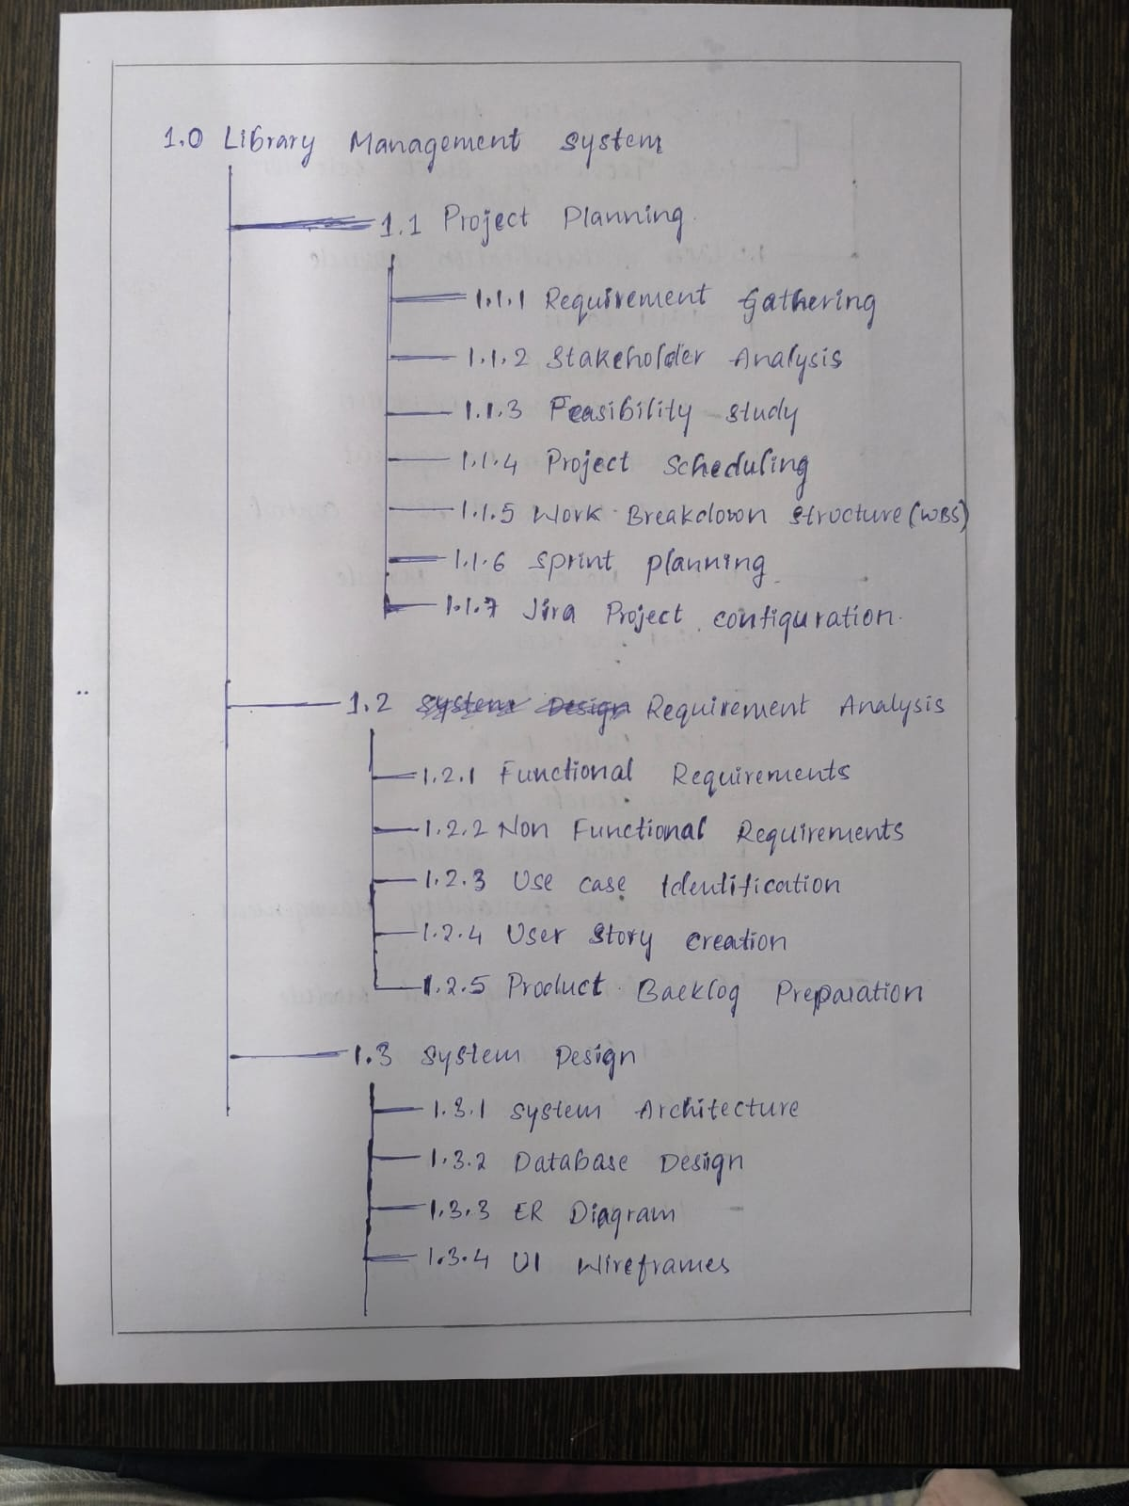

This figure shows the initial structure of the Work Breakdown Structure, planning the project setup (1.1), requirement analysis (1.2), and design phases (1.3).

Figure 2: Hand-written WBS Planning - Authentication & Core Modules
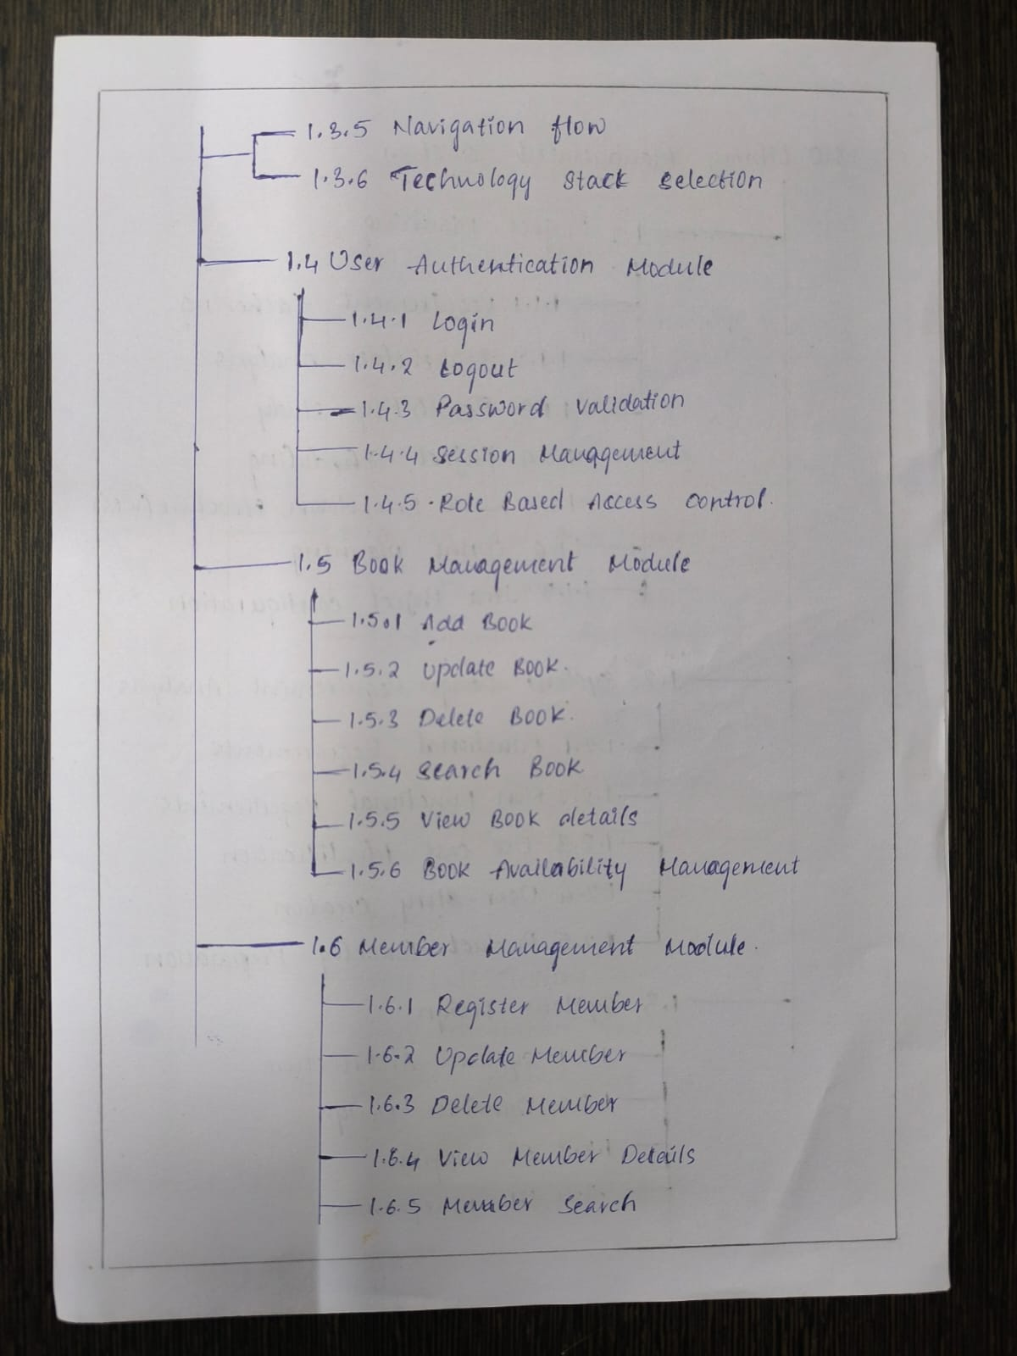

This figure continues the WBS plan, detailing user authentication (1.4), book management (1.5), and member registration (1.6).

Figure 3: Hand-written WBS Planning - Circulation & Testing
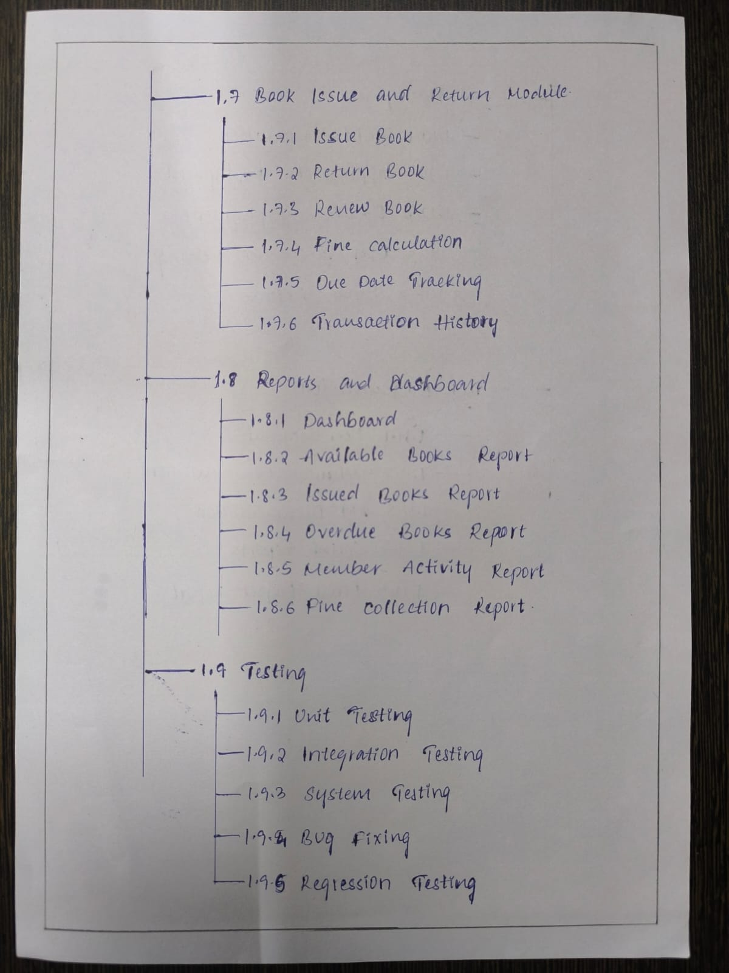

This figure shows WBS modules covering the circulation engine (1.7), reports (1.8), and integration testing stages (1.9).

Figure 4: Hand-written WBS Planning - Deployment & Documentation
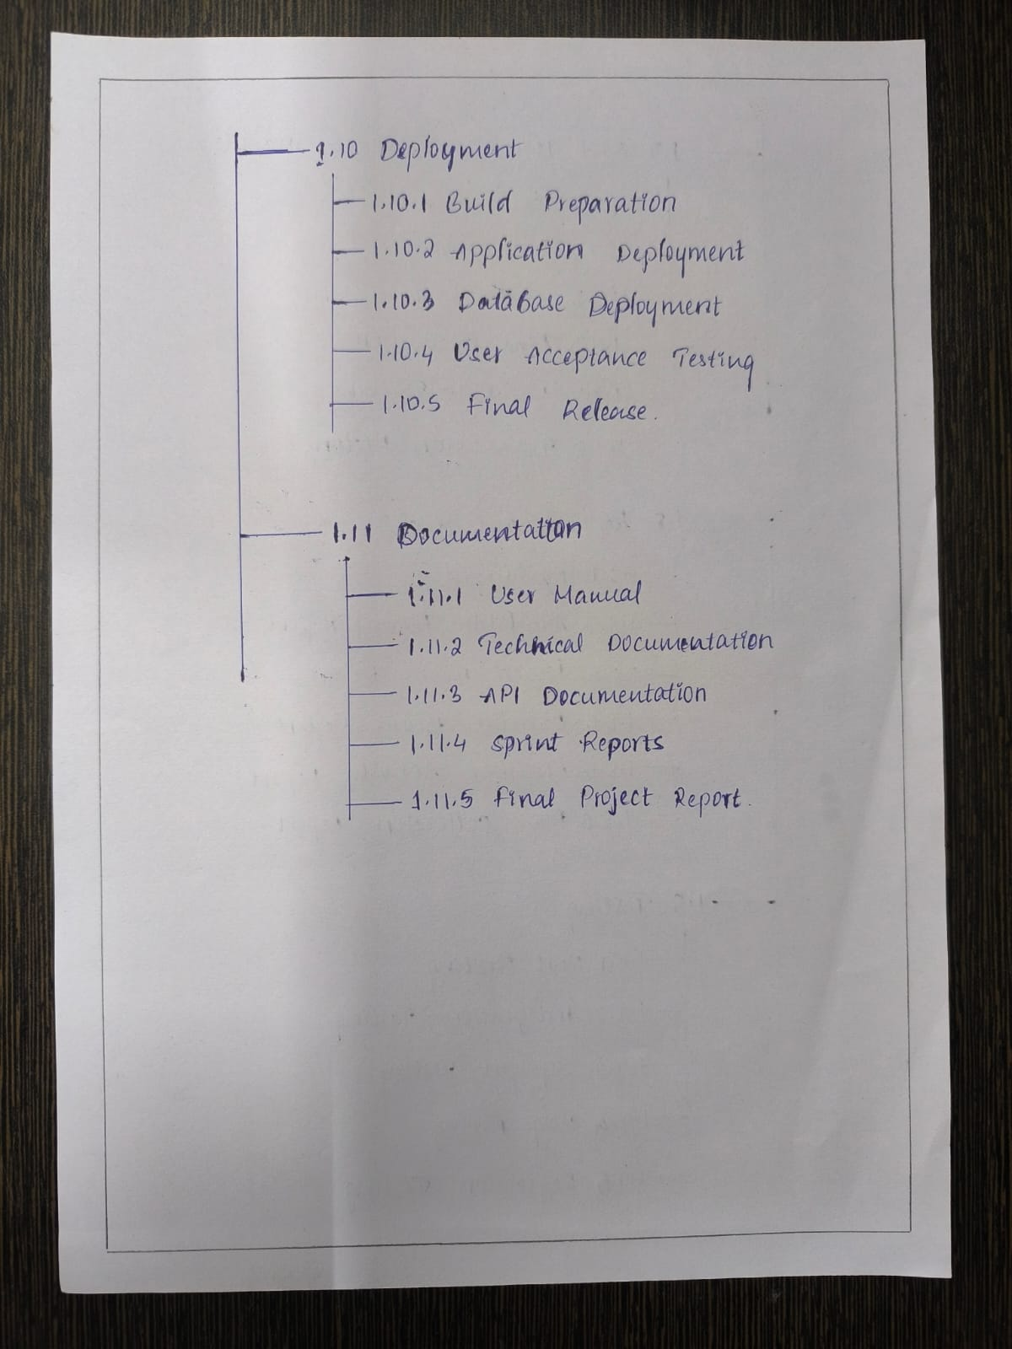

This figure outlines the final project stages: build preparation and deployment steps (1.10) alongside academic manuals and reports (1.11).

Figure 5: System Use Case Diagram Model
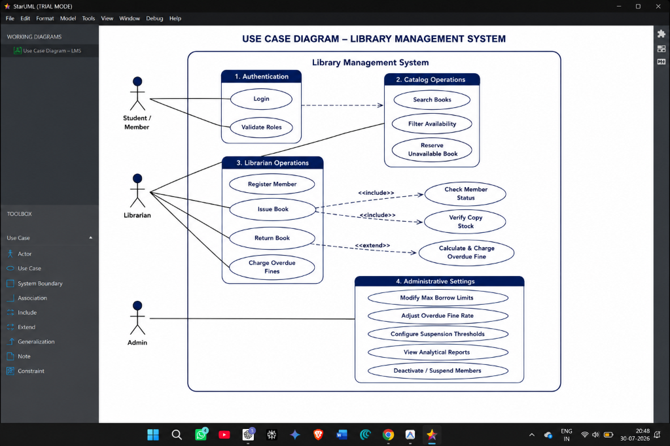

This StarUML model represents the core library actors (Student, Librarian, Admin) and their relative boundary interactions.

Figure 6: Book Checkout (Issue) Workflow Diagram
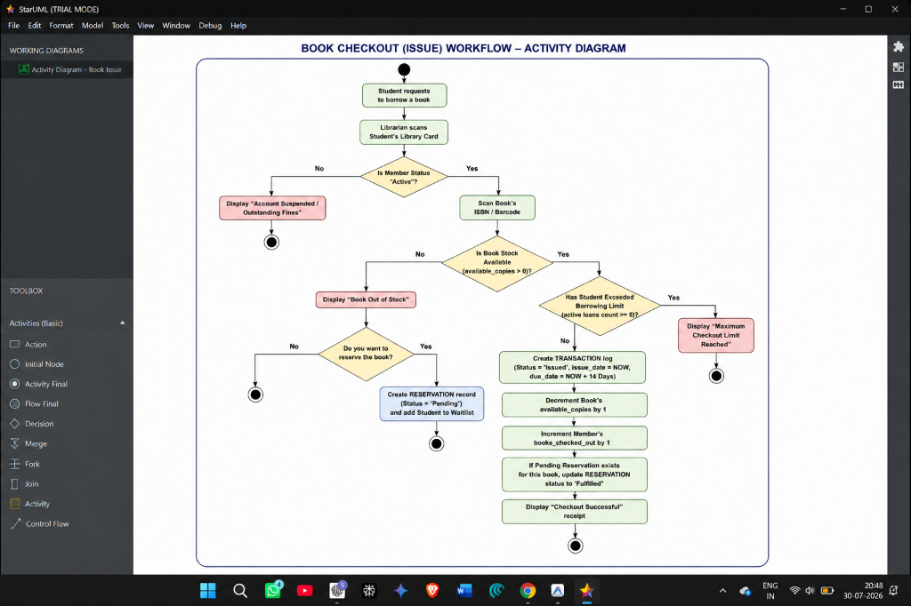

This activity diagram models checkout validations: verification of member eligibility, stock checks, copy allocation, and waitlist routing.

Figure 7: Book Return & Fine Accrual Workflow Diagram
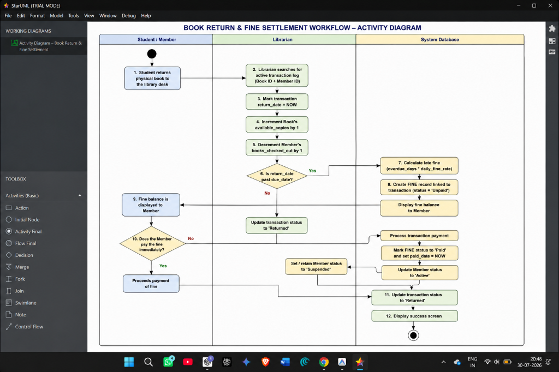

This diagram details the return flow: recording the check-in date, calculating due date differences, charging fines, and updating stock.

Figure 8: Normalized Relational Entity-Relationship Diagram (ERD)
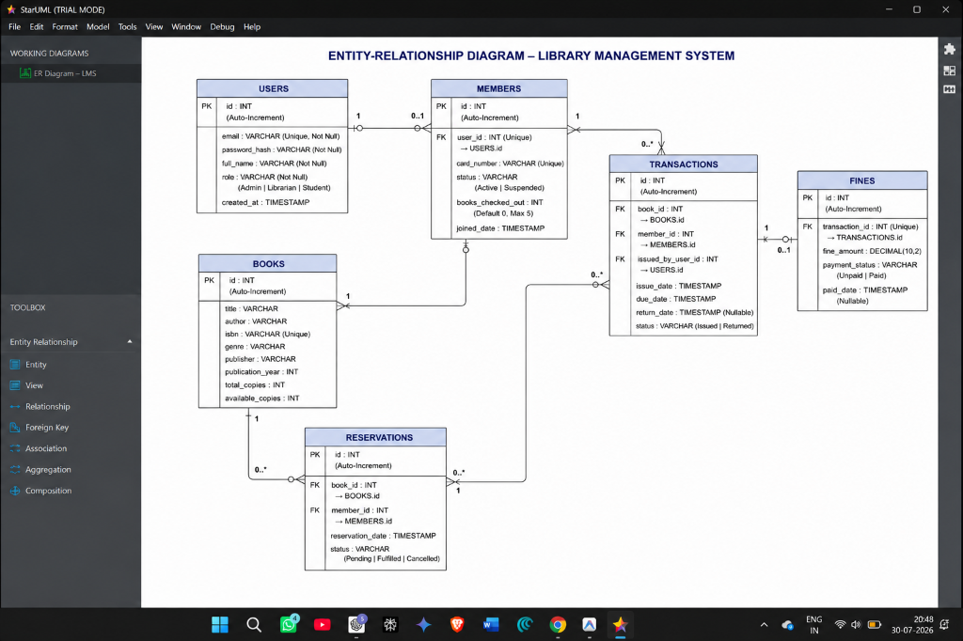

This ERD shows normalized schemas (users, books, transactions, fines, reservations) with PK/FK mappings and constraints.

Figure 9: User Authentication Sign-In Screen
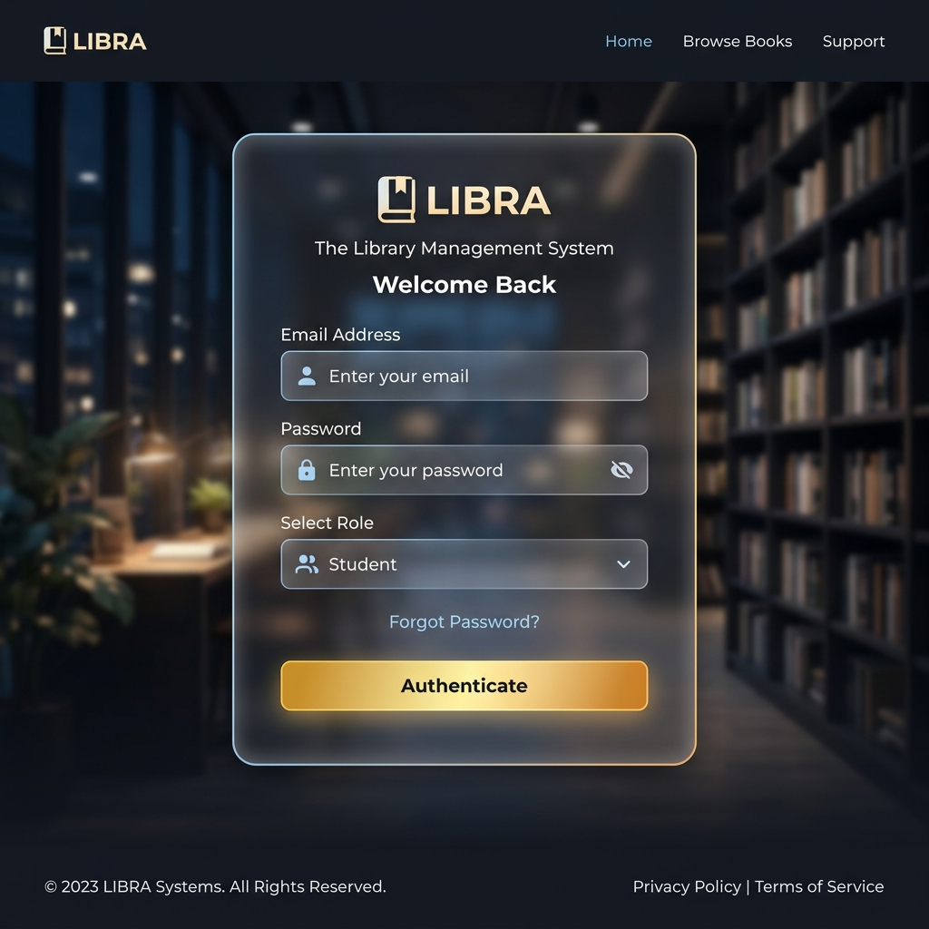

This screenshot shows the React login card view with credentials validation and secure routing.

Figure 10: Librarian Administrative Dashboard
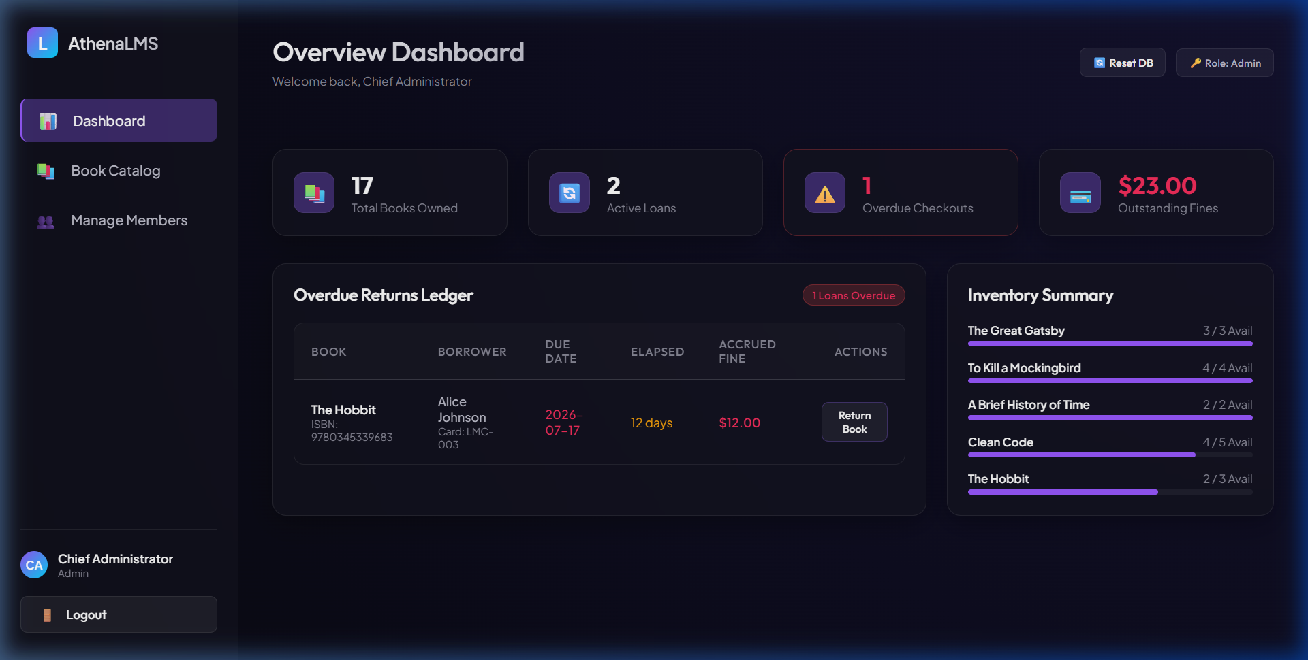

This screenshot captures the live dashboard dashboard. Real-time metric cards list total books, active members, out-of-stock items, and fine collections.

Figure 11: Book Inventory Catalog List view
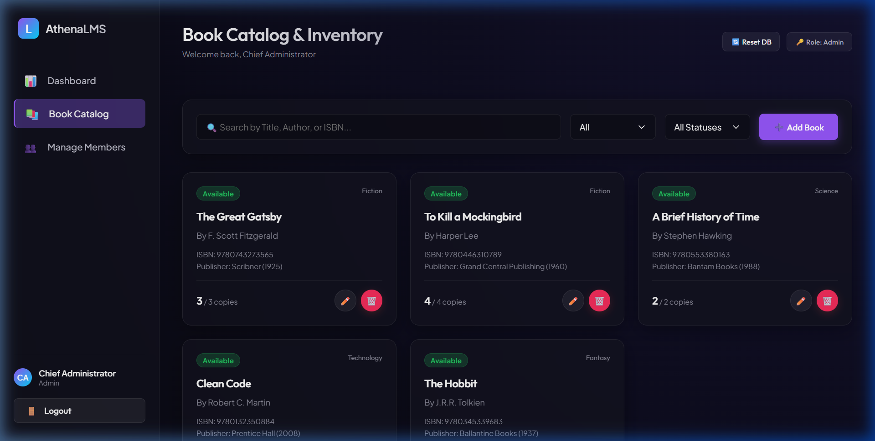

This screenshot captures the inventory list page, highlighting search filters, add/edit buttons, and availability indicators.

7. Agile Ceremonies & Project Management Reporting
To track developmental progress, the Scrum team logged Agile ceremonies on the Jira Scrum board:
1. Daily Standups: Logged on tickets to communicate task status (e.g. 'Completed AuthContext login logic, starting routing guards today. No blockers').
2. Sprint Retrospectives: Completed at the end of each sprint to review velocity, identify process improvements, and establish action items.
3. Reporting metrics: The board uses Sprint Burndown and Velocity charts to measure the team's historical execution speed.

