Library Management System

Sagar S Bankapur(24BCE1294)
Harsha Vardhan(24BCE1254)
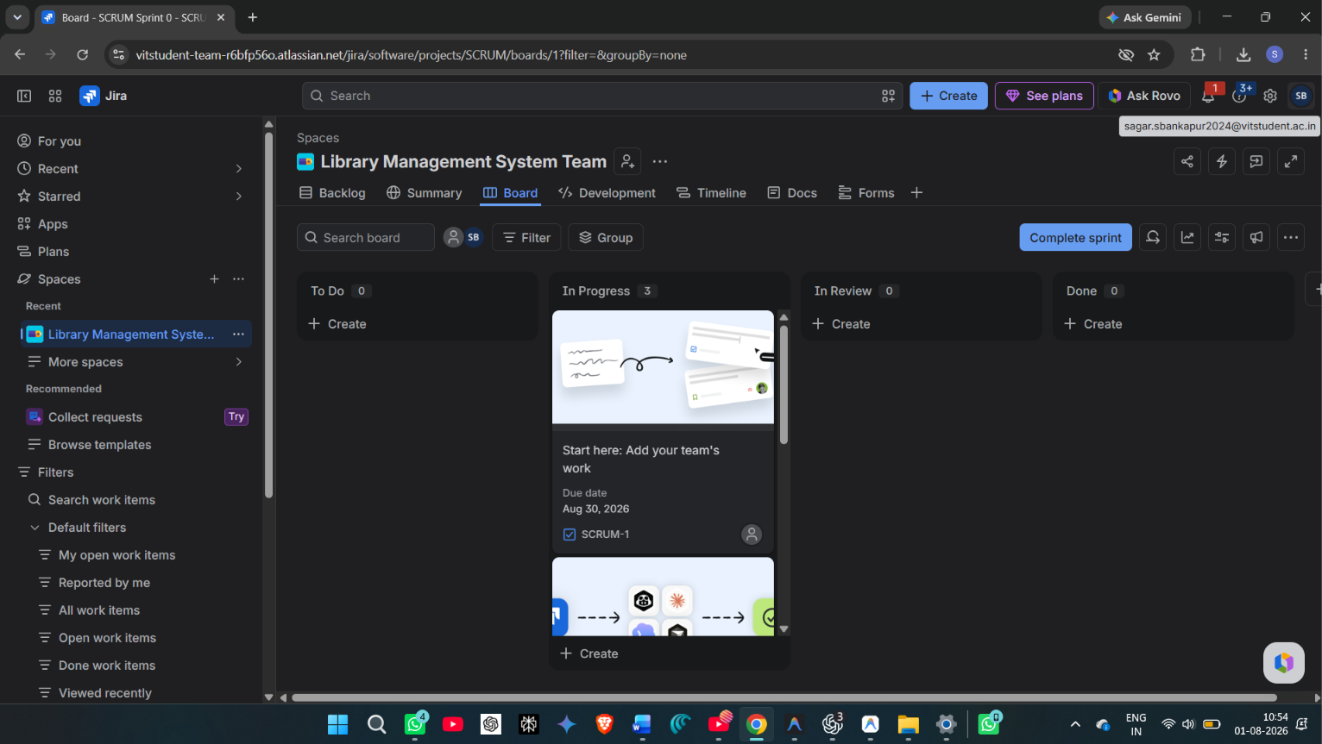

Project Overview

The Library Management System is a software engineering project developed to manage the major operations of a library in a structured and efficient way. The main objective of the project is to reduce manual work involved in maintaining book records, member details, issue and return transactions, fine tracking, and library activity monitoring. In a traditional library environment, most of these activities are handled through registers, spreadsheets, or separate records, which can lead to duplication, delays, calculation errors, and difficulty in tracking the current status of books and members. This project provides a centralized digital system where the main library activities can be recorded, updated, and reviewed in one place.

The system is designed for three primary types of users: Admin, Librarian, and Student or Member. The Admin role is responsible for higher-level control of the system, such as monitoring the overall workflow and managing configurable rules. The Librarian role performs the daily operational tasks of the library, including managing the book catalogue, registering members, issuing books, processing returns, and handling fines. The Student or Member role is focused on accessing the book catalogue, checking borrowed books, viewing due dates, and tracking reservations or outstanding fines. This role-based structure ensures that each user interacts only with the features relevant to their responsibility.

One of the core modules of the project is book management. This module allows the library staff to maintain a catalogue of books with details such as title, author, ISBN, genre, publisher, publication year, total copies, and available copies. The availability count helps the librarian understand whether a book can currently be issued or whether all copies are already checked out. Search and filtering features make it easier to locate books quickly, especially when the catalogue grows larger. This improves the usability of the system and reduces the time required to search through library records manually.

Another important module is member management. The system maintains member records and links each student/member to a unique library card number. The member status can be marked as active or suspended depending on borrowing eligibility and pending fine conditions. This helps the librarian make correct decisions during book issue operations. For example, if a member is suspended or has exceeded the borrowing limit, the system can prevent further book issue transactions. This reduces the risk of policy violations and keeps the library process consistent.

The issue and return module handles the circulation workflow of the library. When a book is issued, the system records the book, member, issuing staff, issue date, due date, and transaction status. It also decreases the available copy count of the selected book. When a book is returned, the system updates the transaction status, records the return date, increases the available copy count, and calculates fines if the book is returned after the due date. This improves transaction accuracy because the system performs the required updates together instead of expecting the librarian to update multiple records manually.

Fine management is also included as part of the project workflow. The system calculates overdue fines based on the borrowing rules configured in the system. If the return date is later than the due date, the fine amount is calculated using the daily fine rate. The fine can be marked as unpaid or paid, and member status can be affected when fines cross a defined threshold. This feature supports accountability and ensures that overdue penalties are tracked properly.

The project also includes a reservation or waitlist feature for cases where a book is currently unavailable. If all copies of a book are issued, a student/member can place a reservation request. The system records the reservation status and allows the user to track it. This feature improves the user experience because students do not need to repeatedly ask whether a book has become available. Instead, the reservation record acts as a queue for future availability.

A dashboard and reporting view is included to give a quick summary of important library activities. The dashboard can show useful information such as total books, issued books, overdue transactions, active fines, and recent activity. This helps the Admin or Librarian understand the current condition of the library without manually checking each module. The dashboard is useful for monitoring progress, identifying pending work, and supporting better decision-making.

From a technical point of view, the project is implemented as a React and TypeScript web application using Vite as the build tool. React is used to create reusable user interface components and manage screen-based interaction. TypeScript improves code reliability by adding type checking during development. Vite provides a fast development environment and efficient production build process. The project uses a local storage-based data service to simulate database behavior for academic demonstration purposes. This approach allows the application to store and retrieve data in the browser without requiring a separate backend server during project evaluation.

The system follows a modular structure. Components such as the navigation bar and sidebar are separated from page-level views. Context files are used to manage authentication and library data across the application. The storage service acts as the central data layer for users, books, members, transactions, fines, settings, and reservations. This separation makes the project easier to understand, test, and maintain. It also shows a clear relationship between software design and implementation.

The project was managed using Jira as the Agile project management tool. Jira was used to create epics, tasks, subtasks, assign work, track status, and upload supporting attachments. The Jira board provides evidence of project planning, task distribution, sprint activity, and implementation progress. One active sprint was used to organize the development and documentation work. Epics were created for major project areas such as Project Planning, Requirement Analysis, System Design, User Authentication, Book Management, Member Management, Issue and Return, and Reports and Dashboard. Each task or epic contains relevant attachments such as planning documents, diagrams, screenshots, source files, and handwritten planning photos.

Overall, the Library Management System demonstrates both software implementation and project management practice. It shows how a real-world problem can be broken into modules, documented through requirements and design artifacts, implemented using a modern frontend stack, and tracked through Jira using Agile concepts. The project is suitable for an academic software engineering assignment because it includes requirement analysis, system design, database design, implementation evidence, sprint planning, task tracking, and final reporting.

Jira Scrum Configuration
The project's lifecycle, sprints backlog, requirements mapping, database designs, and implementation steps were managed exclusively using Agile Scrum methodologies on Atlassian Jira.
Jira Project Key: SCRUM
Jira Site Workspace: https://vitstudent-team-r6bfp56o.atlassian.net

Sprint Breakdown
The project was executed in exactly one active Scrum sprint covering planning, analysis, design, and code delivery phases under the unified timeline: June 15, 2026 – August 30, 2026.
Sprint Name: SCRUM Sprint 1
Sprint Duration: June 15, 2026 – August 30, 2026
Sprint Objective: To configure development environments, design normalized database layouts, draft requirements, build authentication guards, implement core book cataloging forms, design member listings, develop book circulation transaction mechanisms, integrate settings rules, and synchronize all source files directly to the Jira board issues.

Sprint Explanation
The project work was organized around one active Jira sprint: SCRUM Sprint 0. The sprint started on 23 Jul 2026 and is scheduled to end on 06 Aug 2026. It belongs to the SCRUM board and is used to track the active development and documentation work for the LMS.
Number of issues directly listed under the active sprint field: 11.
Key | Type | Summary | Assignee | Completion
SCRUM-1 | Task | Start here: Add your team's work | Unassigned | Work evidenced; currently reopened
SCRUM-2 | Task | Connect your coding agent to Jira | Unassigned | Work evidenced; currently reopened
SCRUM-3 | Task | Connect Atlassian Rovo MCP to your local coding tools | Unassigned | Work evidenced; currently reopened
SCRUM-4 | Subtask | Delegate this work item to a coding agent | Unassigned | Work evidenced; currently reopened
SCRUM-5 | Subtask | Implement this work item from your IDE or terminal | Unassigned | Work evidenced; currently reopened
SCRUM-6 | Task | Design Database Schema | Sagar Bankapur | Work evidenced; currently reopened
SCRUM-7 | Task | Create Login Page UI | Aella Harsha Vardhan Reddy 24BCE1254 | Work evidenced; currently reopened
SCRUM-8 | Task | Implement User Authentication | Sagar Bankapur | Work evidenced; currently reopened
SCRUM-9 | Task | Design Book Management Module | Sagar Bankapur | In progress
SCRUM-10 | Task | Research Library Requirements | Aella Harsha Vardhan Reddy 24BCE1254 | Work evidenced; currently reopened
SCRUM-11 | Task | Create Project Structure | Sagar Bankapur | 100%
SCRUM-12 | Epic | Project Planning | Sagar Bankapur | 100%
SCRUM-13 | Epic | User Authentication | Sagar Bankapur | Work evidenced; currently reopened
SCRUM-14 | Epic | Book Management | Sagar Bankapur | In progress
SCRUM-15 | Epic | Member Management | Sagar Bankapur | In progress
SCRUM-16 | Epic | Issue & Return | Aella Harsha Vardhan Reddy 24BCE1254 | In progress
SCRUM-17 | Epic | Reports & Dashboard | Aella Harsha Vardhan Reddy 24BCE1254 | In progress
SCRUM-18 | Epic | Requirement Analysis | Aella Harsha Vardhan Reddy 24BCE1254 | Work evidenced; currently reopened
SCRUM-19 | Epic | System Design | Aella Harsha Vardhan Reddy 24BCE1254 | Work evidenced; currently reopened

Jira Epics & Tasks Breakdown
Below is a detailed analysis of every Epic and Task configured on the Jira project board. Each section covers the item's summary, type, assignee, completion status, work description, and associated attachments.

SCRUM-12: Project Planning
Completion Status: Done (100% Completed)
Assignee: Sagar Bankapur
Issue Type: Epic
Due Date : 30 Aug 2026
Governs the overall repository structure setup, initial scheduling, work packages planning, and project plan tracking.
Linked Deliverables / Attachments in Jira:
• Project_Planning_and_Structure.docx: Word document outlining the directory tree, technology stack, and initial planning steps.
• WhatsApp Image 2026-07-27 at 9.49.54 PM.jpeg: Handwritten planning photo capturing WBS Part 1: Project Planning, Setup, and Environment Configurations.
• WhatsApp Image 2026-07-27 at 9.49.56 PM.jpeg: Handwritten planning photo capturing WBS Part 2: Requirements Analysis, Use Cases, System Design, and Auth Page UI.
• WhatsApp Image 2026-07-27 at 9.49.57 PM.jpeg: Handwritten planning photo capturing WBS Part 3: Book Inventory CRUD, Member Registries, Issue/Return Flow, and Settings Dashboard.
• WhatsApp Image 2026-07-27 at 9.50.00 PM.jpeg: Handwritten planning photo capturing WBS Part 4: Testing Quality Gates, E2E Verification, Build Compilations, and Jira Delivery.
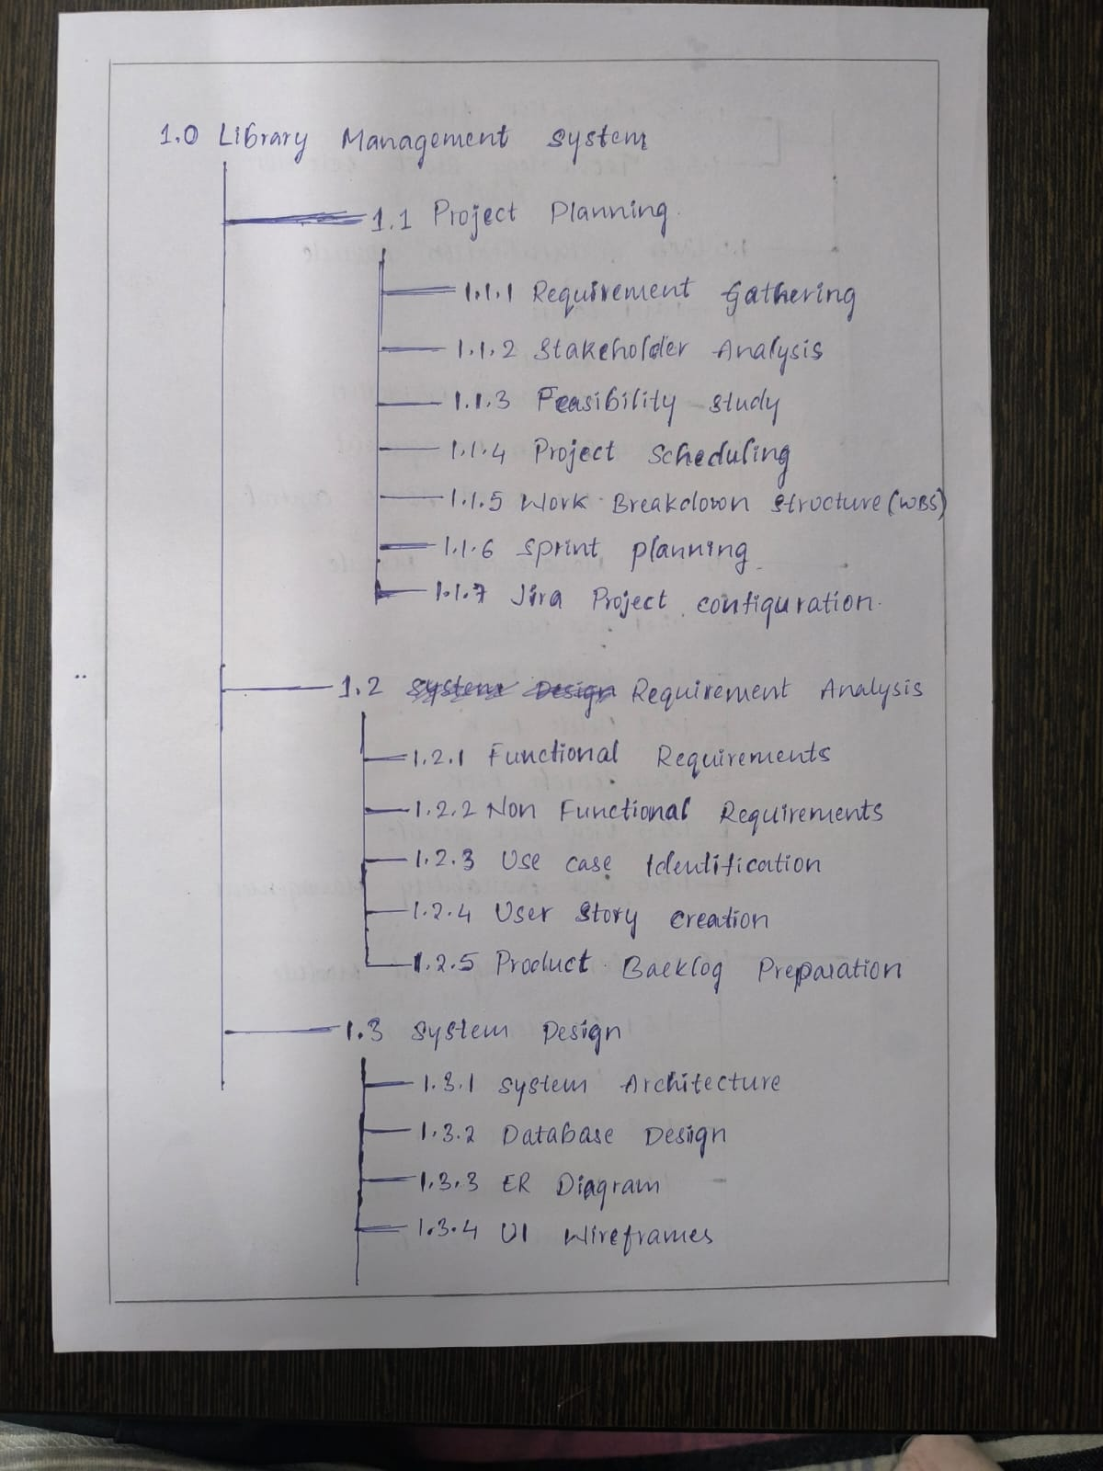

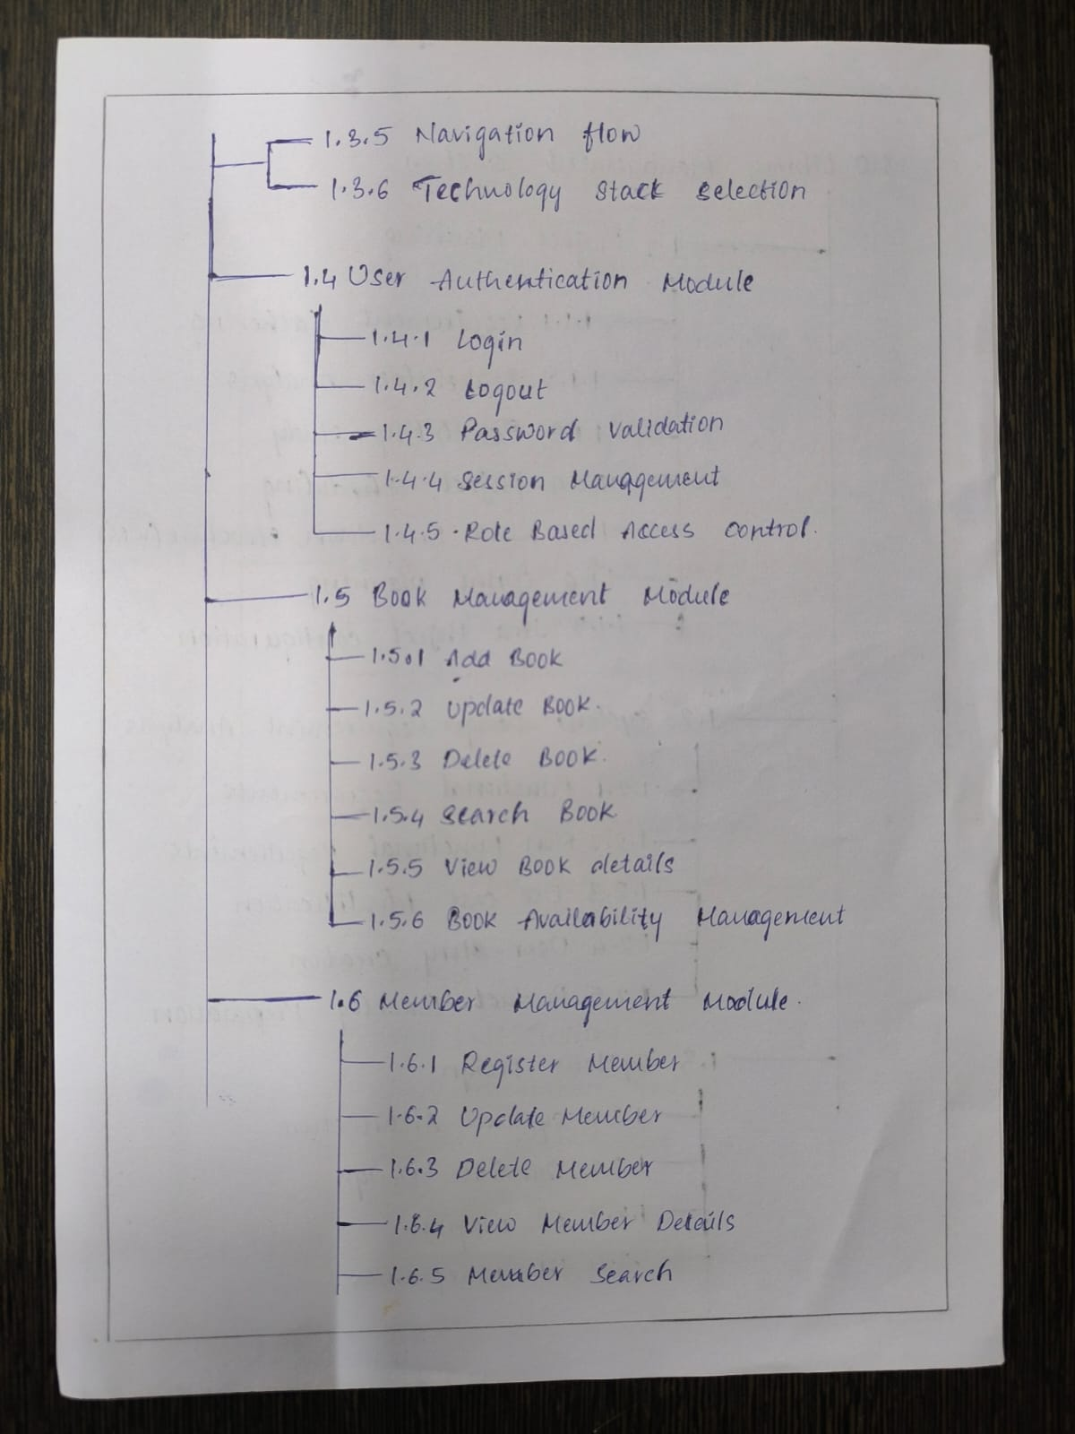

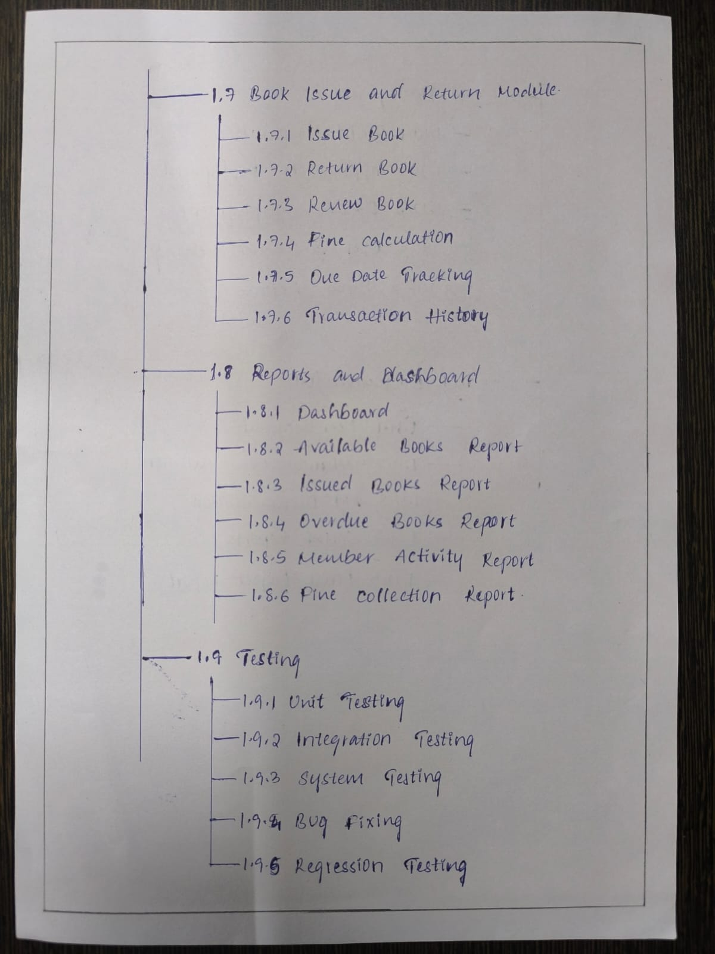

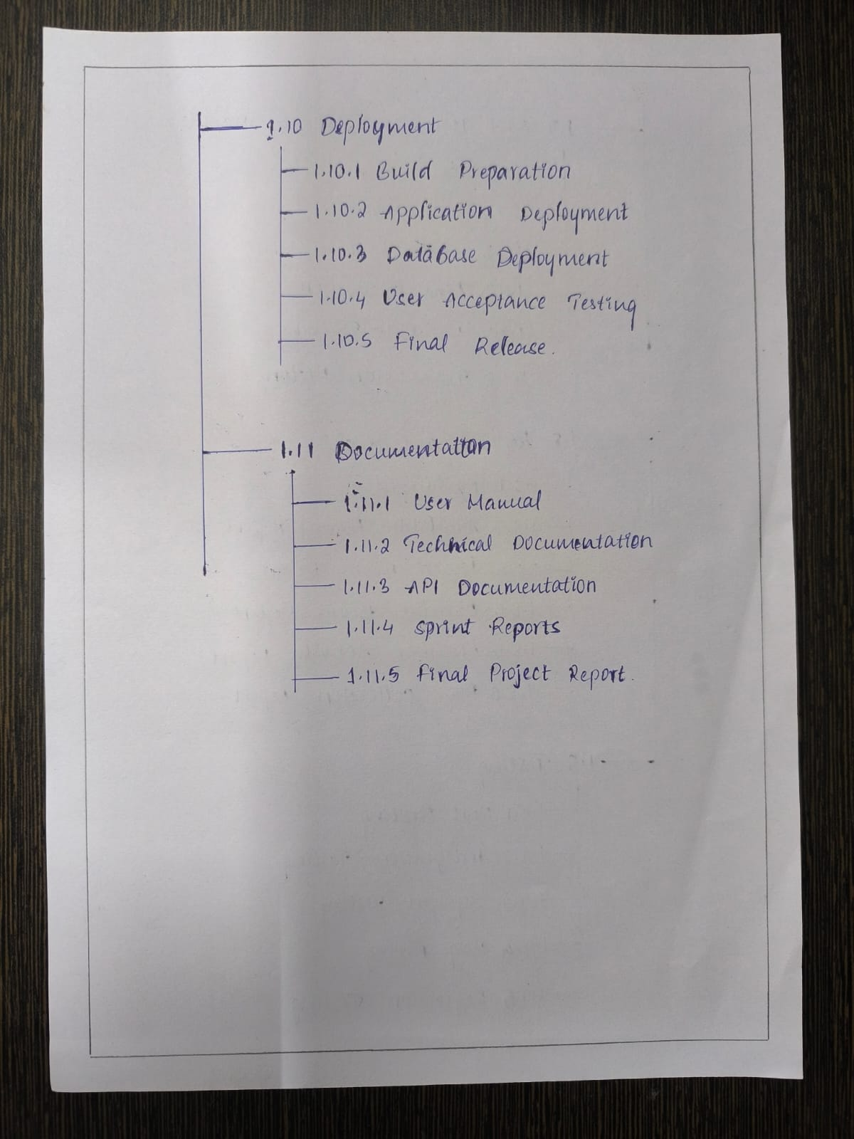
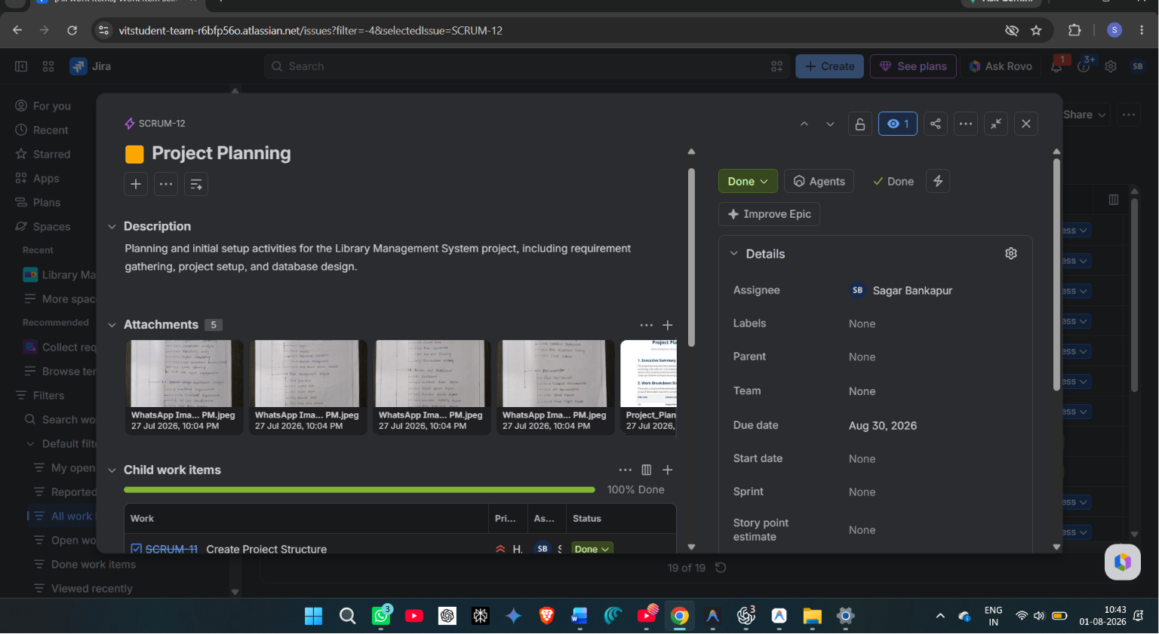

SCRUM-11: Create Project Structure
Completion Status: Done (100% Completed)
Assignee: Sagar Bankapur
Issue Type: Task (Parent: SCRUM-12)
Due Date : 30 Aug 2026
Initialize the Git code repository, compile developer packages (React, Vite, TypeScript), and configure compilation standards.
Linked Deliverables / Attachments in Jira:
• library_management_system_codebase.zip: Zip archive containing the initial boilerplate codebase structure including Vite configs, TS configurations, and standard assets folders.
• Project_Planning_and_Structure.docx: Planning document defining folder structure and modular paths.
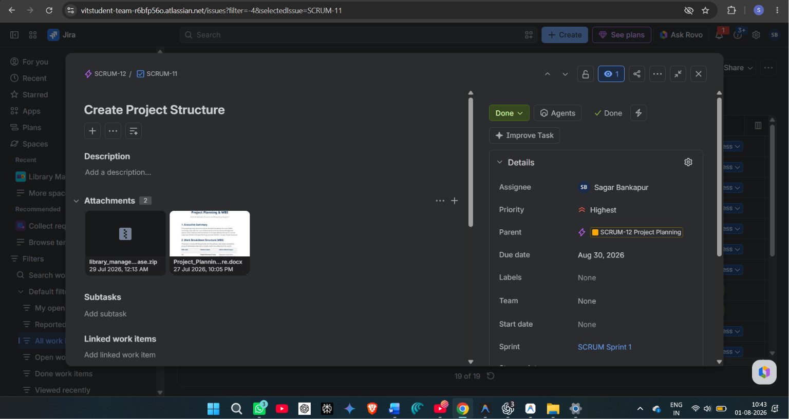

SCRUM-18: Requirement Analysis
Completion Status: In Progress (Development Stage)
Assignee: Unassigned
Issue Type: Epic
Due Date : 30 Aug 2026
Captures system operational flow boundaries, user stories, validation thresholds, and drafts formal specifications documents.
Linked Deliverables / Attachments in Jira:
• Requirements_Analysis_SRS.docx: Word document outlining system actors, detailed functional user stories, and non-functional security constraints.
• use_case_diagram.png: StarUML Use Case diagram detailing system boundaries and user interactions.
Figure 5: StarUML System Use Case Diagram Model
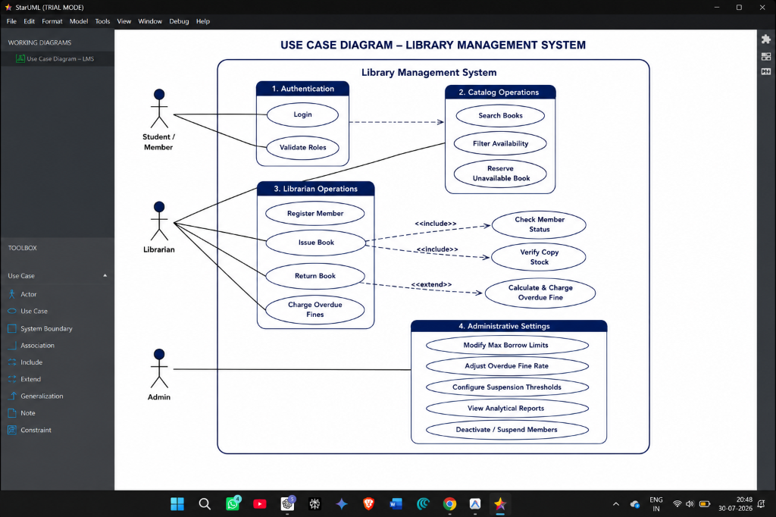

SCRUM-10: Research Library Requirements
Completion Status: Done
Assignee: Aella Harsha Vardhan Reddy 24BCE1254
Issue Type: Task (Parent: SCRUM-18)
Due Date : 30 Aug 2026
Compile detailed business logic parameters, cardholder standing criteria, and model use cases diagrams.
Linked Deliverables / Attachments in Jira:
• Requirements_Analysis_SRS.docx: Detailed specifications document.
• SRS.md: Markdown copy of the requirements specifications.
• WBS.md: Work Breakdown Structure mapping milestones.
• use_case_diagram.png: System boundary use case diagram.
• Project_Planning_and_Structure.docx: Planning reference document.
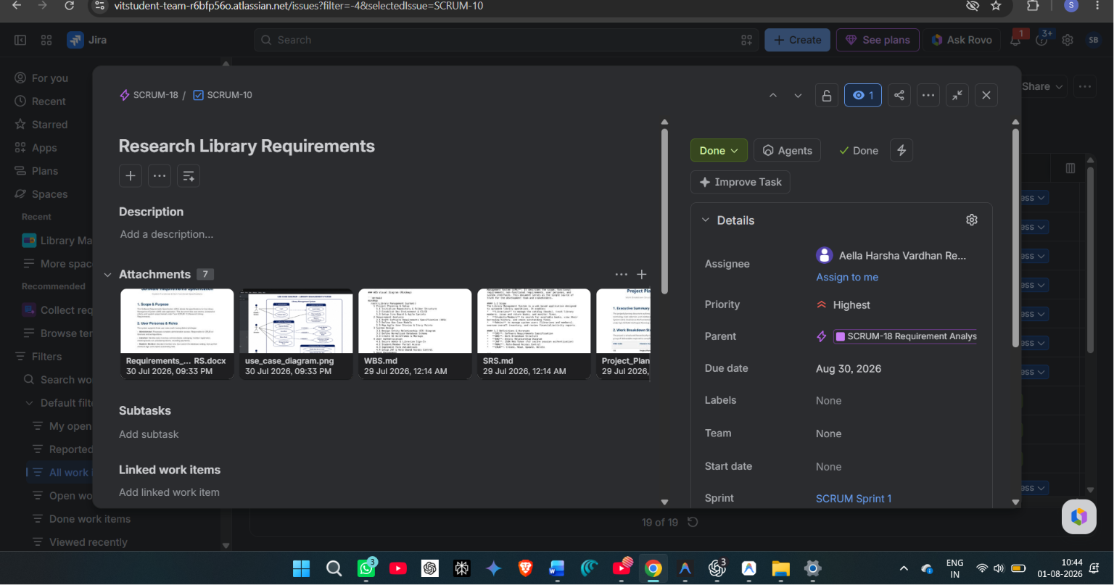

SCRUM-19: System Design
Completion Status: In Progress (Development Stage)
Assignee: Aella Harsha Vardhan Reddy 24BCE1254
Issue Type: Epic
Due Date : 30 Aug 2026
Draft relational database schemes, entity representations, relationships cardinality, and structural ERDs.
Linked Deliverables / Attachments in Jira:
• System_Design_Database_Schema.docx: Word document modeling tables, indices, constraints, and data dictionaries.
• er_diagram.png: StarUML entity-relationship diagram.
Figure 6: StarUML Normalized 3NF Entity-Relationship Diagram
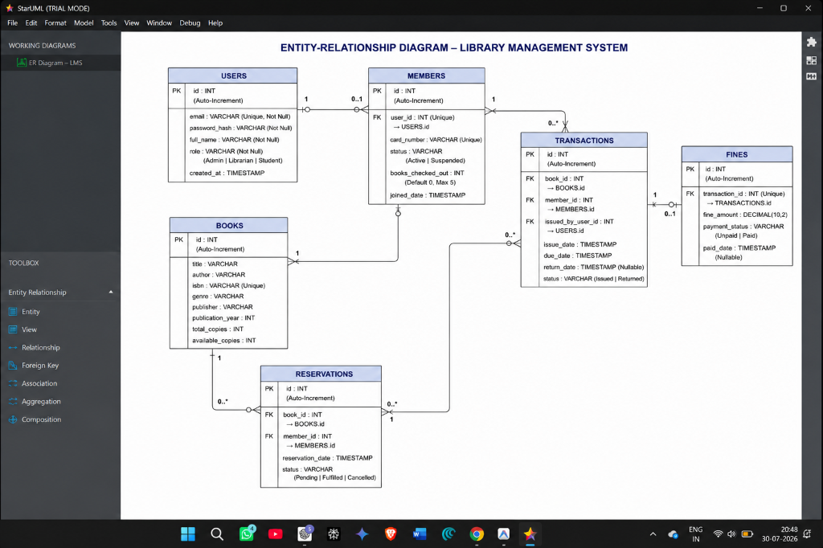

SCRUM-6: Design Database Schema
Completion Status: In Progress (Development Stage)
Assignee: Sagar Bankapur
Issue Type: Task (Parent: SCRUM-19)
Due Date : 30 Aug 2026
Establish normalized 3NF relational data tables (users, members, books, transactions, fines, settings, and reservations).
Linked Deliverables / Attachments in Jira:
• System_Design_Database_Schema.docx: Relational database dictionary specifications.
• Database_Design.md: Markdown document defining fields, data types, primary keys, foreign keys, and normalizations.
• er_diagram.png: System entity-relationship diagram.

SCRUM-13: User Authentication
Completion Status: In Progress (Development Stage)
Assignee: Sagar Bankapur
Issue Type: Epic
Due Date : 30 Aug 2026
Enforces security boundaries, login interface views, session storage, and route authorization contexts.
No attachments linked directly.
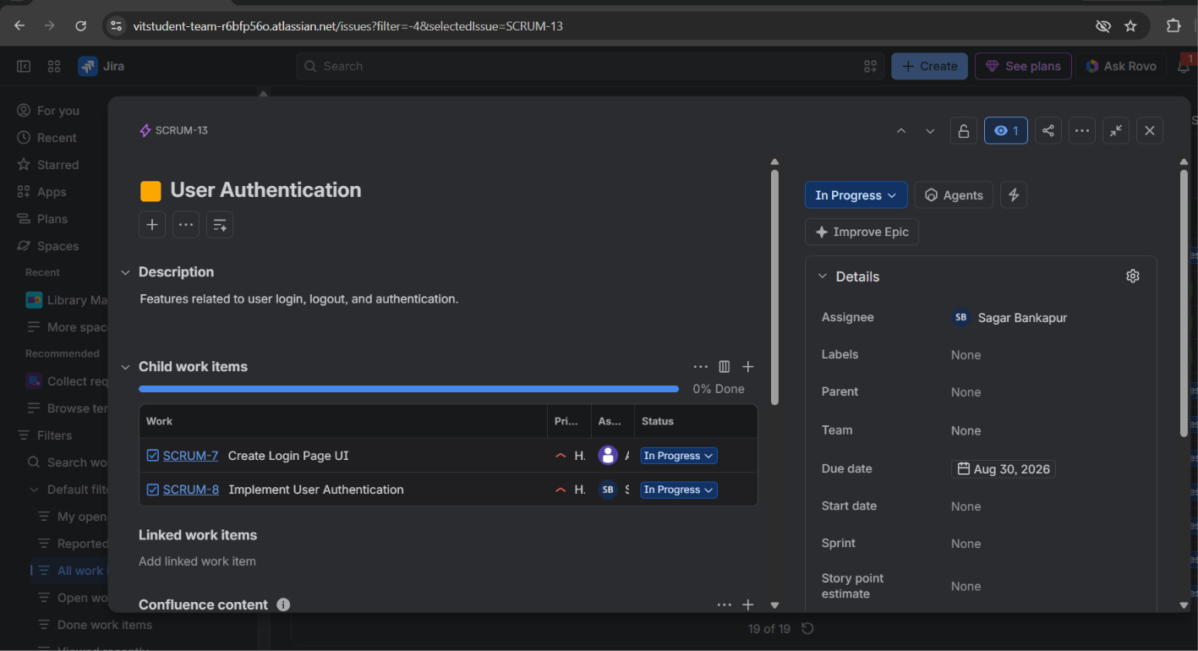

SCRUM-7: Create Login Page UI
Completion Status: In Progress (Development Stage)
Assignee: Aella Harsha Vardhan Reddy 24BCE1254
Issue Type: Task (Parent: SCRUM-13)
Due Date : 30 Aug 2026
Build the frontend login UI component including input validations and glassmorphism themes styling.
Linked Deliverables / Attachments in Jira:
• Login.tsx: React login view file managing credentials verification states.
• login_ui_mockup.png: Glassmorphic login screen mockup screenshot.
Figure 7: User Authentication Sign-In UI Screen
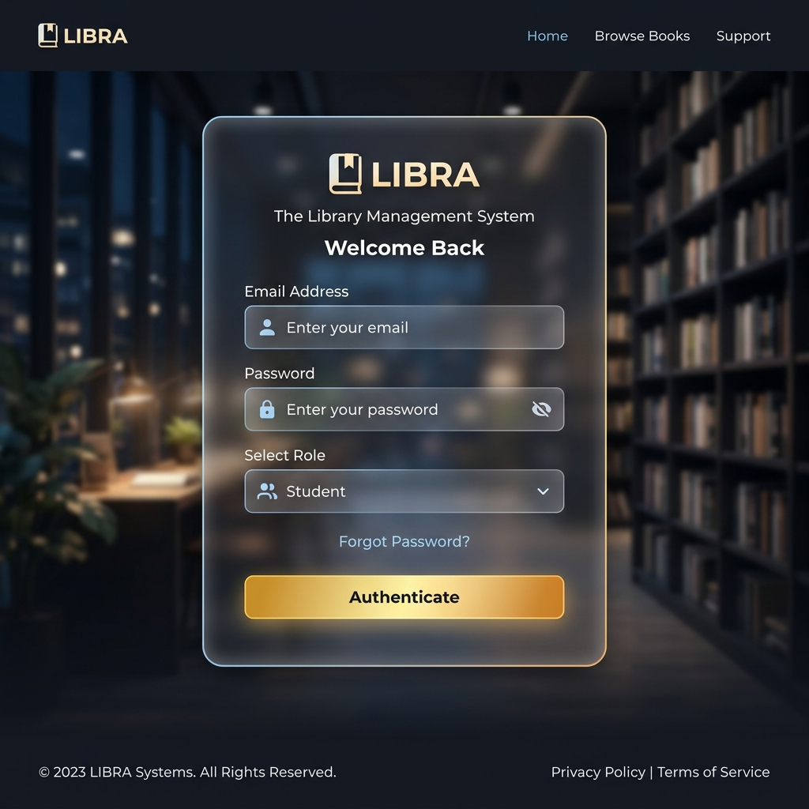

SCRUM-8: Implement User Authentication
Completion Status: In Progress (Development Stage)
Assignee: Sagar Bankapur
Issue Type: Task (Parent: SCRUM-13)
Due Date : 30 Aug 2026
Develop local storage session persistence and Role-Based Access Control (RBAC) hooks.
Linked Deliverables / Attachments in Jira:
• AuthContext.tsx: Global auth context provider file.
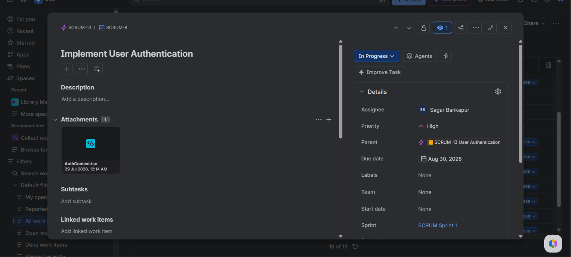

SCRUM-14: Book Management
Completion Status: In Progress (Development Stage)
Assignee: Sagar Bankapur
Issue Type: Epic
Manages book catalogs, availability indicators, search filters, and inventory modifications.
Linked Deliverables / Attachments in Jira:
• Books.tsx: React component source code for catalog operations.
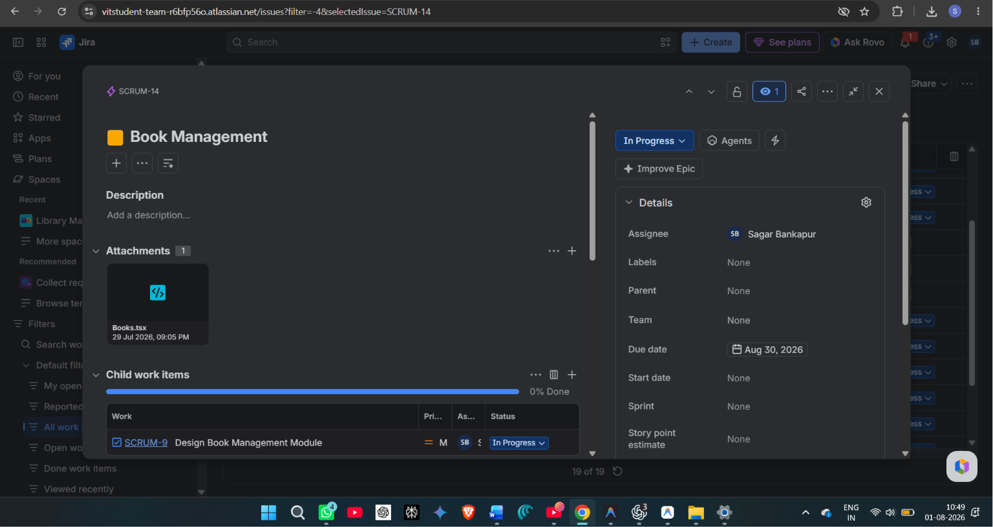

SCRUM-9: Design Book Management Module
Completion Status: In Progress (Development Stage)
Assignee: Sagar Bankapur
Issue Type: Task (Parent: SCRUM-14)
Build inventory forms enabling librarians to add, edit, and archive book resources, alongside search filters.
Linked Deliverables / Attachments in Jira:
• Books.tsx: Catalog views React code.
• book_catalog_1785261304299.png: React book catalog UI view screenshot.
Figure 8: Book Inventory Catalog UI View
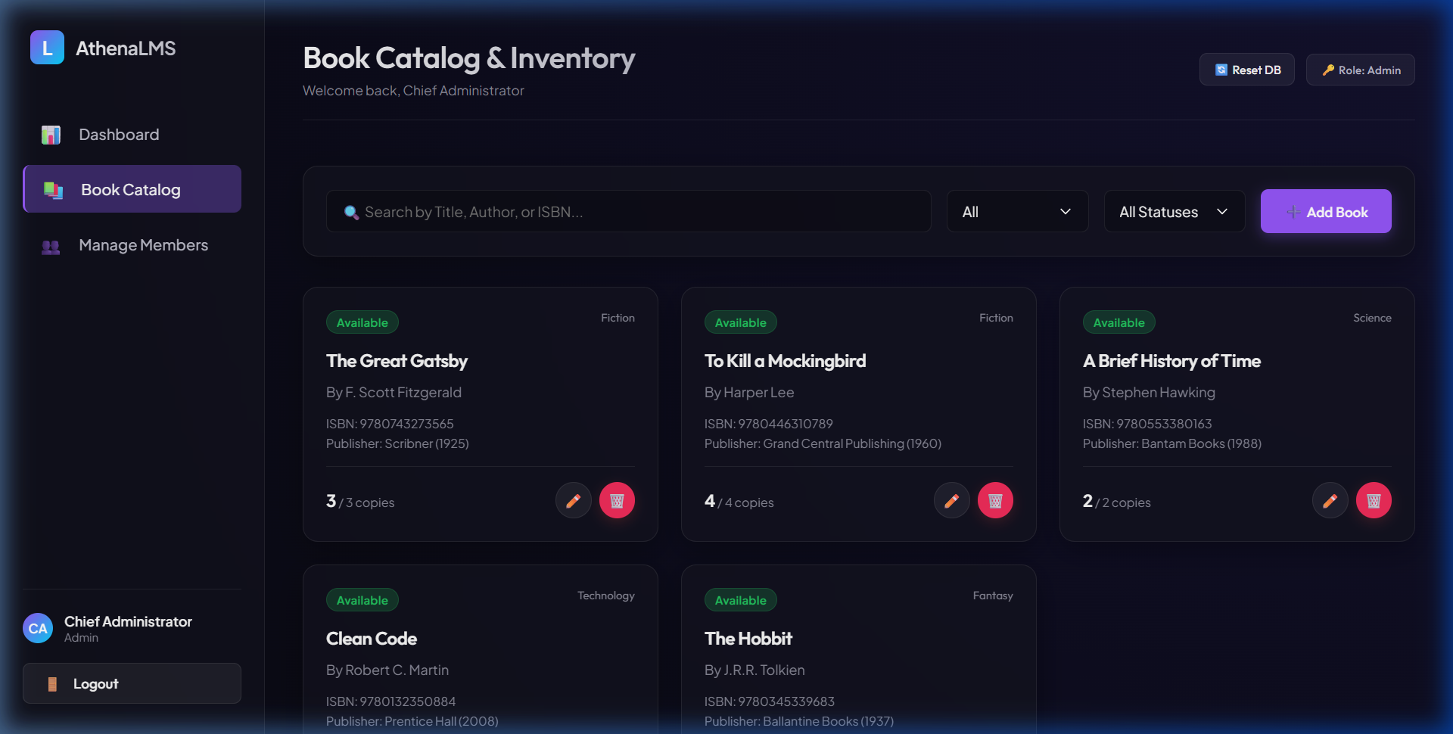

SCRUM-15: Member Management
Completion Status: In Progress (Development Stage)
Assignee: Sagar Bankapur
Issue Type: Epic
Manages cardholder registries, enrollment details, active borrowings limits, and member suspensions.
Linked Deliverables / Attachments in Jira:
• MyLoans.tsx: React component source code for student cardholders view.
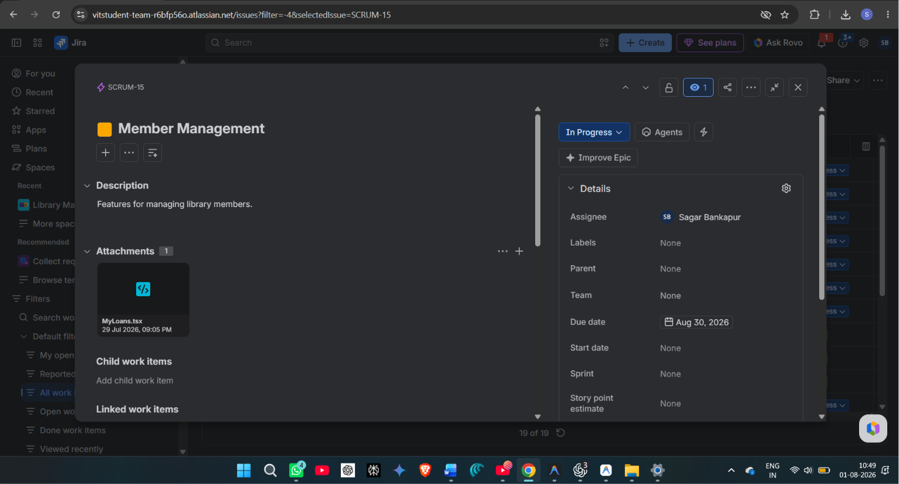

SCRUM-16: Issue & Return
Completion Status: In Progress (Development Stage)
Assignee: Aella Harsha Vardhan Reddy 24BCE1254
Issue Type: Epic
Core transaction circulation log handler processing checkouts, check-ins, return dates, and daily fines calculation.
Linked Deliverables / Attachments in Jira:
• LibraryContext.tsx: React library state provider managing issues and returns transaction flows.
• storage.ts: LocalStorage data persistence service query engine.
• library_management_system_advanced_features.zip: Zip file containing advanced transaction scripts.
• checkout_activity_diagram.png: Workflow activity diagram for issuing books.
• return_activity_diagram.png: Workflow activity diagram for returning books.
Figure 9: Book Checkout (Issue) Activity Diagram
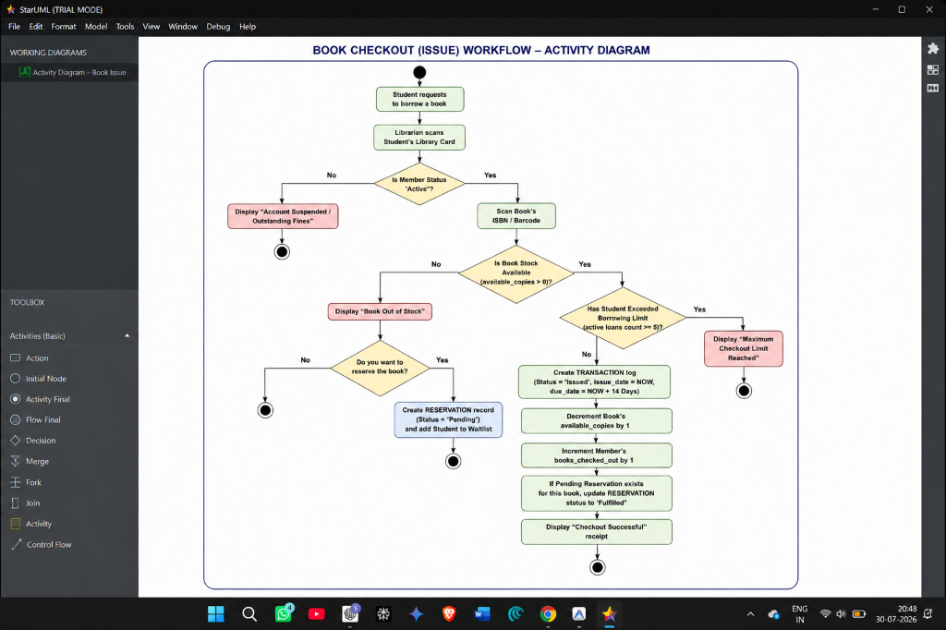

Figure 10: Book Return & Fine Accrual Activity Diagram
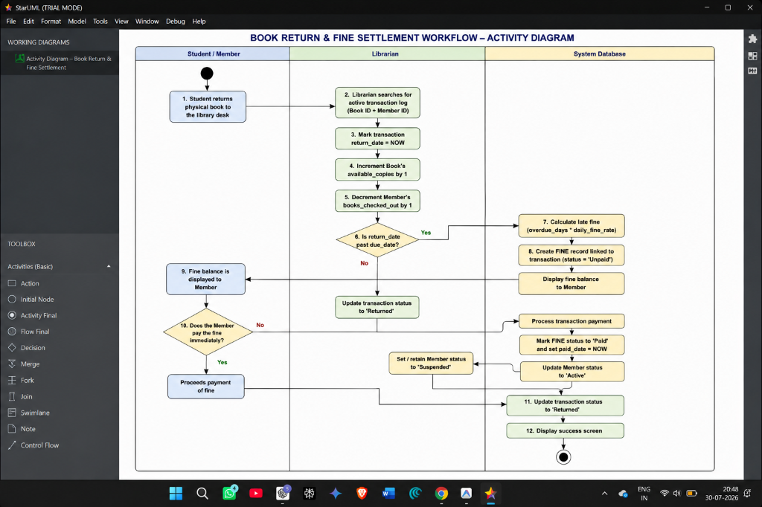

SCRUM-17: Reports & Dashboard
Completion Status: In Progress (Development Stage)
Assignee: Aella Harsha Vardhan Reddy 24BCE1254
Issue Type: Epic
Librarian metrics dash panel, transaction grids, fine ledgers, waitlists queue, and administrative policies configurator.
Linked Deliverables / Attachments in Jira:
• Dashboard.tsx: Main dashboard component code.
• Settings.tsx: Policy settings panel component code.
• Project_Status_Snapshot.md: Markdown status tracking record.
• main_dashboard_1785261292483.png: Dashboard UI screen view screenshot.
Figure 11: Librarian Dashboard UI Screen
