Library Management System
Jira Project Management Report
Jira-focused project evidence report

Project Overview
The project managed in Jira is a Library Management System (LMS). The system objective is to support core library operations such as maintaining a book catalogue, allowing user authentication, managing members, issuing and returning books, handling fines, and showing dashboard/report information for the library workflow.
This report is based on the Jira project named Library Management System Team with project key SCRUM. It focuses on the Jira sprint, epics, tasks, assignees, completion status, and evidence attachments recorded in Jira.

Jira Project Snapshot
- Jira site: https://vitstudent-team-r6bfp56o.atlassian.net
- Project key/name: SCRUM - Library Management System Team
- Board: SCRUM board
- Total Jira issues reviewed: 19 (8 epics, 9 tasks, 2 subtasks)
- Current status count: 2 Done, 17 In Progress

Sprint Explanation
The project work was organized around one active Jira sprint: SCRUM Sprint 0. The sprint started on 23 Jul 2026 and is scheduled to end on 06 Aug 2026. It belongs to the SCRUM board and is used to track the active development and documentation work for the LMS.
Number of issues directly listed under the active sprint field: 11.
Key | Type | Summary | Assignee | Completion
SCRUM-1 | Task | Start here: Add your team's work | Unassigned | Work evidenced; currently reopened
SCRUM-2 | Task | Connect your coding agent to Jira | Unassigned | Work evidenced; currently reopened
SCRUM-3 | Task | Connect Atlassian Rovo MCP to your local coding tools | Unassigned | Work evidenced; currently reopened
SCRUM-4 | Subtask | Delegate this work item to a coding agent | Unassigned | Work evidenced; currently reopened
SCRUM-5 | Subtask | Implement this work item from your IDE or terminal | Unassigned | Work evidenced; currently reopened
SCRUM-6 | Task | Design Database Schema | Sagar Bankapur | Work evidenced; currently reopened
SCRUM-7 | Task | Create Login Page UI | Aella Harsha Vardhan Reddy 24BCE1254 | Work evidenced; currently reopened
SCRUM-8 | Task | Implement User Authentication | Sagar Bankapur | Work evidenced; currently reopened
SCRUM-9 | Task | Design Book Management Module | Sagar Bankapur | In progress
SCRUM-10 | Task | Research Library Requirements | Aella Harsha Vardhan Reddy 24BCE1254 | Work evidenced; currently reopened
SCRUM-11 | Task | Create Project Structure | Sagar Bankapur | 100%
SCRUM-12 | Epic | Project Planning | Sagar Bankapur | 100%
SCRUM-13 | Epic | User Authentication | Sagar Bankapur | Work evidenced; currently reopened
SCRUM-14 | Epic | Book Management | Sagar Bankapur | In progress
SCRUM-15 | Epic | Member Management | Sagar Bankapur | In progress
SCRUM-16 | Epic | Issue & Return | Aella Harsha Vardhan Reddy 24BCE1254 | In progress
SCRUM-17 | Epic | Reports & Dashboard | Aella Harsha Vardhan Reddy 24BCE1254 | In progress
SCRUM-18 | Epic | Requirement Analysis | Unassigned | Work evidenced; currently reopened
SCRUM-19 | Epic | System Design | Aella Harsha Vardhan Reddy 24BCE1254 | Work evidenced; currently reopened

Epics, Tasks, Assignees, Completion, and Attachments
The following section records each Jira item exactly as a project-management artifact: issue key, issue type, assignee, current status, finishing evidence from Jira status history, completion state, and the attachments uploaded to that issue.

SCRUM-1 - Start here: Add your team's work
Type | Task | Status | In Progress
Assignee | Unassigned | Reporter | Sagar Bankapur
Priority | Not set | Due date | 30 Aug 2026
Finished by | Sagar Bankapur on 30 Jul 2026 | Completion | Work evidenced; currently reopened
Attachment count | 4 | Completion note | Earlier Done transition by Sagar Bankapur on 30 Jul 2026; current status is In Progress
Initial Jira starter work item used to add the team's work and attach early implementation evidence.

Attachments Recorded in Jira
Attachment | Uploaded by/date | Brief description
add-your-teams-work.png | Sagar Bankapur; 23 Jul 2026 | Jira starter-screen evidence showing how the team's work item was initiated.
implementation_report.md | Sagar Bankapur; 29 Jul 2026 | Short implementation note uploaded as supporting work evidence.
main_dashboard_1785261292483.png | Sagar Bankapur; 29 Jul 2026 | Dashboard UI screenshot showing system metrics and implementation progress.
Project_Documentation.html | Sagar Bankapur; 29 Jul 2026 | Compiled project documentation page attached as implementation evidence.

SCRUM-2 - Connect your coding agent to Jira
Type | Task | Status | In Progress
Assignee | Unassigned | Reporter | Sagar Bankapur
Priority | Not set | Due date | 30 Aug 2026
Finished by | Sagar Bankapur on 30 Jul 2026 | Completion | Work evidenced; currently reopened
Attachment count | 1 | Completion note | Earlier Done transition by Sagar Bankapur on 30 Jul 2026; current status is In Progress
Configured connection between the coding workflow and Jira so project activity could be tracked from the board.

Attachments Recorded in Jira
Attachment | Uploaded by/date | Brief description
connect-agents-to-jira.png | Sagar Bankapur; 23 Jul 2026 | Screenshot showing Jira coding-agent connection instructions/evidence.

SCRUM-3 - Connect Atlassian Rovo MCP to your local coding tools
Type | Task | Status | In Progress
Assignee | Unassigned | Reporter | Sagar Bankapur
Priority | Not set | Due date | 30 Aug 2026
Finished by | Sagar Bankapur on 30 Jul 2026 | Completion | Work evidenced; currently reopened
Attachment count | 1 | Completion note | Earlier Done transition by Sagar Bankapur on 30 Jul 2026; current status is In Progress
Set up Atlassian Rovo/MCP integration support for local coding-tool interaction.

Attachments Recorded in Jira
Attachment | Uploaded by/date | Brief description
connect-atlassian-mcp.png | Sagar Bankapur; 23 Jul 2026 | Screenshot showing Atlassian MCP/Rovo connection instructions/evidence.

SCRUM-4 - Delegate this work item to a coding agent
Type | Subtask | Status | In Progress
Assignee | Unassigned | Reporter | Sagar Bankapur
Priority | Not set | Due date | 30 Aug 2026
Finished by | Sagar Bankapur on 30 Jul 2026 | Completion | Work evidenced; currently reopened
Attachment count | 0 | Completion note | Earlier Done transition by Sagar Bankapur on 30 Jul 2026; current status is In Progress
Subtask for delegating a Jira work item to a coding agent.
Attachments recorded in Jira: none.

SCRUM-5 - Implement this work item from your IDE or terminal
Type | Subtask | Status | In Progress
Assignee | Unassigned | Reporter | Sagar Bankapur
Priority | Not set | Due date | 30 Aug 2026
Finished by | Sagar Bankapur on 30 Jul 2026 | Completion | Work evidenced; currently reopened
Attachment count | 0 | Completion note | Earlier Done transition by Sagar Bankapur on 30 Jul 2026; current status is In Progress
Subtask for implementing the delegated Jira work item from the development environment.
Attachments recorded in Jira: none.

SCRUM-6 - Design Database Schema
Type | Task | Status | In Progress
Assignee | Sagar Bankapur | Reporter | Sagar Bankapur
Priority | Highest | Due date | 30 Aug 2026
Finished by | Sagar Bankapur on 30 Jul 2026 | Completion | Work evidenced; currently reopened
Attachment count | 5 | Completion note | Earlier Done transition by Sagar Bankapur on 30 Jul 2026; current status is In Progress
Database design task covering schema modelling, normalized entities, and ER diagram evidence.

Attachments Recorded in Jira
Attachment | Uploaded by/date | Brief description
Database_Design.md | Sagar Bankapur; 29 Jul 2026 | Database design markdown describing tables, constraints, relationships, and normalization.
er_diagram.png | Sagar Bankapur; 30 Jul 2026 | StarUML-style ER diagram image showing entities and relationships for the LMS database.
System_Design_Database_Schema.docx | Sagar Bankapur; 30 Jul 2026 | System design document containing database schema and design explanation.
System_Design_Database_Schema.docx | Sagar Bankapur; 29 Jul 2026 | System design document containing database schema and design explanation.
System_Design_Database_Schema.docx | Sagar Bankapur; 27 Jul 2026 | System design document containing database schema and design explanation.

Embedded Visual Evidence
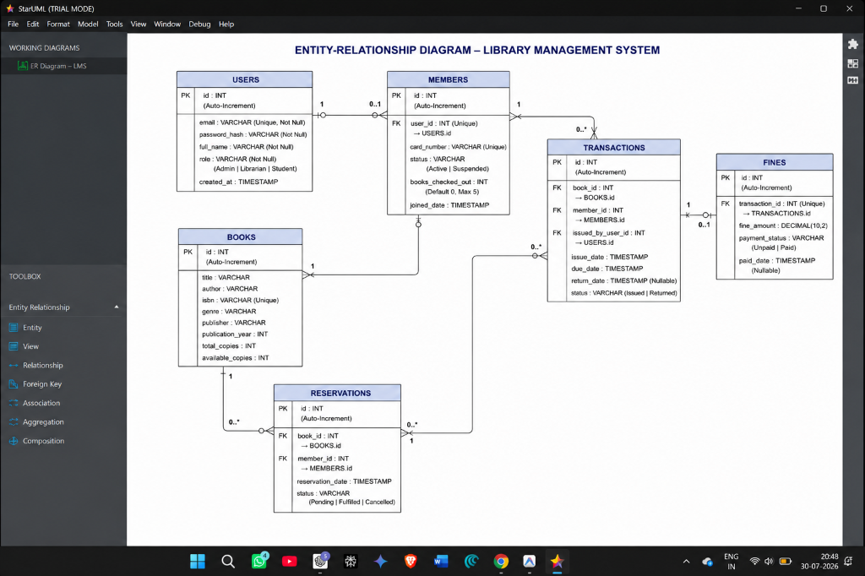
SCRUM-6 attachment: er_diagram.png

SCRUM-7 - Create Login Page UI
Type | Task | Status | In Progress
Assignee | Aella Harsha Vardhan Reddy 24BCE1254 | Reporter | Sagar Bankapur
Priority | High | Due date | 30 Aug 2026
Finished by | Sagar Bankapur on 30 Jul 2026 | Completion | Work evidenced; currently reopened
Attachment count | 3 | Completion note | Earlier Done transition by Sagar Bankapur on 30 Jul 2026; current status is In Progress
Login page UI task for the authentication entry screen and visual interface proof.

Attachments Recorded in Jira
Attachment | Uploaded by/date | Brief description
login_ui_mockup.png | Sagar Bankapur; 29 Jul 2026 | Login screen screenshot/mockup used as UI evidence.
login_ui_mockup.png | Sagar Bankapur; 27 Jul 2026 | Login screen screenshot/mockup used as UI evidence.
Login.tsx | Sagar Bankapur; 29 Jul 2026 | React TypeScript source for the login page UI.

SCRUM-8 - Implement User Authentication
Type | Task | Status | In Progress
Assignee | Sagar Bankapur | Reporter | Sagar Bankapur
Priority | High | Due date | 30 Aug 2026
Finished by | Sagar Bankapur on 30 Jul 2026 | Completion | Work evidenced; currently reopened
Attachment count | 1 | Completion note | Earlier Done transition by Sagar Bankapur on 30 Jul 2026; current status is In Progress
Authentication implementation task covering the React authentication context.

Attachments Recorded in Jira
Attachment | Uploaded by/date | Brief description
AuthContext.tsx | Sagar Bankapur; 29 Jul 2026 | React context source implementing login, session persistence, and role information.

SCRUM-9 - Design Book Management Module
Type | Task | Status | In Progress
Assignee | Sagar Bankapur | Reporter | Sagar Bankapur
Priority | Medium | Due date | 30 Aug 2026
Finished by | Not recorded as finished | Completion | In progress
Attachment count | 2 | Completion note | Not marked Done in Jira; current status is In Progress
Book management design task for catalog browsing and inventory-management UI.

Attachments Recorded in Jira
Attachment | Uploaded by/date | Brief description
book_catalog_1785261304299.png | Sagar Bankapur; 29 Jul 2026 | Book catalog screenshot showing catalog search and availability UI.
Books.tsx | Sagar Bankapur; 29 Jul 2026 | React TypeScript source for book catalog/search and book-management screens.

SCRUM-10 - Research Library Requirements
Type | Task | Status | In Progress
Assignee | Aella Harsha Vardhan Reddy 24BCE1254 | Reporter | Sagar Bankapur
Priority | Highest | Due date | 30 Aug 2026
Finished by | Sagar Bankapur on 30 Jul 2026 | Completion | Work evidenced; currently reopened
Attachment count | 7 | Completion note | Earlier Done transition by Sagar Bankapur on 30 Jul 2026; current status is In Progress
Requirement research task covering WBS, SRS, use-case analysis, and early planning documents.

Attachments Recorded in Jira
Attachment | Uploaded by/date | Brief description
Project_Planning_and_Structure.docx | Sagar Bankapur; 29 Jul 2026 | Planning document describing project structure and management approach.
Requirements_Analysis_SRS.docx | Sagar Bankapur; 30 Jul 2026 | Formal requirements/SRS document uploaded as requirements evidence.
Requirements_Analysis_SRS.docx | Sagar Bankapur; 29 Jul 2026 | Formal requirements/SRS document uploaded as requirements evidence.
Requirements_Analysis_SRS.docx | Sagar Bankapur; 27 Jul 2026 | Formal requirements/SRS document uploaded as requirements evidence.
SRS.md | Sagar Bankapur; 29 Jul 2026 | Markdown SRS containing user roles, functional requirements, and acceptance criteria.
use_case_diagram.png | Sagar Bankapur; 30 Jul 2026 | StarUML-style use-case diagram showing Admin, Librarian, and Student interactions.
WBS.md | Sagar Bankapur; 29 Jul 2026 | Work Breakdown Structure document mapping LMS work into project phases.

Embedded Visual Evidence
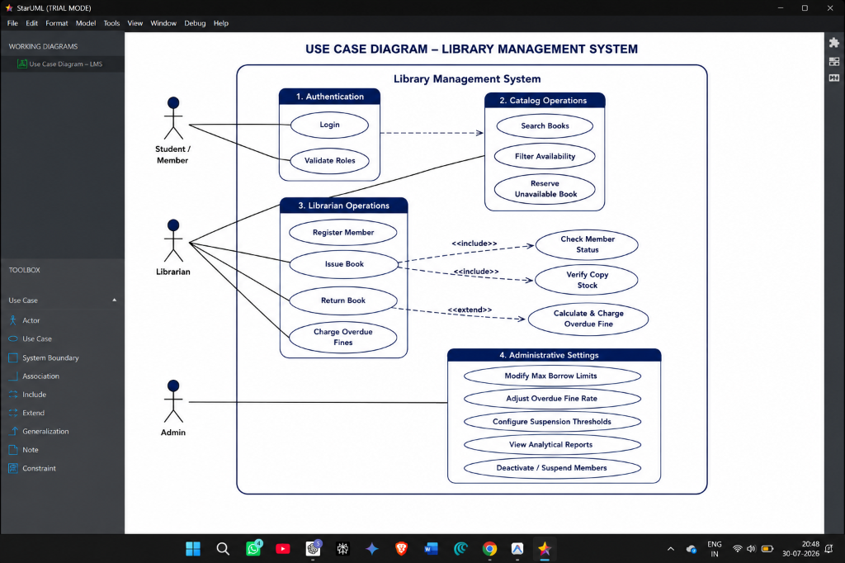
SCRUM-10 attachment: use_case_diagram.png

SCRUM-11 - Create Project Structure
Type | Task | Status | Done
Assignee | Sagar Bankapur | Reporter | Sagar Bankapur
Priority | Highest | Due date | 30 Aug 2026
Finished by | Sagar Bankapur on 30 Jul 2026 | Completion | 100%
Attachment count | 2 | Completion note | Done in Jira
Project structure task covering the application codebase and folder/document organization.

Attachments Recorded in Jira
Attachment | Uploaded by/date | Brief description
library_management_system_codebase.zip | Sagar Bankapur; 29 Jul 2026 | Compressed project codebase uploaded as project-structure evidence.
Project_Planning_and_Structure.docx | Sagar Bankapur; 27 Jul 2026 | Planning document describing project structure and management approach.

SCRUM-12 - Project Planning
Type | Epic | Status | Done
Assignee | Sagar Bankapur | Reporter | Sagar Bankapur
Priority | Medium | Due date | 30 Aug 2026
Finished by | Sagar Bankapur on 30 Jul 2026 | Completion | 100%
Attachment count | 5 | Completion note | Done in Jira
Project Planning epic containing planning document evidence and handwritten planning photographs.

Attachments Recorded in Jira
Attachment | Uploaded by/date | Brief description
Project_Planning_and_Structure.docx | Sagar Bankapur; 27 Jul 2026 | Planning document describing project structure and management approach.
WhatsApp Image 2026-07-27 at 9.49.54 PM.jpeg | Sagar Bankapur; 27 Jul 2026 | Handwritten project-planning photo showing manual planning notes.
WhatsApp Image 2026-07-27 at 9.49.56 PM.jpeg | Sagar Bankapur; 27 Jul 2026 | Handwritten project-planning photo showing manual planning notes.
WhatsApp Image 2026-07-27 at 9.49.57 PM.jpeg | Sagar Bankapur; 27 Jul 2026 | Handwritten project-planning photo showing manual planning notes.
WhatsApp Image 2026-07-27 at 9.50.00 PM.jpeg | Sagar Bankapur; 27 Jul 2026 | Handwritten project-planning photo showing manual planning notes.

Embedded Visual Evidence
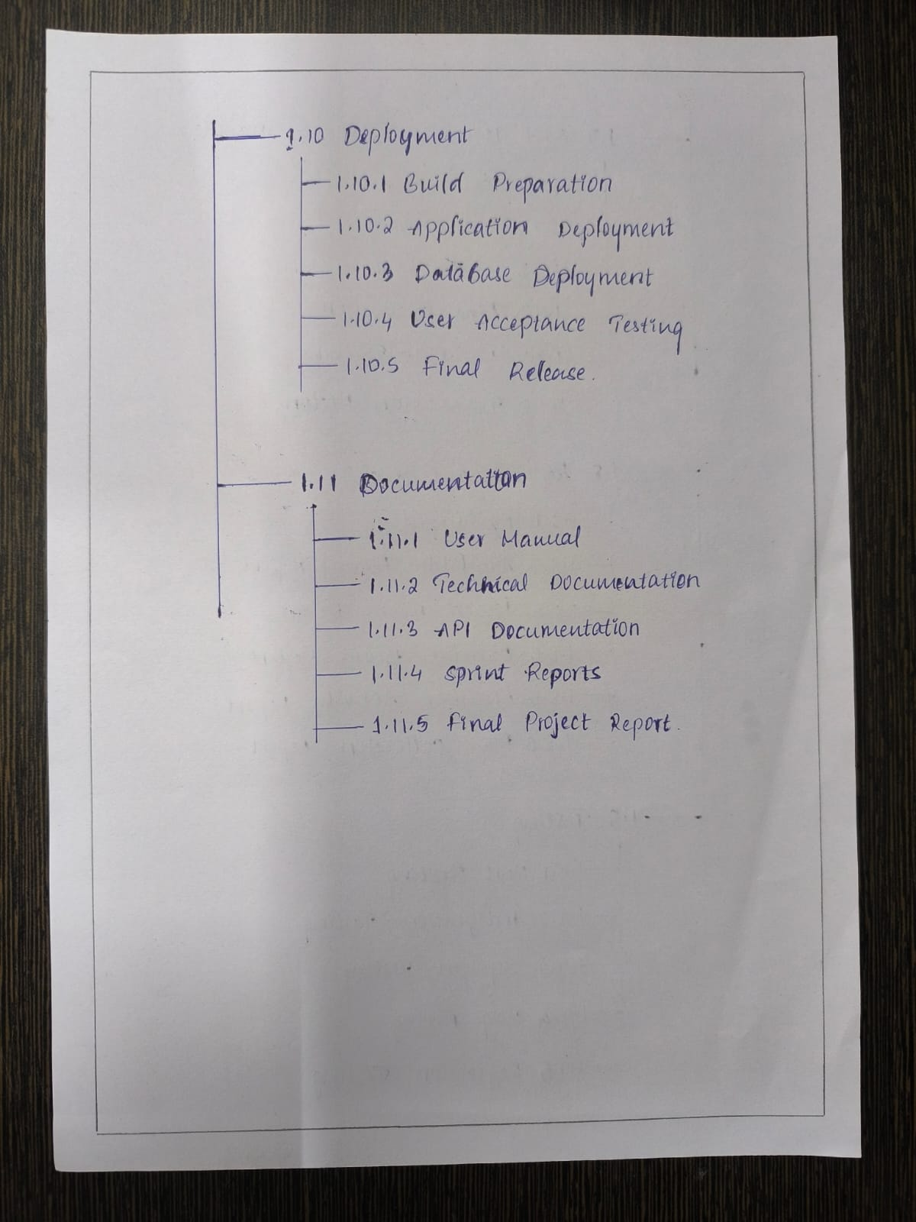
SCRUM-12 attachment: WhatsApp Image 2026-07-27 at 9.49.54 PM.jpeg
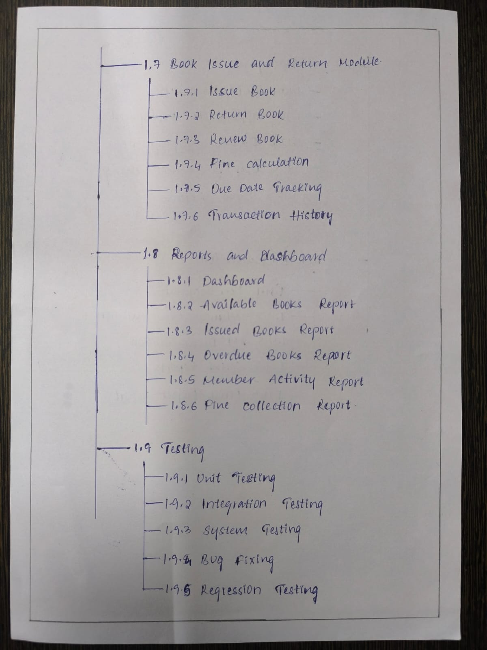
SCRUM-12 attachment: WhatsApp Image 2026-07-27 at 9.49.56 PM.jpeg
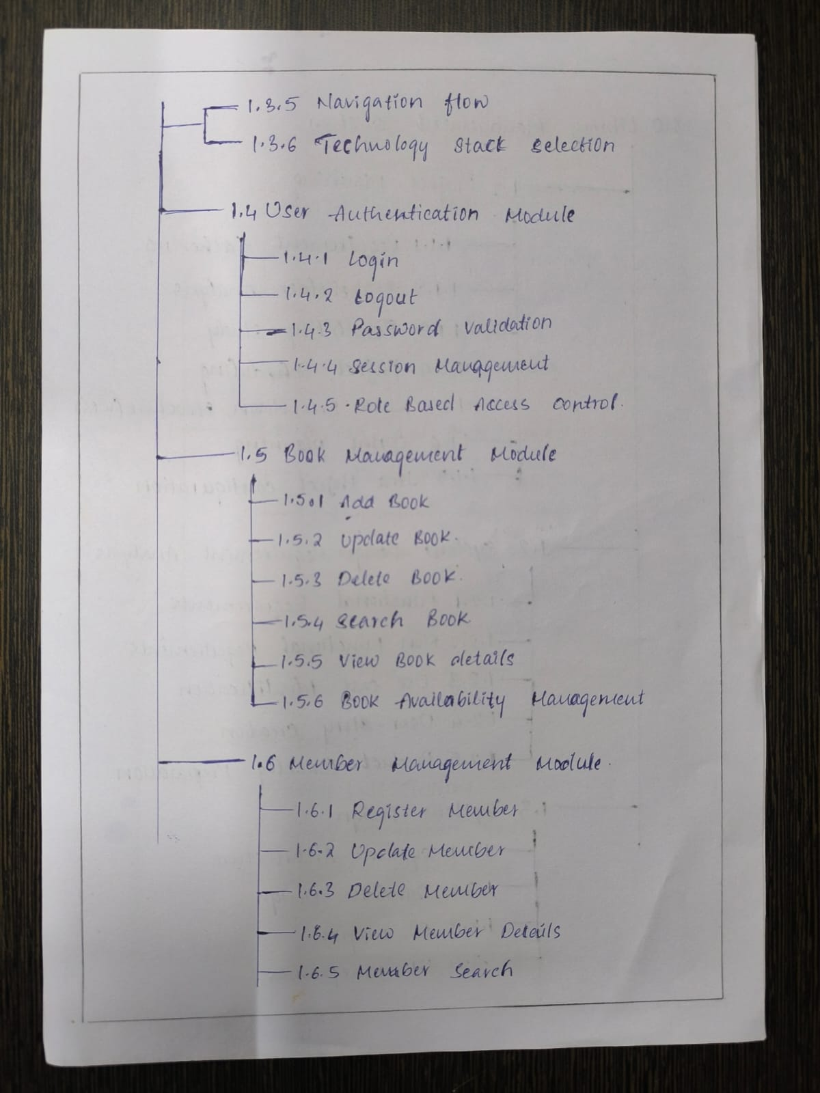
SCRUM-12 attachment: WhatsApp Image 2026-07-27 at 9.49.57 PM.jpeg
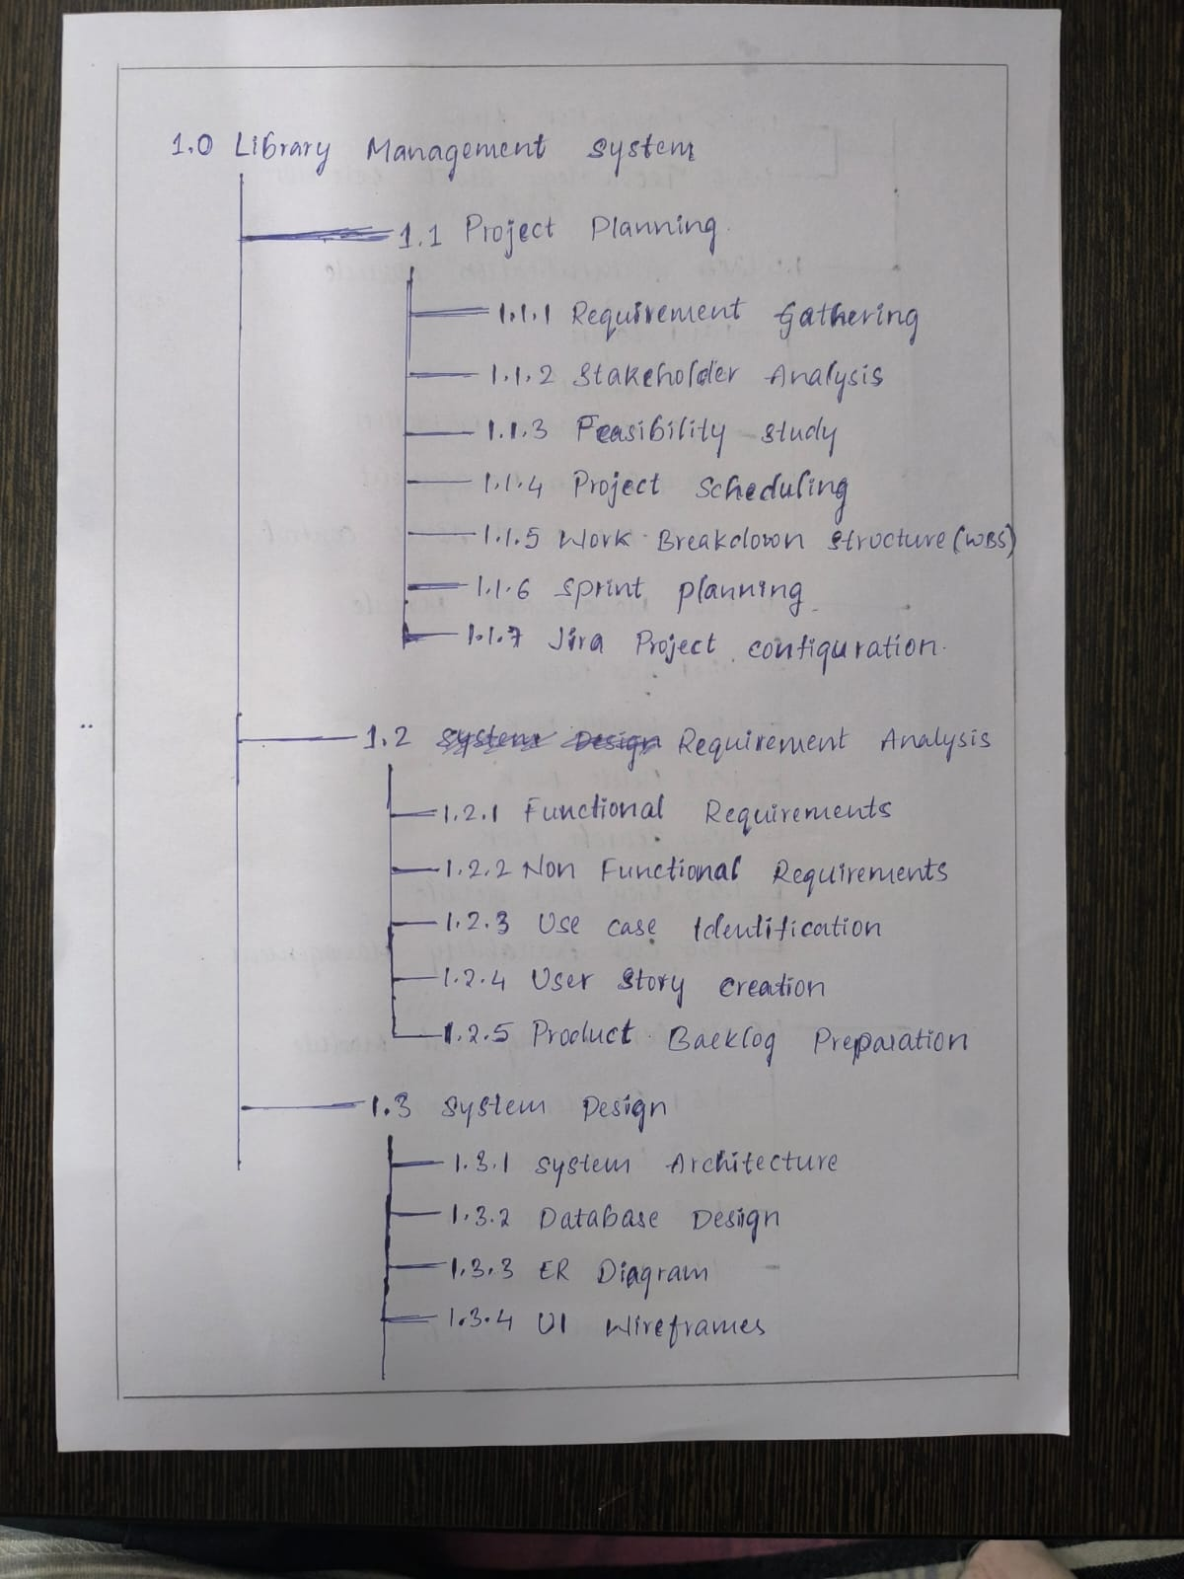
SCRUM-12 attachment: WhatsApp Image 2026-07-27 at 9.50.00 PM.jpeg

SCRUM-13 - User Authentication
Type | Epic | Status | In Progress
Assignee | Sagar Bankapur | Reporter | Sagar Bankapur
Priority | Medium | Due date | 30 Aug 2026
Finished by | Sagar Bankapur on 30 Jul 2026 | Completion | Work evidenced; currently reopened
Attachment count | 0 | Completion note | Earlier Done transition by Sagar Bankapur on 30 Jul 2026; current status is In Progress
User Authentication epic for login, role-aware sessions, and access-control work.
Attachments recorded in Jira: none.

SCRUM-14 - Book Management
Type | Epic | Status | In Progress
Assignee | Sagar Bankapur | Reporter | Sagar Bankapur
Priority | Medium | Due date | 30 Aug 2026
Finished by | Not recorded as finished | Completion | In progress
Attachment count | 1 | Completion note | Not marked Done in Jira; current status is In Progress
Book Management epic for catalog CRUD, search, filtering, and book availability handling.

Attachments Recorded in Jira
Attachment | Uploaded by/date | Brief description
Books.tsx | Sagar Bankapur; 29 Jul 2026 | React TypeScript source for book catalog/search and book-management screens.

SCRUM-15 - Member Management
Type | Epic | Status | In Progress
Assignee | Sagar Bankapur | Reporter | Sagar Bankapur
Priority | Medium | Due date | 30 Aug 2026
Finished by | Not recorded as finished | Completion | In progress
Attachment count | 1 | Completion note | Not marked Done in Jira; current status is In Progress
Member Management epic covering student/member loan and reservation visibility.

Attachments Recorded in Jira
Attachment | Uploaded by/date | Brief description
MyLoans.tsx | Sagar Bankapur; 29 Jul 2026 | React TypeScript source for the student loans/reservations view.

SCRUM-16 - Issue & Return
Type | Epic | Status | In Progress
Assignee | Aella Harsha Vardhan Reddy 24BCE1254 | Reporter | Sagar Bankapur
Priority | Medium | Due date | 30 Aug 2026
Finished by | Not recorded as finished | Completion | In progress
Attachment count | 5 | Completion note | Not marked Done in Jira; current status is In Progress
Issue & Return epic covering checkout, return, fine, reservation, and circulation logic.

Attachments Recorded in Jira
Attachment | Uploaded by/date | Brief description
checkout_activity_diagram.png | Sagar Bankapur; 30 Jul 2026 | StarUML-style activity diagram showing the book checkout workflow.
library_management_system_advanced_features.zip | Sagar Bankapur; 29 Jul 2026 | Compressed bundle of advanced LMS feature files.
LibraryContext.tsx | Sagar Bankapur; 29 Jul 2026 | React context source exposing book, member, issue/return, fine, settings, and reservation APIs.
return_activity_diagram.png | Sagar Bankapur; 30 Jul 2026 | StarUML-style activity diagram showing the book return workflow.
storage.ts | Sagar Bankapur; 29 Jul 2026 | LocalStorage database service containing mock relational data and transaction logic.

Embedded Visual Evidence
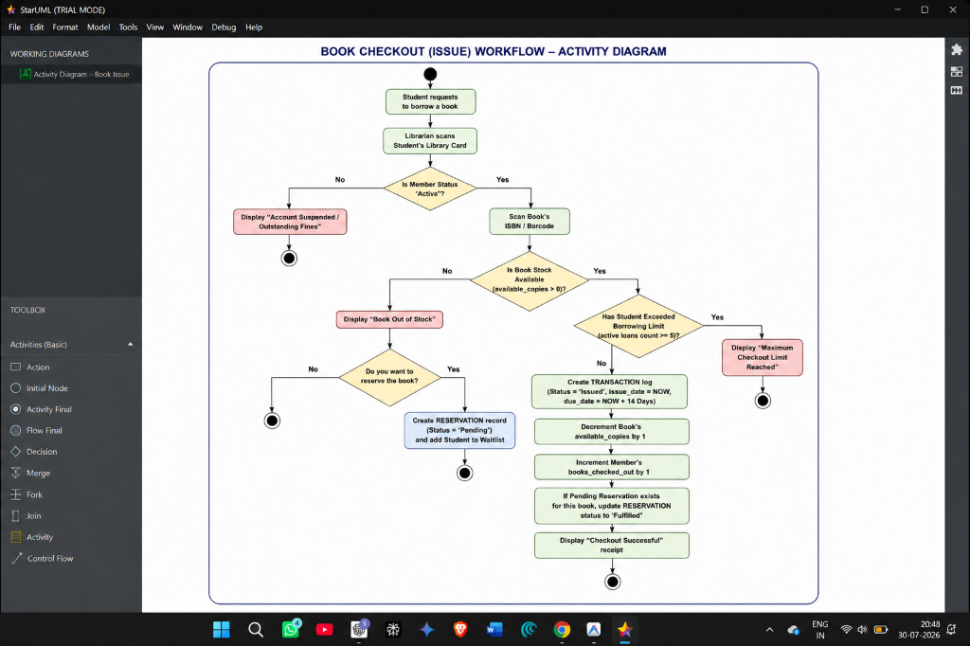
SCRUM-16 attachment: checkout_activity_diagram.png
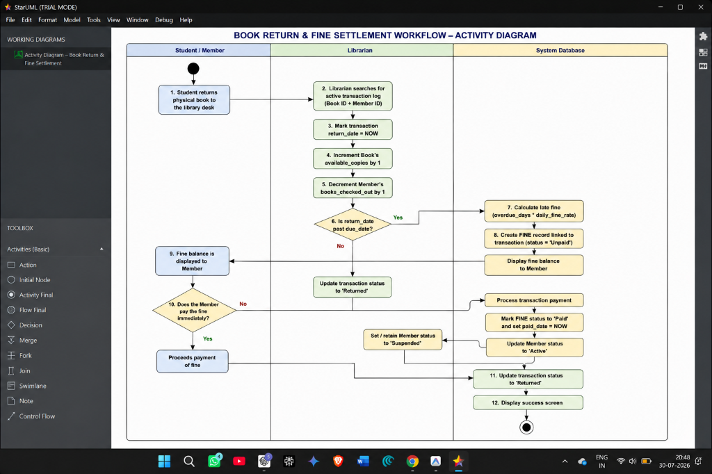
SCRUM-16 attachment: return_activity_diagram.png

SCRUM-17 - Reports & Dashboard
Type | Epic | Status | In Progress
Assignee | Aella Harsha Vardhan Reddy 24BCE1254 | Reporter | Sagar Bankapur
Priority | Medium | Due date | 30 Aug 2026
Finished by | Not recorded as finished | Completion | In progress
Attachment count | 3 | Completion note | Not marked Done in Jira; current status is In Progress
Reports & Dashboard epic covering dashboard metrics and settings evidence.

Attachments Recorded in Jira
Attachment | Uploaded by/date | Brief description
Dashboard.tsx | Sagar Bankapur; 29 Jul 2026 | React TypeScript source for dashboard metrics and operational summaries.
Project_Status_Snapshot.md | Sagar Bankapur; 29 Jul 2026 | Status snapshot documenting implementation progress and Jira synchronization.
Settings.tsx | Sagar Bankapur; 29 Jul 2026 | React TypeScript source for administrative borrowing and fine policy settings.

SCRUM-18 - Requirement Analysis
Type | Epic | Status | In Progress
Assignee | Unassigned | Reporter | Sagar Bankapur
Priority | Medium | Due date | 30 Aug 2026
Finished by | Sagar Bankapur on 30 Jul 2026 | Completion | Work evidenced; currently reopened
Attachment count | 2 | Completion note | Earlier Done transition by Sagar Bankapur on 30 Jul 2026; current status is In Progress
Requirement Analysis epic covering formal SRS and use-case diagram evidence.

Attachments Recorded in Jira
Attachment | Uploaded by/date | Brief description
Requirements_Analysis_SRS.docx | Sagar Bankapur; 30 Jul 2026 | Formal requirements/SRS document uploaded as requirements evidence.
use_case_diagram.png | Sagar Bankapur; 30 Jul 2026 | StarUML-style use-case diagram showing Admin, Librarian, and Student interactions.

Embedded Visual Evidence
SCRUM-18 attachment: use_case_diagram.png

SCRUM-19 - System Design
Type | Epic | Status | In Progress
Assignee | Aella Harsha Vardhan Reddy 24BCE1254 | Reporter | Sagar Bankapur
Priority | Medium | Due date | 30 Aug 2026
Finished by | Sagar Bankapur on 30 Jul 2026 | Completion | Work evidenced; currently reopened
Attachment count | 2 | Completion note | Earlier Done transition by Sagar Bankapur on 30 Jul 2026; current status is In Progress
System Design epic covering ER modelling and database schema documentation.

Attachments Recorded in Jira
Attachment | Uploaded by/date | Brief description
er_diagram.png | Sagar Bankapur; 30 Jul 2026 | StarUML-style ER diagram image showing entities and relationships for the LMS database.
System_Design_Database_Schema.docx | Sagar Bankapur; 30 Jul 2026 | System design document containing database schema and design explanation.

Embedded Visual Evidence
SCRUM-19 attachment: er_diagram.png

Overall Completion Based on Jira
Out of 19 Jira issues, 2 are currently marked Done and 17 remain In Progress. Several issues have earlier Done transitions in the changelog but were later moved back to In Progress; these are reported as work evidenced but currently reopened. No extra completion claim has been added beyond the Jira status and history records.

