Library Management System
System Design & Database Schema
Relational Schema, Keys, Constraints, and Data Dictionary

1. Database Model Overview
This system design specification details the relational database design for the Library Management System, satisfying the requirements under Task SCRUM-6 (Design Database Schema).

Entity-Relationship Diagram (ERD)
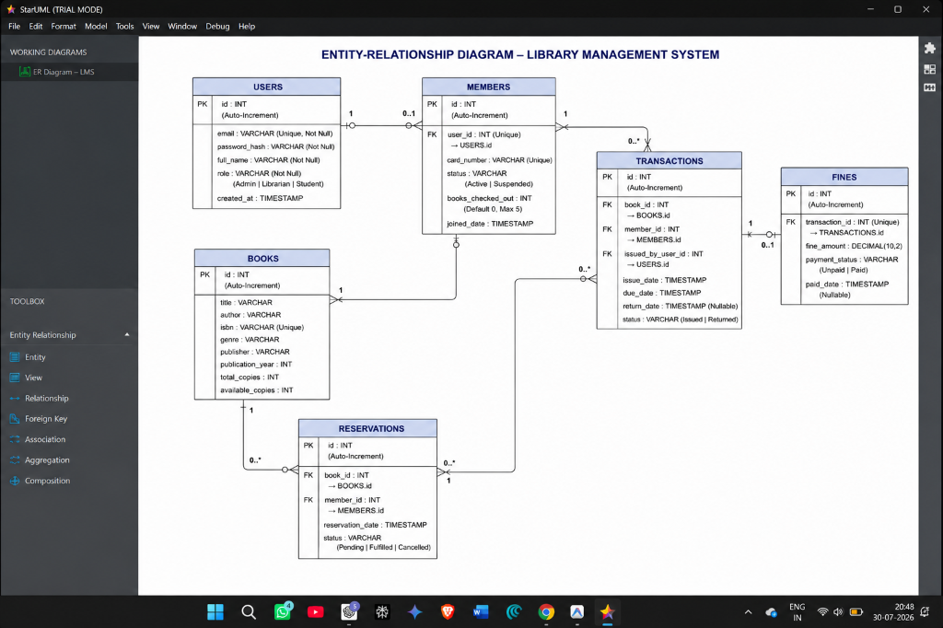
Figure 1: Normalized (3NF) Entity-Relationship Diagram detailing database table cardinalities, PK/FK mappings, and constraints.

2. Schema Normalization (3NF)
To maximize data integrity and minimize storage redundancies, the schemas are normalized to the Third Normal Form (3NF):
• 1NF: All columns represent atomic, single-valued attributes.
• 2NF: All tables are in 1NF and all non-key properties fully depend on the primary keys.
• 3NF: All tables are in 2NF and no transitive functional dependencies exist (e.g. member details are not repeated in transaction logs).

3. Data Dictionary (Table Schemas)

3.1 users Table
Stores authentication credentials and permissions for all users.
Column Name | Data Type | Constraints | Description
id | SERIAL / INT | PK, Auto-Inc | Unique system user identifier.
email | VARCHAR(150) | UNIQUE, NOT NULL | Login email address.
password_hash | VARCHAR(255) | NOT NULL | Bcrypt password hash.
full_name | VARCHAR(100) | NOT NULL | User's display name.
role | VARCHAR(20) | NOT NULL | Role designation: 'Admin' | 'Librarian' | 'Student'.
created_at | TIMESTAMP | DEFAULT NOW() | Account registration timestamp.

3.2 books Table
Stores cataloged books info and real-time physical availability count.
Column Name | Data Type | Constraints | Description
id | SERIAL / INT | PK, Auto-Inc | Catalog reference key.
title | VARCHAR(255) | NOT NULL | Book title.
author | VARCHAR(255) | NOT NULL | Author's name.
isbn | VARCHAR(20) | UNIQUE, NOT NULL | International Standard Book Number.
genre | VARCHAR(50) | NOT NULL | Classification genre (e.g. Fiction).
total_copies | INT | DEFAULT 1 | Total stock units owned by the library.
available_copies | INT | DEFAULT 1 | Copies remaining on the shelves.

3.3 transactions Table
Logs all book checkouts, due targets, and return validations.
Column Name | Data Type | Constraints | Description
id | SERIAL / INT | PK, Auto-Inc | Transaction ID.
book_id | INT | FK -> books(id) | Borrowed book title catalog ID.
member_id | INT | FK -> members(id) | Borrowing member identification.
issued_by_user_id | INT | FK -> users(id) | Librarian user ID approving the checkout.
issue_date | TIMESTAMP | DEFAULT NOW() | Timestamp of checkout transaction.
due_date | TIMESTAMP | NOT NULL | Target return date (typically issue_date + 14 days).
return_date | TIMESTAMP | NULLABLE | Timestamp when book was physically checked back in.
status | VARCHAR(20) | DEFAULT 'Issued' | Status state: 'Issued' | 'Returned'.

3.4 fines Table
Tracks fees linked to overdue return transactions.
Column Name | Data Type | Constraints | Description
id | SERIAL / INT | PK, Auto-Inc | Unique fine ticket ID.
transaction_id | INT | FK -> transactions(id) | Associated loan transaction log ID.
fine_amount | DECIMAL(10,2) | DEFAULT 0.00 | Accrued overdue balance value.
payment_status | VARCHAR(20) | DEFAULT 'Unpaid' | Payment status: 'Unpaid' | 'Paid'.
paid_date | TIMESTAMP | NULLABLE | Timestamp of fee payment resolution.

4. Relational Constraints & Business Rules
• Inventory Counter Triggers: Book checkout requires `books.available_copies` > 0. On transaction insert, decrement copies count. On return, increment copies count.
• Borrow Limits: Students are limited to maximum 5 concurrent active issues. Checkout blocks if `books_checked_out` >= 5.
• Fine Logic: Overdue daily penalty rate is configured at $1.00/day. Fine calculations trigger on return if `return_date` > `due_date`.

