Library Management System
Software Requirements Specification
System Functional & Non-Functional Specifications

1. Scope & Purpose
This Software Requirements Specification (SRS) details the specifications for the Library Management System (LMS) web application. This document lists user stories, acceptance criteria, and system scope tracked under Task SCRUM-10 (Research Library Requirements).

2. User Personas & Roles
The system supports three user roles, each having distinct privileges:
• Administrator: Possesses complete administration access. Responsible for CRUD on librarians and configurations.
• Librarian: Handles daily inventory controls (books cataloging, member registration, checking books out, processing returns, recording payments).
• Student / Member: Standard member role. Can search the database catalog, look up their checkout logs, and inspect outstanding fees.

Use Case Diagram Model
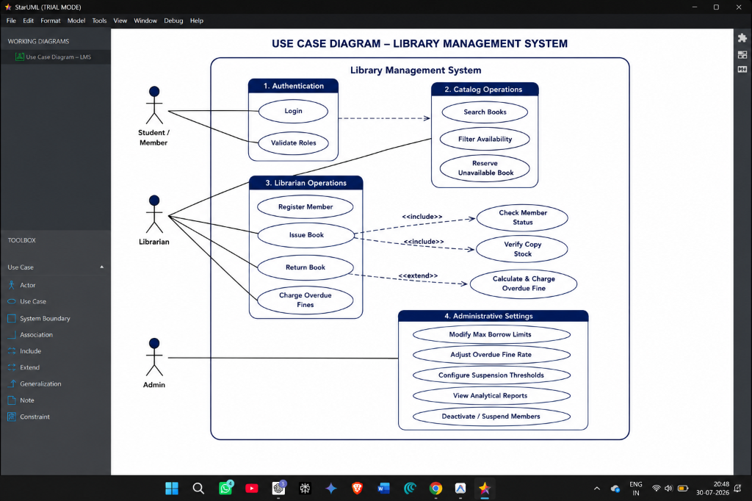
Figure 1: Use Case Diagram representing core library system actor boundaries.

3. Functional Requirements (User Stories)
The following stories outline the functional expectations for Sprint 1 and 2:

LMS-AUTH-01: User Authentication (3 SP)
As a user, I want to securely log in with my email/password so that I can open my dashboard.
Acceptance Criteria:
- Validates email formatting and password rules (min 8 chars).
- Issues secure JWT tokens on authentication success.
- Checks role and redirects users to their appropriate page.

LMS-BOOK-01: Manage Book Catalog (5 SP)
As a librarian, I want to add, edit, and delete books in the system catalog to manage inventory.
Acceptance Criteria:
- Form checks ISBN unique format.
- Input constraints reject invalid publishers/years.
- Blocks deletes if book copies are checked out.

LMS-BOOK-02: Book Search & Filter (2 SP)
As a student or librarian, I want to search and filter book listings to find available copies.
Acceptance Criteria:
- Debounced search bar query.
- Filters by Title, Author, ISBN, or Genre.
- Availability state indicator (Available vs Out of Stock).

LMS-TX-01: Checkout Book (5 SP)
As a librarian, I want to issue books to active library members to track borrowings.
Acceptance Criteria:
- Decrements copies count on issue.
- Checks member is Active and has borrowed < 5 books.
- Applies a default return due date of 14 days.

LMS-TX-02: Return Book & Fines (5 SP)
As a librarian, I want to mark returns and calculate overdue penalties automatically.
Acceptance Criteria:
- Increments available stock copy count.
- Computes days overdue between Due Date and Return Date.
- Charges $1.00 fine per day overdue and appends it to member's account.

4. Non-Functional Requirements
• Security: Passwords must be encrypted using cryptographically strong hashing (bcrypt). Client sessions must rely on encrypted JWT tokens.
• Usability: UI must adjust adaptively across desktop, tablet, and mobile devices.
• Performance: Database search queries and filter matches must return values within 500ms.

5. System Workflows & Activity Diagrams

Book Checkout (Issue) Workflow
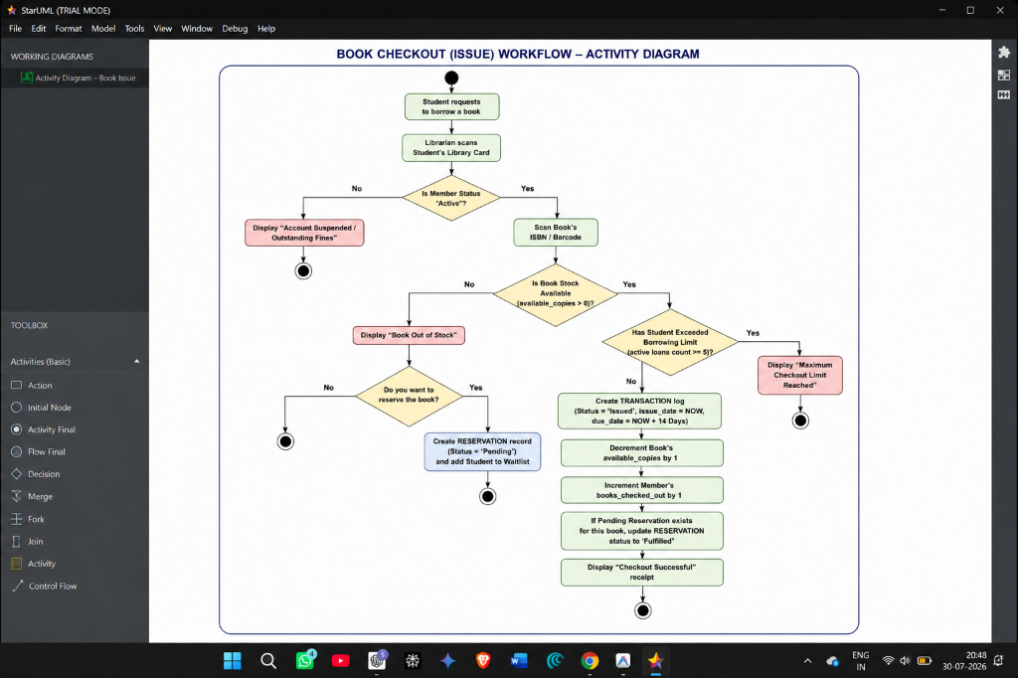
Figure 2: Unified Activity Diagram detailing checkout validations, suspension checks, stock updates, and waitlist allocations.

Book Return & Fine Accrual Workflow
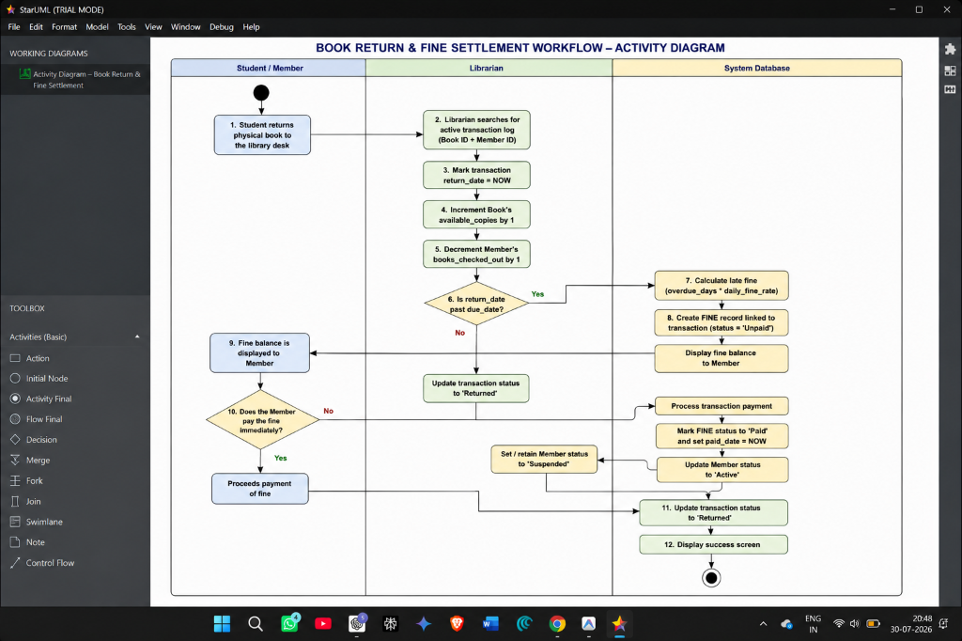
Figure 3: Activity Diagram representing book returns, overdue check-in triggers, fine calculations, and payment transitions.

