# Chapter 2 Analysis

# 2.1Introduction

Analysis defines the objectives, aims and goals of a particular system by analyzing or understanding the system structure. In analysis step, requirements are collected from different sources and a clear vision of how and what the system should be is known. Various requirements gathering process such as case study, filling the form, direct communication to the client can be used. The analysis report helps the developer to know the cost, risk, time, resources and other vital project components. **(BusinessDictionary.com, 2018)**

The initial phase in building a system is to comprehend what that system ought to be. Analysis is the first step which is bridge to gather the information. Through the analysis process it is easy to understand the what system should do. The reason for analysis is to discover the requirements which distinguishes and organize the data need that helps the system to get the system objective. And also, description of all aspects of the current information system.

Systems analysis and design, as performed by systems analysts, seeks to understand what humans need to analyze data input or data flow systematically, process or transform data, store data, and output information in the context of a particular organization or enterprise.

## PEST Analysis

A PEST analysis is a widely used [strategic planning](http://www.business2community.com/strategy/7-strategic-planning-essentials-0885815#1LydMZbw7SLdM0T8.97) tool. It is used by many to identify the political, economic, social and technological factors that may have an effect on a project and its planning process. Sometimes it’s expanded to include legal and environmental factors and called a PESTLE analysis.

With this analysis, you can identify potential opportunities and threats associated with your strategy and figure out ways to take advantage of them and avoid them.

* **Political factors** include tax policies, employment laws, tariff & trade restrictions, consumer protection laws, environmental regulations, political stability of a country etc.
* **Economic factors** include economic growth indicators, inflation rate, interest rates, exchange rates, fiscal policies, unemployment trends etc.
* **Social factors** include cultural aspects, age distribution, career attitudes, health consciousness, population growth rate, social classes etc.

## SWOT Analysis

SWOT Analysis is a useful technique for understanding your Strengths and Weaknesses, and for identifying both the Opportunities open to you and the Threats you face.

SWOT analysis is used in a business context; it helps you to carve a sustainable niche in your market. Used in a [personal context](https://www.mindtools.com/pages/article/newTMC_05_1.htm), it helps you to develop your career in a way that takes best advantage of your talents, abilities and opportunities.

**Business SWOT Analysis**

What makes SWOT particularly powerful is that, with a little thought, it can help you uncover opportunities that you are well-placed to exploit. And by understanding the weaknesses of your business, you can manage and eliminate threats that would otherwise catch you unawares.

## CATWOE Analysis

CATWOE Analysis is a technique for understanding a stakeholder’s perspective and the impact that this view will have on the direction of the business change. CATWOE Analysis is one of [many techniques that a business analyst uses](https://businesschange.co.za/oodles-of-business-analysis-techniques-at-your-disposal/) to identify the what it is that the business is trying to achieve, what the problem areas are and how stakeholder perspectives affects the people involved in it.

One of the primary reasons for managing stakeholder relationships is to understand their viewpoint before putting forward any recommendations, or, worse still, implementing business change.

CATWOE stands for:

* **Customer**: the recipient of the outputs from the business system
* **Actor**: the roles that perform the business system processes
* **Transformation**: the core process that delivers the outputs to the customer
* **World view**: the underlying world-view for the transformation
* **Owner**: the stakeholder with the overall authority for the business system
* **Environment**: the rules and constraints surrounding the business system

# 2.2 Feasibility study:

Feasibility study Is investigation about the how effectively project can be finished. It is not only the project research but the plan to run profitable business to long term. it is utilized for examine ability to work successfully for a long time by ensuring that whether the project is technically, legally and economical feasible. The following are feasibility analysis:

* Operational feasibility
* Technical feasibility
* Economic feasibility
* Legal feasibility
* Schedule feasibility
* Economic feasibility

Investigation of an undertaking's expenses and incomes with an end goal to decide if it is intelligent and conceivable to finish.

* Technical feasibility

Technical feasibility can likewise feature particular dangers of the undertaking that ought to be considered for the green light choice.

* Legal feasibility

Decides if the proposed system clashes with lawful necessities.

* Operational feasibility

The measure of solving problems with the help of a new proposed system.

* Schedule feasibility

The degree to which a deadline for a strategy, plan, project or process is realistic and achievable.

# 2.3 Requirement Analysis

## i)Functional requirements

Functional requirements are that any prerequisite which determines what the system should do. It describes the core functionality of the system. The functional requirements describe the core functionality of the application. This segment incorporates the information and functional process necessities.

**ADMIN:**

|  |  |  |  |  |
| --- | --- | --- | --- | --- |
| **Id** | **Title** | **Description** | **Rational** | **Dependencies** |
| FR1 | Admin Login | Login into system with authorized username and password | Access to the system | N/A |
| FR2 | Add categories | Admin can categories the job. | It was easy to select category wise. | N/A |
| FR3 | Add jobs and Update/edits jobs | information about the new jobs should be added update/edit to database by admin. | To adds or update the new jobs | FR2 |
| FR4 | Delete items | From the database admin can delete easily information regards to the particular job | To erase the jobs that are full. | FR2, FR3 |
| FR5 | Manage application | Admin can manage application from jobseekers | To view the application details | FR2, FR3 |
| FR6 | Logout | From admin panel admin can logout | To end session | FR1 |

**USER**

|  |  |  |  |  |
| --- | --- | --- | --- | --- |
| **Id** | **Title** | **Description** | **Rational** | **Dependencies** |
| FR1 | User Registration | User will be sign-up to the account with personal information. | To register user in the system | FR2 |
| FR2 | User login | User Login into system with authorized username and password | To authorized user is accessible to use system | FR1 |
| FR3 | Views available jobs | User will be able to view available jobs | To view available jobs | N/A |
| FR4 | To apply for job | from web application easily. | To select the job | N/A |
| FR5 | Logout | After finshing the task user is able to logout. | To end the session of the user. | FR2 |

## ii)Non-functional Requirements:

A non-functional prerequisite necessity explains an execution normal for a specific system. non-functional necessities characterize how well it needs to work

|  |  |  |  |  |
| --- | --- | --- | --- | --- |
| **Id** | **Title** | **Description** | **Rational** | **Dependencies** |
| NFR1 | Performance | System ought to be capable handle numerous clients at once and will have speedy reaction rate. | To enhance data processing speed. | NFR1 |
| NFR2 | Security | System ought to be secured that username and password | To secured from unauthorized cannot access or deny the system. | NFR1 |
| NFR3 | Availability | At any time, user should get their contents need. | To use the system, it should be available when needed at any time. | NFR4 |
| NFR4 | Reliability | System should be accurate and reliable. | To increase the system performance and level of accuracy. | NFR3 |
| NFR5 | Maintainability | If any problems arise system should be maintaining quickly. | Maintained further in an easy way | N/A |
| NFR6 | Portability | system can fit on any devices to completed the requirements | Making system can be available in various platforms. | NFR3 |
| NFR7 | Usability | System should be easily use and becomes user friendly. | If it is user friendly then more clients are enlisting. | N/A |

## Moscow

**(Must, Should, Could, Won’t) prioritization: -**

The requirements prioritization technique that is used in this project is MOSCOW Prioritization. These techniques elaborate the important level of each requirement of the system. All the requirements provided by the clients are fulfilled but to fulfill all requirements many time and resources can be required. So, with MOSCOW prioritization more time and resources is provided to most important requirements. **(Dsdm.org, 2018)**

The meaning of each terms of MOSCOW prioritization are given below:

**Must have: -**This point depicts in the final solution requirements that must be fulfilled. Project will be failure if the requirements are not implemented. It is the most vital things where the requirements are non-negotiable.

**Should have: -**

A high-need highlight that isn't basic to dispatch. Here, the things we consider as important but not vital.

**Could have: -**

It is an attractive prerequisite but not necessary. if the project’s timescales are at danger this point will be erased from first scope.

**Won’t have: -**

In Current release this prerequisite will not implemented but might in future it will be included in phase of development. these types of requirements do not hamper to be project successful.

The MOSCOW Prioritization of the requirements of Our Job is shown below:

|  |  |  |
| --- | --- | --- |
| ID | Functional Requirement | Moscow |
| FR1 | Customer sign-up | Must have |
| FR2 | Admin and user Login | Must have |
| FR3 | Add, customers | Should have |
| FR4 | Change password | Should have |
| FR5 | Add categories | Should have |
| FR6 | Add items | Must have |
| FR7 | Search items | Should have |
| FR8 | Update items | Must have |
| FR9 | Delete items | Should have |
| FR10 | Upload feedback | Won’t have |
| FR11 | Manage payments | Could have |
| FR12 | Manage orders | Should have |
| FR 13 | Help centre | Won’t have |
| FR14 | Logout | Must have |

|  |  |  |
| --- | --- | --- |
| ID | Non-functional Requirements | Moscow |
| NFR1 | Performance | Could have |
| NFR2 | Security | should have |
| NFR3 | Availability | Could have |
| NFR4 | Reliability | Could have |
| NFR5 | Maintainability | Should have |
| NFR6 | portability | Should have |
| NFR7 | usability | Should have |

Table: MOSCOW Prioritization

# 2.4 System Architecture

It is the discipline that defines the structure and behavior of the system and the components used in the system. In this system, Web Development technique is used. So, the coding pattern is divided into three different layers. The three layers are: Presentation, Application and Data layer. The whole code is divided into different layer so that it is easy to write and modify them. The System Architecture that is used in this project is shown below:

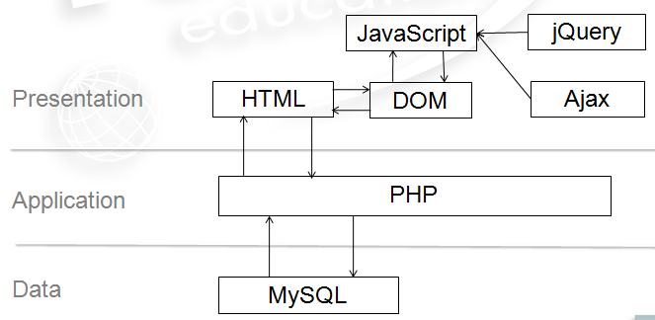

Figure 6 System Architecture

# 2.5 Use Case Diagram:

The use case diagram is a tool which plays a significant role in dealing our abstraction. It enables us to represent to the wide interaction between the system parts.

* It catches the dynamic part of the system.
* It demonstrates how actor interact with the system.
* The system architecture is validated.
* The content of the system is determining.

The following points are the basic symbols which are used in use case as: System: - It helps in the collaboration between one or more external entities in the system.

**System**: -By using rectangle shape draw our boundaries of the system which contains the use cases. Actor should be placed outside the system boundaries

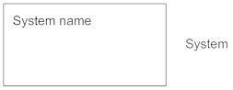

* 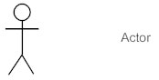**Actors**: - Actors are something that interact with our system .it is denoted by the symbol.
* **Use case**: - Use case is oval in shaped which represent various uses that an actor might have. It is denoted by symbol the symbol.

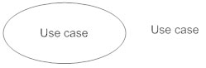

* **Relationship**: Relationship can be labeled by arrow either uses or extends among use cases. To perform a task on use case is needed by another is indicates by uses relationship where extends indicates optional under a certain use case.

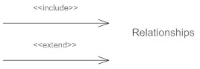

I have made use case diagram for My Job Portal.

**User**

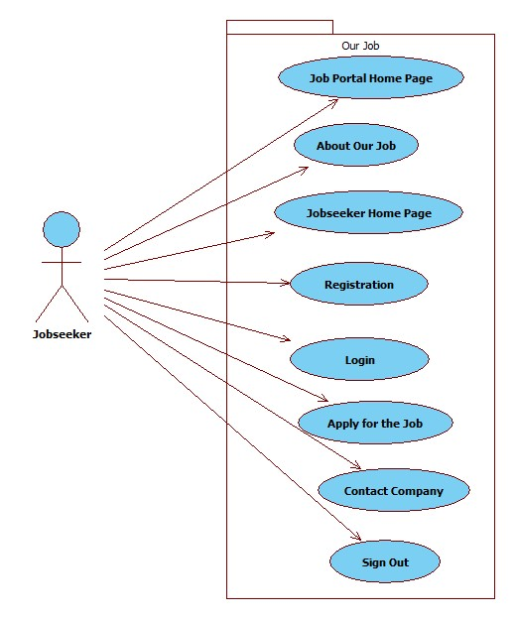

**Company/Admin**

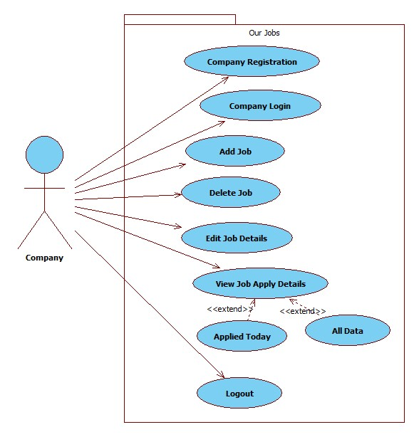

**Registration**

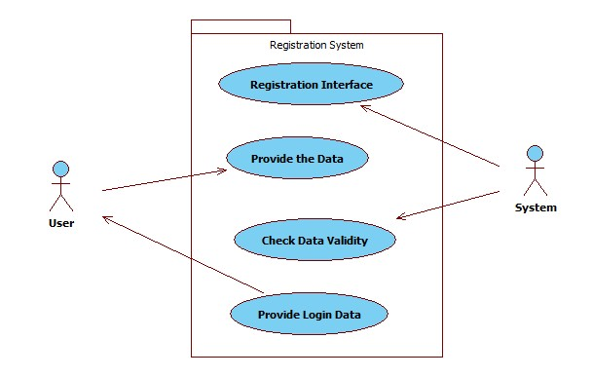

Login

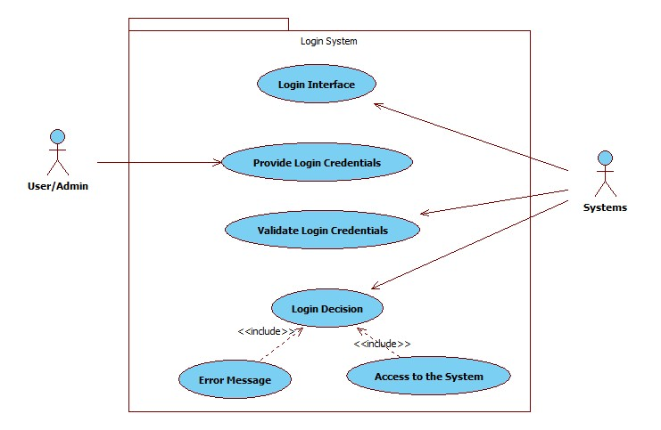

# Natural Language analysis (NLA)

Natural Language Analysis permits us to obtain a list of ***candidate classes***, their relationships and their attributes. It will decrease the duplication and efficiency of the system is increased.

|  |  |
| --- | --- |
| **Classes** | **Functionality** |
| Login, Registration, ApplyForJob, OurJob, Database, PostJob | user registration, user login, select jobs, apply for job, update profile, admin login, add jobs, update jobs, delete jobs, view application, view user, view jobs . |

# Initial class diagram

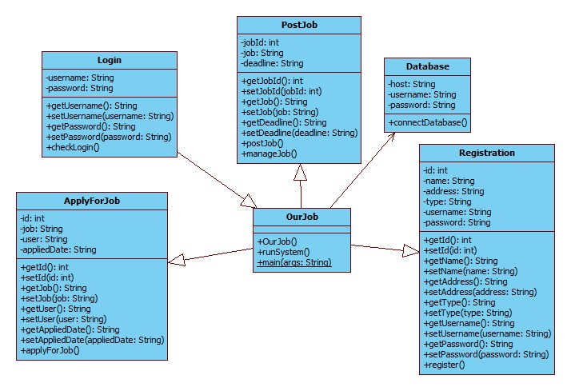

# Conclusion: -

In the process of analysis. I have used use case diagram which interacts with actor and system. Also function requirement and non-functional requirements are depicted. By the use of Moscow prioritization, we take the vital important and necessary requirements in this project analysis. Finally, design is marked by the pattern called MVC and as needed initial class diagram is provided. At last with all of this above project analysis is successfully completed.