**Project Proposal on**

**Job Portals**



Sagar Bhasima Submitted to:

00174412 Niman Maharjan

Computing Project

Level 5 Diploma in Computing

Softwarica College of IT & E-Commerce

Kathmandu, Nepal

09 April 2019

Contents

Chapter 1 4

Introduction 4

Problem Identification 5

Chapter 2 6

Scope 6

Aims 7

Objectives 7

Development methodology 8

Chapter 3 9

Project Plan 9

Work Breakdown Structure (WBS) and Time Estimate 9

Milestones 10

Schedule 11

Chapter 4 12

Risk Management 12

**Table of Figures**

Figure 1 Application Structure 4

Figure 2 Stages of Waterfall Model 8

Figure 3 Configuration Management 13

# Chapter 1

## Introduction

The topic of the computing project is researched and decides as “Jobs Portal” where a website is build for the company “Our Job”. The project set a hypothetical company as their client and build the website for them. The project analyses the requirements that might exist for that company and make further moves. The company is “Our Job” which is a platform for both employees and employers. This organization shakes hand with different organizations in the town and collect their requirements of employee for different post. Our Job organization then posts the job details in their website and people can view that and apply for the job. Employee can login in to the system and can view updates about the job and can apply to various jobs available. (web development, 2018)



Figure 1 Application Structure

The above diagram shows how the organization manages the job. The features that the website must have are: create and account, search jobs, post jobs, post resume, register and so on.

The system that will be built in this project is web-based system that is build using latest version of PHP programming language along with its supporting tools. The project also delivers a report that documents every step.

## Problem Identification

In real scenario, various companies are facing problem to get the right candidate in their office. The case is same with skilled manpower, they are also not getting the opportunities according to their caliber. This is the actual problem that the project is trying to solve. The project aims in bridging the gap between company and employee. The company can use the web to post their job vacancy and employee can also use their internet facilities to search for the job. Currently company posts their job vacancy in newspaper and employee see the newspaper article and apply for the job manually. But this process is made computerized through this project.

Various scenarios are researched, and this scenario draws the attention to build an application. The gap between company and skilled resources is the main issue of the society. So building Jobs Portal system helps minimize this problem.

The project aims building a website that is build using the most popular web programming language PHP. This helps to develop the skill of programming in PHP language and helps to develop overall system without error. So the knowledge of other module of the course will also be utilized to develop the complete project.

The project is student project, so it does not involve cost factor. But if the project is built in real scenario then the developing company must bear each cost of development process. Later the company can earn by posting job and advertisements in the website.

# Chapter 2

## Scope

The features that the project will have are listed below:

* A complete web-based application is built.
* A documentation that includes all the project contents.
* A platform for the company to post and manipulate their job details.
* A platform for the employee to search and apply for the job.
* Login system for company and employee
* Highly secure login system
* Contact information of the company along with the platform to send review and feedback to the company.
* Error free system with high usability.
* Highly refined and easy to use user interface
* Short term persistency using cookies and session
* Long term persistency using MySQL database
* Messaging and notification

The features that the project will not have:

* User needs internet facilities to use the system i.e. system is only available online.
* No mobile application; needs browser and website link to access the system
* Lacks some advance features in the website that might make the usability more robust.

The system is built in the PHP Programming language and its supporting tools. The interface is built using HTML and CSS. Advance GUI features and some validation is done using JavaScript. The main logic is written using PHP language. The data is stored in MySQL database. The system is hosted locally in Apache Server using XAMPP Control Panel. The coding is done in the text editor Sublime Text.

A fully functional web application is planned to be built. So, there might be some of the technical challenges that might be faced. PHP and other various programming languages will be used. So, to use them together is a challenging thing. To make the system error free and easy to access is also another challenging factor. Making the system robust and portable is also a challenge. Minimizing this challenge will help the developer to build the system that will meet all the requirements of Our Job organization.

## Aims

* To develop complete website that helps to post and apply for the job
* To develop a document that will include every aspect of development.
* To develop errors free Our Job website.

## Objectives

* To learn the web programming language and use the concept here.
* To utilize the knowledge of every module to develop single large project.
* To analyze the requirements of Our Job organization
* Make design and implement it
* Test the developed system
* Remove any error and take user feedbacks.

## Development methodology

The project is small scale student project with some of the features. The requirements of the project and the system that will be built are also more or less fixed. So, the development methodology that will be used in this system is “**Waterfall Model**”. Waterfall model is the systematic approach where each stage must be completed to go to other step. Waterfall model is best suited in scenario where the project size is small, and the requirements are already known and will not be changed in future. This model is best for web application development and fits better with the system that uses database system. (tutorialspoint, 2018)

There are various stages of waterfall model that are shown by the figure below:

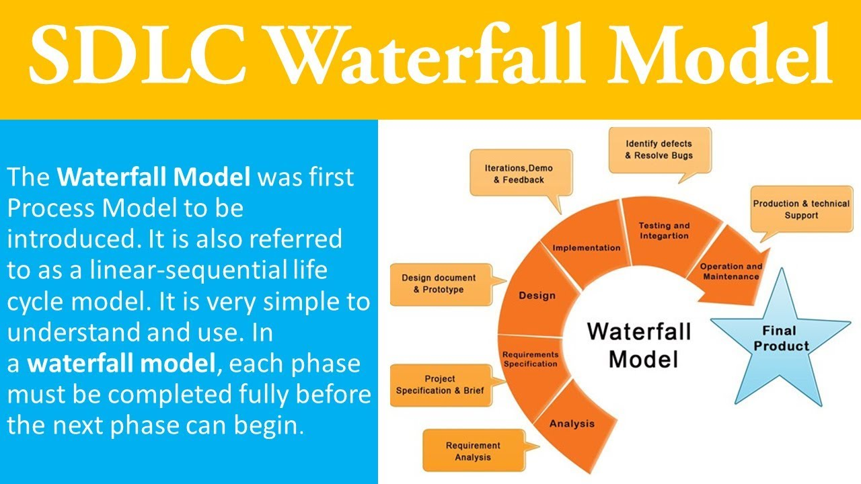

Figure 2 Stages of Waterfall Model

# Chapter 3

## Project Plan

The planning for the project includes the planning of the time so that the project is developed within the given time-frame. The project is academic based, and a deadline is fixed by the university and the different modules of the project must be delivered within that time frame.

A thoroughly analysis is done on the different tasks and the time required to finish each task is decided. The time frame is shown using the Gantt Chart that will be drawn using Microsoft Visio.

## Work Breakdown Structure (WBS)

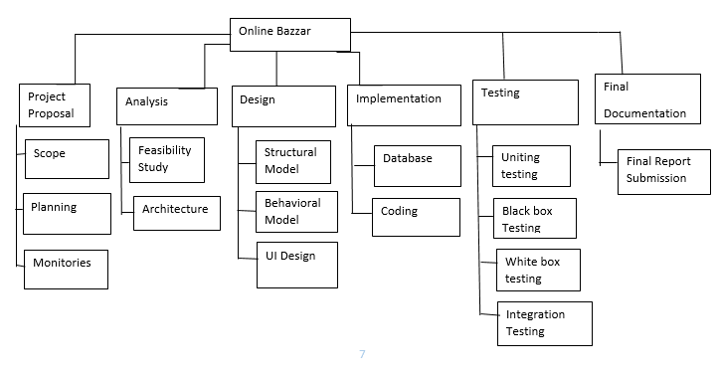

**Job Portal**

The work breakdown of the project is demonstrated by the above figure and represents the task is separated in the six distinct parts. Project proposal is set in the first stage of the project through which a good planning can be done. After my proposal submission I will do the analysis part of the undertaking which will be the initial step after the proposal submission. I will do the testing part on the grounds that there might be minor bugs, which I may have done in the coding time. I will do Integration, black box, White box Unit testing. This will let realize that the site that I have planned is useful or not. Likewise, toward the finish of the work breakdown, I will do the documentation part. This part will assist other individuals with understanding about the application. They will give the insight about the application that I have structured through documentation.

## Time Estimate

The task that needs to be done is divided into different time frame and the time frame is given below:

|  |  |  |
| --- | --- | --- |
| **WBS** | **Task name** | **Days** |
| **1** | **Project proposal** | **16** |
| 1.1 | Scope | 8 |
| 2 | Planning | 5 |
| 2.1 | Monitories | 3 |
| **2.2** | **Analysis** | **28** |
| 2.3 | Feasibility study | 10 |
| 3 | Architecture | 18 |
| **3.1** | **Design** | **25** |
| 3.2 | Structural Model | 5 |
| 4 | Behavioural Model | 6 |
| 4.1 | UI design | 14 |
| **4.2** | **Implementation** | **20** |
| 5 | Database | 11 |
| 5.1 | Coding | 9 |
| **5.2** | **Testing** | **7** |
| 6 | Unit testing | 2 |
| 6.1 | Black box Testing | 2 |
| 6.2 | White box testing | 2 |
| 7 | Integration testing | 1 |
| **7.1** | **Final Documentation** | **11** |
| 7.2 | Final report submission | 6 |

Table: Time estimation.

## Milestones

The various milestones of the project are listed below along with the date completion

|  |  |  |
| --- | --- | --- |
| S. N | Milestones | Date |
| 1 | Project proposal | 9th April, 2019 |
| 2 | Analysis | 8th May, 2019 |
| 3 | Design | 3rd June, 2019 |
| 4 | Implementation | 24th June, 2019 |
| 5 | Testing | 1st July, 2019 |
| 6 | Final Documentation | 12th July, 2019 |

Table: Milestone of the project

## **Schedule**

Gantt Chart is built as the part of scheduling. The Gantt Chart is presented below:

(gantt, 2019)

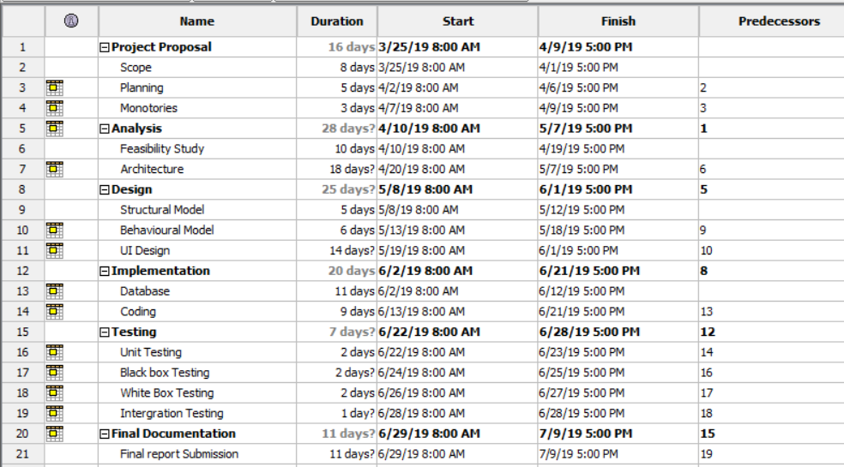

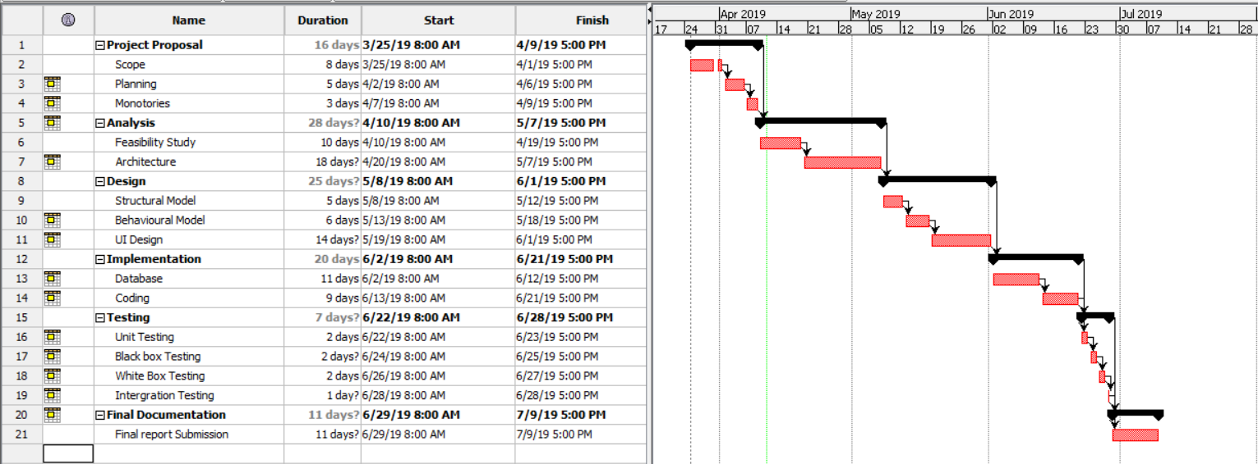

# Chapter 4

## Risk Management

There might be risk factor in the project that must be analyzed and presented. The risk that may affect the project progress must be minimized throughout the project lifecycle.

The formula (impact (I) = likelihood (L) * consequence (C )) is used to calculate the impact. The likelihood and consequences are defined as:

|  |  |
| --- | --- |
| **Likelihood (L)** | **Value** |
| Low | 1 |
| Medium | 2 |
| High | 3 |

|  |  |
| --- | --- |
| **Consequences (C )** | **Value** |
| Very Low | 1 |
| Low | 2 |
| Medium | 3 |
| High | 4 |
| Very High | 5 |

The risk that the project might have is:

|  |  |  |  |  |  |
| --- | --- | --- | --- | --- | --- |
| SN | Risks | Likelihood | Consequence | Impact | Actions |
| 1 | Failure of Hardware | 3 | 3 | 9[3*3] | Proper maintenance |
| 2 | Natural Disaster | 1 | 3 | 3[1*3] | Backup for files |
| 3 | DDOS Attack | 2 | 3 | 6[2*3] | Powerful server should be used |
| 4 | Theft or Robbery | 2 | 3 | 6[2*3] | Password protected or backup |
| 5 | Failure in the time schedule | 1 | 3 | 3[1*3] | Proper planning should be made |
| 6 | Project requirements may not be found easily | 3 | 1 | 3[3*1] | Looks for various website, teachers, seniors. |

Table: Risk management analysis

**Chapter 5**

**Configuration Management**

The configuration management of the project is shown below:

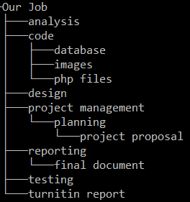

Figure 3 Configuration Management

**Conclusion**

The proposal is finally written by defining the task that will be done in this project. The proposal is written in the topic “Jobs Portal” that will develop a website for “Our Job” organization. The system will be developed in PHP programming language and the tools and techniques that will be required are analyzed. The aims and objectives along with the scope that will be on the project or that will not be on the project is also mentioned. The time frame is divided into different parts and the time analysis report are presented.

Waterfall model is chosen as the development process because it is systematic approach and the project size is small, so it best suits the scenario.

Any risks that may arise in the project is analyzed and mentioned in the project. The action that will be taken to minimize the risk is also provided.

**Bibliography**

Webdevelopment.com.pk. (2018). *Online Job Portal System, Software Development Company Pakistan*. [online] Available at: <http://www.webdevelopment.com.pk/Job-Portal-System>[Accessed 20 Mar. 2018].

www.tutorialspoint.com. (2018). *SDLC Waterfall Model*. [online] Available at: <https://www.tutorialspoint.com/sdlc/sdlc_waterfall_model.htm> [Accessed 24 Mar. 2018].

Gantt.com. (2018). *What is a Gantt Chart? Gantt Chart Software, Information, and History*. [online] Available at: <http://www.gantt.com/>[Accessed 26 Mar. 2018].