Basic Unix Command

1. Passwd

The passwd utility is used to update user’s authentication token(s).

This task is achieved through calls to the Linux-PAM and Libuser API.
Essentially, it initializes itself as a "passwd" service with Linux-PAM
and utilizes configured password modules to authenticate and then
update a user’s password.

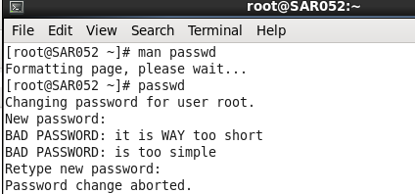

2. pwd

Print the full filename of the current working directory.
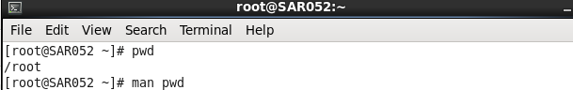

3. Apropos

apropos searches a set of database files containing short descriptions of system commands for keywords and displays the result on the standard output.

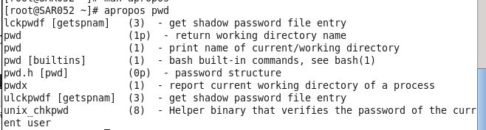

4. su

Change the effective user id and group id to that of USER.
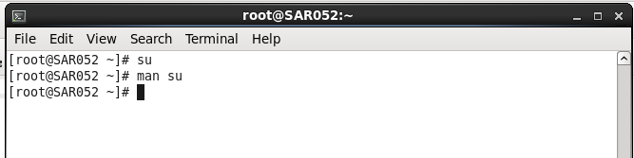
5. ssh
ssh (SSH client) is a program for logging into a remote machine and for
executing commands on a remote machine. It is intended to replace rlogin
and rsh, and provide secure encrypted communications between two
untrusted hosts over an insecure network. X11 connections and arbitrary
TCP ports can also be forwarded over the secure channel.

ssh connects and logs into the specified hostname (with optional user
name). The user must prove his/her identity to the remote machine using
one of several methods depending on the protocol version used (see
below).

If command is specified, it is executed on the remote host instead of a
login shell.

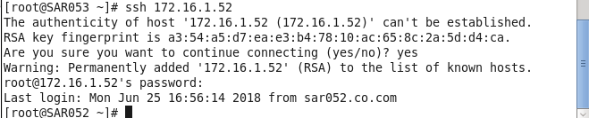
6. chown
This manual page documents the GNU version of chown. chown changes the
user and/or group ownership of each given file. If only an owner (a
user name or numeric user ID) is given, that user is made the owner of
each given file, and the files’ group is not changed. If the owner is
followed by a colon and a group name (or numeric group ID), with no
spaces between them, the group ownership of the files is changed as
well. If a colon but no group name follows the user name, that user is
made the owner of the files and the group of the files is changed to
that user’s login group. If the colon and group are given, but the
owner is omitted, only the group of the files is changed; in this case,
chown performs the same function as chgrp. If only a colon is given,
or if the entire operand is empty, neither the owner nor the group is
changed.

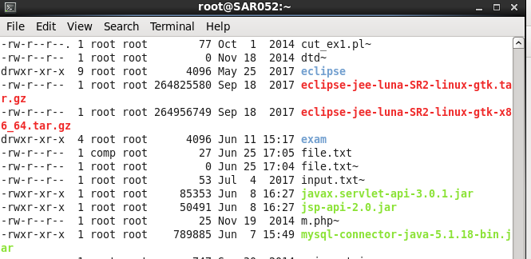

7.top
The top program provides a dynamic real-time view of a running system.
It can display system summary information as well as a list of tasks
currently being managed by the Linux kernel. The types of system sum-
mary information shown and the types, order and size of information
displayed for tasks are all user configurable and that configuration
can be made persistent across restarts.

The program provides a limited interactive interface for process manip-
ulation as well as a much more extensive interface for personal config-
uration -- encompassing every aspect of its operation. And while top
is referred to throughout this document, you are free to name the pro-
gram anything you wish. That new name, possibly an alias, will then be
reflected on top’s display and used when reading and writing a configu-
ration file.
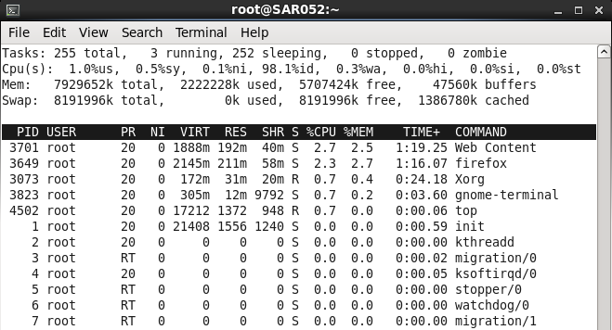
8. kill
The command kill sends the specified signal to the specified process or
process group. If no signal is specified, the TERM signal is sent.
The TERM signal will kill processes which do not catch this signal.
For other processes, it may be necessary to use the KILL (9) signal,
since this signal cannot be caught.

Most modern shells have a builtin kill function, with a usage rather
similar to that of the command described here. The ‘-a’ and ‘-p’
options, and the possibility to specify pids by command name is a local
extension.

If sig is 0, then no signal is sent, but error checking is still per-
formed.
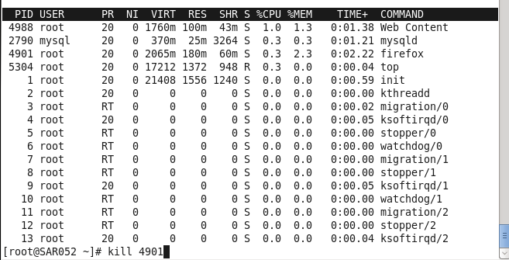
9. sort
Write sorted concatenation of all FILE(s) to standard output.
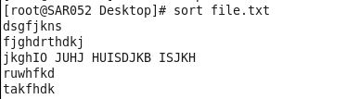

10.gedit
gedit is the official text editor of the GNOME desktop environment.

While aiming at simplicity and ease of use, gedit is a powerful general
purpose text editor. It can be used to create and edit all kinds of
text files.

gedit features a flexible plugin system which can be used to dynami-
cally add new advanced features to gedit itself.

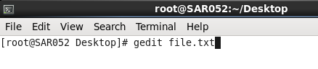

11.mkdir
Create the DIRECTORY(ies), if they do not already exist.

Mandatory arguments to long options are mandatory for short options
too.
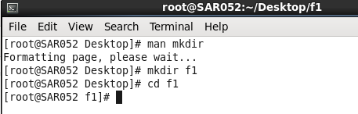

12.rmdir
Remove the DIRECTORY(ies), if they are empty.
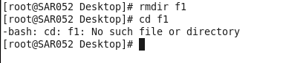

13.mv
Rename SOURCE to DEST, or move SOURCE(s) to DIRECTORY.

Mandatory arguments to long options are mandatory for short options
too.
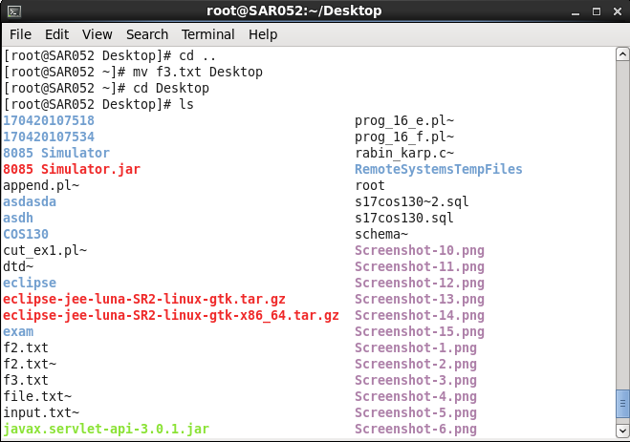

14.rm
This manual page documents the GNU version of rm. rm removes each
specified file. By default, it does not remove directories.

If the -I or --interactive=once option is given, and there are more
than three files or the -r, -R, or --recursive are given, then rm
prompts the user for whether to proceed with the entire operation. If
the response is not affirmative, the entire command is aborted.

Otherwise, if a file is unwritable, standard input is a terminal, and
the -f or --force option is not given, or the -i or --interac-
tive=always option is given, rm prompts the user for whether to remove
the file. If the response is not affirmative, the file is skipped.
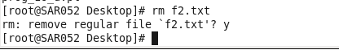

: PRACTICAL QUESTIONS :

1. Which command is used for finding host/domain name and IP address of the local machine?

2.
Which command will display the assigned IP address of current network adapter?
3.
Which command is used for checking the network reach ability ?
4.
Which command is used to view user information, user’s login name, real name, terminal name and write status ?
5.
What are the text based web browser available through command line ?
6.
Which command is used for displaying or manipulating the ARP (Address Resolution Protocol) information on a network device or computer. ?
7.
Which command is used for checking/starting/stopping networking services,users,messaging,configuration and so on... ?
8.
Which command is used for displaying and manipulating routing table ?
9.
Which command is used to monitor access control for supported services ?
10.
Which command is used to view network traffic ?
11.
Which command is used for connecting to a host with encryption ?
12.
Which Command can be used to find out the intermediate nodes between the host and the server?
13.
Which command is used to find out the domain names of intermediate nodes between the host and the server ?
14.
Command used to follow all the information a particular DNS server has about a particular domain.
15.
Which command is used to get documents/files from a server or send documents to a server?
16.
This protocol allows you to send and receive files between two computers. Generally used to upload web content to the web server or download the web content from the web server.
17.
Part of the `ssh` package.
This command is similar to ftp but uses an encrypted
tunnel to connect to an ftp server and is therefore more secure than just plain ftp.
18.
Another Part of the `ssh` package. Allows you to copy files from one computer to another computer encryption.
19.
Which command should be used to generate the hash of a
file?

