**Forecasting Project**

1. **Forecasting Using ARIMA**

* In this project the Sales data of a store was given for six years from 2013 to 2018. Objective of the project is to create a forecasting model to forecast the sales.
* In the first stage the data which was in form of dataframe was converted into Time series to make it suitable for forecasting.
* For forecasting the time series needs to be stationary i.e. its rolling mean and rolling standard deviation should not change with time.
* To convert the non-stationary series to stationary series multiple transformations were applied. Then the stationarity of the series was validated using Augmented Dickey -Fuller Test.
* The Autocorrelation plot gives us the value of **‘d = 1’**
* The original time series was deseasonalised and **ARIMA** model was applied with the parameters that gave optimal fit with original plot. In the plot below blue line is the original deseasonalised sales and red line is the forecast output of **ARIMA.**

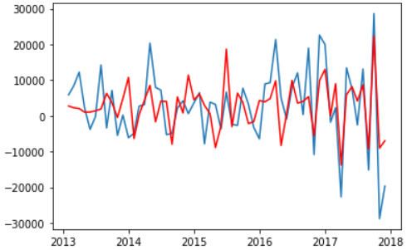

* The Percentage error in this model is 3.51 % and this model can be used for forecasting the Monthly sales of the store.

1. **Forecasting Using FB Prophet**

* The objective of this project is building a forecasting model for predicting hourly consumption of the powerplant. The data consists of hourly power consumption at powerplant.
* In first stage some Exploratory Data analysis was performed to spot the patterns and abnormalities in the data.
* This model takes the traditional forecasting a step further and can break down into the Timeseries into its constituting components like trend (Daily, Weekly, Day of Week, Monthly), seasonality etc.
* This model is especially useful for deep drilling into the seasonal cycles present into the timeseries.

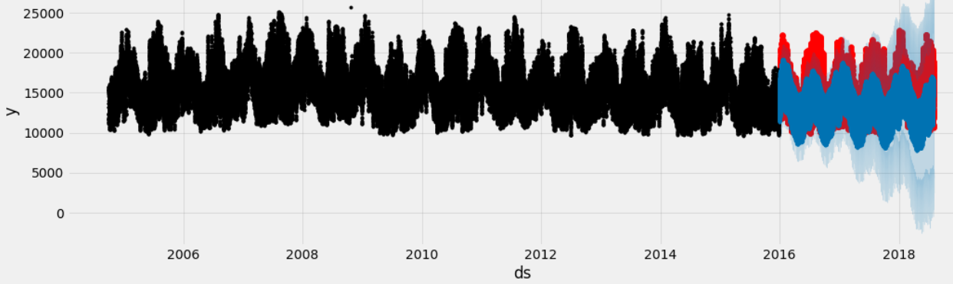

* As we can see in the Actual Vs Forecast plot the seasonality and trend has been perfectly predicted by the Prophet forecasting model. But it has limitations to predict the peaking values.
* Another functionality of this model is that it can accommodate the effect of holidays and special events in the forecasting. Once we pass the list of holidays and special events the algorithm ignores them during model building. Thus, keeping the forecast as accurate as possible.
* It was found that excluding holidays increased the error in forecast, which is logical since holidays have a great impact on the energy consumption and should not be excluded from forecasting model.