* Project goal: describes the purpose of this project
  + The goal of this project is to create a news feed application where a user can view news stories from several different sources and quickly see a brief description. To complete the extra credit portion of the assignment, Google’s natural language processing RESTful API is used to perform an entity analysis on the article description to produce Wikipedia links of the relevant topics.
* Project features: abstract from the user stories
  + As a user, I want to be able to look at top news stories
  + As a user, I want to be able to quickly lookup topics that come up in the news
  + As a regular user of this application, I want to be able to see what articles I looked up in the past
  + As a user, I want to be able to look at different types of news (business, politics, technology, etc.)
* Project design: visual diagram of project components/flow
  + App flow
    - When a new user opens the application for the first time, it defaults to a list displaying top news from all English sources. The user can see a title, image, description, and entities that have a corresponding Wikipedia page.
    - Users have the option of clicking directly on the article to open it in a browser.
    - Users have the option to click on any of the entities and open the respective entity’s Wikipedia page
    - Users can also toggle a navigation drawer that contains the ability to sign in/create a new account, and pick news categories.
      * When one of the categories is picked, the list of articles is refreshed with news in that category
      * When the user logs in, an additional history option appears in the menu, when the user clicks on it, the article list gets refreshed with the user’s recently viewed articles
  + Visual Diagrams
    - 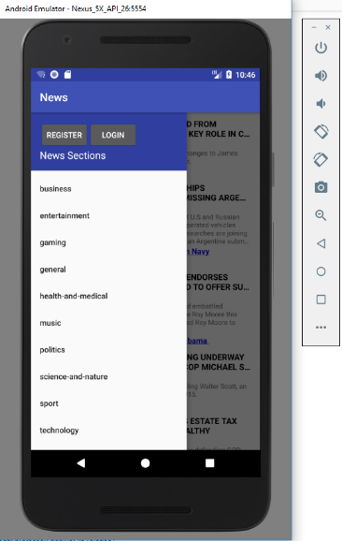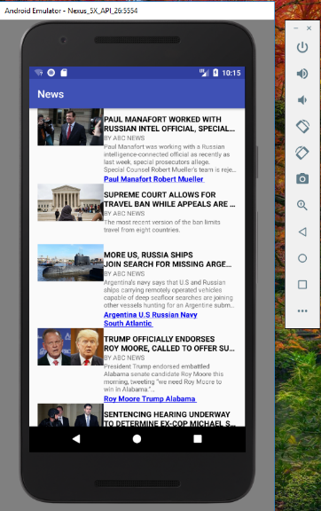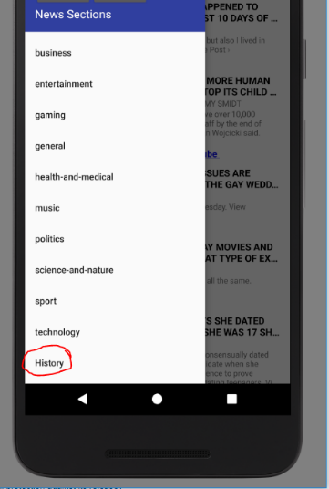
    - Top Right: The navigation drawer before the user logs in
    - Top left: View hen the application is first opened
    - Bottom: The navigation drawer with the users signed in history view
    - Mockup of initial design:
    - 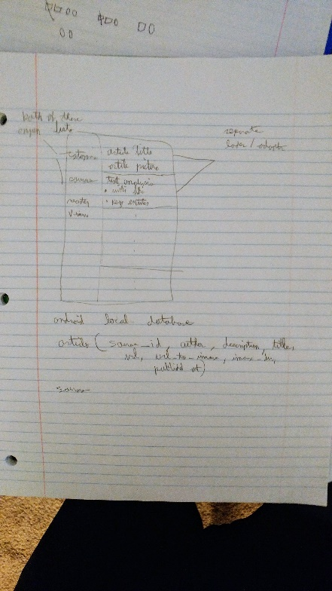
    - High level UML diagram showing all the different classes (generated with code Iris):
    - 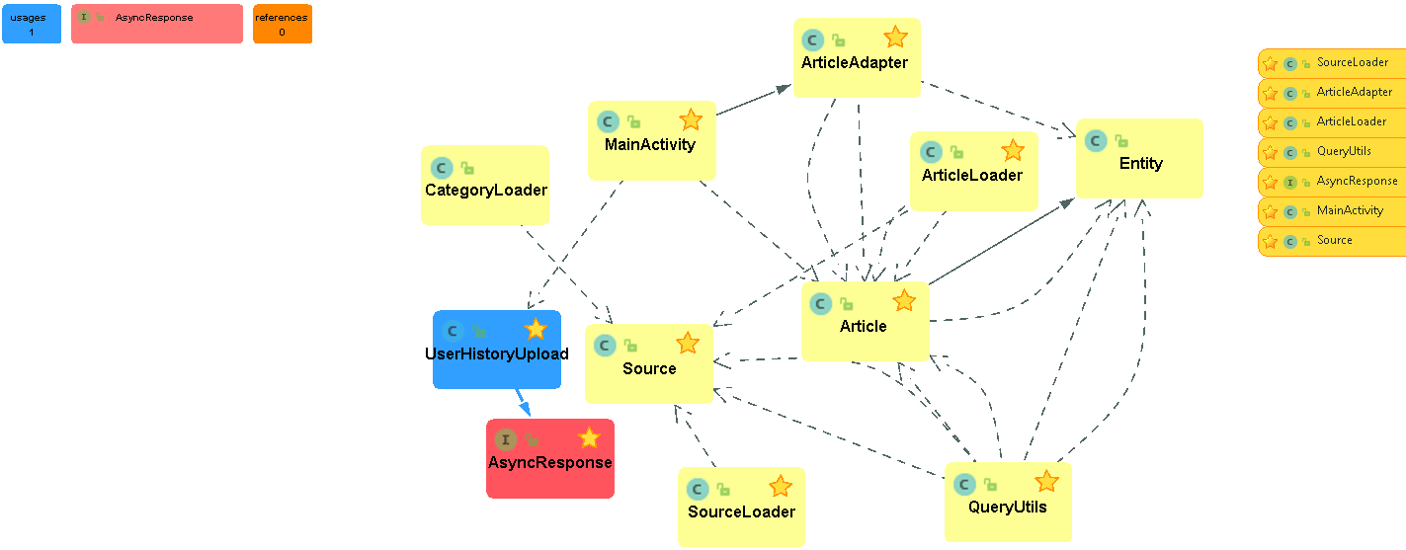
    - Model structure
      * Articles 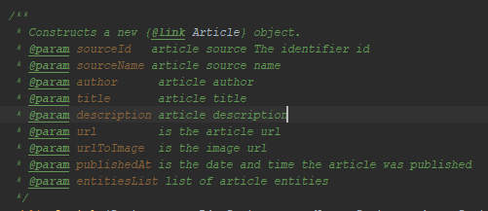
      * Source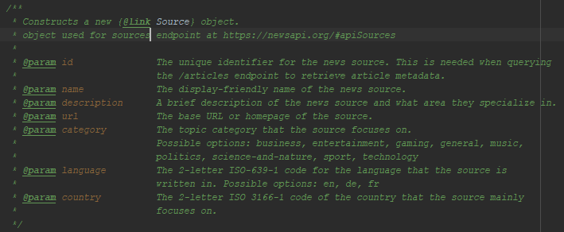
      * Entity 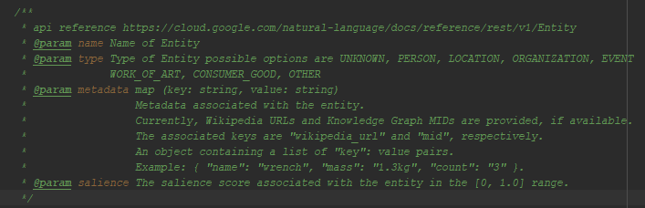
* File structure: what does each file do and who wrote that file
  + Java/model/ defines the models uses by the three REEST API calls (Article, Entity, Source) used in this application. They are all immutable models; the only time the class’s data is set is in the contractor. Each model is used to store data returned from the APIs in objects to be used by the application and firebase.
    - Author: Christopher Pearce
  + Java/ArticleAdapter extends ArrayAdapter used to create the list of articles and list of entities with Wikipedia articles.
    - Author: Christopher Pearce and Jacob Rothmel
  + Java/ArticleLoader extends an AsyncTaskLoader uses QueryUtils.fetchArticleData and QueryUtils. fetchSourceData to asynchronously generate a list of articles to be used by ArticleAdapter
    - Author: Christopher Pearce, Robert Farinelli
  + Java/CategoryAdapter extends ArrayAdapter used to create a list of Categories
    - Author: Robert Farinelli, Christopher Pearce
  + Java/CategoryLoader used to generate a list of categories
    - Author: Robert Farinelli, Christopher Pearce
  + Java/ImageLoadtask used to set image from url in Java/ArticleAdapter
    - Author: Jacob Rothmel
  + Java/LoginActivity used to handle the user’s login to firebase
    - Author: Jacob Rothmel
  + Java/MainActivity is Entry point for application
    - Author: Christopher Pearce, Jacob rothmel, Robert Farinelli
  + Java/QueryUtils is where all the logic required to make the various RESTAPI calls is located. Methods that query every version of <https://newsapi.org/> is located here. Also methods to query <https://cloud.google.com/natural-language/> is here as well. These methods query the APIs and construct lists of objects defined in Java/model.
    - Author: Christopher Pearce, Robert Farinelli
  + Java/RegistrationActivity contains logic to register a new user to the application
    - Author: Robert Farinelli
  + Java/SourceLoader loader to use QueryUtils.fetchSourceData
    - Author: Christopher Pearce
  + Java/HistoryUpload asyncTask used to save articles to a user’s history in firebase
    - Author: Robert Farinelli