1. Analysis of Retail /sales Data

Input Files: input files are specified in <Input_dataSet> folder

Schema:

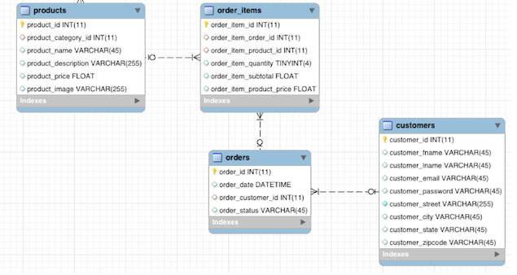

Write Spark SQL Syntax for below use cases (using pyspark or scala):

* order\_items dataset has sales for each order, orders dataset having order\_date

1. Total sales for each date (hint: join orders & order\_items)

2. Total sales for each month

3. Average sales for each date

4. Average sales for each month

5. Name of Month having highest sale

6. Top 10 revenue generating products

7. Top 3 purchased customers for each day/month

8. Most sold products for each day/month

9. Count of distinct Customer, group by State (use customer table)

10. Most popular product category