Activity Logs Feature
Full Technical Documentation

Project: Fideon OS Platform
Feature: Audit Trail & Activity Log System
Roles Covered: global_admin · admin · user · viewer · guest
Date: 2026-03-16

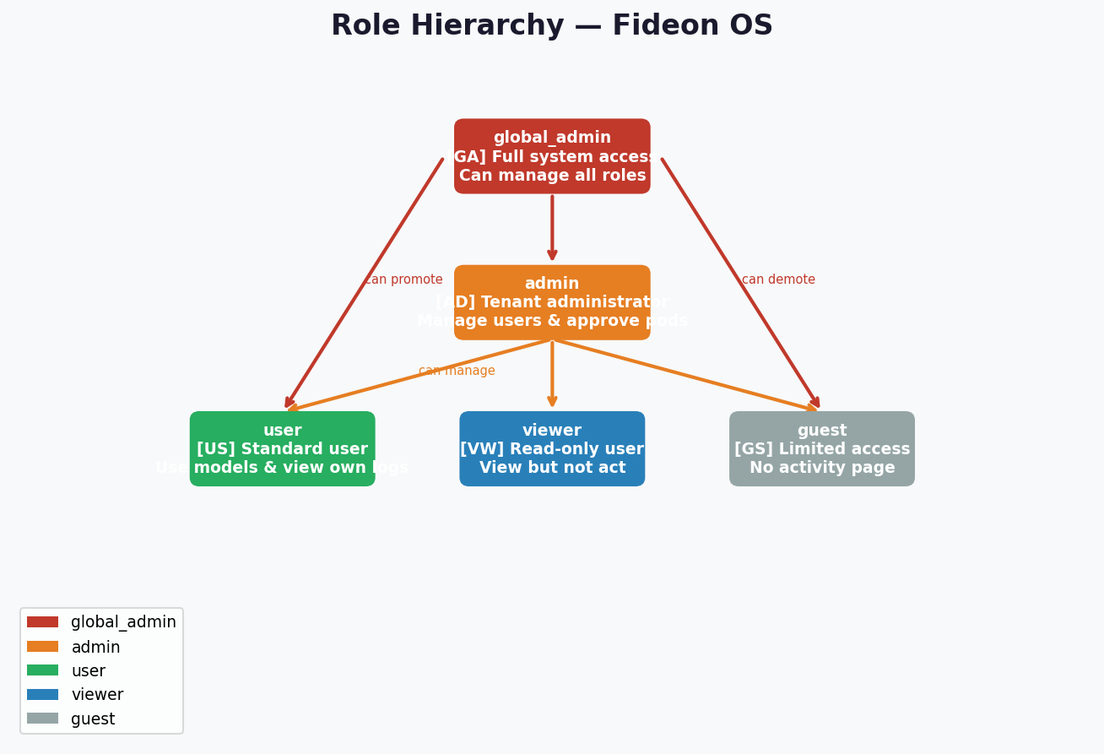
Figure 1 — Role Hierarchy Overview

1. Feature Overview

The Activity Logs system provides a tamper-evident, role-scoped audit trail of all significant actions taken across the Fideon OS platform. It is built on two Supabase PostgreSQL tables (auth_audit and audit_logs), enforced by PostgreSQL Row-Level Security (RLS) policies, and surfaced to users via the /activity frontend page.

Core Design Principles
- Tamper-Evidence: Each auth_audit row stores a SHA-256 integrity_hash computed from non-PII fields. Any post-write modification invalidates the hash.
- Privacy (PII Protection): The email field is stored in the row but deliberately excluded from the integrity hash. Backend server logs use PII scrubbing for fields like password, token, email, phone, ssn.
- Least Privilege: Each role sees only what they are authorized to see via RLS policies. Users see only their own rows; admins see their org; global_admin sees all.
- ATNA Compliance: Action codes (C/R/U/D/E) and outcome codes (0/4/8/12) follow the ATNA healthcare audit standard.
- Immutability: Audit rows are protected by PostgreSQL BEFORE UPDATE / BEFORE DELETE triggers (prevent_audit_modification()) that raise an exception for any modification attempt — including service_role and direct DB connections. Enforces EU AI Act Art.12, SOC2 CC7.2, and NAIC compliance.

2. Role Definitions & Hierarchy

The platform uses a five-tier role model stored as a PostgreSQL enum (app_role) and managed through the user_roles table. Only global_admin can assign or change roles.
Role | Colour | Can Assign Roles | Sees All Audit Logs | Description
global_admin | Red | YES | YES | Full platform control. Assigns/changes all roles.
admin | Orange | NO | YES | Manages users and pods within their scope.
user | Green | NO | Own only | Standard authenticated user.
viewer | Blue | NO | Own only | Read-only access to permitted resources.
guest | Grey | NO | Own only (DB-level) | Most restricted. No /activity frontend page (route guard blocks). However the 'Users see own' RLS policy applies to all authenticated users — guest CAN query own auth_audit and audit_logs rows directly via the Supabase SDK. Frontend UI is the only blocked layer (intentional design: permissive at DB, restricted at UI).


Figure 2 — Role Hierarchy with Promotion Paths

3. Entity-Relationship (ER) Diagram

The diagram below shows all seven database tables and their relationships. The auth_audit and audit_logs tables both reference auth.users via user_id. Device-related logs are linked to the devices table.
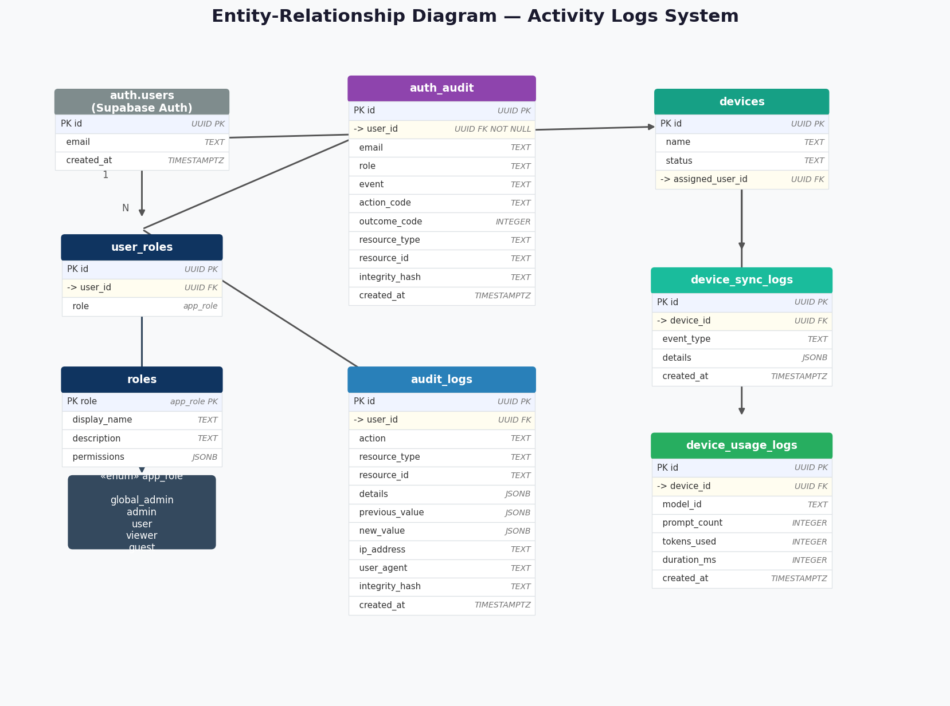
Figure 3 — Full Entity-Relationship Diagram

4. Database Schema — Column-Level Detail

Detailed column specifications for the two primary audit tables and the role assignment table, including data types, constraints, and descriptions.
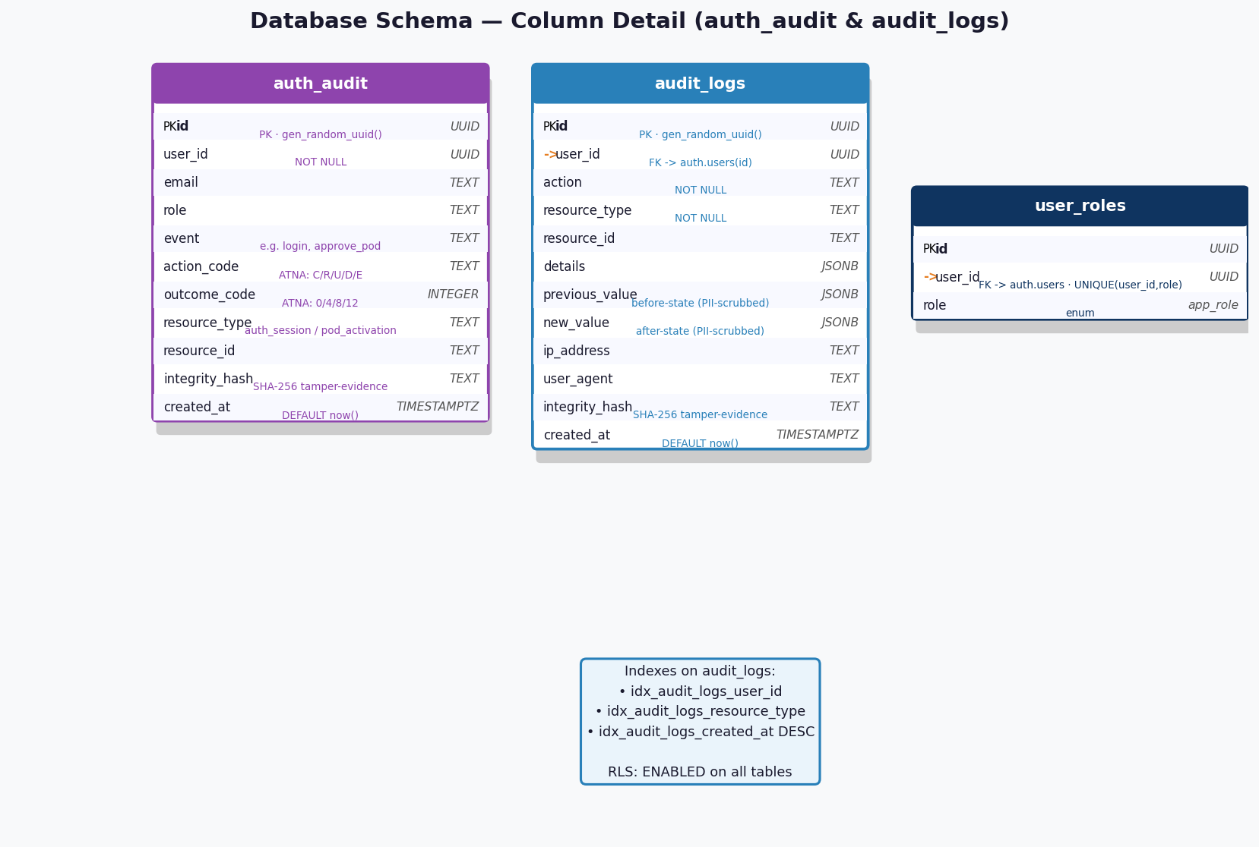
Figure 4 — Schema Column Detail Diagram

4.1 auth_audit — SQL Definition
CREATE TABLE public.auth_audit (
id UUID PRIMARY KEY DEFAULT gen_random_uuid(),
user_id UUID NOT NULL REFERENCES auth.users(id),
email TEXT,
role TEXT,
event TEXT,
action_code TEXT, -- ATNA: C/R/U/D/E
outcome_code INTEGER, -- ATNA: 0/4/8/12
resource_type TEXT,
resource_id TEXT,
integrity_hash TEXT, -- SHA-256 tamper-evidence
created_at TIMESTAMPTZ DEFAULT now()
);

4.2 audit_logs — SQL Definition
CREATE TABLE public.audit_logs (
id UUID PRIMARY KEY DEFAULT gen_random_uuid(),
user_id UUID REFERENCES auth.users(id),
action TEXT NOT NULL,
resource_type TEXT NOT NULL,
resource_id TEXT,
details JSONB,
previous_value JSONB, -- before-state, PII-scrubbed (migration 20260316000002)
new_value JSONB, -- after-state, PII-scrubbed (migration 20260316000002)
ip_address TEXT,
user_agent TEXT,
integrity_hash TEXT, -- SHA-256 tamper-evidence (migration 20260316000001)
created_at TIMESTAMPTZ DEFAULT now()
);
CREATE INDEX idx_audit_logs_user_id ON public.audit_logs (user_id);
CREATE INDEX idx_audit_logs_resource_type ON public.audit_logs (resource_type);
CREATE INDEX idx_audit_logs_resource_id ON public.audit_logs (resource_id) WHERE resource_id IS NOT NULL;
CREATE INDEX idx_audit_logs_created_at ON public.audit_logs (created_at DESC);

5. Row-Level Security (RLS) Policies

All audit tables have RLS enabled. The policies enforce that each role can only access the rows it is authorized to see. There are no UPDATE or DELETE policies and additionally, database-level BEFORE UPDATE / BEFORE DELETE triggers (prevent_audit_modification()) make audit records truly immutable — even service_role and direct Postgres connections cannot modify rows. The has_role(uid, 'admin') helper function is hierarchical and returns true for both admin and global_admin, so global_admin retains full access to device logs and audit_logs via those policies.
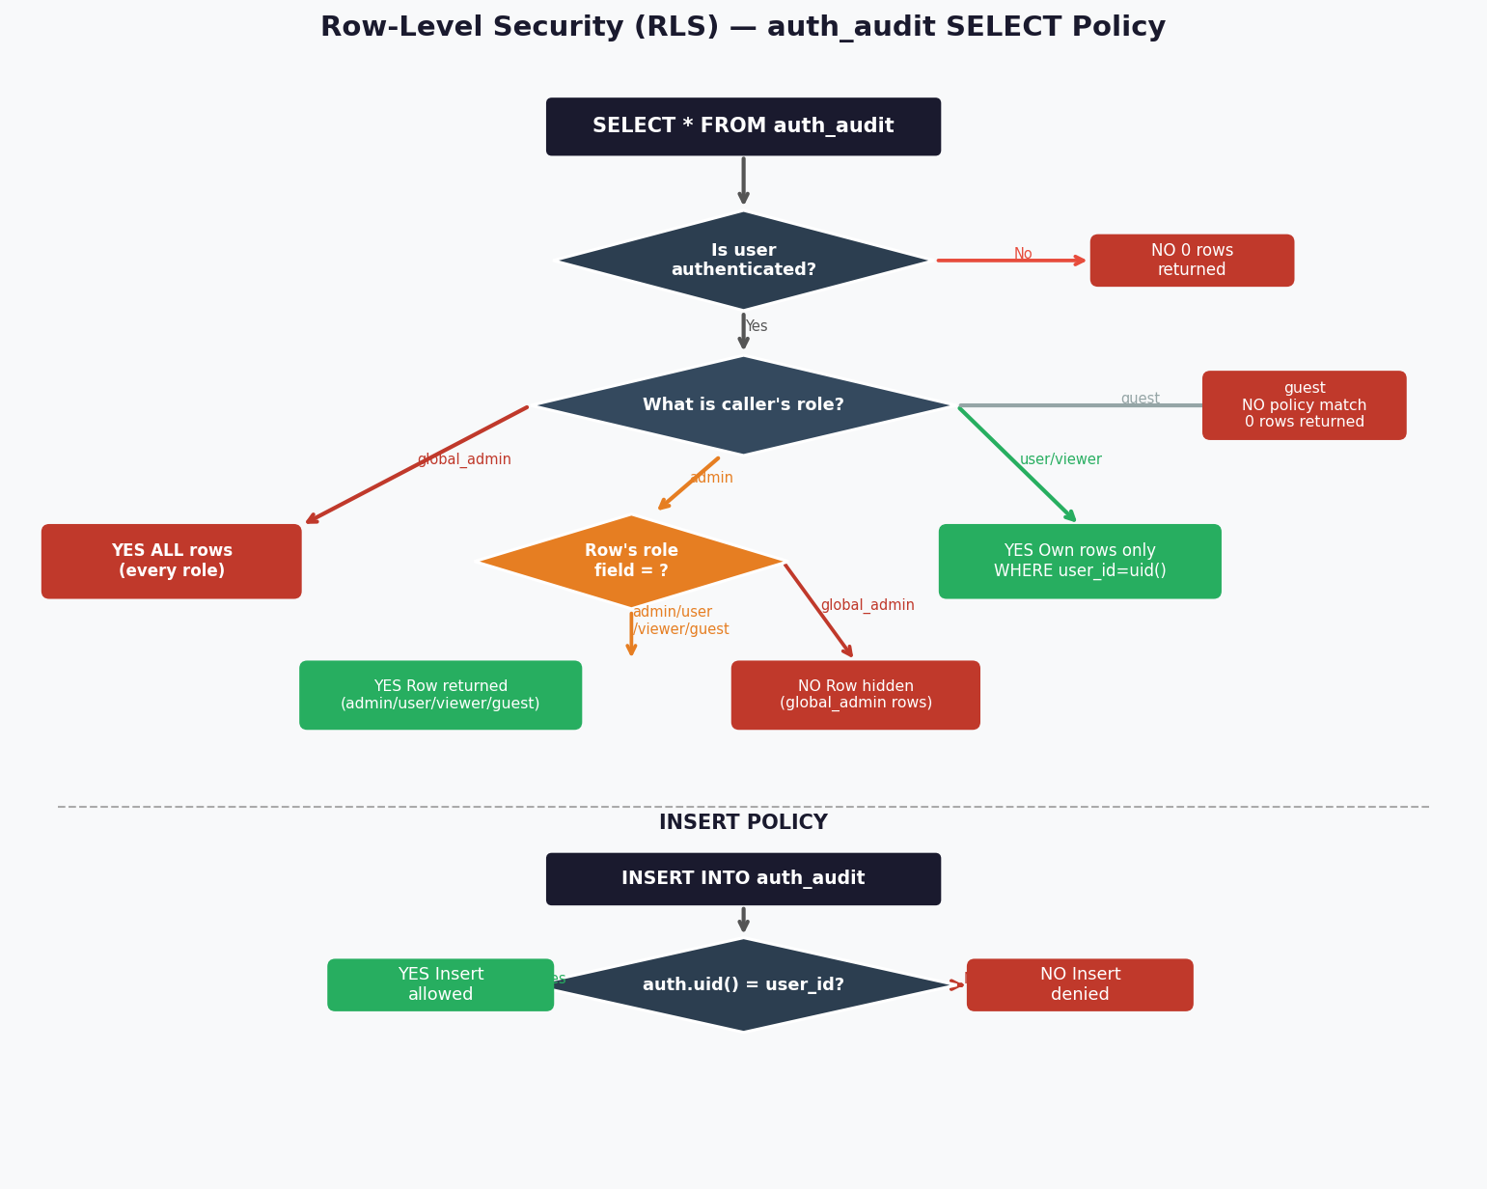
Figure 5 — RLS Policy Decision Flow
Table | Policy Name | Operation | Who | Condition
auth_audit | Users insert own | INSERT | Any auth user | auth.uid() = user_id
auth_audit | Users see own | SELECT | user/viewer/guest ¹ | user_id = auth.uid()
auth_audit | Admins see all except global_admin | SELECT | admin | role IN ('admin','user','viewer','guest')
auth_audit | Global admins see all | SELECT | global_admin | No restriction
audit_logs | System can insert | INSERT | Any | true
audit_logs | Users see own | SELECT | Any | auth.uid() = user_id
audit_logs | Admins view all | SELECT | admin/global | has_role(uid,'admin') [hierarchical]
device_sync_logs | Admins only view | SELECT | admin/global | has_role(uid,'admin') [hierarchical]
device_usage_logs | Admins only view | SELECT | admin/global | has_role(uid,'admin') [hierarchical]

¹ Guest & 'Users see own': The policy has no role restriction — the condition user_id = auth.uid() applies to ALL authenticated users including guest. Guest can therefore query their own auth_audit and audit_logs rows at the DB level. The /activity frontend page is blocked by the route guard for UX reasons, not by RLS. Design intent: permissive at DB, restricted at UI layer.

6. Data Flow — How Logs Are Created

Every audit row follows a five-step pipeline: the user triggers an action in the frontend, the relevant component captures the event, auditHash.ts computes a SHA-256 integrity hash, the Supabase RLS INSERT policy validates the caller, and finally the row is persisted in the auth_audit table.
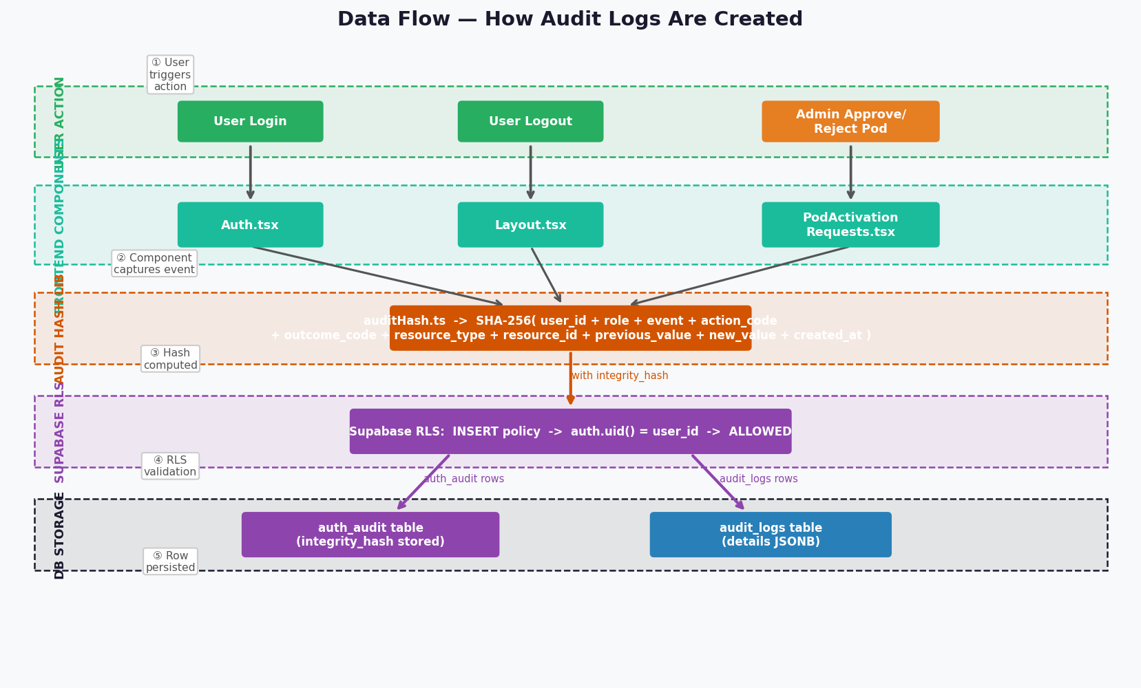
Figure 6 — Audit Data Flow with Swim Lanes

7. Sequence Diagrams

7.1 Login Audit Event
When a user successfully signs in, Auth.tsx immediately captures the timestamp, calls auditHash.ts to compute the integrity hash, then inserts a login event row into auth_audit.
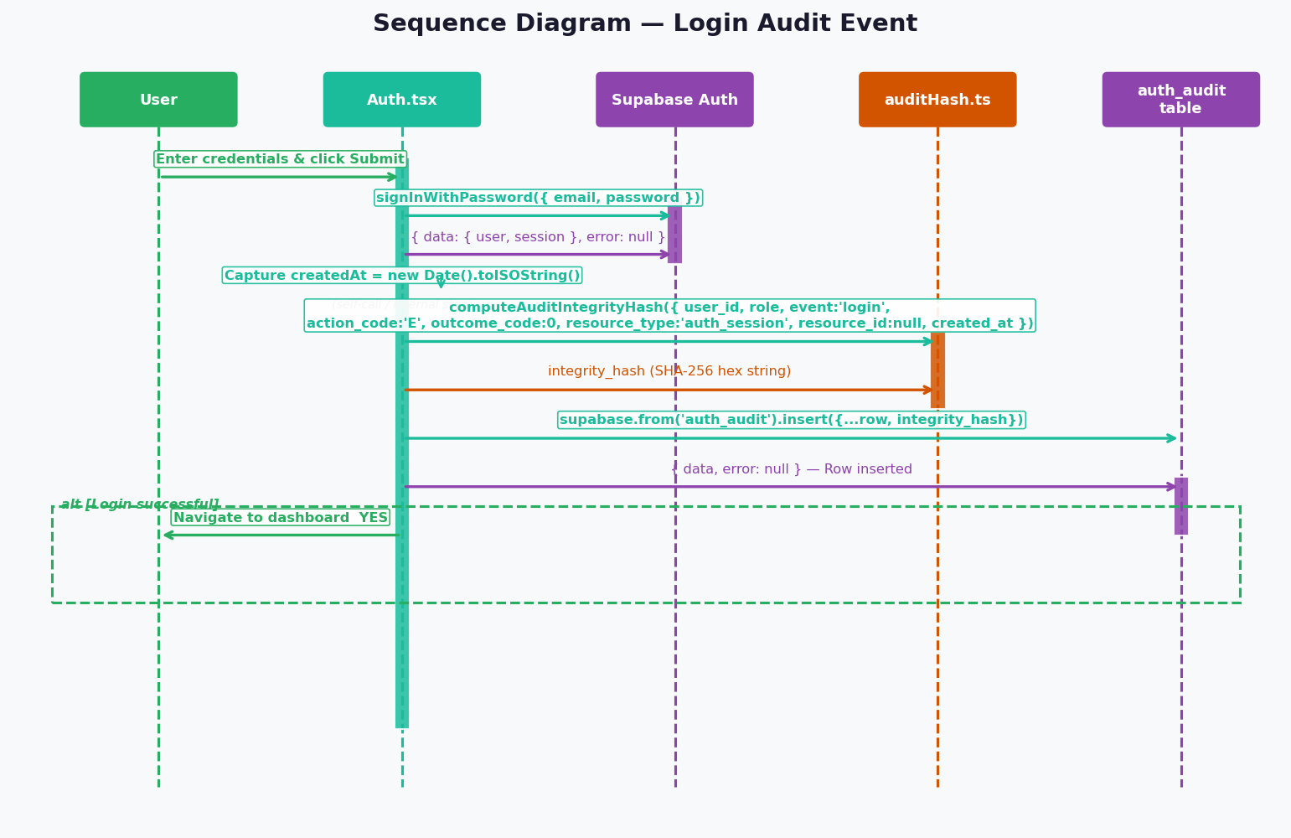
Figure 7 — Login Audit Sequence

7.2 Admin Approves Pod Activation
When an admin clicks Approve on a pod request, the component first updates the pod_activation_requests table, then computes the audit hash and writes an approve_pod:{model_id} event to auth_audit.
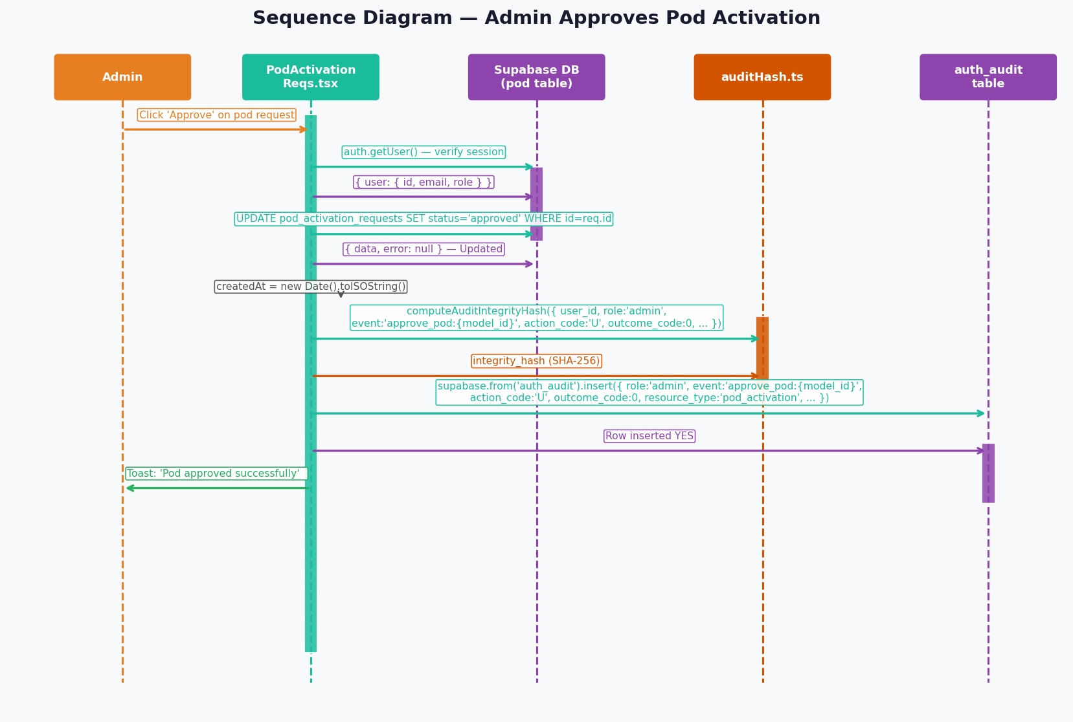
Figure 8 — Admin Approve Pod Sequence

7.3 Viewing Activity Logs
When any authenticated user navigates to /activity, Activity.tsx issues a SELECT query. The Supabase RLS layer automatically filters rows based on the caller's role — global_admin sees all, admin sees most (all except global_admin rows), user/viewer sees only their own rows. Guest receives 0 rows through the frontend (route guard blocks the /activity page) but CAN read own rows at the DB level via the 'Users see own' RLS policy — the frontend is the restriction layer, not RLS.
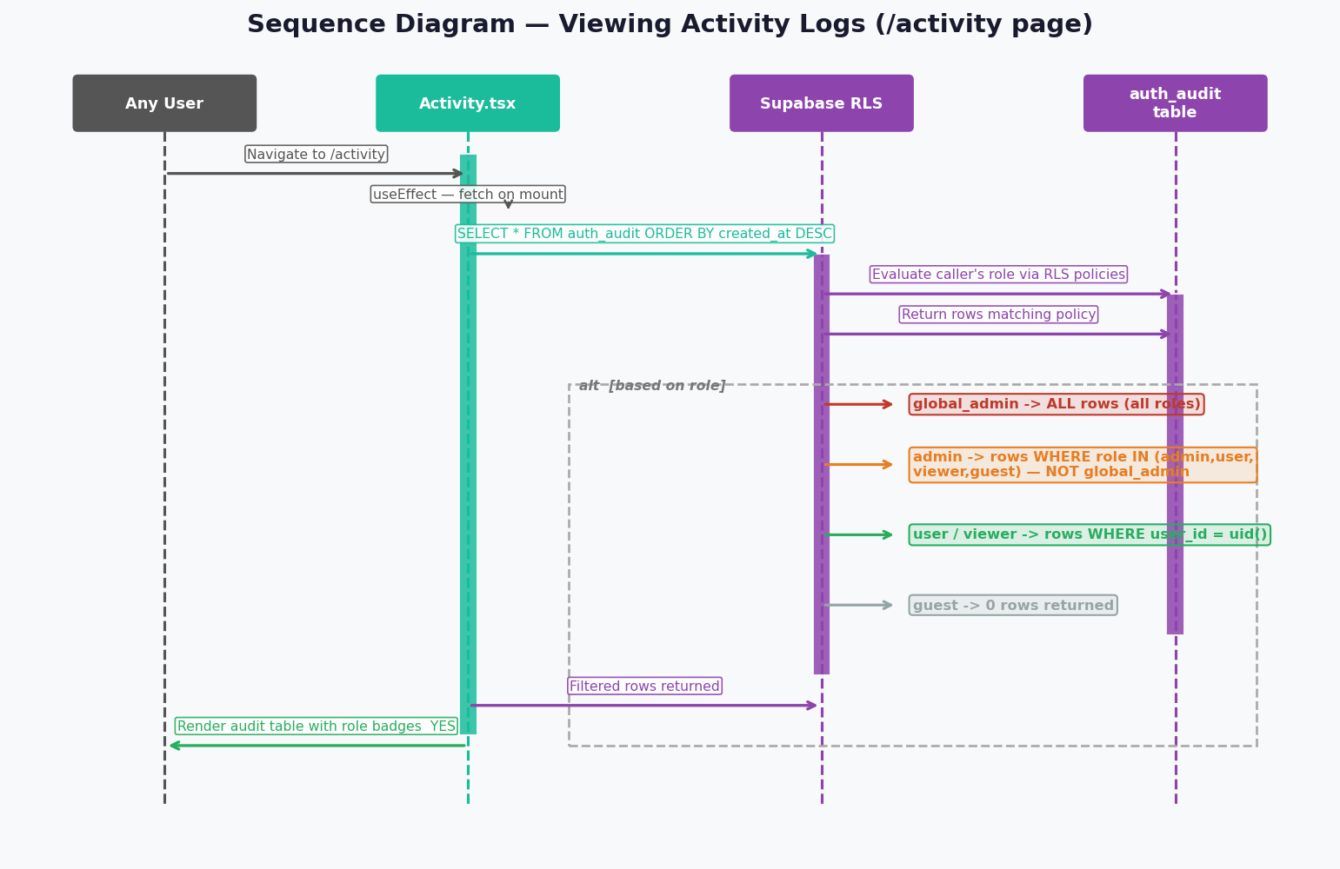
Figure 9 — View Activity Logs Sequence

8. Audit Integrity Hash — Tamper Evidence

Every row in auth_audit includes an integrity_hash field computed using SHA-256 via the Web Crypto API (crypto.subtle.digest). The hash is computed from eight non-PII fields. The email field is deliberately excluded from the hash to protect personally identifiable information.
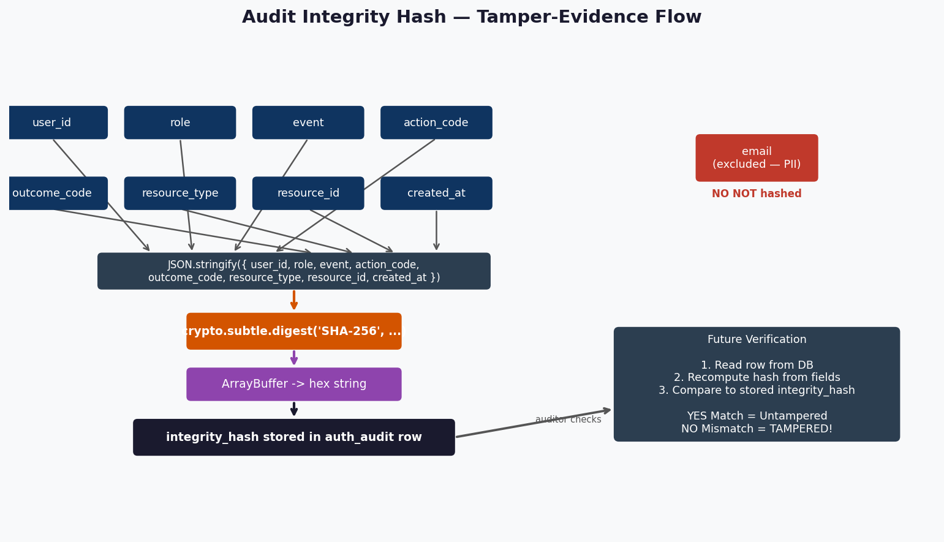
Figure 10 — Integrity Hash Computation & Verification

Hash Input Fields
- user_id — the UUID of the acting user
- role — the user's role at time of action
- event — the event name (login, logout, approve_pod, etc.)
- action_code — ATNA action code (C/R/U/D/E)
- outcome_code — ATNA outcome code (0/4/8/12)
- resource_type — resource category (auth_session, pod_activation)
- resource_id — specific resource identifier (nullable: null for login/logout events)
- previous_value — before-state JSON, PII-scrubbed (audit_logs only)
- new_value — after-state JSON, PII-scrubbed (audit_logs only)
- created_at — ISO 8601 timestamp
Excluded from hash: email (PII — stored in row but not hashed)

9. Frontend Component Architecture

The frontend is a React/TypeScript single-page application. Role detection is centralized in the useUserRole hook. All audit writes flow through auditHash.ts. Route protection is enforced by ProtectedRoute.tsx.
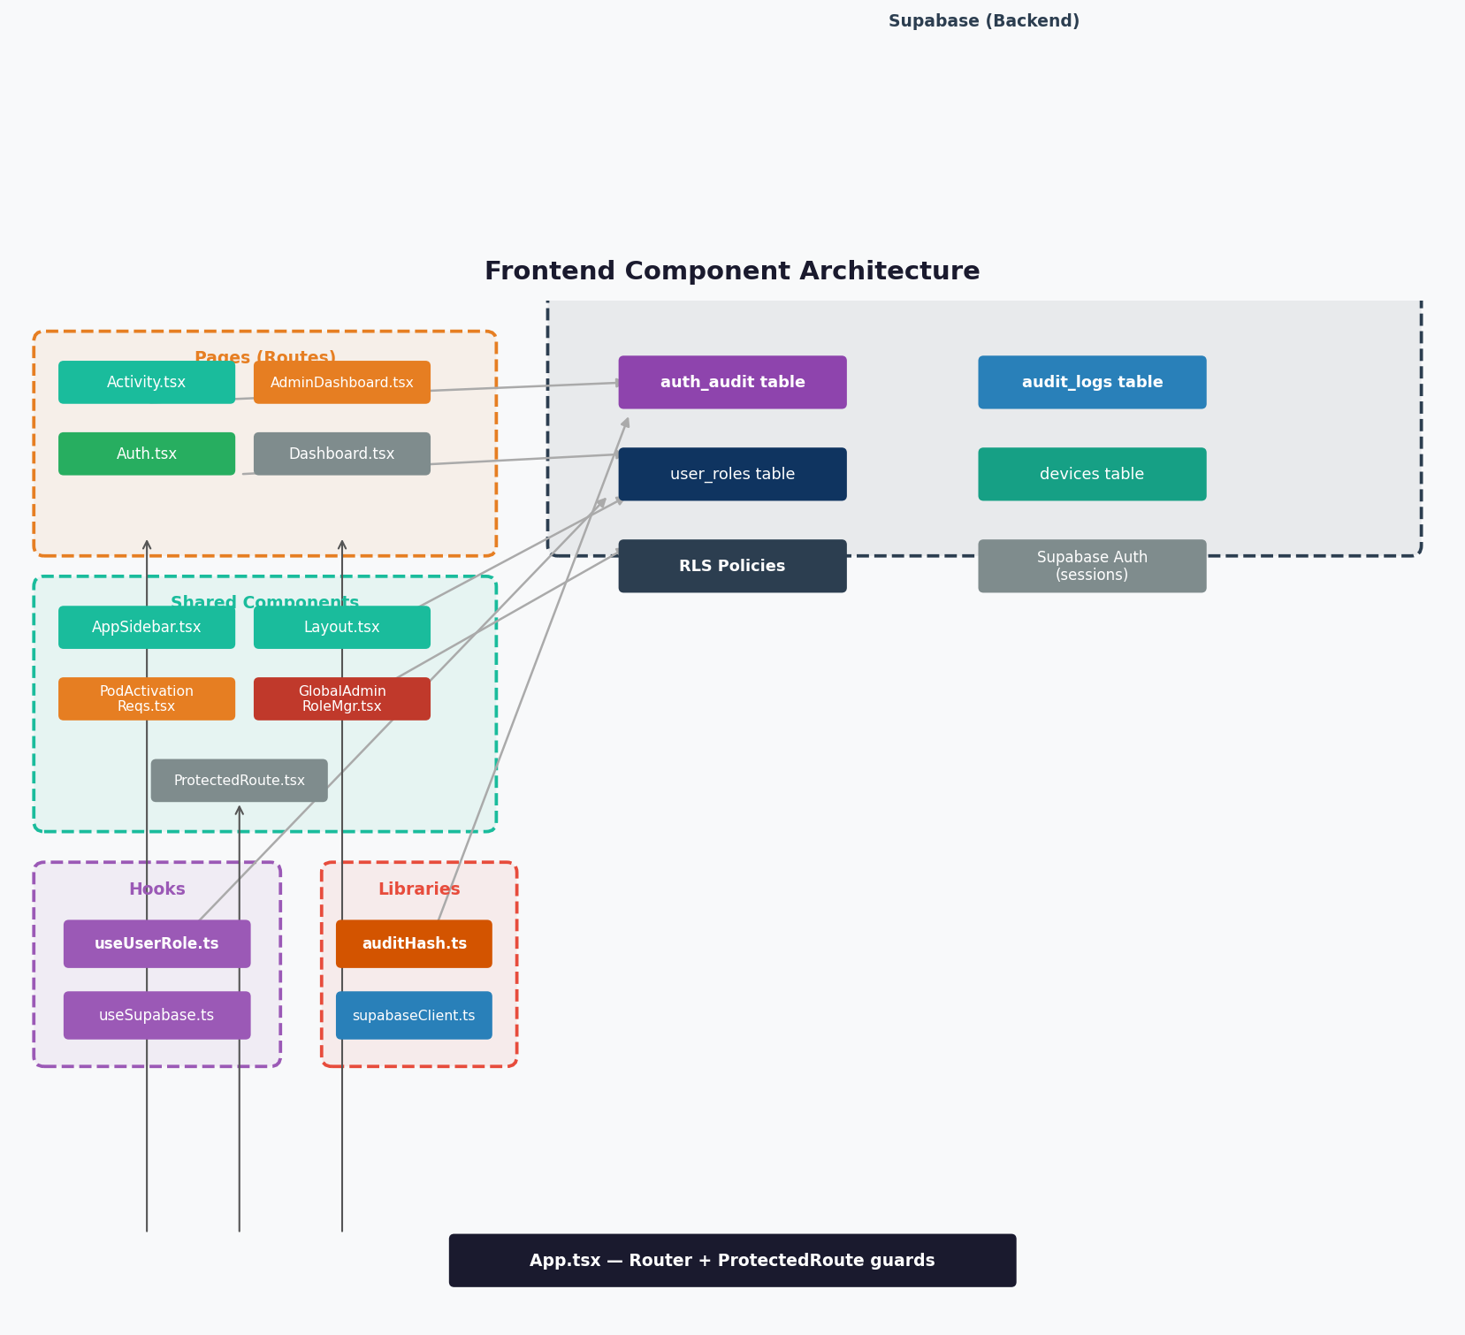
Figure 11 — Frontend Component Architecture Diagram

10. Access Control Matrix

The matrix below provides a complete overview of which roles can perform which operations across the activity logs system and related features.
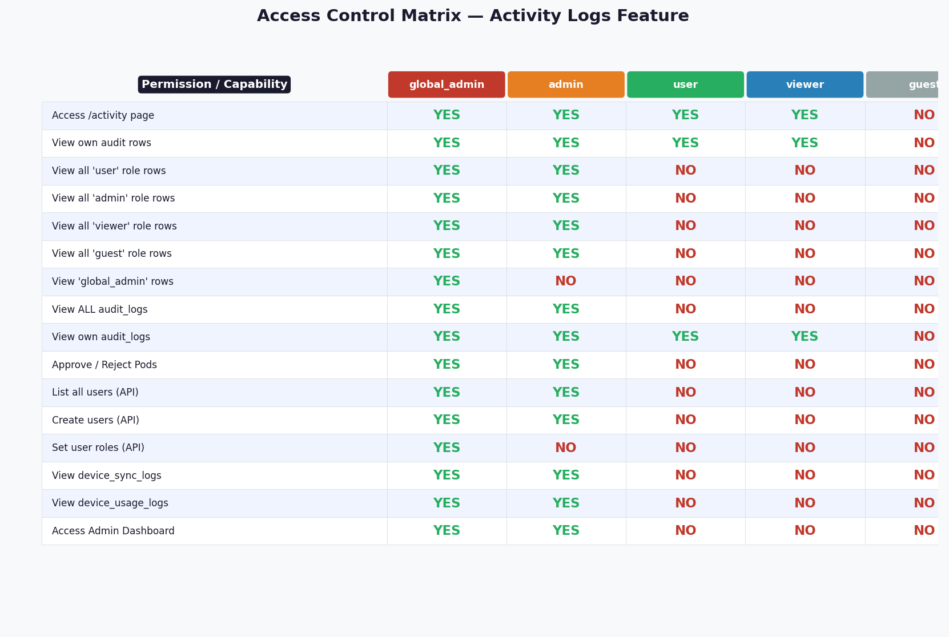
Figure 12 — Full Access Control Matrix

Detailed Access Matrix
Data Scope | global_admin | admin | user | viewer | guest
Access /activity page (UI) | YES | YES | YES | YES | NO (route guard)
Own auth_audit rows (DB via RLS) | YES | YES | YES | YES | YES ¹
Own audit_logs rows (DB via RLS) | YES | YES | YES | YES | YES ¹
All user role rows | YES | YES | NO | NO | NO
All admin role rows | YES | YES ² | NO | NO | NO
All viewer role rows | YES | YES | NO | NO | NO
All guest role rows | YES | YES | NO | NO | NO
global_admin role rows | YES | NO | NO | NO | NO
All audit_logs rows | YES | YES | NO | NO | NO
device_sync_logs | YES | YES | NO | NO | NO
device_usage_logs | YES | YES | NO | NO | NO

¹ Guest DB-level access (intentional design): The RLS policy 'Users see own' evaluates user_id = auth.uid() for ALL authenticated users — there is no role restriction in the policy condition. Guest users CAN read their own auth_audit and audit_logs rows directly via the Supabase SDK or API. The /activity frontend page is blocked by the route guard (UX/product decision), not by RLS. This is an intentional permissive-at-DB, restricted-at-UI design.
² Cross-admin visibility (intentional by design): An admin can read the full audit trail of OTHER admins within the same tenant. The RLS condition role IN ('admin','user','viewer','guest') includes all admin rows. This is deliberate — it ensures accountability: any admin action is visible to peer admins and to global_admin. This is NOT a privilege escalation: admins cannot see global_admin rows, and no UPDATE/DELETE policy exists so audit rows are immutable to all roles.

11. Event Types & ATNA Codes

The table below lists all audit event types currently implemented, along with the ATNA-standard action and outcome codes, and the resource types they apply to.
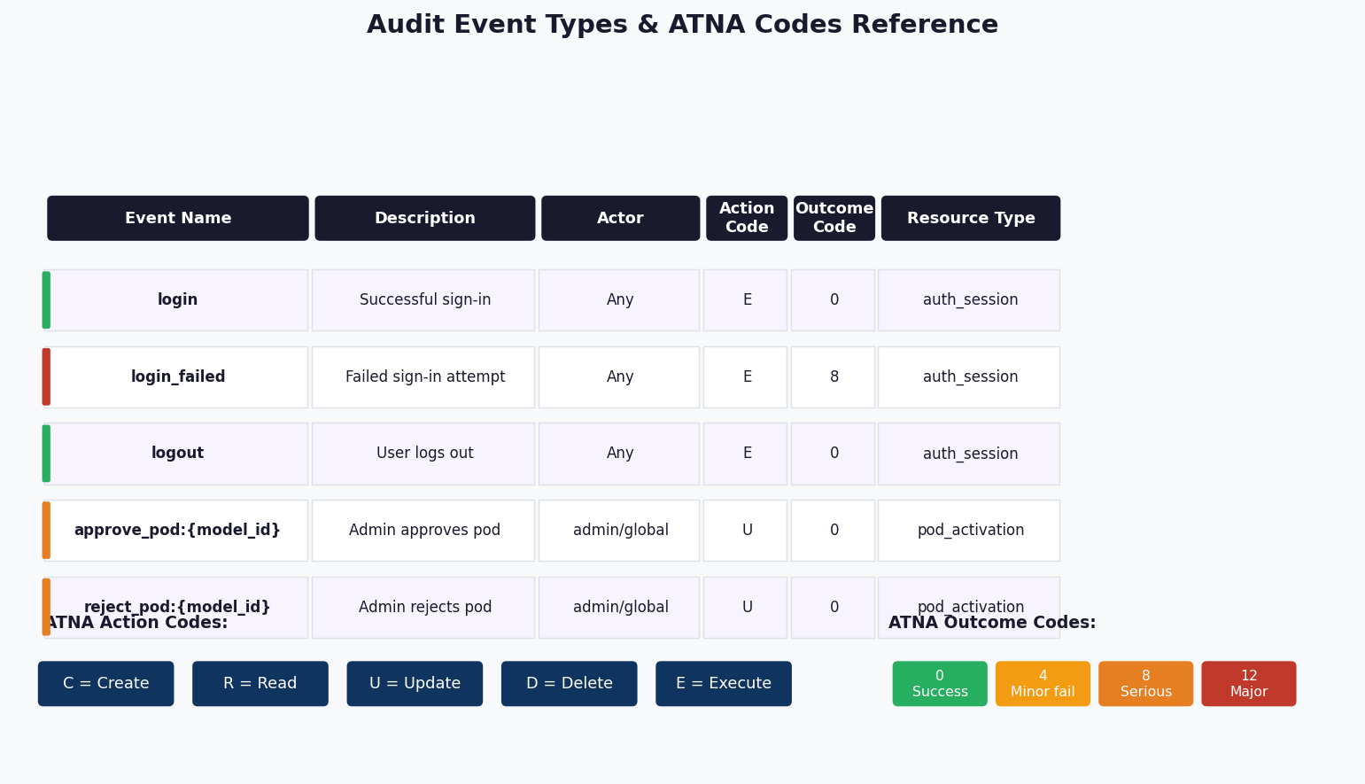
Figure 13 — Event Types & ATNA Codes Reference

Event Types Table
Event | Description | Actor | action_code | outcome_code | resource_type
login | Successful sign-in | Any | E | 0 | auth_session
login_failed | Failed sign-in attempt | Any | E | 8 | auth_session
logout | Sign-out click | Any | E | 0 | auth_session
approve_pod:{model_id} | Admin approves pod | admin/global | U | 0 | pod_activation
reject_pod:{model_id} | Admin rejects pod | admin/global | U | 0 | pod_activation

ATNA Action Code Reference
Code | Meaning | Status | Used By
C | Create | Planned — no events assigned yet | Reserved for future: e.g. user creation events
R | Read | Planned — no events assigned yet | Reserved for future: e.g. document view events
U | Update | Active | approve_pod:{model_id}, reject_pod:{model_id}
D | Delete | Planned — no events assigned yet | Reserved for future: e.g. record deletion events
E | Execute | Active | login, login_failed, logout

Note: Codes C, R, and D are defined per the ATNA standard and reserved for future use. They are marked 'Planned' to signal no current event uses them — a reader should not expect to find live rows with these codes.

ATNA Outcome Code Reference
Code | Meaning | Severity
0 | Success | None — operation completed normally
4 | Minor failure | Low — minor issue occurred
8 | Serious failure | High — significant problem
12 | Major failure | Critical — severe error

12. Backend Logging Architecture

In addition to the Supabase-based audit tables, the FastAPI backend implements structured JSON logging via structlog. A RequestLoggingMiddleware intercepts every HTTP request, assigns a unique request_id, and logs method, path, client IP, status code, and duration. Unhandled exceptions are captured at ERROR level with full traceback (exc_info=True) before being re-raised, so 500s are never invisible. The log level is configurable via the LOG_LEVEL environment variable (default: INFO). Log files use a RotatingFileHandler (10 MB per file, 5 backups — 50 MB max on disk), preventing unbounded disk growth. A two-pass PII scrubbing pipeline protects all log output — Pass 1 (field-name keywords, sync) runs in the structlog processor chain; Pass 2 (Microsoft Presidio NLP) runs asynchronously via scrub_text() and a ThreadPoolExecutor(max_workers=2) so the asyncio event loop is never blocked — see Section 13 for full detail. A startup warning is emitted if Presidio is unavailable. An insert_audit_log() helper in backend/app/core/supabase.py is called by all admin and pod activation routes to write rows into audit_logs with ip_address, user_agent, previous_value, new_value, and a server-side SHA-256 integrity_hash. Audit writes are fire-and-forget — failures are silently swallowed so auditing never blocks the main request path.
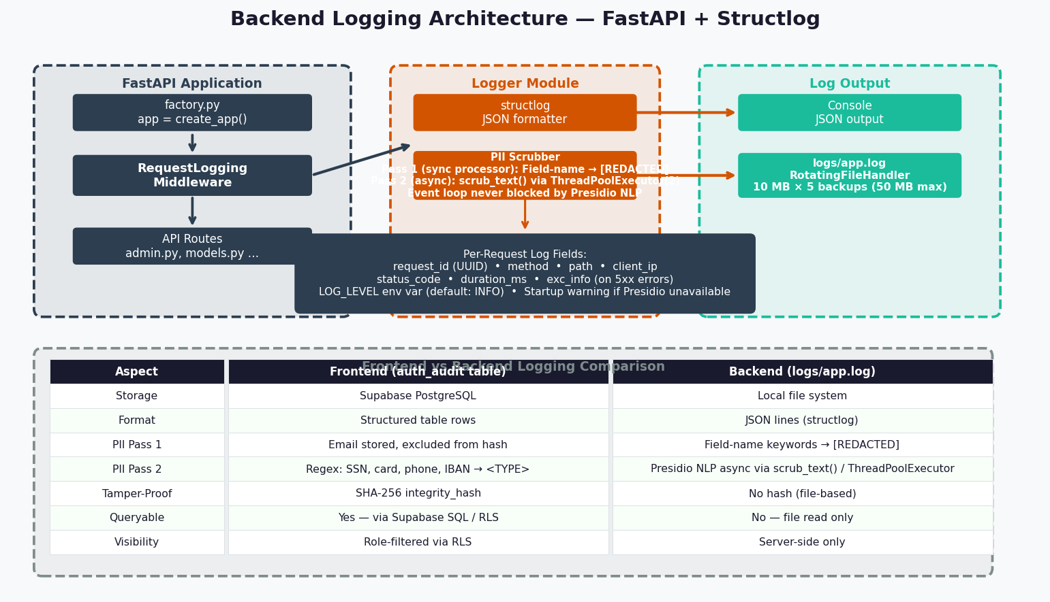
Figure 14 — Backend Logging Architecture

13. PII Detection — Presidio & Regex

All log data passes through a two-pass PII scrubbing pipeline before being written to any output. The pipeline runs in backend/app/logger/__init__.py (Python/Presidio) and is mirrored in frontend/src/logger/index.ts (TypeScript/regex).

Pass 1 — Field-name Keyword Match
Every key in the log payload is compared against a hard-coded set of 20 sensitive field names (case-insensitive). A match unconditionally replaces the value with [REDACTED] — regardless of the actual content. Fields covered: password, passwd, secret, token, api_key, authorization, ssn, social_security, credit_card, card_number, cvv, dob, date_of_birth, birth_date, full_name, first_name, last_name, mobile, phone, phone_number, address.

Pass 2 — Async Content-based PII Detection
After field-name scrubbing, string values can be scanned for PII content — catching sensitive data inside generic fields like 'message' or 'details' regardless of the key name. Pass 2 does NOT run inside the sync structlog processor — doing so would block the asyncio event loop under load. Instead, Pass 2 is exposed as await scrub_text(value), an async helper that offloads Presidio NLP work to a dedicated ThreadPoolExecutor(max_workers=2) via loop.run_in_executor(). Call it from route handlers or middleware whenever you need to log potentially sensitive free-text.
On the backend, Microsoft Presidio (presidio-analyzer + presidio-anonymizer) uses a spaCy English NLP model to detect named entities. Detected entities are replaced with labelled placeholders such as <PERSON>, <US_SSN>, <CREDIT_CARD>. Email addresses are pre-masked to u***@domain format before the Presidio scan. If Presidio or the spaCy model is unavailable, _PRESIDIO_AVAILABLE is set to False, a startup warning is logged, and the system degrades gracefully to Pass 1 only — no exception is raised.
On the frontend, contentScrubString() applies regex-based PII_PATTERNS that mirror Presidio entity labels, producing identical <ENTITY_TYPE> replacements. No ML model is required — the patterns run in-browser or in Node.js with zero additional dependencies.
Entity Type | Example Input | Replacement | Backend | Frontend
PERSON | John Smith | <PERSON> | Presidio NLP | —
EMAIL_ADDRESS | user@example.com | u***@example.com | Email mask + Presidio | Email mask + regex
PHONE_NUMBER | +1 (555) 123-4567 | <PHONE_NUMBER> | Presidio NLP | Regex
CREDIT_CARD | 4111 1111 1111 1111 | <CREDIT_CARD> | Presidio NLP | Regex
US_SSN | 123-45-6789 | <US_SSN> | Presidio NLP | Regex
IBAN_CODE | GB29NWBK60161331926819 | <IBAN_CODE> | Presidio NLP | Regex
LOCATION | New York, NY | <LOCATION> | Presidio NLP | —
IP_ADDRESS | 192.168.1.1 | (kept — forensic) | Intentionally excluded | —

Backend Installation
pip install presidio-analyzer presidio-anonymizer spacy
python -m spacy download en_core_web_sm
# Or via requirements.txt:
# presidio-analyzer>=2.2.0
# presidio-anonymizer>=2.2.0
# spacy>=3.4.0,<4.0.0
# structlog>=23.1.0,<25.0.0
# en-core-web-sm @ https://github.com/explosion/spacy-models/releases/download/en_core_web_sm-3.7.1/...
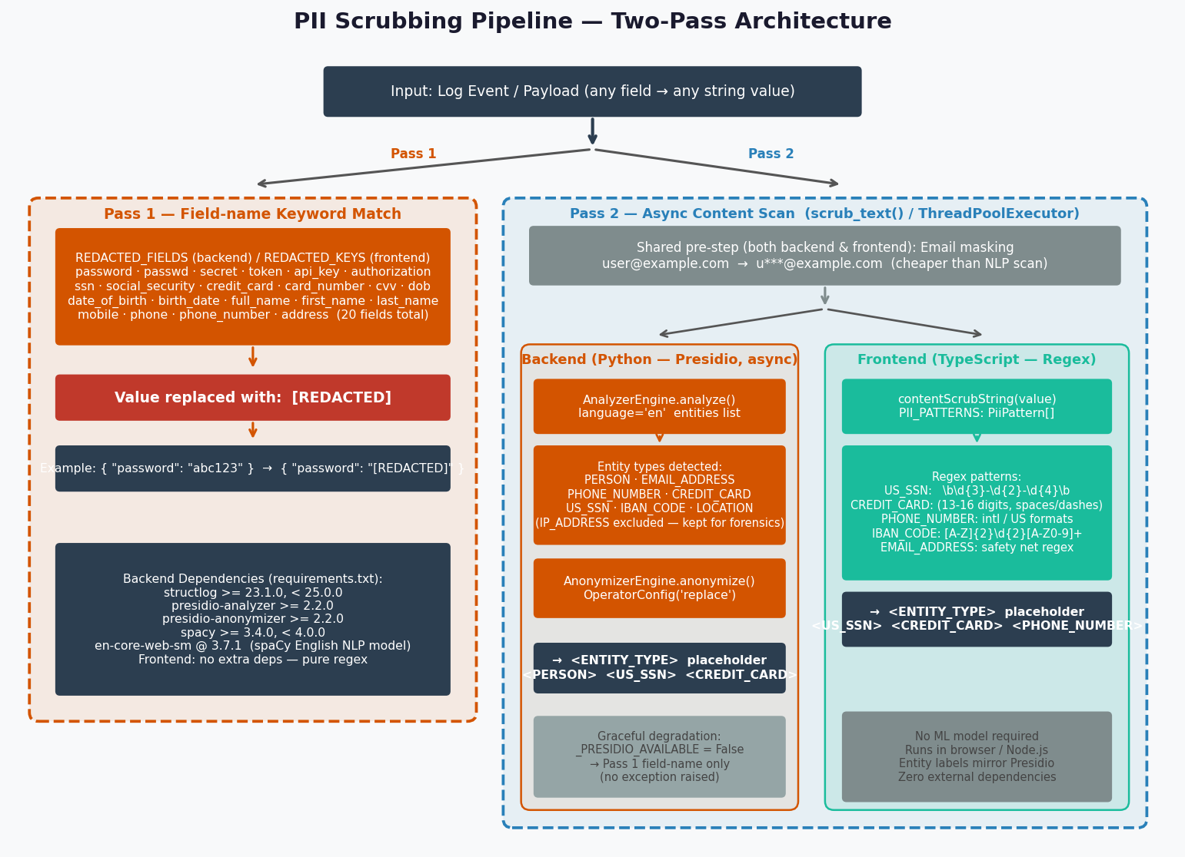
Figure 15 — PII Scrubbing Pipeline (Two-Pass Architecture)

14. File Reference

Key source files implementing the Activity Logs feature:
Category | File Path | Purpose
DB Migration | supabase/migrations/20260313091500_auth_audit_logs.sql | auth_audit table + RLS policies
DB Migration | supabase/migrations/20251116145514_03b8c065-31f2-46c1-a062-a1f2e4363a04.sql | audit_logs table + RLS policies
DB Migration | supabase/migrations/20260312193000_fnf9_schema_closure.sql | Role enum + user_roles + roles tables
DB Migration | supabase/migrations/20260312194000_fnf10_rls_hardening.sql | RLS hardening pass
DB Migration | supabase/migrations/20260316000000_auth_audit_user_id_fk.sql | FK constraint auth_audit.user_id -> auth.users(id)
DB Migration | supabase/migrations/20260316000001_audit_immutability.sql | Immutability triggers + integrity_hash on audit_logs + archive tables
DB Migration | supabase/migrations/20260316000002_audit_logs_change_tracking.sql | previous_value + new_value JSONB columns + resource_id index on audit_logs
Frontend Page | frontend/src/app-pages/Activity.tsx | Activity log UI page
Frontend Lib | frontend/src/lib/auditHash.ts | SHA-256 integrity hash utility
Frontend Page | frontend/src/app-pages/Auth.tsx | Login/login_failed audit writer (resource_id: null)
Frontend Comp | frontend/src/components/Layout.tsx | Logout audit event writer (resource_id: null)
Frontend Comp | frontend/src/components/admin/PodActivationRequests.tsx | Pod approve/reject audit
Frontend Comp | frontend/src/components/AppSidebar.tsx | Role-filtered navigation
Frontend Hook | frontend/src/hooks/useUserRole.ts | Role detection hook
Backend | backend/app/core/supabase.py | insert_audit_log() helper (ip_address, user_agent, integrity_hash, previous_value, new_value)
Backend | backend/app/routes/admin.py | Admin API endpoints + create_user/set_role audit calls
Backend | backend/app/routes/pod_activation.py | Pod activation endpoints + approve/reject/allocate audit calls
Backend | backend/app/logger/__init__.py | Structured request logging + two-pass Presidio PII scrubber
Backend | backend/requirements.txt | presidio-analyzer, presidio-anonymizer, spacy, en-core-web-sm
Frontend | frontend/src/logger/index.ts | Pino logger + two-pass PII scrubber (field-name + regex content scan)

15. Compliance & Immutability

The Activity Logs system is designed to meet the audit trail requirements of EU AI Act (Art. 12/13), SOC2 (CC7.2/CC9.1), and NAIC AI Bulletin. The following mechanisms are in place:

15.1 Database-Level Immutability
Migration 20260316000001_audit_immutability.sql installs four BEFORE UPDATE / BEFORE DELETE triggers on both auth_audit and audit_logs. The trigger function prevent_audit_modification() raises a P0001 exception for any modification attempt. This fires regardless of RLS bypass — service_role, backend calls, and direct Postgres connections are all blocked. Only a superuser running ALTER TABLE ... DISABLE TRIGGER can circumvent this, and that action is itself logged by Postgres.
Verified behavior in Supabase SQL Editor (role: postgres):
UPDATE public.auth_audit SET event = 'tampered' WHERE id = (...);
Result: ERROR P0001: Audit log records are immutable (EU AI Act Art.12 / SOC2 CC7.2 / NAIC). Operation "UPDATE" on table "auth_audit" is not permitted.

15.2 Integrity Hash Coverage
Both audit tables now carry integrity_hash (SHA-256). For auth_audit: computed in auditHash.ts (frontend, Web Crypto API) over 8 non-PII fields before insert. For audit_logs: computed in insert_audit_log() (backend, Python hashlib) over user_id, action, resource_type, resource_id, previous_value, new_value, and created_at before insert. Email and other PII are excluded from both hashes.

15.3 IP Address & User Agent Capture
All backend-initiated audit writes (admin actions, pod approvals/rejections, model allocations) populate ip_address from request.client.host and user_agent from the HTTP request header. This provides a complete forensic trail for regulatory review.

15.4 Retention Policy
EU AI Act requires logs retained for a minimum of 6 months; SOC2 and NAIC require 12 months. The following architecture is implemented via pg_cron (enabled in Supabase):
- audit_logs_archive and auth_audit_archive tables mirror the live tables with identical immutability triggers.
- A SECURITY DEFINER function (archive_old_audit_logs() / archive_old_auth_audit()) copies rows older than 12 months to the archive tables, then deletes from the live table.
- A pg_cron job runs every Sunday at 02:00 UTC: SELECT cron.schedule('archive-old-audit-logs', '0 2 * * 0', ...)

15.5 Compliance Framework Coverage
Framework | Requirement | Implementation
EU AI Act Art.12/13 | Immutable, traceable AI decision logs | Immutability triggers + integrity_hash
EU AI Act Art.12 | Retain logs >= 6 months | pg_cron archival — rows never deleted
SOC2 CC7.2 | No unauthorized modification | DB triggers block all UPDATE/DELETE
SOC2 CC9.1 | Complete and accurate audit trail | ip_address + user_agent + integrity_hash
NAIC AI Bulletin | Full AI decision audit trail | approve_pod/reject_pod logged with details
NAIC AI Bulletin | Available for regulatory review | audit_logs_archive retained indefinitely

This document was auto-generated from the Fideon OS codebase. All diagrams are drawn from live source code analysis. Generated on 2026-03-16.

