Activity Logs Feature — Full Documentation
**Project:** Fideon OS
**Feature:** Activity Logs & Audit Trail System
**Roles Covered:** `global_admin`, `admin`, `user`
**Date:** 2026-03-17 *(updated — Audit Ledger + SHAP)*

Table of Contents
- [Feature Overview](#1-feature-overview)
- [Role Definitions & Hierarchy](#2-role-definitions--hierarchy)
- [Feature Capabilities by Role](#3-feature-capabilities-by-role)
- [Database Schema — Supabase Tables](#4-database-schema--supabase-tables)
- [ER Diagram (Entity-Relationship)](#5-er-diagram-entity-relationship)
- [Schema Diagram — Supabase Column-Level Detail](#6-schema-diagram--supabase-column-level-detail)
- [Row-Level Security (RLS) Policy Diagram](#7-row-level-security-rls-policy-diagram)
- [Data Flow Diagram — How Logs Are Created](#8-data-flow-diagram--how-logs-are-created)
- [Sequence Diagram — Login Audit Event](#9-sequence-diagram--login-audit-event)
- [Sequence Diagram — Admin Approves Pod](#10-sequence-diagram--admin-approves-pod)
- [Sequence Diagram — Viewing Activity Logs](#11-sequence-diagram--viewing-activity-logs)
- [Component Architecture Diagram](#12-component-architecture-diagram)
- [Audit Integrity Hash Flow](#13-audit-integrity-hash-flow)
- [Event Types Reference](#14-event-types-reference)
- [ATNA Standard Code Reference](#15-atna-standard-code-reference)
- [Access Control Matrix](#16-access-control-matrix)
- [Navigation & Route Guard Diagram](#17-navigation--route-guard-diagram)
- [Backend Logging Architecture](#18-backend-logging-architecture)
- [Full System Interaction Diagram](#19-full-system-interaction-diagram)
- [PII Detection — Presidio & Regex](#20-pii-detection--presidio--regex)
- [Cryptographic Audit Ledger](#21-cryptographic-audit-ledger)
- [SHAP AI Explainability Integration](#22-shap-ai-explainability-integration)
- [Backend Audit Write Architecture](#23-backend-audit-write-architecture)
- [Audit Ledger Verification Flow](#24-audit-ledger-verification-flow)
- [Migration History & Schema Evolution](#25-migration-history--schema-evolution)

1. Feature Overview
The Activity Logs system provides a tamper-evident, role-scoped audit trail of all significant actions taken across the Fideon OS platform. It is built on two Supabase tables (auth_audit and audit_logs), enforced by PostgreSQL Row-Level Security (RLS) policies, and surfaced to users via the /activity frontend page.
As of 2026-03-17, audit_logs has been upgraded to a full cryptographic ledger with a SHA-256 chain linking every row to its predecessor (blockchain-style), append-only enforcement via database triggers, SHAP-based AI explainability columns, and a verify_audit_ledger() SQL function for compliance audits.

Core Design Principles
Principle | Implementation
Tamper-Evidence | Each auth_audit row stores a SHA-256 integrity_hash; each audit_logs row also carries a chain_hash that cryptographically links it to the previous row
Cryptographic Ledger | audit_logs is a blockchain-style append-only ledger: chain_hash_N = SHA-256(chain_hash_{N-1} ∥ integrity_hash_N); any insertion, deletion, or reordering breaks every subsequent hash
Append-Only Enforcement | Database-level BEFORE UPDATE / BEFORE DELETE triggers on both auth_audit and audit_logs raise an exception if any row is modified after insertion
AI Explainability (SHAP) | AI decision rows store shap_values (feature contributions), model_id, prediction, and auto-generated reasoning text — all included in the per-row integrity_hash
Privacy | PII (email, name) is excluded from hash computation; backend logs use two-pass PII scrubbing (field-name match + Presidio NLP)
Least Privilege | Each role sees only what they are authorized to see via RLS policies
ATNA Compliance | Action codes (C/R/U/D/E) and outcome codes (0/4/8/12) follow ATNA audit standards
Change Tracking | audit_logs stores previous_value and new_value (JSONB) for full before/after state on every recorded change
Compliance | EU AI Act Art. 12/13 (AI decision logging), SOC2 CC7.2 (audit trail integrity), NAIC AI Bulletin

2. Role Definitions & Hierarchy
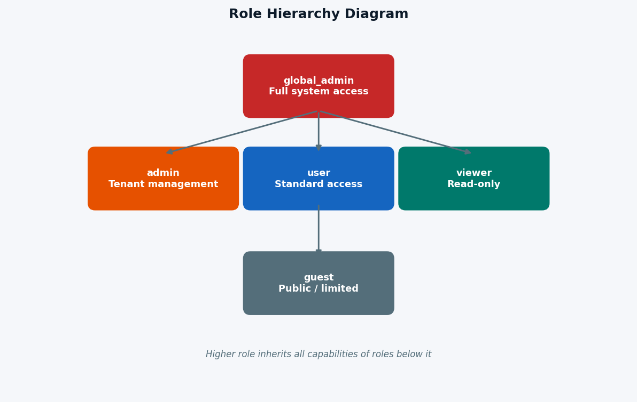
Figure 2.1 - Role Hierarchy Diagram

Role Descriptions
Role | Enum Value | Description
global_admin | 'global_admin' | Platform-level superuser. Can see ALL audit records from all roles, assign any role, create users. The only role whose audit rows are hidden from regular admins.
admin | 'admin' | Tenant/organization administrator. Can approve/reject pod activation requests, view audit records for admin, user, viewer, and guest roles. Cannot see global_admin audit rows.
user | 'user' | Standard platform user. Can use AI models, submit pod activation requests, and view only their own activity logs.
viewer | 'viewer' | Read-only role. Can view dashboards and their own logs but cannot trigger actions.
guest | 'guest' | Most restricted. No access to the /activity frontend page (blocked by route guard). However, the database-level RLS policy "Users see own" applies to all authenticated users including guest — so a guest can query their own auth_audit and audit_logs rows directly via the Supabase SDK or API. The frontend page is the only access point that is blocked.

3. Feature Capabilities by Role

Activity Page (`/activity`)
Capability | global_admin | admin | user | viewer | guest
Access /activity page | ✅ | ✅ | ✅ | ✅ | ❌
View own audit rows (UI) | ✅ | ✅ | ✅ | ✅ | ❌ (page blocked)
View own audit rows (DB via RLS) | ✅ | ✅ | ✅ | ✅ | ✅ ¹
View all user role rows | ✅ | ✅ | ❌ | ❌ | ❌
View all admin role rows | ✅ | ✅ | ❌ | ❌ | ❌
View all viewer role rows | ✅ | ✅ | ❌ | ❌ | ❌
View all guest role rows | ✅ | ✅ | ❌ | ❌ | ❌
View global_admin role rows | ✅ | ❌ | ❌ | ❌ | ❌

¹ **Guest DB-level note:** The RLS policy `"Users see own"` has no role restriction — it evaluates `user_id = auth.uid()` for all authenticated users, including guest. Guest rows are readable at the database level. The frontend `/activity` page is blocked by the route guard for UX/product reasons, not by RLS. This is an intentional design choice (permissive at DB, restricted at UI).

Audit Events Generated
Event | global_admin | admin | user | viewer | guest
login logged | ✅ | ✅ | ✅ | ✅ | ✅
logout logged | ✅ | ✅ | ✅ | ✅ | ✅
approve_pod:{model_id} logged | ✅ | ✅ | ❌ | ❌ | ❌
reject_pod:{model_id} logged | ✅ | ✅ | ❌ | ❌ | ❌

Admin Capabilities
Capability | global_admin | admin | user
View Admin Dashboard | ✅ | ✅ | ❌
View Devices | ✅ | ✅ | ❌
View Pending Approvals | ✅ | ✅ | ❌
Approve/Reject Pod Requests | ✅ | ✅ | ❌
List all users | ✅ | ✅ | ❌
Create users | ✅ | ✅ | ❌
Set user roles | ✅ | ❌ | ❌

4. Database Schema — Supabase Tables

4.1 `public.auth_audit` — Primary Activity Log Table
CREATE TABLE public.auth_audit (
id UUID PRIMARY KEY DEFAULT gen_random_uuid(),
user_id UUID NOT NULL REFERENCES auth.users(id),
email TEXT,
role TEXT,
event TEXT,
created_at TIMESTAMPTZ DEFAULT now(),
action_code TEXT, -- ATNA: C, R, U, D, E
outcome_code INTEGER, -- ATNA: 0, 4, 8, 12
resource_type TEXT, -- e.g. auth_session, pod_activation
resource_id TEXT,
integrity_hash TEXT -- SHA-256 of non-PII fields
);
Row-Level Security: ENABLED Indexes: implicit on id (primary key)

4.2 `public.audit_logs` — Cryptographic Audit Ledger
**Updated 2026-03-17:** Upgraded from a generic log table to a full cryptographic ledger with chain hashing, append-only enforcement, SHAP AI explainability columns, and before/after change tracking.
CREATE TABLE public.audit_logs (
-- Core identity
id UUID PRIMARY KEY DEFAULT gen_random_uuid(),
user_id UUID REFERENCES auth.users(id),
-- Action fields
action TEXT NOT NULL,
resource_type TEXT NOT NULL,
resource_id TEXT,
details JSONB,
-- Change tracking (added 2026-03-16)
previous_value JSONB, -- state before the action (PII-scrubbed)
new_value JSONB, -- state after the action (PII-scrubbed)
-- Request context
ip_address TEXT,
user_agent TEXT,
created_at TIMESTAMPTZ DEFAULT now(),
-- Integrity (row-level hash, computed by application)
integrity_hash TEXT, -- SHA-256 of all non-PII fields including SHAP data
-- Cryptographic ledger (added 2026-03-17)
sequence_num BIGINT GENERATED ALWAYS AS IDENTITY, -- monotonic insert order
chain_hash TEXT, -- SHA-256(prev_chain_hash ∥ integrity_hash), set by DB trigger
-- AI Explainability / SHAP (added 2026-03-17, nullable — AI decisions only)
shap_values JSONB, -- {feature_name: shap_float, ...}
model_id TEXT, -- model identifier (e.g. "fraud-detector-v3")
prediction JSONB, -- model output / decision outcome
reasoning TEXT -- auto-generated human-readable SHAP explanation
);
-- Standard indexes
CREATE INDEX idx_audit_logs_user_id ON public.audit_logs (user_id);
CREATE INDEX idx_audit_logs_resource_type ON public.audit_logs (resource_type);
CREATE INDEX idx_audit_logs_created_at ON public.audit_logs (created_at DESC);
CREATE INDEX idx_audit_logs_resource_id ON public.audit_logs USING GIN (resource_id);
-- Ledger indexes (added 2026-03-17)
CREATE INDEX idx_audit_logs_sequence_num ON public.audit_logs (sequence_num DESC);
CREATE INDEX idx_audit_logs_model_id ON public.audit_logs (model_id) WHERE model_id IS NOT NULL;
Row-Level Security: ENABLED
Append-Only Enforcement: BEFORE UPDATE and BEFORE DELETE triggers on audit_logs raise an exception — rows cannot be modified or deleted after insertion. This is enforced at the database level, not just RLS.
Chain Hash Trigger: compute_audit_chain_hash() fires BEFORE INSERT, acquires an advisory lock to serialize concurrent inserts, and sets chain_hash = SHA-256(prev_chain_hash ∥ integrity_hash). The genesis block uses the seed 'GENESIS'.

4.3 `public.user_roles` — Role Assignment Table
CREATE TABLE public.user_roles (
id UUID PRIMARY KEY DEFAULT gen_random_uuid(),
user_id UUID NOT NULL REFERENCES auth.users(id) ON DELETE CASCADE,
role app_role NOT NULL,
UNIQUE (user_id, role)
);

4.4 `public.roles` — Role Metadata Table
CREATE TABLE public.roles (
id UUID PRIMARY KEY DEFAULT gen_random_uuid(),
name TEXT UNIQUE NOT NULL,
description TEXT,
permissions JSONB
);

4.5 `public.device_sync_logs` — Device Sync Activity
CREATE TABLE public.device_sync_logs (
id UUID PRIMARY KEY DEFAULT gen_random_uuid(),
device_id UUID REFERENCES devices(id),
event_type TEXT, -- check_in, model_sync, config_update
details JSONB,
created_at TIMESTAMPTZ DEFAULT now()
);

4.6 `public.device_usage_logs` — AI Model Usage Tracking
CREATE TABLE public.device_usage_logs (
id UUID PRIMARY KEY DEFAULT gen_random_uuid(),
device_id UUID REFERENCES devices(id),
model_id TEXT,
prompt_count INTEGER,
tokens_used INTEGER,
duration_ms INTEGER,
created_at TIMESTAMPTZ DEFAULT now()
);

5. ER Diagram (Entity-Relationship)
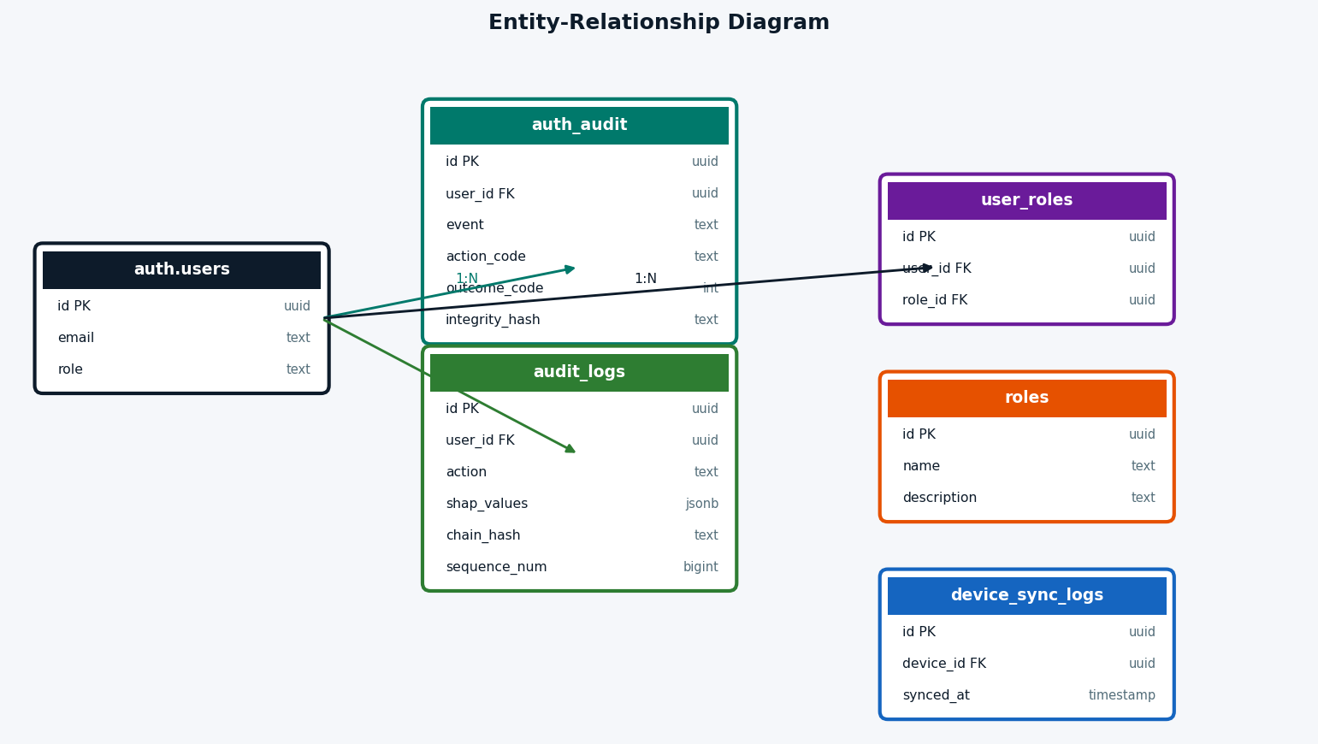
Figure 5 - ER Diagram: Entity-Relationship

6. Schema Diagram — Supabase Column-Level Detail
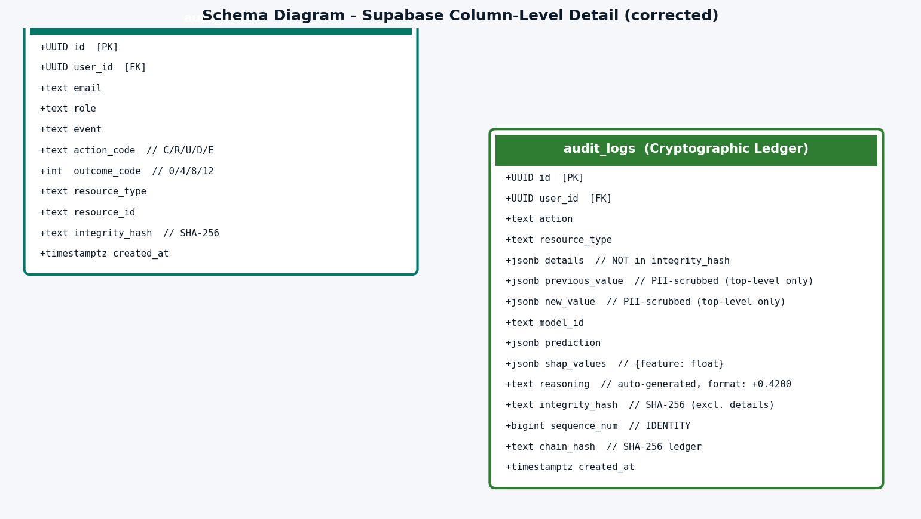
Figure 6 - Schema Diagram: Column-Level Detail (corrected: details not hashed, top-level PII scrub only)

7. Row-Level Security (RLS) Policy Diagram
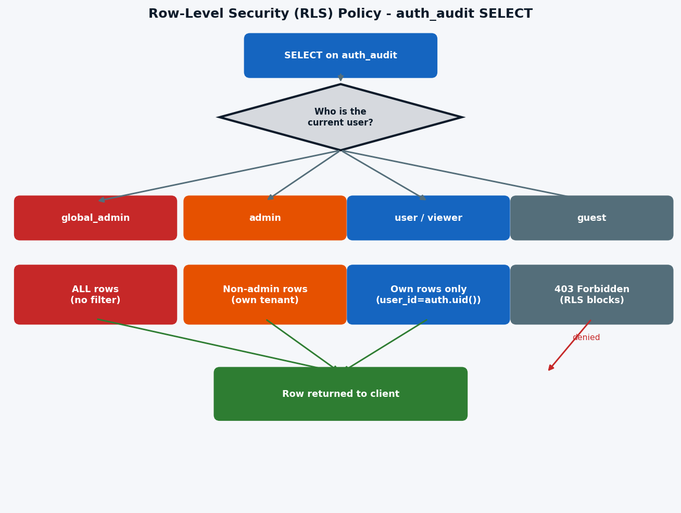
Figure 7 - Row-Level Security (RLS) Policy Diagram

RLS Policies Summary Table
Table | Policy Name | Operation | Who | Condition
auth_audit | Users insert own | INSERT | Any authenticated | auth.uid() = user_id
auth_audit | Users see own | SELECT | user/viewer/guest | user_id = auth.uid()
auth_audit | Admins see all except global_admin | SELECT | admin | role IN ('admin','user','viewer','guest')
auth_audit | Global admins see all | SELECT | global_admin | No restriction
audit_logs | System can insert | INSERT | Any | true (system writes)
audit_logs | Users see own | SELECT | Any | auth.uid() = user_id
audit_logs | Admins view all | SELECT | admin/global_admin | has_role(auth.uid(), 'admin')
device_sync_logs | Admins only view | SELECT | admin/global_admin | has_role(auth.uid(), 'admin')
device_usage_logs | Admins only view | SELECT | admin/global_admin | has_role(auth.uid(), 'admin')

8. Data Flow Diagram — How Logs Are Created
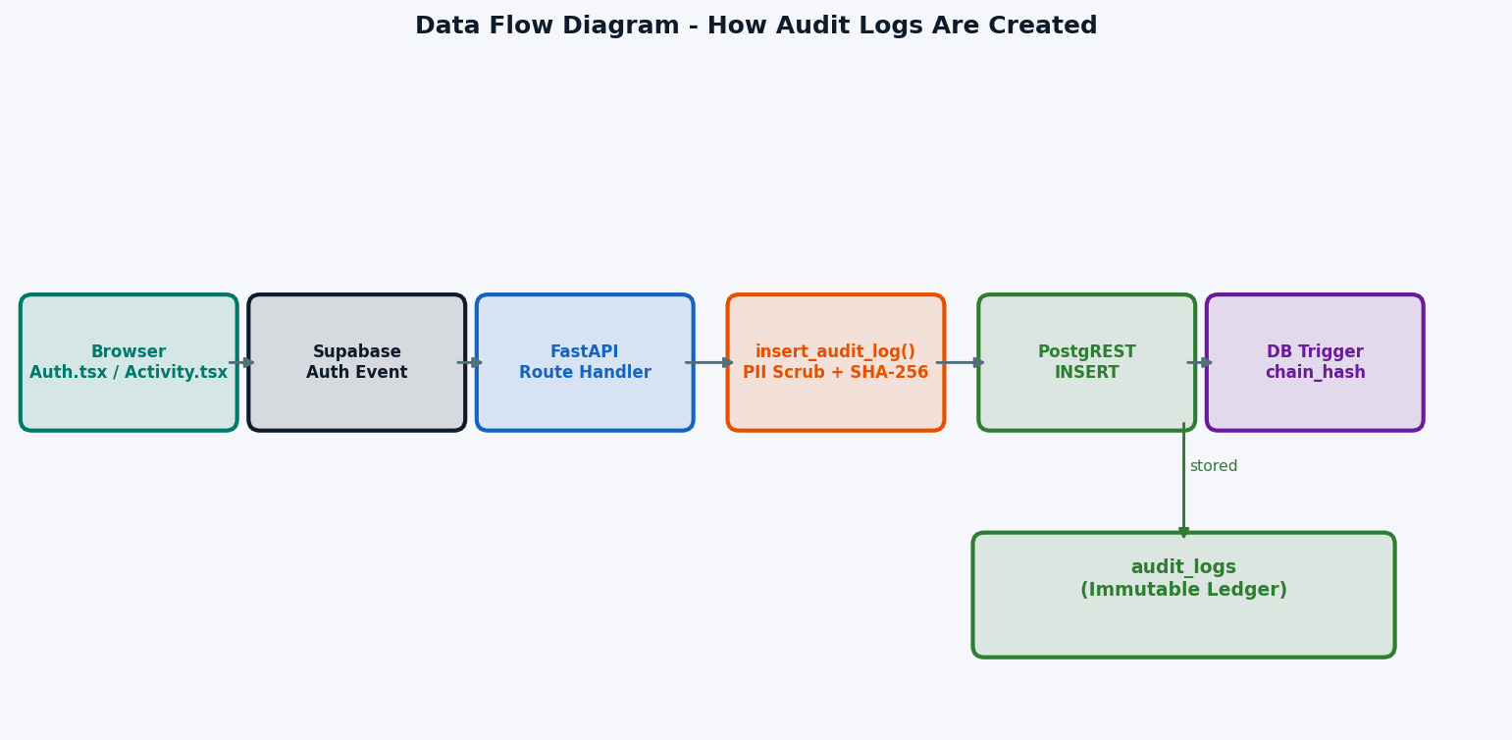
Figure 8 - Data Flow Diagram: How Logs Are Created

9. Sequence Diagram — Login Audit Event
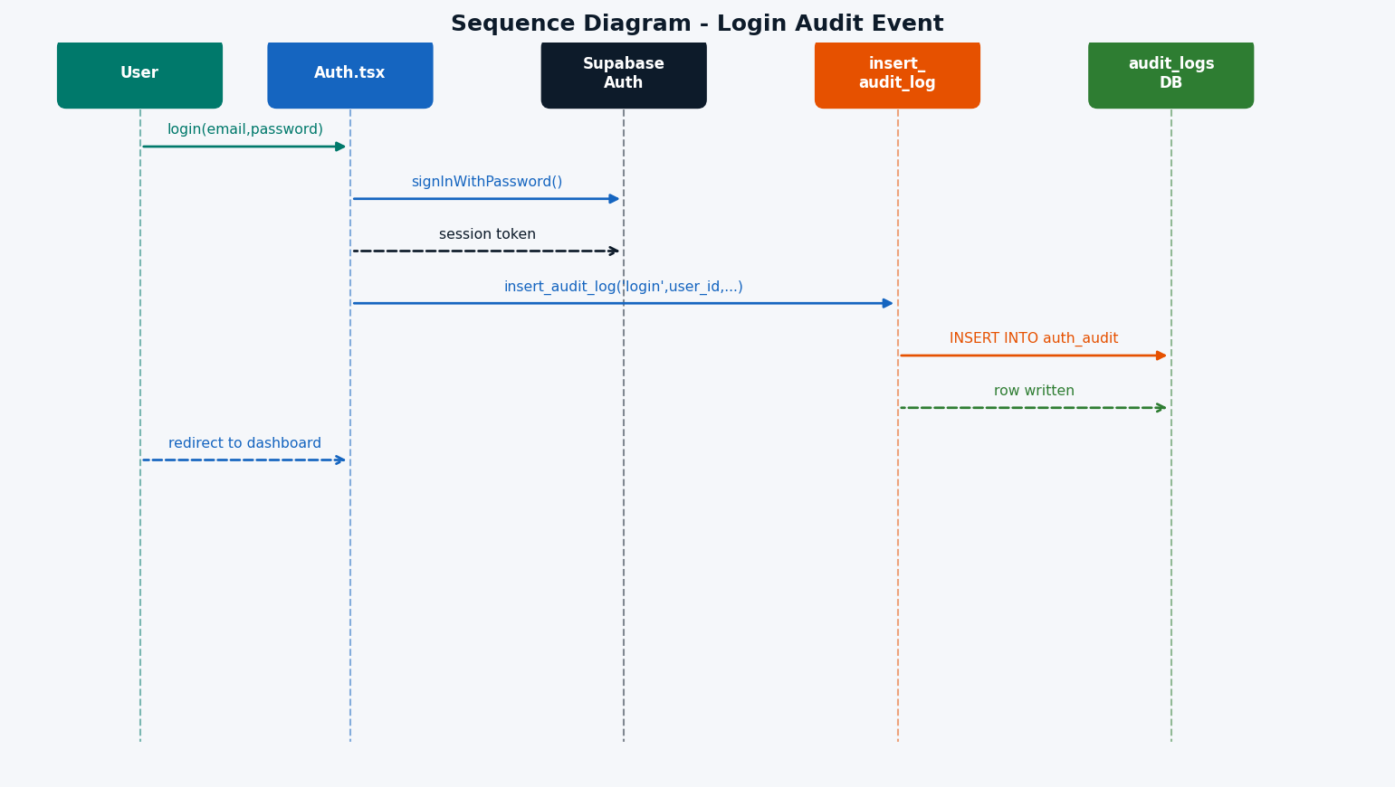
Figure 9 - Sequence Diagram: Login Audit Event

10. Sequence Diagram — Admin Approves Pod
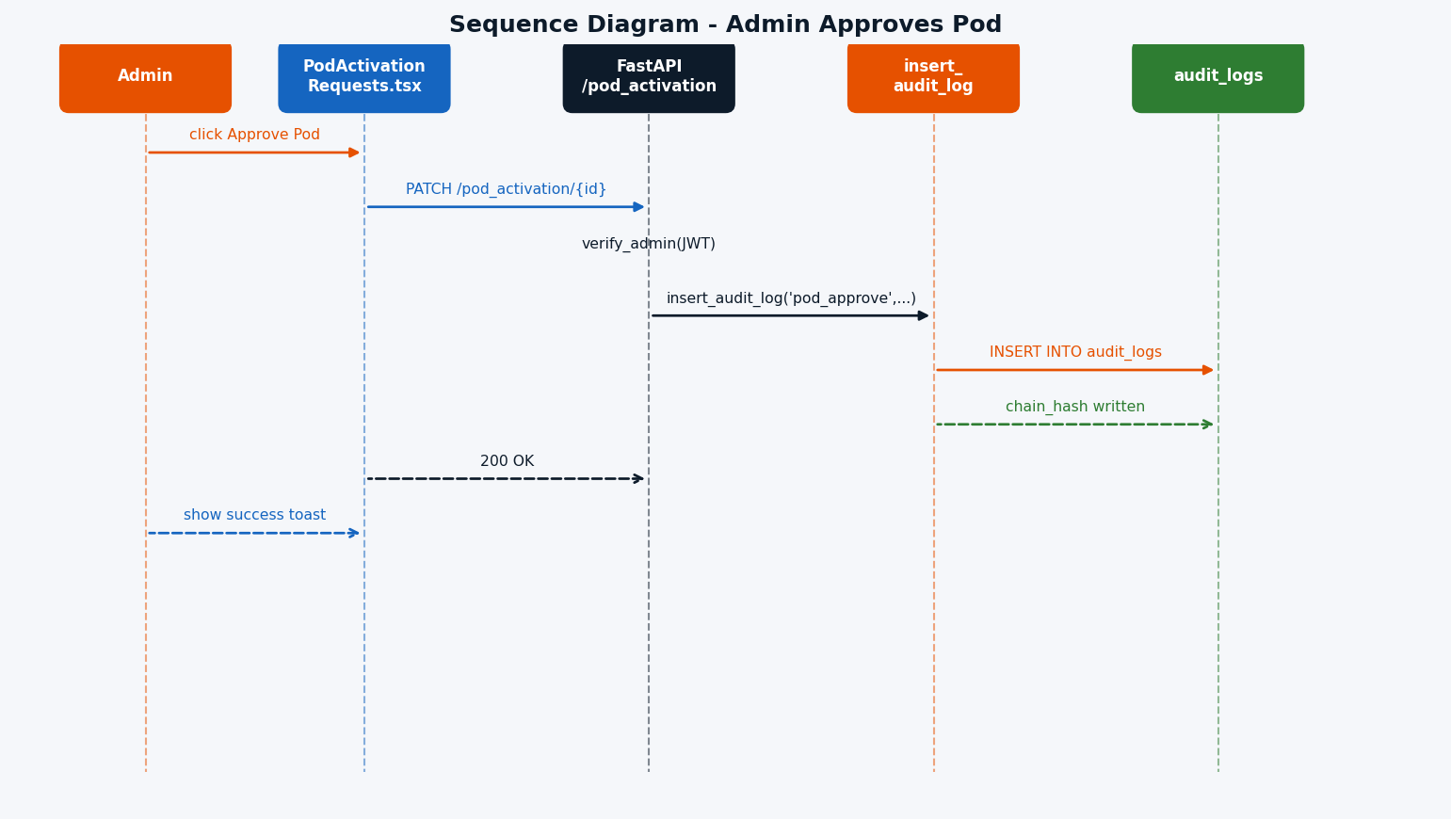
Figure 10 - Sequence Diagram: Admin Approves Pod

11. Sequence Diagram — Viewing Activity Logs
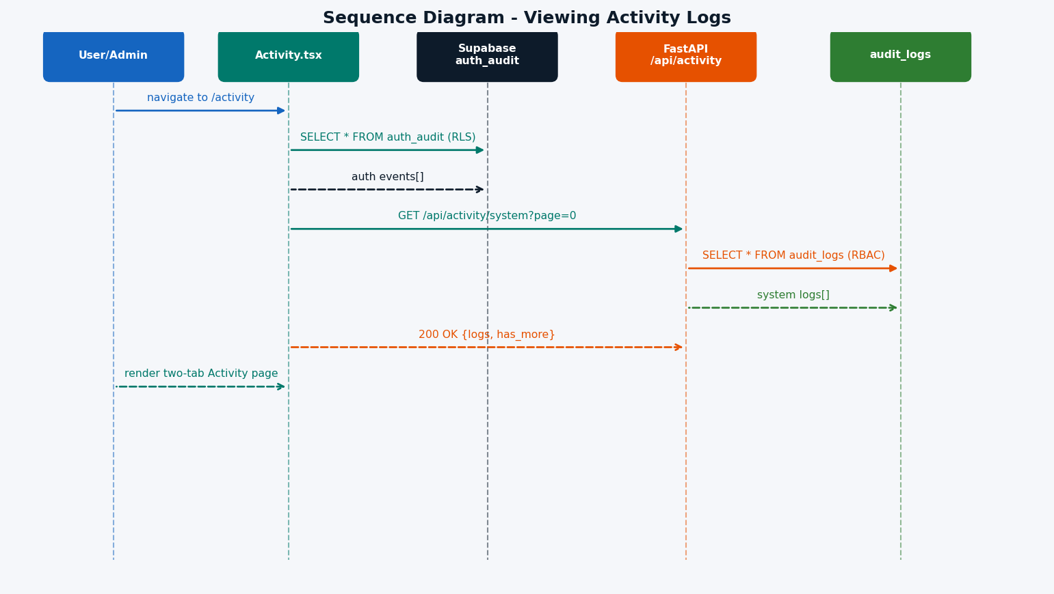
Figure 11 - Sequence Diagram: Viewing Activity Logs

12. Component Architecture Diagram
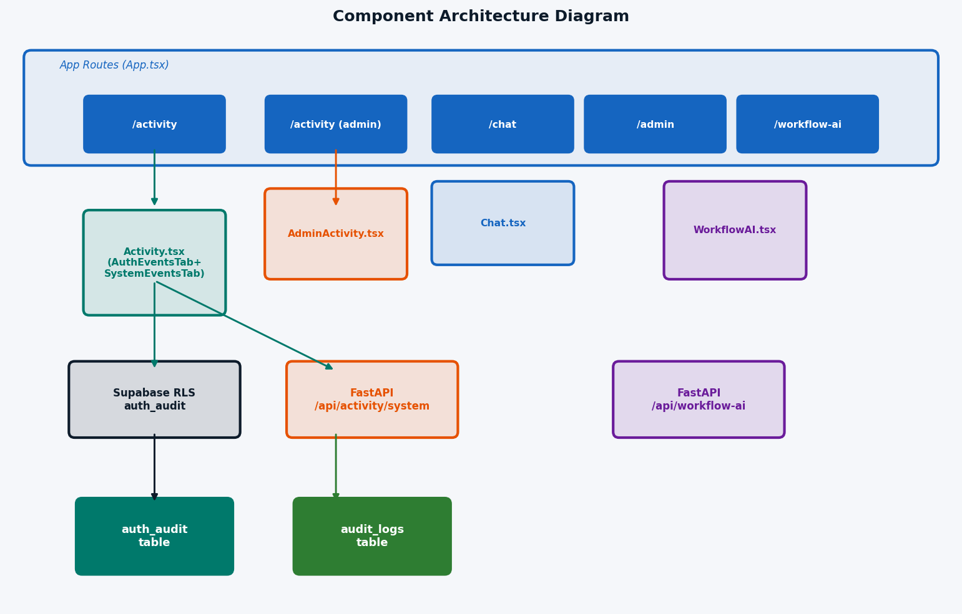
Figure 12 - Component Architecture Diagram

13. Audit Integrity Hash Flow

13.1 `auth_audit` — Frontend SHA-256 Hash (`auditHash.ts`)
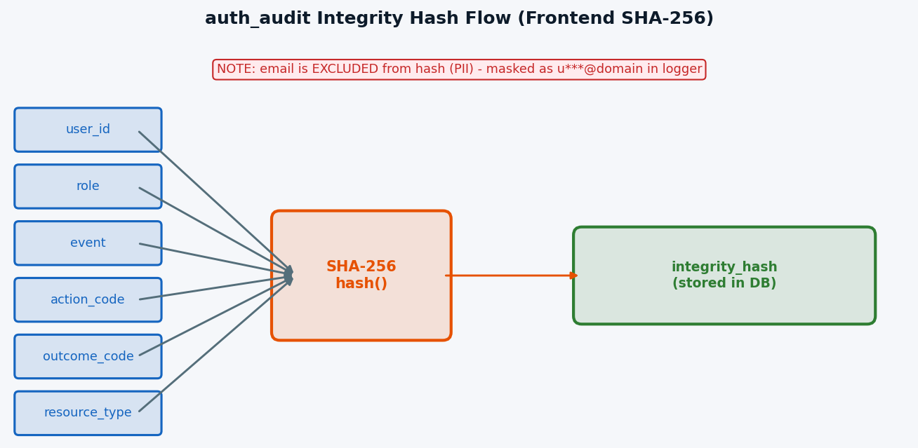
Figure 13.1 - auth_audit Integrity Hash Flow (corrected: email masked as u***@domain, not [REDACTED])

13.2 `audit_logs` — Backend SHA-256 Hash + Cryptographic Chain (`supabase.py` + DB trigger)
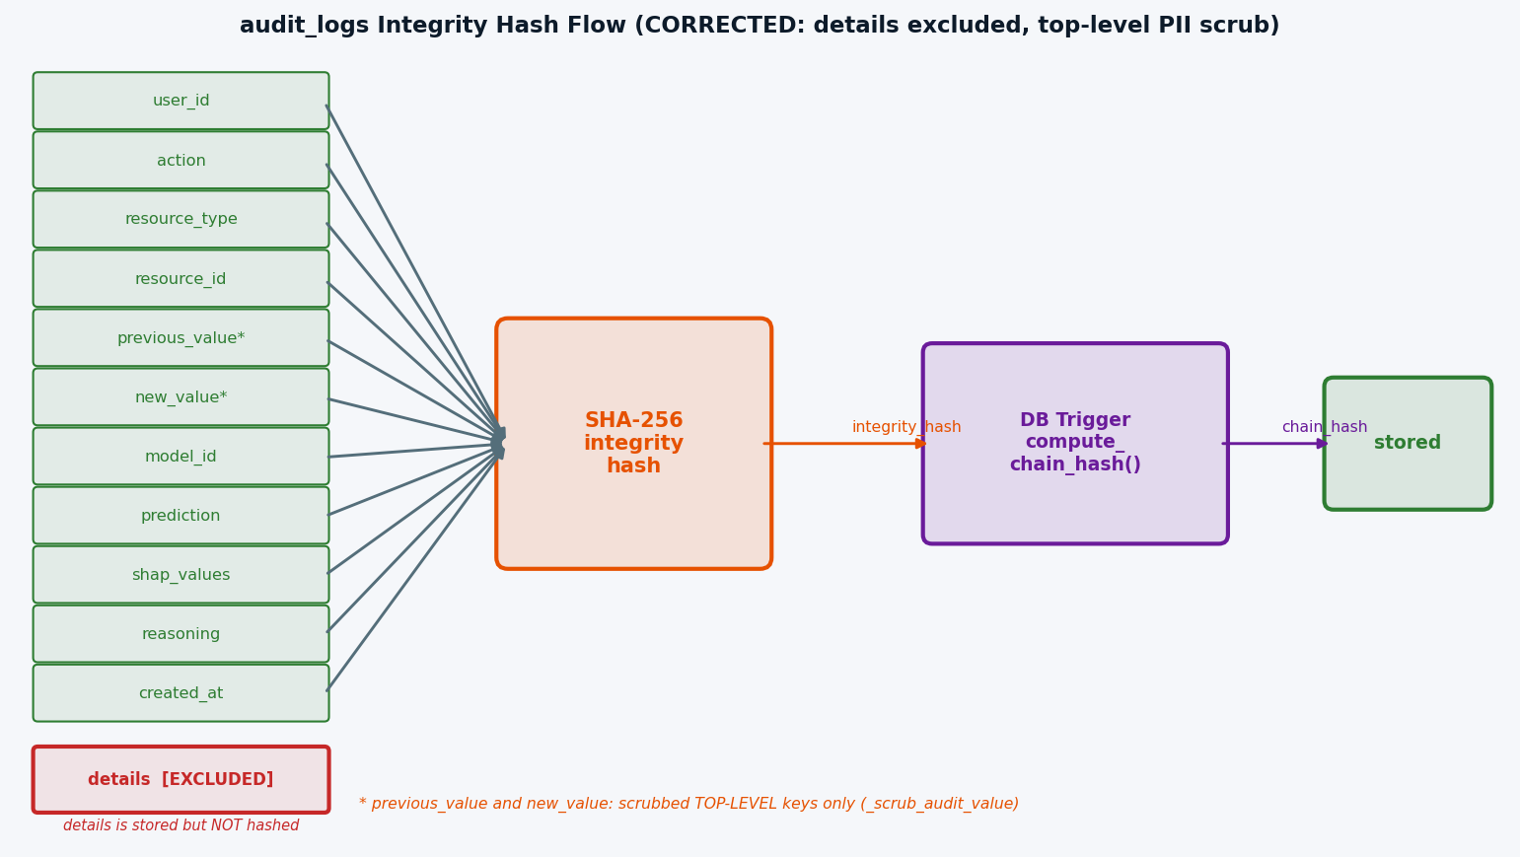
Figure 13.2 - audit_logs Hash + Chain Flow (corrected: details excluded from hash, top-level PII scrub only)

Why the Two-Layer Hash Matters
Layer | Table | Computed By | Covers | Detects
integrity_hash | auth_audit, audit_logs | Application (Python / JS) | All non-PII fields of one row | Single-row tampering
chain_hash | audit_logs only | DB trigger | Links every row to predecessor | Row insertion, deletion, or reordering anywhere in history

- Any modification to a row's fields breaks its integrity_hash.
- Any insertion, deletion, or reordering of rows breaks the chain_hash of every subsequent row.
- For auth_audit, email is excluded from the hash to protect PII (email is stored in the row but not hashed).
- For audit_logs, SHAP values (shap_values, model_id, prediction, reasoning) are included in integrity_hash — tampering with AI explainability data is detectable.

14. Event Types Reference
Event | Trigger | Actor | action_code | outcome_code | resource_type
login | Successful sign-in | Any role | E (Execute) | 0 (Success) | auth_session
logout | Sign-out click | Any role | E (Execute) | 0 (Success) | auth_session
approve_pod:{model_id} | Admin approves pod activation | admin / global_admin | U (Update) | 0 (Success) | pod_activation
reject_pod:{model_id} | Admin rejects pod activation | admin / global_admin | U (Update) | 0 (Success) | pod_activation

15. ATNA Standard Code Reference

Action Codes
Code | Meaning | Used For | Status
C | Create | Creating new resources (e.g. user creation events) | Planned — no events assigned yet
R | Read | Reading/viewing records (e.g. document view events) | Planned — no events assigned yet
U | Update | Modifying existing records | Active — approve_pod, reject_pod
D | Delete | Deleting records | Planned — no events assigned yet
E | Execute | Executing operations | Active — login, logout

Outcome Codes
Code | Meaning | Severity
0 | Success | None — operation completed normally
4 | Minor failure | Low — minor issue occurred
8 | Serious failure | High — significant problem
12 | Major failure | Critical — severe error

16. Access Control Matrix

`/activity` Page — What Each Role Sees
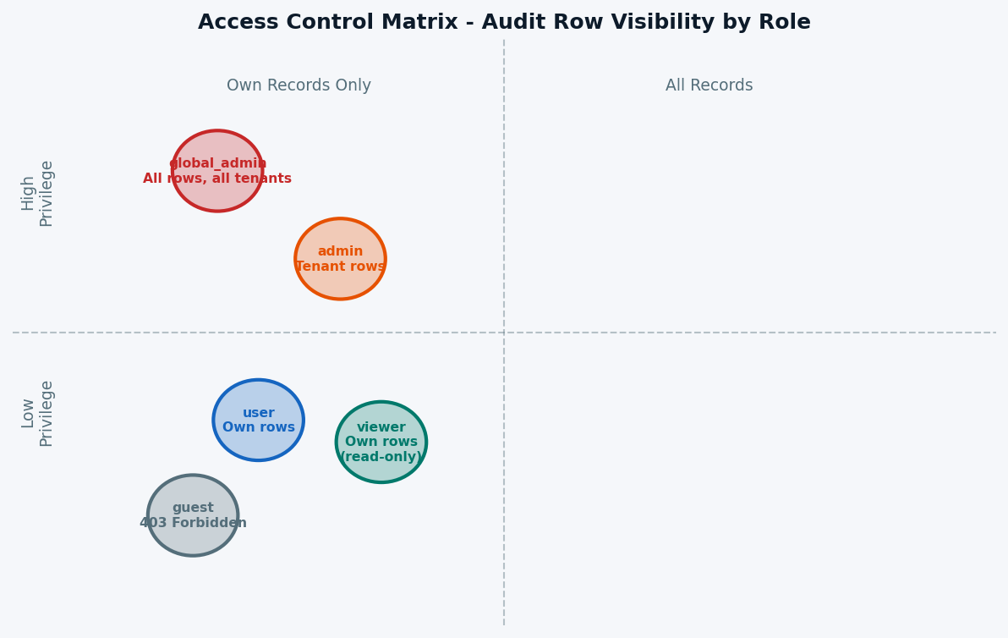
Figure 16 - Access Control Matrix: Audit Row Visibility by Role

Detailed Access Matrix
Data Scope | global_admin | admin | user | viewer | guest
Own auth_audit rows (DB via RLS) | ✅ | ✅ | ✅ | ✅ | ✅ ¹
All user role rows | ✅ | ✅ | ❌ | ❌ | ❌
All admin role rows | ✅ | ✅ ² | ❌ | ❌ | ❌
All viewer role rows | ✅ | ✅ | ❌ | ❌ | ❌
All guest role rows | ✅ | ✅ | ❌ | ❌ | ❌
global_admin role rows | ✅ | ❌ | ❌ | ❌ | ❌
All audit_logs rows | ✅ | ✅ | ❌ | ❌ | ❌
Own audit_logs rows (DB via RLS) | ✅ | ✅ | ✅ | ✅ | ✅ ¹
device_sync_logs | ✅ | ✅ | ❌ | ❌ | ❌
device_usage_logs | ✅ | ✅ | ❌ | ❌ | ❌

¹ **Guest DB access:** Guest users can read their own `auth_audit` and `audit_logs` rows at the database level via the `"Users see own"` RLS policy (`user_id = auth.uid()`). The frontend `/activity` page is blocked by the route guard — DB-level access exists but is not exposed in the UI. This is intentional: permissive at DB, restricted at UI layer.
>
² **Cross-admin visibility (intentional by design):** An `admin` can read the full audit trail of **other admins** within the same tenant (`role IN ('admin','user','viewer','guest')` includes all admin rows). This is deliberate for accountability — any admin action is visible to other admins and to `global_admin`. This is **not** a privilege escalation: admins cannot see `global_admin` rows, and cannot modify any audit row (no UPDATE/DELETE policy exists).

API Endpoint Access Matrix
Endpoint | global_admin | admin | user | viewer | guest
GET /api/list-users | ✅ | ✅ | ❌ | ❌ | ❌
POST /api/admin-create-user | ✅ | ✅ | ❌ | ❌ | ❌
POST /api/admin-set-user-role | ✅ | ❌ | ❌ | ❌ | ❌

17. Navigation & Route Guard Diagram
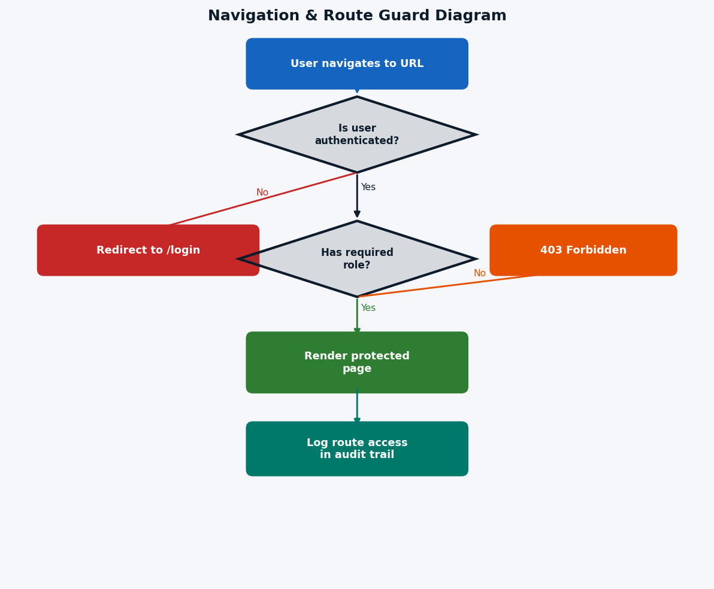
Figure 17 - Navigation & Route Guard Diagram

18. Backend Logging Architecture
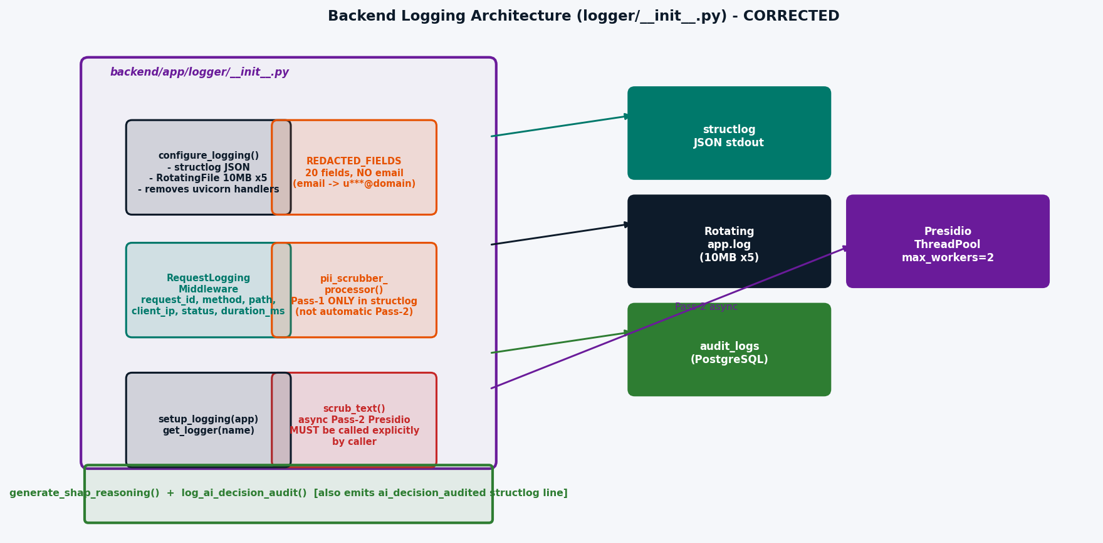
Figure 18 - Backend Logging Architecture (corrected: Pass-2 not automatic, structlog line from log_ai_decision_audit)

Backend vs Frontend Logging Comparison
Aspect | Frontend (auth_audit table) | Backend (logs/app.log) | Backend (audit_logs ledger)
Storage | Supabase PostgreSQL | Local file system | Supabase PostgreSQL
Format | Structured table rows | JSON lines (structlog) | Structured rows + JSONB
PII Handling — Pass 1 | Email stored, excluded from hash | Field-name keyword match → [REDACTED]; email → u***@domain | _scrub_audit_value() before storage
PII Handling — Pass 2 | Regex content scan (SSN, card, phone, IBAN) | Presidio content scan (PERSON, EMAIL, PHONE, CREDIT_CARD, US_SSN, IBAN, LOCATION) | Presidio via scrub_text()
Tamper Evidence | SHA-256 integrity_hash | No hash (file-based) | SHA-256 integrity_hash + SHA-256 chain_hash
Append-Only | RLS (no DELETE policy) | File append-only (OS) | DB trigger raises exception on UPDATE/DELETE
AI Explainability | — | — | shap_values, model_id, prediction, reasoning
Queryable | Yes — via Supabase SQL/RLS | No — file read only | Yes — GET /api/activity/system
Retention | Permanent (no delete policy) | File rotation (10 MB × 5 = 50 MB max) | Permanent (append-only, no delete policy)
Visibility | Role-filtered via RLS | Server-side only | Role-filtered via FastAPI endpoint
Compliance | ATNA | Operational debug | EU AI Act Art.12/13, SOC2 CC7.2

19. Full System Interaction Diagram
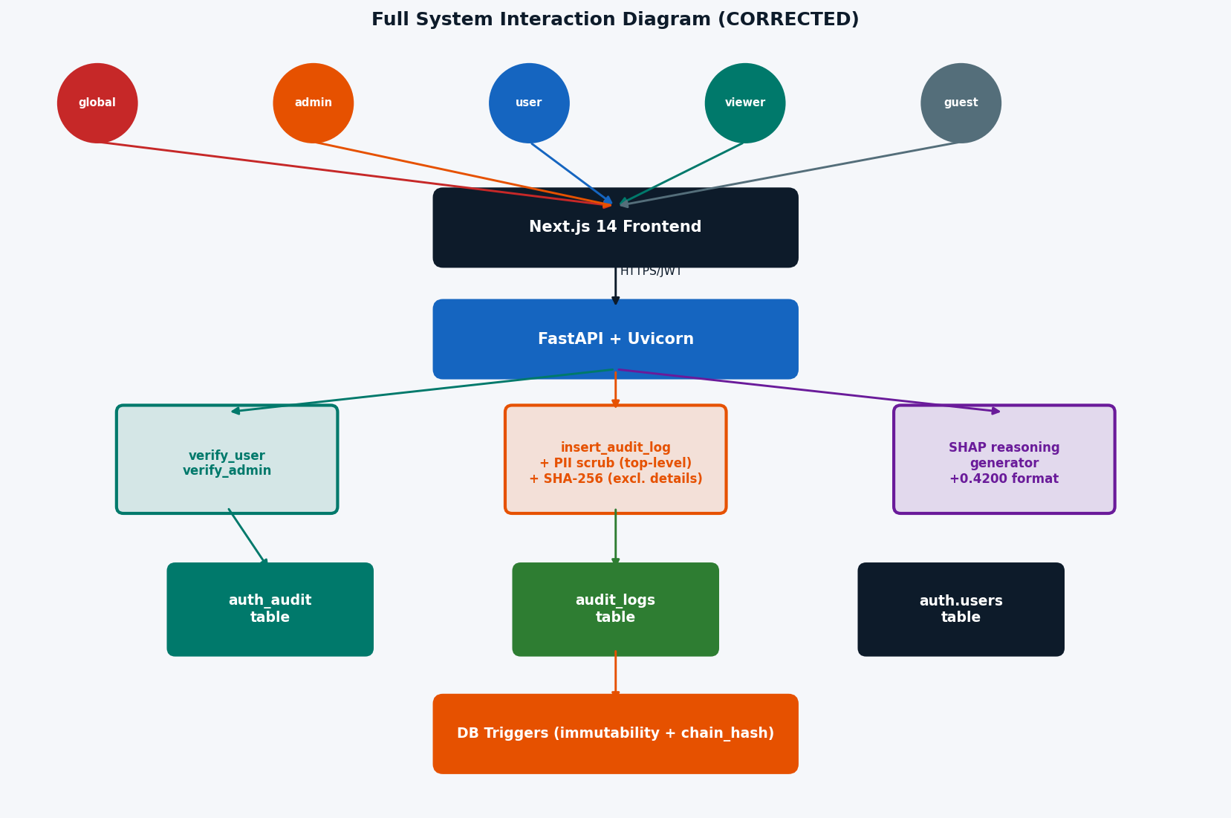
Figure 19 - Full System Interaction Diagram (corrected)

20. PII Detection — Presidio & Regex
All log data passes through a two-pass PII scrubbing pipeline before being written to any output, implemented in backend/app/logger/__init__.py (Python) and frontend/src/logger/index.ts (TypeScript).

Pass 1 — Field-name Keyword Match (fast)
Every key in the log payload is compared (case-insensitive) against a hard-coded set of sensitive field names. A match unconditionally replaces the value with [REDACTED].
logger.REDACTED_FIELDS - 20 fields (email NOT included here): password, passwd, secret, token, api_key, authorization, ssn, social_security, credit_card, card_number, cvv, dob, date_of_birth, birth_date, full_name, first_name, last_name, mobile, phone, phone_number, address. Email is handled separately: detected via '@' character and masked as u***@domain (not [REDACTED]). NOTE: supabase._AUDIT_PII_FIELDS (used in _scrub_audit_value) has 21 fields and DOES include email -> [REDACTED], but this only applies to previous_value/new_value top-level keys.

Pass 2 — Content-based PII Detection (deep scan)
Pass-2 (Presidio) is NOT automatic. The structlog pii_scrubber_processor runs Pass-1 ONLY. Pass-2 must be explicitly called by the route handler or service using: safe_text = await scrub_text(user_supplied_text). When called, it offloads NLP analysis to a dedicated ThreadPoolExecutor(max_workers=2) so the asyncio event loop is never blocked. Presidio replaces entities with angle-bracket tags: <PERSON>, <EMAIL_ADDRESS>, etc. (not [REDACTED]). Graceful degradation to Pass-1 only if Presidio is unavailable.

Email Pre-masking (shared — both backend & frontend)
Before the deep scan, email addresses are masked to u***@domain.com format (cheaper than NLP/regex scan).

Backend — Microsoft Presidio (Python)
from presidio_analyzer import AnalyzerEngine
from presidio_anonymizer import AnonymizerEngine
from presidio_anonymizer.entities import OperatorConfig
_analyzer = AnalyzerEngine() # uses spaCy en_core_web_sm model
_anonymizer = AnonymizerEngine()
Detected entities are replaced using OperatorConfig("replace", {"new_value": "<ENTITY_TYPE>"}). Output format: <PERSON>, <EMAIL_ADDRESS>, <PHONE_NUMBER>, <CREDIT_CARD>, <US_SSN>, <IBAN_CODE>, <LOCATION>. NOTE: these are angle-bracket tags, NOT [REDACTED].
Graceful degradation: if Presidio or spaCy is unavailable, _PRESIDIO_AVAILABLE=False and only Pass-1 runs. IMPORTANT: Pass-2 is NOT applied automatically to all log output. The structlog pii_scrubber_processor runs Pass-1 ONLY. Pass-2 must be called explicitly: safe_text = await scrub_text(user_text). It runs in ThreadPoolExecutor(max_workers=2, thread_name_prefix="presidio").

Frontend — Regex Patterns (TypeScript)
const PII_PATTERNS: PiiPattern[] = [
{ label: "US_SSN", regex: /\b\d{3}-\d{2}-\d{4}\b/g },
{ label: "CREDIT_CARD", regex: /\b(?:\d[ -]?){13,15}\d\b/g },
{ label: "PHONE_NUMBER", regex: /(?:\+\d{1,3}[\s.-]?)?(?:\(?\d{3}\)?[\s.-]?)(?:\d{3}[\s.-]?\d{4})/g },
{ label: "EMAIL_ADDRESS", regex: /[a-zA-Z0-9._%+\-]+@[a-zA-Z0-9.\-]+\.[a-zA-Z]{2,}/g },
{ label: "IBAN_CODE", regex: /\b[A-Z]{2}\d{2}[A-Z0-9]{4}\d{7}(?:[A-Z0-9]?){0,16}\b/g },
];
No ML model required — runs in browser or Node.js with zero additional dependencies.

Entity Type Reference
Entity Type | Example Input | Replacement | Backend | Frontend
PERSON | John Smith | <PERSON> | Presidio NLP | —
EMAIL_ADDRESS | user@example.com | u***@example.com | Email mask + Presidio | Email mask + regex
PHONE_NUMBER | +1 (555) 123-4567 | <PHONE_NUMBER> | Presidio NLP | Regex
CREDIT_CARD | 4111 1111 1111 1111 | <CREDIT_CARD> | Presidio NLP | Regex
US_SSN | 123-45-6789 | <US_SSN> | Presidio NLP | Regex
IBAN_CODE | GB29NWBK60161331926819 | <IBAN_CODE> | Presidio NLP | Regex
LOCATION | New York, NY | <LOCATION> | Presidio NLP | —
IP_ADDRESS | 192.168.1.1 | (kept) | Intentionally excluded | —

**Note:** `IP_ADDRESS` is excluded from Presidio detection — client IPs are useful for security forensics in HTTP request logs.

Backend Dependencies (`requirements.txt`)
presidio-analyzer>=2.2.0
presidio-anonymizer>=2.2.0
spacy>=3.4.0,<4.0.0
en-core-web-sm @ https://github.com/explosion/spacy-models/releases/download/en_core_web_sm-3.7.1/en_core_web_sm-3.7.1-py3-none-any.whl

Installation
pip install -r requirements.txt
# or manually:
pip install presidio-analyzer presidio-anonymizer spacy
python -m spacy download en_core_web_sm

21. Cryptographic Audit Ledger
**Added:** 2026-03-17 — migrations `20260317000002_audit_ledger_shap.sql` and `20260317000003_verify_audit_ledger_fix.sql`

Overview
The audit_logs table has been upgraded from a conventional log table to a cryptographic append-only ledger — analogous to a simplified blockchain. Every row is linked to its predecessor via a SHA-256 chain hash. Any attempt to insert, delete, reorder, or modify any row will invalidate every chain_hash from that row onward, making tampering detectable.

Chain Hash Formula
chain_hash[0] = SHA-256("GENESIS" || integrity_hash[0]) -- genesis block
chain_hash[N] = SHA-256(chain_hash[N-1] || integrity_hash[N]) -- subsequent blocks
- sequence_num: BIGINT GENERATED ALWAYS AS IDENTITY — strictly monotonic, assigned by PostgreSQL, never supplied by the caller.
- chain_hash: computed exclusively by the compute_audit_chain_hash() BEFORE INSERT trigger — the caller's value is always overwritten.
- integrity_hash: SHA-256 over these fields: user_id, action, resource_type, resource_id, previous_value (json, scrubbed), new_value (json, scrubbed), model_id, prediction (json), shap_values (json), reasoning, created_at. IMPORTANT: 'details' field is stored in the row but is NOT included in the integrity_hash.

Ledger Trigger — `compute_audit_chain_hash()`
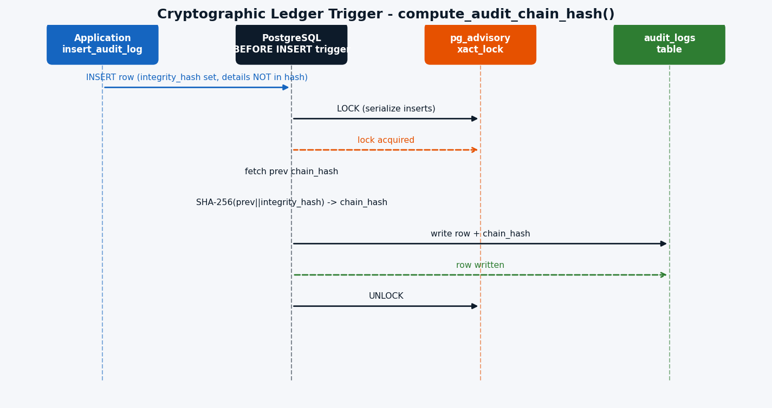
Figure 21 - Cryptographic Ledger Trigger Sequence

Append-Only Enforcement — `prevent_audit_modification()`
A separate trigger fires BEFORE UPDATE or BEFORE DELETE on both auth_audit and audit_logs:
-- Any UPDATE or DELETE raises an exception
RAISE EXCEPTION 'Audit records are immutable and cannot be modified or deleted.';
This makes the append-only property a hard database constraint, not just an RLS policy gap.

Ledger Verification — `verify_audit_ledger()`
Compliance auditors can verify the full ledger at any time:
-- Check for any tampered rows:
SELECT * FROM public.verify_audit_ledger() WHERE NOT is_valid;
-- Full ledger walk:
SELECT * FROM public.verify_audit_ledger() ORDER BY sequence_num;
Return columns:
Column | Type | Meaning
sequence_num | BIGINT | Insert order
id | UUID | Row identifier
stored_chain | TEXT | chain_hash value stored in the row
computed_chain | TEXT | Hash re-derived from scratch by the function
is_valid | BOOLEAN | TRUE if match, FALSE if tampered, NULL if pre-migration sentinel

Pre-migration rows (inserted before the 2026-03-17 migration) have chain_hash = NULL. The fixed verify_audit_ledger() (migration 20260317000003) returns these as sentinel rows (is_valid = NULL) without advancing prev_chain, so the post-migration chain verifies correctly from the first chained row onward.

Compliance Coverage
Standard | Article / Control | Requirement | Ledger Feature
EU AI Act | Art. 12 — Record-keeping | AI systems must log decisions with sufficient detail | shap_values, model_id, prediction, reasoning stored per decision
EU AI Act | Art. 13 — Transparency | Explainability for high-risk AI | Human-readable reasoning auto-generated from SHAP
SOC 2 | CC7.2 — System Monitoring | Detect and respond to unauthorized activity | verify_audit_ledger() detects any tampered row
NAIC AI Bulletin | AI model governance | Audit trail for AI-driven decisions | Full decision + SHAP trace per row

22. SHAP AI Explainability Integration
**Added:** 2026-03-17 — `backend/app/logger/__init__.py` + migration `20260317000002_audit_ledger_shap.sql`

Overview
When an AI model makes a decision (risk assessment, fraud detection, recommendation, etc.), the platform captures the SHAP (SHapley Additive exPlanations) feature contributions alongside the prediction and stores them in the audit_logs ledger. A human-readable explanation is auto-generated from the SHAP values and stored in the reasoning column.

SHAP Columns in `audit_logs`
Column | Type | Description
shap_values | JSONB | {"feature_name": shap_float, ...} — positive values increase prediction, negative decrease
model_id | TEXT | Human-readable model identifier, e.g. "fraud-detector-v3"
prediction | JSONB | Model output — e.g. {"label": "high_risk", "confidence": 0.87}
reasoning | TEXT | Auto-generated sentence — e.g. "Model 'fraud-v3' predicted 'high_risk' (confidence 87.0%). Top factors: transaction_amount (+0.4200, ↑), account_age (-0.3100, ↓)."

All four columns are included in `integrity_hash` — tampering with any AI explainability field is detectable.

`generate_shap_reasoning()` — Auto-explanation Generator
Located in backend/app/logger/__init__.py.
reasoning = generate_shap_reasoning(
shap_values={"transaction_amount": 0.42, "account_age": -0.31, "hour_of_day": 0.18},
prediction={"label": "high_risk", "confidence": 0.87},
model_id="fraud-v3",
top_n=5,
)
# → "Model 'fraud-v3' predicted 'high_risk' (confidence 87.0%).
# Top factors: transaction_amount (+0.4200, ↑), account_age (-0.3100, ↓), hour_of_day (+0.1800, ↑)."
Algorithm:
- Sort features by absolute SHAP value (most influential first).
- Take top N features.
- Render prediction as a string — handles both scalar and dict (extracts label/class and confidence/score).
- Format each feature as: feature_name (value, direction). CORRECTED: uses :+.4f format, e.g. transaction_amount (+0.4200, up), account_age (-0.3100, down). NOT +0.42 - always 4 decimal places.
- Return a single sentence.

`log_ai_decision_audit()` — Convenience Wrapper
Combines SHAP reasoning generation with the audit ledger write in one async call. CORRECTED: also emits a structlog structured log line: structlog.get_logger("ai_decision").info("ai_decision_audited", model_id=..., action=..., reasoning=...). So each AI decision produces BOTH an audit_logs row AND a stdout/file log line.
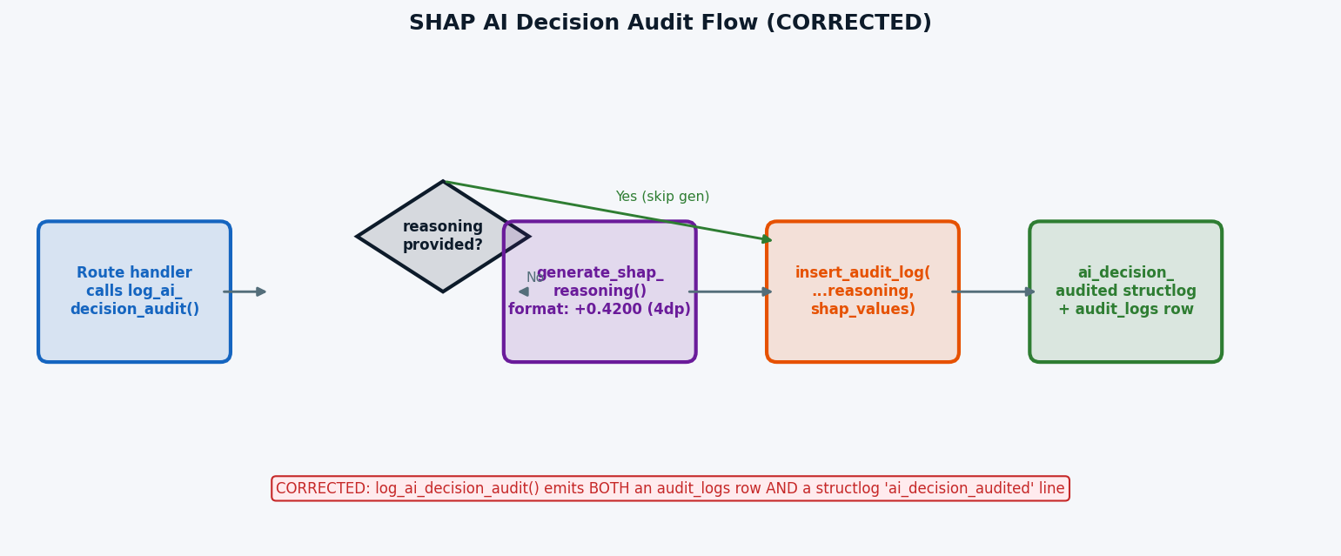
Figure 22 - SHAP AI Decision Audit Flow (corrected: +0.4200 format, structlog also emitted)
Usage example:
await log_ai_decision_audit(
request=request,
user_id=current_user["id"],
action="risk_assessment",
resource_type="transaction",
resource_id=transaction_id,
model_id="fraud-detector-v3",
shap_values={"amount": 0.42, "account_age": -0.31, "hour": 0.18},
prediction={"label": "high_risk", "confidence": 0.87},
)

Frontend — `ShapFactors` Component (`Activity.tsx`)
The System Events tab in Activity.tsx renders SHAP values inline for any row with shap_values populated:
- Top 3 features sorted by absolute SHAP magnitude are displayed.
- Positive values show a green ↑ badge.
- Negative values show a red ↓ badge.
- The full reasoning text is also displayed as an expandable AI Reasoning section.

SHAP Data Flow
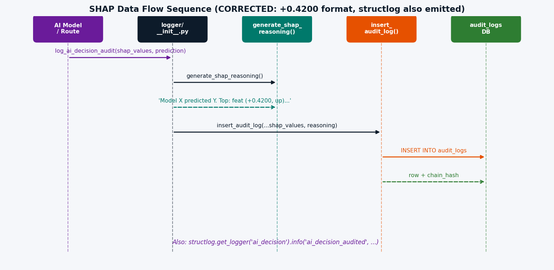
Figure 22b - SHAP Data Flow Sequence (corrected)

23. Backend Audit Write Architecture
**Added:** `backend/app/core/supabase.py` — `insert_audit_log()` function

`insert_audit_log()` — Central Audit Write
All backend routes call a single insert_audit_log() function to persist audit rows. This function:
- Computes `integrity_hash`: SHA-256 over all non-PII structured fields — user_id, action, resource_type, resource_id, ip_address, user_agent, created_at, shap_values, model_id, prediction, reasoning.
- Scrubs PII from previous_value and new_value using _scrub_audit_value() before storage. IMPORTANT: _scrub_audit_value() only scrubs TOP-LEVEL keys (no recursion). Contrast with logger._scrub_value() which recurses up to _MAX_SCRUB_DEPTH=10. previous_value/new_value must be shallow dicts by design.
- Silently swallows exceptions — audit failures never block the main request path.
- Writes to audit_logs via PostgREST; the DB trigger then sets chain_hash.

Routes That Write Audit Rows
Route | Action | Fields Captured
POST /api/admin-create-user | create_user | new_value: {role}
POST /api/admin-set-user-role | set_user_role | previous_value: {role}, new_value: {role}
POST /api/admin-create-user (password update) | update_password | No values stored
POST /api/v1/pods/approve | approve_pod | Pod resource details
POST /api/v1/pods/reject | reject_pod | Pod resource details
Device registration / deactivation | register_device, deactivate_device | Device resource details
Tenant provisioning | create_tenant, provision_admin | Tenant / user details
AI model decisions (via log_ai_decision_audit) | Any | Full SHAP + prediction

`GET /api/activity/system` — System Events Endpoint (`activity.py`)
Returns paginated audit_logs rows with role-based filtering:
Caller Role | Rows Returned
global_admin | All rows
admin | All rows
user / viewer | Only own rows (user_id = caller)
guest | 403 Forbidden

Fields returned (includes all ledger columns): id, user_id, action, resource_type, resource_id, details, previous_value, new_value, ip_address, user_agent, created_at, integrity_hash, sequence_num, chain_hash, shap_values, model_id, prediction, reasoning
Supported filters: action, resource_type, date_from, date_to

24. Audit Ledger Verification Flow
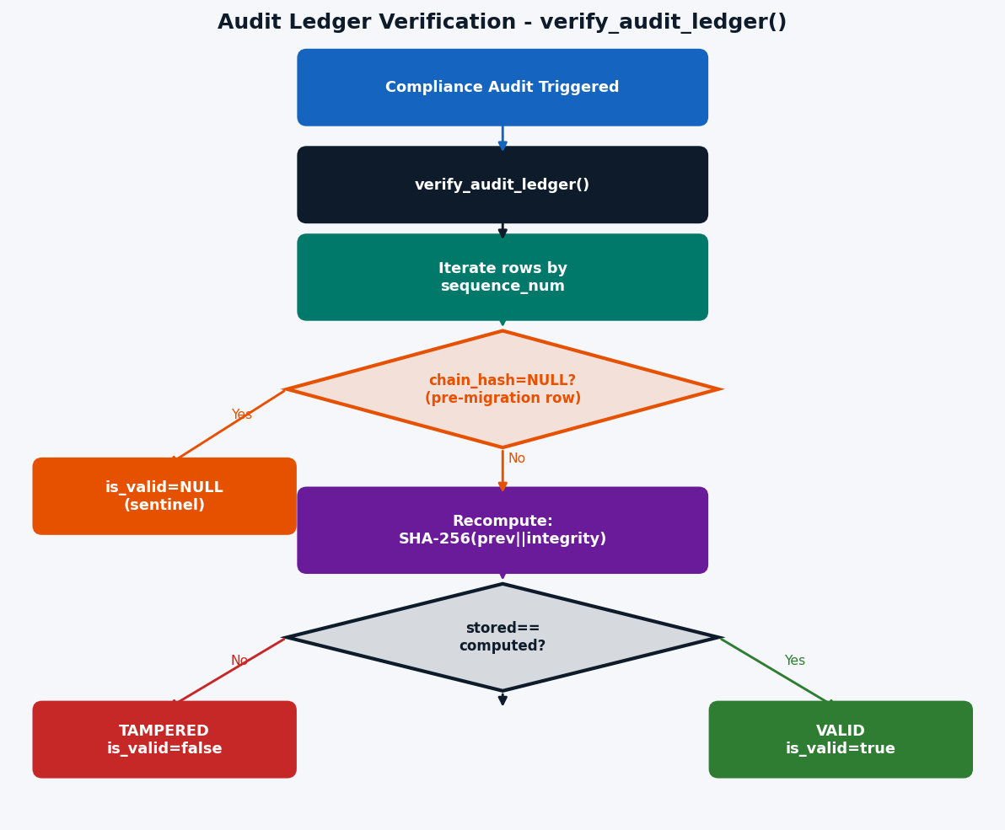
Figure 24 - Audit Ledger Verification Flow

Interpreting Results
is_valid | Meaning | Action
TRUE | Row hash matches — not tampered | None required
FALSE | Stored chain ≠ computed chain — row inserted, deleted, reordered, or modified | Investigate immediately
NULL | Pre-migration row (chain_hash = NULL) — existed before the ledger upgrade | Document as expected, no action

25. Migration History & Schema Evolution
Migration | Date | Changes
20260313091500_auth_audit_logs.sql | 2026-03-13 | Created auth_audit table, ATNA codes, RLS policies, SHA-256 integrity_hash
20260316000000_auth_audit_user_id_fk.sql | 2026-03-16 | Added FK auth_audit.user_id → auth.users(id) ON DELETE CASCADE
20260316000001_audit_immutability.sql | 2026-03-16 | Added prevent_audit_modification() trigger — append-only enforcement for both tables; added integrity_hash to audit_logs
20260316000002_audit_logs_change_tracking.sql | 2026-03-16 | Added previous_value JSONB and new_value JSONB to audit_logs; GIN index on resource_id
20260316000005_rename_auth_audit_admin_policy.sql | 2026-03-16 | Renamed misleading RLS policy name (condition unchanged)
20260317000002_audit_ledger_shap.sql | 2026-03-17 | Major upgrade: added sequence_num, chain_hash, shap_values, model_id, prediction, reasoning; compute_audit_chain_hash() trigger; verify_audit_ledger() function; pgcrypto extension; performance indexes
20260317000003_verify_audit_ledger_fix.sql | 2026-03-17 | Hotfix: replaced verify_audit_ledger() to handle pre-migration NULL chain_hash rows as sentinels

`audit_logs` Column Evolution
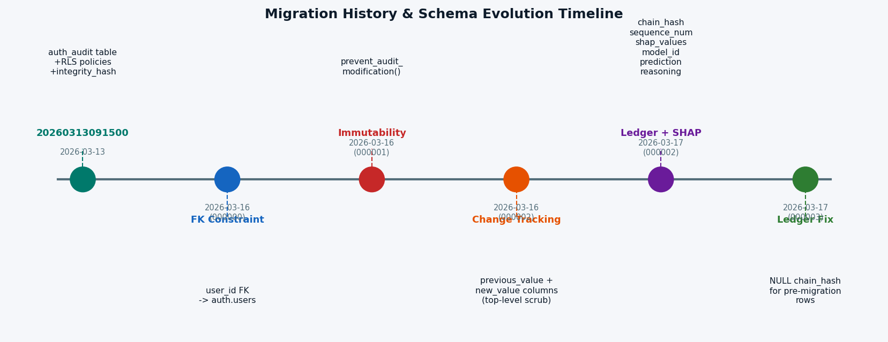
Figure 25 - Migration History & Schema Evolution Timeline

File Reference
File | Purpose
[migrations/20260313091500_auth_audit_logs.sql](next-fastapi-conversion/supabase/migrations/20260313091500_auth_audit_logs.sql) | auth_audit table + RLS policies + ATNA codes
[migrations/20251116145514_...sql](next-fastapi-conversion/supabase/migrations/20251116145514_03b8c065-31f2-46c1-a062-a1f2e4363a04.sql) | audit_logs table + RLS policies (original)
[migrations/20260316000000_auth_audit_user_id_fk.sql](next-fastapi-conversion/supabase/migrations/20260316000000_auth_audit_user_id_fk.sql) | FK referential integrity for auth_audit
[migrations/20260316000001_audit_immutability.sql](next-fastapi-conversion/supabase/migrations/20260316000001_audit_immutability.sql) | Append-only triggers + integrity_hash column on audit_logs
[migrations/20260316000002_audit_logs_change_tracking.sql](next-fastapi-conversion/supabase/migrations/20260316000002_audit_logs_change_tracking.sql) | previous_value + new_value columns + GIN index
[migrations/20260316000005_rename_auth_audit_admin_policy.sql](next-fastapi-conversion/supabase/migrations/20260316000005_rename_auth_audit_admin_policy.sql) | Policy name correction
[migrations/20260317000002_audit_ledger_shap.sql](next-fastapi-conversion/supabase/migrations/20260317000002_audit_ledger_shap.sql) | Cryptographic ledger: `sequence_num`, `chain_hash`, SHAP columns, chain trigger, `verify_audit_ledger()`
[migrations/20260317000003_verify_audit_ledger_fix.sql](next-fastapi-conversion/supabase/migrations/20260317000003_verify_audit_ledger_fix.sql) | Hotfix: `verify_audit_ledger()` handles pre-migration NULL chain rows
[migrations/20260312193000_fnf9_schema_closure.sql](next-fastapi-conversion/supabase/migrations/20260312193000_fnf9_schema_closure.sql) | Role enum + user_roles + roles tables
[migrations/20260312194000_fnf10_rls_hardening.sql](next-fastapi-conversion/supabase/migrations/20260312194000_fnf10_rls_hardening.sql) | RLS hardening pass
[frontend/src/app-pages/Activity.tsx](next-fastapi-conversion/frontend/src/app-pages/Activity.tsx) | Activity log UI page — Auth Events + System Events tabs, ShapFactors component
[frontend/src/lib/auditHash.ts](next-fastapi-conversion/frontend/src/lib/auditHash.ts) | SHA-256 integrity hash utility (auth_audit)
[frontend/src/app-pages/Auth.tsx](next-fastapi-conversion/frontend/src/app-pages/Auth.tsx) | Login/logout with audit writes
[frontend/src/components/Layout.tsx](next-fastapi-conversion/frontend/src/components/Layout.tsx) | Logout audit event
[frontend/src/components/admin/PodActivationRequests.tsx](next-fastapi-conversion/frontend/src/components/admin/PodActivationRequests.tsx) | Pod approve/reject with audit
[frontend/src/components/AppSidebar.tsx](next-fastapi-conversion/frontend/src/components/AppSidebar.tsx) | Role-filtered navigation
[frontend/src/hooks/useUserRole.ts](next-fastapi-conversion/frontend/src/hooks/useUserRole.ts) | Role detection hook
[backend/app/routes/admin.py](next-fastapi-conversion/backend/app/routes/admin.py) | Admin API endpoints — writes audit rows with previous_value/new_value
[backend/app/routes/activity.py](next-fastapi-conversion/backend/app/routes/activity.py) | GET /api/activity/system — serves audit_logs rows with SHAP fields
[backend/app/routes/device.py](next-fastapi-conversion/backend/app/routes/device.py) | Device routes — writes audit rows
[backend/app/routes/tenants.py](next-fastapi-conversion/backend/app/routes/tenants.py) | Tenant provisioning — writes audit rows
[backend/app/routes/pod_activation.py](next-fastapi-conversion/backend/app/routes/pod_activation.py) | Pod approve/reject — writes audit rows
[backend/app/core/supabase.py](next-fastapi-conversion/backend/app/core/supabase.py) | `insert_audit_log()` — central audit write: SHA-256, PII scrub, SHAP fields
[backend/app/logger/__init__.py](next-fastapi-conversion/backend/app/logger/__init__.py) | `generate_shap_reasoning()`, `log_ai_decision_audit()` + structured request logging + two-pass Presidio PII scrubber
[backend/requirements.txt](next-fastapi-conversion/backend/requirements.txt) | presidio-analyzer, presidio-anonymizer, spacy, en-core-web-sm
[frontend/src/logger/index.ts](next-fastapi-conversion/frontend/src/logger/index.ts) | Pino logger — two-pass PII scrubber (field-name + regex content scan)

Documentation generated for Fideon OS — Activity Logs Feature Updated 2026-03-17: Added Cryptographic Audit Ledger (sections 21–24), SHAP AI Explainability (section 22), Backend Audit Write Architecture (section 23), and Migration History (section 25). All diagrams use [Mermaid](https://mermaid.js.org/) syntax and render in GitHub, GitLab, and most Markdown viewers.

