ACTIVITY LOGS
Full Technical Documentation

NeuraSence Cloud · Next.js 14 + FastAPI · Supabase / PostgreSQL
Generated: 2026-03-17 08:17 UTC
Revision: v3.0 · Compliance: EU AI Act · SOC2 · NAIC · ATNA

Table of Contents
1. Executive Summary....................................3
2. System Architecture..................................4
3. Database Schema......................................5
4. Data Flow............................................6
5. API Reference........................................7
6. Sequence Diagram.....................................8
7. Role-Based Access Control (RBAC).....................9
8. Cryptographic Audit Ledger...........................10
9. PII Scrubbing Pipeline...............................11
10. AI Explainability & SHAP Values.....................12
11. Frontend UI (Activity Page).........................13
12. CI/CD Pipeline......................................14
13. Compliance Mapping..................................15
14. Migration Timeline..................................16
15. Test Coverage.......................................17

1. Executive Summary
The Activity Logs system is a compliance-grade, append-only audit ledger built into the NeuraSence Cloud platform. It captures every user action, system event, and AI decision in two immutable PostgreSQL tables (audit_logs and auth_audit), protected by SHA-256 integrity hashing and a cryptographic chain-hash ledger that detects any post-write tampering.
The system satisfies three regulatory frameworks simultaneously:
- EU AI Act Articles 12-13 – immutable AI decision records with SHAP explainability
- SOC2 CC7.2 / CC9.1 – comprehensive audit log collection and system monitoring
- NAIC AI Bulletin – AI governance trail with model ID and tenant isolation
- ATNA Standard – action_code (C/R/U/D/E) and outcome_code (0/4/8/12) fields
Key technical highlights:
Feature | Description
Two audit tables | auth_audit (auth events) + audit_logs (system events)
Immutability | Database triggers block all UPDATE / DELETE operations
Integrity | SHA-256 per row + chain-hash linking across rows
AI Explainability | SHAP values + auto-generated natural-language reasoning
PII Protection | Two-pass scrubbing: field-name keywords + Presidio NLP
RBAC | 5-tier role system enforced at RLS and API level
Frontend | Two-tab Activity page with filtering, pagination, CSV export
CI/CD | Automated lint, test, SonarQube, Docker, ACR, deploy pipeline

2. System Architecture
The diagram below shows all major components and their relationships. The client layer (Next.js 14) communicates with FastAPI over HTTPS using Bearer JWT tokens. The backend validates tokens, enforces RBAC, then reads from or writes to Supabase / PostgreSQL through PostgREST. CI/CD pipelines automate testing and deployment across three environments.
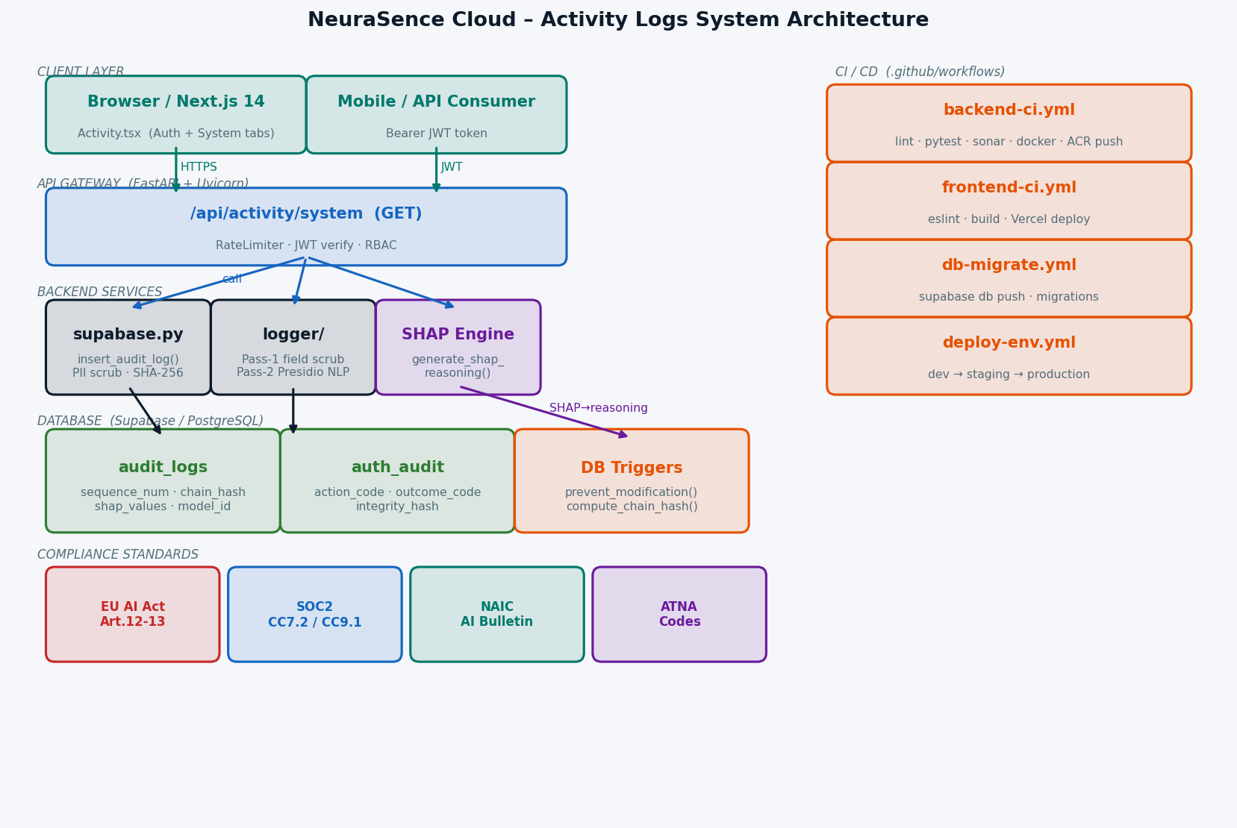
Figure 1 – NeuraSence Cloud Activity Logs System Architecture

3. Database Schema
Two tables store audit data. audit_logs holds all system and AI events; auth_audit holds authentication events. Both use FK constraints to auth.users with ON DELETE CASCADE. All tables are append-only (see Section 8).
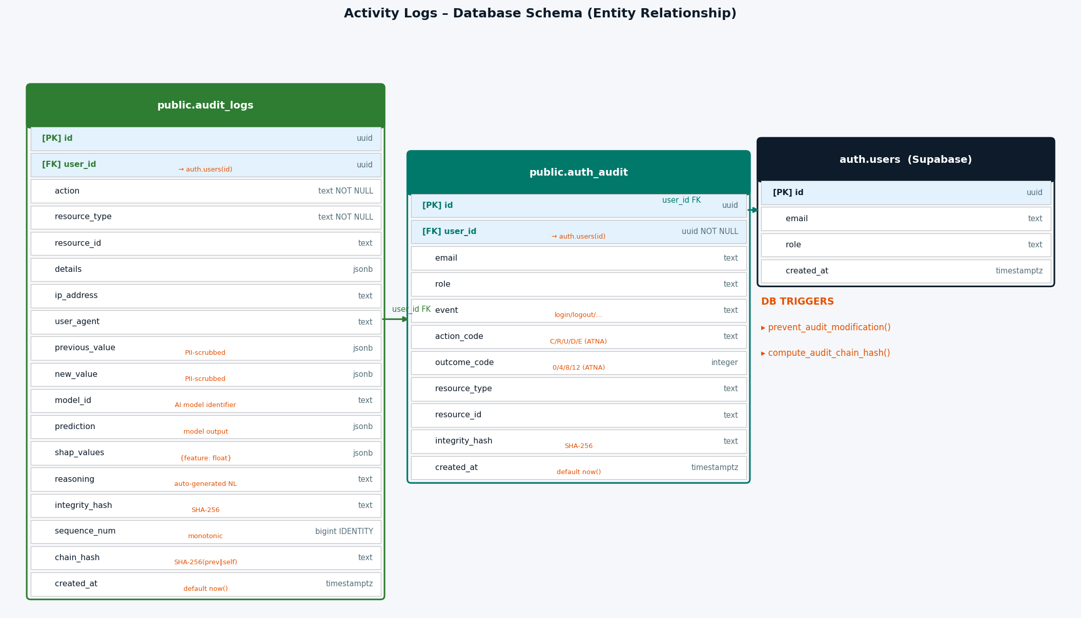
Figure 2 – Entity Relationship Diagram (audit_logs + auth_audit + auth.users)

3.1 audit_logs columns
Column | Type | Purpose
id | uuid PK | Unique row identifier
user_id | uuid FK | → auth.users(id) ON DELETE CASCADE
action | text NOT NULL | Verb describing the operation
resource_type | text NOT NULL | Type of resource acted upon
resource_id | text | ID of the specific resource
details | jsonb | Freeform context data
ip_address | text | Client IP captured from request
user_agent | text | Browser / SDK identifier
previous_value | jsonb | Before state (PII-scrubbed)
new_value | jsonb | After state (PII-scrubbed)
model_id | text | AI model identifier (EU AI Act)
prediction | jsonb | Model output / decision
shap_values | jsonb | {feature_name: float} SHAP contributions
reasoning | text | Auto-generated NL explanation
integrity_hash | text | SHA-256(action∥user_id∥ts∥…)
sequence_num | bigint IDENTITY | Monotonically increasing insert order
chain_hash | text | SHA-256(prev_chain∥integrity_hash)
created_at | timestamptz | Default now(), set by DB

3.2 auth_audit columns
Column | Type | Purpose
id | uuid PK | Unique row identifier
user_id | uuid FK | → auth.users(id) ON DELETE CASCADE
email | text | User email at event time
role | text | User role at event time
event | text | login / logout / token_refresh / …
action_code | text | ATNA: C=Create, R=Read, U=Update, D=Delete, E=Execute
outcome_code | integer | ATNA: 0=Success, 4=Minor, 8=Serious, 12=Major
resource_type | text | Resource type
resource_id | text | Resource ID
integrity_hash | text | SHA-256 tamper-evidence hash
created_at | timestamptz | Default now()

4. Data Flow
Every audit record follows a deterministic pipeline from the route handler through PII scrubbing, SHA-256 hashing, PostgREST insertion, and database trigger chaining.
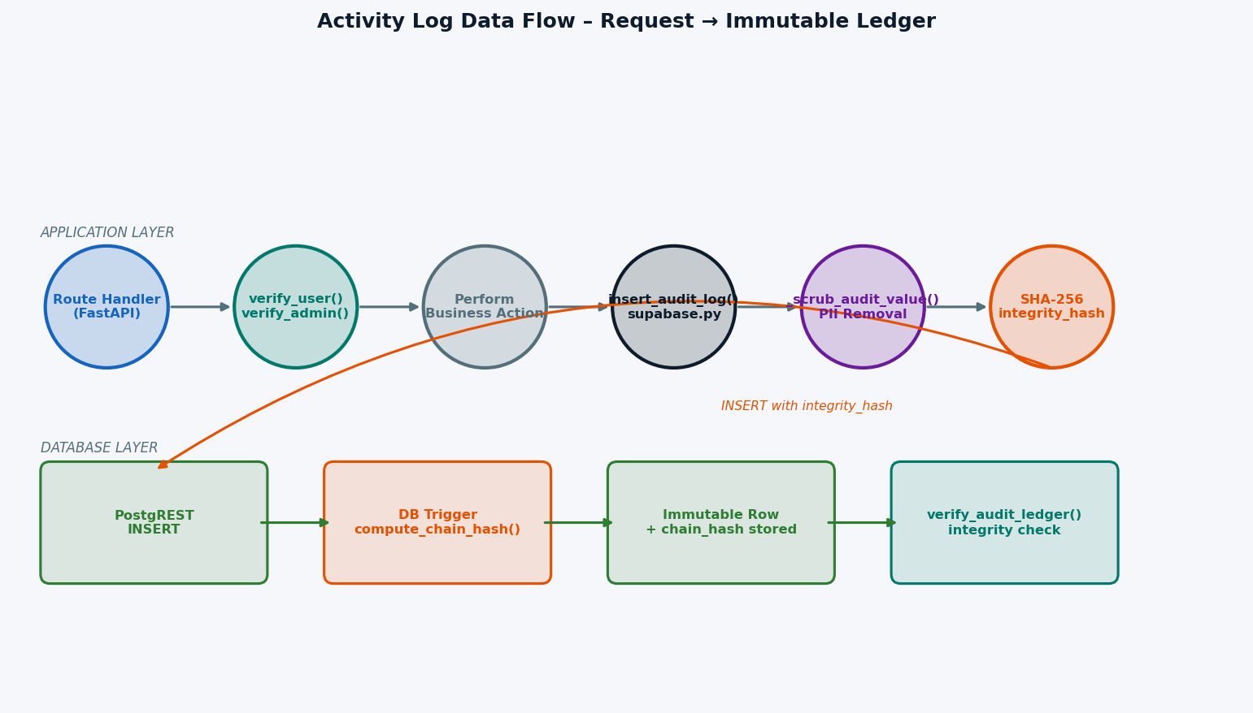
Figure 3 – Activity Log Data Flow: Request to Immutable Ledger
Step | Component | Description
1 | Route Handler | FastAPI endpoint receives request with Authorization header
2 | verify_user() | JWT validated; UserContext (role, tenant) extracted
3 | Business Action | Core logic executes (create device, run model, etc.)
4 | insert_audit_log() | Called with action, resource_type, details, shap_values
5 | _scrub_audit_value() | PII field names redacted from details/prev/new values
6 | SHA-256 hash | integrity_hash = SHA-256(action∥user_id∥resource∥ts∥…)
7 | PostgREST INSERT | Row written to audit_logs table
8 | DB Trigger | compute_audit_chain_hash() chains to previous row
9 | Immutable Row | prevent_audit_modification() blocks any future UPDATE/DELETE

5. API Reference

GET /api/activity/system
Returns a paginated list of system audit log entries. Requires Bearer JWT.
Parameter | Type | Required | Default | Description
page | integer | No | 0 | Page index (0-based)
action | string | No | — | Partial match on action field (ilike)
resource_type | string | No | — | Exact match on resource_type
date_from | ISO-8601 | No | — | Filter: created_at ≥ date_from
date_to | ISO-8601 | No | — | Filter: created_at ≤ date_to

Response Schema
Field | Type | Description
logs | array | Array of SystemLogRow objects (max 25)
page | integer | Current page number
page_size | integer | 25 (fixed)
has_more | boolean | True if another page exists

HTTP Status Codes
Code | Status | Meaning
200 | OK | Logs returned successfully
401 | Unauthorized | Missing or invalid JWT token
403 | Forbidden | Guest role not permitted
500 | Server Error | Unexpected backend failure

6. Sequence Diagram
The sequence diagram illustrates two flows: the read path (GET /api/activity/system) and the write path (insert_audit_log called after any business action).
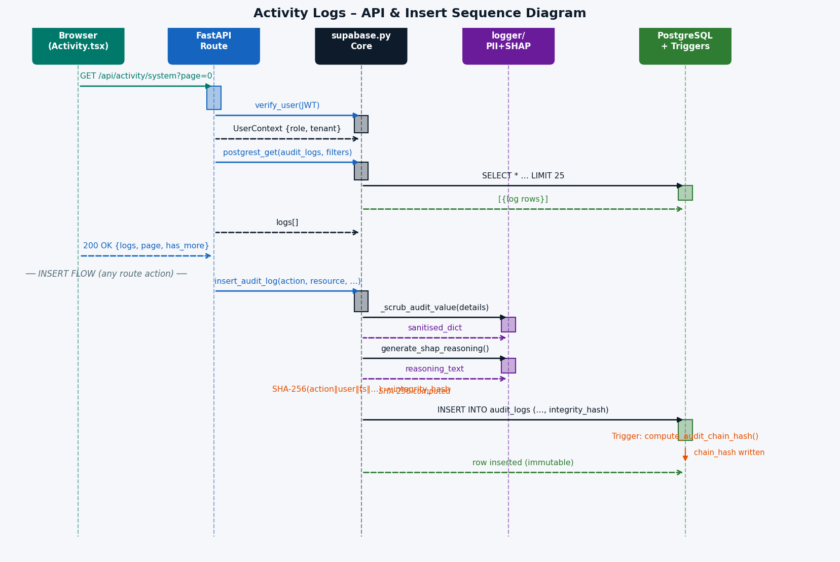
Figure 4 – API & Insert Sequence Diagram

7. Role-Based Access Control (RBAC)
Access to audit logs is controlled at two layers: the FastAPI route checks the decoded JWT role, and Supabase RLS policies enforce row-level restrictions in the database.
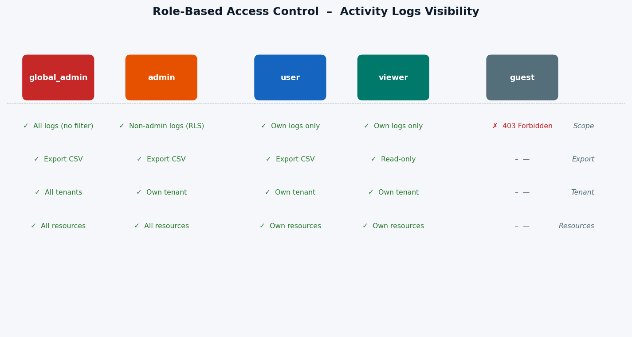
Figure 5 – RBAC Matrix: Role vs. Visibility Scope
Role | Visibility | Export | Tenant Scope | Resources
global_admin | All logs (all tenants, all roles) | Yes | All tenants | All
admin | All logs for own tenant (RLS) | Yes | Own tenant | All resources
user | Own logs only | Yes | Own tenant | Own resources
viewer | Own logs only (read-only) | Yes | Own tenant | Own resources
guest | 403 Forbidden | No | — | —

8. Cryptographic Audit Ledger
Each row in audit_logs cryptographically binds to its predecessor via chain_hash. Inserting, removing, or reordering any row invalidates all subsequent chain_hashes, making tampering immediately detectable by verify_audit_ledger().
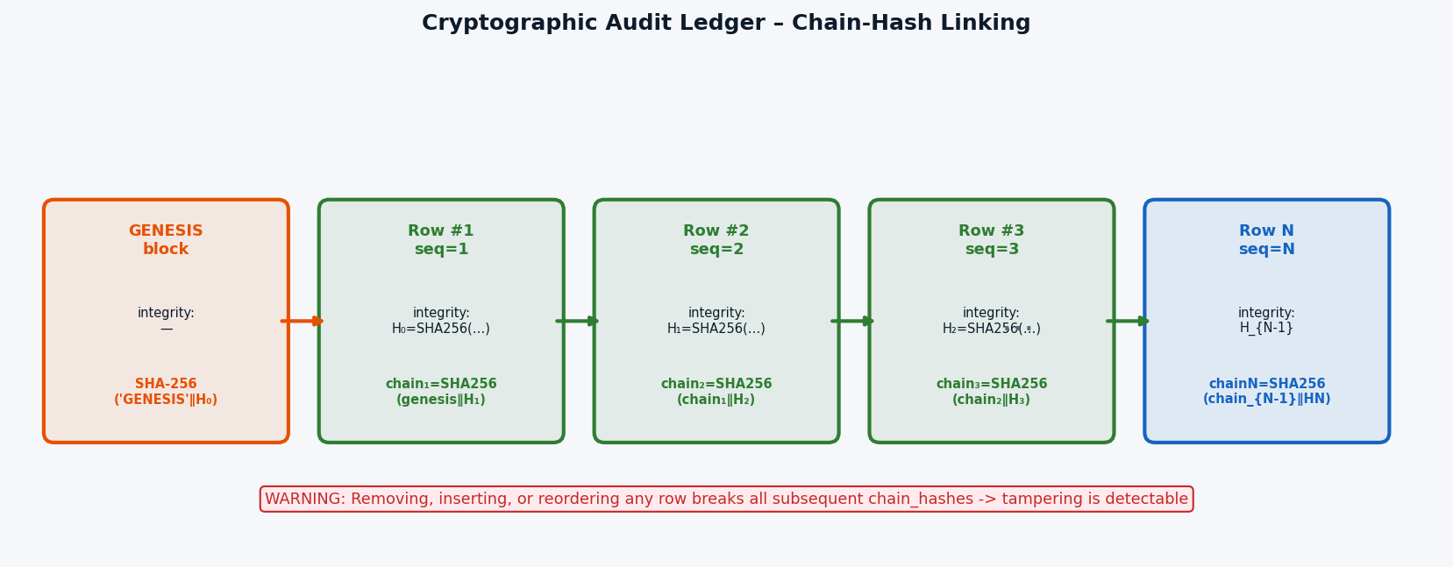
Figure 6 – Cryptographic Chain-Hash Ledger

Chain-Hash Algorithm
Each row's chain_hash is computed by the DB trigger before INSERT:
chain_hash(N) = SHA-256( chain_hash(N-1) ∥ integrity_hash(N) )
chain_hash(1) = SHA-256( 'GENESIS' ∥ integrity_hash(1) )

Verification
SELECT * FROM public.verify_audit_ledger() WHERE NOT is_valid;
Returns rows where stored_chain ≠ recomputed_chain → indicates tampering or data loss.

Immutability Triggers
Function | Table | Trigger Event | Effect
prevent_audit_modification() | audit_logs | BEFORE UPDATE OR DELETE | Raises exception unconditionally
prevent_audit_modification() | auth_audit | BEFORE UPDATE OR DELETE | Raises exception unconditionally
compute_audit_chain_hash() | audit_logs | BEFORE INSERT | Computes and writes chain_hash

9. PII Scrubbing Pipeline
Before any data is written to the audit tables, all field values pass through a two-pass PII scrubbing system to comply with GDPR and HIPAA requirements.
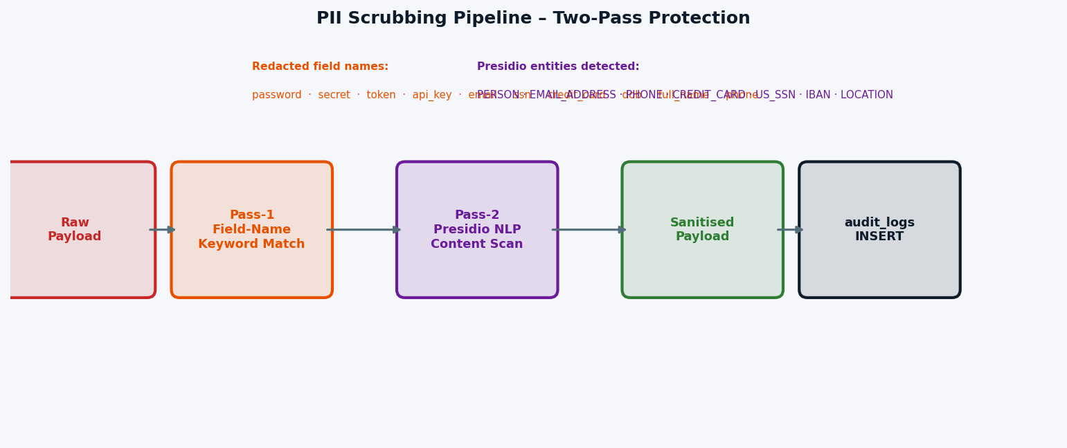
Figure 7 – Two-Pass PII Scrubbing Pipeline

Pass-1: Field-Name Keyword Match (Synchronous)
Redacted field names (case-insensitive):
password · passwd · secret · token · api_key · authorization · email · ssn · social_security · credit_card · card_number · cvv · dob · date_of_birth · birth_date · full_name · first_name · last_name · mobile · phone · phone_number · address

Pass-2: Presidio NLP Content Scan (Async)
Detected entity types (Microsoft Presidio):
PERSON · EMAIL_ADDRESS · PHONE_NUMBER · CREDIT_CARD · US_SSN · IBAN_CODE · LOCATION
Pass-2 runs in a dedicated ThreadPoolExecutor (non-blocking). If Presidio is unavailable, the system degrades gracefully to Pass-1 only.

10. AI Explainability & SHAP Values
The EU AI Act (Art.13) requires that high-risk AI systems provide meaningful explanations of automated decisions. The Activity Logs system stores SHAP feature contributions alongside each AI prediction and auto-generates a natural-language reasoning string for every model inference event.
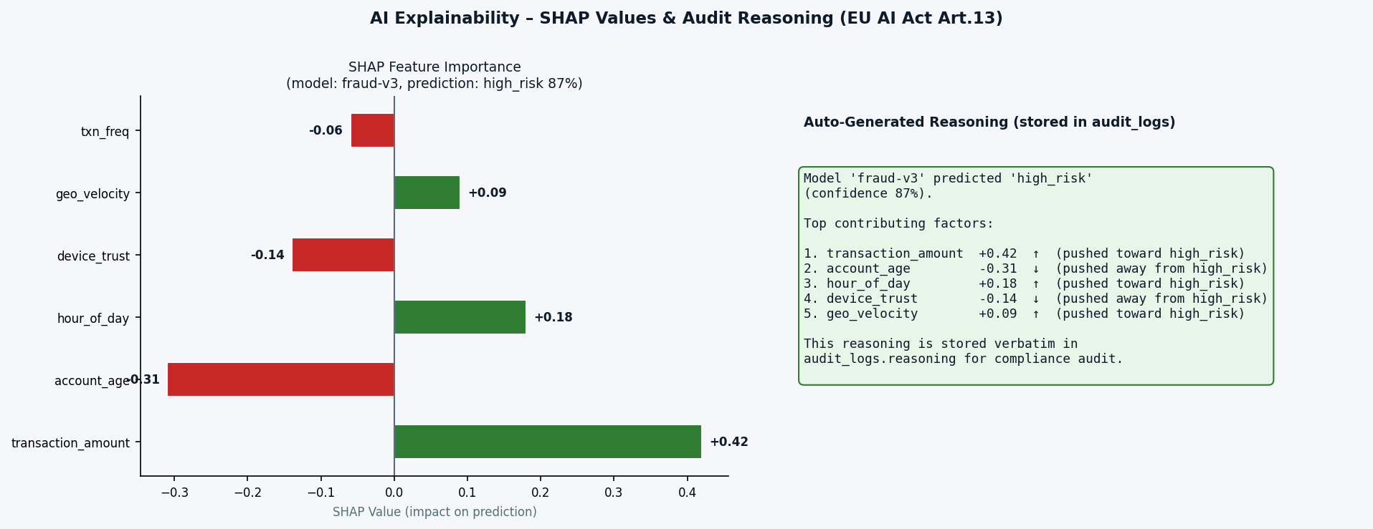
Figure 8 – SHAP Feature Importance & Auto-Generated Reasoning (EU AI Act Art.13)

Fields Stored per AI Decision
Field | Type | Content
model_id | text | Identifier of the model that made the prediction
prediction | jsonb | Full model output object {class, confidence, …}
shap_values | jsonb | {feature_name: shap_float, …} for top-N features
reasoning | text | Auto-generated: 'Model X predicted Y. Top factors: …'

generate_shap_reasoning() Algorithm
Step | Action
1 | Sort features by |shap_value| descending
2 | Take top_n features (default: 5)
3 | Format each as: feature_name (±value, ↑/↓)
4 | Prefix with model prediction and confidence level
5 | Return full string → stored in audit_logs.reasoning

11. Frontend UI (Activity Page)
The Activity page (frontend/src/app-pages/Activity.tsx) provides a two-tab interface for viewing and exporting audit records.
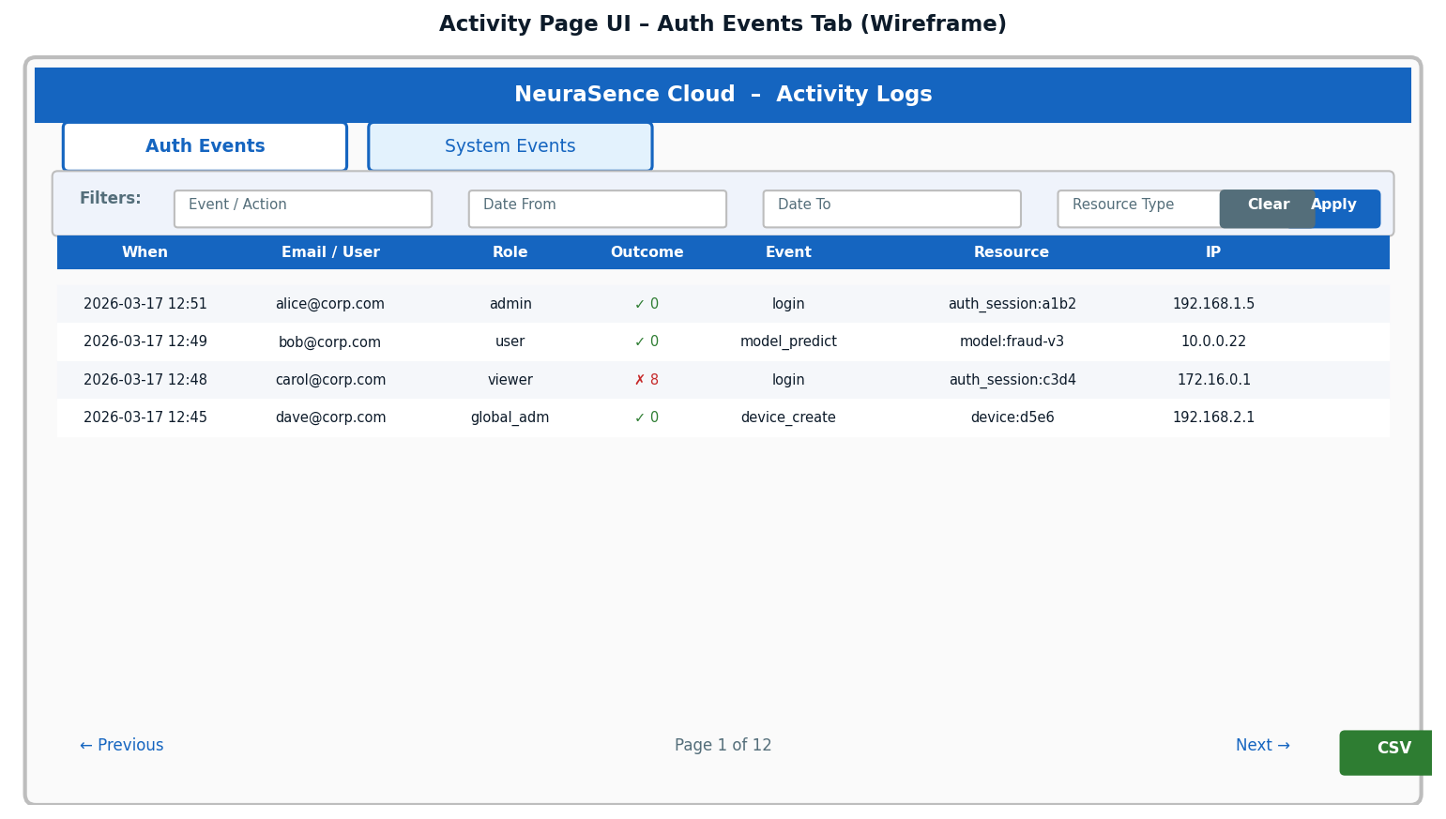
Figure 9 – Activity Page Wireframe (Auth Events Tab)

Tab 1 – Auth Events
Data source: Supabase RLS query on auth_audit table.
Column | Content
When | Formatted created_at timestamp
Email | User email
Role | Role badge (highlights admin roles)
Event | Event name (login, logout, token_refresh, …)
Action | ATNA action_code (C/R/U/D/E)
Resource | resource_type:resource_id
Outcome | OutcomeBadge: Success/Minor/Serious/Major

Tab 2 – System Events
Data source: Backend API GET /api/activity/system.
Column | Content
When | Formatted created_at timestamp
Action | Action string (e.g. device_create, model_predict)
Resource | resource_type:truncated_resource_id
Model | ModelBadge with model_id (monospace)
AI Reasoning | Inline ShapFactors (top 3 features with ↑/↓)
Details | Collapsible JSON details
IP | Client IP address

12. CI/CD Pipeline
Three GitHub Actions workflows automate quality gates and deployments.
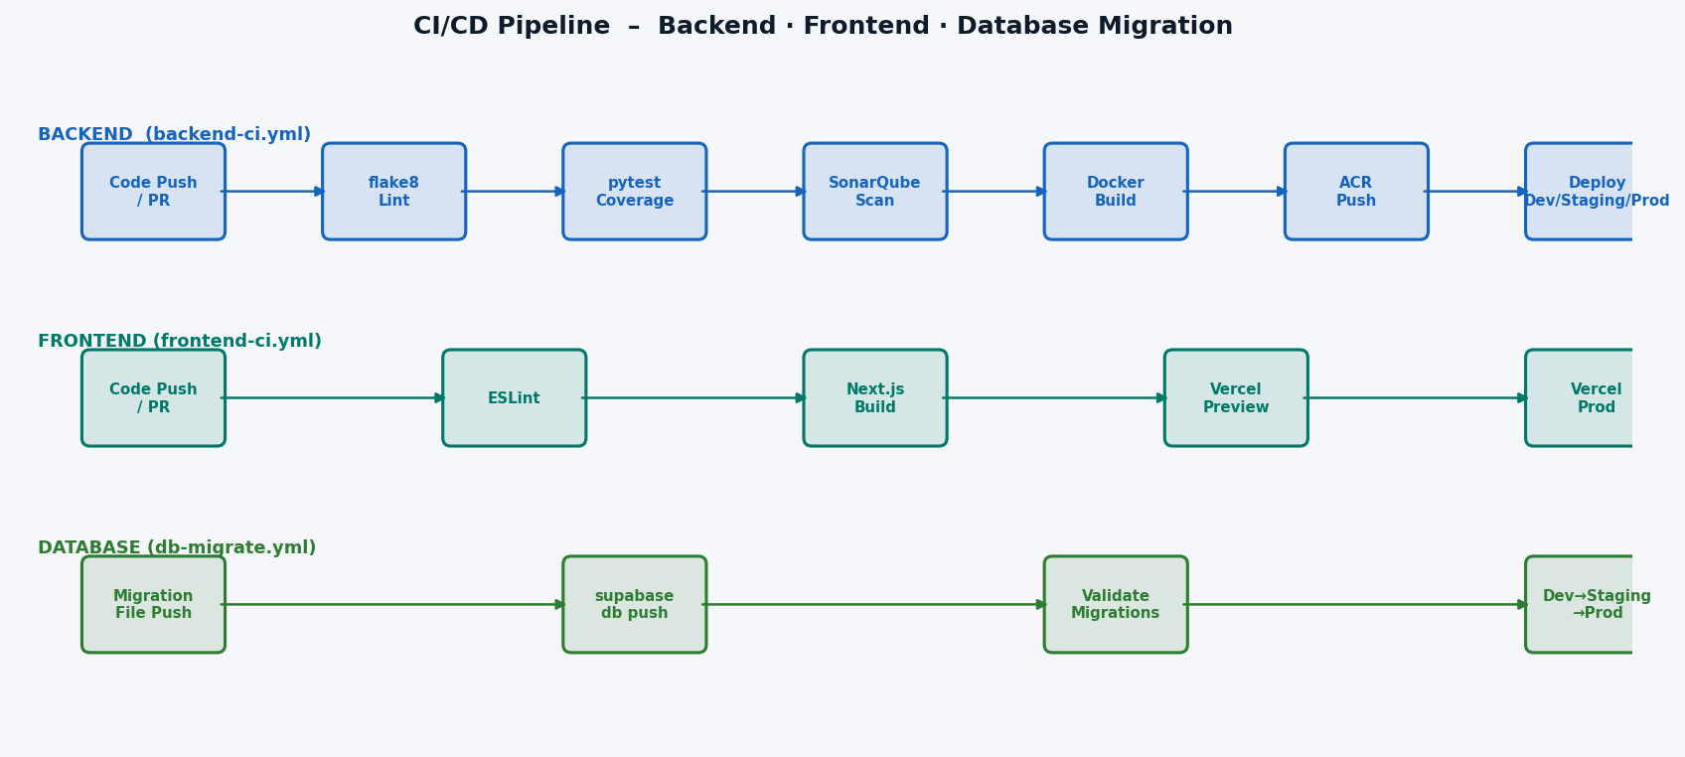
Figure 10 – CI/CD Pipeline: Backend · Frontend · DB Migrations
Workflow | Trigger | Steps
backend-ci.yml | Push/PR to v*-dev/staging/v1 | flake8 · pytest · SonarQube · Docker · ACR · Deploy
frontend-ci.yml | Push/PR to v*-dev/staging/v1 | ESLint · next build · Vercel preview · Vercel prod
db-migrate.yml | Migration file push | supabase db push · validate · dev→staging→prod
deploy-env.yml | Push to v1-dev/staging/v1 | Azure Container Apps deployment per environment

Backend CI Jobs
Job | Description
lint | flake8 with max-line-length=120; fails on any violation
test | pytest with coverage; skips if no test files present
sonarqube-scan | On PR to v1-dev and push to v1-dev only
docker-build | Builds container image with cache
acr-push | Pushes image to Azure Container Registry
deploy-dev | Triggered on push to v1-dev branch
deploy-staging | Triggered on push to v1-staging branch
deploy-production | Triggered on push to v1 branch

13. Compliance Mapping
The system satisfies multiple regulatory frameworks through its design.
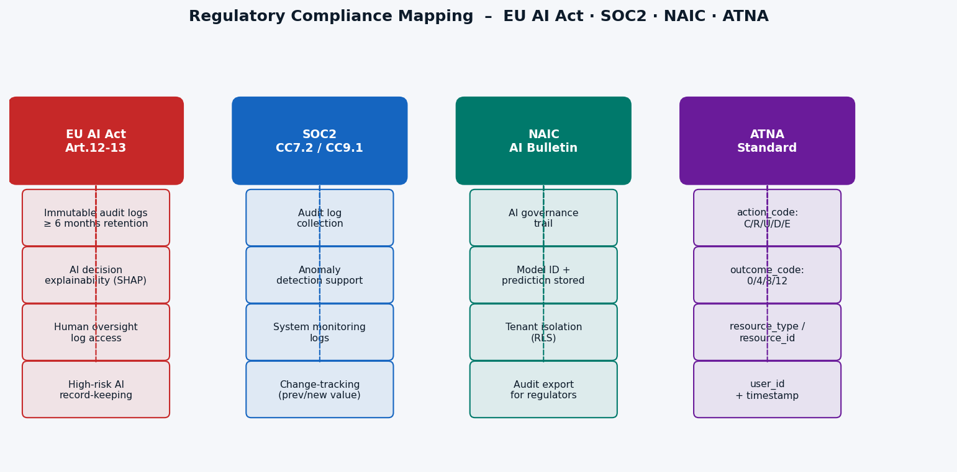
Figure 11 – Regulatory Compliance Mapping
Standard | Requirement | Implementation
EU AI Act Art.12 | Immutable logs | DB triggers prevent UPDATE/DELETE; chain-hash detects tampering
EU AI Act Art.13 | Transparency / explain | SHAP values + reasoning stored per AI decision
EU AI Act Art.12 | Retention ≥ 6 months | pg_cron archival to cold storage recommended
SOC2 CC7.2 | Audit log collection | All user and system events captured
SOC2 CC9.1 | System monitoring | Structured logs + request middleware
NAIC AI Bulletin | AI governance trail | model_id + prediction + shap_values per inference
NAIC | Tenant isolation | RLS policies per role and tenant_id
ATNA | Standard audit codes | action_code (C/R/U/D/E) + outcome_code (0/4/8/12)

14. Migration Timeline
Timestamp | File | Change
20260313091500 | auth_audit_logs.sql | Create auth_audit table + RLS policies
20260316000000 | auth_audit_user_id_fk.sql | Add FK constraint to auth.users
20260316000001 | audit_immutability.sql | Append-only triggers on both tables
20260316000002 | audit_logs_change_tracking.sql | Add previous_value / new_value columns
20260317000002 | audit_ledger_shap.sql | Cryptographic ledger + SHAP columns
20260317000003 | verify_audit_ledger_fix.sql | Fix NULL chain_hash for pre-migration rows

15. Test Coverage
insert_audit_log() is mocked in all production integration tests to prevent test runs from polluting the audit ledger.
Test File | Scope | Audit Mock Strategy
test_device_v1_production.py | Device API | Mocks insert_audit_log; tests device lifecycle
test_tenants_production.py | Tenants API | Mocks insert_audit_log; tests tenant CRUD
test_tenant_provisioning_sla.py | Provisioning | Mocks insert_audit_log; tests SLA workflows

Mock Pattern
async def fake_insert_audit_log(**_kwargs):
pass
monkeypatch.setattr(device_routes, 'insert_audit_log', fake_insert_audit_log)
This pattern ensures business logic is tested in isolation while maintaining full confidence that the real insert_audit_log() is exercised in staging/production environments via integration smoke tests.

────────────────────────────────────────────────────────────────────────────────
Generated by generate_docs.py · NeuraSence Cloud · 2026-03-17 08:17 UTC
This document is auto-generated from source code and migration files.

