FIDEON OS
Fine-Tuning Pipeline Architecture
User Approval → Training → Quantization → Electron Download

──────────────────────────────────────────────────────────────────────────────────────────

1. Overview
Fideon OS uses a continuous fine-tuning loop. Every time a user approves AI-extracted data in the Electron app, that approval becomes training data. Once enough approvals are collected, the system automatically trains a smarter model, quantizes it into multiple GGUF variants, stores everything in SeaweedFS, and makes the right variant available for the user's device to download — all without manual intervention.

1a. What Is Stored at Each Approval
Three pieces of data are permanently stored together for every approved run:

Data | Where Stored | Column / Path | Used For
Source file (ACORD PDF) | SeaweedFS | source_forms/<run_id>.pdf | Audit trail, re-extraction if needed
Displayed output (AI initial) | Supabase | original_extracted_json | Baseline — what the AI showed before correction
Corrected output (user truth) | Supabase | corrected_json (feedback table) | Training label — the ground truth the model learns

The training pair used for fine-tuning is: INPUT = raw_text (from PDF) → OUTPUT = corrected_json. The original AI output is preserved separately so we can measure how much the user changed.

2. Full Pipeline Flow
The diagram below shows all five phases of the pipeline, from user approval to offline model deployment on the Electron device.

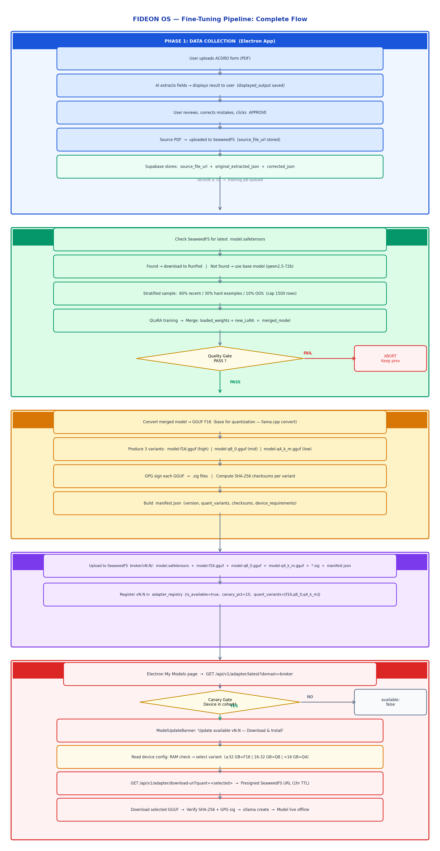

3. SeaweedFS Storage Layout
Two file types are stored per version: PyTorch weights for re-training, and GGUF for inference.

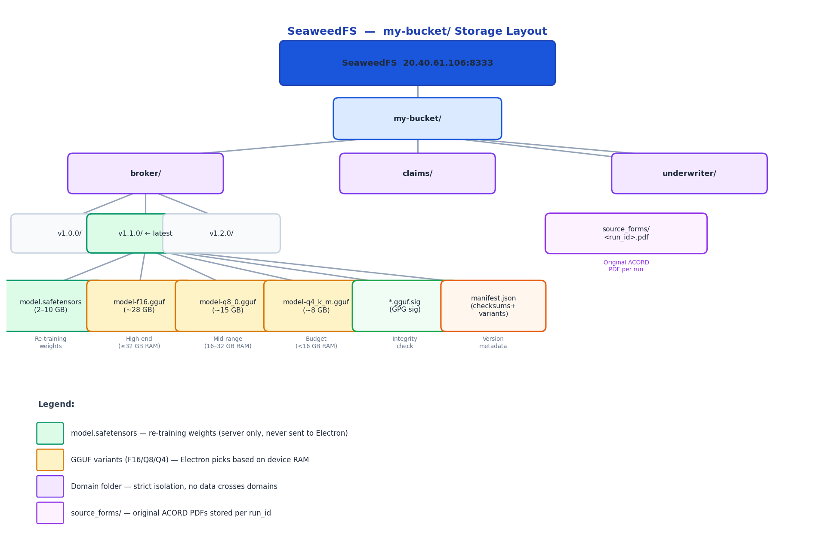

KEY RULES:
- GGUF = inference only. Electron downloads ONE variant based on device RAM and uses via Ollama.
- safetensors = training only. Never sent to Electron. Used as starting point for next fine-tune.
- 3 GGUF variants stored per version: F16 (high-end) / Q8_0 (mid-range) / Q4_K_M (low-end).
- Source ACORD PDFs stored under source_forms/<run_id>.pdf — permanent audit trail.
- Each domain has its own folder in SeaweedFS. Data never crosses domains.

4. Why Multiple File Formats?

Format | File | Size (14B model) | Purpose | Who Uses It
PyTorch safetensors | model.safetensors | 2–10 GB | Next fine-tune starting point | Server/RunPod only
GGUF F16 | model-f16.gguf | ~28 GB | Full precision inference — high-end devices | Electron (≥32 GB RAM)
GGUF Q8_0 | model-q8_0.gguf | ~15 GB | 8-bit quantized — mid-range devices | Electron (16–32 GB RAM)
GGUF Q4_K_M | model-q4_k_m.gguf | ~8 GB | 4-bit quantized — budget/laptop devices | Electron (<16 GB RAM)

GGUF cannot be fine-tuned — it has no gradient support. safetensors preserves full precision weights needed for continued training. The Electron app reads available RAM from device configuration settings and downloads only the appropriate GGUF variant — not all three.

5. Progressive Fine-Tuning — Each Cycle Builds on Previous
The system never goes back to the base model after the first training cycle. Each cycle downloads the previous safetensors from SeaweedFS and trains on top.

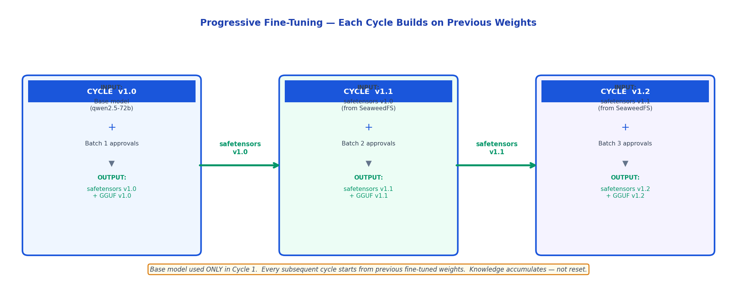

6. Stratified Data Sampling — Handles Growing Dataset
After months of use, tens of thousands of approvals accumulate. Training on all data would be slow and expensive. Smart sampling keeps training time constant.

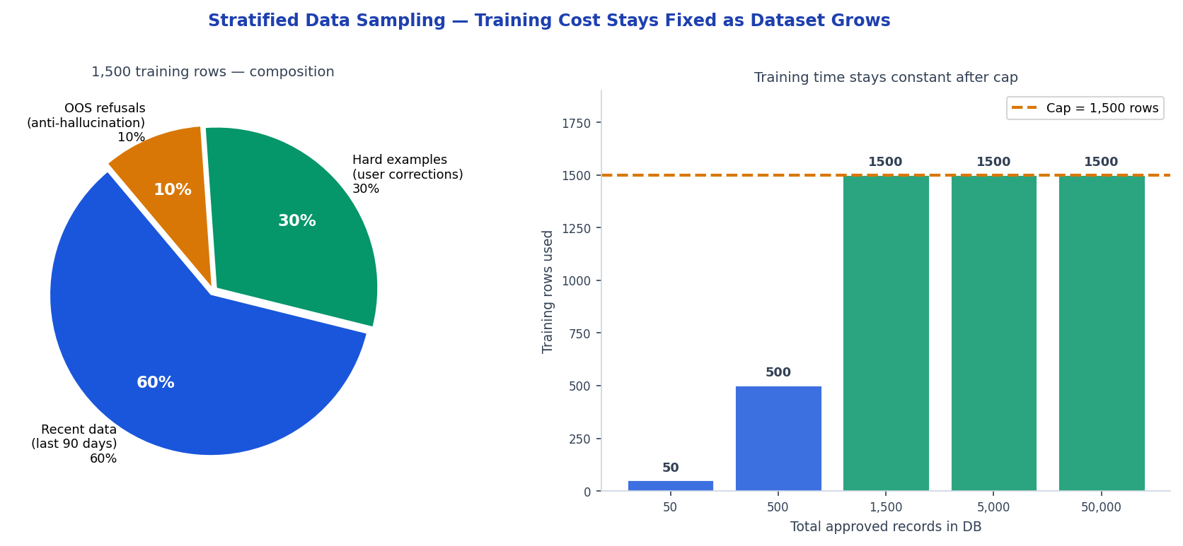

Bucket | % of Training | Source | Why
Recent data | 60% | Approvals from last 90 days | Learn current patterns and new form types
Hard examples | 30% | Records where user corrected AI output | Never forget edge cases and mistakes
OOS refusals | 10% | Out-of-scope examples (code-embedded) | Prevent hallucination on unknown inputs

7. Domain Isolation
Every domain has completely separate data, models, and access tokens. No training data or model weights ever cross domain boundaries.

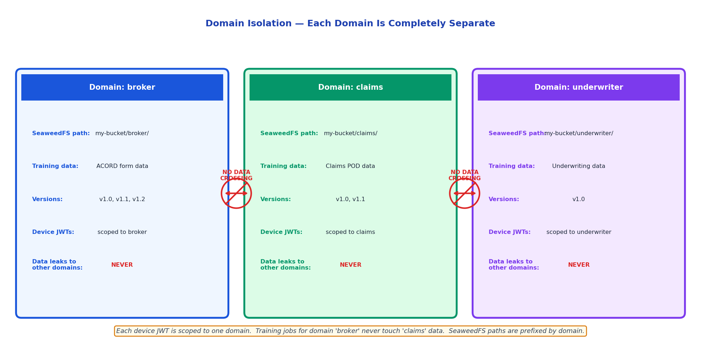

8. Canary Rollout — Safe Model Updates
New model versions roll out gradually. This prevents a bad model from reaching all users at once. The gate is deterministic — the same device always gets the same answer.

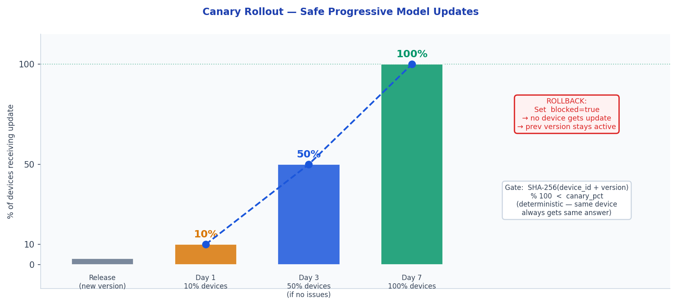

9. Quality Gate — Never Ship a Bad Model
After every training cycle, the model is evaluated against a holdout split before being allowed into SeaweedFS. A failure aborts the release and keeps the previous version active.

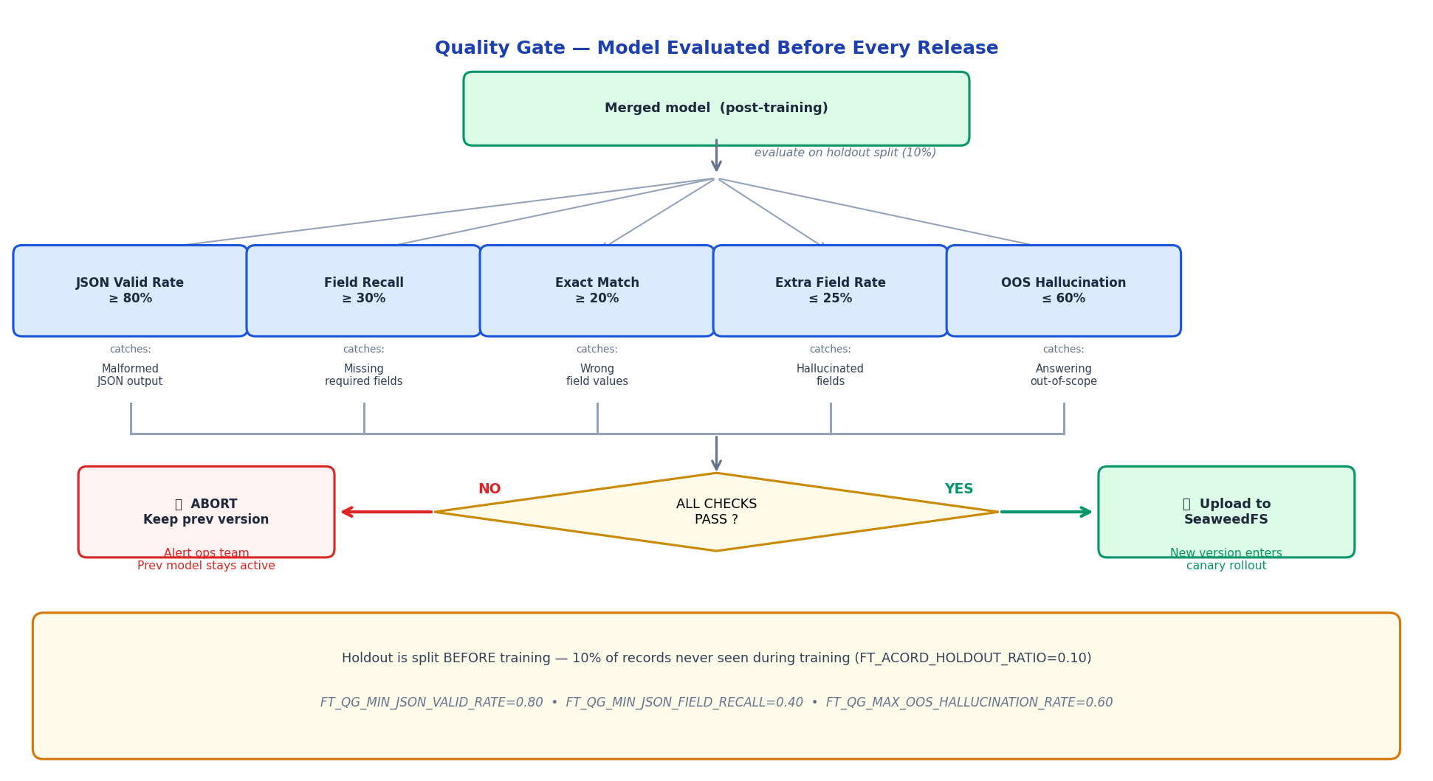

Check | Threshold | What it catches
JSON valid rate | >= 80% | Model outputting malformed JSON
Field recall | >= 30% | Model missing required fields
Exact match rate | >= 20% | Model getting field values completely wrong
Extra field rate | <= 25% | Model hallucinating non-existent fields
OOS hallucination rate | <= 60% | Model answering questions it should refuse

10. Key Configuration Variables

Variable | Default | Purpose
ACORD_TRAINING_MIN_RECORDS | 19 | Min approvals before training triggers
FT_MAX_TRAINING_ROWS | 1500 | Hard cap on training rows (sampling)
FT_RECENT_DAYS | 90 | Defines 'recent' for 60% bucket
FT_ACORD_HOLDOUT_RATIO | 0.10 | 10% held out for quality gate evaluation
FT_QG_MIN_JSON_VALID_RATE | 0.80 | Quality gate: JSON parse success rate
FT_QG_MIN_JSON_FIELD_RECALL | 0.40 | Quality gate: required field coverage
FT_QG_MAX_OOS_HALLUCINATION_RATE | 0.60 | Quality gate: out-of-scope refusal rate
SEAWEEDFS_ENDPOINT | ... | Storage server for models and weights
SEAWEEDFS_BUCKET | my-bucket | Root bucket for all domain data

11. Simple Summary

1 | User uploads ACORD form, AI extracts fields | Source PDF saved to SeaweedFS. AI output (displayed_output) saved to Supabase.
2 | User corrects mistakes and clicks Approve | corrected_json saved. All 3 records linked: source PDF + displayed + corrected.
3 | Enough approvals collected (19+) | System starts training job on RunPod GPU
4 | Training starts from PREVIOUS fine-tuned weights | Not from scratch — downloads safetensors from SeaweedFS
5 | New model trained, quality checked, quantized | Produces safetensors + 3 GGUF variants: F16 / Q8_0 / Q4_K_M
6 | All files uploaded to SeaweedFS | New version registered in adapter_registry
7 | Electron user opens My Models page | Banner: 'Model update available vN.N — Download & Install'
8 | App reads device RAM, selects GGUF variant | ≥32 GB=F16 | 16-32 GB=Q8_0 | <16 GB=Q4_K_M
9 | User clicks Download | Only the matching GGUF downloaded from SeaweedFS, installed into Ollama

