LLM Fine-Tune · Quantize · Azure Blob / SeaweedFS
Distribution Pipeline — Architecture & Integration Guide
Neura-Box Cloud · v1.0 · April 2026
This document describes the end-to-end automated pipeline for taking a QLoRA fine-tuned LLM (trained on Vast.ai) through GPU-accelerated quantization, uploading signed GGUF artifacts to Azure Blob Storage (with SeaweedFS as an on-premise mirror), and delivering them to the Electron desktop app as a one-click model update — with zero data egress and full integrity verification.

1. Pipeline Architecture Overview
The pipeline has four stages. GPU billing is active only during Stage 1 (~52 min total). All subsequent stages run on CPU-only infrastructure with zero data egress to the cloud.
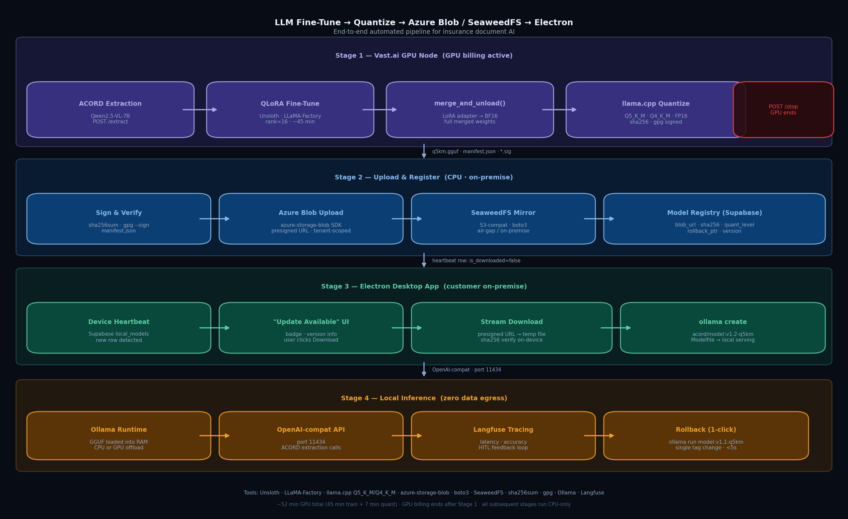
Figure 1 — Full pipeline: Vast.ai → Azure Blob / SeaweedFS → Electron Ollama

2. Stage-by-Stage Breakdown

Stage 1 — Vast.ai GPU Node (GPU billing active)
The Vast.ai node is provisioned via POST /start. The base model is loaded into VRAM. QLoRA fine-tuning runs in a background thread (~45 min). Once training completes, the LoRA adapter is merged into the base BF16 weights using merge_and_unload(), then llama.cpp GGML CUDA kernels quantize the merged model in ~7 min. The node is terminated immediately after — GPU billing ends here.
Step | Detail
ACORD Extraction | Qwen2.5-VL-7B · POST /extract · page images → JSON fields
HITL Corrections | Next.js review app · verified_text.json · JSONL builder · PII redacted
QLoRA Fine-Tuning | Unsloth + LLaMA-Factory · rank=16 · α=32 · BF16 · 3 epochs · ~45 min
merge_and_unload() | Merges LoRA adapter into base weights: W' = W + (α/r)·B·A
llama.cpp Quantize | Q5_K_M (~10.7 GB, production) · Q4_K_M (~8.0 GB, edge/air-gap) · FP16 (CI reference)
Sign Artifacts | sha256sum per file · gpg --detach-sign · manifest.json generated
POST /stop | Graceful shutdown · VRAM released · GPU billing ends · ~52 min total billed

Stage 2 — Upload to Azure Blob & SeaweedFS (CPU)
Signed GGUF artifacts are uploaded from the Vast.ai node (or the backend orchestrator) to Azure Blob Storage as the primary store. SeaweedFS acts as an on-premise S3-compatible mirror for air-gapped customers. Both use the same boto3/azure-sdk code path with different endpoint configs. On successful upload the model registry row is written to Supabase.
Step | Detail
Azure Blob Upload | azure-storage-blob SDK · models/{domain}/v{ver}/{quant}/ · presigned URL · 24hr expiry · tenant-scoped
SeaweedFS Mirror | boto3 S3 PutObject · same path schema · different endpoint URL in config · air-gap support
SHA-256 Verify | Server-side checksum against manifest.json · mismatch → reject + alert webhook
Registry Insert | Supabase model_registry: blob_url · sha256 · quant_level · docker_sha · rollback_ptr · version
Heartbeat Trigger | New row inserted into public.local_models with is_downloaded=false for all active devices

Stage 3 — Electron Desktop App — Detection & Download (on-premise)
The Electron app's existing device heartbeat (device-client.ts) polls Supabase for model sync state. When it detects a new local_models row with is_downloaded=false it surfaces an 'Update Available' notification. The user clicks Download — a presigned Azure Blob URL is fetched from the backend, the GGUF is streamed to a temp file, sha256 is verified on-device, then ollama create registers the model.
Step | Detail
Heartbeat Poll | device-client.ts polls /device/sync · new local_models row detected · is_downloaded=false
UI Notification | main.ts: badge on tray icon + in-app banner · version info · quant level · file size
Presigned URL Fetch | IPC: model:download-update → backend GET /models/download-url → returns Azure Blob presigned URL
Stream Download | electron/model-updater.ts · httpx/fetch stream → temp file · progress bar via IPC
SHA-256 Verify | sha256 computed on downloaded file · compared against manifest.json · mismatch → delete + alert
ollama create | ollama create acord/qwen25-14b:v1.2-q5km -f Modelfile (points to .gguf path)
Registry Update | PATCH /device/models → is_downloaded=true · updated_at · version confirmed

Stage 4 — Local Inference (zero data egress)
Once registered in Ollama, the model serves ACORD extraction requests via the OpenAI-compatible API on port 11434. Langfuse tracing captures latency and accuracy. The Electron app can roll back to the previous version with a single tag change — no retraining required.
Step | Detail
Ollama Runtime | GGUF loaded into RAM/VRAM · CPU or GPU offload · no PEFT library needed on serving node
OpenAI-compat API | port 11434 · /api/chat · /api/generate · drop-in for existing ACORD extraction calls
Langfuse Tracing | Latency · token throughput · extraction accuracy · HITL feedback loop
Rollback | ollama run acord/model:v1.1-q5km — single tag change · <5 seconds · no retraining
Air-gap Path | SeaweedFS presigned URL · or SFTP push to DMZ · or signed .tar.gz via USB courier

3. Existing Codebase Integration
The diagram below maps each pipeline step to existing files in the neura-box-cloud repository. Green = no changes needed. Blue = extend. Orange = new file to create.
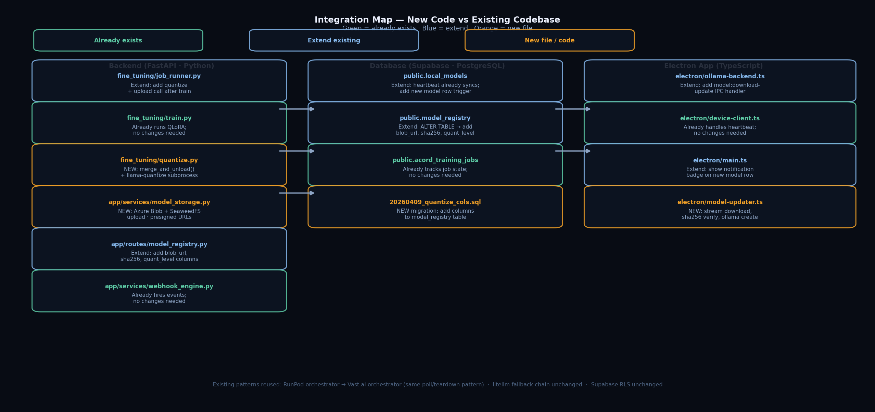
Figure 2 — Integration map: new code vs existing files

3.1 Files That Already Exist (No Changes)
File | Existing Role → Used As-Is
fine_tuning/train.py | QLoRA training · already runs on GPU node · no changes
fine_tuning/evaluate.py | Eval metrics · already called by job_runner · no changes
app/services/runpod_orchestrator.py | Pod provision/teardown pattern → copy for Vast.ai orchestrator
app/services/webhook_engine.py | Already fires events · used for 'new model ready' webhook
app/routes/device.py | Heartbeat + model sync · already writes local_models rows
electron/device-client.ts | Heartbeat poll · already reads local_models · detect new rows
electron/ollama-backend.ts | ollama create/delete/list · already implemented
electron/preload.ts | IPC bridge · just add new channel names

3.2 Files to Extend
File | What to Add
fine_tuning/job_runner.py | After train completes: call quantize.py → model_storage.py → registry insert
app/routes/model_registry.py | Handle new columns: blob_url · sha256 · quant_level · rollback_ptr
electron/main.ts | IPC handler: model:download-update · tray badge on new model notification
electron/ollama-backend.ts | modelCreateFromFile(path, modelName) helper for local GGUF registration

3.3 New Files to Create
New File | Purpose
fine_tuning/quantize.py | merge_and_unload() + llama-quantize subprocess · outputs q5km.gguf · sha256 · manifest.json
app/services/model_storage.py | Azure Blob upload (azure-storage-blob) + SeaweedFS mirror (boto3) · presigned URL generation
electron/model-updater.ts | Stream download from presigned URL · sha256 verify · call ollama create · IPC progress events
supabase/migrations/YYYYMMDD_quantize_cols.sql | ALTER TABLE model_registry ADD COLUMN blob_url, sha256, quant_level, rollback_ptr

4. Database Schema Changes
Add the following columns to the existing model_registry table:
-- supabase/migrations/20260410_quantize_distribution_cols.sql
ALTER TABLE public.model_registry
ADD COLUMN IF NOT EXISTS blob_url text,
ADD COLUMN IF NOT EXISTS sha256 text,
ADD COLUMN IF NOT EXISTS quant_level text, -- 'q5km' | 'q4km' | 'fp16'
ADD COLUMN IF NOT EXISTS rollback_ptr text, -- model_registry.id of prev version
ADD COLUMN IF NOT EXISTS seaweedfs_url text; -- optional on-premise mirror URL

The existing local_models table already has is_downloaded (boolean) and device_id. A new row is inserted here for each active device when a new model version is registered — the heartbeat picks it up automatically without any schema changes.

5. Azure Blob vs SeaweedFS — How They Coexist
Dimension | Azure Blob (Primary)
Purpose | Tenant download via presigned URL
SDK | azure-storage-blob Python SDK
Auth | SAS token · tenant-scoped · 24hr
Path schema | models/{domain}/v{ver}/{quant}/
Integrity | SHA-256 verified on upload
When used | Connected Electron app (default)
Code change | New model_storage.py

Both targets are written in a single upload_model() function. Setting SEAWEEDFS_ENDPOINT in the environment enables the mirror — if unset, only Azure Blob is written.

6. Suggested Implementation Order
Each step is independently testable before the next is started.
Step 1 — fine_tuning/quantize.py
Implement merge_and_unload() + llama-quantize subprocess. Test locally: give it a dummy adapter, confirm .gguf output + sha256 file.
Step 2 — app/services/model_storage.py
Azure Blob upload + SeaweedFS upload + presigned URL generation. Test with a dummy 1 MB file against a dev Azure container.
Step 3 — Supabase migration
Run ALTER TABLE on model_registry. Confirm local_models insert trigger works with a test row.
Step 4 — job_runner.py extension
Wire quantize.py → model_storage.py → registry insert into the post-train hook. Test full flow end-to-end with a small model on Vast.ai.
Step 5 — electron/model-updater.ts
Implement IPC download handler: presigned URL fetch → stream → sha256 verify → ollama create. Test with a pre-uploaded GGUF in Azure Blob.
Step 6 — electron/main.ts notification
On heartbeat response, check for new local_models rows. Show tray badge + in-app banner. Wire to model-updater.ts.
Step 7 — End-to-end test
Run a full training cycle on Vast.ai. Verify GGUF appears in Azure Blob, notification fires in Electron, download completes, ollama serves correctly.

7. Toolchain Summary
Stage | Tools
Stage 1 — Training | Unsloth · LLaMA-Factory · HuggingFace PEFT + TRL · bitsandbytes · BF16
Stage 1 — Quantization | llama.cpp (GGML CUDA build) · convert_hf_to_gguf.py · llama-quantize · gpg · sha256sum
Stage 2 — Storage | azure-storage-blob SDK · boto3 (SeaweedFS S3-compat) · weed filer · manifest.json
Stage 2 — Registry | Supabase PostgreSQL · FastAPI route · webhook_engine.py
Stage 3 — Electron | electron/model-updater.ts · Node.js fetch stream · electron-store · IPC
Stage 4 — Serving | Ollama (GGUF native) · OpenAI-compat API · Langfuse tracing · rollback by tag

GPU cost estimate: ~52 min per fine-tuning cycle (45 min QLoRA + 7 min quantization). All stages after GPU termination run on CPU-only infrastructure. Rollback to any prior version: single ollama tag change, under 5 seconds, no retraining required.

