Quantization Pipeline — Implementation Update
What was built · Architecture decisions · Next steps
This document covers the Quantization/ folder created in the project — all files, what each does, key architecture decisions made (especially around SeaweedFS sitting on Azure Blob / AWS S3 / GCP), the corrected storage design, and the remaining steps to run the pipeline end-to-end.

1. What Was Built — Quantization/ Folder
A self-contained Quantization/ folder has been created in the project root. It is designed to be transferred to the Vast.ai node and run there. It covers the full pipeline from merging the LoRA adapter through to uploading signed GGUF files to SeaweedFS and updating the Supabase model registry.
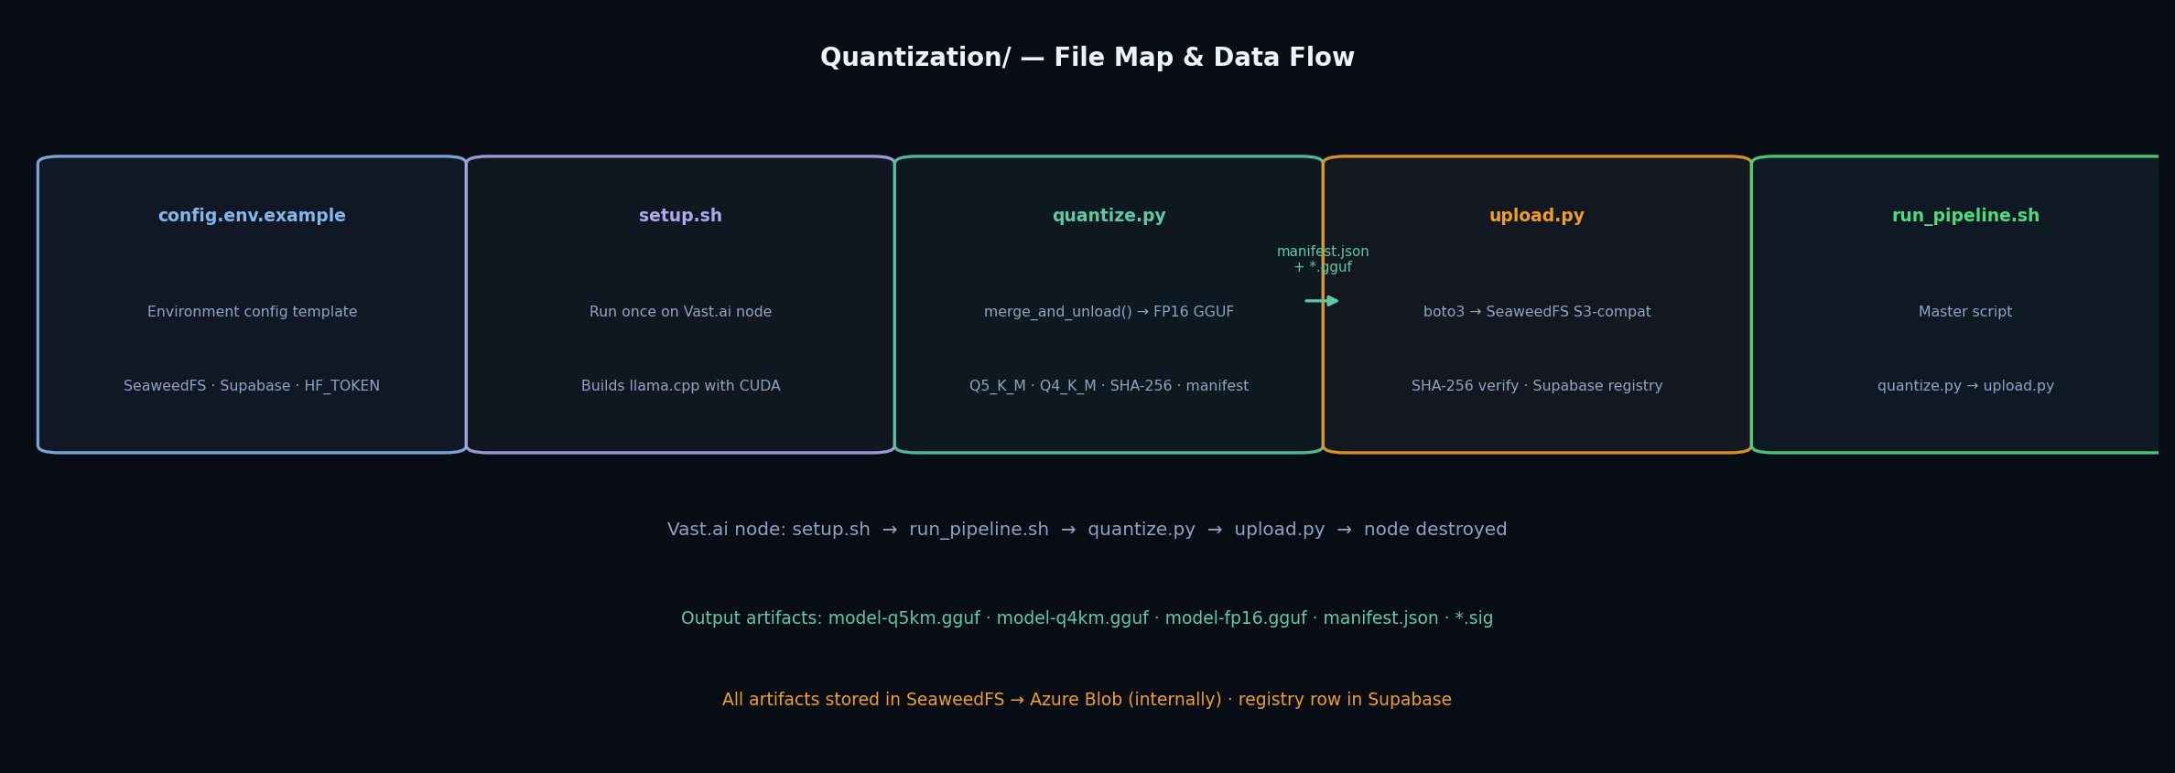
Figure 1 — Files in Quantization/ and their data flow
File | Purpose | Run where
config.env.example | Environment config template — copy to config.env | Local machine
requirements.txt | Python dependencies — boto3, transformers, peft, etc. | Vast.ai node
setup.sh | One-time node setup: installs llama.cpp with CUDA | Vast.ai node
quantize.py | Merge adapter → FP16 GGUF → Q5_K_M → Q4_K_M → sign | Vast.ai node
upload.py | Upload to SeaweedFS · verify SHA-256 · update Supabase | Vast.ai node
run_pipeline.sh | Master script — runs quantize.py then upload.py | Vast.ai node
STEPS.md | Step-by-step operator guide | Reference

2. quantize.py — What It Does
This is the core quantization script. It runs entirely on the Vast.ai GPU node and produces the GGUF artifacts that are later uploaded to SeaweedFS.
Step | Action | Detail
1 | Load base model in BF16 | Qwen/Qwen2.5-14B-Instruct · ~28 GB into VRAM · device_map=auto
2 | Load LoRA adapter | PeftModel.from_pretrained(model, adapter_path)
3 | merge_and_unload() | W' = W + (α/r)·B·A · single merged model · no PEFT needed after this
4 | Save merged BF16 to disk | /workspace/merged_bf16/ · tokenizer saved alongside
5 | Free VRAM | del model · gc.collect() · torch.cuda.empty_cache()
6 | convert_hf_to_gguf.py --outtype f16 | FP16 GGUF (~28 GB) · CI reference baseline
7 | llama-quantize Q5_K_M | ~10.7 GB · production use · attn 6-bit · FFN 5-bit
8 | llama-quantize Q4_K_M | ~8.0 GB · edge / air-gap use · attn 5-bit · FFN 4-bit
9 | SHA-256 per file | Computed locally after each quantize step
10 | GPG sign (optional) | gpg --detach-sign · *.sig file per GGUF
11 | Write manifest.json | schema_version · artifacts[] · sha256 · size_bytes · purpose

3. Storage Architecture — Key Design Decision
This is the most important architectural decision confirmed during implementation. It directly follows sir's specification.
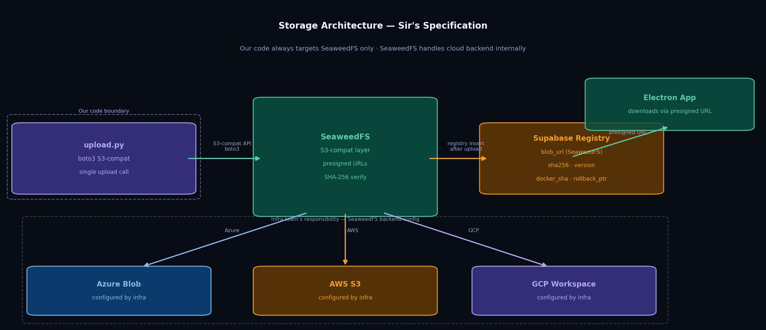
Figure 2 — SeaweedFS sits on top of Azure Blob / AWS S3 / GCP Workspace

3.1 The Rule
Our code (upload.py) uploads ONCE to SeaweedFS via its S3-compatible API using boto3. SeaweedFS internally persists data to the cloud backend — which could be Azure Blob, AWS S3, or GCP Workspace depending on how the infra team has configured SeaweedFS on the server. Our pipeline code never calls any cloud SDK directly.
What our code does | What SeaweedFS does internally (infra team)
boto3 S3-compat PutObject | Persists to Azure Blob (if on Azure)
boto3 generate_presigned_url | Persists to AWS S3 (if on AWS)
Single endpoint in config.env | Persists to GCP Workspace (if on GCP)
No Azure/AWS/GCP SDK needed | SeaweedFS config file sets the backend

3.2 What Was Corrected
An earlier version of upload.py incorrectly called both Azure Blob SDK and SeaweedFS as separate upload targets. This was corrected after clarification:
 | Before (wrong) | After (correct)
Upload 1 | SeaweedFS — S3-compat boto3 | SeaweedFS — S3-compat boto3
Upload 2 | Azure Blob — azure-storage-blob SDK | Nothing — removed entirely
SDK deps | boto3 + azure-storage-blob | boto3 only
config.env | AZURE_STORAGE_CONNECTION_STRING needed | Not needed — infra concern
blob_url | Azure presigned URL | SeaweedFS presigned URL

4. upload.py — What It Does
Runs after quantize.py. Reads manifest.json, verifies local SHA-256 for each file, uploads to SeaweedFS, verifies SHA-256 on SeaweedFS, then inserts a row into the Supabase model_registry table.
Step | Action | Detail
1 | Read manifest.json | Parses artifact list: filename · sha256 · size_bytes · purpose
2 | Local SHA-256 verify | Computed before upload — mismatch → exit(1), do not upload
3 | Upload to SeaweedFS | boto3 S3 PutObject · endpoint from SEAWEEDFS_ENDPOINT env var
4 | Remote SHA-256 verify | get_object → hash body → compare with manifest · mismatch → delete + error
5 | Generate presigned URL | s3.generate_presigned_url · 24hr expiry · this is blob_url in registry
6 | Upload *.sig files | GPG signatures uploaded alongside each GGUF
7 | Upload manifest.json | Uploaded to models/{version}/manifest/ path
8 | Supabase registry INSERT | model_version · sha256 · blob_url · docker_sha · rollback_ptr

4.1 Supabase model_registry Fields (Sir's Spec)
Field | Value | Status
model_version | e.g. v1.0 | Set from MODEL_VERSION env var
sha256 | SHA-256 of the GGUF file | Computed and verified twice
blob_url | SeaweedFS presigned URL (24hr) | Generated after upload
docker_sha | null | Set later when Docker image is built
rollback_ptr | null | Set by backend when promoting to active
quant_level | q5_k_m · q4_k_m · fp16 | From artifact in manifest.json
is_available | true | Set on insert

5. Supabase Migration Required
Before the pipeline can run, the following columns must be added to the existing model_registry table in Supabase:
-- Run in Supabase SQL Editor
ALTER TABLE public.model_registry
ADD COLUMN IF NOT EXISTS blob_url text,
ADD COLUMN IF NOT EXISTS sha256 text,
ADD COLUMN IF NOT EXISTS quant_level text,
ADD COLUMN IF NOT EXISTS docker_sha text,
ADD COLUMN IF NOT EXISTS rollback_ptr text,
ADD COLUMN IF NOT EXISTS filename text,
ADD COLUMN IF NOT EXISTS size_bytes bigint,
ADD COLUMN IF NOT EXISTS is_available boolean default true;

6. Next Steps
1. SeaweedFS deployment
Confirm SeaweedFS is deployed and accessible. Provide SEAWEEDFS_ENDPOINT, SEAWEEDFS_ACCESS_KEY, SEAWEEDFS_SECRET_KEY for the config.env file. This is the blocker before the pipeline can run.
2. Supabase migration
Run the ALTER TABLE migration in Section 5 against the production Supabase project.
3. Fill config.env
Copy config.env.example → config.env. Fill in SEAWEEDFS_*, SUPABASE_*, HF_TOKEN, MODEL_VERSION.
4. Confirm adapter availability
The fine-tuned LoRA adapter (adapter_model.safetensors + adapter_config.json + tokenizer files) must be available to transfer to the Vast.ai node.
5. Rent Vast.ai node + run pipeline
Rent 40GB with 200GB disk and PyTorch (Vast) template. Transfer Quantization/ folder + adapter. Run setup.sh then run_pipeline.sh.
6. Verify & destroy node
Confirm GGUF files appear in SeaweedFS and model_registry row is inserted in Supabase. Destroy the node immediately to stop billing.
7. Electron model-updater.ts
Separate task: implement the download handler in Electron that reads blob_url from Supabase, streams the GGUF, verifies sha256, and calls ollama create.

Key constraint: SeaweedFS must be running and accessible before any upload can happen. All other steps (quantize.py, setup.sh, Supabase migration) can be prepared in parallel.

