Fideon OS
Pending Implementation Tasks — Backend & Frontend

Version: 1.0 | Branch: v1-dev | April 2026

Table of Contents
- 1. Summary — What Is Done vs Pending
- 2. Progress & Effort Charts
- 3. C1 — Migrate Existing Routes to tenant_scoped helpers
- 4. C2 — Pass tenant_id Through Vector Ingestion
- 5. W2 — Wire Circuit Breaker record_success / record_failure
- 6. W3 — Migrate Existing Routes to CurrentTenant Dependency
- 7. C3 — Frontend apiBaseUrl.ts HTTP Guard
- 8. Recommended Implementation Order
- 9. Definition of Done Checklist

1. Summary — What Is Done vs Pending
ID | Task | Severity | Status | Scope
C1 | Service role key — migrate routes to tenant_scoped | CRITICAL | Pending | 26 route files, ~80+ call sites
C2 | pgvector tenant_id — wire through ingestion pipeline | CRITICAL | Partial | vectorstore_ingestion.py + acord.py
W2 | Circuit breaker — wire record_success/failure in llm.py | WARNING | Partial | 1 file, ~15 lines
W3 | CurrentTenant dependency — migrate all routes | WARNING | Pending | 26 route files
C3 | Frontend apiBaseUrl.ts — HTTP fallback guard | CRITICAL | Pending | 1 file, 5 lines

C1 and W3 touch the same 26 route files — implement together to avoid doing two passes over the same code. Total combined effort: 2 days, not 4.

2. Progress & Effort Charts

2.1 Completion Status per Task
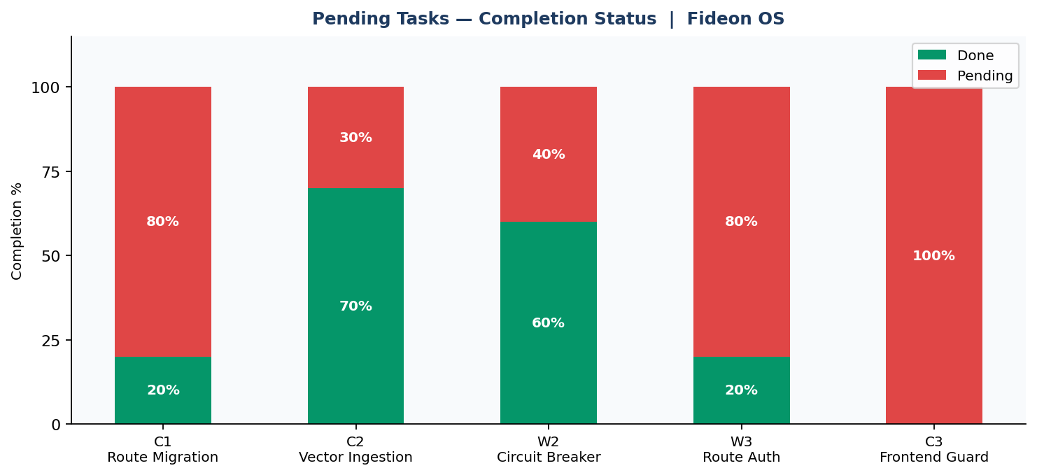

2.2 Effort Distribution
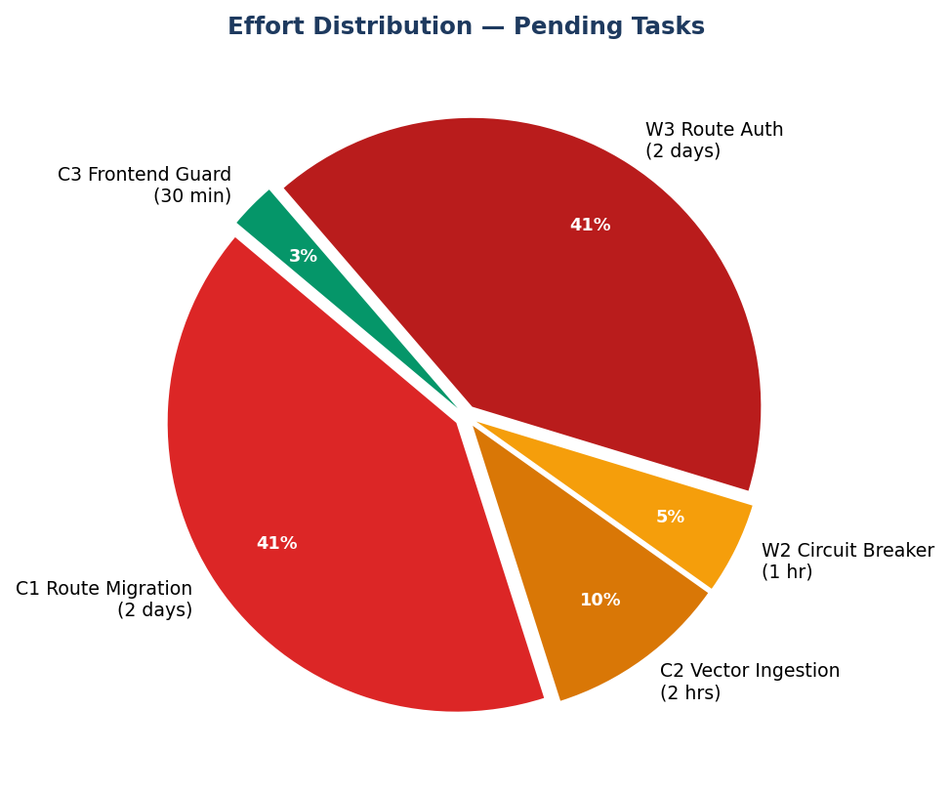

3. C1 — Migrate Routes to tenant_scoped Helpers
Severity: CRITICAL | Status: PENDING | Effort: 2 days (combined with W3)

3.1 What Was Built
The following helpers were added to backend/app/core/supabase.py:
- tenant_scoped_get(table, query, tenant_id) — appends &tenant_id=eq.<id> to every GET
- tenant_scoped_insert(table, data, tenant_id) — injects tenant_id into INSERT payload
- tenant_scoped_patch(table, query, data, tenant_id) — scopes PATCH to tenant's rows only
- MULTI_TENANT_TABLES frozenset — 24 tables registered as requiring tenant scoping
- _assert_tenant_id() guard — raises ValueError immediately if tenant_id is missing

3.2 What Is Still Missing
26 route files still call postgrest_get() / postgrest_insert() / postgrest_patch() directly without any tenant_id filter. A bug in any of these can silently return another tenant's data.

3.3 Affected Files
File | Issue
backend/app/routes/activity.py | postgrest_get on audit_logs — no tenant filter
backend/app/routes/admin.py | user listing, role changes — no tenant filter
backend/app/routes/agents.py | agent_pipelines reads — no tenant filter
backend/app/routes/chat.py | chat_conversations reads/writes — no tenant filter
backend/app/routes/decision_reviews.py | decision_reviews reads — no tenant filter
backend/app/routes/device.py | devices reads/writes — no tenant filter
backend/app/routes/device_admin.py | devices admin reads — no tenant filter
backend/app/routes/federated_learning.py | federated_rounds reads — no tenant filter
backend/app/routes/model_registry.py | activated_models reads — no tenant filter
backend/app/routes/notifications.py | notifications reads — no tenant filter
backend/app/routes/pods.py | pod extraction runs — no tenant filter
backend/app/routes/acord.py | acord_extraction_runs — no tenant filter
backend/app/routes/settings.py | app_users / tenants — no tenant filter
backend/app/routes/tenants.py | tenants reads — no tenant filter
backend/app/routes/webhooks.py | webhooks reads/writes — no tenant filter
backend/app/routes/workflow_ai.py | workflows reads — no tenant filter
backend/app/services/acord_training.py | training_jobs reads — no tenant filter
backend/app/services/pod_training.py | training_jobs reads — no tenant filter
backend/app/services/webhook_engine.py | webhooks service reads — no tenant filter

3.4 How to Fix (Pattern)
Before (current — unsafe):
# Any route — current pattern
user = await verify_user(authorization)
user_id = user.get("id")
rows = await postgrest_get("devices", f"user_id=eq.{user_id}")
# Bug: if user_id is from another tenant this returns their devices
After (correct — tenant-scoped):
# Any route — safe pattern
from app.core.deps import CurrentTenant
from app.core.supabase import tenant_scoped_get
async def list_devices(ctx: CurrentTenant):
rows = await tenant_scoped_get(
"devices",
f"user_id=eq.{ctx['user_id']}",
ctx["tenant_id"], # always scoped — no cross-tenant leakage
)
return rows

4. C2 — Pass tenant_id Through Vector Ingestion
Severity: CRITICAL | Status: PARTIAL | Effort: 2 hours

4.1 What Was Built
- pgvector_store.py — upsert_chunks() now accepts tenant_id parameter
- pgvector_store.py — query_similar() now accepts tenant_id parameter
- query_similar() without tenant_id now restricts to tenant_id IS NULL rows only
- Migration 20260421000000_vector_service_role.sql — vector_service role created

4.2 What Is Still Missing
The callers of upsert_chunks() and query_similar() have not been updated to pass tenant_id. Chunks are still being stored and queried with tenant_id=NULL.

4.3 Files to Fix
File | Fix Required
backend/app/services/vectorstore_ingestion.py | ingest_text_into_vectorstore() calls upsert_chunks() without tenant_id. Add tenant_id parameter and pass it through.
backend/app/routes/acord.py | _ingest_acord_into_vectorstore() calls vectorstore_ingestion without tenant_id. Extract tenant_id from request context and pass down.
backend/LLM/rag/generator.py | query_similar() calls may lack tenant_id. Verify and add tenant_id to all RAG query calls.

4.4 How to Fix
vectorstore_ingestion.py — add tenant_id parameter:
# Before
def ingest_text_into_vectorstore(*, collection_name, doc_id, text, ...):
upsert_chunks(collection_name=collection_name, chunks=chunks)
# After
def ingest_text_into_vectorstore(*, collection_name, doc_id, text,
tenant_id: str | None = None, ...):
upsert_chunks(collection_name=collection_name, chunks=chunks,
tenant_id=tenant_id)
acord.py — pass tenant_id from request context:
# Before
await _ingest_acord_into_vectorstore(text=extracted_text, pod_id=pod_id)
# After
ctx = await get_user_context(authorization)
await _ingest_acord_into_vectorstore(
text=extracted_text,
pod_id=pod_id,
tenant_id=ctx["tenant_id"], # scopes chunks to this tenant only
)

5. W2 — Wire Circuit Breaker record_success / record_failure
Severity: WARNING | Status: PARTIAL | Effort: 1 hour

5.1 What Was Built
- resilience.py — SimpleCircuitBreaker class with CLOSED / OPEN / HALF states
- resilience.py — runpod_circuit_breaker singleton instance
- resilience.py — @runpod_retry decorator (tenacity, 3 retries, 2s-8s backoff)
- llm.py — @runpod_retry applied to _runpod_generate_text()
- llm.py — runpod_circuit_breaker.before_call() added to _offline_fallback_stream()

5.2 What Is Still Missing
record_success() and record_failure() are never called after RunPod requests complete. The circuit breaker tracks zero failures and never opens. It blocks calls when OPEN (before_call works) but it can never become OPEN because the failure count never increases.

5.3 File to Fix
File: backend/app/services/llm.py

5.4 How to Fix
# backend/app/services/llm.py
from app.core.resilience import runpod_circuit_breaker
async def _runpod_generate_text(payload: dict, model_name: str) -> str:
runpod_token = _clean_bearer_token(FIDEON_SECRET_KEY or RUNPOD_API_KEY)
if not runpod_token:
raise RuntimeError("RunPod token not configured")
# Step 1 — check circuit before hitting RunPod
runpod_circuit_breaker.before_call()
try:
result = await _do_runpod_call(payload, model_name)
# Step 2 — record success so circuit stays CLOSED
runpod_circuit_breaker.record_success()
return result
except Exception as exc:
# Step 3 — record failure; after 5 failures circuit opens
runpod_circuit_breaker.record_failure()
raise
Same pattern applies to _try_runpod_openai_compat_stream() if it exists in llm.py.

6. W3 — Migrate Existing Routes to CurrentTenant Dependency
Severity: WARNING | Status: PENDING | Effort: 2 days (combined with C1)

6.1 What Was Built
- deps.py — get_current_tenant() FastAPI dependency
- deps.py — get_current_tenant_strict() — raises 403 if tenant_id is NULL
- deps.py — get_current_admin() — enforces admin / global_admin role
- deps.py — CurrentTenant, CurrentTenantStrict, CurrentAdmin Annotated shortcuts
- deps.py — GetDB — Annotated[DBRepository, Depends(get_db)]

6.2 What Is Still Missing
All 26 route files still repeat the same 4-line auth pattern manually on every endpoint. This is error-prone — if any route forgets to call verify_user() it becomes unauthenticated. With CurrentTenant the dependency is declared in the function signature and FastAPI enforces it automatically.

6.3 How to Fix (Pattern)
Before (current — manual, repetitive):
@router.get("/devices")
async def list_devices(authorization: Optional[str] = Header(None)):
user = await verify_user(authorization) # repeated in every route
user_id = user.get("id")
profile = await postgrest_get("app_users",
f"user_id=eq.{user_id}&select=tenant_id&limit=1")
tenant_id = profile[0].get("tenant_id") # repeated in every route
rows = await postgrest_get("devices",
f"user_id=eq.{user_id}") # no tenant scope
return rows
After (correct — dependency injection):
from app.core.deps import CurrentTenant, GetDB
from app.core.db import DBQuery
@router.get("/devices")
async def list_devices(ctx: CurrentTenant, db: GetDB):
# ctx["user_id"], ctx["tenant_id"], ctx["role"] all pre-resolved
rows = await db.tenant_get(
"devices",
DBQuery(filters={"user_id": ctx["user_id"]}, limit=100),
tenant_id=ctx["tenant_id"],
)
return rows

6.4 Migration Strategy
Recommended approach — migrate one route file at a time:
- 1. Pick one route file (start with the smallest, e.g. activity.py)
- 2. Replace verify_user() + manual tenant_id lookup with ctx: CurrentTenant
- 3. Replace postgrest_get/insert/patch with db.tenant_get/insert/update
- 4. Run existing tests to confirm no regression
- 5. Repeat for next file
Do NOT migrate all 26 files in one PR — it will be impossible to review.

7. C3 — Frontend apiBaseUrl.ts HTTP Guard
Severity: CRITICAL | Status: PENDING | Effort: 30 minutes

7.1 Problem
frontend/src/lib/apiBaseUrl.ts currently falls back to http://127.0.0.1:8080 if NEXT_PUBLIC_API_URL is not set. In a misconfigured Azure App Service deployment, all API calls — including JWT Bearer tokens — would be sent over plaintext HTTP.

7.2 File to Change
File: frontend/src/lib/apiBaseUrl.ts

7.3 Exact Code Change
Current code (unsafe):
export function getApiBaseUrl(): string {
const url = process.env.NEXT_PUBLIC_API_URL;
if (!url) {
return 'http://127.0.0.1:8080'; // silently returns HTTP in production
}
return url;
}
Fixed code (safe — throws in production if env var is missing):
export function getApiBaseUrl(): string {
const url = process.env.NEXT_PUBLIC_API_URL;
if (!url) {
const isLocalhost =
typeof window !== 'undefined' &&
(window.location.hostname === 'localhost' ||
window.location.hostname === '127.0.0.1');
if (!isLocalhost) {
throw new Error(
'[Fideon OS] NEXT_PUBLIC_API_URL is not set. ' +
'Set it to the HTTPS backend URL in your Azure App Service config.'
);
}
return 'http://127.0.0.1:8080'; // local dev only
}
return url;
}

7.4 Additional Required Steps
- Add NEXT_PUBLIC_API_URL=https://<backend>.azurewebsites.net to GitHub Actions secrets for staging and production environments
- Add NEXT_PUBLIC_API_URL to the deploy-app-service.yml env var sync step
- Never copy http://localhost:8000 from .env.local to App Service config

8. Recommended Implementation Order
Ordered by: highest security impact first, then effort efficiency (batching overlapping files together).
Order | Task | Effort | Severity | Notes
1 | C3 Frontend HTTP guard | 30 min | CRITICAL | Single file, zero risk of regression. Do first.
2 | W2 Circuit breaker wiring | 1 hr | WARNING | Single file (llm.py), ~15 lines. Quick win.
3 | C2 Vector ingestion tenant_id | 2 hrs | CRITICAL | 2-3 files. Low regression risk.
4 | C1 + W3 Route migration | 2 days | CRITICAL | 26 files. Do together. One file per PR.

Quick wins (C3 + W2 + C2) can be done in a single half-day sprint. Route migration (C1 + W3) should be a separate sprint with dedicated PR reviews.

9. Definition of Done Checklist
A task is complete ONLY when all items below are checked.
C3 — Frontend HTTP Guard
- [ ] apiBaseUrl.ts throws on non-localhost when NEXT_PUBLIC_API_URL is unset
- [ ] NEXT_PUBLIC_API_URL added to GitHub Actions staging + production secrets
- [ ] deploy-app-service.yml syncs NEXT_PUBLIC_API_URL to App Service
- [ ] Tested: deploy without env var causes visible build/runtime error (not silent HTTP)

W2 — Circuit Breaker Wiring
- [ ] runpod_circuit_breaker.before_call() called before every RunPod HTTP request
- [ ] runpod_circuit_breaker.record_success() called after every successful response
- [ ] runpod_circuit_breaker.record_failure() called after every failed response
- [ ] Manual test: 5 consecutive RunPod failures cause circuit to OPEN
- [ ] Manual test: after 60s, circuit moves to HALF-OPEN and one probe is allowed

C2 — Vector Ingestion tenant_id
- [ ] vectorstore_ingestion.py ingest_text_into_vectorstore() accepts tenant_id param
- [ ] acord.py passes tenant_id from request context to ingestion function
- [ ] rag/generator.py query_similar() calls include tenant_id
- [ ] Verified: new chunks have tenant_id populated in rag_chunks table
- [ ] Verified: query_similar() without tenant_id returns zero rows (not all tenants)

C1 + W3 — Route Migration
- [ ] Every route that reads a multi-tenant table uses tenant_scoped_get() or db.tenant_get()
- [ ] Every route that writes a multi-tenant table uses tenant_scoped_insert() or db.tenant_insert()
- [ ] No route calls postgrest_get() on a MULTI_TENANT_TABLES table without tenant_id filter
- [ ] All routes use ctx: CurrentTenant instead of manual verify_user() + tenant lookup
- [ ] Cross-tenant test: JWT from tenant A cannot return data from tenant B on any endpoint
- [ ] All existing tests pass with no regression

